# Unlock multiple demand replenishment picks for bulk selection location based on config

## Issue:

There 10 lanes currently is setup as bulk selection location, which is also used as receiving stage lane, items in these lanes are very fast moving item, currently the existing DR unlock job only unlock one DR when it reaches minimum value which is not fast enough to fulfill outbound picking. there is a need for this type of location we allow the job to unlock multiple DRs based on config.

## Approach:

Improve the existing unlock job USR-UNLOCK-RPL-FOR-MIN-QTY, add 2nd part logic to unlock DRs according to a policy driven config:

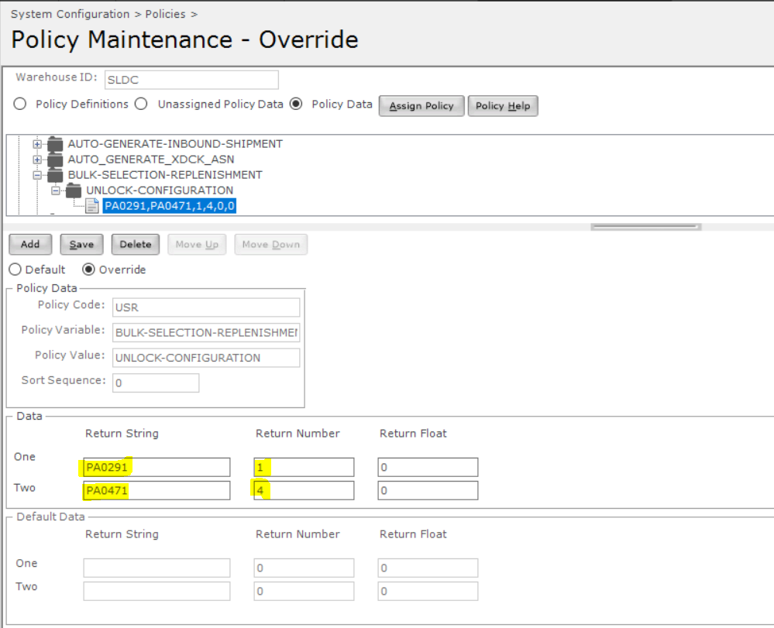

The job will read above policy and unlock DR accordingly:

**Return Number One:** 1 Enable, 0 Disable this logic.

**Return Number Two:** Defines how many pallets to be allowed sits in the lane at same time. e.g when this value is 4 and in the location you have 2 LPNs, system will unlock 2 more DRs.

**Return String One:** Defines the start location.

**Return String Two:** Defines the end location.

**Note:** above defines a location range for which this unlock logic will be run.

.

## Test scenario:

For location AN0211, 1 LPN in the location:

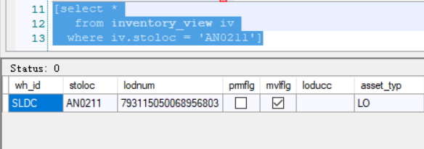

7 DRs in LOCK status:

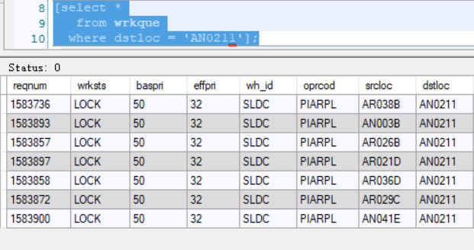

After running the new job, 3 earliest more unlocked:

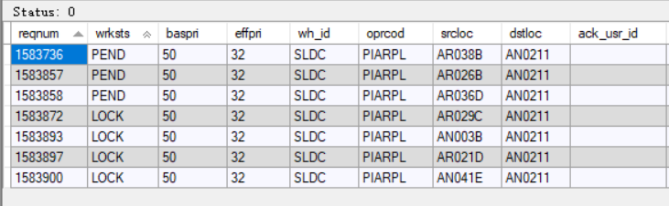

## Deployment:

1. Mload the poldat.csv file.

2. put command ‘process_usr_replenishment_pick_unlock_based_on_min_quantity.mcmd’ into USRInt folder.

3. Run ‘mbuild’ and bounce the server.