# Test document for UNLOCK Demand Replenishment Work based on Minimum Quantity

## Issue:

In TC we have many different foot prints received, So we could have the same item with say 10 pallets @ 3 layers high and 10 pallets @ 5 layers high the next day. Because we unlock on qvl we are getting many DR’s unlocked. So we end up with the user being asked to replen to a location that’s already got 3 layers in.

This has been an issue even in SLDC but we see it much more for TC.

## Approach:

Create a new custom job to look at all demand replenishment operation codes at LOCKED status in the work queue. from the item number / destination location we can get the min item level from items replenishments settings.

We can then check the select location inventory level when the job runs and when =< the minimum item level we unlock the replenishment. We could have more than one replenishment in the work queue we will only un-lock one (lowest reqnum) when we the reach the min again we unlock the next one etc.

the demand replenishment work operation code can then be changed to have NO release work command and the above can be built into a job.

**This customized unlock job will be used for entire warehouse which means system doesn’t not check Volume to unlock demand replenishment pick, instead just looking at if inventory level on picking face reached minimum level.**

Job:

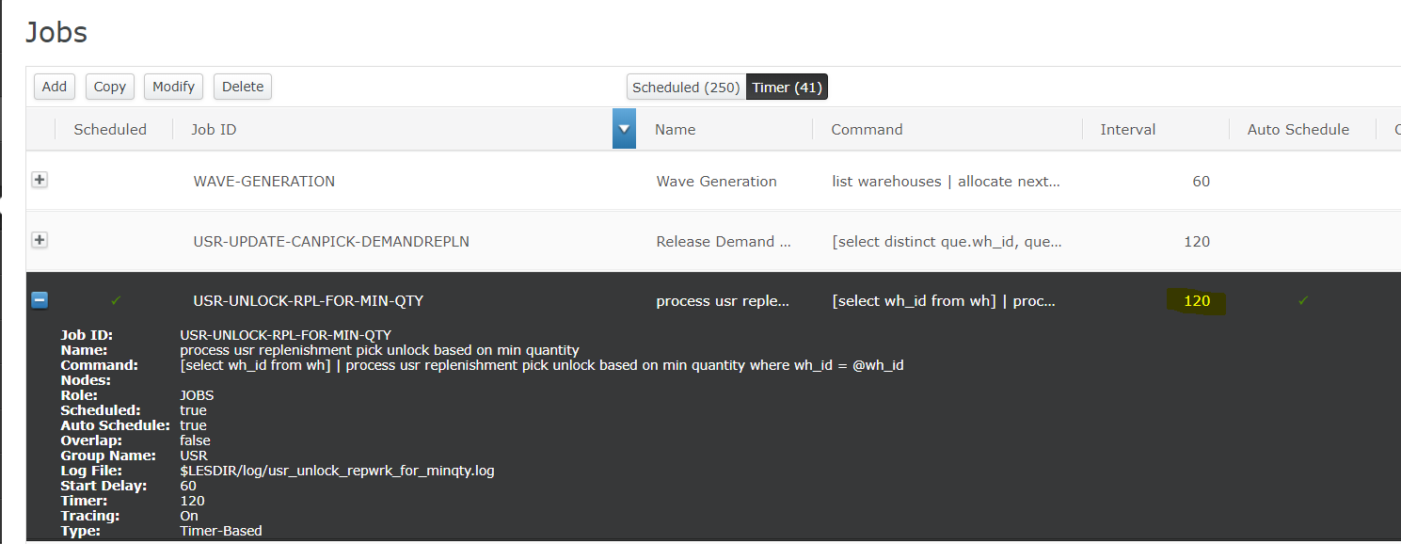

This job is configured as run every 2 minutes which is same as standard QVL unlock based job EXECUTE-WORK-RLS.

## Test scenarios:

### Scenario 1: run minimum quantity based unlock.

For location MD0561, minunt is 187:

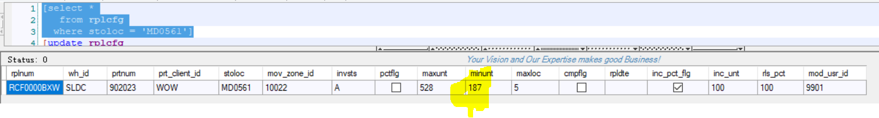

But in this location the untqty is 186:

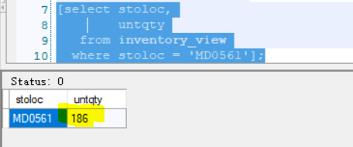

Initially there are 2 LOCK demand replenishment works:

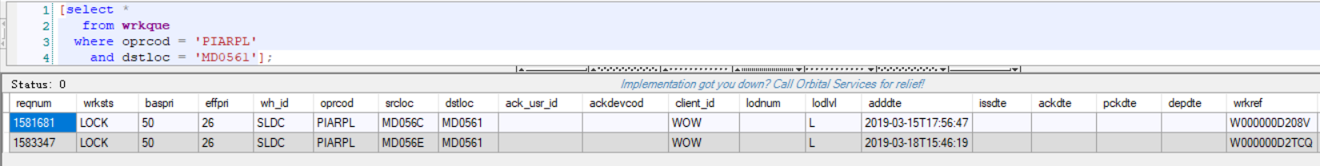

After 5 minutes, first work is unlocked:

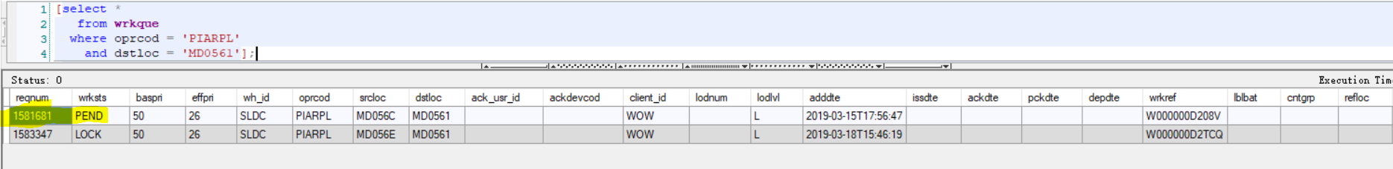

Check trace it runs newly added minimum qty based unlock logic:

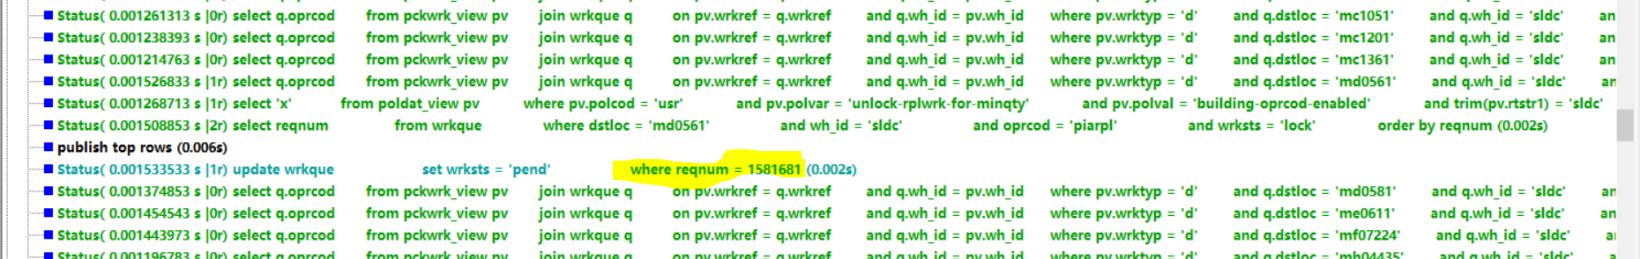

## Deployment:

1. Mload the poldat.csv file.

2. Mload the job_definition.csv file.

3. put command ‘process_usr_replenishment_pick_unlock_based_on_min_quantity.mcmd’ into USRInt folder.

4. Run ‘mbuild’ and bounce the server.

Note: Also need to remove the ‘Work Release Command’ for DR operation code:

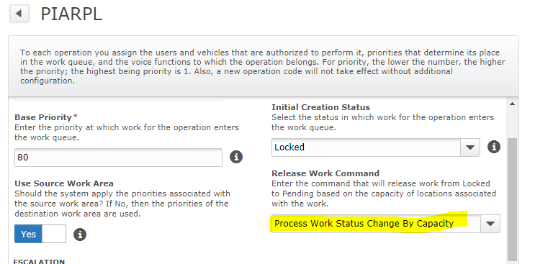

Or even disable job ‘EXECUTE-WORK-RLS’ if there is no other work need to be released by this job.