# Do case replenishment split when putaway pallet

## Issue:

When receiving item which are assigned to CLS location, as the entire pallet cannot fit into the location, so currently system always suggest deposit to reserve, next morning when wave allocation finished Forklift driver will be end up with doing many CLS replenishments which is an overhead,

Now expectation is that we want system do case replenishment to CLS location as earlier as doing putaway, this way it is more efficient and save forklift driver’s time for next morning’s demand replenishment work.

## Approach:

Create a background workflow with exit point of ‘move inventory’ to do check:

1. Are we moving pallet from receiving stage lane?

2. Is this item assigned to a picking face location where has replenishment split configured?

3. Is the inventory level in the picking face lower than minimum value?

4. There is no older inventory in other storage location for this item?

If all above questions are true, then we do:

1. Deallocate storage location where the pallet is booked to.

2. Book the pallet to picking face location.

3. Prepare data for RF to run REPLEN_SPLIT form for replenishment split.

## Workflow configuration:

Create a master workflow, named ‘SPLT-CTN-TO-PCKFACE’:

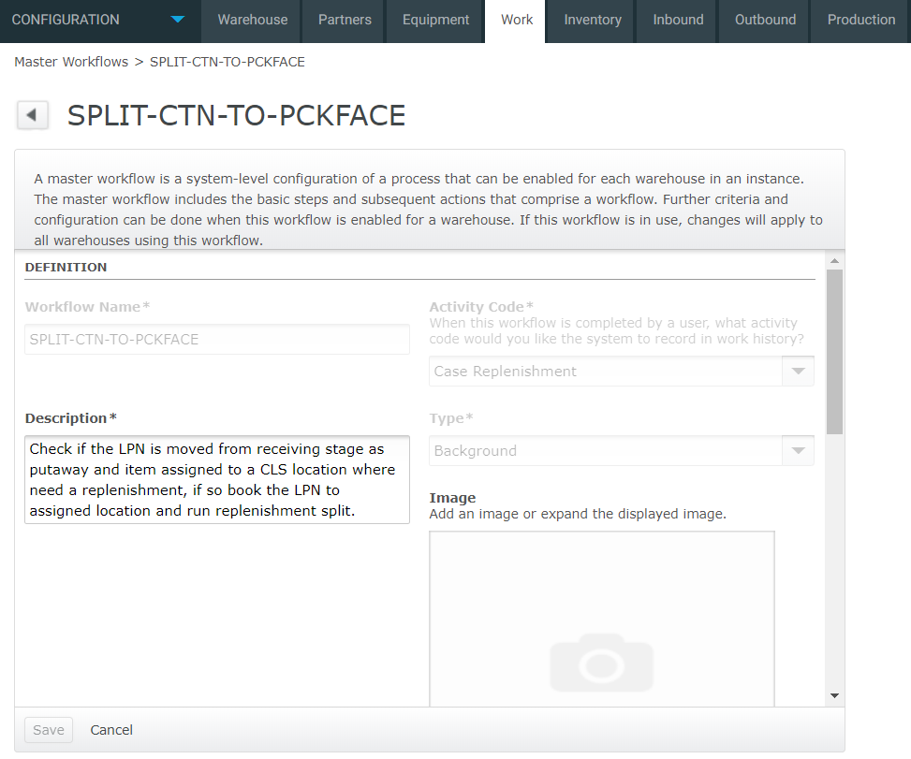

Click ‘User Instructions’:

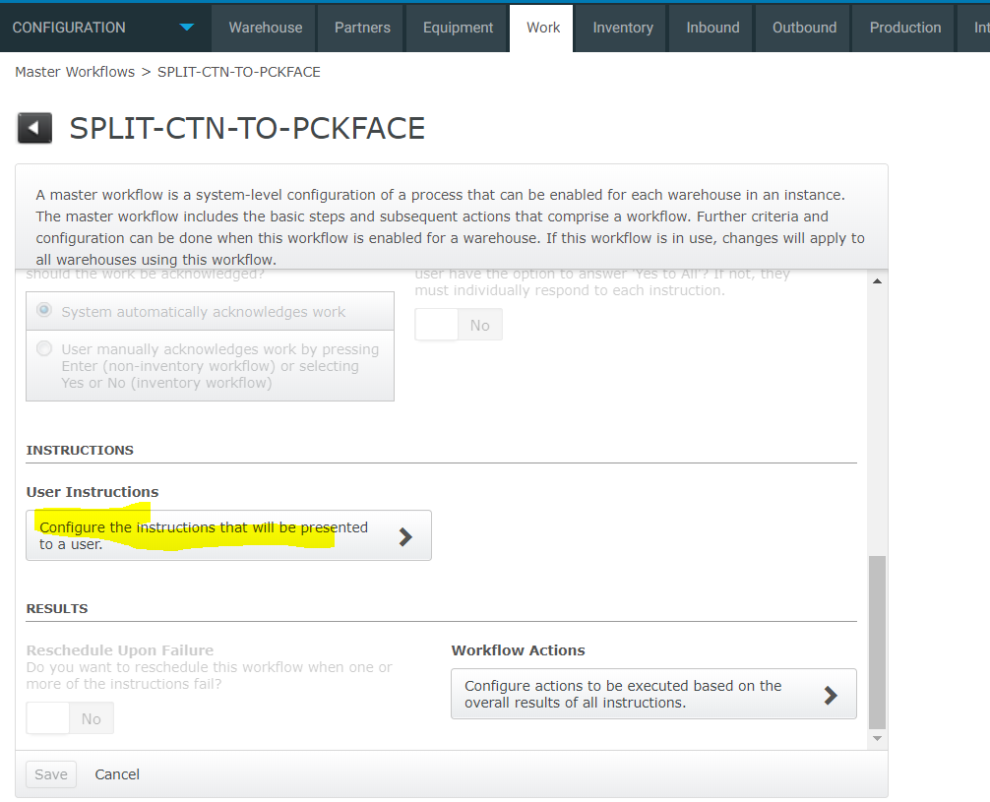

Add one entry:

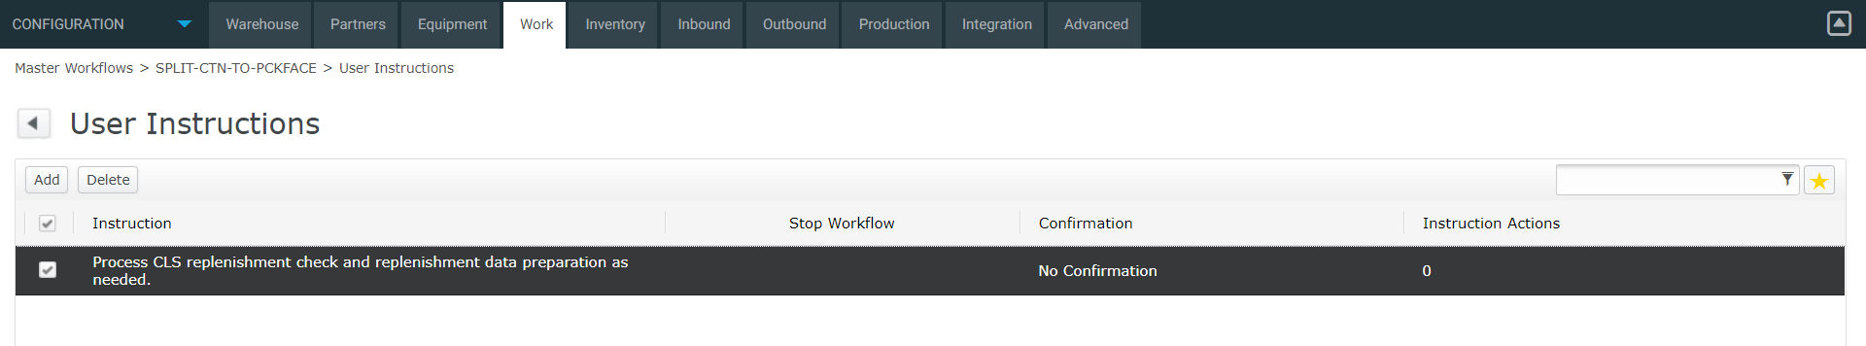

Detail as below:

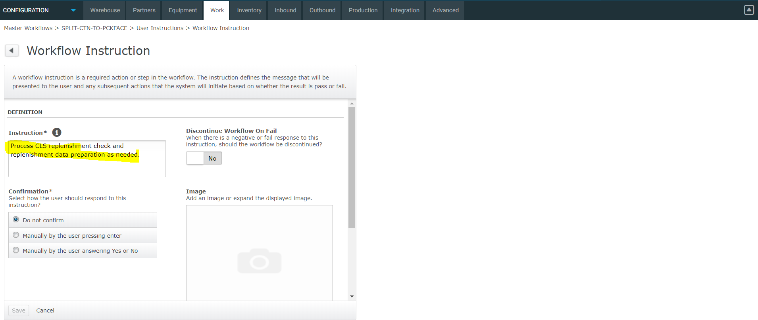

Scroll down and click ‘Instruction Actions’:

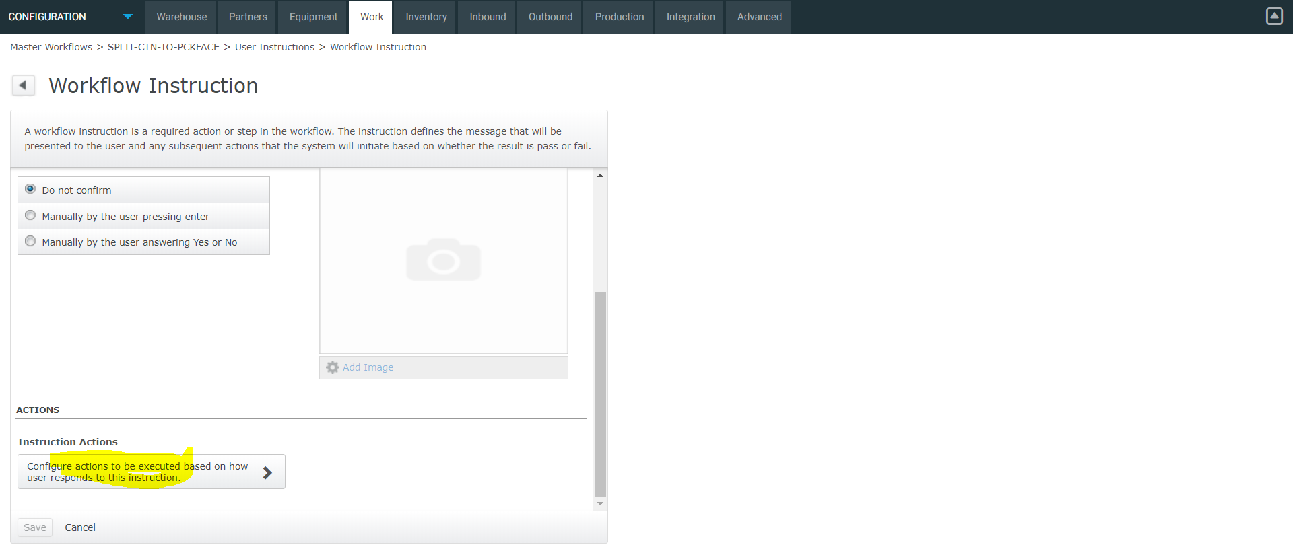

Add one entry:

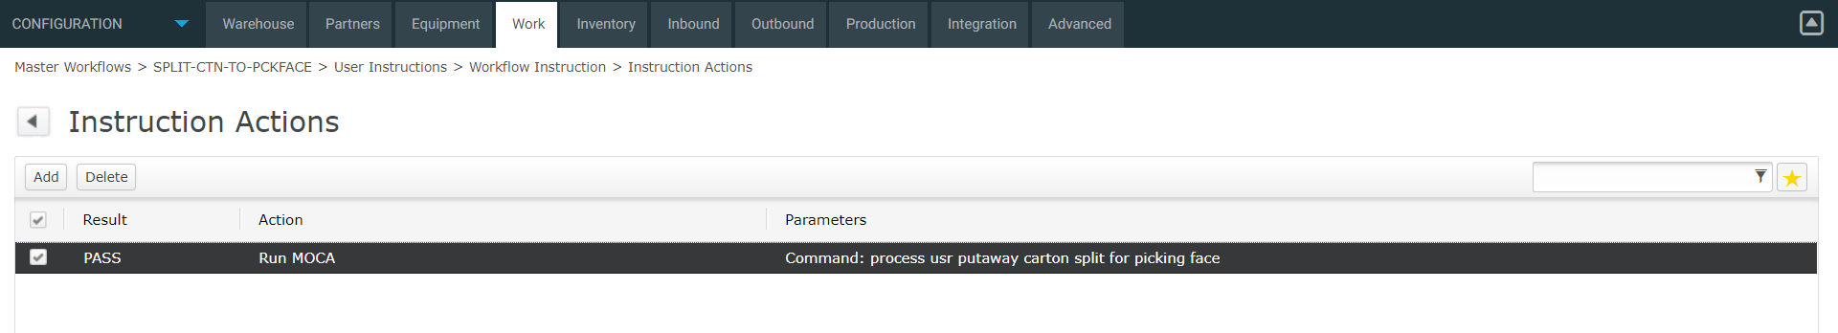

Code to run:

process usr putaway carton split for picking face

Note: Above is a new moca command which need a mbuild.

Now config a background workflow:

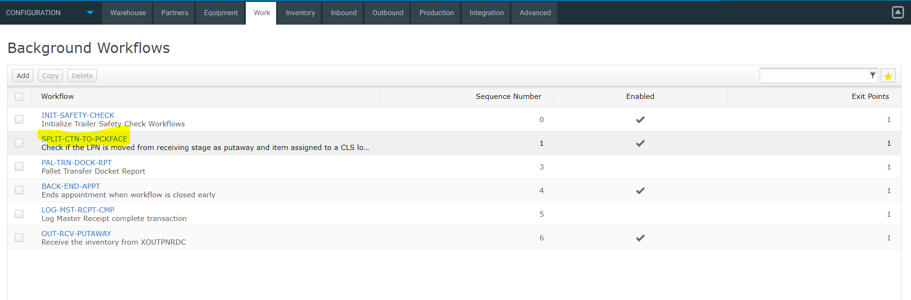

Detail:

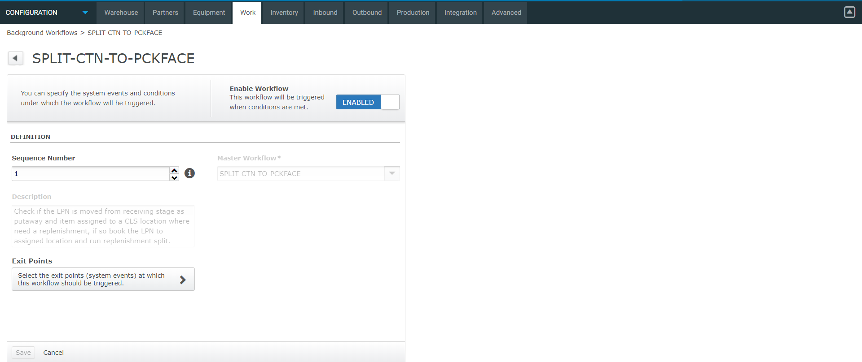

Exit point:

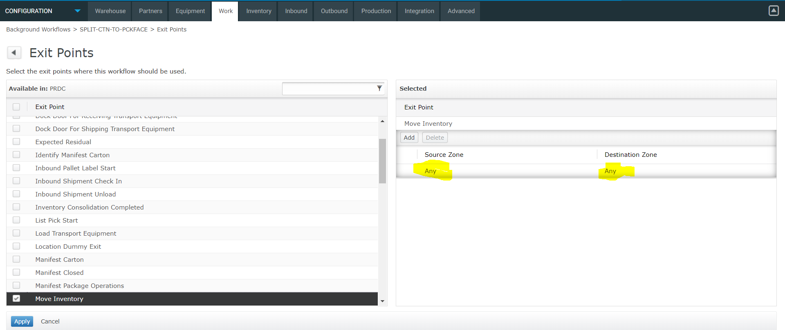

Note: the Source Zone should be all movement zones for receiving stage as we only want fire this workflow when moving pallet from receiving stage to RF device, so Destination Zone should be RDT, however the workflow also check location type to make sure it’s from receiving stage lane.

## Test trace screenshots:

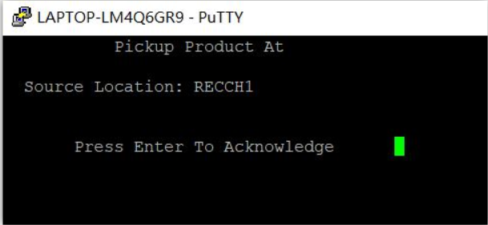

Get putaway work, Press Enter to acknowledge

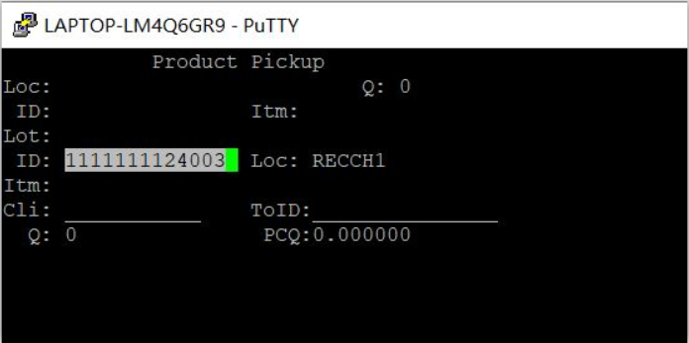

Scan the LPN

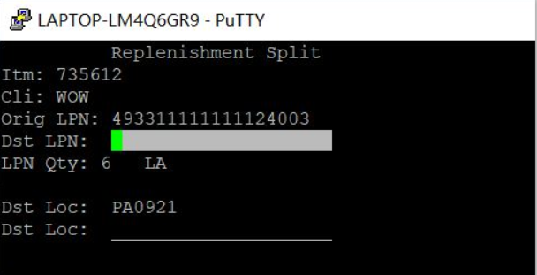

System goes to replenishment split, F3 generate a new LPN.

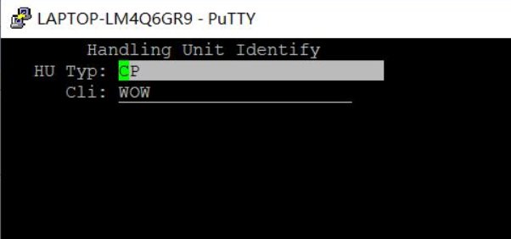

Goes to Handling Unit identify form

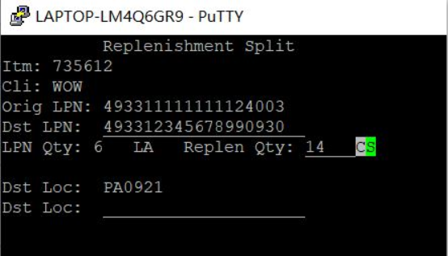

Split 14 CS to the picking face.

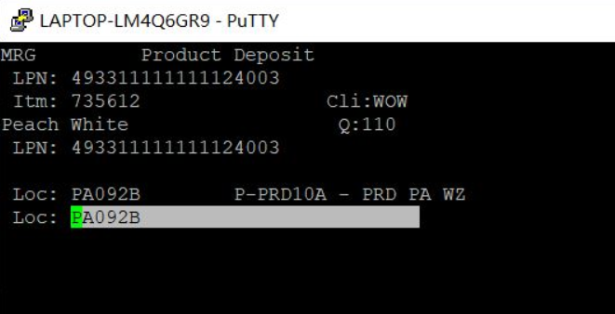

Put back remaining cartons to reserve location.

## Deployment:

1. put the command process_usr_putaway_carton_split_for_picking_face.mcmd into usrint.

2. mbuild and soft bounce moca server.

3. Configure the workflow by the steps listed in this document.