# Workflow for correcting ftpcod on pick when multiple ftpcods exists for inventory

**Summary:**

There is an issue that when single item exists multiple ftpcod, system won’t be able to generate demand replenishment if the selection location has inventory with different ftpcod in which case system creates short.

To fix this problem, it is decided to allow mixing ftpcod only when untcas and untpak are same, but if the untcas/untpak are different which means it is physically different size of package. WW won’t allow them to mix as it will causing picking issue, in this case WW want system create short as they expect the old package size carton to be shipped completed before shipping new size of carton.

**Approach:**

Few things to update:

1. For storage mixing restriction we need to remove ftpcod from the list as we allow ftpcod to be mixed, and we add untcas, untpak into the list since we don’t want these to be mixed, this should only for selection storage zone.

2. For consolidation attribute list, we should remove ftpcod from the list as we want different ftpcod to be consolidated.

3. Add a workflow to ‘Move Inventory’, to do the same update if inventory with different ftpcod is moved to the selection location. we will make sure the ftpcod on pick work always stay with the inventory available from the location.

4. Add a logic post pick release job, for any shipping pick from selection location, if the pick need inventory from a DR, and with ftpcod from DR but different with the ftpcod on existing selection location, then we will update the ftpcod on pick work to be same ftpcod on existing inventory, this is needed after wave allocation and before DR deposited to picking face.

**Configuration:**

**1. Mixing rule restriction configuration change**

make sure we add untcas/untpak into the list and remove ftpcod from the list:

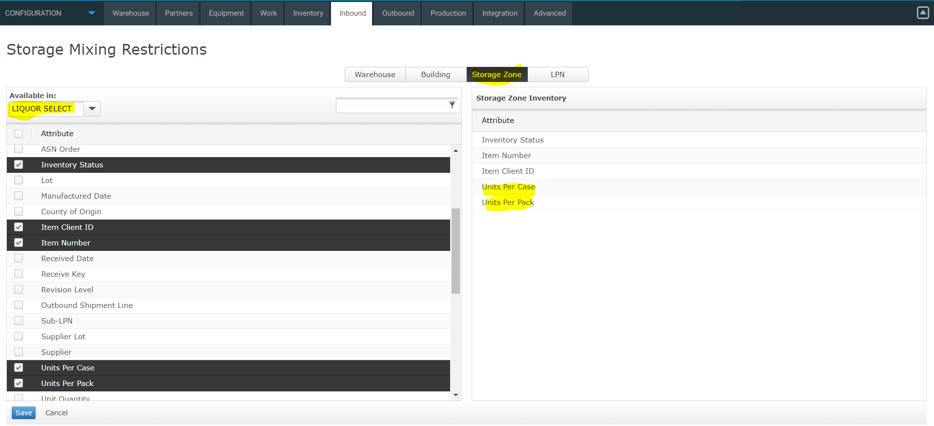

**2. Consolidation attribute policy change**

remove ftpcod from the list so we allow ftpcod to be consolidated

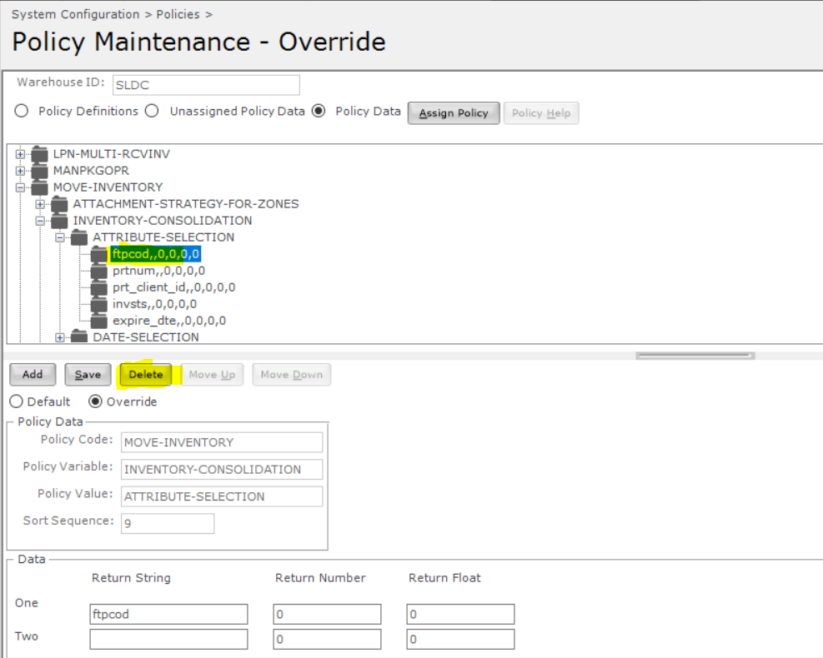

**3. Add a workflow to ‘Inventory Move’**

Add a master workflow:

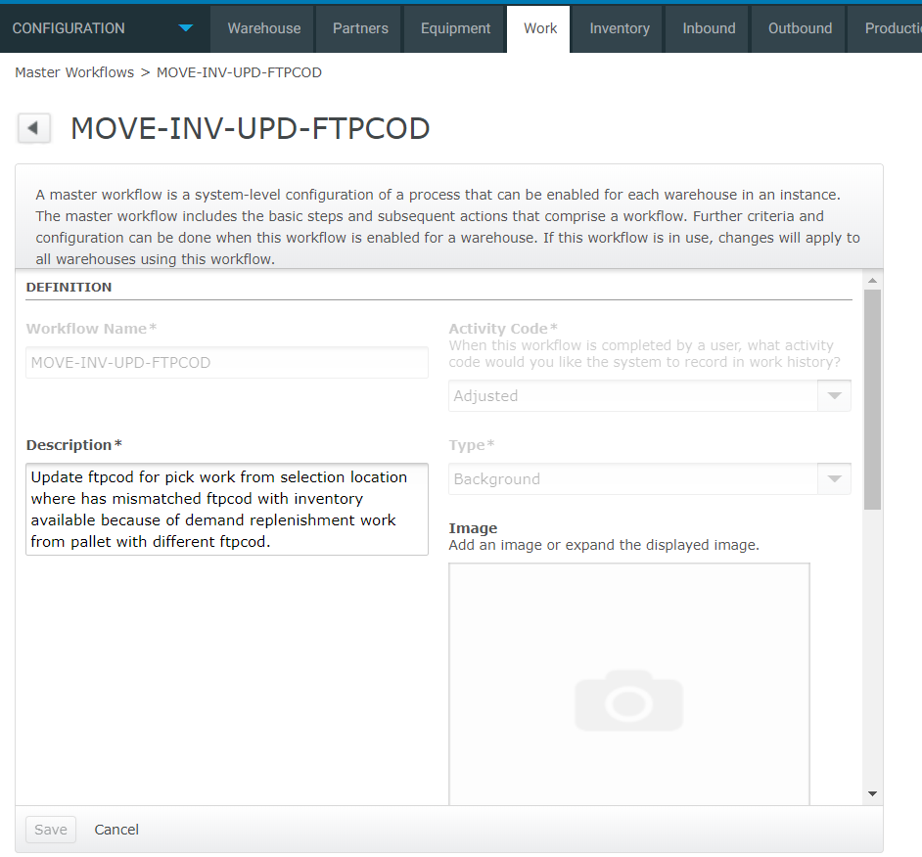

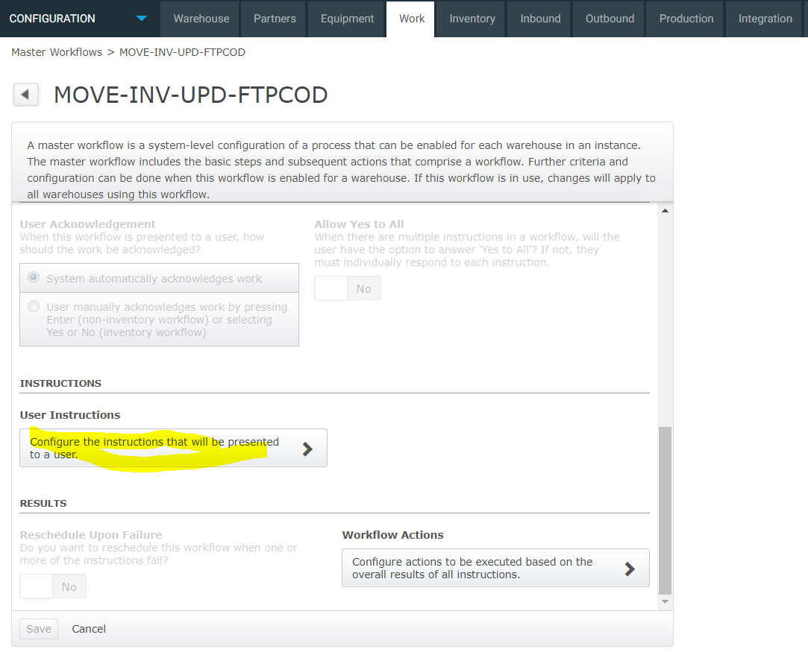

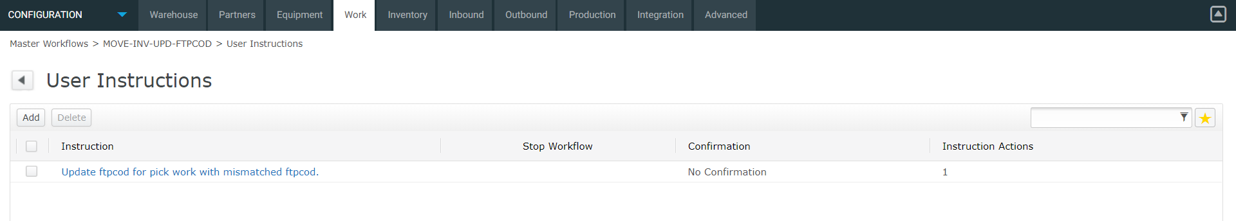

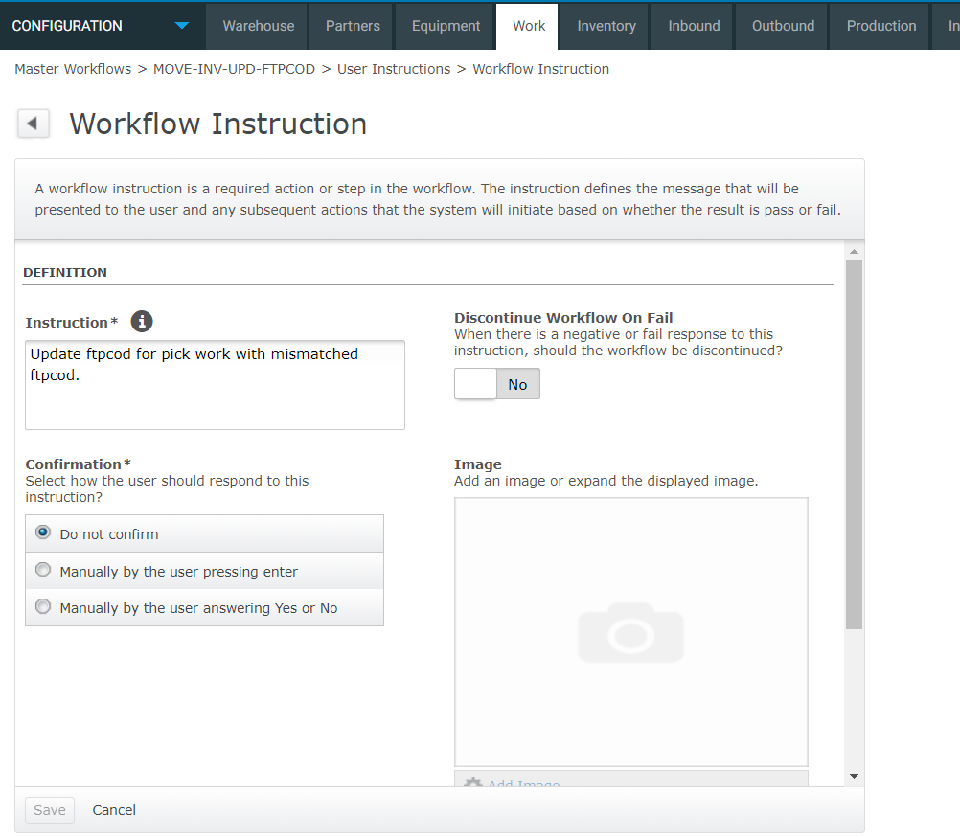

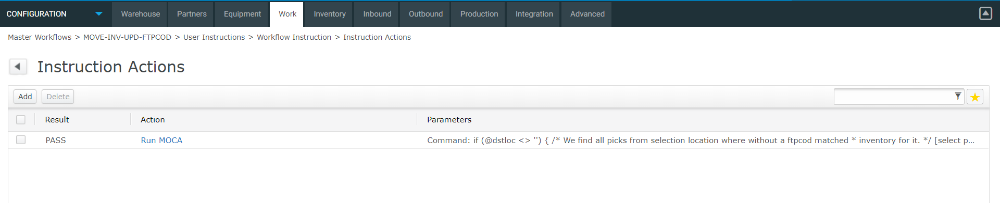

Code to run:

See code: move_inventory_update_ftpcod_for_pick_mismatched_with_inventory.mcmd

Add a background workflow:

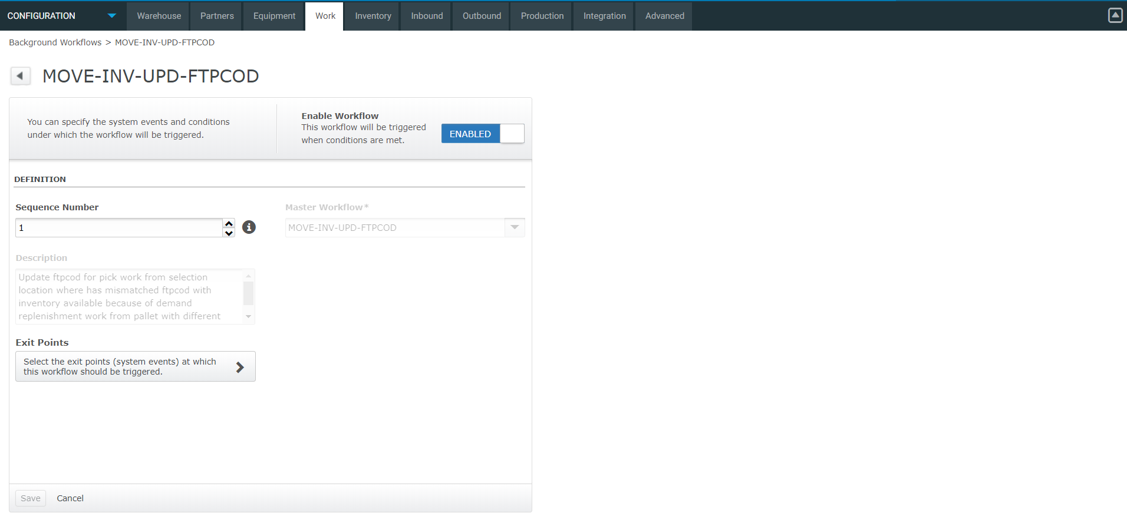

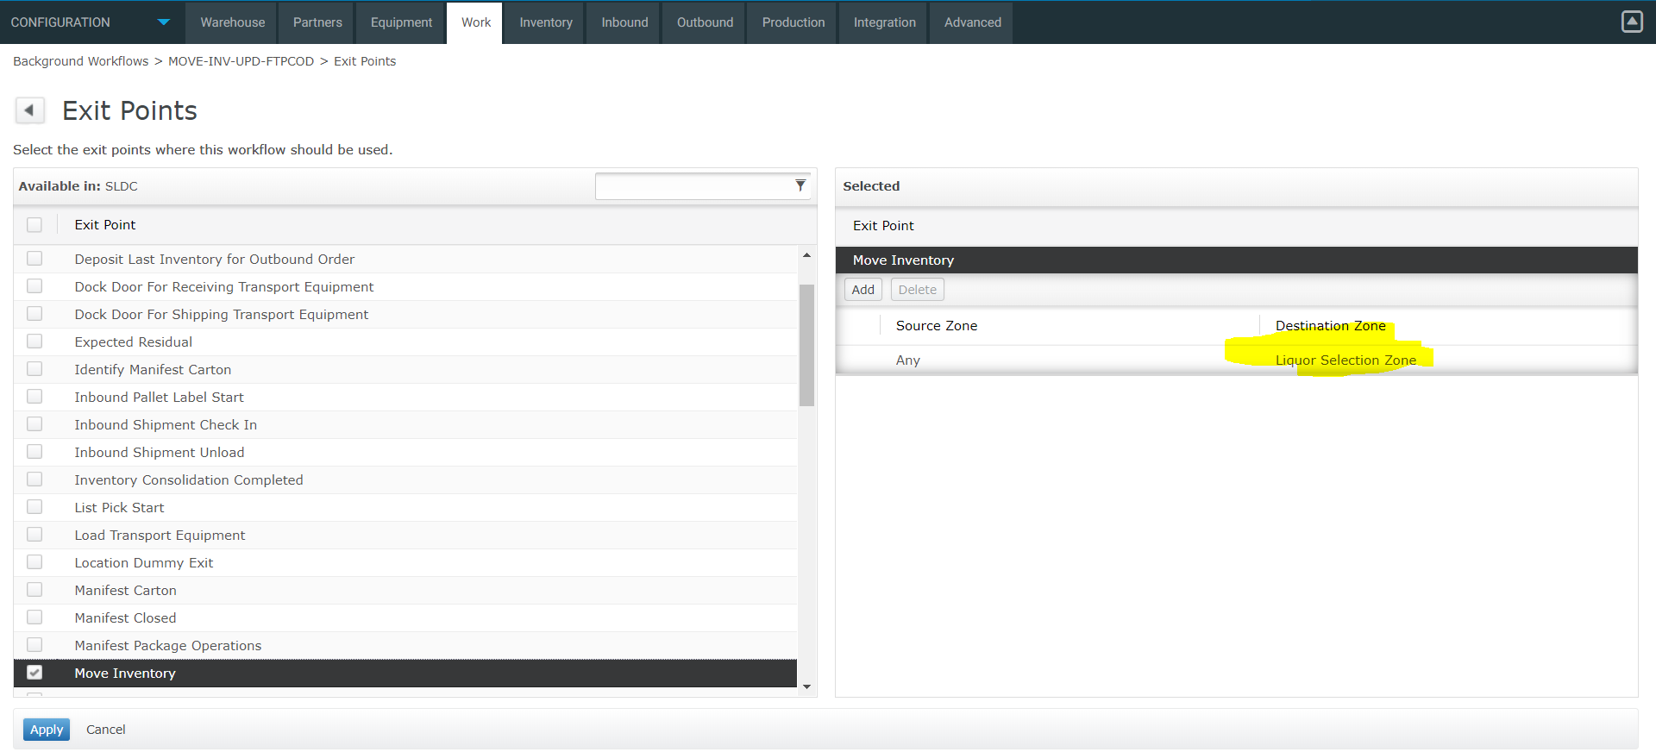

Note: Make sure to configure destination zone with list of your selection picking movement zones.

**4. logic to run post job pick release**

We need to run the same logic after pick release job, see file:

pick_release_job_update_ftpcod_for_pick_mismatched_with_inventory.mcmd

Copy the content and replace the command field for PCKRELMGR job.

5. A test of trace:

Inventory-Move:

Since the ftpcod is consolidated with exiting ftpcod already, so no more update:

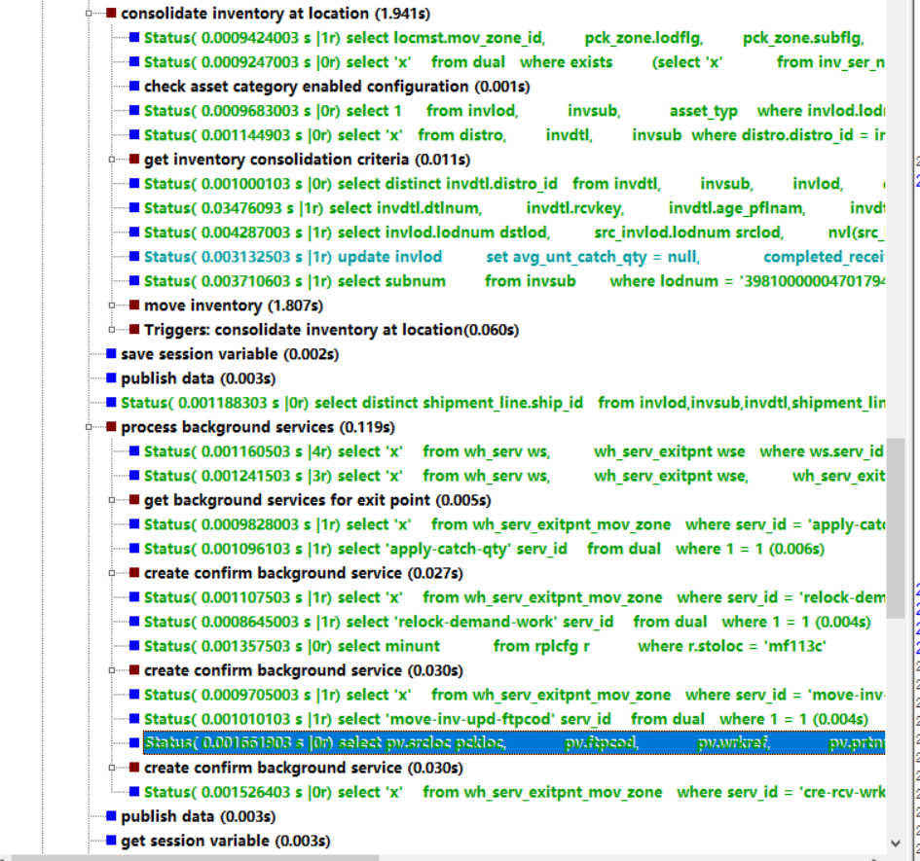

A trace of the code running for post of the job:

