## Receiving/Shipping Handling Units without order

**Scenario 1: Receiving HU:**

1. Go to GUI ‘Handling Unit Display’, non serialized handling unit is empty:

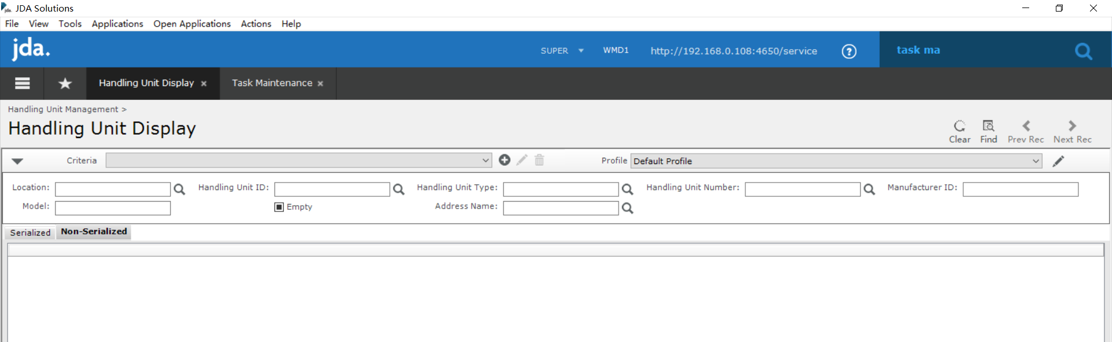

1. Login RF

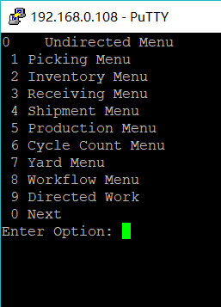

1. F7:

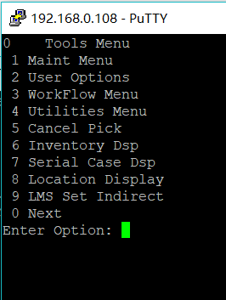

1. 0 Next:

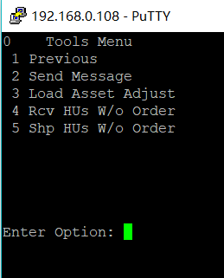

1. Select 4, ‘Rcv Hus w/o Order’ menu item:

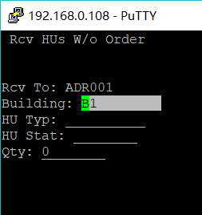

Please note The ‘Rcv To:’ field is populated with current warehouse address ID as readonly field, cursor starts from Building field.

F2 lookup for Building, ‘HU Typ’, and ‘HU stat’ are available:

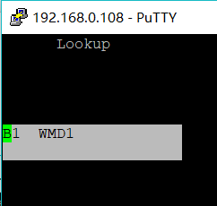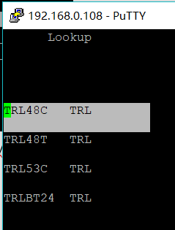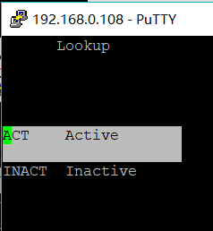

And validations are available for these fields:

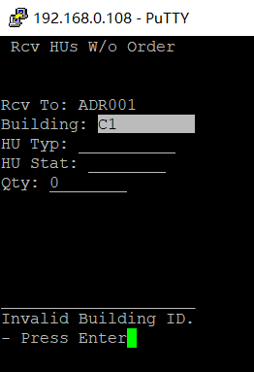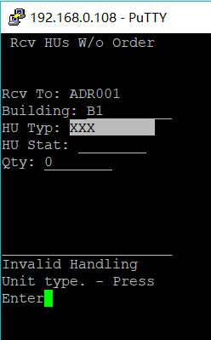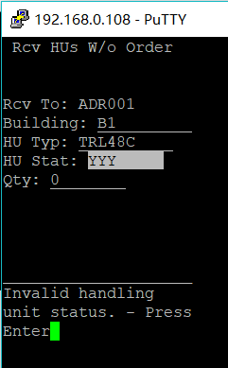

1. Now start receiving some HUs:

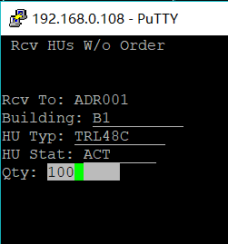

1. Enter, display success message:

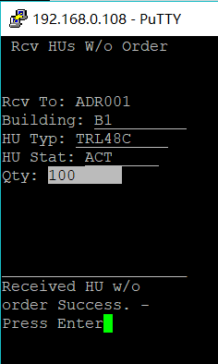

1. Enter, reset form:

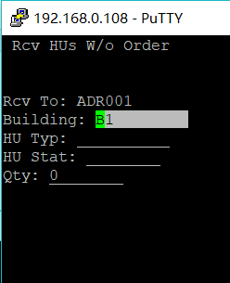

1. Go to GUI ‘Handling Unit Display’:

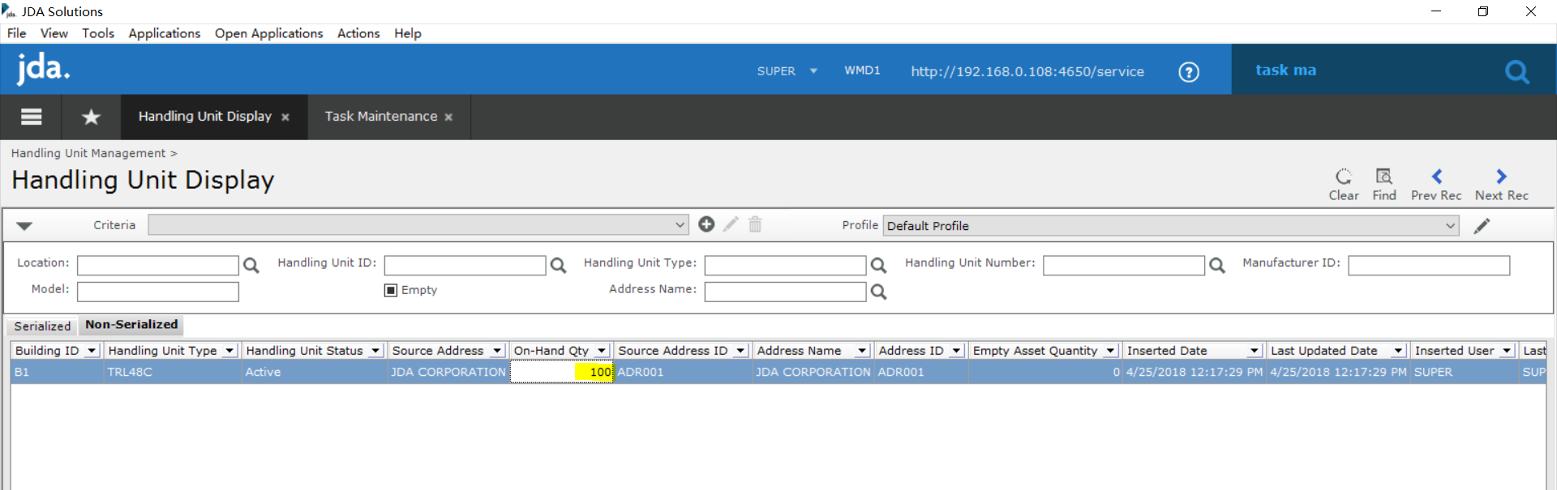

On hand quantity is 100.

1. Now Receiving 23 more:

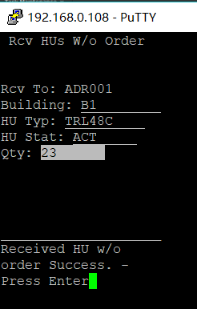

1. GUI on hand quantity becomes 123:

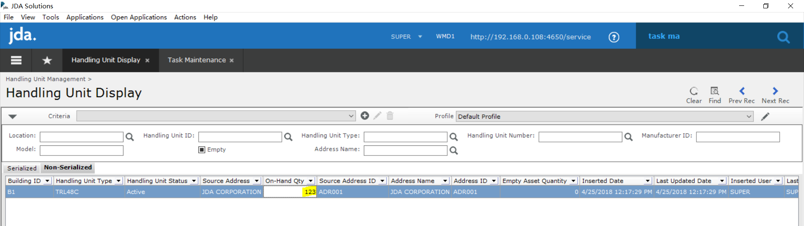

**Scenario 2: Shipping HU:**

1. Now go to Shipping Form:

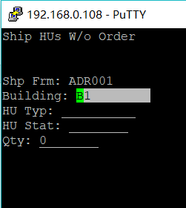

Note: ‘Shp Frm:’ is auto populated with current warehouse address ID, readonly, Lookups and validations are available which is same as receiving.

1. Now shipping quantity 23 out:

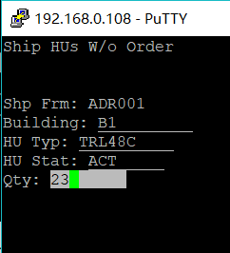

1. Enter, display shipping success message:

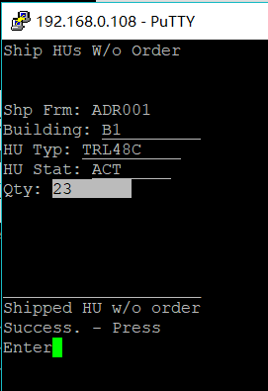

1. Go to GUI ‘Handling Unit Display’

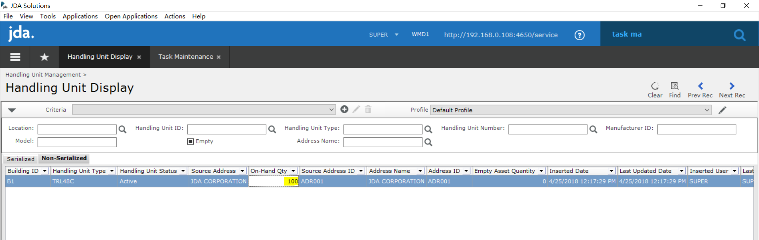

On hand quantity comes back to 100.

1. Let’s try shipping HU with stat ‘INACT’ which is not existing:

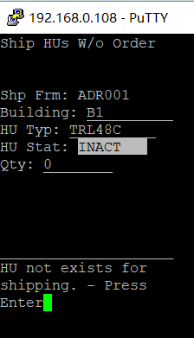

It finds such HU does not exists.

1. Now let’s try to ship 120 out:

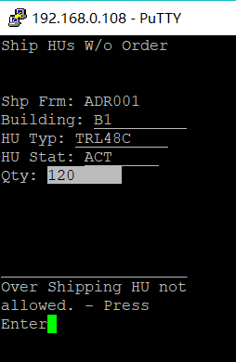

Error with over shipping HU not allowed.

1. Finally let’s ship 100 out from current warehouse:

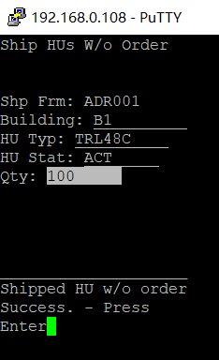

It says shipped success.

1. Go to GUI ‘Handling Unit Display’:

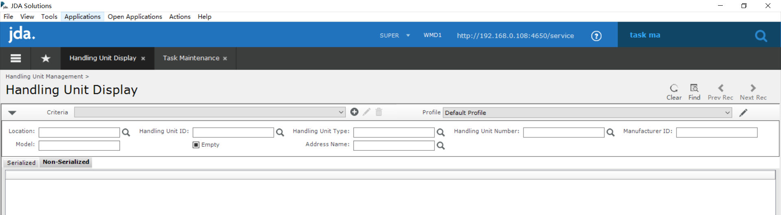

Record is removed as we shipped all of them out.