The reason that you cannot preview ‘Report Archive’ is because the generated report file is being removed by a job ‘PUR-DIRS’:

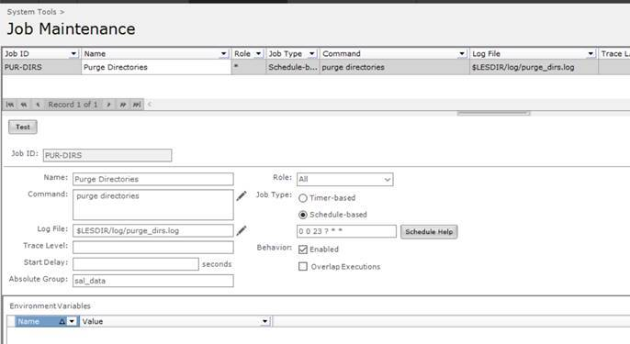

This job will purge below policy defined folders for file which is older than defined days:

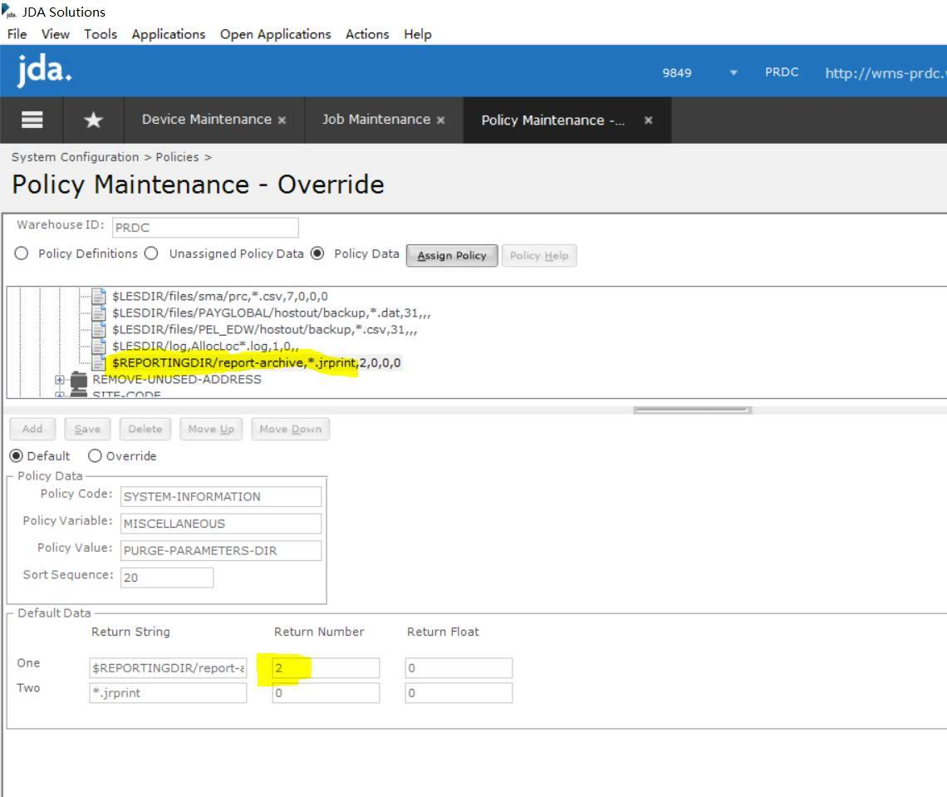

So for the archived report, it is configured as 2 days which is why you can not preview report older than 3 days. If needed we can override above policy to give it a big value like 7 days.