**Analysis report of WeRateDogs**

**Introduction**

This report illustrates a brief analysis of the WeRateDogs.

[WeRateDogs](https://en.wikipedia.org/wiki/WeRateDogs). is a Twitter account that rates people's dogs with a humorous comment about the dog. These ratings almost always have a denominator of 10. The numerators, though? Almost always greater than 10. 11/10, 12/10, 13/10, etc. Why? Because "[they're good dogs Brent](http://knowyourmeme.com/memes/theyre-good-dogs-brent)." WeRateDogs has over 4 million followers and has received international media coverage.

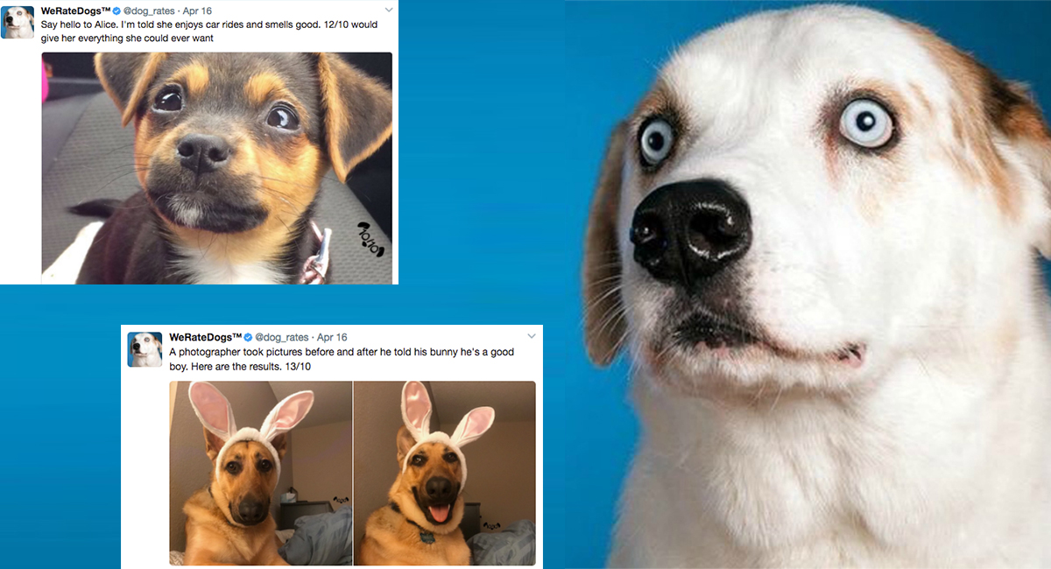

Did you now that there is a Dogtionary too? I didn’t until I started this project! That’s the funn of Data Analysis: you always learn something interesting on the stuff you do!

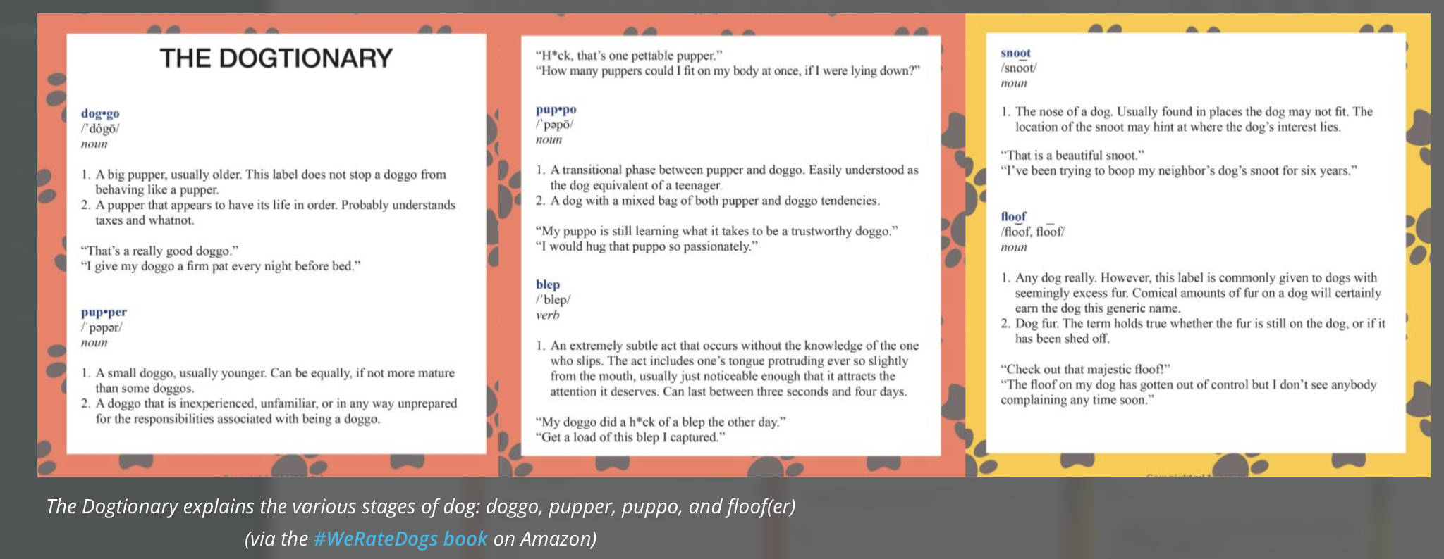

*Note: This is one of the projects part of the Udacity NanoDegree Data Analyst course.*

**Summary:**

Some questions were raised during the analysis process. Also, during the wrangling, some other questions were raised. Now I can understand why people say this is an interative process!

This report shows:

-What are the most rated and likeable dogs? If a post is retweeted, would that mean that people liked it? How many breeds were rated? What is the split among the “dog stages”, according to the “dogtionary” below?

**a) 113**

**is the number of dog breeds found in the dataset. Did you know that by 2020 there are more than 400 breeds in the world? What is your favorite type of dog?**

**Well, from the tweets evaluated, you can see that the famous Golden retriever is the most favorite dog by far, followed by the Labrador retriever, and third by the Pembroke:**

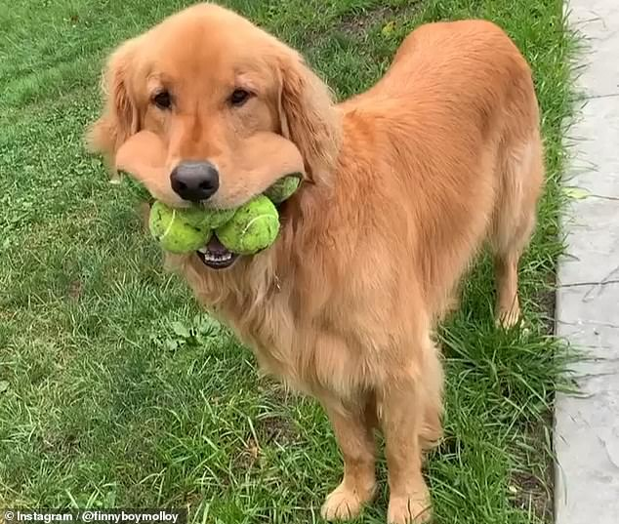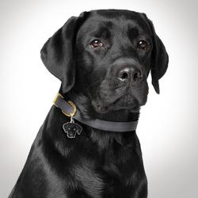 

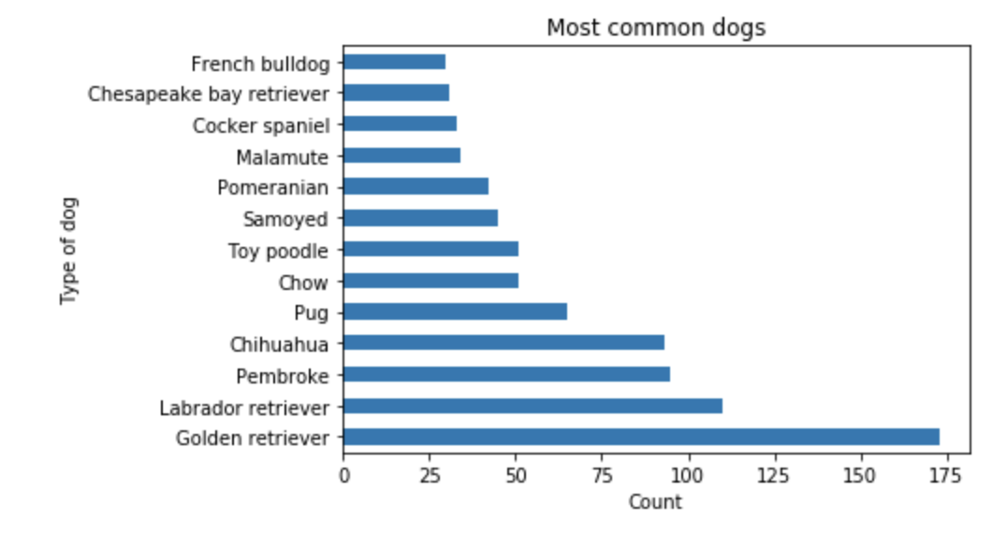

**c)**

**The more likes a post had, the more it has been retweeted, showing a strong correlation between those, and that people usually repost what they like (of course, some folks repost what they don’t like…or hate…who couldn’t like dogs?**

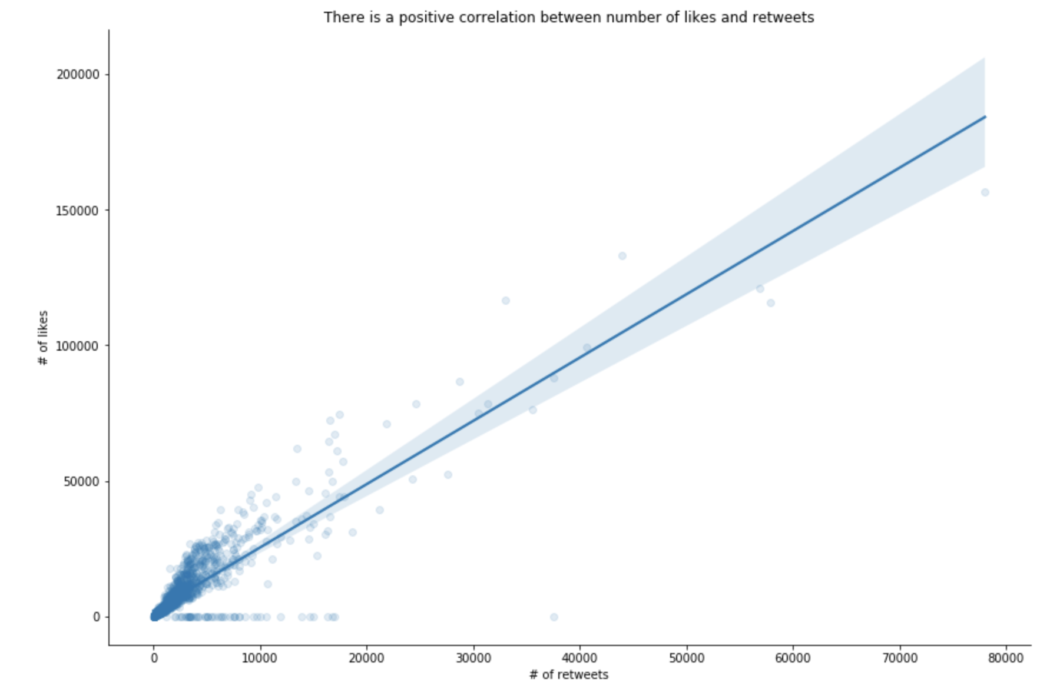

**d) on the dog_stages, here you have the split (please refer to image on page 1 to get a refresh on each stage type):**

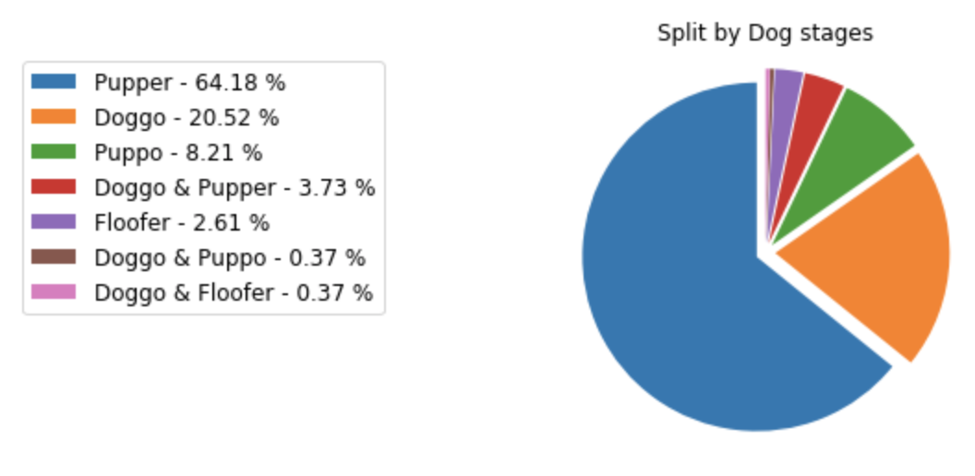

**Thank you for reading this report. Hope you had some fun and learned a bit more about the best friends ever!**