Neither So Close It Burns the Saint, Nor So Far It Leaves Him in the Dark: From Fossil Fuels to Renewable Energy
May 24, 2020; revised January 2022
Subsequently published in HOMINIS magazine, March 6, 2022, pp. 12–13; second installment of a three-part series.
Author’s note: this essay was written in May 2020, revised in January 2022, and is reproduced here as a historical document. Figures and the regulatory framework reflect those dates and have not been updated.

Mauricio De la Maza-Benignos

We have exceeded our planet's regenerative capacity.
Nothing justifies obstructing the transition from fossil fuels to renewable energy.
There is a moral duty, as an obligation of reason over will, to consider impacts on biodiversity.
Invoking reduced industrial energy consumption due to the pandemic; placing the ideals of energy security and self-sufficiency above the greater good of climate mitigation; disguising operational inefficiency as corrective measures to address the “pre-existing” increase in the imbalance between electricity generation capacity and demand, blaming the past for the inefficiencies of the present; and posing false dichotomies in the face of vices such as corruption: all of this is demagoguery in its purest form, built on argumentative fallacies.
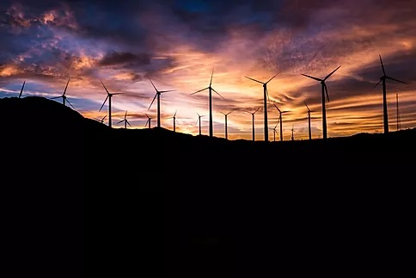
Photo by Master Wen on Unsplash
It is a fact that, in statu quo ante, we have exceeded our planet's regenerative capacity. Experts estimated that our demand for resources and ecosystem services exceeded the planet's regenerative capacity by roughly 70%. We have disturbed and impacted it in lasting and, in many cases, irreparable ways; to wit, we have altered the natural climate cycle, triggered the mass extinction of species, and caused the loss of some ecosystems.
According to the IPCC, in 2010 electricity and heat production accounted for 25% of global anthropogenic greenhouse gas emissions, while the industrial and transport sectors were responsible for 21% and 14%, respectively.
According to official figures from Mexico's Ministry of Energy (SENER), the integrated energy system supplied 128 million Mexicans living across two million square kilometers and had reached 98.7% service coverage. Installed generation capacity was 80,000 MW. This figure exceeded by 30,000 MW the maximum instantaneous demand of the National Electric System, which peaked at 50,000 MW in week 26 of 2019. Installed capacity and peak demand are different indicators; the difference between them does not necessarily represent an effectively available reserve.
According to SENER's official figures, as of December 31, 2019, installed wind and photovoltaic generation capacity in operation accounted for 11.86% of total installed capacity. As of January 26, 2020, the ministry reported 67% installation progress on the projects awarded in the Long-Term Auctions.
On April 27, 2020, the National Energy Control Center (CENACE) issued the “Agreement to guarantee the efficiency, quality, reliability, continuity, and security of the National Electric System (SEN), in light of the recognition of the epidemic of disease caused by the SARS-CoV-2 virus (COVID-19),” published in the Official Gazette of the Federation (DOF) on April 29, 2020. Subsequently, on May 15, 2020, the Ministry of Energy (SENER) published in the DOF the Policy on Reliability, Security, Continuity, and Quality in the National Electric System.
Now, without going into the substance of the argumentative flaws of that agreement—which invite the study of argumentative fallacies, starting with the argumentum ex silentio (an argument based on the absence of evidence) that appears in the rationale behind its title—and which reveal the heavy doses of demagoguery we have been prescribed since long before the Fourth Transformation (4T), the act invites serious reflection on the real risks of what the—risky, but necessary—transition from fossil to renewable energy entails, in this oscillating pendulum we call human history.
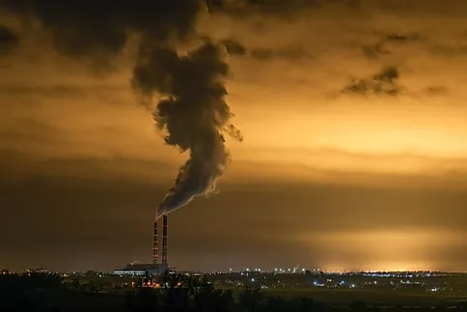
Photo by Roman Khripkov on Unsplash
The Intergovernmental Panel on Climate Change (IPCC) considers that the greatest human influence on global warming has been the emission of greenhouse gases such as carbon dioxide, methane, and nitrous oxide (N₂O).
According to the IPCC “Special Report on the impacts of global warming of 1.5 °C above pre-industrial levels and related global greenhouse gas emission pathways, in the context of strengthening the global response to the threat of climate change, sustainable development, and efforts to eradicate poverty,” published in 2018, by 2017 human-induced global warming had reached approximately 1 °C (likely between 0.8 °C and 1.2 °C) above pre-industrial levels, increasing at 0.2 °C (likely between 0.1 °C and 0.3 °C) per decade.
The phenomenon is palpable. Many terrestrial and ocean ecosystems, as well as some of the services they provide, have been altered by global warming. The same IPCC report—prepared at the request of the Conference of the Parties to the United Nations Framework Convention on Climate Change, in the decision of its 21st session adopting the Paris Agreement—states that warming caused by anthropogenic emissions from the pre-industrial period to the present will persist for centuries to millennia and will continue to cause further long-term changes in the climate system, such as sea level rise. Although emissions to date (including greenhouse gases, aerosols and their precursors) are unlikely on their own to cause global warming of 1.5 °C, or further warming of more than 0.5 °C over the next two to three decades or on a century time scale, whether or not we cross that threshold will depend on what we emit from here on.
Impacts and their risks depend on the magnitude and rate of warming, geographic location, and levels of development and vulnerability, as well as on the adaptation and mitigation options chosen and how they are implemented.
The same report warns that “reaching and sustaining net zero global anthropogenic CO₂ emissions and declining net non-CO₂ radiative forcing would halt anthropogenic global warming on multi-decadal time scales [...]. The maximum temperature reached is then determined by cumulative net global anthropogenic CO₂ emissions up to the time of net zero CO₂ emissions [...] and the level of non-CO₂ radiative forcing in the decades prior to the time that maximum temperatures are reached.”
These conclusions have been endorsed by the leading national academies of science and by a broad majority of prestigious national and international scientific organizations; there is a solid scientific consensus on the anthropogenic origin of climate change.
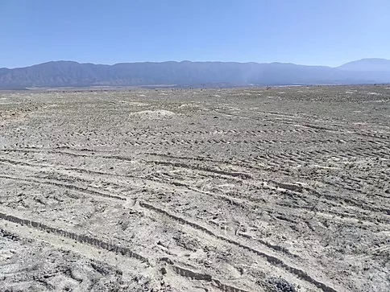
Photo by Mauricio De la Maza-Benignos
Climate change is already causing more severe droughts and more intense hurricanes, hunger, poverty, and destruction. We must transition from fossil fuels to renewable energy if we are to achieve a state of well-being.
And while the COVID-19 emergency, the prevalence of corruption and its incidence rate both before and after the start of the 4T—as documented by INEGI in its 2019 National Survey of Government Quality and Impact (ENCIG)—and the structural limitations of the National Transmission Grid in terms of design capacity, along with the risk to systemic performance of having to rely frequently on System Protection Schemes (EPS) and Remedial Action Schemes (EAR) to preserve grid integrity, are all indisputably true, it is equally indisputable that the Executive's measures discourage public and private investment in clean energy and encourage electricity generation from the fuel oil produced by PEMEX—which releases more carbon dioxide (CO₂) and sulfur dioxide (SO₂) into the atmosphere—thereby uncivilly contributing to worsening the harmful effects of climate change and to the deterioration of Mexicans' health, causing premature deaths and respiratory illnesses, among many other harms.
That said, it is essential to recognize that, although the agreement did not originate during the so-called “neoliberal period” that drove and promoted the Federal Electricity Commission's energy procurement auctions, not everything was a bed of roses in matters of biodiversity during that time. For then, as now, the voices of those of us environmentalists who care about the diversity of life rang out as little more than cries in the wilderness; we were branded “radicals” for failing to “understand” that, given the urgency of global warming, we must “accept” the loss of biodiversity as collateral damage of progress: a positivist conception sensu Comte, which presupposes sacrifice as a necessary condition of modernity and hides behind the premise of an urgent evolutionary transition toward clean energy; never mind that, for example, wind turbines act as veritable “blender blades” against bats and migratory birds—the latter, whose flocks ride, in their age-old migrations, the very air currents we aim to turn into electricity; or that vast expanses of solar panels disrupt the ecosystem connectivity that different species need to survive; or that, as the President of the Republic has rightly and repeatedly observed, we blight the landscape with large infrastructure works that pollute it visually.
Every new technology carries risks and has unknown side effects, and renewable energy is no exception. There are aspects that have not been sufficiently taken into account. With current technology, renewable energy takes up too much space, mars the landscape, and, when poorly planned, becomes a death trap for flying and terrestrial species—and also for aquatic species in the case of hydropower plants.
This is not about casting aside, just like that, the ideals of the modern world—the continuous progress of knowledge, the improvement of technique, social and moral betterment, or its emancipatory teleologies—for, as Jürgen Habermas argues, modernity is an unfinished project; rather, it is about seeking to understand phenomena in order to find the golden mean, recognizing the intrinsic and extrinsic value of all forms of life as a moral obligation of reason over will. For only if we mitigate these elements from the planning stage can we prevent further losses to our natural capital and achieve the long-awaited state of well-being.

Photo by Mauricio De la Maza-Benignos
Quoting Pope Francis's encyclical Laudato si’: “Each year sees the disappearance of thousands of plant and animal species which we will never know, which our children will never see [...]. Because of us, thousands of species will no longer give glory to God by their very existence [...]. We have no right.” And while it is true that the teleology of law is the common good and not the holiness of the citizen, it is also true that the epistemological, axiological, deontological, and legal problem posed by the separation between law and morality (e.g., the land ethic) is one of form rather than substance, since the absolute separation of the two stems from a fundamentalism that seeks to divorce the logical from the metaphysical on the pretext of science, arguing that the abstract cannot be specified objectively and that universal values rest mainly on subjective value judgments.
Here lies an opportunity. Our current vision of clean energy is disjointed. For example, as Steve Holmer, a renewable energy expert at the NGO American Bird Conservancy, told me: “…in the United States we are seeing a transition toward both [solar and wind]. Mexico has excellent sun, so there is a lot of potential there. I would think about promoting solar generation, since between the two, solar has proven to be more economically competitive.” Although each specific case must be analyzed on its own merits, location and proximity to the transmission grid are, in fact, important factors to take into account.
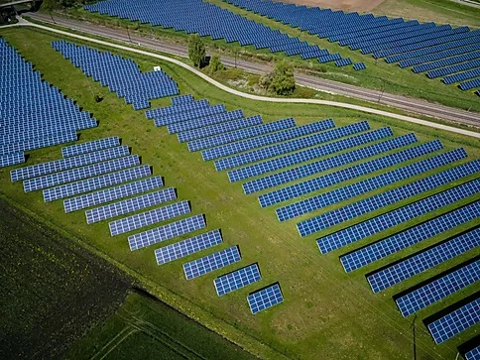
Photo by Roman Khripkov on Unsplash
Installing solar panels in cities, parking lots, and rooftops offers important prospects for contributing to a solution. Even so, the development of both energies poses challenges: landscape degradation and fragmentation, impacts on biodiversity, spatial incompatibility with agriculture and livestock, and the social issues associated with land tenure and land-use change, to name a few. Nevertheless, these facilities can be sited—following the concepts of opportunity cost and additionality—in urban areas and highly degraded areas whose restoration may cost considerably more than conserving areas of higher biological value, and designed so as to minimize collateral damage.
In short, invoking reduced industrial energy consumption due to the pandemic; placing the ideals of energy security and self-sufficiency above the greater good of climate mitigation; disguising operational inefficiency as corrective measures to address the “pre-existing” increase in the imbalance between generation capacity and demand, blaming the past for the inefficiencies of the present; posing false dichotomies, such as the “need” to halt progress on renewable energy—in the face of vices such as corruption—in order to ensure an efficient ordering of the energy system, or the need for rational economic regulation before clean energy can begin to be reincorporated in an accelerated and progressive manner, as a conditio sine qua non for achieving energy self-sufficiency through the optimal and sustainable use of all its primary energy resources; or having to wait for a comprehensive policy to develop scientific, technological, and industrial capabilities, aimed at increasing the energy sector's productivity, in order to keep end-user rates low: this is demagoguery in its purest form, built on argumentative fallacies.
The challenge is to analyze, begin to understand, and learn what this change entails. Nothing justifies obstructing the transition from fossil to renewable energy, since doing so runs counter to the public interest and is therefore unlawful. The explanations put forward by the Executive are not conditions without which the transition should not or cannot continue. While the arguments collapse under their own weight, the damage being done to Mexico's credibility, reputation, and economy, on the pretext of energy self-sufficiency, is permanent.
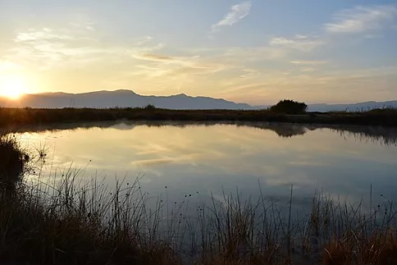
Photo by Mauricio De la Maza-Benignos
We must commit to renewable energy under sound regulatory management and effective laws that mitigate emissions and safeguard ecosystems and their biological diversity, upholding the human right to a healthy environment for our development and well-being; plan the gradual but accelerated phase-out of fossil fuels as a guarantee of the human right to health; and harmonize and develop structures and policies that enable decision-makers to do so on a strong scientific footing, in a comprehensive, informed, and coordinated way that incorporates biodiversity as a variable.
Philosophy, politics, and the sciences are among the greatest and most remarkable triumphs of the human intellect, but we must be careful. Many historical problems and conflicts arose from the political distortion of science, philosophy, religion, or morality. That is why, when it comes to energy self-sufficiency, as my grandmother used to say: ni tanto que queme al santo, ni tanto que no lo alumbre—don't hold the candle so close that it burns the saint, nor so far that it leaves him in the dark.
----------------------------------------------------------------------------------

Mauricio De la Maza-Benignos is an agricultural engineer specializing in animal science and holds a law degree; he also has an international MBA, a master's degree in Film and Multimedia Arts, and a PhD in Biological Sciences with a concentration in Wildlife Management and Sustainable Development.

References
• Global Footprint Network. National Footprint Accounts 2019 Edition. Global ecological footprint estimate (1.7 planets; global data through 2016).
• IPCC (2014). Climate Change 2014: Mitigation of Climate Change. Working Group III, Summary for Policymakers, figura SPM.2.
• Secretaría de Energía (SENER). “El Gobierno de México fortalece el Sistema Eléctrico Nacional” [The Government of Mexico strengthens the National Electric System], May 2020. Figures on coverage, installed capacity, peak demand, wind and photovoltaic capacity, and Long-Term Auction progress.
• IPCC (2018). Global Warming of 1.5°C. Summary for Policymakers, sections A.1 and A.2.
• INEGI (2020). Encuesta Nacional de Calidad e Impacto Gubernamental (ENCIG) 2019 [National Survey of Government Quality and Impact]. Main results.
• Comisión Federal de Electricidad (CFE). Technical guide SPA00-55, fuel oil specifications and sulfur content.
• Centro Nacional de Control de Energía (CENACE). “Acuerdo para garantizar la eficiencia, calidad, confiabilidad, continuidad y seguridad del Sistema Eléctrico Nacional, con motivo del reconocimiento de la epidemia de enfermedad por el virus SARS-CoV-2 (COVID-19).” Diario Oficial de la Federación, April 29, 2020.
• Secretaría de Energía (SENER). “Acuerdo por el que se emite la Política de Confiabilidad, Seguridad, Continuidad y Calidad en el Sistema Eléctrico Nacional.” Diario Oficial de la Federación, May 15, 2020.
• Francis (2015). Laudato si’: On Care for Our Common Home, no. 33. Vatican City: Libreria Editrice Vaticana.
• Habermas, J. (1980). “Modernity—An Incomplete Project.” Acceptance speech for the Theodor W. Adorno Prize, Frankfurt am Main.
• Holmer, S. American Bird Conservancy. Personal communication with the author, n.d.

