Using Debug With Lab 3

Green screen compile requires an option to be changed. Debugging views should be set to all. RDi compile does this by default.

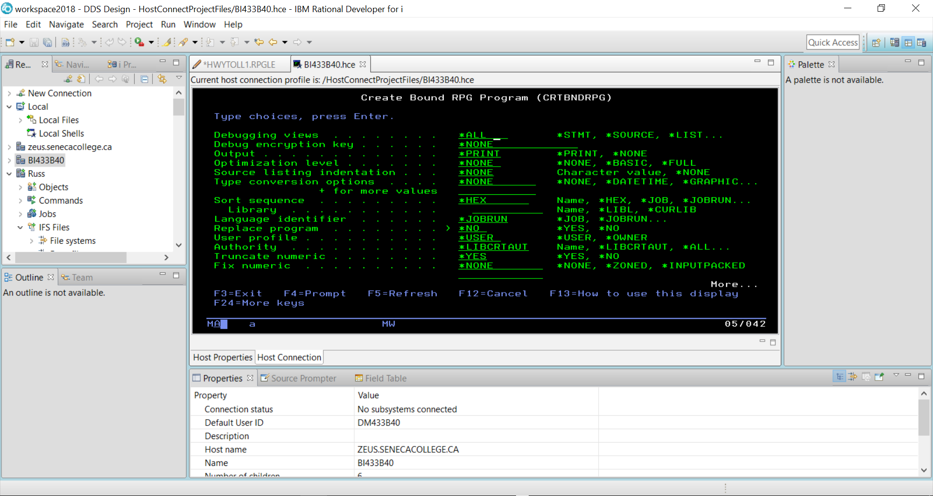

The STRDBG command allows you to set a breakpoint in the program when it is running.

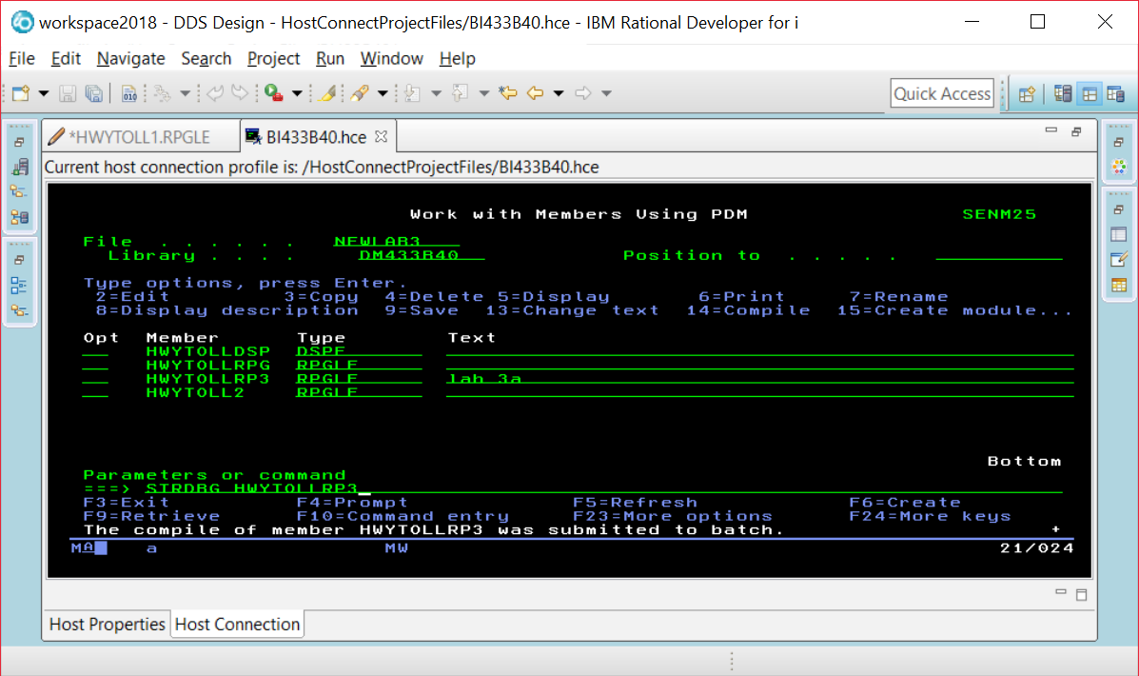

If you are already in DEBUG mode, this command will not work. Just enter the ENDDBG command to exit from DEBUG mode and then enter the STRDBG command with your program name.

Page down and put your cursor on the line where you want a breakpoint, and press F6.

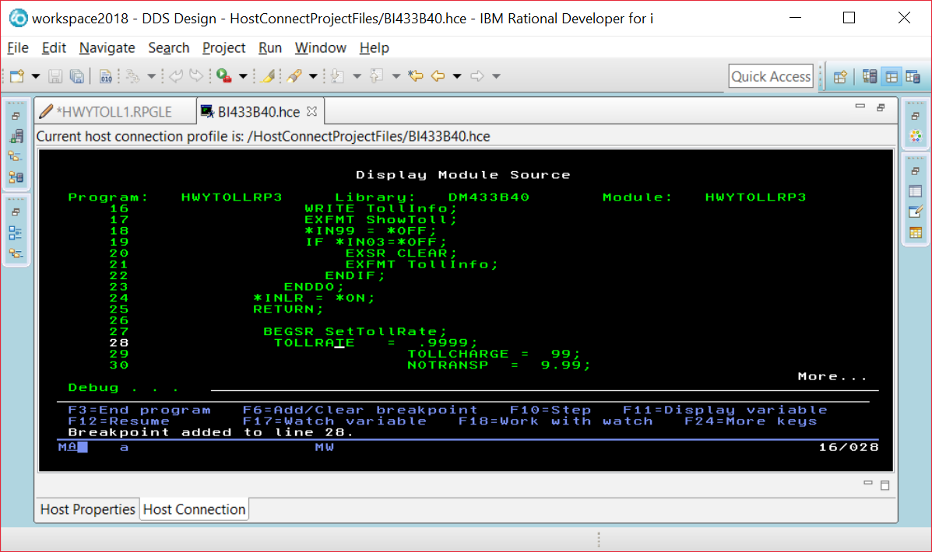

When you run the program you will see screens the program displays before the breakpoint. Our breakpoint was after the EXFMT line, so we see this screen and can enter data into the fields.

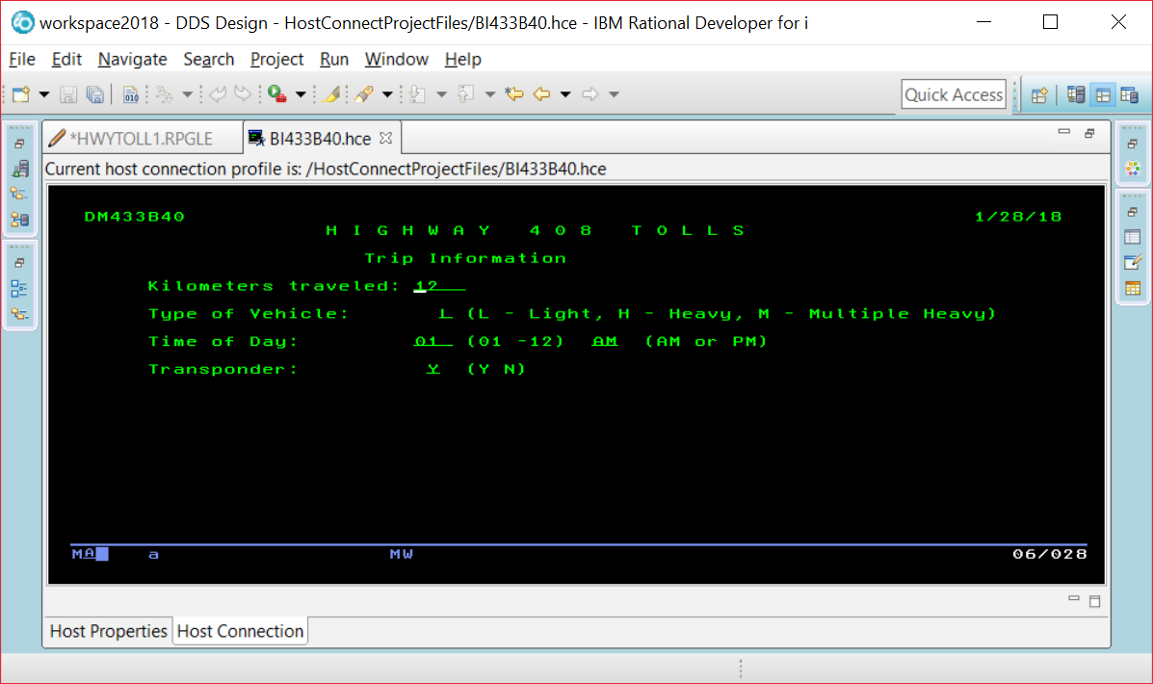

The breakpoint is reached and this line has not been executed yet. So TOLLRATE would still be set at 0.

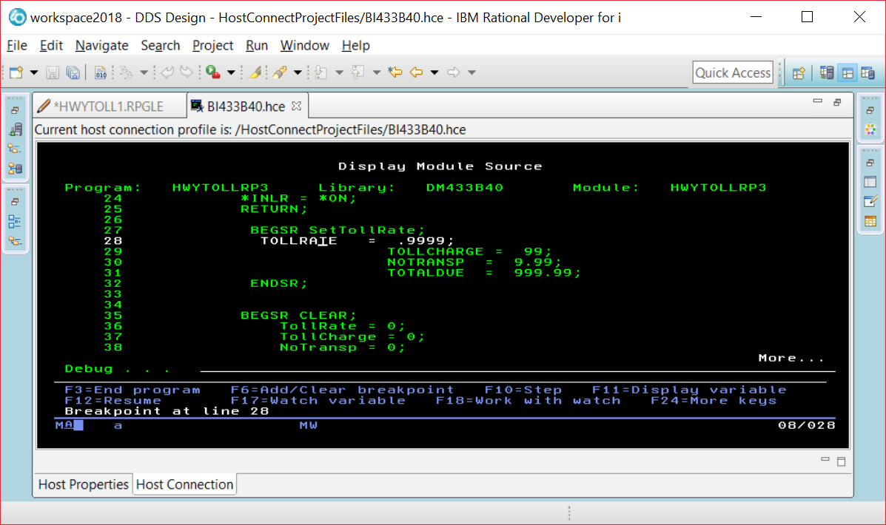

If you put your cursor on the TOLLRATE field, you will see what is currently stored in the field.

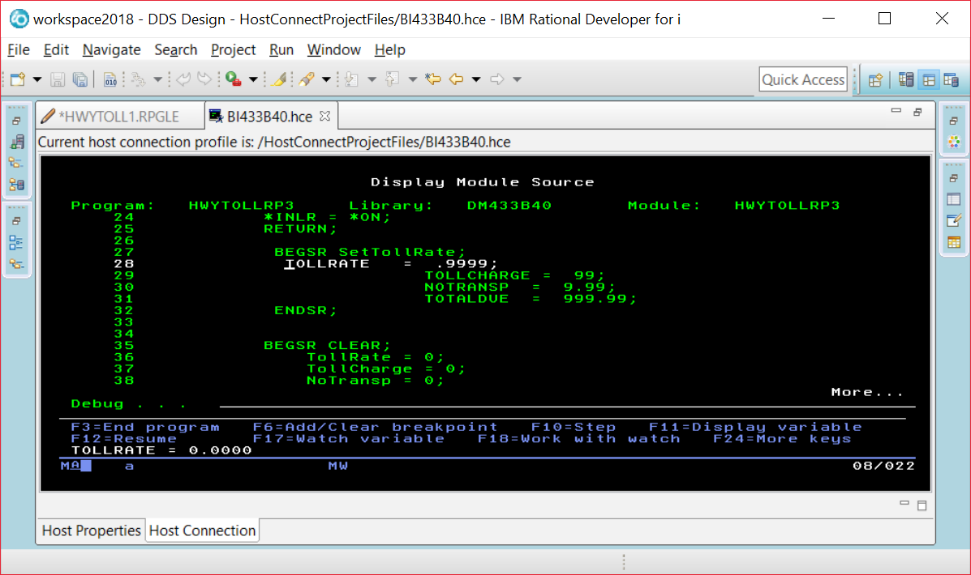

Instead of using F11, you run the command EVAL VEHICLE command at the prompt and be able to find out what is in a field that is not currently being displayed in a line of code on your screen.

EVAL VEHICLE

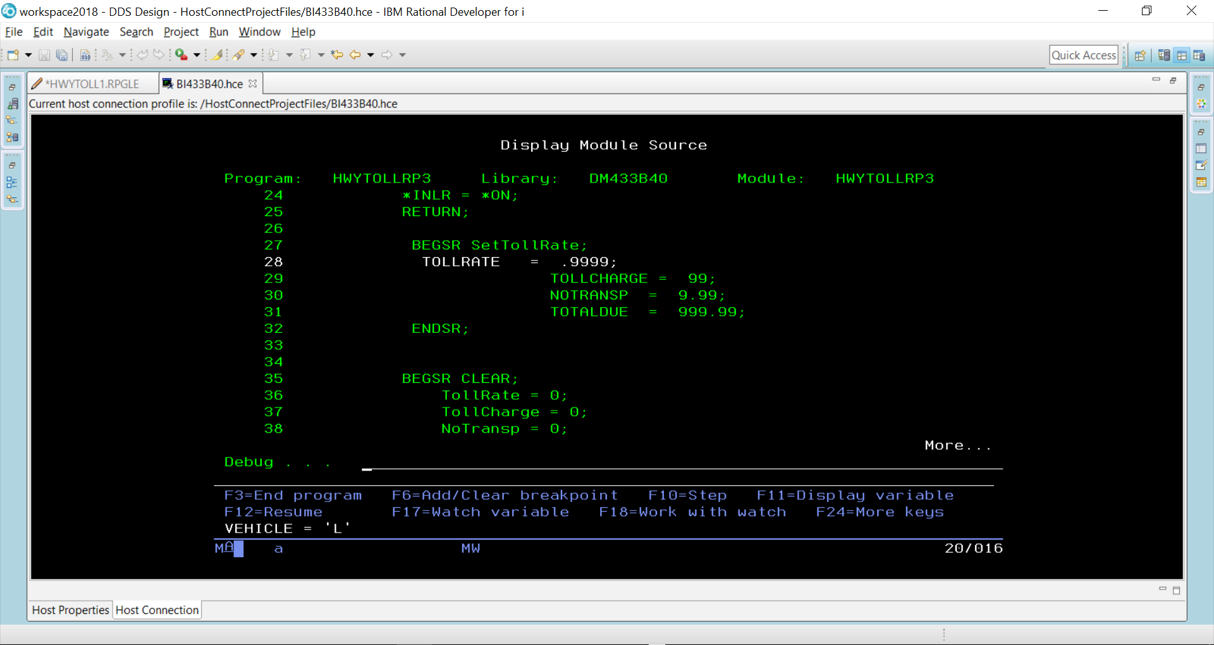

You can alter the contents of a field while your program is running.

EVAL VEHICLE = ‘H’

EVAL VEHICLE

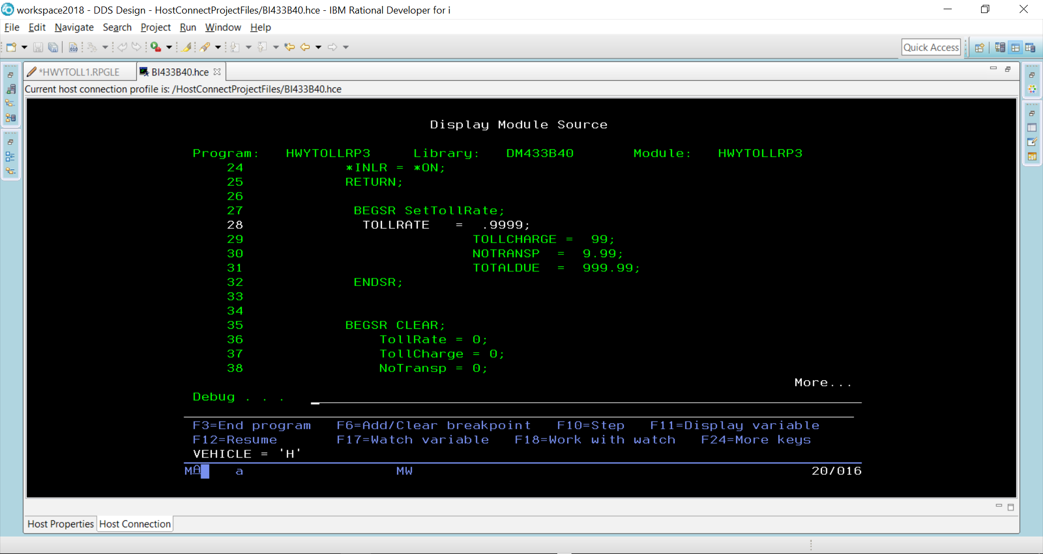

F10 is pressed to step through each line of code

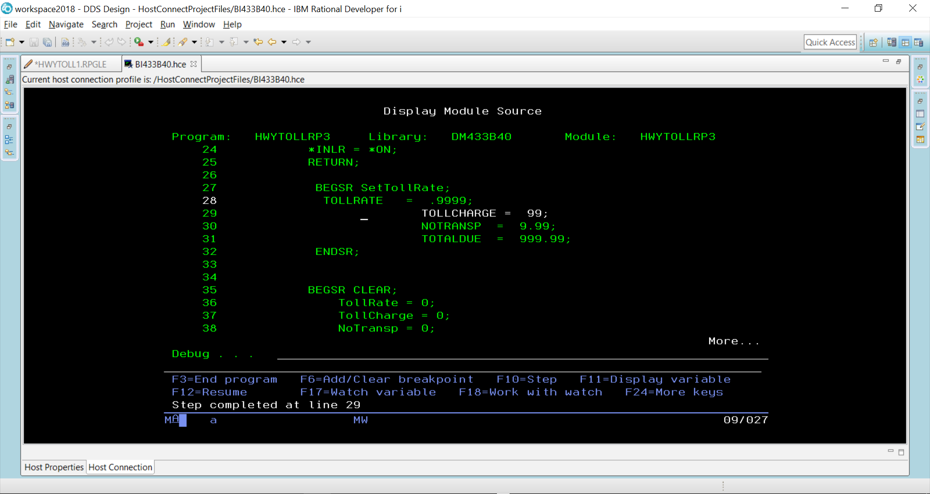

TollRate would now be set at 9999 because line 28 has executed.

When F12 pressed – the rest of the code executes until we get to where the two screens are made available and the program is paused.

