Jobs and Subsystems

Work needs to be organized, managed and completed on the Power System. This work is arranged into various jobs that may consist of a CL command or the execution of one or more application programs.

A job is a unit of work that is done on the system. A job should include all the required computer programs, files and instructions to the operating system for accomplishing a task.

The system maintains information about all aspects of every job and this data is available to you on the Work with Job screen. (WRKSBMJOB and option 5 beside a Job) A job number is assigned and a job description will be associated with the job that will indicate the default job queue to use. A job priority on the job queue, output priority on the output queue would be some of the information found in a job description.

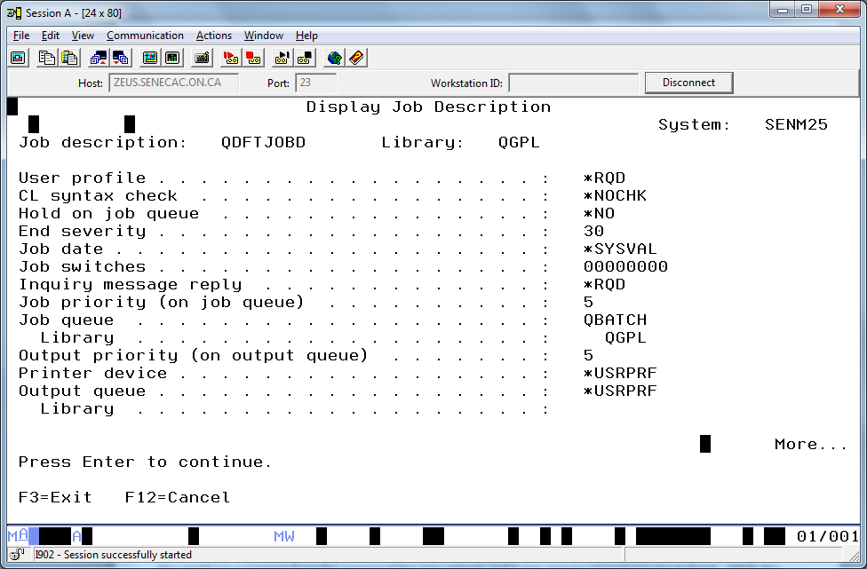

A job runs in a subsystem. A subsystem is a work management environment that supports various types of jobs. A subsystem is made up of resources such as a subsystem description (the blueprint or plan that describes the kind of work the subsystem is tuned to handle); main storage to allow the system for loading and running of programs (pools); display stations to start and run interactive jobs; job queues to start batch jobs; and communication devices and locations.

Two of the most common categories of jobs are Interactive and Batch.

An interactive job is started when you sign on the system and ends when you log off. You interact with the system at the command line by entering CL commands, selecting menu choices or running various programs. Eventually you will sign off the system and this interactive conversation is terminated.

A batch job can be handled by the system without a continuous collaboration between the user and system to get work accomplished.

Job status attributes will tell you when the job entered the system and when it started running. You can check this information for a batch job to check if the job has been running too long possibly in a never-ending loop.

You could run a program from the command line interactively and it may require several minutes to finish. While the job is running, the screen is frozen and you do not have access to the command line.

Another choice would be to use the submit job command and allow this job to run in the background.

Jobq1 ---------------------------

Jobq2 --------------------------- QBATCH Subsystem

Jobq3---------------------------

JobqA --------------------------

JobqB ---------------------------QINTER Subsystem

The QINTER subsystem is tuned to give a faster response than QBATCH. You would use the QBATCH subsystem for your program that freezes the screen for several minutes and continue to interact at the command line with the QINTER subsystem.

Jobq1 Status Priority Work to Do

FirstJob HLD 3 a simple task printing a report

SecondJob ACTV 5 a series of tasks –update customer with daily batched daily sales

Analyze customer sales patterns

Print Reports

ThirdJob RLS 5 Delete Old Unused Objects

FourthJob RLS 2 Process 100,000 records

Which job is running, which job should run next? What would happen if the QBATCH subsystem was held?

WRKSBS

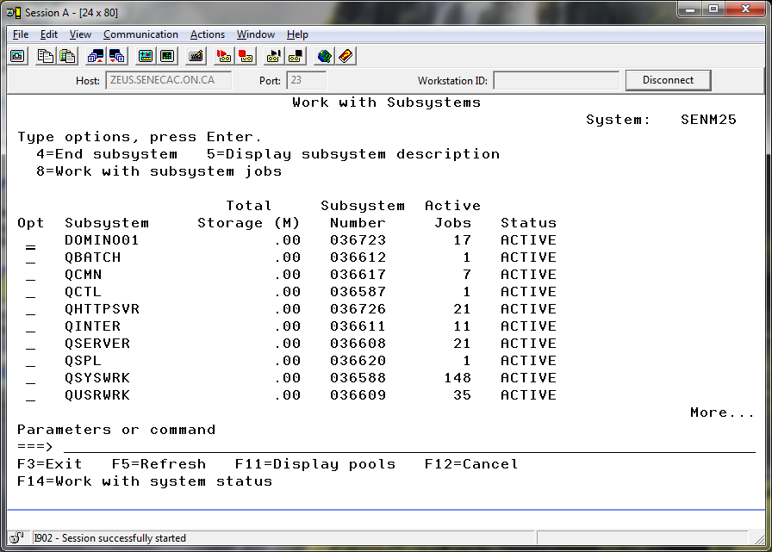

QBATCH Subsystem

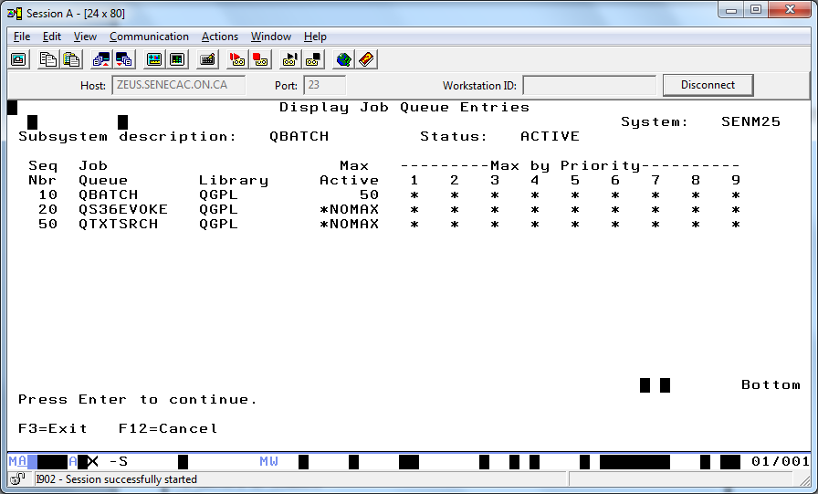

QINTER Subsystem

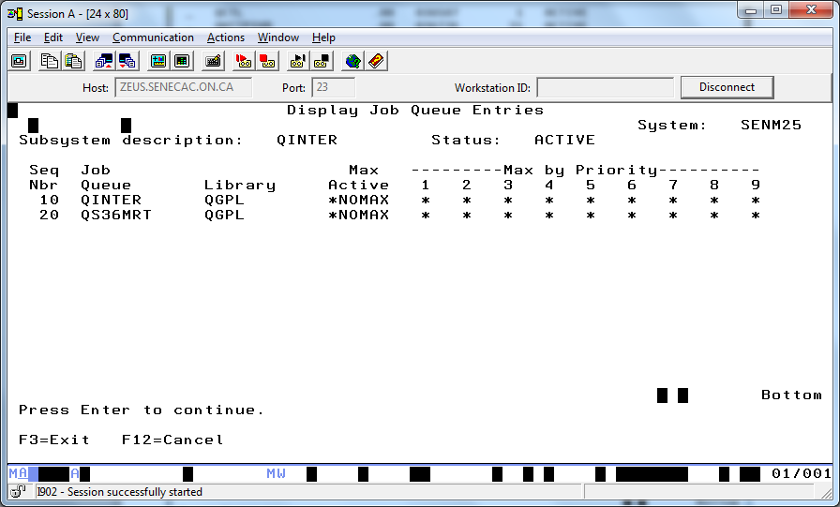

Which subsystems have more system resources allocated?

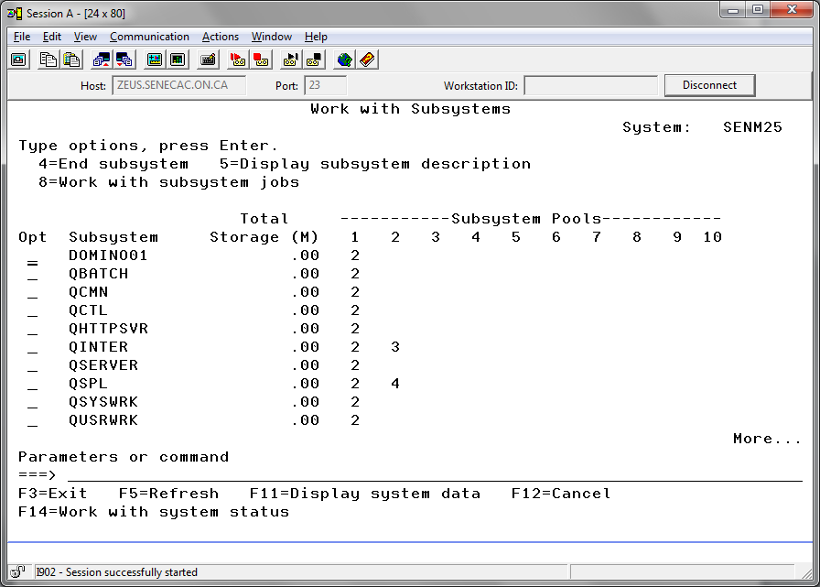

Too much CPU is being used here:

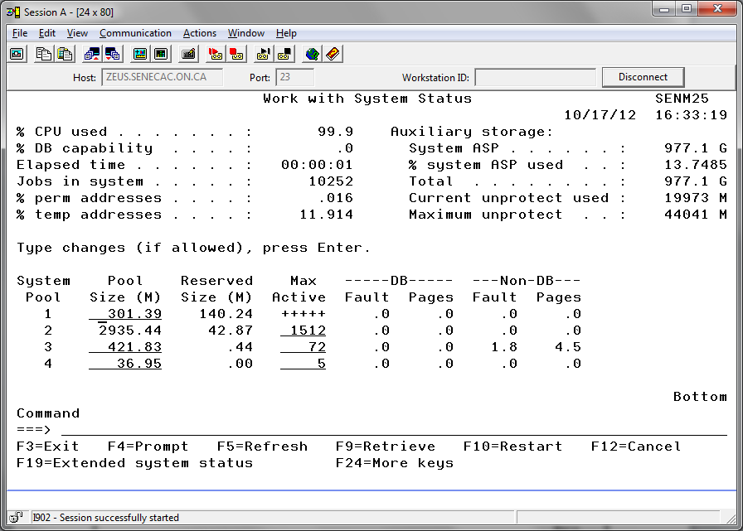

WRKACTJOB

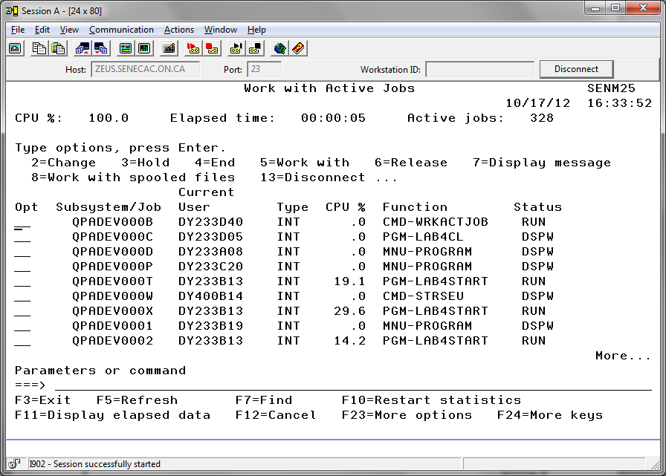

Sign on a second time.

Look for your two interactive jobs. One will be your out of control program and the other will be your WRKACTJOB function.

Use option 4 to end your out of control program.