Creating A User Defined Function

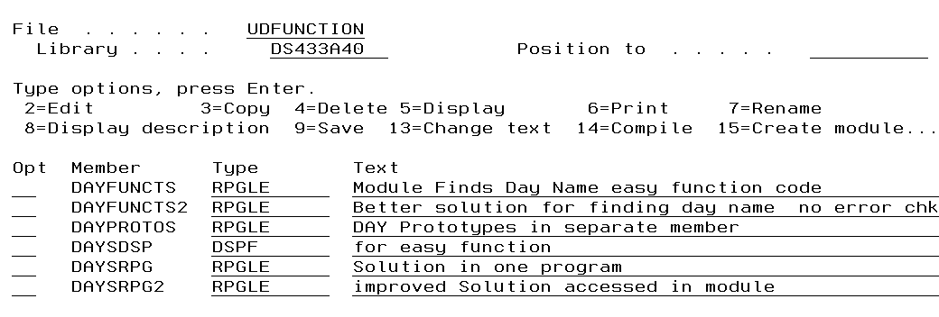

Running standalone program or program with function and modules

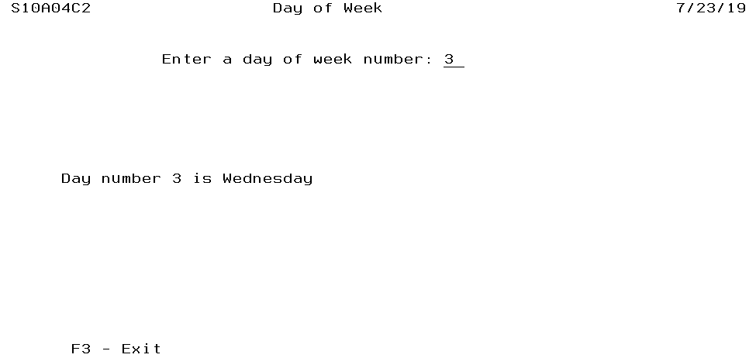

Stand Alone Program

DCL-f DaysDsp Workstn;

EXFMT RECORD1;

DOW NOT(*IN03);

**EXSR GETDAY;**

WRITE RECORD1;

EXFMT RECORD2;

IF *IN03 = '0';

DayNum = 0;

EXFMT RECORD1 ;

ENDIF;

ENDDO;

EXFMT RECORD3;

*INLR = *ON;

RETURN;

BEGSR GETDAY; // This subroutine will be moved out as a user defined function

SELECT;

WHEN DAYNUM = 1;

DAYNAME = 'Monday';

WHEN DAYNUM = 2;

DAYNAME = 'Tuesday';

WHEN DAYNUM = 3;

DAYNAME = 'Wednesday';

WHEN DAYNUM = 4;

DAYNAME = 'Thursday';

WHEN DAYNUM = 5;

DAYNAME = 'Friday';

WHEN DAYNUM = 6;

DAYNAME = 'Saturday';

WHEN DAYNUM = 7;

DAYNAME = 'Sunday';

other ;

DAYNAME = 'Invalid';

ENDSL;

ENDSR;

To run the standalone program requires compiling the display file and compiling DAYSRPG.

To convert the standalone program to a program implementing the user defined function the subroutine is not used. It is replaced by a single line of code referencing the function. Another line is added at the top to copy in the prototype for the function.

This is the code for the DAYSRPG2 module.

DCL-f DaysDsp Workstn;

// get the prototype for the function into this program

________________________________________________________// slash in column 7

EXFMT RECORD1;

DOW NOT(*IN03);

EXSR GETDAY; // cross out this line and replace it with use of a function

____________________________________________________________________

WRITE RECORD1;

EXFMT RECORD2;

IF *IN03 = '0';

DayNum = 0;

EXFMT RECORD1 ;

ENDIF;

ENDDO;

EXFMT RECORD3;

*INLR = *ON;

RETURN;

DAYPROTOS (A source member in UDFUNCTIONS)

_________________________________________________________________________

_________________________________________________________________________

_________________________________________________________________________

DAYFUNCTS

_________________________________________________________________________

_________________________________________________________________________

_________________________________________________________________________

_________________________________________________________________________

_________________________________________________________________________

_________________________________________________________________________

_________________________________________________________________________

SELECT;

WHEN NUMBER = 1;

DAYNAME = 'Monday';

WHEN NUMBER = 2;

DAYNAME = 'Tuesday';

WHEN NUMBER = 3;

DAYNAME = 'Wednesday';

WHEN NUMBER = 4;

DAYNAME = 'Thursday';

WHEN NUMBER = 5;

DAYNAME = 'FRIDAY';

WHEN NUMBER = 6;

DAYNAME = 'Saturday';

WHEN NUMBER = 7;

DAYNAME = 'Sunday';

OTHER;

DAYNAME = 'Unknown';

ENDSL;

_________________________________________________________________________

_________________________________________________________________________

Two modules are compiled. DAYSRPG2 is the module using the function and DAYFUNCTS is the module containing one or more functions. They are combined with the

___________________ command.

Improving on the solution

Same starting code

…

End-PI

DCL-s DayName Char(9);

// this is replaced with an array and the select statement is not required

_________________________________________________________________________

_________________________________________________________________________

_________________________________________________________________________

_________________________________________________________________________

_________________________________________________________________________

_________________________________________________________________________

_________________________________________________________________________

_________________________________________________________________________

_________________________________________________________________________

_________________________________________________________________________

_________________________________________________________________________

_________________________________________________________________________

_________________________________________________________________________

_________________________________________________________________________