Processing with embedded SQL (review of lab 9A and 9B)

BKCUSTOMER

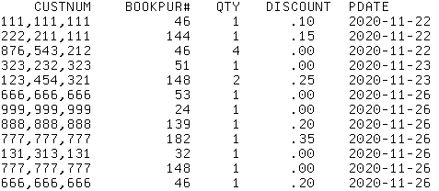

AUDIBLEBKS

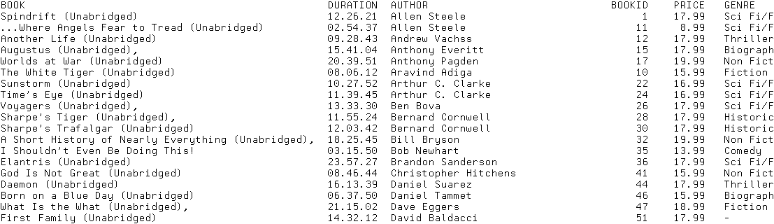

1 method – READ the first file with RPGLE READ statement and use EMBEDDED SQL to get a matching record. SELECT INTO – only gets one matching record at a time.

REPORT generated by program

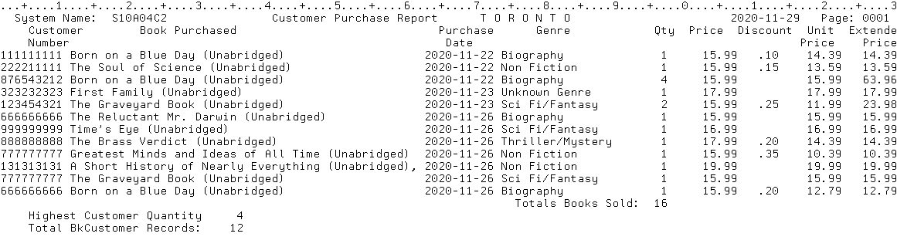

Alternate order with BYCUST index override

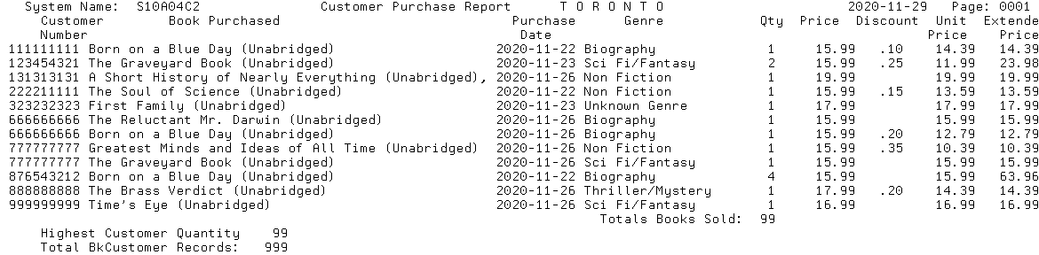

Notice the override has some problems in above report

2. Read both files at the same time by producing a temporary result table in memory to process.

This is what the temporary result table would look like getting book title within genre order

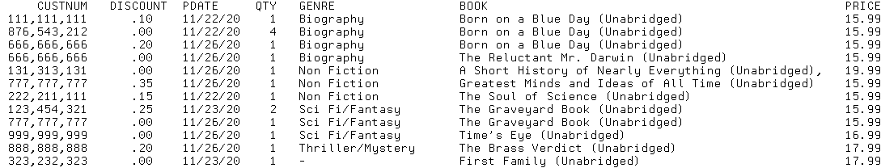

Report produced

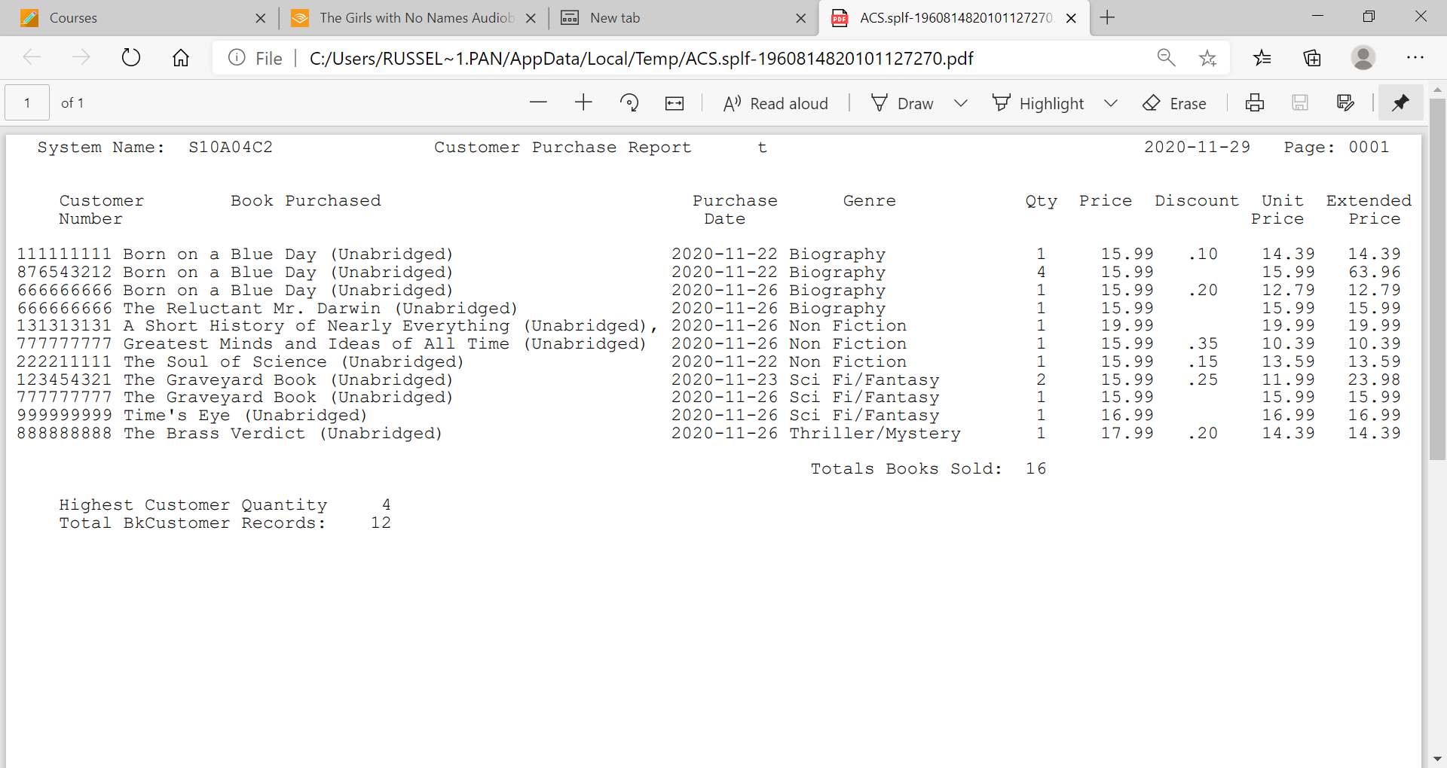

Code for printer file BOOKRPT shown on next page and available in BCI433LIB/Lab9RV

