**Incident Management Report System**

**System Design Document**

**1. INTRODUCTION**

**1.1 Overview**

This document has been developed for the Incident Management Report System project.  This document was developed from the Incident Management Report System Software Requirements Specification and is intended to detail the

* Technical Architecture
* Class Diagram
* Database Design

**1.2 Scope**

Servers: Internet Information Services (IIS) 10

Database: SQL Server 2014

Languages & Frameworks: ASP.NET 4.5, C# 5.0

**1.3 Reference Material**

Other system documentation for this system should include:

* System Requirement Specification
* System Configuration Document

**1.4 Document Conventions**

All diagrams, charts and tables are generated using standard UML guidelines.

**2. SYSTEM OVERVIEW**

This enterprise project consists of three major layers. The front-end layer is the portal that users will log into and make requests from. These requests are handled in the business layer, in which lie the various Incident Management Report System services. These services retrieve and manipulate data through the data access layer. The service returns the necessary data to the front-end, which then updates a view or renders a new view for the user.

**3. SYSTEM ARCHITECTURE**

**3.1 Architectural Design**

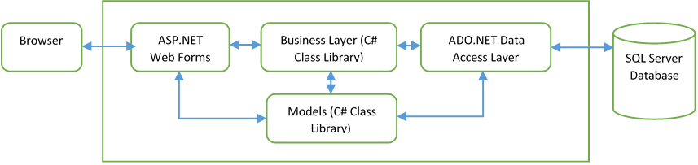

**3.2 Decomposition Description [Systems of Incident Management Report System]**

**3.2.1 Car Inventory Dashboard**

          The Car Inventory Dashboard is designed to keep track of all the Cars in the Inventory for RideXpress, as well as keep track of car specifications and pricing details.

**3.2.2 Incident Report Management**

         The Incident Report Management is designed to keep track of all Incident Reports for the Car Inventory. When the User creates an Incident Report for a Car, the Report contains the Date of the Incident, Name and Description of the Incident.

**4. DATA DESIGN**

**4.1 Data Description**

Data will be structured into classes which are mapped to tables within the database.

**4.2 Data Dictionary**

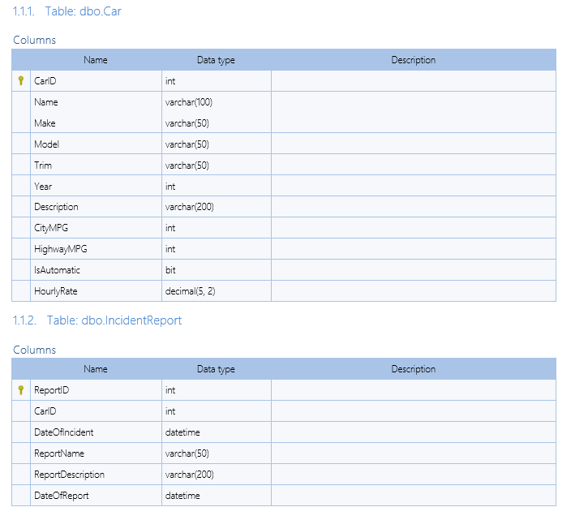

**4.3 Database Design Diagram**

**4.4 Class Diagram**

**4.5 Sequence Diagram**

https://preview-v2-app.revature.com/core/resources/ckfileupload?f_name=29e087ded15634179fe8fa651ef4975b.png