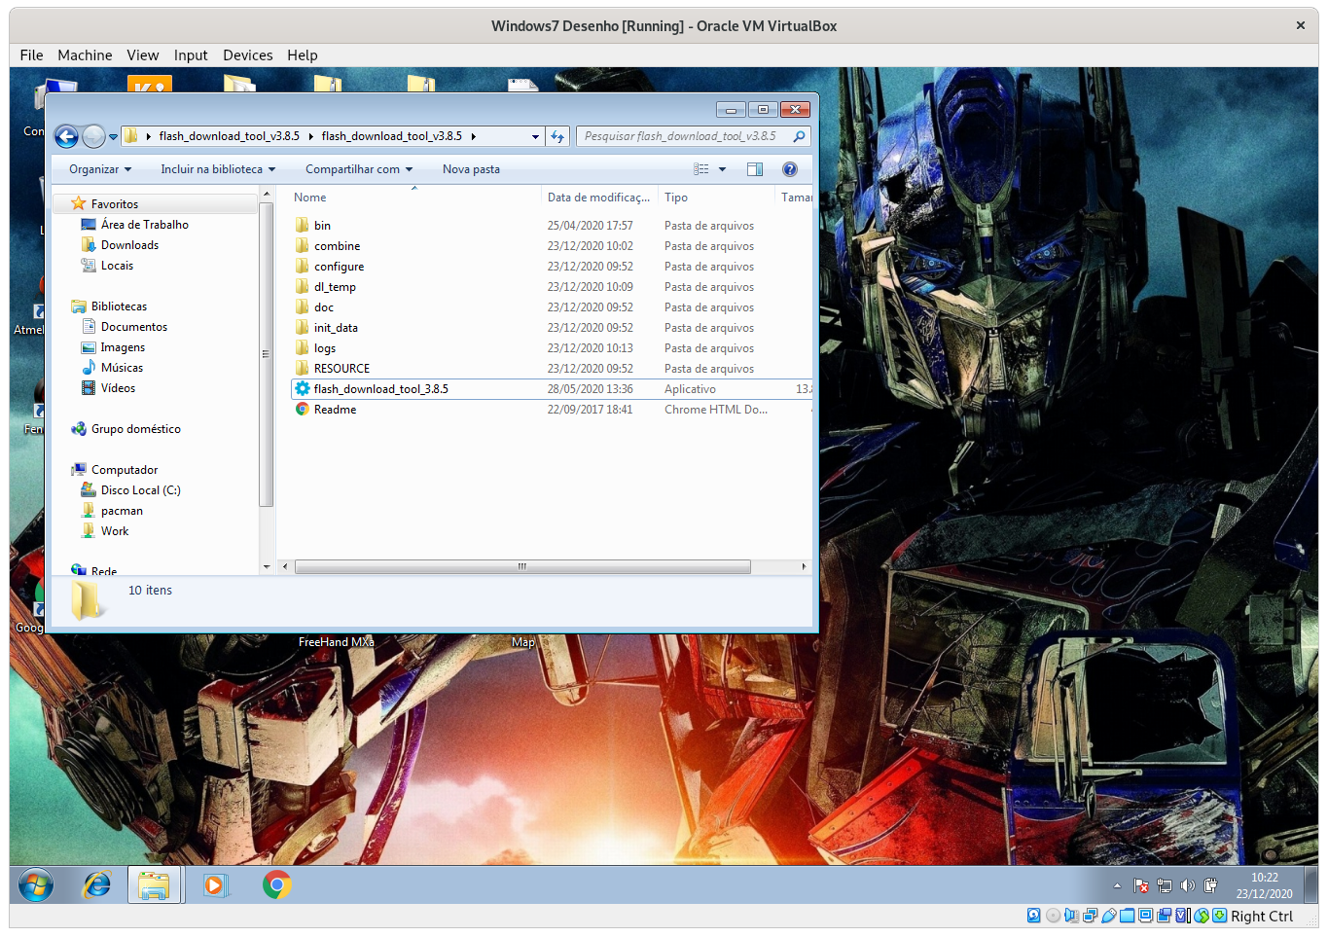
After uncompress the files, run the flash_download_tool_3.8.5 by double-click this

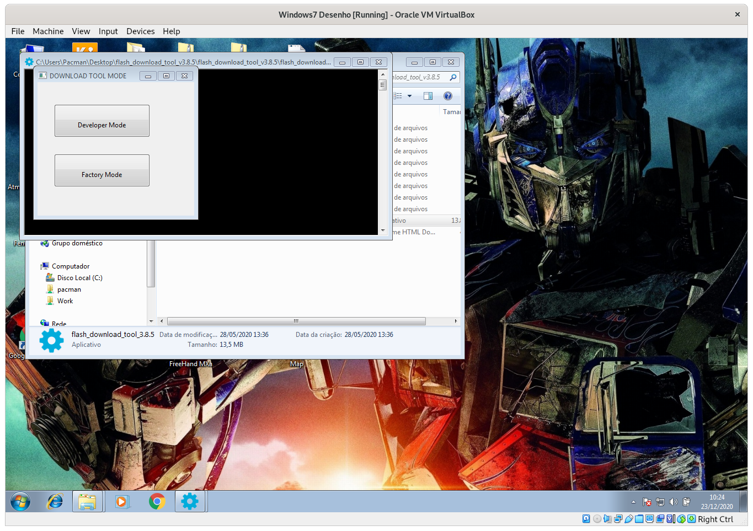
Click on “DEVELOPER MODE” button
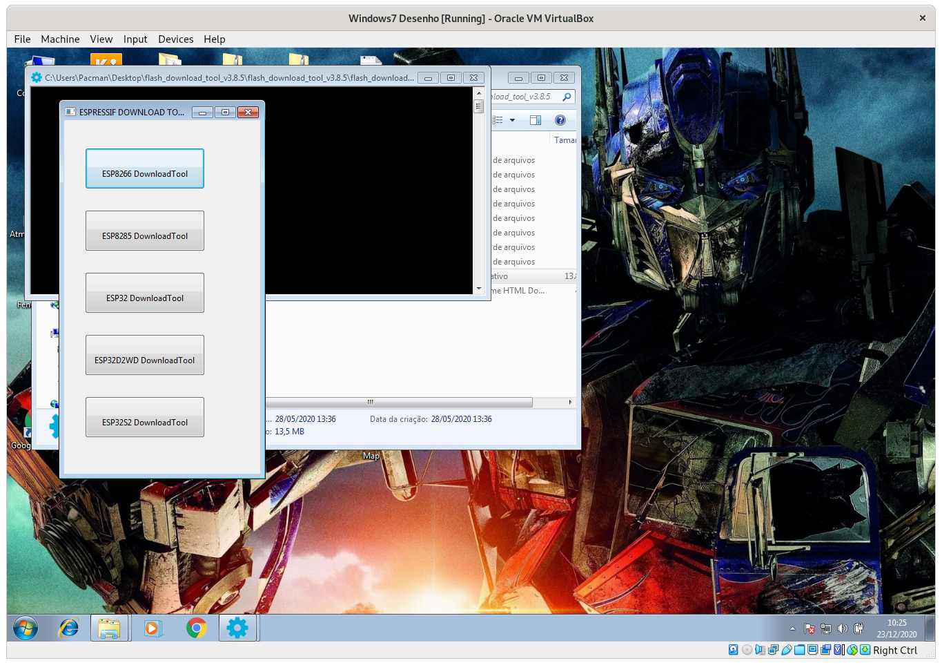
Then, click on “ESP32 Download Tool” Button
Select the check to mark file to download

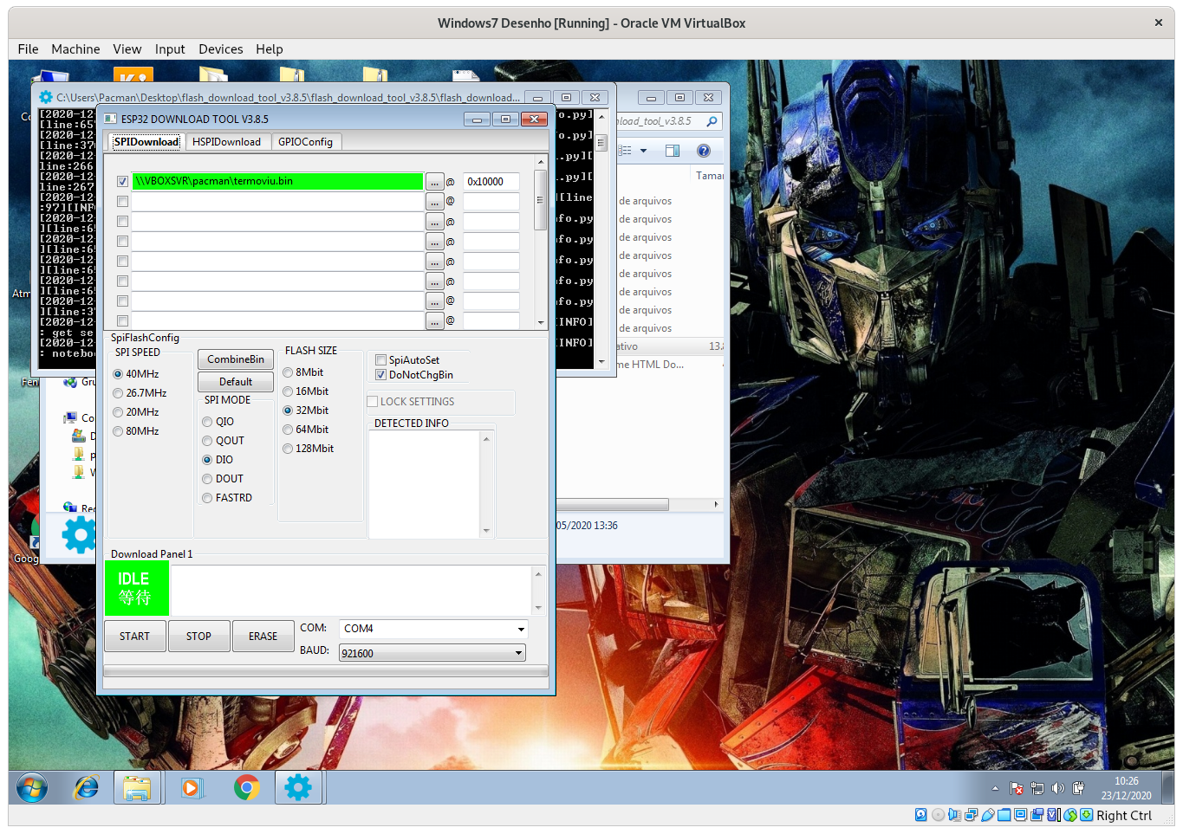
Select the file for download to your TermoVIU

Type 0x10000 initial address on the form

Choose the COM port where TermoVIU is attached

At least click the “START” button

IMPORTANT STEP AHEAD

Now press the BOOT Button on TermoVIU board for 5 seconds. After release, wait the start of your download.

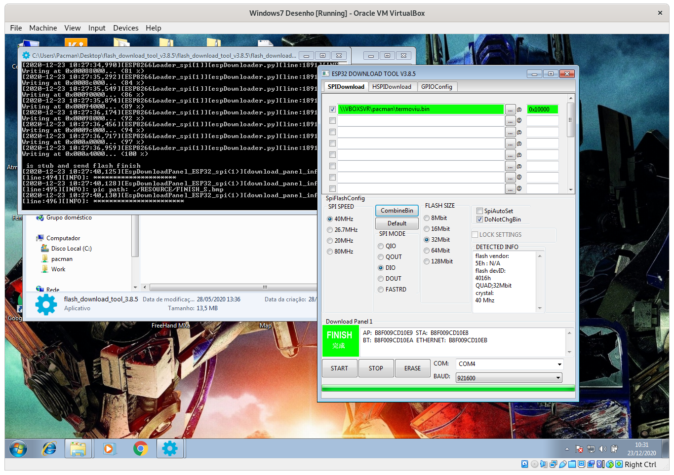
In the log screen your download feedback information is shown.

When ends, the FINISH message are printed on screen!

