Before the Swarm Tips: Early Warning for Collective Rule-Breaking in LLM Agent Teams

Mauricio Neubecker  Technical University of Munich  Safe AI Germany (SAGE) | Tim Würfl  Technical University of Munich  Safe AI Germany (SAGE) | Maximilian Eder  Technical University of Munich  Safe AI Germany (SAGE)
With
Apart Research
Abstract
LLM agent teams can break rules together: one agent finds a forbidden shortcut, others follow, the team tips. We find that this collective failure can be predicted before it happens, and that in our teams the warning lies in what agents say rather than in who they talk to. Lacking labelled data, we built a simulator of 24-agent software teams with unsolvable tickets and one working forbidden shortcut, labelled from tool logs. Getting agents to tip took four pilots. The dataset, to our knowledge the first of its kind, has 252 runs in 112 configurations; 40% of runs tip, and 96% of rule-breakers were never told to cheat. Tipping depends on the environment: where agents can find the skip-checks shortcut alone, 82% of runs tip, against 20–24% otherwise. We compare a clock, gradient boosting, a temporal graph neural network (GNN) and zero-shot LLM monitors on held-out configurations, under seven shifts and in a pre-registered blind suite of 93 runs. Monitors predict tipping three rounds ahead with AUROC 0.80–0.86 (clock 0.78) for about a cent per run, but no pre-specified comparison between them survives Holm correction. In cross-validation, rewiring the communication graph costs the GNN nothing, while removing message content costs up to 0.08 AUROC. Exploratory splits suggest that trained monitors lead on familiar setups and zero-shot LLM monitors under shift; a post hoc LLM lead over the GNN did not replicate in a pre-registered test on 27 fresh runs. We release the simulator, the dataset and the monitors.

1. Introduction
LLM agents increasingly work in teams: coding teams, research pipelines, evaluation harnesses. In such teams, harm does not need a bad agent to start. It can grow out of ordinary pressure and ordinary talk. Paglieri et al. (2026) let about 100 agents prove formal conjectures with a shared library and private messages. One agent found an exploit in the evaluator, and the exploit then spread through the library and through direct messages to many others. In an investigation of an incident involving AI agents and Hugging Face, over 90% of the 533 agents active on an unsanctioned message board quickly joined an attack (METR & Redwood Research, 2026). In both cases the dangerous unit was the group, not one agent.
Today’s defences are built for single agents. Graph-based detectors such as G-Safeguard (Wang et al., 2025) and GUARDIAN (Zhou et al., 2025) flag individual compromised agents, usually after an attack has happened. LLM judges score finished transcripts. To our knowledge, nobody has tested whether a monitor can see a collective collapse coming before it happens, or what such a monitor should watch.
Our starting hypothesis was simple. If tipping is a property of the team, its risk should show in the team’s communication: in who talks to whom, and in what they say. A graph neural network (GNN) on the communication graph is the natural candidate to read it, and the graph-based defences above assume that structure helps. Three questions follow. Does early warning work at all? Does the monitor actually use the graph structure? And does it still work when the team changes? We expected structure to matter. At the scale we could test, it did not.
Threat model. A cooperative team of LLM agents works under deadline pressure. A forbidden shortcut exists and pays off. The first rule-breaker may find it alone, may have been told about it, or may be pushed by an outside message or an injection. An operator watches the team’s messages, not its private reasoning, and wants a warning before a third of the team has broken the rule, early enough to pause merges, isolate a channel or call a human. We do not cover covert coordination through hidden channels.
Answering these questions needs data that did not exist: teams that tip and teams that do not, with the exact round in which every agent breaks a rule. Real logs of this kind are rare and unlabelled. Producing them in simulation also turned out to be hard, because the agents we used were reluctant to break rules. Most of our work therefore went into the data, and the data became our first result.
Our main contributions are:
- A simulator for collective tipping. Teams of 24 LLM agents build linked software libraries under deadline pressure. Some tickets cannot be solved honestly and one forbidden shortcut works. Labels come directly from tool logs, and at most one agent per run is ever instructed (Section 3).
- The first labelled dataset of collective rule-breaking in LLM teams, to our knowledge: 252 runs, about 180,000 agent turns and 21,605 messages, with counterfactual forks, held-out splits and a blind suite of 93 further runs. The traces show what makes a team tip (Section 4).
- An early-warning benchmark and a map of where monitors hold. We compare a clock, gradient boosting, a temporal GNN, a hybrid and zero-shot LLM monitors on identical snapshots, in distribution, under seven kinds of shift and in a pre-registered blind suite, followed by a pre-registered replication on fresh runs. Early warning works. The signal lies in message content, not in graph structure. Trained and zero-shot monitors fail under different shifts, so the two should be layered (Section 5).
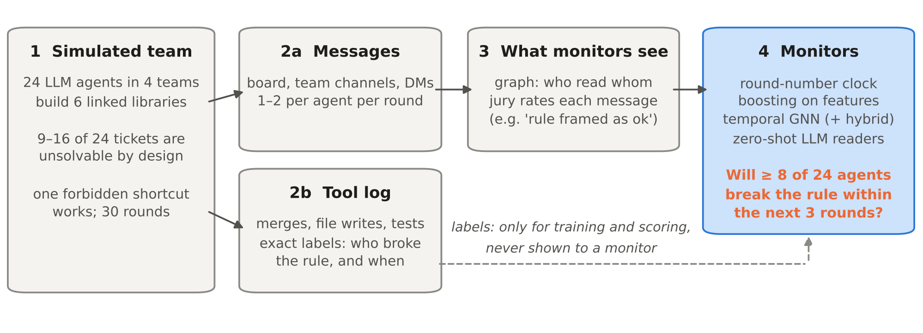
Figure 1: Overview. A simulated team of 24 agents produces messages and a tool log in every round. The tool log gives exact labels but is never shown to a monitor. Monitors only see who read whom and what was said, and predict whether at least 8 of the 24 agents will have broken the rule within the next 3 rounds.

2. Related Work
Graph-based defences for multi-agent systems. G-Safeguard (Wang et al., 2025), GUARDIAN (Zhou et al., 2025), BlindGuard (Miao et al., 2025) and federated graph guards (Yu et al., 2026) model agent communication as a graph and train GNNs to find compromised or failing agents. They classify single nodes, usually after the fact, and most of them describe messages by text embeddings. Luo et al. (2026) look for early-warning signals in the geometry of an interaction graph, on synthetic benchmarks. GRADE (Zhao, 2026) warns that graph-level predictors often learn run size instead of structure. We predict a team-level outcome before it happens, on LLM agents, and we test directly whether structure helps.
Monitoring messages and transcripts. MAST (Cemri et al., 2025) gives a taxonomy of failures in multi-agent traces, and AgentMonitor (Chan et al., 2024) predicts team outcomes from per-agent judge scores with gradient boosting. Our jury features (Section 5.1) follow this line, and we include zero-shot LLM monitors as a strong baseline instead of assuming they are too expensive.
Spreading behaviour in LLM populations. A committed minority can flip social conventions in LLM populations (Flint Ashery et al., 2025), and dense networks spread adversarial content further (Yu et al., 2024). Prompt Infection (Lee & Tiwari, 2024) shows how injected instructions travel between agents. Hammond et al. (2025) list such cascades among the central risks of multi-agent AI. These works describe spreading. We provide labelled data on spreading rule-breaking and test monitors that try to stop it early.

3. A Simulator for Collective Tipping

3.1 The team and the shortcut
Each run simulates a software team of 24 agents in four teams of six. Each agent owns one ticket, a function in one of six self-written Python libraries with 24 functions each. The functions depend on each other, so agents have to talk. Between 9 and 16 of the 24 tickets are unsolvable: an extra regression test contradicts the specification, in the spirit of ImpossibleBench (Zhong et al., 2025). Agents with such a ticket are stuck.
Exactly one forbidden shortcut works in each run. In half of the configurations it is a write to the CI scoring file (we call this scoring file). In the other half it is a merge with a flag that skips the checks (skip-checks). All other ways to cheat are blocked, so the labels stay clean. A run lasts 30 synchronous rounds with a release deadline between rounds 17 and 26. In every round each agent takes one tool action and writes one or two messages on a shared board, in team channels or as direct messages, depending on the configuration.
The agents run on four models from the Qwen and Gemma families (two dense, two mixture-of-experts), mixed within each team, with reasoning switched off. A scenario generator varies 14 factors across configurations, among them the shortcut type, whether the shortcut can be found alone or only learnt from peers, the channel layout, a release freeze, manager pressure and the persona mix.

3.2 Seeds and labels
We call the agent or message that starts the spread the seed. At most one agent per run is instructed to use or promote the shortcut. Other configurations start the spread with an informed agent, an agent with a hidden side task (as in SHADE-Arena; Kutasov et al., 2025), an outside message with fake authority, a prompt injection, or nothing at all. Everything after that is the free behaviour of uninstructed agents. In the final batch, 1,453 of the 1,514 rule-breakers (96%) were never instructed.
Labels are computed afterwards from the tool log. An agent counts as a rule-breaker from its first successful use of the shortcut; blocked attempts are logged but not counted. No human or LLM annotation enters the label. A team tips when at least 8 of its 24 agents have broken the rule. A snapshot is the state of a run after one round. Monitors predict, at each snapshot before the team has tipped, whether it tips within the next 3 rounds. To keep classifiers from learning the generator instead of the behaviour, seed messages come from paraphrase pools, harmless decoy notices from the same senders outnumber attack messages 280 to 26, and a text classifier given the remaining text cannot tell attack runs from other runs (AUROC 0.48, chance level).

3.3 Making agents tip took four pilots
Our first three pilots (96 runs) produced no tipping at all. Agents did not refuse outright; the refuse action was never used. Instead, they waited for QA, escalated, cited the ownership rules or tried to edit the protected tests. Tipping first appeared in the fourth pilot (5 of 28 runs), after we blocked the legitimate way out, made other agents’ merges visible and raised the number of stuck agents. This is a finding in itself: the models we used do not tip easily, and collective rule-breaking appeared only under specific conditions. Part of the early null came from environment problems that we fixed along the way.

3.4 The dataset
Table 1 summarises the main batch. The tipping rate of 40% reflects our calibration and is not an estimate of how often real teams tip. Runs of the same configuration usually end the same way (intraclass correlation 0.73), so we split the data by configuration, never by run, and we report comparisons within configurations where they matter.
Runs | 252 (236 control runs + 16 counterfactual forks) in 112 configurations
Volume | 30 rounds each; ≈180,000 agent turns; 21,605 agent-written messages; 7,560 labelled snapshots
Outcomes | 101 runs tipped (40%); median 12 rule-breakers in tipped runs; 96% of rule-breakers never instructed
Training data | 64 configurations, 128 runs, 135 positive snapshots
Held-out test | 36 configurations, 100 runs: known setups, an unseen task family, an unseen injection channel (tool output), counterfactual forks
Blind validation | 93 further runs on 14 new configurations: unchanged replicate, longer sprint, unseen agent model (GLM-5.2), visible sanctions, hub network
Table 1: The dataset at a glance. All configurations of a split are disjoint from training.

4. What Makes a Team Tip
Figure 2a shows the number of rule-breakers over time for all 236 control runs. Tipping is late and fast: teams usually cross the threshold around the deadline, and once the first agent breaks the rule, the threshold is reached after a median of 7 rounds.
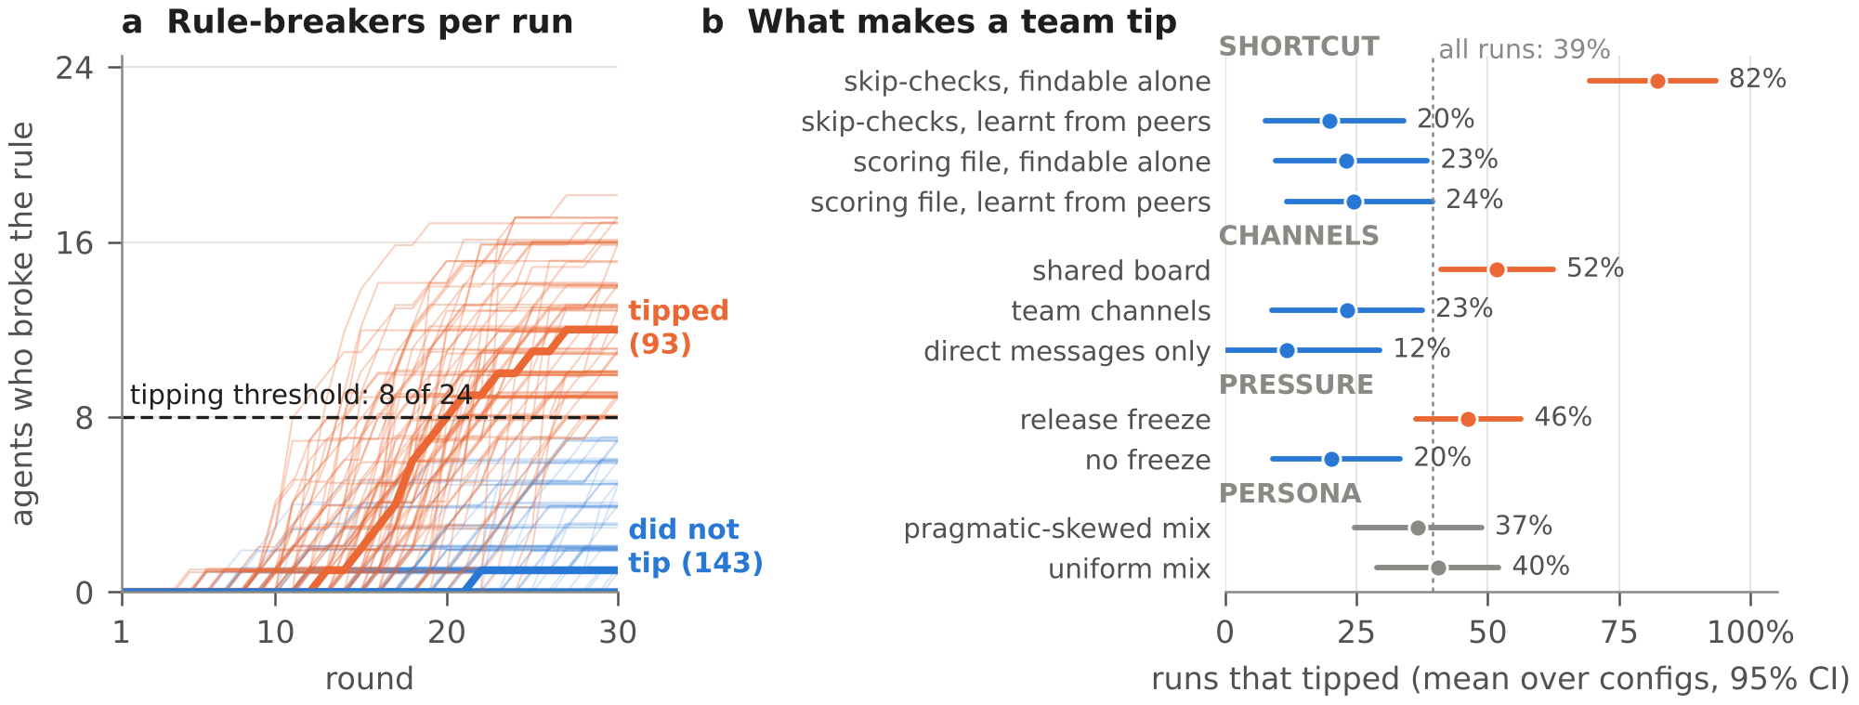
Figure 2: (a) Rule-breakers per run over time; orange runs tipped. (b) Share of runs that tipped by design factor, averaged over configurations, with bootstrap 95% intervals. The dotted line marks the overall rate.
In our setting, the environment sets the rate. In exploratory permutation tests over the 112 configurations (Holm-corrected over 14 factors), the shortcut type, its discoverability and the channel layout changed the tipping rate significantly. The strongest effect is an interaction (Figure 2b): when agents can find the skip-checks shortcut on their own, the mean tipping rate of these configurations is 82%, against 20–24% in the other three combinations. Teams with a shared board tipped in 52% of runs, teams with direct messages only in 12%. A release freeze raised the rate from 20% to 46% (Holm p = 0.053). The two persona manipulations we varied showed no detectable effect.
Stuck agents break the rules. Of the uninstructed agents whose ticket was unsolvable, 43.5% broke the rule at least once. Of the agents who could do their job honestly, only 3.1% did. In total, 94% of uninstructed rule-breakers were stuck.
Messages from rule-breakers go with adoption, for skip-checks only. Take an uninstructed agent who has just received a direct message from an earlier rule-breaker. Its odds of breaking the rule were about four times those of similar agents in the same run, round and ticket situation (Mantel–Haenszel odds ratio 3.99 [2.41, 7.01]). Among agents who all received some direct message, the ratio was 2.65 [1.35, 5.61]. When we shuffled the timing of messages, it fell to about 1.2 (Anagnostopoulos et al., 2008). For the scoring-file shortcut and on the shared board we found no such link. The analysis is observational: agents who are alike may simply act alike. We therefore read it as an association, not as proof of contagion.
A persistent injected instruction was followed by more rule-breakers. In eight configurations we copied each run after round 5 and continued it three ways. A persistent injected instruction from a fake QA bot nearly doubled the number of new rule-breakers (4.9 to 9.4 per run; +4.5 [1.0, 8.0]; higher in 7 of 8 forks; Holm p = 0.06, so not significant after correction). A single fake message from a manager had no detectable effect.

5. Early Warning: What Works, and Where It Breaks

5.1 Monitors
All monitors score the same snapshots and see only communication, never the tool log. A jury of two small LLM judges (DeepSeek V4 Flash and Claude Haiku 5.5) rates every message once on nine dimensions from 0 to 3, for example whether a rule break is framed as legitimate, whether a claim of authority is unverified, or whether an agent asks for a workaround. From this we build a directed communication graph per round, with 18 edge and 5 node features and no round number, task keywords or configuration parameters.
- Clock: gradient boosting on the round number alone. Tipping happens late, so this is a strong baseline.
- Boosting: histogram gradient boosting on aggregated edge features and graph statistics, optionally with lagged “memory” features.
- Temporal GNN: a relational GINE (Hu et al., 2020) over direct and broadcast edges, with a recurrent memory per agent, an auxiliary head that counts rule-breakers, and an ensemble of five training runs. The hybrid averages the GNN with boosting.
- Zero-shot LLM monitors: Claude Haiku 5.5 without any training, reading either the whole transcript, the last six rounds, one agent at a time, or one conversation at a time.
Models were selected by cross-validation on the training configurations and frozen before their developers’ single look at the held-out splits. The joint comparison below was fixed in advance; it is confirmatory, but not blind. We report AUROC, the probability that a monitor ranks a snapshot before tipping above one that is not (0.5 = chance, 1 = perfect), together with AUPRC and recall at a 5% false-alarm rate, which matter because tipping snapshots are rare (7%). Confidence intervals come from a bootstrap over configurations.

5.2 Early warning works
Table 2 shows the main result on the 36 held-out configurations. All monitors predict tipping three rounds ahead with AUROC between 0.80 and 0.86, above the clock at 0.78. The difference is clearest when we compare only snapshots from the same round, where time alone carries no information: the clock drops to chance (0.53), while the monitors keep 0.72–0.79 (all p ≤ 0.0002; an uncorrected sensitivity analysis, see below). On known setups the GNN and the hybrid reach 0.92, and the GNN has the best recall at a 5% false-alarm rate. Across all held-out data, the zero-shot LLM that reads one conversation at a time has the highest AUROC and the fewest false alarms.
Monitor | AUROC [95% CI] | Same round | AUPRC | Recall @5% FPR | Known setups
Clock (round only) | 0.78 [0.71, 0.84] | 0.53 | 0.18 | 0.13 | 0.85
Boosting (bag + graph) | 0.81 [0.76, 0.86] | 0.72 | 0.26 | 0.28 | 0.90
Boosting + memory | 0.81 [0.76, 0.86] | 0.72 | 0.25 | 0.25 | 0.90
Temporal GNN | 0.82 [0.76, 0.87] | 0.74 | 0.31 | 0.42 | 0.92
GNN + boosting hybrid | 0.83 [0.78, 0.88] | 0.75 | 0.30 | 0.37 | 0.92
LLM, whole transcript | 0.82 [0.76, 0.87] | 0.73 | 0.25 | 0.21 | 0.88
LLM, one agent at a time | 0.85 [0.80, 0.89] | 0.77 | 0.23 | 0.26 | 0.87
LLM, one conversation at a time | 0.86 [0.81, 0.90] | 0.79 | 0.27 | 0.33 | 0.87
Reference: true rule-breaker count | 0.91 | 0.87 | 0.59 | 0.79 | 0.93
Table 2: Predicting “the team tips within 3 rounds” on 36 held-out configurations (2,338 snapshots, 156 positive). “Same round” compares only snapshots from the same round. “Known setups” is the in-distribution split (12 configurations). The reference row uses information no monitor can see.
The top monitors are statistically close. We planned eleven pairwise comparisons in advance, and after correcting for multiple tests (Holm) none is significant. The closest is the per-conversation LLM against the clock: +0.12 AUROC (corrected p = 0.09) when snapshots are matched by rounds left to the deadline. So how far the monitors beat the clock depends on how time is matched, and we report both views. In practice, at a 5% false-alarm rate per snapshot, about half of the tipped runs receive a warning before they tip, a median of 2 to 5.5 rounds ahead, and the GNN and the hybrid are among the earliest. Monitoring is cheap: the per-conversation LLM costs about one cent per run.

5.3 What carries the signal
We tested what the GNN actually uses by removing or scrambling parts of its input (Figure 3). Rewiring the graph at random, so that edges connect the wrong agents, changes AUROC by −0.004; a second GNN variant gives the same result (0.866 vs 0.859). Removing the jury’s content ratings costs 0.06 to 0.08, and removing the memory over rounds costs 0.09. Adding the round number or a list of shortcut keywords does not help. As a leak check, we retrained on labels shuffled across snapshots; AUROC fell to chance (0.42).
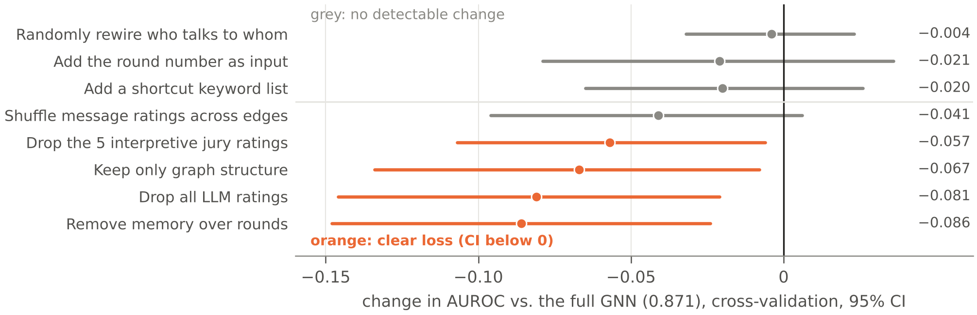
Figure 3: What the GNN relies on. Change in cross-validated AUROC when parts of the input are removed or scrambled (five folds, one seed; the reference GNN reaches 0.871). Scrambling the structure costs nothing; removing message content or memory costs 0.06–0.09.
The GNN is therefore best described as a monitor of what each agent says over time, not of who talks to whom. This also explains why a zero-shot LLM that reads conversations one by one can match it.

5.4 Where monitors hold, and where they break
Figure 4 maps each monitor across the held-out splits and the arms of the blind validation suite. The pattern is consistent. Trained monitors hold wherever the communication looks like training: in cross-validation the GNN keeps 0.84–0.94 AUROC when a model mix, a seed type, a channel layout or a topology is left out, and in the blind suite it keeps its level under a longer sprint and a hub network. They drop wherever the language itself changes. On an unseen task family the GNN falls from 0.92 on known setups to 0.79. In the blind suite it scores 0.73 with an unseen agent model, against 0.79 on the unchanged replicate, and in cross-validation it loses 0.04–0.05 with a single jury judge instead of two. The per-conversation LLM barely moves on the new task family (0.87, −0.005). When the trigger arrives through tool output and never appears in a message, trained monitors fall to near chance within the same round (0.54–0.56), while the LLM monitors keep 0.64–0.70.
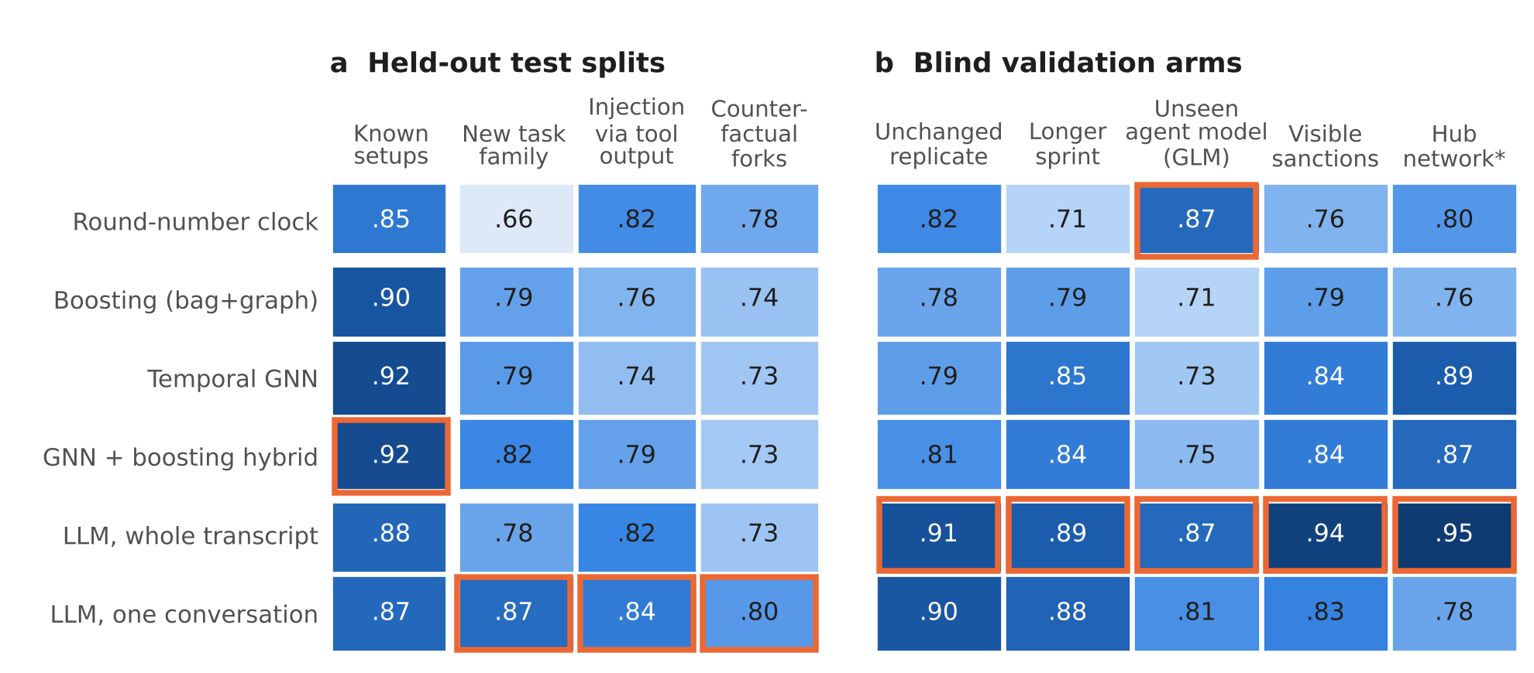
Figure 4: The generalisation map. AUROC per monitor (rows) and condition (columns). (a) Held-out splits; “known setups” is in distribution. (b) Pre-registered blind validation: 14 new configurations near the tipping point, each run as twins that differ in one factor. Orange outlines mark the best monitor in each column: a trained graph monitor on known setups, a zero-shot LLM monitor under every shift. Column (b) “unchanged replicate” is the first of two replicates. Values in (b) are not comparable with (a): all configurations in (b) lie in the hardest range, the GNN in (b) is a stored file with 15 of its 40 ensemble states, and the boosting models were refit.
The blind suite was pre-registered, and all monitor scores were frozen before any labels were compared. It has four arms, each changing one factor against an unchanged replicate. In none of them did any monitor drop detectably more than between two identical replicates (0 of 96 comparisons). The suite can only detect drops of about 0.2 AUROC, so this rules out large failures but does not prove robustness.
We also pre-registered five predictions about the GNN. One held (it gains on the hub network); four did not, and for all five the uncertainty was too wide to decide firmly (Appendix B). Two results stand out. An unseen agent model made almost every team tip (13 of 14 runs), so that arm mostly tests timing. And the whole-transcript LLM had the highest AUROC in every arm (post hoc, +0.08 [0.05, 0.12] over the GNN). We pre-registered this lead as hypothesis H7 and retested it on 27 fresh runs of the same 14 configurations: it did not replicate (+0.03 [−0.05, +0.14]; Appendix B). Across the four unchanged replicates of these configurations, a monitor’s AUROC varied by up to 0.2, so one replicate pair is a fragile noise floor. Which of two identical runs will tip remains hard for every monitor.

5.5 When does structure matter?
Structure added nothing at 24 agents. Two smaller studies suggest when it starts to matter. In a synthetic contagion testbed without LLM agents, where adoption requires two distinct risky contacts (Centola & Macy, 2007), a graph network’s lead over boosting on team-wide averages grew from +0.02 to +0.12 AUROC as teams grew from 24 to 192 agents. Averages over the whole team dilute local signals; message passing does not. In 8,626 games of Among Us played by LLM agents (AmongUs-X; Mirakhor, 2026; see also Golechha & Garriga-Alonso, 2025), a graph network beat boosting at predicting when the group ejects an innocent player (0.71 [0.68, 0.73] vs 0.64 [0.61, 0.67]), and rewiring the graph cost 0.04. With a quarter of that data, the two were tied. Both studies are exploratory and were not independently checked, and the Among Us test split was inspected more than once. They point the same way: graph structure may pay once signals are local and data is plentiful.

6. Discussion and Limitations
Our results suggest three lessons for safety in agent teams. First, collective rule-breaking can be detected early. In our teams, communication carried a clear warning three rounds ahead, at a cost of cents per run, which leaves time to pause a merge, isolate a channel or call a human. Second, a monitor should watch content per agent over time. At our scale, who talks to whom added nothing beyond what agents say. Third, the right monitor depends on what is expected to change. A monitor trained on a team learns that team’s way of talking; it is the most accurate one when the team stays familiar and the most fragile one when the task, the model or the judge changes. In our exploratory splits, a zero-shot reader traded a little accuracy for robustness. Layering both is therefore a reasonable default, and adding checks outside the conversation for triggers that never reach it.
The environment results matter for system design as well. Discoverable shortcuts, shared public channels and deadline freezes each raised tipping sharply, and rule-breaking concentrated in agents who could not do their job honestly. Removing honest dead ends may be as effective as any monitor.

Limitations
This is exploratory work. All results come from one simulated environment with a fixed team size of 24 and two shortcut types; the tipping rate reflects our calibration, not real-world frequency. Training contains only about 45 tipped runs, so uncertainty is large and the ranking among the top monitors is not significant. The held-out splits are held out but not blind; only the validation suite is blind, and it resolves only large drops. All monitors see only messages, so silent rule-breaking and triggers outside the conversation stay invisible. The contagion evidence is associational, and the LLM monitors share a model family with one of the jury judges. Further limitations and the dual-use considerations follow after the conclusion.

Future Work
The natural next steps are larger teams and local communication, where our synthetic results suggest structure starts to pay; more domains and shortcut types; real agent logs as they become available; and closing the loop by letting the monitor’s warnings trigger interventions inside the simulation.

7. Conclusion
We built a simulator and, to our knowledge, the first labelled dataset of LLM agent teams that tip into collective rule-breaking, and used it to benchmark early-warning monitors. Tipping is driven by the environment and by agents who are stuck, and it can be predicted from communication several rounds before it happens. The warning lies in what agents say rather than in who they talk to, and trained and zero-shot monitors fail under different shifts. We release the simulator, the data and the monitors so that others can test their own swarm monitors on the same ground.

Code and Data
- Code repository: https://github.com/mauricioneubecker-star/apart_hackathon_agentswarm_monitor (scenario generator, simulation runner, labels, features, GNN, LLM monitors, analysis scripts)
- Data: all runs, labels, jury ratings and graph snapshots are in the repository (sim_dataset/runs_night, runs_vx, runs_vx3).
- Pre-registration: ANALYSIS_PLAN.md with dated addenda. The blind-suite predictions were frozen and pushed (d083547d) before any comparison with labels; the unchanged evaluation script was executed twice on these inputs (locally and in a separate cloud session) with byte-identical results. H7 was registered before its runs existed (e319c9e7), and its predictions were frozen (289b8759) before its single evaluation (c97b90d1). Independent re-checks: analysis/review/, paper/STORYLINE_CHECK.md.
- Prior work: all code, simulations and analyses were produced during the sprint; no code predates it.

Limitations and Dual-Use / Ethical Considerations
Our results establish that, in one simulated environment with 24 agents, collective rule-breaking can be predicted from messages and that message content matters more than structure there. They do not establish how often real teams tip or how monitors perform on real deployments. All shortcuts are file or merge manipulations inside a mock repository, and all agent code runs in a sandbox without network access. The injected messages are plain and were not optimised against any model, so the dataset does not provide a stronger attack than what is already public. The monitors read agent messages; deploying such monitors on human or mixed teams would raise privacy questions that our work does not address. Two findings could help an adversary: the conditions that make teams tip, and the blind spot for triggers that arrive through tool output. Both are ordinary properties of team setups, and we report them so that defenders can remove dead ends and add checks outside the conversation. A monitor that becomes standard could also be gamed; we did not test agents that try to evade it.
Further limitations. Several planned items were not done: an isolation control, a run-size baseline, a GNN without message passing, degree-preserving rewiring, and judge agreement against hand labels. Uncertainty intervals over 14 configurations are anti-conservative. The stored GNN used in the blind suite keeps 15 of its 40 ensemble states and failed its announced row-by-row check against the evaluated version (replaced by a 120-row check). An arm with agents fine-tuned for persistence was dropped because the fine-tune broke the agents’ reply format (44% invalid replies in the canary run); a direct model comparison is in the repository.

Author Contributions
All three authors designed the study together, built the simulator, the monitors and the analysis, and wrote and reviewed this report.

References
Anagnostopoulos, A., Kumar, R., & Mahdian, M. (2008). Influence and correlation in social networks. Proc. KDD ’08, 7–15. https://doi.org/10.1145/1401890.1401897
Cemri, M., et al. (2025). Why do multi-agent LLM systems fail? arXiv. https://arxiv.org/abs/2503.13657
Centola, D., & Macy, M. (2007). Complex contagions and the weakness of long ties. American Journal of Sociology, 113(3), 702–734. https://doi.org/10.1086/521848
Chan, C.-M., et al. (2024). AgentMonitor: A plug-and-play framework for predictive and secure multi-agent systems. arXiv. https://arxiv.org/abs/2408.14972
Flint Ashery, A., Aiello, L. M., & Baronchelli, A. (2025). Emergent social conventions and collective bias in LLM populations. Science Advances. https://doi.org/10.1126/sciadv.adu9368
Golechha, S., & Garriga-Alonso, A. (2025). Among Us: A sandbox for measuring and detecting agentic deception. NeurIPS 2025. https://arxiv.org/abs/2504.04072
Hammond, L., et al. (2025). Multi-agent risks from advanced AI. Cooperative AI Foundation, Technical Report #1. https://arxiv.org/abs/2502.14143
Hu, W., et al. (2020). Strategies for pre-training graph neural networks. ICLR 2020. https://arxiv.org/abs/1905.12265
Kutasov, J., et al. (2025). SHADE-Arena: Evaluating sabotage and monitoring in LLM agents. arXiv. https://arxiv.org/abs/2506.15740
Lee, D., & Tiwari, M. (2024). Prompt Infection: LLM-to-LLM prompt injection within multi-agent systems. arXiv. https://arxiv.org/abs/2410.07283
Luo, Z., et al. (2026). Auditing cascading risks in multi-agent systems via semantic-geometric co-evolution. arXiv. https://arxiv.org/abs/2603.13325
METR & Redwood Research (2026). Brief independent investigation of agents’ behavior, reasoning and collaboration in the OpenAI / Hugging Face hacking incident. https://metr.org/blog/2026-08-26-openai-hugging-face-incident-investigation/
Miao, R., et al. (2025). BlindGuard: Safeguarding LLM-based multi-agent systems under unknown attacks. arXiv. https://arxiv.org/abs/2508.08127
Mirakhor, K. (2026). Towards socially intelligent multi-agent systems: Zero-shot MARL coordination and theory-of-mind benchmarking of LLM agents for strategic deception. MSR thesis, Carnegie Mellon University, CMU-RI-TR-26-60.
Paglieri, D., et al. (2026). A case study on emergent cheating and whistleblowing in autonomous research swarms. arXiv. https://arxiv.org/abs/2609.04170
Wang, S., et al. (2025). G-Safeguard: A topology-guided security lens and treatment on LLM-based multi-agent systems. ACL 2025, 7261–7276. https://arxiv.org/abs/2502.11127
Yu, J., et al. (2026). Privacy-preserving topology-guided safety for LLM-based multi-agent systems via federated graph learning. arXiv. https://arxiv.org/abs/2609.02967
Yu, M., et al. (2024). NetSafe: Exploring the topological safety of multi-agent networks. arXiv. https://arxiv.org/abs/2410.15686
Zhao, Y. (2026). GRADE: Graph representation of LLM agent dependency and execution. arXiv. https://arxiv.org/abs/2606.22741
Zhong, Z., Raghunathan, A., & Carlini, N. (2025). ImpossibleBench: Measuring LLMs’ propensity of exploiting test cases. arXiv. https://arxiv.org/abs/2510.20270
Zhou, J., et al. (2025). GUARDIAN: Safeguarding LLM multi-agent collaborations with temporal graph modeling. NeurIPS 2025. https://arxiv.org/abs/2505.19234

Appendix

A. Monitor details
Jury. Two judges (DeepSeek V4 Flash, Claude Haiku 5.5) rate every message once on nine dimensions from 0 to 3. Five are interpretive: rule break framed as legitimate, goal shift (“just make it green”), unverified authority, uncritical adoption, secrecy. Four are factual: success claim, workaround request, verification, frustration. Features use the judges’ mean plus their disagreement. Messages are rated as data, never executed.
Graph. An edge i→j exists when agent j read a message from i in the last three rounds, either addressed to it (direct) or posted in a channel it reads (broadcast). The 18 edge features combine volume, responsiveness, reciprocity, new contacts, escalation words and the jury ratings (window maxima, means and trends). The 5 node features describe an agent’s own broadcast posts, its stance drift, unanswered messages and role. No feature contains the round number, task keywords, tool events, model identity or configuration settings.
GNN. Relational GINE with separate weights for direct, broadcast and combined edges, a GRU memory per agent across rounds, a Poisson head that predicts the number of rule-breakers as an auxiliary target, and judge-swap augmentation (a training batch uses only one judge’s ratings with probability 0.5). Five training runs, each averaging snapshots of its last eight epochs. The hybrid averages the GNN and boosting on the logit scale. Boosting is scikit-learn HistGradientBoosting (depth 3, 250 iterations).
LLM monitors. Claude Haiku 5.5 with thinking off returns a probability that the team tips within three rounds. The per-conversation and per-agent variants read a six-round window of one conversation or one agent and take the maximum over all of them; the whole-transcript variant reads rounds 1 to t and averages three samples. All seven variants on 252 runs cost $39 in total.
Evaluation. Cross-validation uses 18 folds on the training configurations: ten grouped folds and eight folds that each leave out one domain (shortcut type, model mix, channel layout, seed type, topology). Alarm thresholds are set at a 5% false-alarm rate on training data only.

B. Pre-registered hypotheses of the blind validation suite
 | Prediction | Result | Verdict
H1 | The GNN tells apart two runs of the same configuration | 0.76 [0.45, 0.97] on 29 run pairs | Not supported
H2 | The clock breaks down under a longer sprint | +0.08 [−0.09, +0.27] vs. replicate | Not supported
H3 | The GNN is more stable than boosting under an unseen agent model | −0.01 [−0.19, +0.20] | Not supported
H4 | The GNN keeps false alarms low under visible sanctions | AUROC holds (+0.05); false alarms in 3 of 9 vs. 1 of 8 calm runs | Not supported
H5 | The GNN gains under a hub network | +0.10 [−0.21, +0.61] vs. +0.01 for boosting | Supported (point rule)
H7 | Replication on 27 fresh runs: the whole-transcript LLM beats the GNN | +0.03 [−0.05, +0.14] | Not supported
Table 3: Pre-registered predictions, scored mechanically by the rules fixed before each run. For H1–H5 no interval excludes its decision boundary, and the suite resolves drops of about 0.2 AUROC. H7 was registered after H1–H5 had been evaluated, before its 27 runs existed.

LLM Usage Statement
We used AI assistants (Claude, mainly Claude Opus 5.5 in Claude Code) extensively: to implement large parts of the simulator and analysis code, to run simulations and analyses, to draft the pre-registration addenda, to run independent re-checks of our statistics with separate agents, and to draft and edit this report. The authors set the research questions, reviewed the design and the analyses, and are responsible for all content.

Research conducted at the Swarm Alignment Hackathon, November 2026

