ML Classification Assignment

# Introduction

Cross-selling is a common selling practice in which addittional products or services are offered to current customers. In this assignment you will use Machine Learning techniques on client of an insurance company that has suscribed a health insurance in order to predict if they could be interested in a vehicle insurance provided by the same company.

# Dataset Description

You will receive two datasets containing a list of clients with their personal and commercial information.

There is a total of 102351 records and 12 explanatory variables divided into two datasets.

• model.csv: the dataset contains the information of 102351 client with the respective target variable. You must use this data to create and evaluate your model.

• predictions.csv: the dataset contains the information of 45196 clients without the target variable. You are requested to provide the predictions for this set of records.

The task is formulated as a binary classification. Your grade will be based on the F1-score metric and on the modeling process presented in the report.

## Target Class:

The target attribute is binary: 1 – the customer is interested , 0 – the customer is not interested.

## Attribute Information:

|  |  |  |  |
| --- | --- | --- | --- |
| **n** | **Attribute** | **Type** | **Values** |
| 1 | id | numerical | ID for the customer |
| 2 | Age | numerical | Age of the customer |
| 3 | gender | categorical | Gender of the customer |
| 4 | Driving_Licence | categorical | 0 : Customer does not have a driver licence,  1 : Customer already has driver licence |
| 5 | Licence_Type | categorical | Driver licence class |
| 6 | Region_Code | numerical/categorical | Unique code for the region of the customer |
| 7 | Previously_Insured | categorical | Customer already has Vehicle Insurance |
| 8 | Vehicle_Age | categorical | < 1 Year, 1-2 Year, >2 Year |
| 9 | Vehicle_Damage | categorical | 1 : Customer got his/her vehicle damaged in the past.  0 : Customer didn't get his/her vehicle damaged in the past. |
| 10 | Annual_Premium | numerical | The amount customer needs to pay as premium in the year |
| 11 | PolicySalesChannel | numerical/categorical | Anonymized Code for the channel of outreaching to the customer ie. Different Agents, Over Mail, Over Phone, In Person, etc. |
| 12 | Seniority | numerical | Number of Days, Customer has been associated with the company |
| 13 | Target | categorical | 1 : Customer is interested, 0 : Customer is not interested |

### Submission Instructions

**1. Model Training Data Release: 12 March 2021, 20:00.**

**2. Description of analysis on the training set and model identification: 16 March 2021 20:00.**  
 You are asked to kindly send an email with the following supporting information:

a) A **brief report** of the step-by-step methodology (i.e. pre-processing, visualization, training, testing, etc.) that you have followed to develop your model, this document must illustrate the motivation behind your selected approach.

• File Format: .pdf • Filename: surname1_surname2_surname3.pdf (e.g. orsenigo_soto.pdf)

b) **The commented python code** that you used in your model. Comments in the code must ensure that the code is easy to follow.

• File Format: .ipynb, .py • Filename: surname1_surname2_surname3 (e.g. orsenigo_soto.ipynb or orsenigo_soto.py)

**3. Prediction Data Release: 19 March 2021 20:30.**

**4. Prediction Submission: 21 March 2021 20:00.**

You are kindly requested to strictly follow the described submission guidelines:

• File Format: .csv

• Filename: surname1_surname2_surname3 (e.g. orsenigo_soto.csv)

• Column Format: **A single** column named “target”

• Row Format: Your predictions (0 or 1) with **the same number of rows** and in the same order as the **prediction** test set.

Example:

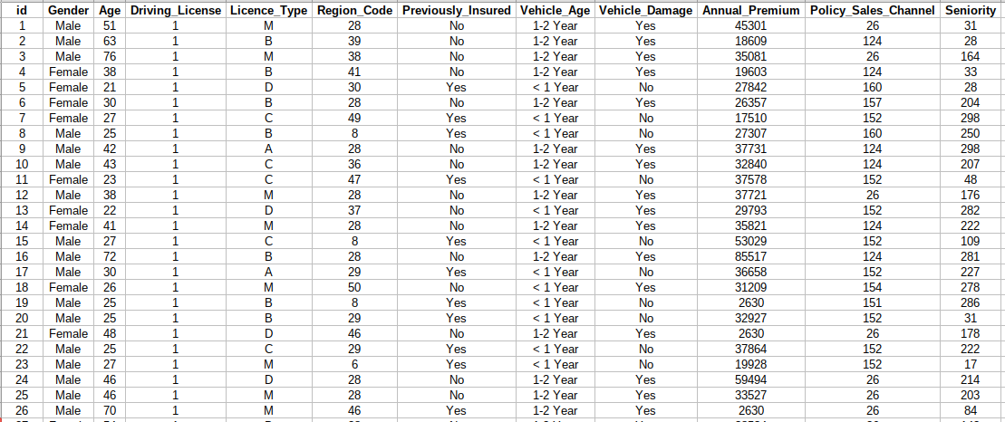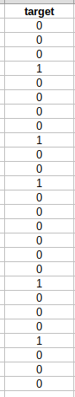

### 

### 

### 

### 

### 

### Further Instructions

• **Any submission that does not respect the guidelines (submission after deadline, empty file, wrong student code) will not be graded**.