Classification: Predicting survival in patients after myocardial infarction

# Introduction

**All the patients in the dataset suffered heart attacks at some point in the past.** Some are still alive and some are not. The problem addressed by past researchers was to predict from the other variables whether or not the patient will survive at least one year.

**Myocardial infarction** (**MI**) or **acute myocardial infarction** (**AMI**) occurs when blood flow stops to a part of the heart causing damage to the heart muscle.

Most MIs occur due to coronary artery disease. Risk factors include high blood pressure, smoking, diabetes, lack of exercise, obesity, high blood cholesterol, poor diet, and excessive alcohol intake, among others.

Blockages on the **left side** of your heart are usually **more dangerous**

The AHA (America Heart Association) has divided the muscle and cavity of the left ventricle in 17 segments:

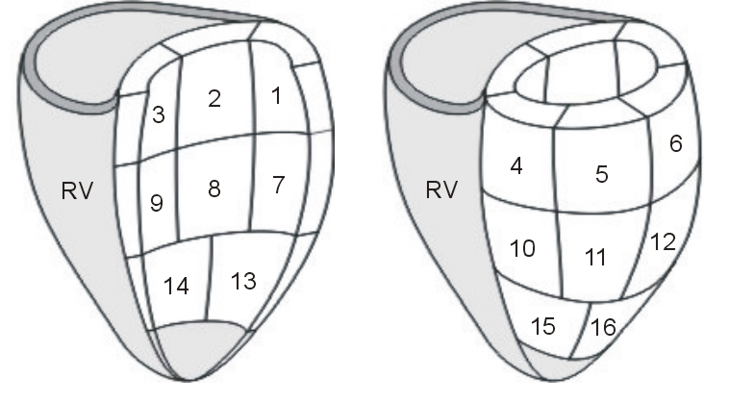

An **echocardiogram is an ultrasound of the heart**. It can make an assessment of the blood flowing through the heart

## Target Class:

## Attributes Information:

**Area**: where the patient lives.

**Age:** age of the patient

**Shortening** **fraction**: measures **change ratio in the diameter of the left ventricle** between the contracted and relaxed states-:

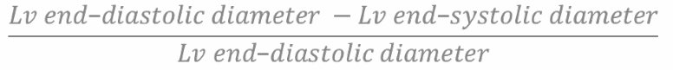

LV=left ventricle, diastolic=relaxed, systolic=contracted.

**Above 30% is considered normal**, with **26% to 30%** representing a **mild decrease** in function.

**Atrial dimension of the LV:** measured at the end-systole when the LA chamber is at its greatest dimension.

|  |  |  |  |  |
| --- | --- | --- | --- | --- |
| LA dimensions | Normal | Mildly dilated | Moderately dilated | Severely dilated |
| Diameter (mm) | 28-40 | 41-46 | 47-52 | >52 |

**Wall motion score sum:** is the sum of the wall motion score for each segment visualized. Each segment is scored on the basis of systolic thickening and motion.

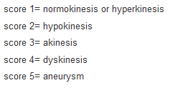

**Wall motion index:** sum of wall motion score divided by the number of observed segments. If >1.30 identifies patients with substantial infarction.

**Hematocrit:** the ratio of the volume of red blood cells to the total volume of blood. If the number of red blood cells is too high, the blood will be more dense (viscous) and circulate more slowly. A normal value is between 37% and 42%.

**Pericardial effusion:** abnormal accumulation of fluid in the pericardial cavity. Sometimes it can make the heart work poorly.