# INSTALLING ANACONDA - PYTHON

1. Go to [Anaconda download website](https://www.anaconda.com/products/individual). At the end of the page you will find the download links:

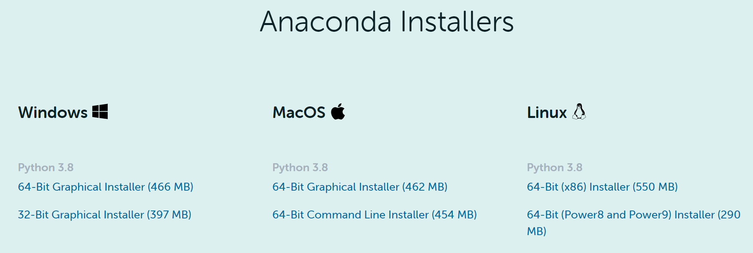

1. Choose the Python Installer for your operating system (Windows, macOS or Linux).   
   Pay attention to choose the right 64-Bit or 32-Bit version of the installer.
2. Locate your download and double click it.
3. Go through the installation steps leaving default options set. Read the license agreement and click on **I Agree**.

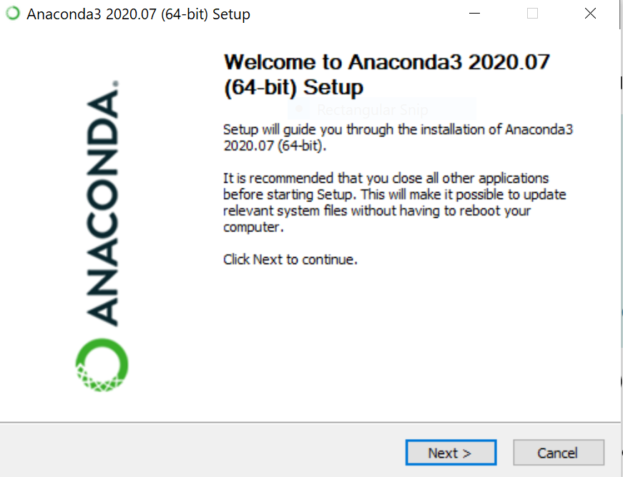

1. When requested, choose to check the box to register Anaconda as default Python 3.8 (recommended approach).
2. TEST YOUR INSTALLATION – Open an **anaconda prompt** instance and type   
   **conda --version** and then **python --version**  to check if the installation ended successfully.

If you require any further information about the installation procedure, see [link](https://docs.anaconda.com/anaconda/install/).

# INSTALLING ORANGE

Orange is an interactive data analysis tool that allows you to create simple Machine Learning models using a graphical interface. Orange is based on Python, so if a Python distribution (such a Anaconda) is already installed, you can install the tool within Python, otherwise it can be installed as a stand-alone application.

OPTION 1. Install Orange as a Anaconda application

1. Open the **Anaconda Navigator** application:

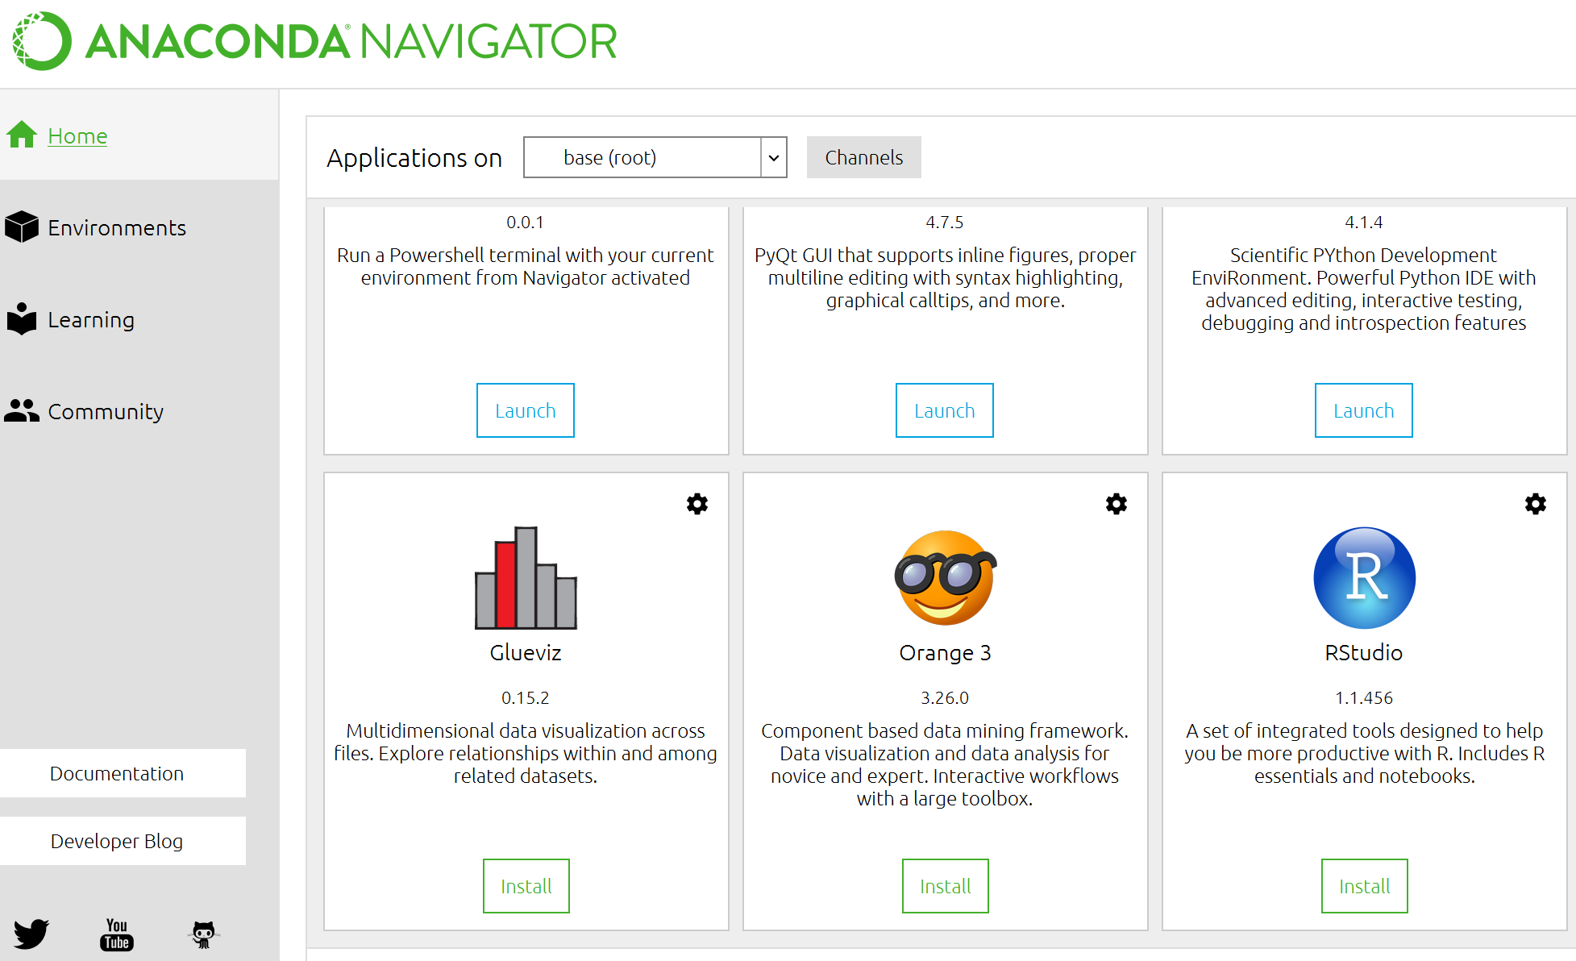

1. Intall Orange from the list of applications (it could take several minutes).

OPTION 2. Install Orange as a Python package

In Python you can install Orange by running the following command at the prompt:

**pip install orange3**

For more information about the installation procedure, go to the folowing link:

https://orange.biolab.si/download/

OPTION 3. Install Orange as an external application

You can follow the instructions in the following video: <https://youtu.be/XDdi978Xk7Y?t=18>

1. Go to the [Orange download page](https://orange.biolab.si/download)

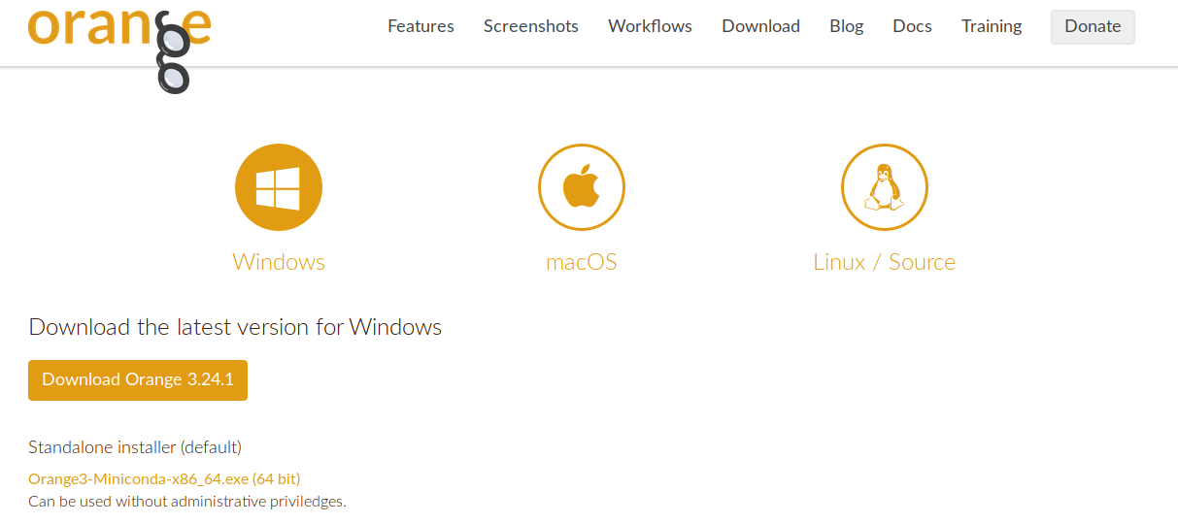

1. Select your operating system and click on Download
2. Go to your download folder
3. Run the installation file (Orange3-*.exe)
4. Follow the installation process
5. You can choose whether the tool is installed for the current user or for all users on your computer
6. You can choose the destination folder for the tool (please verify that you have enough space in your hard disk)
7. You can use the tool by opening the **orange-canvas** application