We have used a New Keynesian model with price stickiness and information frictions.

In fact, when the agent selects the price of his good and, thus, his target for labor, he doesn’t know the value of the money transfers (the realization of the shock of tau is not known yet) but tries to forecast it according to the process followed by tau.

We have assumed that tau and g follow two AR(1) process:

Thus, given the value of , the forecast for is , while the forecast for is , since the expected value of each shock is zero.

The value of the labor target in each period is. As we can see, a greater expectation of future growth rate of money implies a reduction of the labor target, because the expected loss of purchasing power increases reducing the incentive to work. Moreover, also the structure of the competition affects labor: the greater the market power (the lower ) is, the lower the target of labor is.

The realized labor is , so, when the agent is surprised positively (I.E. the realized growth rate of money is greater than its expectations), he will work more than his target, otherwise, when he is surprised negatively, he will work less.

I have conducted a Monte Carlo simulation (simulating the model 1000 times), to compute the statistics of model and their distributions.

The results are very sensible to the assumptions made on the characteristics of the process followed by the growth rate of money.

Setting and , we get the following results:

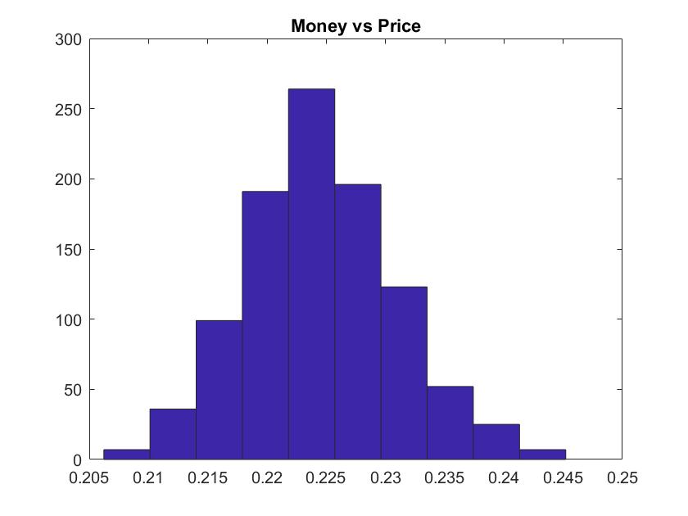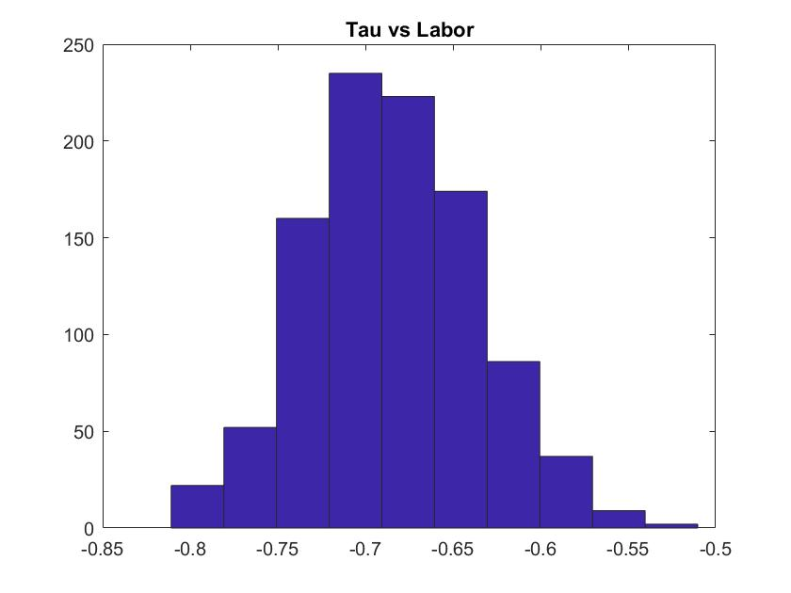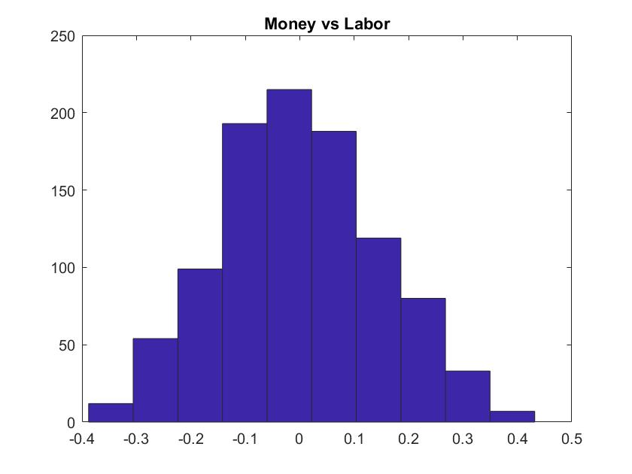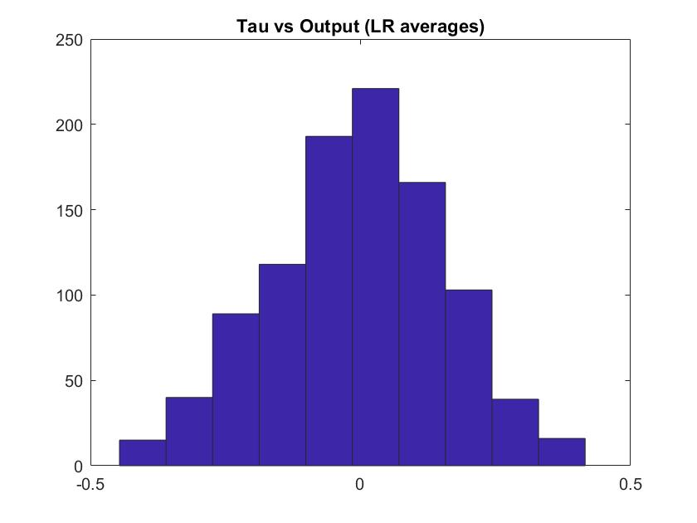

The correlation between Money and Prices is positive with mean 0.2246

The correlation between Tau and Labor is negative with mean -0.68

The correlation between Money and Labor and the one between LR averages of Tau and Output follows a bell shaped distribution around 0

Setting and , we get the following results:

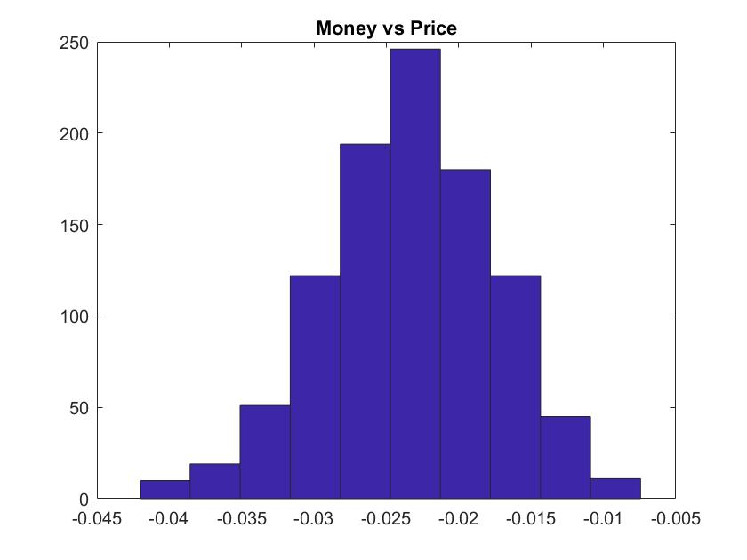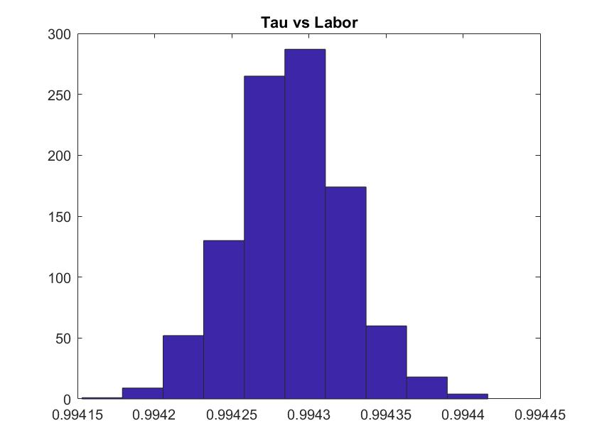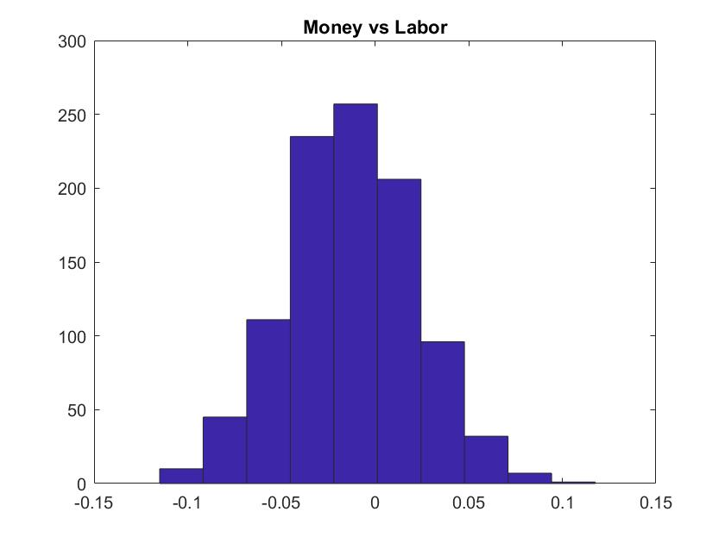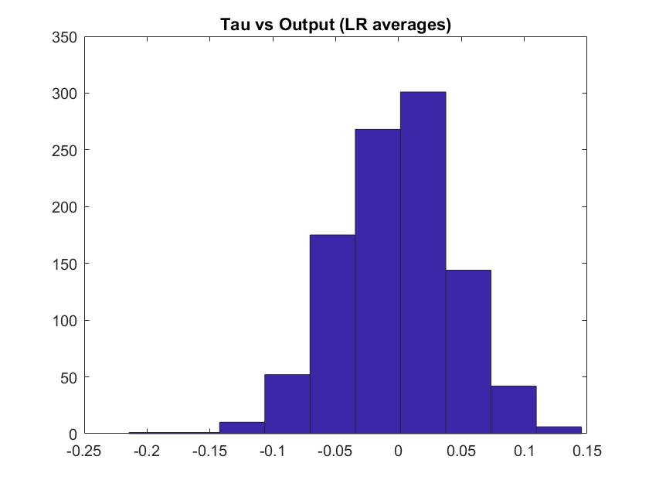

The correlation between Money and Labor and the one between LR averages of Tau and Output are still distributed around 0.

Whereas, the correlation between Money and Prices is now really low and negative (mean=-0.234)

The correlation between Tau and Labor is now very close to 1. This is due to the fact that, reducing the persistence of Tau, the “surprise” effect (generated by the stochastic component) dominates the expected loss of purchasing power effect (due to the anticipated component of Tau)

In exercise 17, I have considered three different levels for the mean of the growth rate of money (0.02; 0.06; 0.10). Consequently, for any realization of the shock of tau, the realized tau and, thus, the labor target and the realized labor effort will differ accordingly to the mean of tau considered.

In particular, for any given realized shock, the higher the mean of the process, the higher the value of the realizes growth rate will be, and consequently the lower the labor target. As a matter of facts, a higher mean implies higher realized values and higher expectations of the future values. This results in a higher expected loss of purchasing power and reduces the labor target. Consequently, also the realized labor effort will be reduced.

For every mean of the process considered, I plotted the scatter plot of the growth rate of money supply and the labor effort, which is the equivalent of the Philipps Curve in our New Keynesian model.

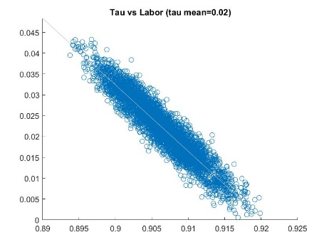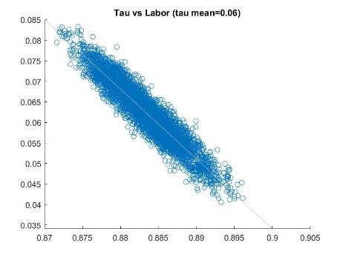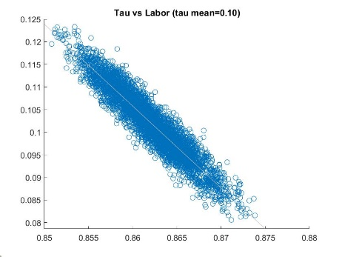

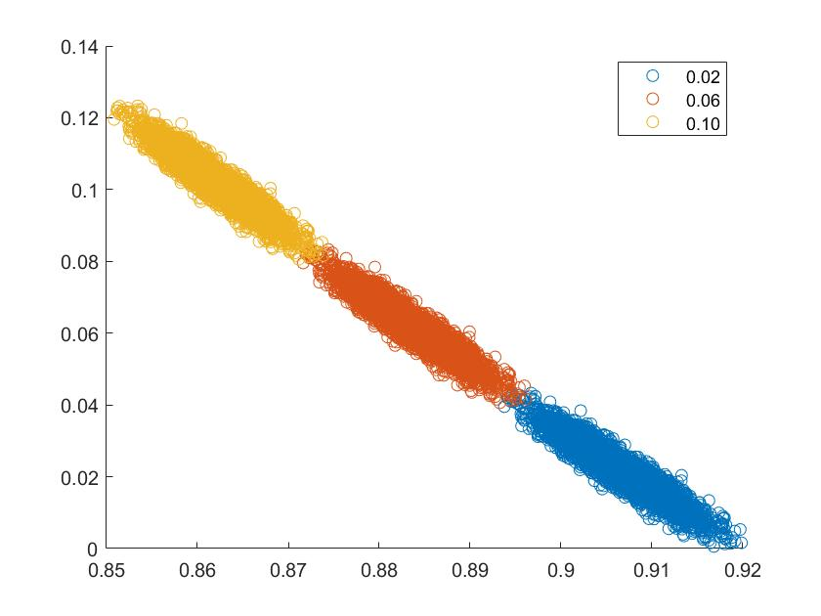

As we can see, an higher mean of growth rate of money implies higher realized growth rate of money and lower labor efforts.

Finally, I plotted the scatter plot of the shocks against the labor efforts under the three different means. Again, we can see how for any given shocks the lower the value of the mean of the growth rate of money is, the higher the realized labor is.

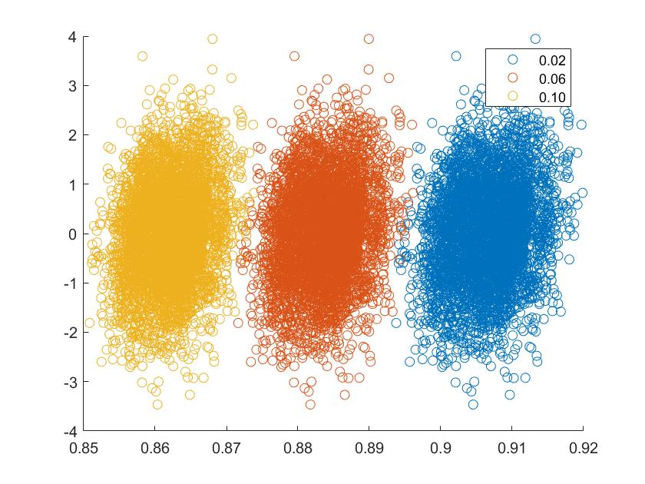

From this analysis, we can get interesting insights on the trade-off faced by the central banks when deciding the growth rate of money. In particular, they have to compare a short term benefit of increasing the Money supply more than what the agents expect (in the model, this is represented by a positive shock), increasing labor, with the long term of cost of doing it (higher expected growth rate of money, due to the persistence of tau (which follows an AR(1)), that decreases future labor). Moreover, if the agents are surprised positively for many periods, they will adjust the way the do forecasts for the future. Increasing the mean of the AR process is a way to incorporate in the model this increase in the expectations. As agents adjust their forecast, the realized growth labor is decreased.