**1.**

The Representative agent maximizes its welfare solving the following problem:

$$maxW={α\frac{c^{1-ρ}}{1-ρ}}+(1-α)ln⁡(1-h)$$

s.t. $c=w*h*\left(1-τ\right)+a+λ$, where $a=k*r=r$ (since $k=1$)

Imposing the derivative w.r.t h to be equal to zero we get the FOC that solves the maximization problem: $U_{1}\left(w*h*\left(1-τ\right)+a+λ\right)*w*\left(1-τ\right)=V_{1}(1-h)$

$$α {\left(w*h*\left(1-t\right)+r+λ\right)}^{-ρ}*w*\left(1-τ\right))=\frac{1-α}{1-h}$$

When all the government revenues are rebated back to individuals, that is when $λ=τ*w*h$, the FOC becomes:

$$α {\left(w*h+r\right)}^{-ρ}*w*\left(1-τ\right))=\frac{1-α}{1-h}$$

The firm maximizes its profit solving the following problem:

$\max{}π=y-r*k-wh$ where $y=k^{θ}*h^{1-θ}$

Thus, the FOC for the firm w.r.t. k will be $\frac{∂F\left(k,h\right)}{∂K}=r$, thus $r=θ*k^{θ-1}*h^{1-θ}$ = $θ*h^{1-θ}$ and the FOC w.r.t to h will be $\frac{∂F\left(k,h\right)}{∂h}=w$, thus $w=(1-θ)*k^{θ}*h^{-θ}=(1-θ)*h^{-θ}$

Substituting those values for w and r in FOC of the RA we get

$α {\left(\left(1-θ\right)*h^{-θ}*h+ θ*h^{1-θ}\right)}^{-ρ}*\left(1-θ\right)*h^{-θ}*\left(1-τ\right)=\frac{1-α}{1-h}$

$α {\left(h^{1-θ}\right)}^{-ρ}*\left(1-θ\right)*h^{-θ}*\left(1-τ\right)=\frac{1-α}{1-h}$ (*)

It is worth noticing that $w*h+r*k=\left(1-θ\right)*h^{-θ}*h+ θ*h^{1-θ}=h^{1-θ }=y=F(k,h)$, which is consistent with the Euler’s theorem $F\left(k,h\right)=\frac{∂F\left(k,h\right)}{∂K}*k+\frac{∂F\left(k,h\right)}{∂h}*h$. Consequently, in equilibrium, the firm makes no profit and, when resources are not taken away from the economy by the government, the consumption is equal to the total output.

**2*.*** *(script GE.m)*

Solving numerically the equation (*) through the Walras algorithm, the obtain solution for the labor effort is $h=0.2481$. (the algorithm checks if there are corner solutions(h=hmax if mbl(hnmax)>mcl(hmax), h=hmin if mbl(hmin)<mcl(hmin))

Thus, the GDP will be ${y=h^{1-θ}=0.2481}^{1-0.3}=0.3769$ and the transfers payment will be $λ=τ*w*h=0.3*1.0635*0.2481=0.0791$ where w is the wage, that is equal to the marginal productivity of labor ($w=\left(1-θ\right)*h^{-θ}=\left(1-0.3\right)*{0.2481}^{-0.3}=1.0635$

*Objective function*

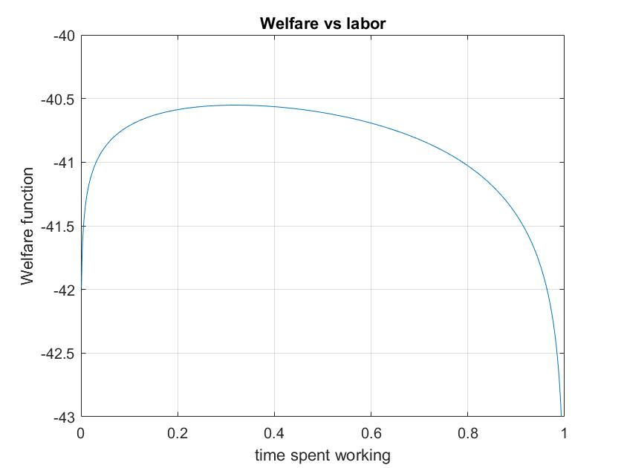

**3.** *(script giftforamericans.m)*

-a Since it is assumed that the increase in the tax rate won’t affect the labor effort, the tax rate must be doubled, in order to table the transfers.

The new tax rate will be $τ2=2*τ=0.6$

-b The new fiscal regime discourages the labor supply. (increasing the tax rate generates a greater negative substitution effect that reduces the labor effort)

The new level of labor effort will be $h2= 0.1590$, while the new level of transfers will be $λ2=τ2*w2*h2=0.159<2*λ$.

The GDP will be ${y2={h2}^{1-θ}=0.159}^{1-0.3}=0.2761$. The new fiscal regime has decreased the output.

To check if the program is feasible, I computed the level of transfers with different of the tax rate.

The algorithm could work only with tax rates smaller than 0.77, but, plotting the level of transfers vs the tax rate, it can be noted that the level of transfers is a monotone function of the tax rate which reaches its peak around 0.6. Thus, we could focus on the [0.0.77) interval without worrying about the missing values. Then, I compared the maximum level of the transfers when tau is between 0 and 0.77 with the initial level of transfers. Since the maximum value obtained is smaller than the initial value multiplied by 2, I concluded that the program is not feasible

-c the compensating variation of the consumption under the 2nd tax policy regime to make the RA indifferent between the 2 regimes is $ε=0.1562$ (the program makes the individuals worse off)

*Transfers vs tax rate*

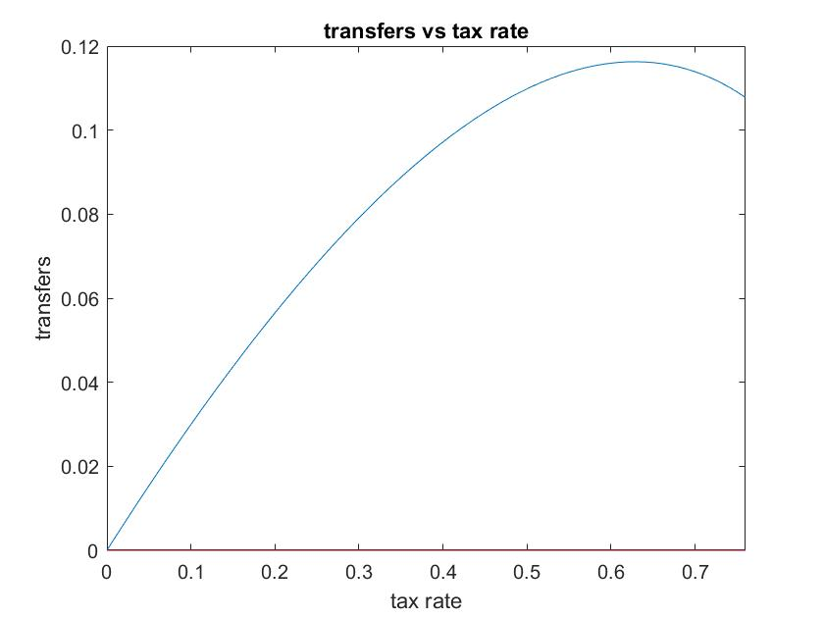

**4.** *(script publicspending.m)*

In the last part I computed the outcomes (labor supply, GDP, welfare), when the government uses the money raised through taxes to fund public expenditures (such as the construction of a statue)

When the government extracts resources for the economy the labor supply will be affected by both a negative substitution effect (caused by the taxes that, holding the labor effort, reduce the marginal benefit of labor) and a negative income effect (caused by the reduction of resources available that makes the individual poorer and, therefore, more willing to work)

Then, I computed the outcomes when there is no public intervention and the behavior of the RA is not distorted.

The labor effort under no intervention is the solution to the following nonlinear equation:

$U_{1}\left(w*h+a\right)*w=V_{1}(1-τ)$

$$α {\left(w*h+r+\right)}^{-ρ}*w=\frac{1-α}{1-h}$$

The solution for the labor effort is $hnoint=0.3199$

Therefore, the GDP will be $y=h^{1-θ}={0.3199}^{1-0.7}=0.4503$ and the welfare will be $W=0.9853$

Finally, I compared the labor effort under no intervention with the labor effort prevailing when the tax rate is 0.3 and all the government revenues are used to fund public spending.

When the individual is taxed and taxes are not rebated back through transfers the individual will be affected by both a negative I.E. that stimulates him to work more and a negative S.E. that prevents him from working. Consequently, when the I.E. dominates the S.E., the individual will work more than when there is no intervention, however when the S.E. dominates the I.E., the individual will work less.

When $τ=0.3$ and $λ=0$ the prevailing labor effort is $hnotransfers=0.2948<hnoint$.

Thus, in this situation, the S.E. dominates the I.E. and the agent work less.