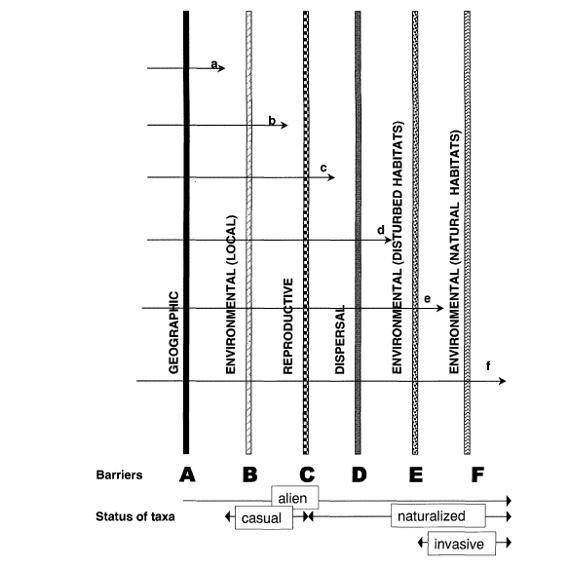
Figure S1. The schematic representation of major barriers limiting the spread of introduced plants proposed by Richardson et al. [S1]. Arrows indicate the paths followed by taxa to reach different states from introduced (arrow a) to invasive in natural vegetation (arrow f). A native species becomes an alien once it overcomes the barrier of geography (Barrier A) that separates its native range from a new geographic area (i.e. it is dispersed with the assistance of humans, intentionally or accidentally, beyond the normal limits of its ability to disperse). Such a species might become a naturalized alien, if it overcomes (largely abiotic) barriers to growth and survival (Barrier B), and then can deal with (largely biotic) barriers to reproduction (Barrier C). Only if it overcomes further barriers to dispersal (Barrier D) can it become invasive, spreading into either disturbed (Barrier E) or undisturbed habitats (Barrier F), with the former usually preceding the latter. The authors noted that crossing of the barriers is not irreversible. Reproduced from [S1], with the permission of John Wiley & Sons Ltd. S1: Richardson, D.M. et al. (2000) Naturalization and invasion of alien plants: concepts and definitions. Divers. Distrib. 6, 93–107

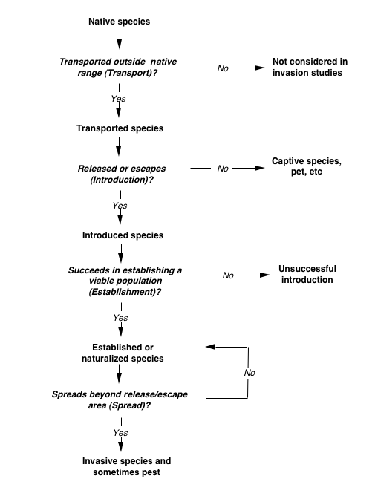
Figure S2. The modification of Williamson’s invasion stage framework presented by Duncan et al. [S2]). The stages through which a species must pass are indicated in bold italics, and the names of categories of species that do or not pass through each stage are given in bold. Passage through any given stage depends on the species overcoming a set of challenges posed by that stage, so that a species can fail to become an invader at any stage and for a variety of reasons. The exact set of challenges depends on the species and the invasion context within which it sits. Reproduced with permission of Annual Reviews Inc. S2: Duncan, R.P. et al. (2003) The ecology of bird introductions. Annu. Rev. Ecol. Evol. Syst. 34, 71-98

