[**https://data.cityofchicago.org/Transportation/Chicago-Traffic-Tracker-Historical-Congestion-Esti/sxs8-h27x/data**](https://data.cityofchicago.org/Transportation/Chicago-Traffic-Tracker-Historical-Congestion-Esti/sxs8-h27x/data)

This dataset contains the historical estimated congestion for over 1,000 traffic segments, starting in approximately March 2018.

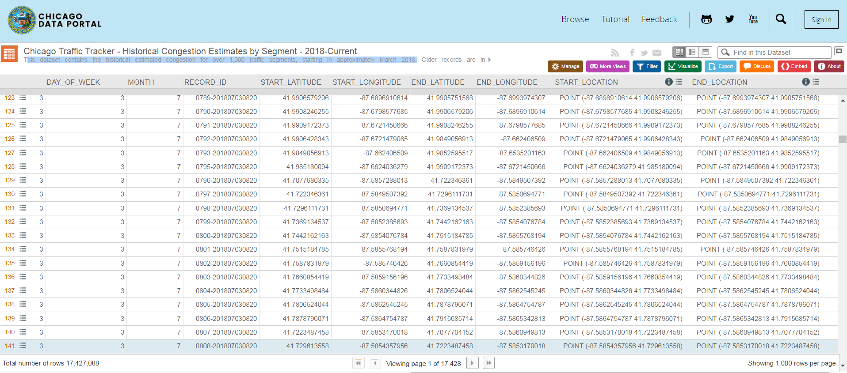

**Columns in this Dataset:**

**TIME**

**SEGMENTID**

**SPEED**

**STREET**

**DIRECTION**

**FROM_STREET**

**TO_STREET**

**LENGTH**

**STREET_HEADING**

**COMMENTS**

**BUS_COUNT**

**MESSAGE_COUNT**

**HOUR**

**DAY_OF_WEEK**

**MONTH**

**START_LONGITUDE**

**START_LATITUDE**

**END_LONGITUDE**

**END_LATITUDE**

**START_LOCATION**

**END_LOCATION**