**Transforming FRED’s semantics in AMR**

RULE NUMBER 1. EXTRACT MAIN VERB

The boy wants the girl to believe him.

AMR

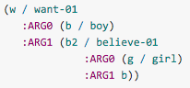

FRED

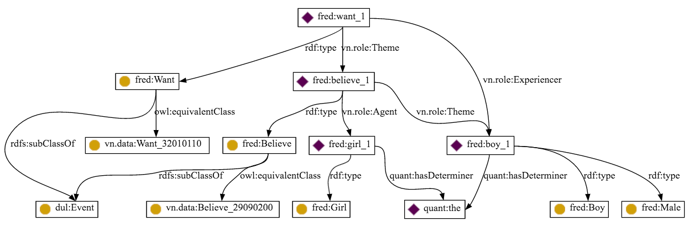

RULE 1 MAIN VERB

SELECT DISTINCT ?mainverb

WHERE {

?mainverb a ?verb . ?verb rdfs:subclassOf dul:Event . FILTER NOT EXISTS { ?a ?prop ?mainverb }

}

Assign a variable to mainverb

RULE 2 VERBS ROLE

Then, let’s get roles. For roles, check predMatrix to map FRED roles (agent, theme, etc.) with ARG0, ARG1, ARG2, etc. needed to ARM.

In the example we would get Theme (believe_1) and Experiencer (boy_1) and let’s assign variables to them if they have not been defined before. If there are roles not present in predMatrix put them at the end

If an ARG is a verb, let’s find its ARGs recursively. In the example, believe_1 is a verb and its arguments are girl_1 and boy_1 having roles Agent and Theme. As boy_1 has already been used, the same variable used for boy_1 should be used here

RULE 3 Modality

The boy must not go (clearly the boy has not to go would not catch the obligate in FRED)

(o / obligate-01

:ARG2 (g / go-02

:ARG0 (b / boy)

:polarity -))

If there is a main verb with modality then modality is root. If modality is Necessary then obligate_1; if modality is Possible then permit_1

Mainverb boxing:hasModality boxing:Necessary

Mainverb boxing:hasModality boxing:Possible

RULE 4 Negation

If

verb boxing:hasTruthValue boxing:False

then add polarity – to the correspondent verb

RULE 5 FOCUS

The marble is white

The white marble

(w / white-03

:ARG1 (m / marble))

?v dul:hasQuality ?q

becomes

(w / ?q

:ARG1 (m / ?v))

RULE 6 FOCUS AND SITUATION

The boy sees that the marble is white.

(s / see-01

:ARG0 (b / boy)

:ARG1 (w / white-03

:ARG1 (m / marble)))

If FRED mainverb has a role thing_1 and relation fred:that to a situation, the children of the situation replace the thing_1

RULE 7 POSSESSIVE ADJECTIVES

his boat

(b / boat

:poss (h / he))

If we find

?x fred:XXXOf male_1 (he) oppure  
?x fred:XXXOf female_1 (she) oppure  
?x fred:XXXOf neuter_1 (it)

RULE 8 WHO

The boy saw the girl who wanted him.

(s / see-01

:ARG0 (b / boy)

:ARG1 (g / girl

:ARG0-of (w / want-01

:ARG1 b)))

If mainverb is not just one but two, one is chosen random. All goes normal. If one ARG node has other incoming ROLE relations, we use ARGx-of

What did the girl find? FRED does not specify that is a question

RULE 9 QUESTION WHERE

Where did the girl find the boy?

Main_verb dul:associatedWith fred:location_1

(f / find-01

:ARG0 (g / girl)

:ARG1 (b / boy)

:location (a / amr-unknown))

RULE 10 QUESTION HOW

How did the girl find the boy?

Main_verb dul:associatedWith fred:location_1

(f / find-01

:ARG0 (g / girl)

:ARG1 (b / boy)

:location (a / amr-unknown))

RULE 11 Adjectives invoking predicates

the attractive man

(m / man

:ARG0-of (a / attract-01))

FRED

Man rdf:type fred:AttractiveMan rdf:subclassOf Man

FROM page 22

Adjectives following be are translated with verbal predicates in AMR. FRED cannot do that.

In AMR the following three sentences

The boy destroyed the room.

The boy’s destruction of the room

The destruction of the room by the boy

Are represented as

( d / destroy-01

:ARG0 (b / boy)

:ARG1 (r / room)

because AMR represents events and not verbs. With FRED this cannot be done.

Whose toy did the girl find?

How fast did the girl run?

What purple thing did the girl see?

Which investigation did she lead?

Did the girl find the boy?

Was the boy found?

The boy doesn’t know whether the girl came.

The boy doesn’t know that the girl came.

Go.

Let’s go.

Yippee!

Yes!

RULE 12 THAT, THOSE, THESE, THIS

That boy

(b / boy

:mod (t / that))

fred:boy_1 quant:hasDeterminer quant:that

RULE 12

In AMR vice-president can be broken whereas brother-in-law cannot

He was charged with public intoxication and resisting arrest. (FRED PROBLEMA CON AND)

The killing happened yesterday.

The killing took place yesterday.

(k / kill-01

:time (y / yesterday)

?mainverb j.0:Source ?time

La data viene anche interpretata come una Location da Fred, bisogna distinguere i luoghi dalle date!

The boy and the girl are happy

(a / and

:op1 (b / boy)

:op2 (g / girl)

<http://msrsplatdemo.cloudapp.net/>

The regulatory documents were changed

Impossibile, regulate-01 non è presente dentro l’output di fred.

It may rain.

It might rain.

Rain is possible.

It’s possible that it will rai

Impossibili, non appare una modality nell’output di fred.

I don’t have any money

Fred in questo caso non restituisce una modalità

the dress is not appropriate

la truthValue questa volta và controllata all’interno della situation che coinvolge il verbo anzichè nel verbo stesso:

?situation j.2:involves ?m

the dress is inappropriate

in questo caso fredo non restituisce una modalità False col verbo appropriate, impossibile convertire in amr correttamente

What did the girl find?

Se alcuni argomenti sono thing_1 e non sono presenti situationChild allora converti in amr-unknown

How did the girl find the boy?

Main_verb dul:associatedWith fred:manner_1

How fast did the girl run?

Fred non fornisce alcuna informazione in merito al verbo run od a fast, impossibile tradurre in amr.

I know who you saw

Fred non collega “who” ad una persona, impossibile tradurre

AMR uses :mode to indicate yes-no questions:

Fred non fornisce alcuna informazione in merito agli interrogativi, impossibile implementare

:mode is also used for imperatives. Exclamatory imperatives are just imperatives in AMR

Impossibile, fred non fornisce alcuna informazione in merito agli imperativi.

:mode expressive is used to mark exclamational words such as ah, ha, hmm, oh, wow, yippee that express emotions, but don't refer to a clear event, object or property. Do **not** use :mode expressive for mere emphasis (text in ALLCAPS), exclamation marks (!) or disfluency markers (uh), which are not annotated in AMR.

Fred non fornisce alcuna informazione di questo tipo

AMR 1.2 does not represent event times (outside of the explicit :time relation), articles, plurals, or quotation marks:

Funziona correttamente grazie alle precedent regole implementate senza necessità di nuove.

Demonstratives are included:

Dunque: those diventa that, these diventa this

If a hyphenated word can be broken down into component meanings, we do it:

(a / account

:mod (m / market

:mod (m2 / money)))

Impossibile, fred considera e fornisce dati solo sulla parola composita e non sulle sue component

In any case, we never make the hyphen itself (“-”) into an AMR concept.

Fred invece lo utilizza per le parole composite, l’unica cosa possibile è dunque rimuovere ogni parola composite dalla conversion in AMR

the man who is a lawyer

The man is a lawyer.

Problema con fred ed il verbo “be”

The boy destroyed the room.

The boy’s destruction of the room

The destruction of the room by the boy

Dovrebbero tutte essere rappresentate come la prima, ma fred fornisce dati sensibilmente diversi nei tre casi.