SOFTWARE ANALYSIS DOCUMENT (DYNAMIC VIEWS)

PROJECT: Traduce Señas

TEAM MEMBERS:
Luis Alejandro Duarte Aldana
Juan Mauricio Suaza Solorzano
Juan Camilo Fierro Esquivel

NATIONAL LEARNING SERVICE – SENA
Software Analysis and Development

2026
Table of Contents
Introduction 3
Purpose of the document 3
Scope of the analysis 3
Context of the analysis 3
Use case model 4
Sequence diagrams 5
Log in 6
Registering and verifying the email 6
Recovering the password 7
Translating signs live 8
Capturing samples and training the recognition 9
Activity diagrams 10
Translation process 11
Registration process 12
State machine diagrams 12
User account states 12
States of a translation session 14
Communication diagram between services 14
Summary of query interactions 15
Conclusions 16
References 17

Introduction
This document presents the analysis of the Traduce Señas software from its dynamic view, that is, it describes how the system behaves over time: which messages its components exchange, which activities are executed, through which states its main objects pass, and how the microservices collaborate to fulfill each requirement.
the Unified Modeling Language (UML) is used, following the notation of Booch et al. (2005). Use case, sequence, activity, state machine, and communication diagrams are included. All diagrams are based on the requirements of the specification report and on the microservices architecture implemented in the backend repository.

Purpose of the document
To describe the dynamic behavior of the system's critical processes so that the development team, the instructor, the evaluators, and anyone else can understand how each requirement is resolved before reviewing the code.

Scope of the analysis
The analysis covers the processes with the greatest value and risk: login, registration with email verification, password recovery, live sign translation, and capture of training samples. Simple query processes (view alphabet, view history, view statistics) follow the same request-response pattern and are summarized in tables.

Context of the analysis
Technically, the system consists of a client built with React Native and Expo (running on Android, iOS, and the web browser) and a microservices backend built with Node.js, Express, and TypeScript: an API Gateway and five domain services (iam, recognition, lexicon, analytics, and profile), each with its own PostgreSQL database, MongoDB for training samples, and RabbitMQ for asynchronous event-based communication.
Table 1
Participants appearing in the dynamic diagrams
Participant | Type | Responsibility in the behavior
End user | Actor | Deaf or hearing person who uses the application
Administrator | Actor | Manages the lexicon, users, and samples, and queries statistics
App (React Native / Expo) | Client | Interface, camera, local recognition with MediaPipe, and REST calls
MediaPipe | On-device library | Detects the hand and returns 21 points per video frame
api-gateway | Edge service | Single entry point: validates JWT, limits requests, and routes
iam-service | Microservice | Accounts, authentication, roles, and password recovery
recognition-service | Microservice | Translations, sign templates, and training samples
lexicon-service | Microservice | Sign catalog, categories, and alphabet
analytics-service | Microservice | Recording of usage events and statistics
profile-service | Microservice | Profile, preferences, notifications, and achievements
RabbitMQ | Message broker | Transports domain events between services

Use case model
The use case diagram defines the boundaries of the actors' interactions with the system and is the starting point for the other dynamic views. The administrator inherits all the capabilities of the end user and also has access to the management functions.
Figure 1
System use case diagram
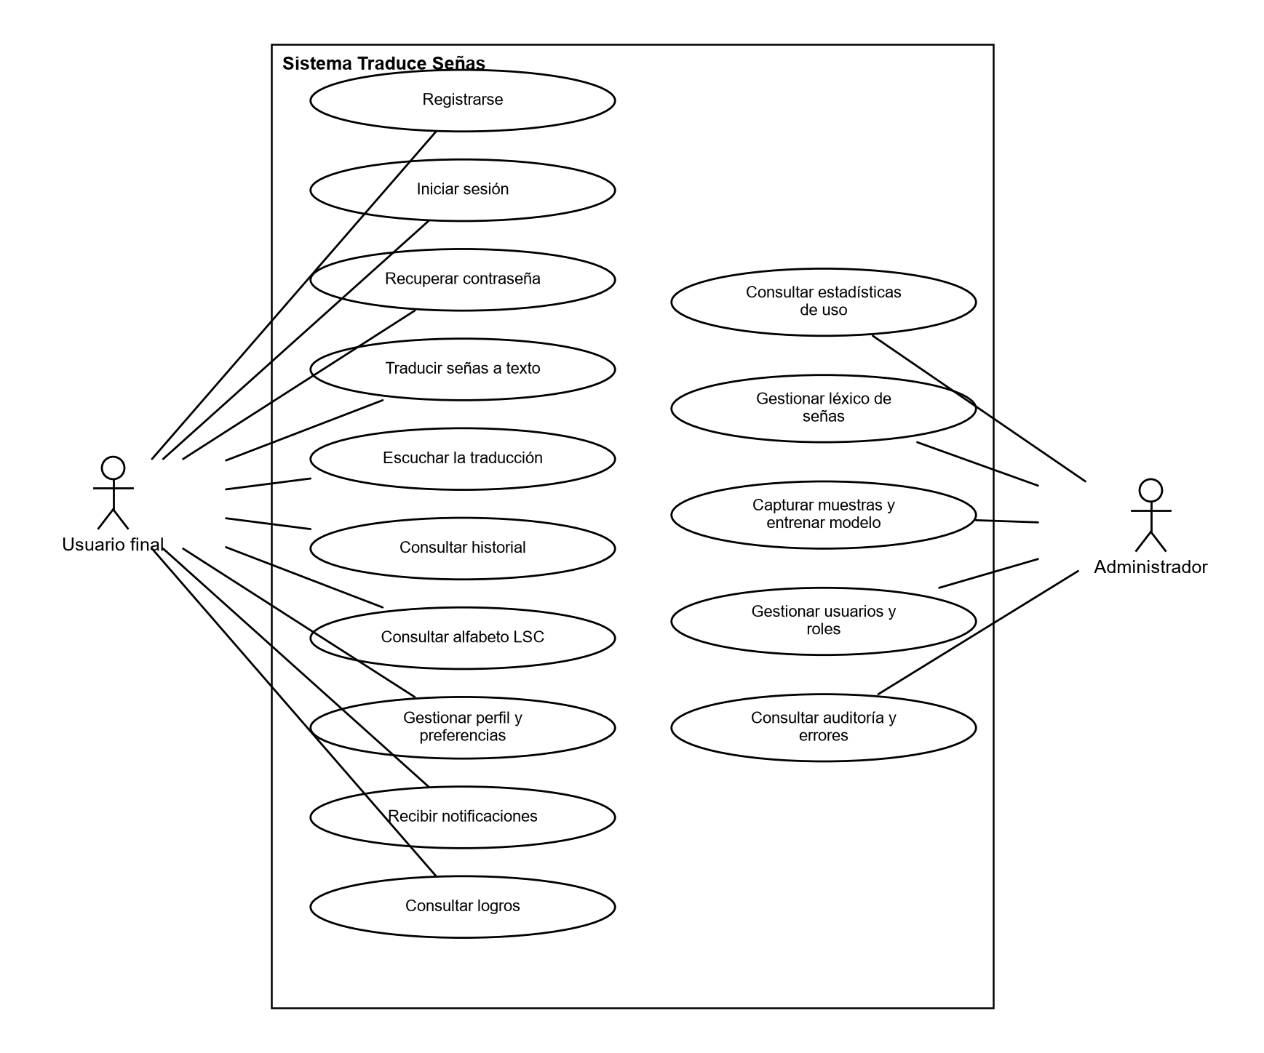
Note. Own elaboration.
Table 2
Relationship between use cases and dynamic diagrams
Use case | Requirement | Diagrams that describe it
CU-01 Log in | RF1 | Sequence (Figure 2), account states (Figure 9)
CU-02 Register | RF1 | Sequence (Figure 3), activities (Figure 8)
CU-03 Recover password | RF1 | Sequence (Figure 4)
CU-04 Translate signs to text | RF3 | Sequence (Figure 5), activities (Figure 7), states (Figure 10), communication (Figure 11)
CU-05 Capture samples and train | RF3 | Sequence (Figure 6)

Sequence diagrams
Sequence diagrams show the temporal order of messages between participants. Solid arrows are calls; dashed arrows are responses. Gray boxes indicate conditions or repetitions.

Log in
The client never calls a microservice directly: all requests go through the api-gateway on port 8080. The /api/auth route is public, so the gateway forwards it without requiring a token. The iam-service compares the password hash with bcrypt, verifies that the account is active, and signs a JWT that includes the user identifier and their roles, so that no other service has to query the iam database (Jones et al., 2015).
Figure 2
Sequence diagram — Log in
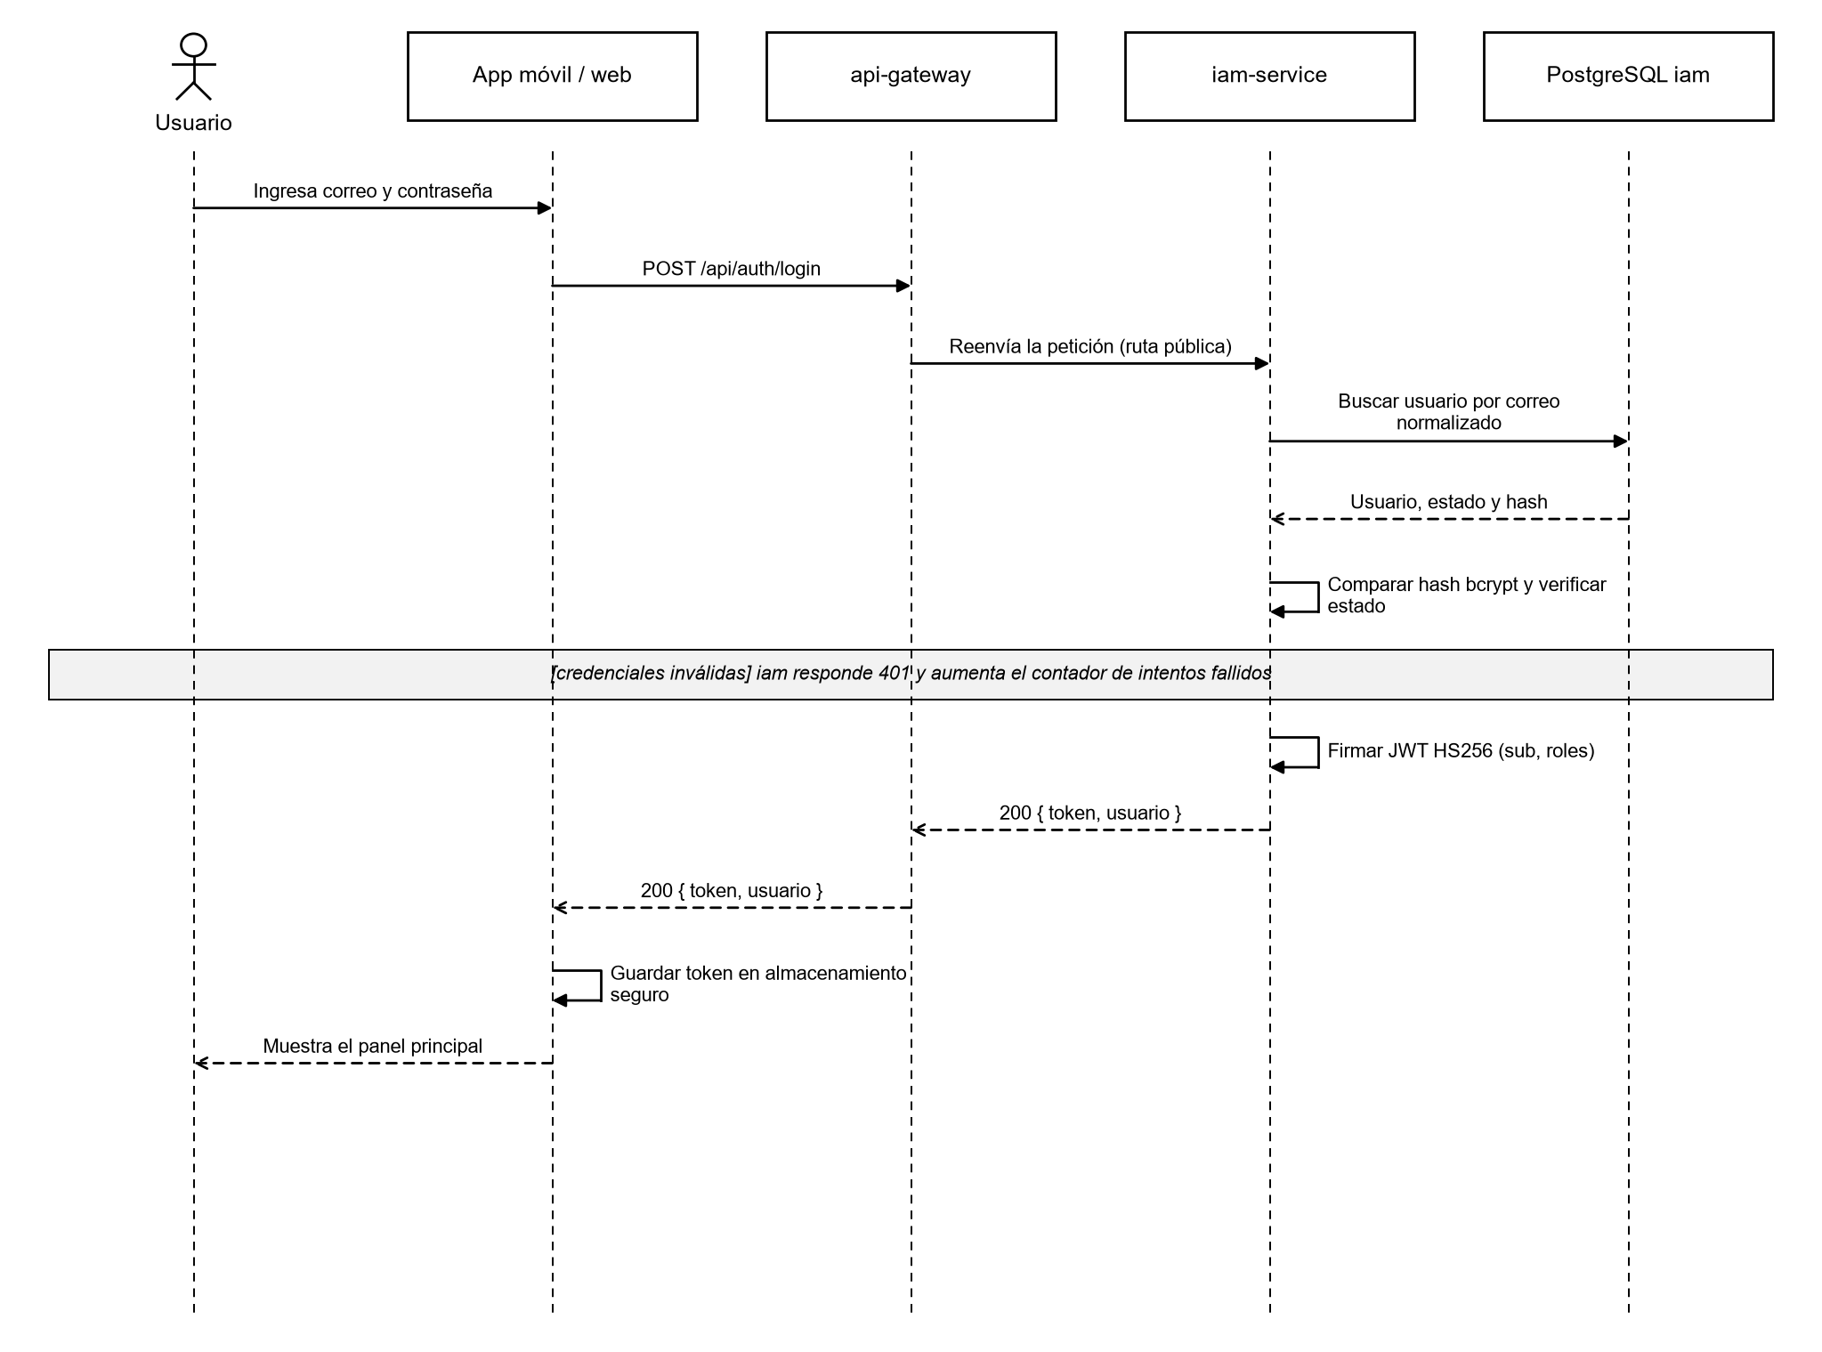
Note. Own elaboration.

Registering and verifying the email
The account is created in the INACTIVE state and is only activated when the user enters the six-digit code sent to their email. The code is stored as a hash, expires, and counts failed attempts. When the account is created, the iam-service publishes the UserRegistered event so that the profile-service creates the profile without a direct call between services.
Figure 3
Sequence diagram — Registration and email verification
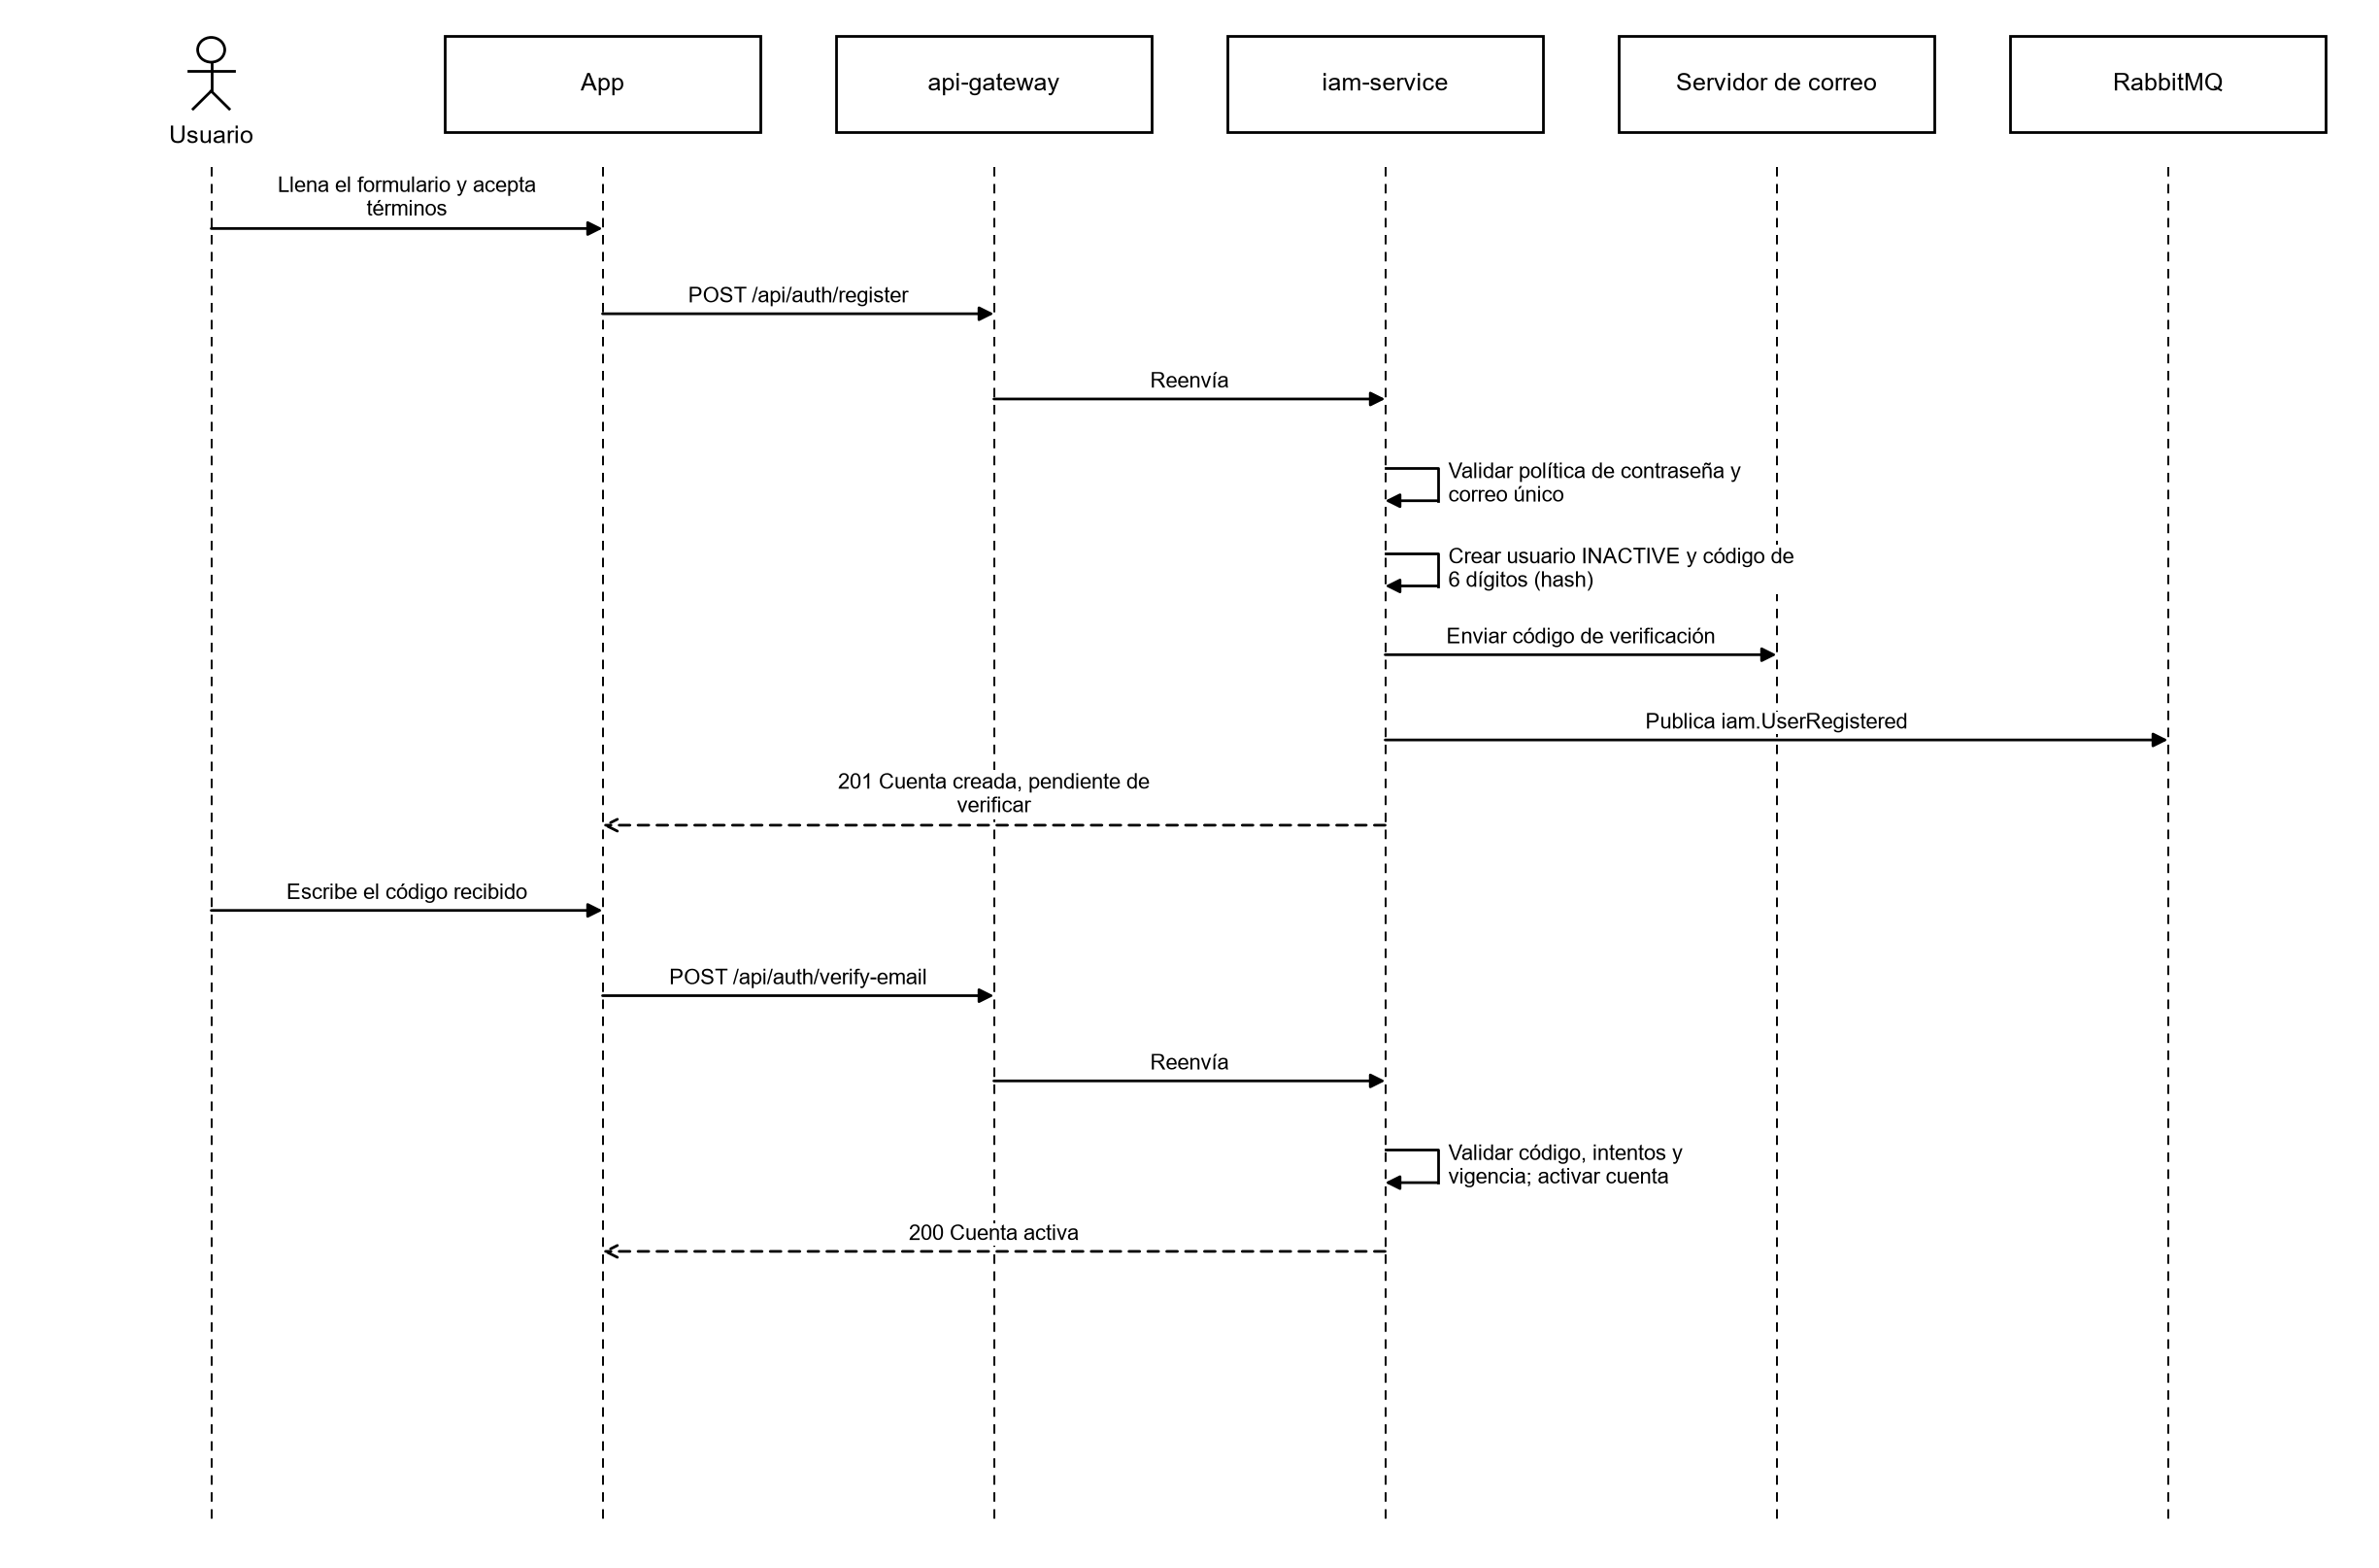
Note. Own elaboration.

Recovering the password
The response to the request is generic so as not to reveal whether an email exists. The code is generated with crypto.randomInt, has an attempt limit, and the /api/auth route has a strict request limit to prevent brute-force attacks.
Figure 4
Sequence diagram — Password recovery
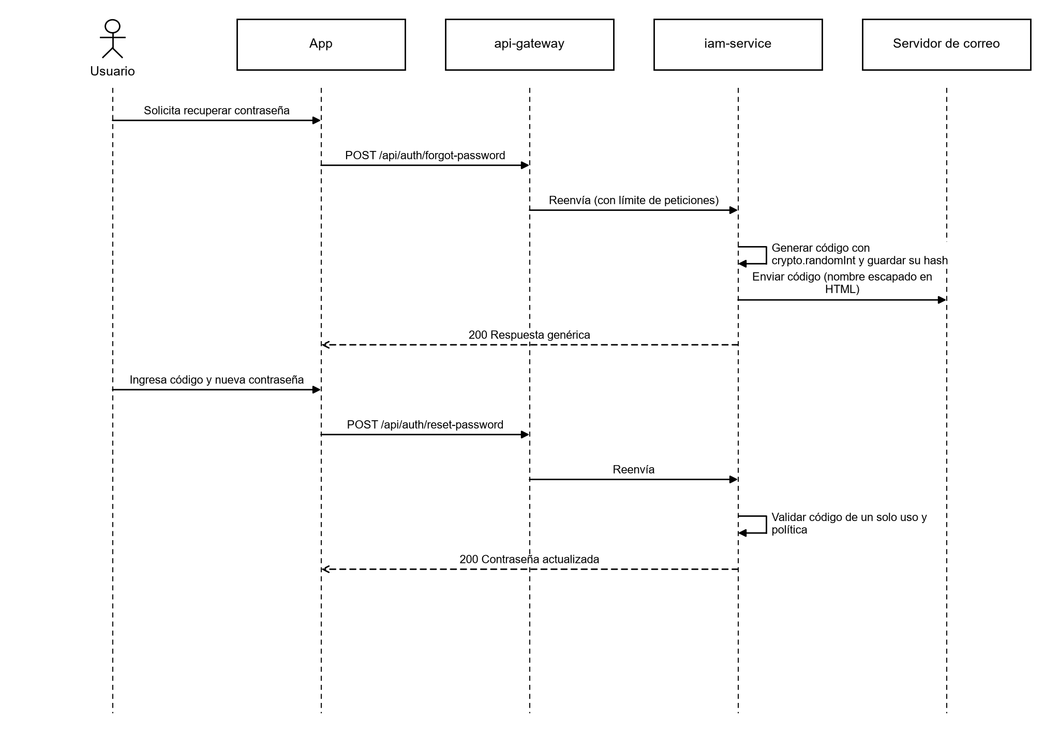
Note. Own elaboration.

Translating signs live
Recognition runs on the device: MediaPipe obtains the 21 hand points in each frame, the application normalizes them (centers them on the wrist and scales them by the size of the palm), and compares them with the templates using Dynamic Time Warping (Sakoe and Chiba, 1978). If the distance exceeds the threshold, the application does not guess: it displays a visual warning. Only the final result is sent to the backend to be saved in the history, which reduces latency and protects privacy because the video never leaves the device.
Figure 5
Sequence diagram — Live translation
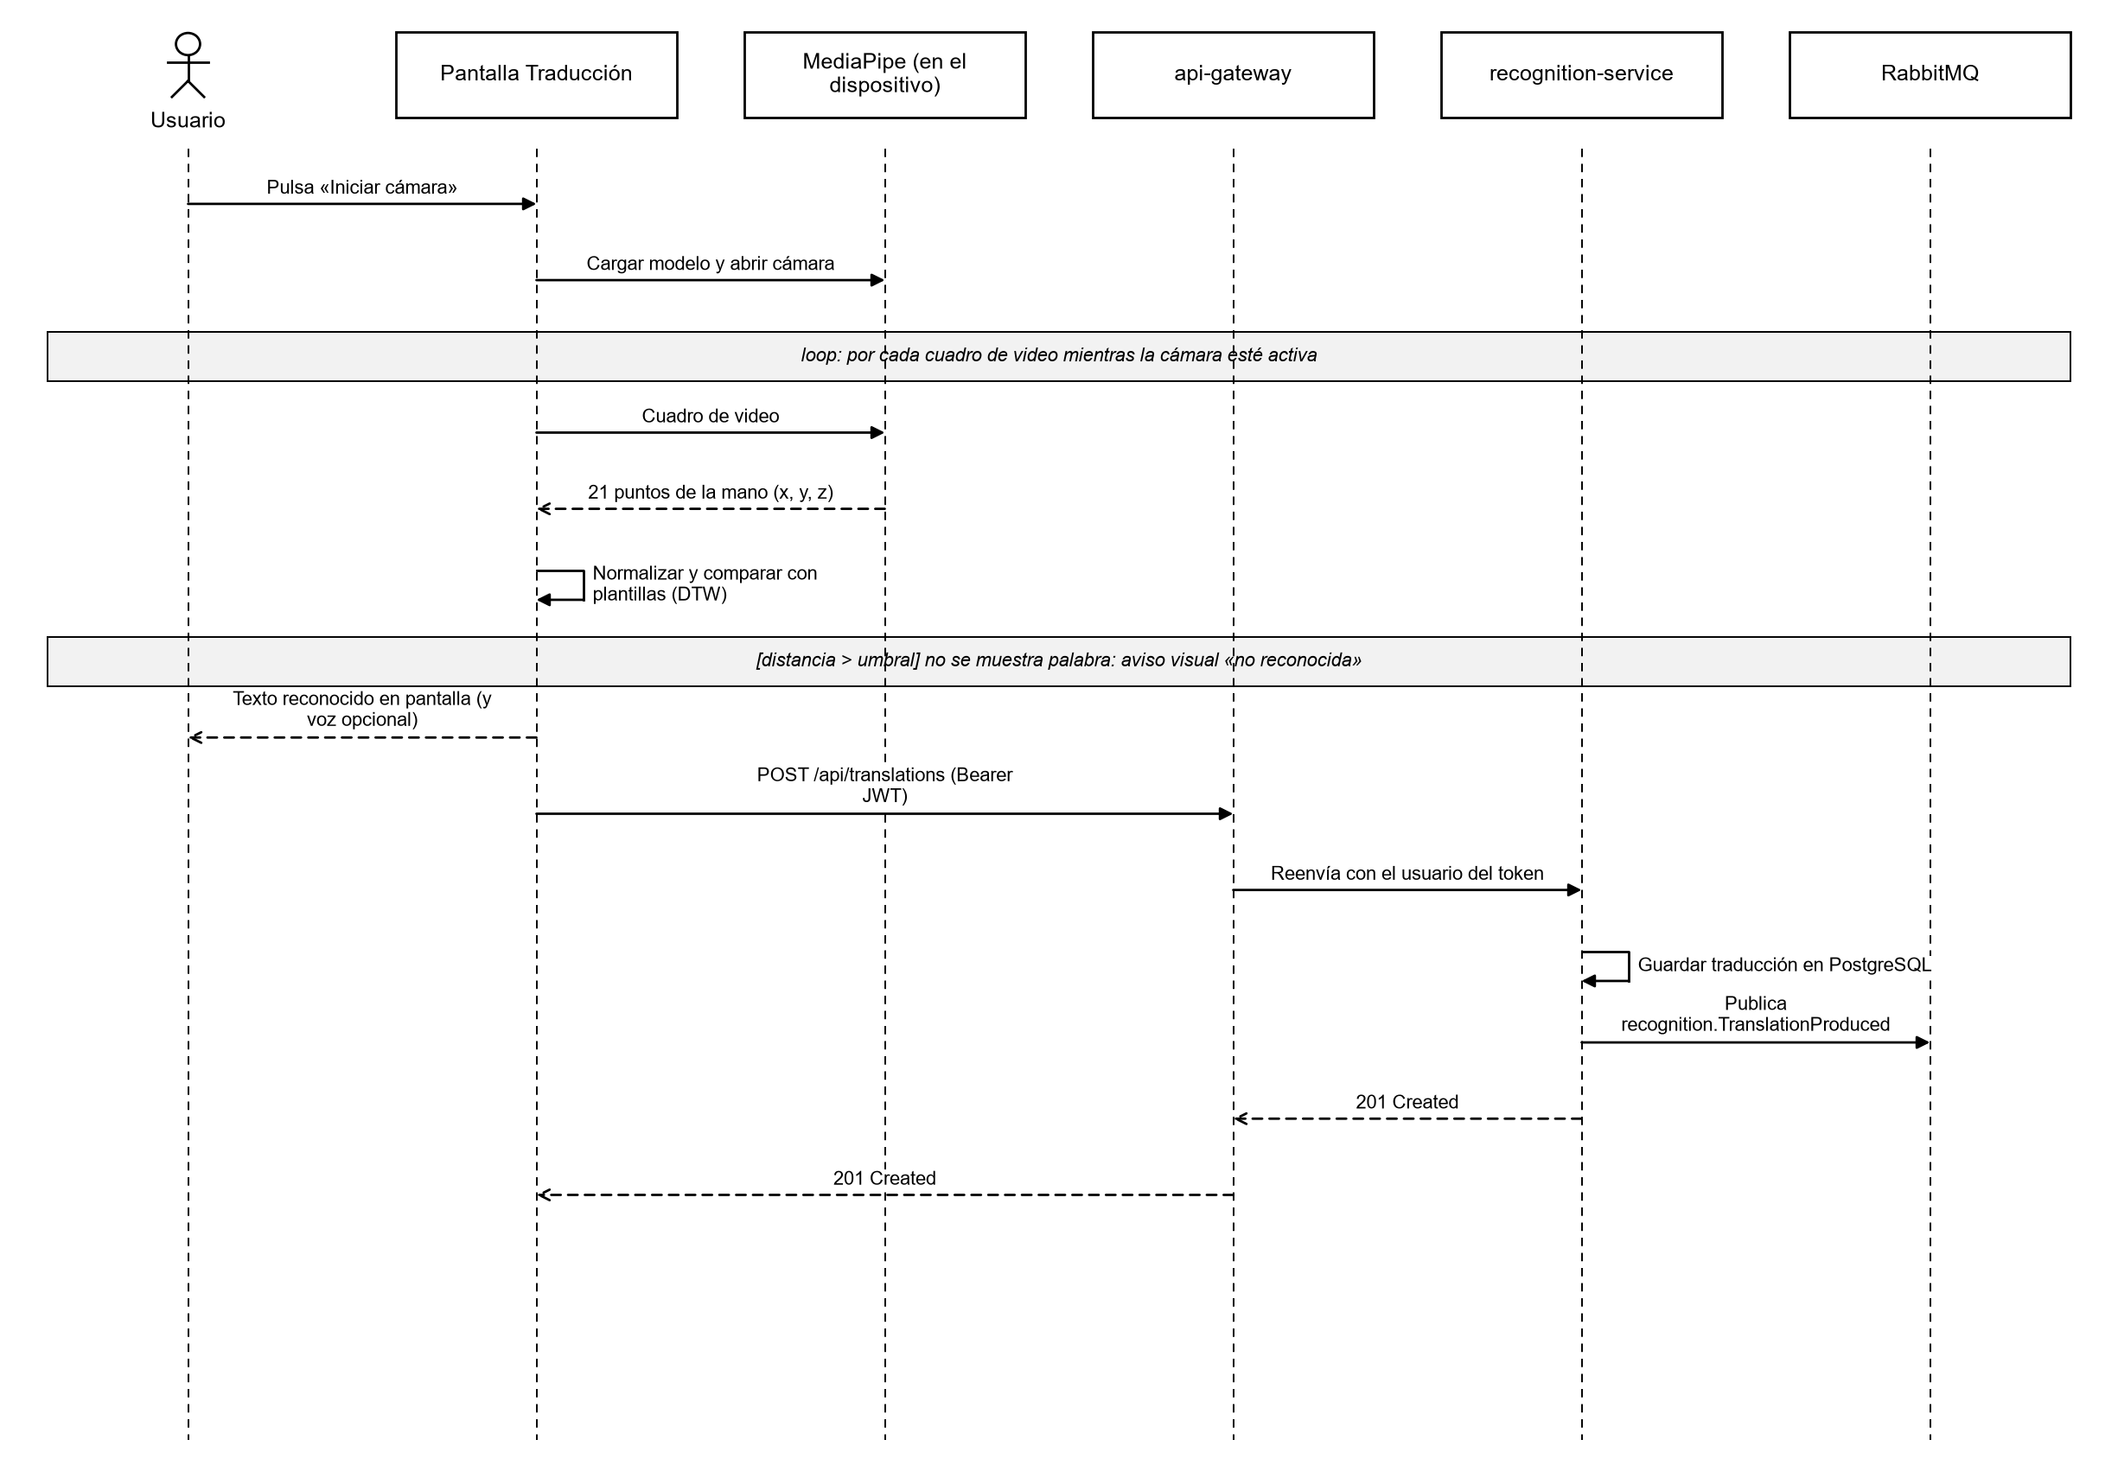
Note. Own elaboration.

Capturing samples and training the recognition
This flow is restricted to the ADMIN role. Each sample requires demonstrable consent from the signer (Law 1581 of 2012) and is stored in MongoDB, separate from the relational data. With enough samples, the templates are generated, which the application then downloads.
Figure 6
Sequence diagram — Sample capture and training
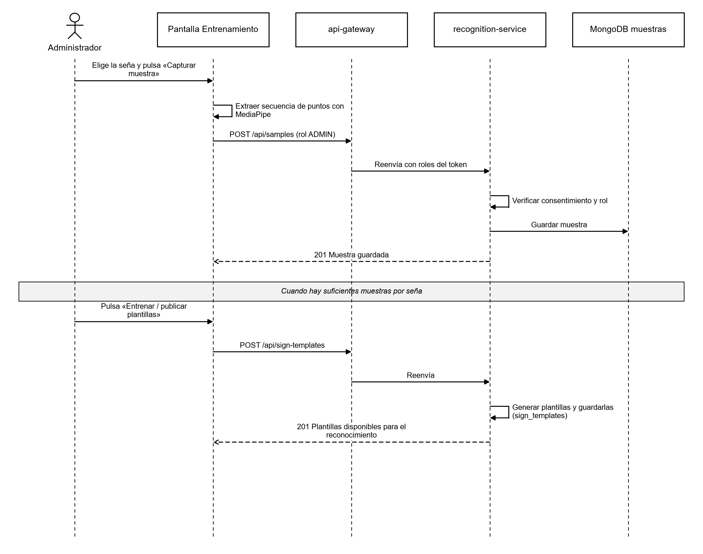
Note. Own elaboration.

Activity diagrams
Activity diagrams describe the workflow of a process, including its decisions and cycles.

Translation process
Figure 7
Activity diagram — Sign translation
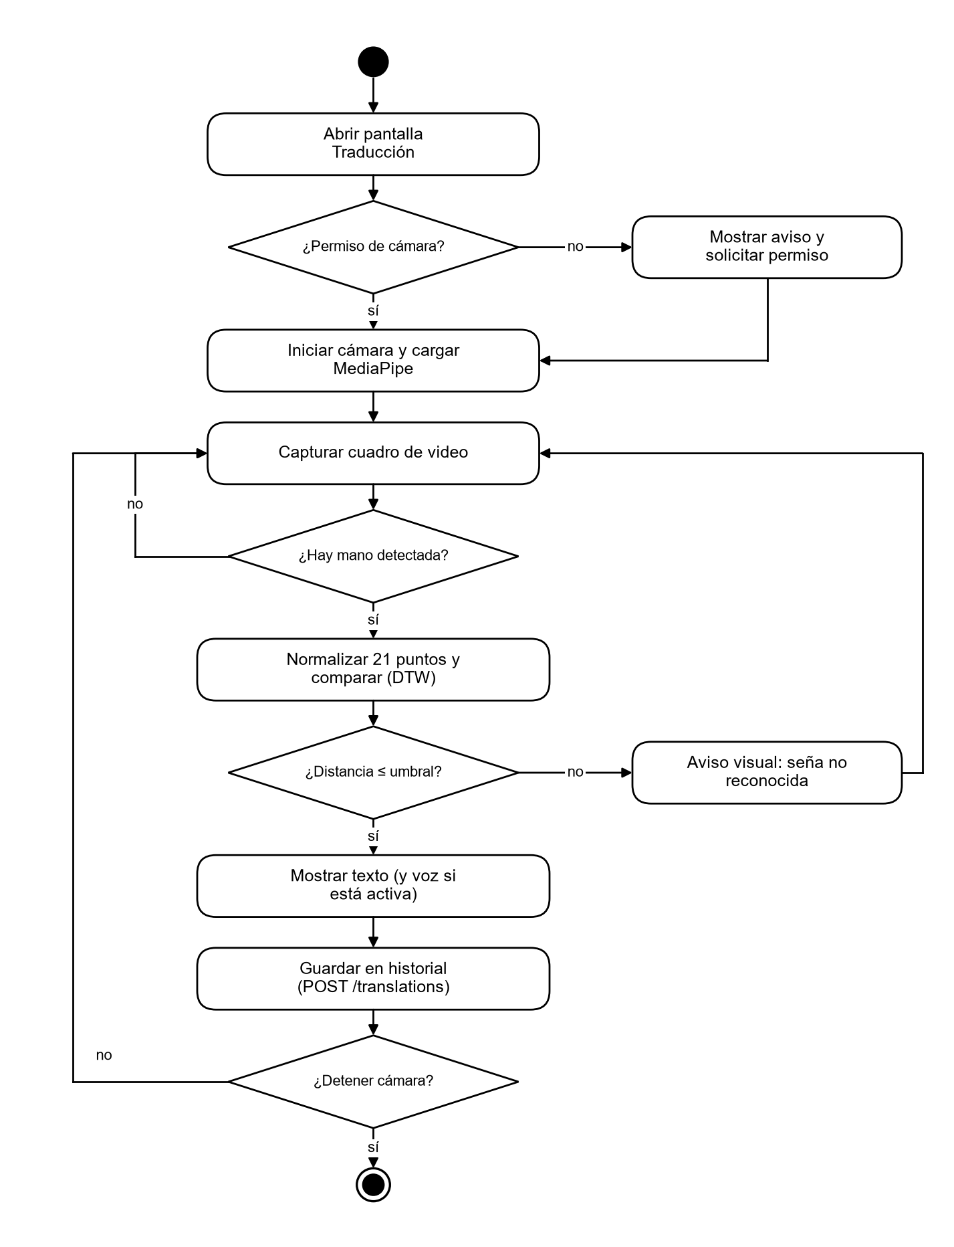
Note. Own elaboration.

Registration process
Figure 8
Activity diagram — User registration
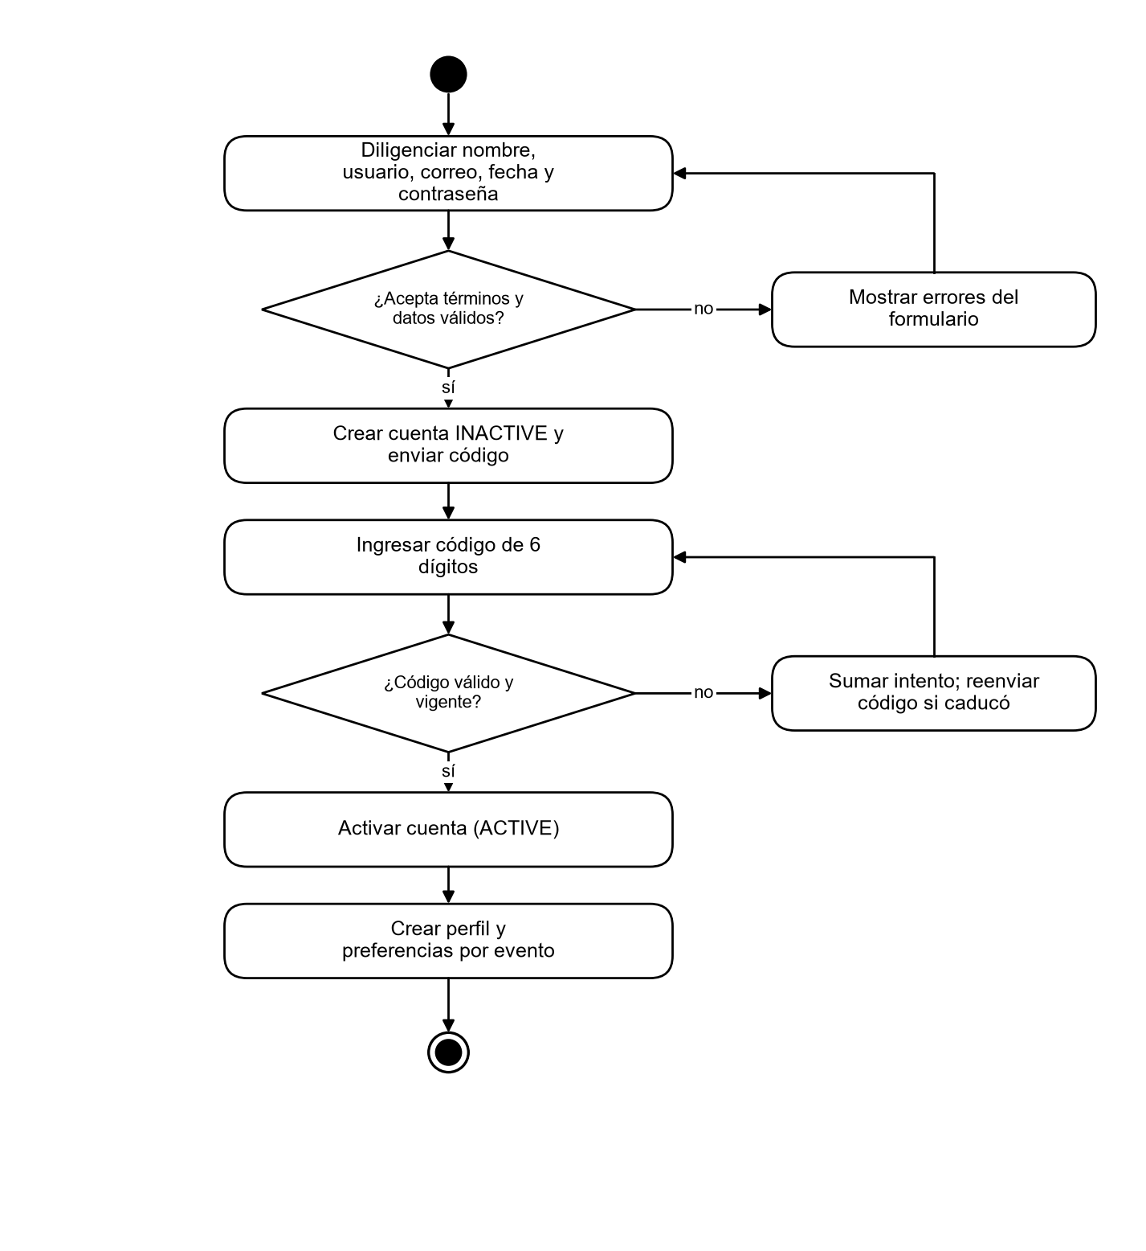
Note. Own elaboration.

State machine diagrams

User account states
The user account is the object with the most important lifecycle for security. A temporary lock is a date that lifts itself; when the lock scale is exhausted, the account moves to BLOCKED, and only an administrator can restore it. Deletion anonymizes the data instead of physically erasing it, to preserve audit integrity and comply with the right to erasure.
Figure 9
State diagram — User account
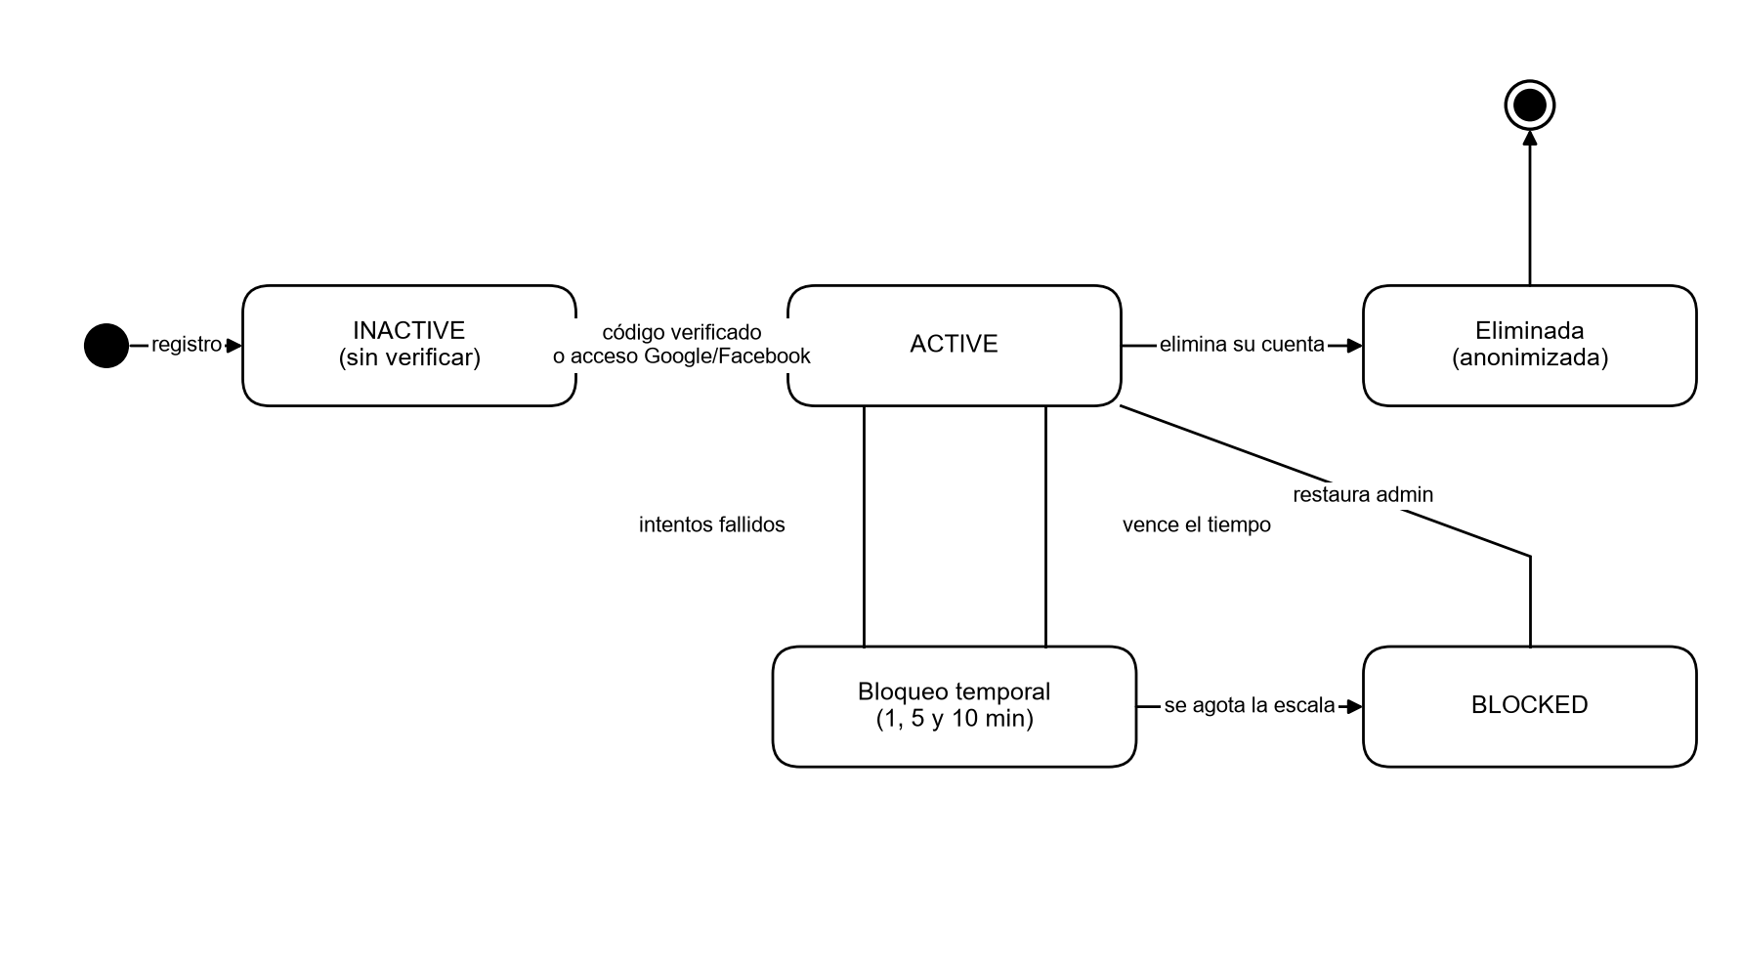
Note. Own elaboration.
Table 3
User account transitions
Source state | Event | Target state | Rule
— | Registration with email | INACTIVE | Must accept terms (FR-002)
— | Registration with Google / Facebook | ACTIVE | The provider has already verified the email (FR-008)
INACTIVE | Valid verification code | ACTIVE | Single-use and valid code (FR-004)
ACTIVE | Repeated failed attempts | Temporary lock | Waits of 1, 5, and 10 minutes (FR-006)
Temporary lock | Lock scale exhausted | BLOCKED | Only an administrator restores (FR-007)
ACTIVE | The user deletes their account | Deleted | The row is anonymized (FR-014)

States of a translation session
Figure 10
State diagram — Translation session
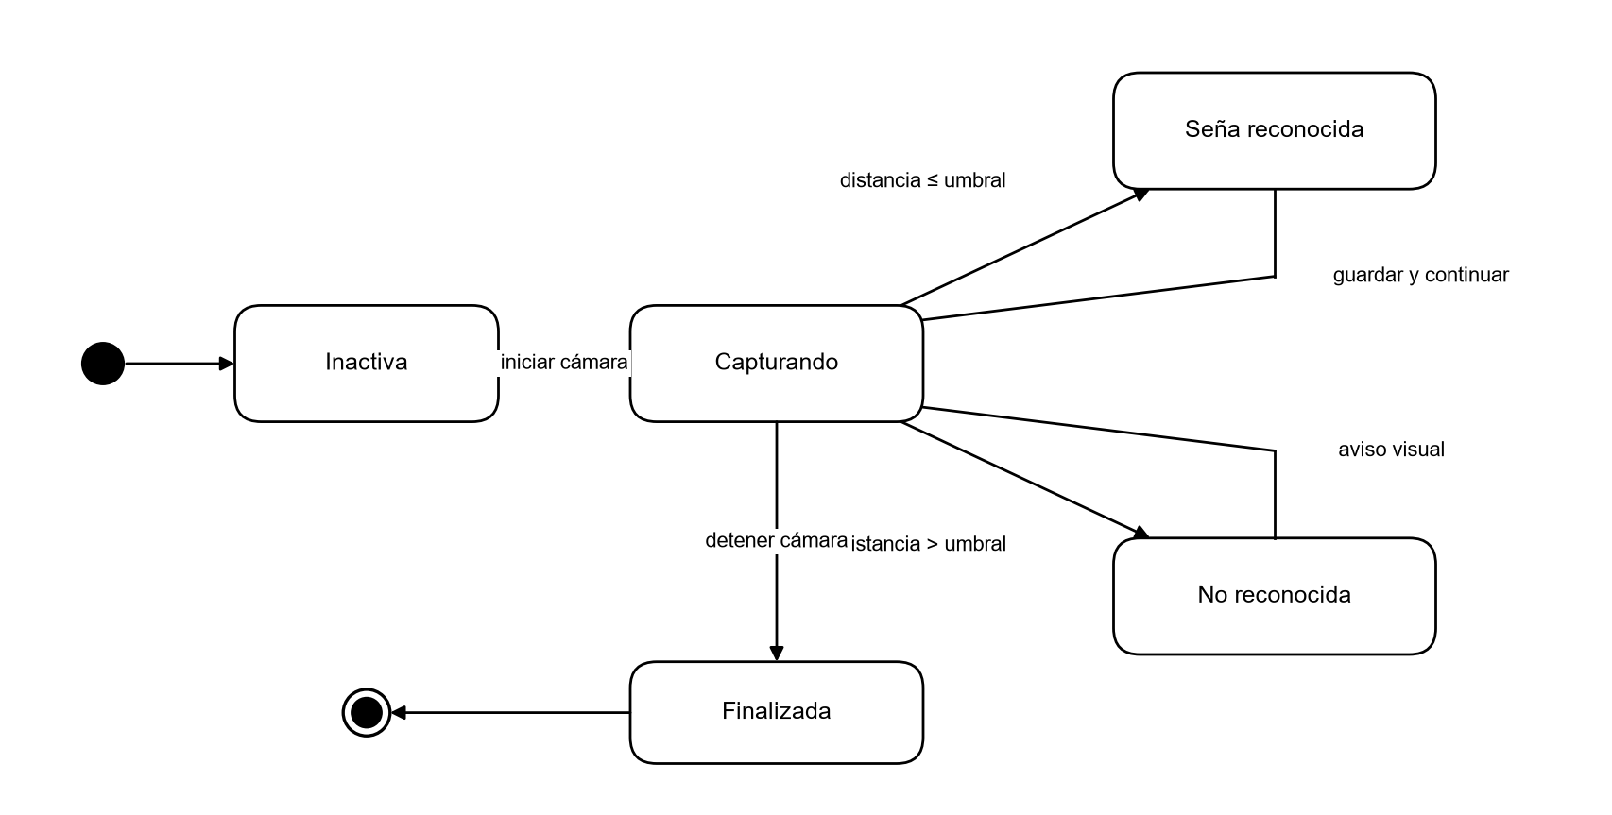
Note. Own elaboration.

Communication diagram between services
The communication diagram shows how the objects collaborate to complete a task, numbering the messages. When a translation is saved, the recognition-service publishes TranslationProduced to the traduce.events exchange. The profile-service consumes it to update achievements (for example, “First translation”) and the analytics-service records it as a usage event. No service waits for another's response to complete the user's request, which reduces coupling (Newman, 2021).
Figure 11
Communication diagram — Saved translation and derived events
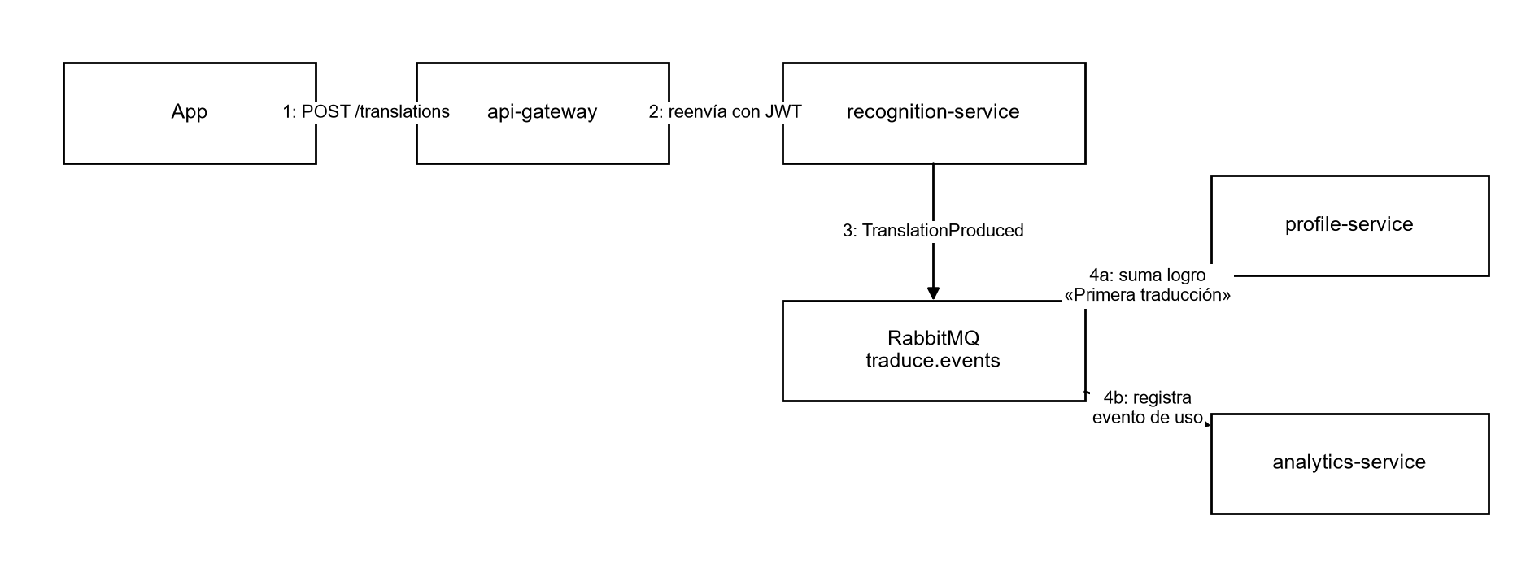
Note. Own elaboration.
Table 4
Main domain events
Event | Publisher | Consumers | Effect
iam.UserRegistered | iam-service | profile, analytics | Creates profile and preferences; counts the registration
iam.AccountDeletionRequested | iam-service | recognition, profile | Anonymizes history and profile data
recognition.TranslationProduced | recognition-service | profile, analytics | Advances achievements; records usage
lexicon.SignPublished | lexicon-service | recognition, analytics | Updates the catalog of recognizable signs
lexicon.SignWithdrawn | lexicon-service | recognition | Removes the sign from recognition

Summary of query interactions
Table 5
Query request-response interactions
Interaction | Route (via gateway) | Service | Access
View alphabet | GET /api/lexicon/alphabet | lexicon-service | Public
Search signs | GET /api/lexicon/search | lexicon-service | Public
View history | GET /api/translations/history | recognition-service | Authenticated user (own data only)
Delete from history | DELETE /api/translations/:id | recognition-service | Owner of the translation
View profile | GET /api/profile/me | profile-service | Authenticated user
View statistics | GET /api/analytics/summary, /daily, /top-signs | analytics-service | ADMIN role
Manage roles | POST /api/iam/users/:id/roles | iam-service | ADMIN role

Conclusions
The dynamic views confirm three decisions from the analysis: recognition is performed on the device to meet the real-time requirement and protect privacy; every request goes through a single gateway that centralizes security; and the services are coordinated through asynchronous events, so that the failure of one does not block the user's operation.
The diagrams in this document serve as a reference for the detailed design and for writing the integration and end-to-end test cases.

References
Booch, G., Rumbaugh, J., & Jacobson, I. (2005). The unified modeling language user guide (2nd ed.). Addison-Wesley.
Congreso de la República de Colombia. (2012, October 17). Ley Estatutaria 1581 de 2012, por la cual se dictan disposiciones generales para la protección de datos personales. Diario Oficial No. 48,587.
Jones, M., Bradley, J., & Sakimura, N. (2015). JSON Web Token (JWT) (RFC 7519). Internet Engineering Task Force. https://doi.org/10.17487/RFC7519
Newman, S. (2021). Building microservices: Designing fine-grained systems (2nd ed.). O'Reilly Media.
Pressman, R. S., & Maxim, B. R. (2020). Software engineering: A practitioner's approach (9th ed.). McGraw-Hill Education.
Sakoe, H., & Chiba, S. (1978). Dynamic programming algorithm optimization for spoken word recognition. IEEE Transactions on Acoustics, Speech, and Signal Processing, 26(1), 43–49. https://doi.org/10.1109/TASSP.1978.1163055
Sommerville, I. (2016). Software engineering (10th ed.). Pearson.
Zhang, F., Bazarevsky, V., Vakunov, A., Tkachenka, A., Sung, G., Chang, C.-L., & Grundmann, M. (2020). MediaPipe Hands: On-device real-time hand tracking (arXiv:2006.10214). arXiv. https://doi.org/10.48550/arXiv.2006.10214

