SOFTWARE TECHNICAL PROPOSAL DOCUMENTATION

PROJECT: Traduce Señas

TEAM MEMBERS:
Luis Alejandro Duarte Aldana
Juan Mauricio Suaza Solorzano
Juan Camilo Fierro Esquivel

NATIONAL LEARNING SERVICE – SENA
Software Analysis and Development

2026
Table of Contents
Introduction 3
Description of the problem and the need 3
Proposed solution 3
Technical scope 4
Selected technologies 5
Alternatives evaluated 5
Proposed architecture 6
Development methodology 6
Schedule 6
Resources 7
Human resources 7
Technical resources 7
Budget 7
Main technical risks 8
Deliverables 8
Conclusions 8
References 10

Introduction
The technical proposal describes the software solution that the team proposes for the communication problem between deaf and hearing people, together with the chosen technologies, the architecture, the work methodology, the schedule, the resources, and the budget needed to build it.
This document is intended for the instructor and any technical evaluator who needs to understand why the solution is built the way it is and which alternatives were discarded.

Description of the problem and the need
In Colombia, the number of LSC interpreters is far lower than the number of deaf people who need them (INSOR, 2020). The World Health Organization (2021) estimates that more than 1,500 million people worldwide live with some degree of hearing loss. Without an interpreter, a deaf person cannot communicate fluently at school, at the shop, or at the counter of a public agency. A tool available on any phone is needed that translates signs into text or voice immediately.

Proposed solution
A cross-platform application is proposed that uses the device's camera to recognize signs and display their translation. The solution consists of:
- Cross-platform client built with React Native and Expo, compiled for Android, iOS, and web (desktop) from a single codebase.
- On-device recognition engine with MediaPipe Hands (Zhang et al., 2020), which extracts 21 hand landmarks per frame, and a template-based classifier based on Dynamic Time Warping.
- Microservices backend in Node.js, Express, and TypeScript, behind an API Gateway, with one database per service.
- Event-based communication with RabbitMQ to keep the services decoupled.
- Container-based deployment with Docker and Docker Compose, reproducible on any server.
Figure 1
Overview of the proposed architecture
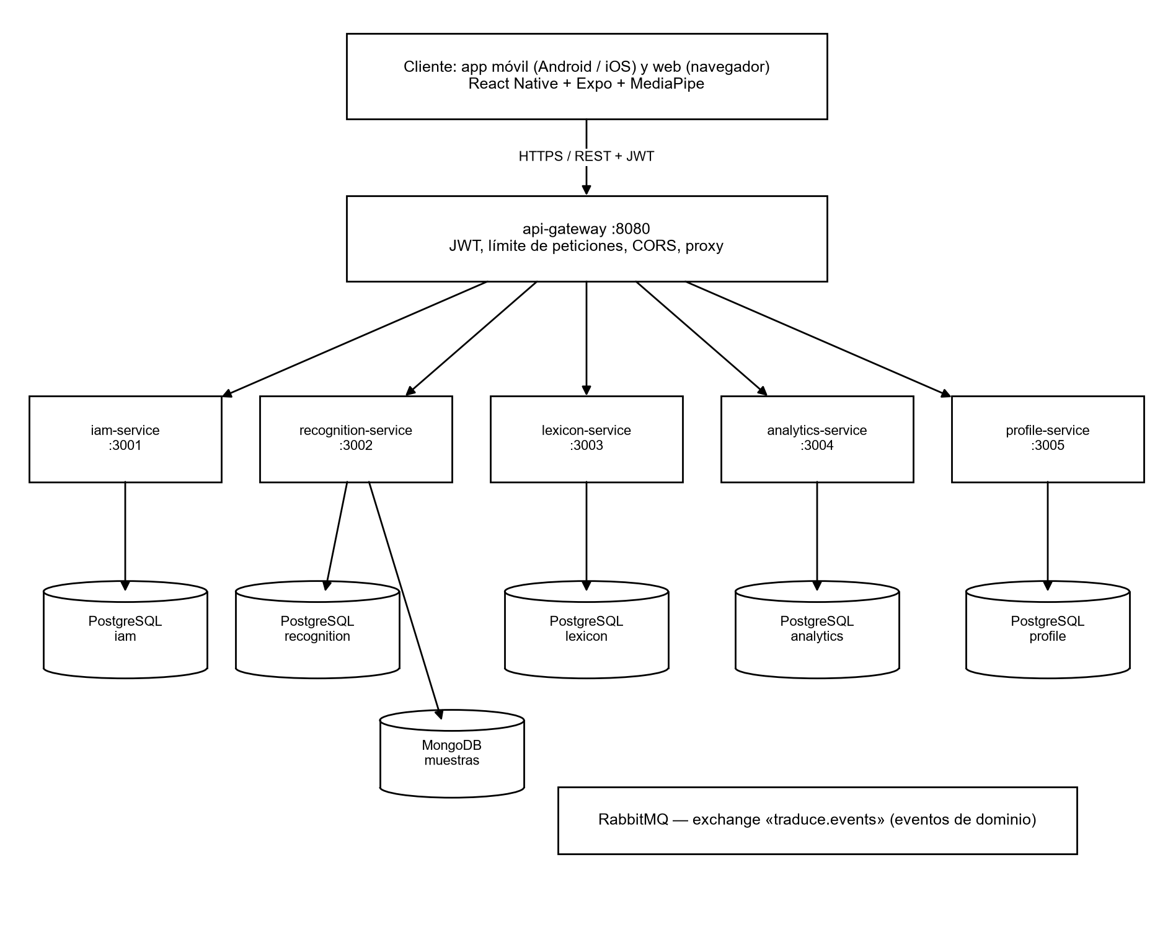
Note. Own elaboration.

Technical scope
Table 1
Functional modules and responsible service
Module | Functionality | Service
User management | Registration, email verification, login, password recovery, roles | iam-service
Translation | Sign recognition, text and voice, history | App + recognition-service
Training | Sample capture, sign templates, model registration | recognition-service
Lexicon and alphabet | Sign catalog, categories, alphabet with 3D models | lexicon-service
Profile | Personal data, theme, language, notifications, and achievements | profile-service
Statistics | Usage events and dashboards for the administrator | analytics-service
Single entry point | Routing, JWT validation, rate limiting, CORS | api-gateway

Selected technologies
Table 2
Technology stack and justification
Layer | Technology | Version | Justification
Client | React Native + Expo | RN 0.86 / Expo 57 | A single codebase for Android, iOS, and web; the team knows JavaScript
Client | React | 19.2 | Common UI library for mobile and web
Client | React Navigation | 6.x | Standard stack and tab navigation in React Native
Vision | MediaPipe Tasks Vision | 0.10.14 | Pre-trained, real-time hand detection on the device
Vision | TensorFlow.js | 4.22 | Execution of classification models on the client
Voice | expo-speech | 57.x | Native speech synthesis for audio output
Backend | Node.js + Express | 20 LTS / 5.2 | Same language as the client; sufficient for the project's traffic
Backend | TypeScript | 5.6+ | Static typing that reduces errors in a shared codebase
Data | PostgreSQL | 16 | Robust, free relational database, one per service
Data | MongoDB | 7 | Flexible documents for the training samples
Messaging | RabbitMQ | 3.x | Event exchange between services; simple and with a web panel
Security | JWT (HS256) + bcrypt | — | Stateless authentication and hashed passwords
Infrastructure | Docker + Docker Compose | 24+ / 2.20+ | Reproducible environment with a single command
Version control | Git + GitHub | — | Feature branches, pull requests, and review

Alternatives evaluated
Table 3
Technical decisions and discarded alternatives
Decision | Discarded alternative | Reason
Microservices with API Gateway | Modular monolith | Allows recognition to scale separately and divides the work by domain; decision confirmed by the product leader on October 4, 2026
PostgreSQL per service | Shared MySQL | Data isolation per service, JSONB types, and more expressive constraints
RabbitMQ | Apache Kafka | Kafka is disproportionate for the project's volume; RabbitMQ is simpler to operate
On-device recognition | Sending video to the server | Lower latency, lower data consumption, and the video does not leave the phone (privacy)
Templates + DTW | Neural network trained from scratch | Works with few examples per sign and is explainable; the network remains a future improvement
Expo (React Native) | Separate native development (Kotlin and Swift) | A three-person team cannot maintain three codebases

Proposed architecture
Each microservice follows the hexagonal architecture (Cockburn, 2005): the domain and use cases do not depend on Express or the database, but on ports that the adapters implement. This makes testing easier and allows the persistence technology to be changed without touching the business logic.
The client is organized by features (feature/) with presentation, business, data, external services, and configuration layers. The details are found in the software design document.

Development methodology
The project is managed with Scrum (Schwaber & Sutherland, 2020) in two-week sprints. The instructor acts as product owner, who reviews and accepts each increment, and the technical lead also fulfills the role of Scrum Master.
Table 4
Scrum events and artifacts in the project
Element | Application in the project
Sprint | Two weeks; 14 sprints planned between January 1 and July 31, 2026
Planning | Selection of user stories from the backlog according to MoSCoW priority
Review | Demonstration of the increment to the instructor
Retrospective | Improvement actions recorded in the corrective actions document
Product backlog | User stories traced to the requirements (03-product/product-backlog.md)
Definition of done | Code reviewed, tests passing, accessibility verified, and documentation updated
Git workflow | Feature branch, commits in English with Conventional Commits, pull request with squash and merge

Schedule
Table 5
Schedule by phases
Phase | Sprints | Period | Deliverables
Analysis and requirements | 1–2 | January 2026 | Requirements report, user stories, use cases
Design | 3–4 | February 2026 | Architecture, data model, interface prototypes
Core construction | 5–9 | March to May 2026 | Authentication, translation, alphabet, history
Complementary modules | 10–12 | June 2026 | Profile, notifications, statistics, achievements
Testing and deployment | 13–14 | July 2026 | Test plan and results, deployment, manuals
Restructuring into microservices | Re-planning | September to October 2026 | Separation of the backend into six components and updated documentation
Note. The original baseline closed on July 31, 2026; the microservices phase corresponds to the subsequent re-planning.

Resources

Human resources
Table 6
Project team
Name | Role | Responsibility | Contact
Juan Mauricio Suaza Solórzano | Technical lead, Scrum Master, analyst and developer | Analysis, design, backend programming (lexicon and recognition), and coordination | suazasolorzano@gmail.com
Luis Alejandro Duarte Aldana | Analyst and developer | Analysis, interface design, and programming | aleosea777@gmail.com
Juan Camilo Fierro Esquivel | Analyst and developer | Analysis, product documentation, and programming | fierroesquiveljuancamilo@gmail.com
Note. Apprentices from the Technologist in Software Analysis and Development program at SENA.

Technical resources
- Three development computers with at least 16 GB of RAM and Docker Desktop.
- Mid-range Android and iOS phones for camera and performance testing.
- Server (physical or cloud) with 4 vCPU, 8 GB of RAM, and 50 GB of disk for deployment.
- GitHub accounts, an SMTP mail server, and Google and Facebook developer accounts for external login.

Budget
Table 7
Estimated project budget (Colombian pesos)
Item | Detail | Value (COP)
Development and programming | Three developers for six months (lead: $3,000,000/month; analysts: $2,500,000/month each) | 48 000 000
Hardware | Development computers and test mobile devices | 15 003 310
Infrastructure and servers | Deployment server and domain | 1 350 000
Testing and training | Pilot testing and user training | 2 000 000
Software and security | Certificates and tools | 225 000
Total |  | 66 578 310
Note. The total corresponds to the sum of the components of the Technical and Economic Proposal; it is the figure considered valid while the partial totals circulating in other documents are reconciled.

Main technical risks
Table 8
Risks and mitigation strategy
Risk | Level | Mitigation
Insufficient LSC training data | Critical | Use the public LSC-54 dataset and capture samples with consent; retrain with the most failed signs
Recognition accuracy lower than expected | High | Threshold that prevents showing doubtful translations; per-sign metrics before publishing templates
Small team facing the complexity of microservices | High | Shared package (@traduce/shared), service templates, and Docker Compose
Privacy of samples (Ley 1581 de 2012) | High | Mandatory consent per sample, access only for ADMIN, video processed on the device
Single server without redundancy | Medium | Daily backups and documented restoration procedure

Deliverables
- Requirements specification report.
- Analysis documentation (dynamic views).
- Technical proposal (this document).
- Software design documentation.
- Code artifacts: mobile, web, and desktop (via browser) applications and backend.
- Testing documentation.
- Implementation procedure.
- Documentation of corrective, preventive, and improvement actions.
- Technical, installation, and end-user manuals.
- Project article.

Conclusions
The proposed solution is viable for a team of three apprentices because it relies on mature components (MediaPipe, Expo, PostgreSQL, RabbitMQ) and concentrates the team's own effort on LSC recognition and the accessible experience. The microservices architecture allows growth in parts, and on-device recognition meets the real-time requirement without exposing the user's video.

References
Broadcom. (2026). RabbitMQ documentation. https://www.rabbitmq.com/docs
Cockburn, A. (2005). Hexagonal architecture. https://alistair.cockburn.us/hexagonal-architecture/
Congreso de la República de Colombia. (2012, October 17). Ley Estatutaria 1581 de 2012, por la cual se dictan disposiciones generales para la protección de datos personales. Diario Oficial No. 48,587.
Docker Inc. (2026). Docker Compose documentation. https://docs.docker.com/compose/
Expo. (2026). Expo documentation. https://docs.expo.dev/
Instituto Nacional para Sordos. (2020). Observatorio social de la población sorda colombiana. INSOR. https://www.insor.gov.co/observatorio/
Lugaresi, C., Tang, J., Nash, H., McClanahan, C., Uboweja, E., Hays, M., Zhang, F., Chang, C.-L., Yong, M. G., Lee, J., Chang, W.-T., Hua, W., Georg, M., & Grundmann, M. (2019). MediaPipe: A framework for building perception pipelines (arXiv:1906.08172). arXiv. https://doi.org/10.48550/arXiv.1906.08172
Newman, S. (2021). Building microservices: Designing fine-grained systems (2nd ed.). O'Reilly Media.
World Health Organization. (2021). Informe mundial sobre la audición. https://www.who.int/publications/i/item/9789240020481
Pressman, R. S., & Maxim, B. R. (2020). Software engineering: A practitioner's approach (9th ed.). McGraw-Hill Education.
Schwaber, K., & Sutherland, J. (2020). The Scrum guide. https://scrumguides.org/
Zhang, F., Bazarevsky, V., Vakunov, A., Tkachenka, A., Sung, G., Chang, C.-L., & Grundmann, M. (2020). MediaPipe Hands: On-device real-time hand tracking (arXiv:2006.10214). arXiv. https://doi.org/10.48550/arXiv.2006.10214

