SOFTWARE DESIGN DOCUMENTATION

PROJECT: Traduce Señas

TEAM MEMBERS:
Luis Alejandro Duarte Aldana
Juan Mauricio Suaza Solorzano
Juan Camilo Fierro Esquivel

NATIONAL LEARNING SERVICE – SENA
Software Analysis and Development

2026
Table of Contents
Introduction 3
Graphical interface design 3
Design principles 3
Design system 3
Navigation map 4
Prototypes of the main screens 4
Architectural model 15
Architectural style 15
Container view 16
Internal architecture of each service 17
Client architecture 17
Deployment view 19
Design patterns 19
SOLID principles 20
Data model 20
Model criteria 20
Entity-relationship diagram 21
Summary data dictionary 21
Conclusions 23
References 24

Introduction
The design document translates the requirements and analysis of Traduce Señas into concrete construction decisions. It brings together four views: the graphical interfaces the user sees, the architectural model that organizes the components, the design patterns applied in the code, and the data model that supports the system's information.
The decisions described here correspond to the code in the frontend and backend repositories (branch feat/microservices-split) and to the high-fidelity prototypes in the documentation repository.

Graphical interface design

Design principles
Because the main users are deaf people, the design is based on accessibility (W3C, 2018) and Nielsen's usability principles (1994):
- Nothing by sound alone: every audio output has a visible text equivalent.
- Sufficient contrast: 4.5:1 for normal text and 3:1 for large text, in light and dark themes.
- Large touch targets: minimum 48 × 48 dp; primary actions are 56 dp high.
- One primary action per view, so that the user always knows what to do next.
- Readable text: body text of 18 px on mobile and 16 px on desktop; no data below 14 px.

Design system
Table 1
Design system elements
Element | Definition
Themes | Light (default) and dark; accent color purple (brand) or green, saved on the device
Typography | Nunito Sans. H1 title 32 px, H2 24 px, H3 20 px, body 18/16 px, buttons 18 px in bold
Spacing | Scale of 4, 8, 12, 16, 20, 24, 32, 40, 48, and 72 px; side margins of 16 px on mobile and 24 px on desktop
Borders | Radius of 12 px on buttons and fields, 18 px on cards
Breakpoints | Mobile < 768 px, tablet 768–1023 px, desktop ≥ 1024 px
States | Success, error, warning (low confidence, temporary lock), and information, always with text in addition to color
Note. Source: 12-ux-ui/design-system.md from the documentation repository.

Navigation map
Table 2
System screens and their access
Screen | File in the frontend | Access
Home (landing), About us, Demos | homescreen/pages | Public
Sign in, Registration, Verify code | auth/pages | Public
Recover and change password | auth/pages | Public / authenticated
Translation | Translation/pages/TranslationScreen.tsx | Authenticated
Alphabet | Alphabet/pages/AlphabetScreen.tsx | Authenticated (public demo)
History | History/pages/HistoryScreen.tsx | Authenticated
Profile, Terms, Privacy | Profile/pages | Authenticated
Statistics | Stats/pages/StatsScreen.tsx | ADMIN
Administration panel, Training, Samples | Admin/pages | ADMIN

Prototypes of the main screens
The following figures show the high-fidelity prototypes. They are the visual reference that the screens implemented in React Native follow.
Figure 1
Prototype — Public home page
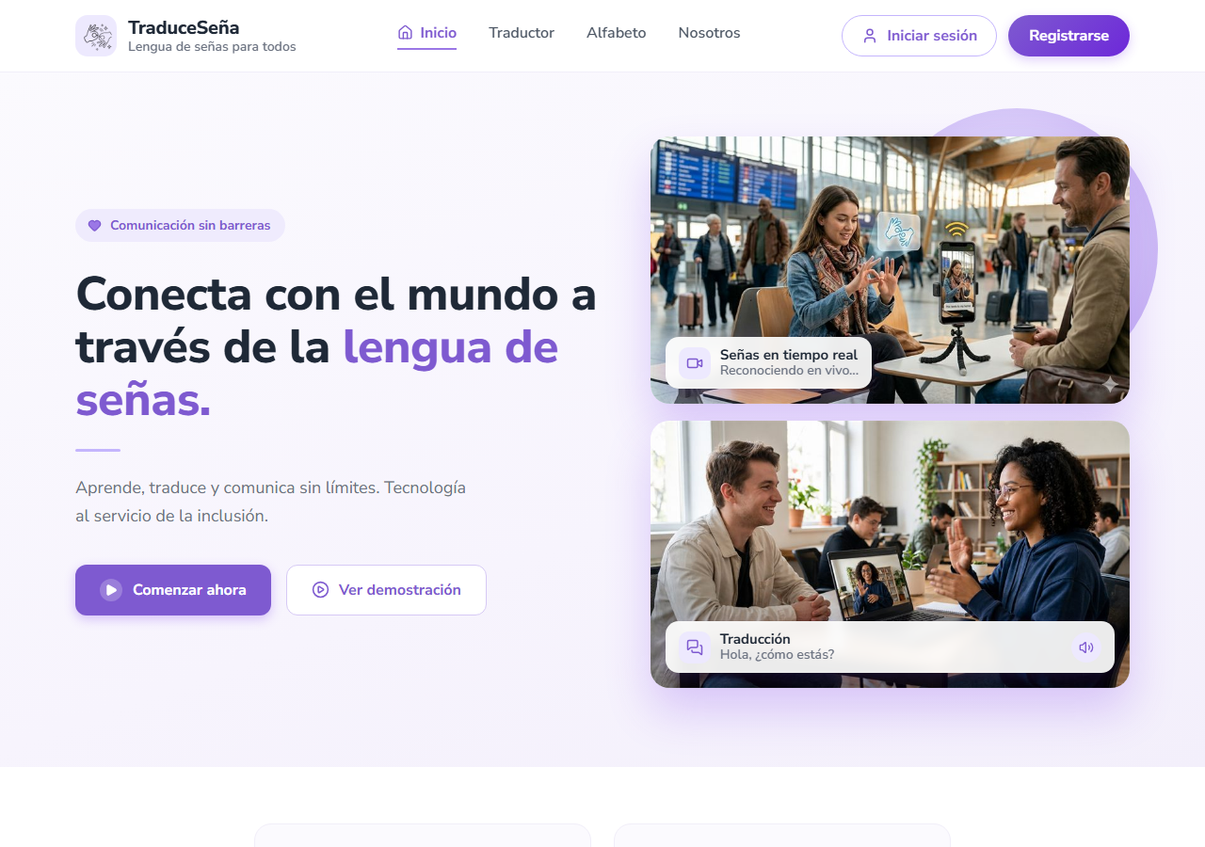
Note. High-fidelity project prototype (folder 12-ux-ui/mockup of the documentation repository).
Figure 2
Prototype — Sign-in
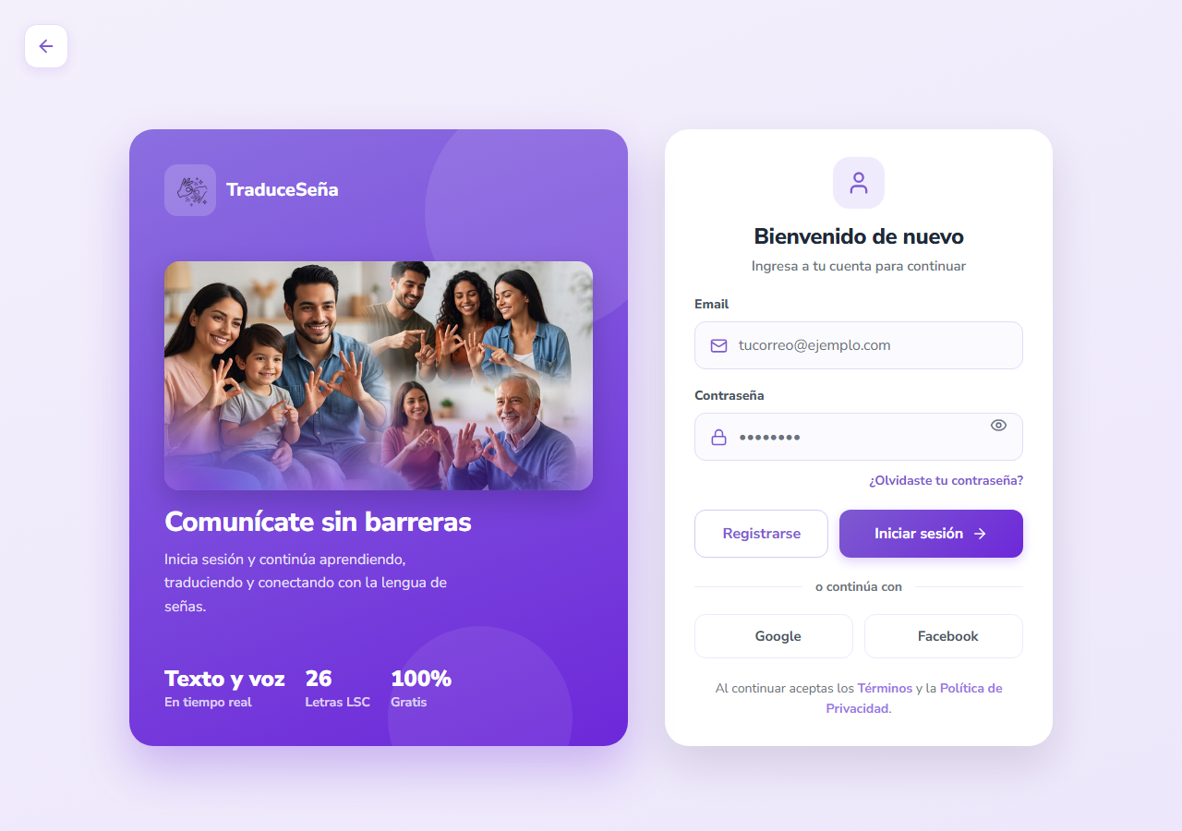
Note. High-fidelity project prototype (folder 12-ux-ui/mockup of the documentation repository).
Figure 3
Prototype — Account registration
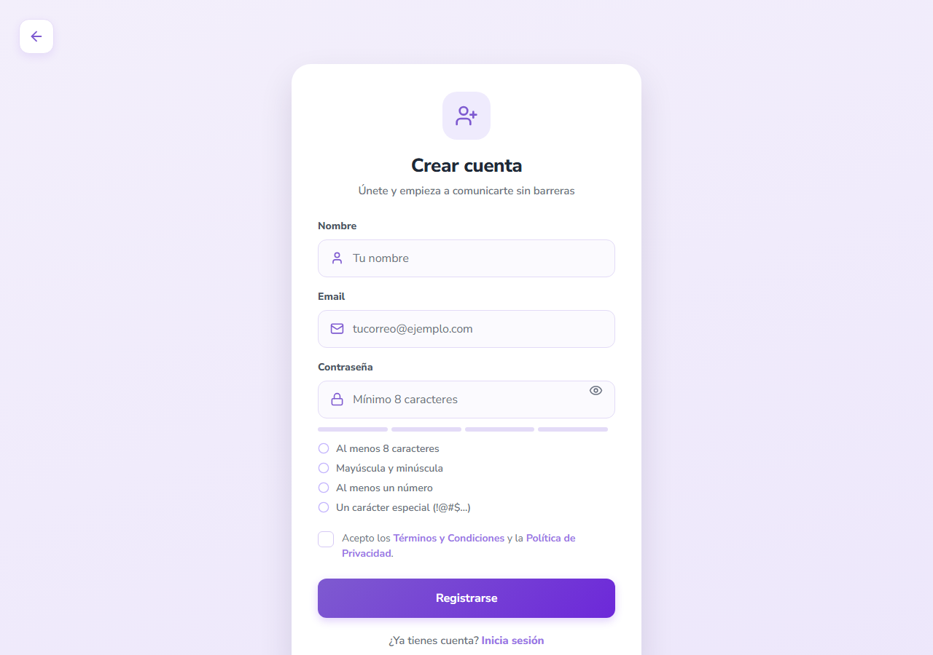
Note. High-fidelity project prototype (folder 12-ux-ui/mockup of the documentation repository).
Figure 4
Prototype — Live translation screen
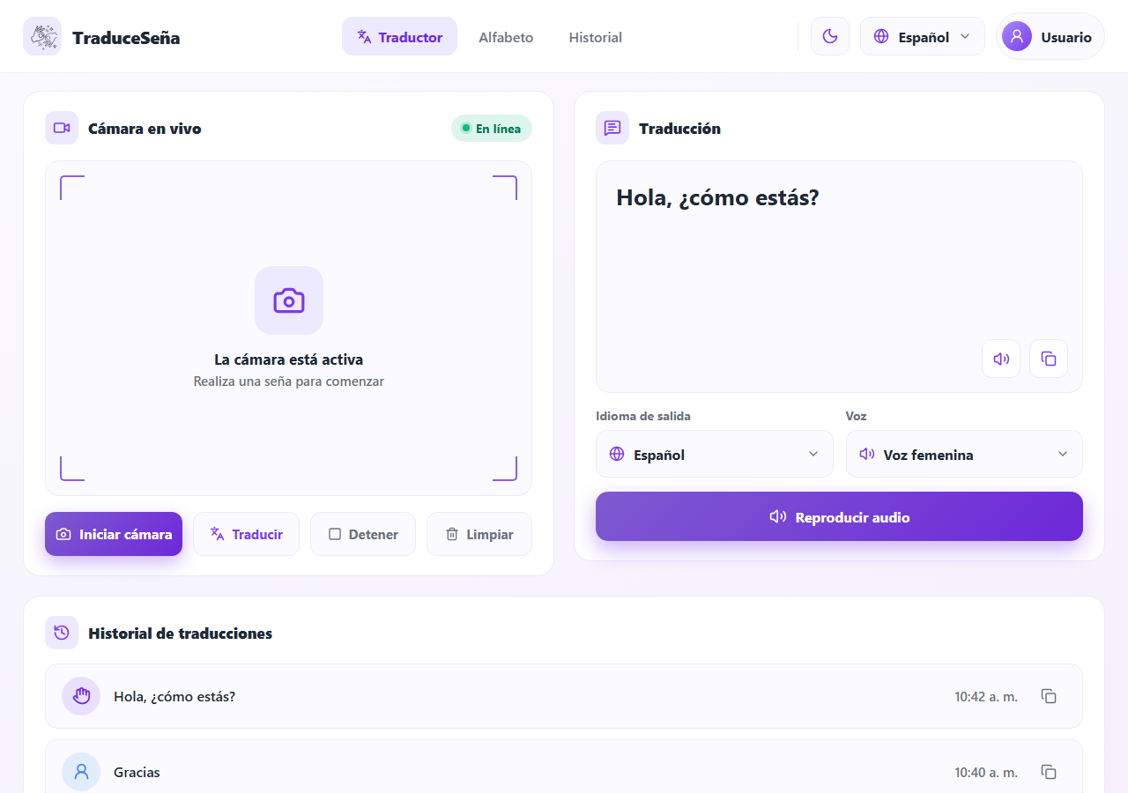
Note. High-fidelity project prototype (folder 12-ux-ui/mockup of the documentation repository).
Figure 5
Prototype — LSC alphabet
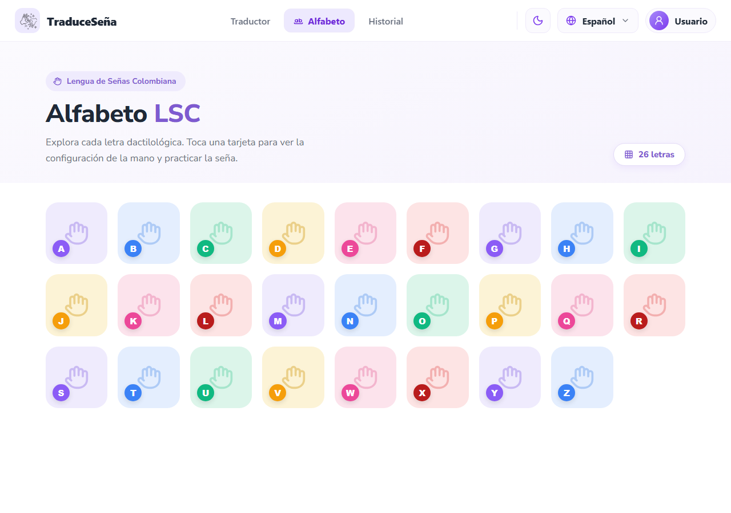
Note. High-fidelity project prototype (folder 12-ux-ui/mockup of the documentation repository).
Figure 6
Prototype — Translation history
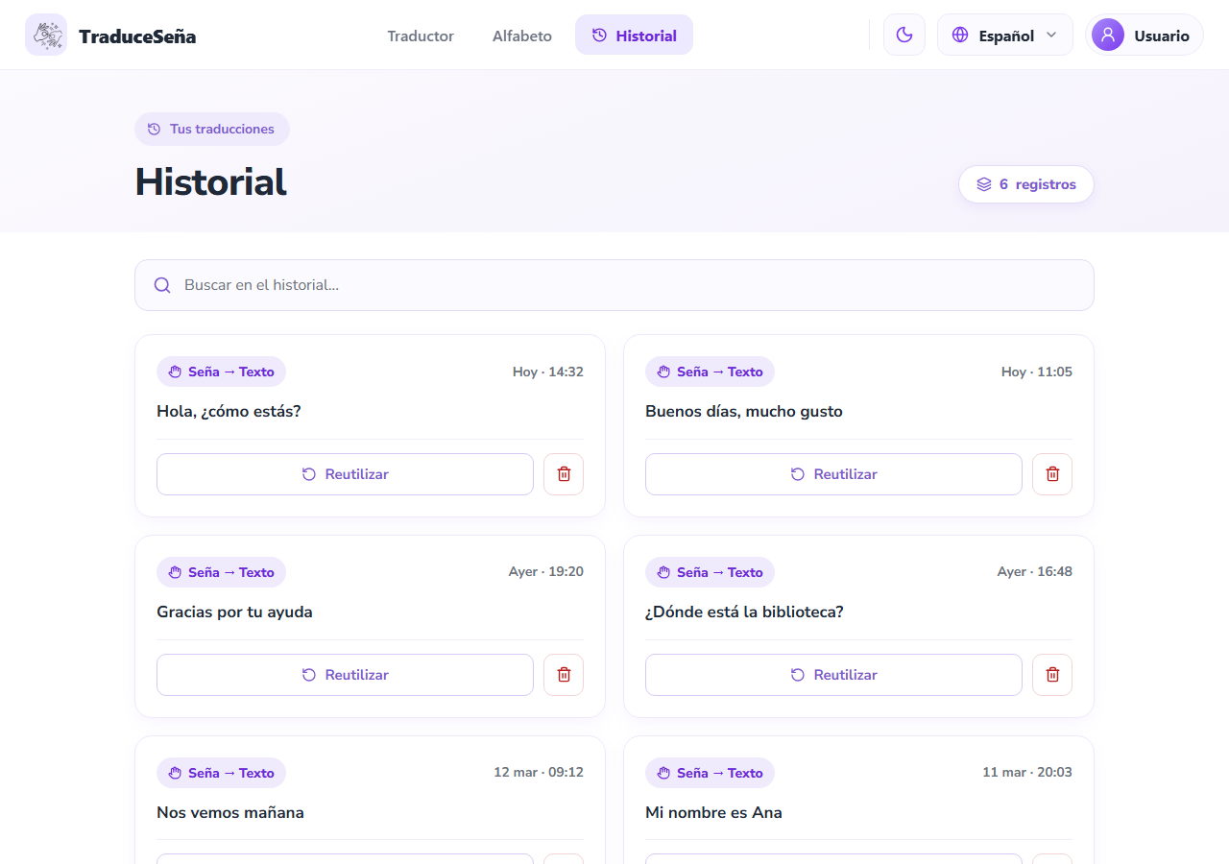
Note. High-fidelity project prototype (folder 12-ux-ui/mockup of the documentation repository).
Figure 7
Prototype — Profile management and preferences
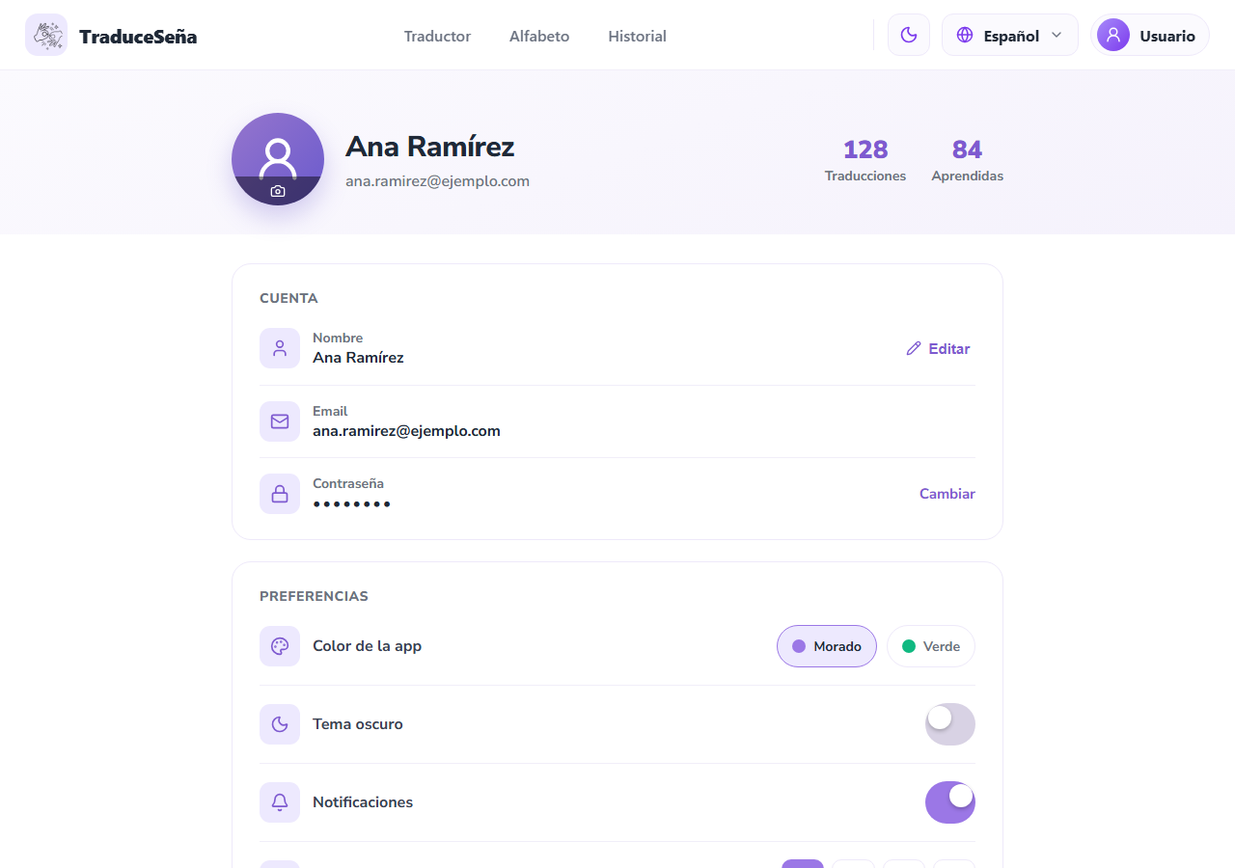
Note. High-fidelity project prototype (folder 12-ux-ui/mockup of the documentation repository).
Figure 8
Prototype — User achievements
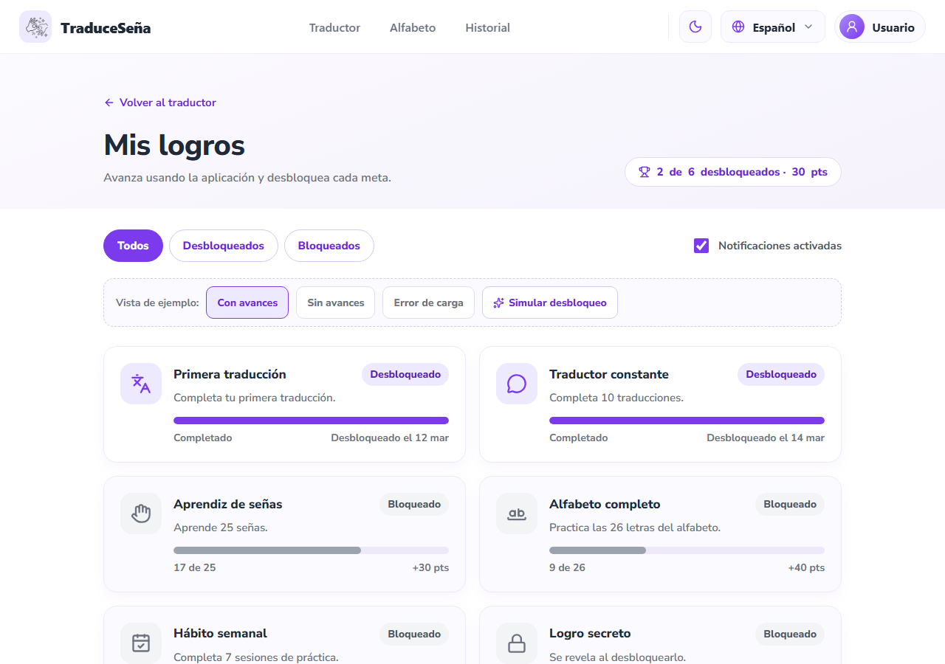
Note. High-fidelity project prototype (folder 12-ux-ui/mockup of the documentation repository).
Figure 9
Prototype — Administration panel
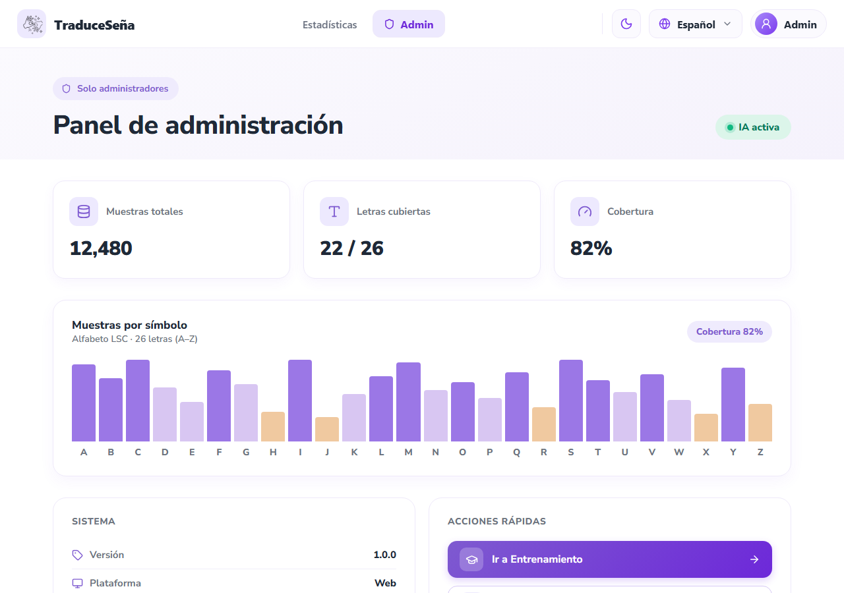
Note. High-fidelity project prototype (folder 12-ux-ui/mockup of the documentation repository).
Figure 10
Prototype — Usage statistics
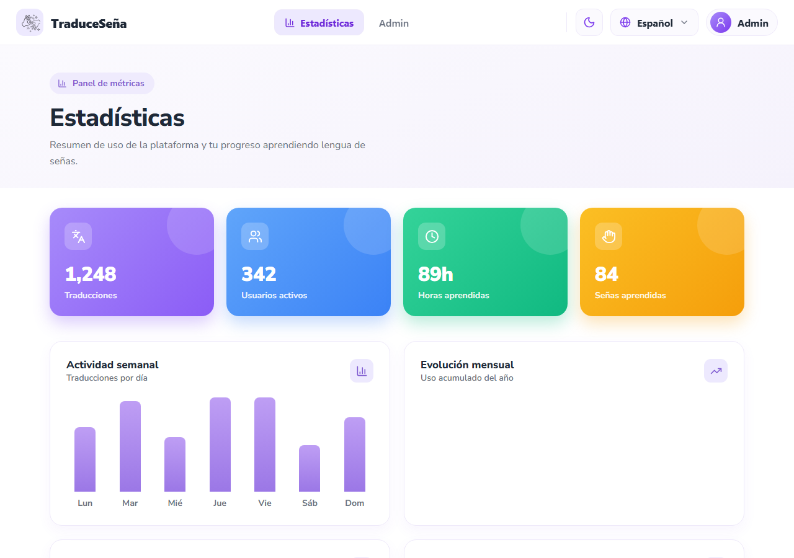
Note. High-fidelity project prototype (folder 12-ux-ui/mockup of the documentation repository).
Figure 11
Prototype — Sample capture for training
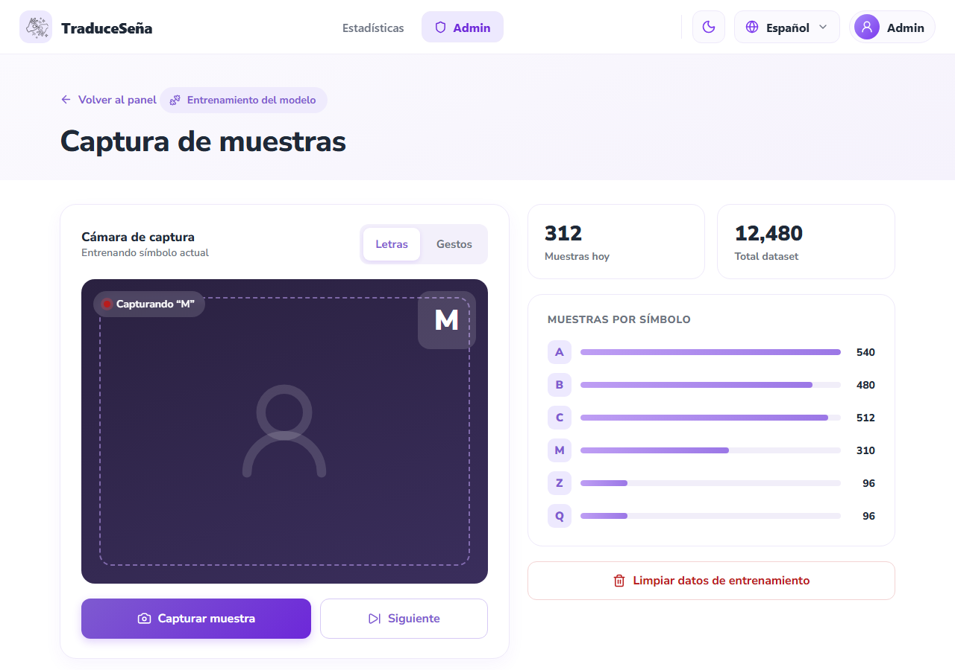
Note. High-fidelity project prototype (folder 12-ux-ui/mockup of the documentation repository).

Architectural model

Architectural style
The backend follows a microservices architecture (Newman, 2021): five domain services behind an API Gateway. Each service has its own process, its own Dockerfile, and its own database; none reads another's database. Synchronous communication is REST through the gateway, and asynchronous communication consists of domain events over RabbitMQ.
Internally, each service applies the hexagonal or ports-and-adapters architecture (Cockburn, 2005; Martin, 2017): the domain and the use cases are at the center and do not know Express, PostgreSQL, or RabbitMQ.

Container view
Figure 12
Container view (C4 model, level 2)
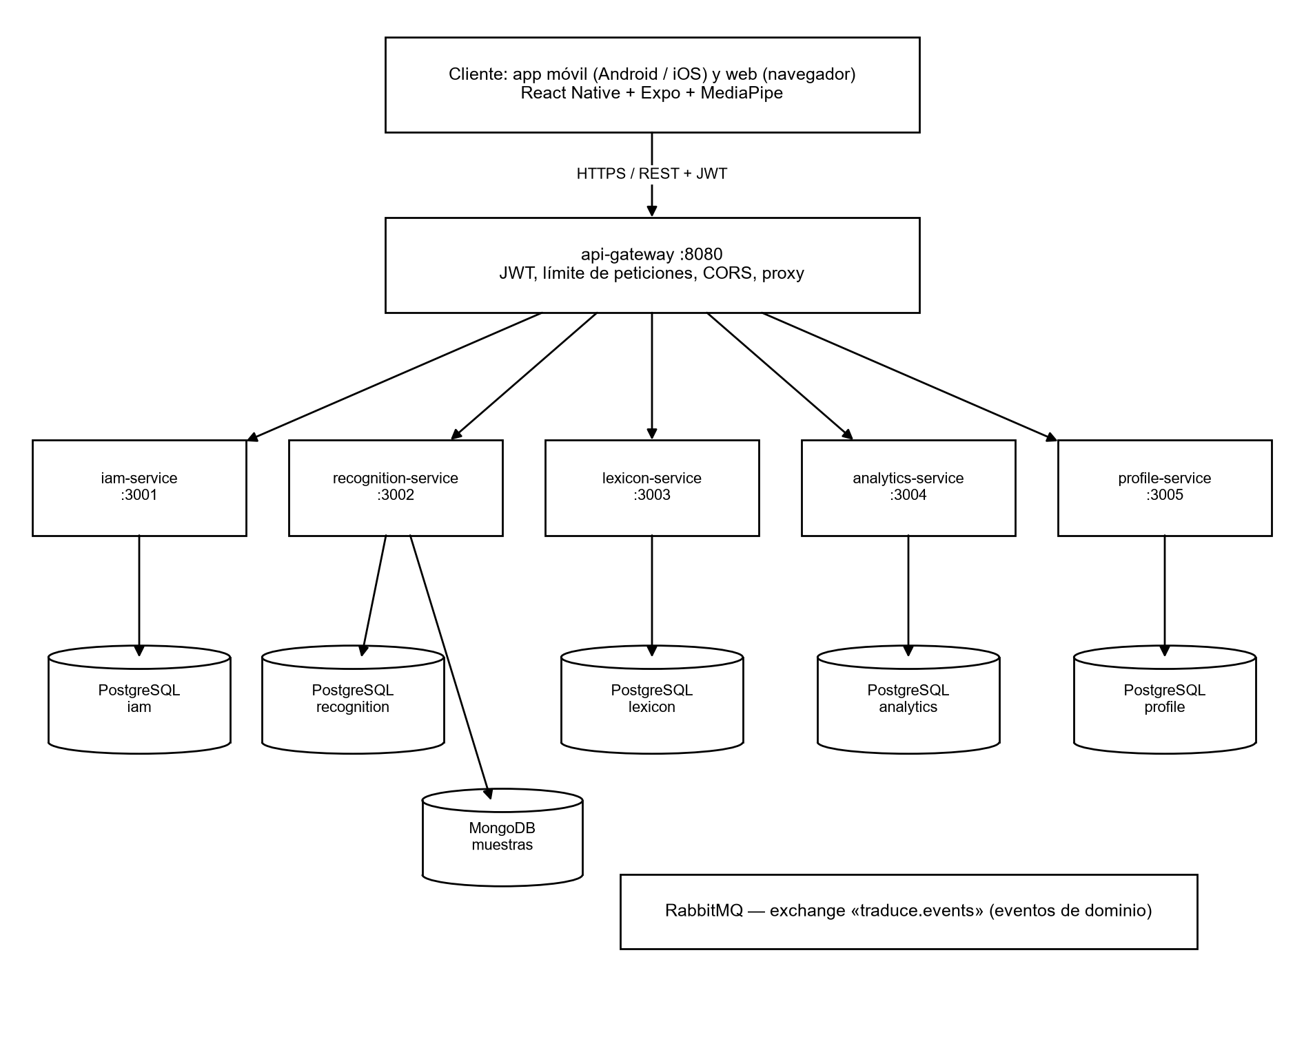
Note. Own elaboration based on the C4 model (Brown, 2018).
Table 3
Backend components
Component | Port | Responsibility | Storage
api-gateway | 8080 | Single entry point, JWT validation, request rate limit, CORS with allowlist, proxy | —
iam-service | 3001 | Registration, sign-in, email verification, roles and permissions, recovery | PostgreSQL iam
recognition-service | 3002 | Translations, sign templates, samples, and training | PostgreSQL recognition + MongoDB
lexicon-service | 3003 | Sign catalog, categories, locations, 3D alphabet, and media | PostgreSQL lexicon + .glb/.png files
analytics-service | 3004 | Usage events and aggregated statistics | PostgreSQL analytics
profile-service | 3005 | Profile, preferences, notifications, and achievements | PostgreSQL profile
@traduce/shared | — | Common package: configuration, JWT, HTTP middleware, and event bus | —

Internal architecture of each service
Figure 13
Hexagonal architecture of a microservice
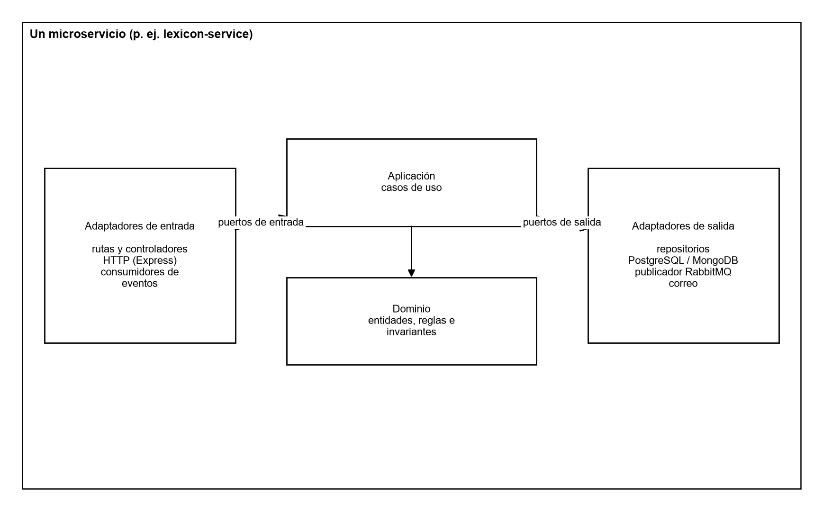
Note. Own elaboration.
services/lexicon-service/src/
├── domain/ entities, rules, and invariants
├── application/ use cases
├── ports/ input and output interfaces
├── adapters/
│ ├── inbound/http/ Express routes and controllers
│ └── outbound/ PostgreSQL repositories, RabbitMQ publisher
├── lexicon.module.ts composition (dependency injection)
└── app.ts service startup

Client architecture
The client is organized by feature (src/feature/Translation, Alphabet, auth, History, Profile, Stats, Admin, homescreen) and, within each one, by layer. Shared pieces live in src/shared and configuration in src/app.
Figure 14
React Native client layers
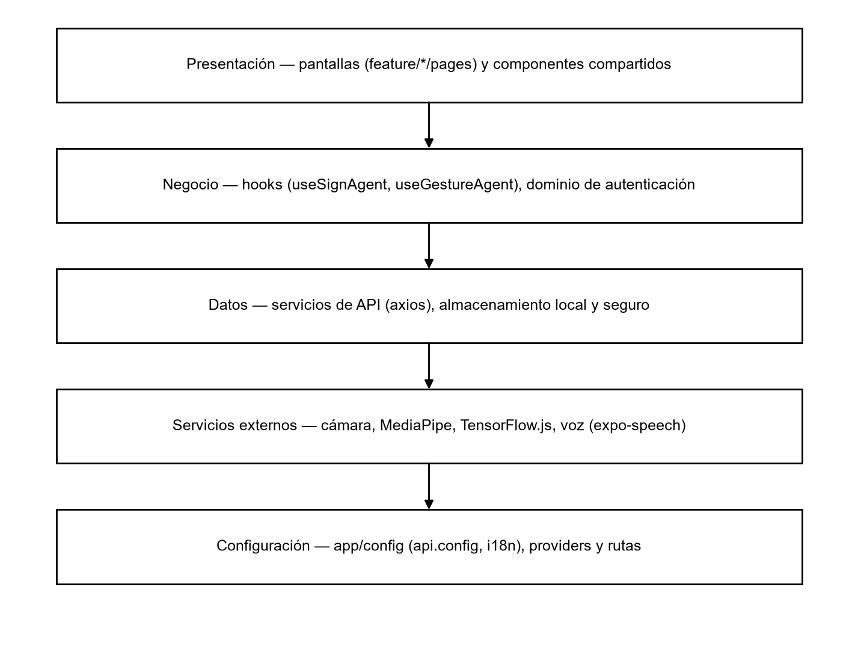
Note. Own elaboration.

Deployment view
Figure 15
Deployment diagram
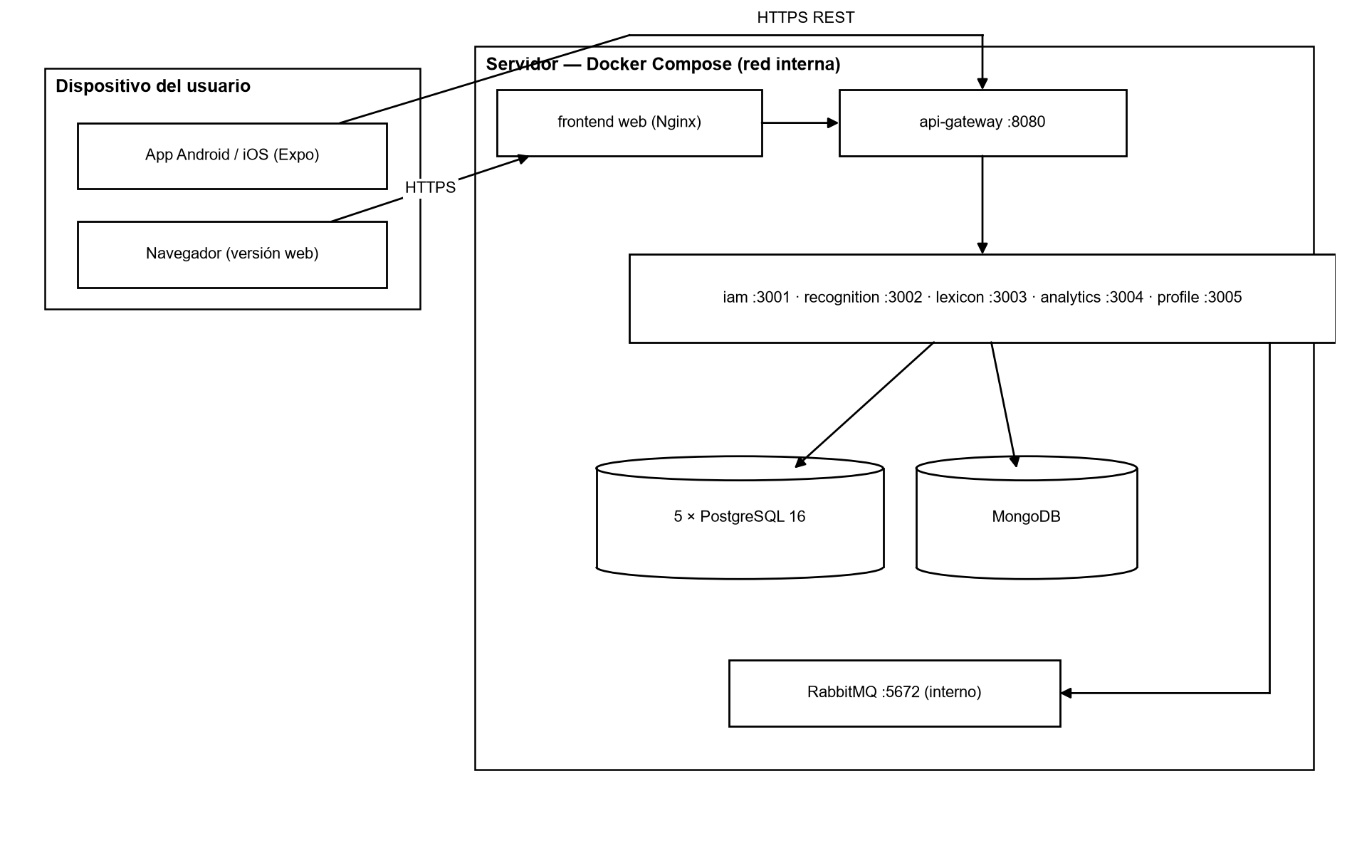
Note. Own elaboration.

Design patterns
The following table summarizes the patterns applied, where they are used, and what problem they solve. They are classified as architectural patterns, object-oriented design patterns (Gamma et al., 1994), and integration patterns.
Table 4
Design patterns applied
Pattern | Type | Where it is applied | Problem it solves
Ports and adapters (hexagonal) | Architectural | All microservices (domain/, ports/, adapters/) | Isolates business logic from technology
API Gateway | Architectural / integration | services/api-gateway | The client knows a single address; security is centralized
Database per service | Architectural | One PostgreSQL per service in docker-compose | Independence of deployment and schema
Publish-subscribe (domain events) | Integration | RabbitMQ bus in @traduce/shared; exchange traduce.events | Coordination without synchronous coupling
Repository | Design (Fowler, 2002) | PostgreSQL and MongoDB output adapters | Data access behind a domain interface
Dependency injection / composition root | Design | *.module.ts of each service | Use cases receive their ports already built; facilitates testing
Strategy | Behavior (GoF) | Client gesture providers: mediapipeProvider, tfjsProvider, mockProvider | Change the recognition engine without touching the screen
Adapter | Structural (GoF) | .web.ts files and native client files (gestureProvider.web.ts) | The same interface works on web and mobile
Chain of responsibility | Behavior (GoF) | Express middleware: CORS → rate limit → JWT → proxy | Each filter processes or rejects the request in order
Observer | Behavior (GoF) | React hooks (useSignAgent, useGestureAgent) and context providers | The interface reacts to changes in camera and session state
Data transfer object (DTO) | Design | Typed event contracts and HTTP responses | Stable contracts between layers and services
Retry with backoff | Resilience | subscribeWithRetry and event bus reconnection | Tolerates temporary RabbitMQ outages

SOLID principles
Table 5
Application of the SOLID principles
Principle | Application in the project
Single responsibility | Each use case is a class or function with a single task (for example, publishing a sign)
Open/closed | A new gesture provider is added by implementing the interface, without modifying the screen
Liskov substitution | The in-memory repositories in the tests substitute the PostgreSQL ones without changing behavior
Interface segregation | Small ports as needed (sign repository, event publisher, role reader)
Dependency inversion | The domain defines the ports; the infrastructure implements them and is injected into the module

Data model

Model criteria
- One database per service; between services only logical identifiers are stored, without foreign keys.
- Relational data in PostgreSQL and gesture samples in MongoDB, because their structure varies and their volume grows separately.
- Logical deletion where the law or auditing requires it (history, anonymized accounts).
- Database constraints for critical rules: normalized and unique email, valid states, codes with attempts ≥ 0, one location per language.
- Names in English and in snake_case; primary keys with _id suffix; dates as TIMESTAMPTZ.

Entity-relationship diagram
Figure 16
Entity-relationship model of the main services (implemented)
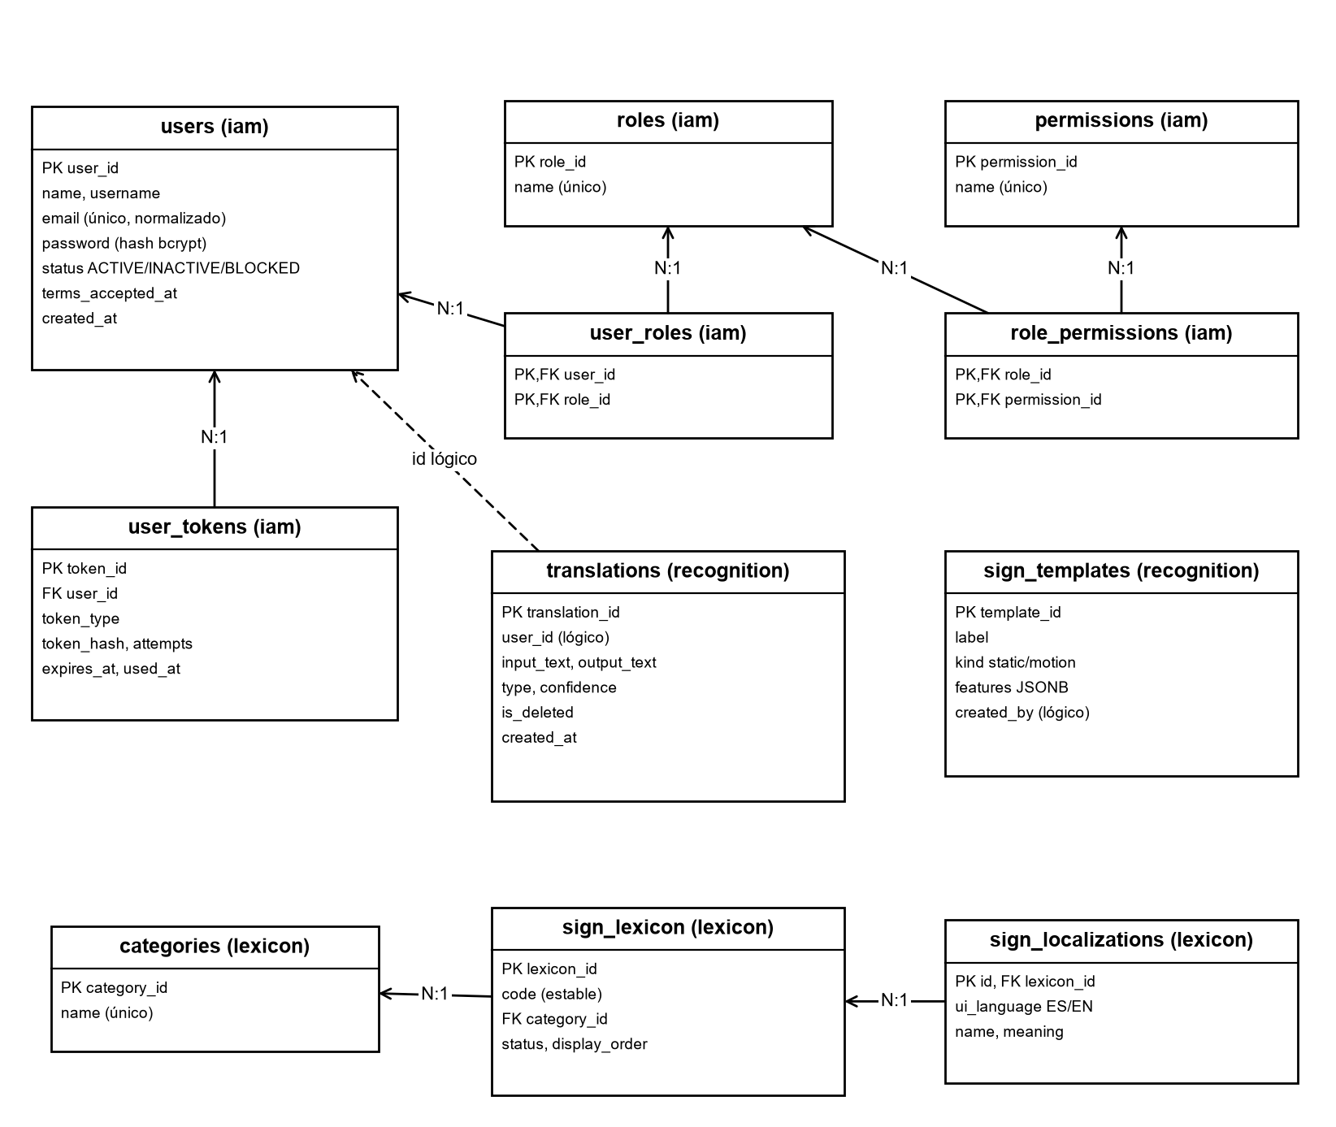
Note. Dashed lines indicate logical references between services, without foreign keys.

Summary data dictionary
Table 6
Data dictionary — users (iam-service)
Field | Type | Constraint | Description
user_id | SERIAL | PK | User identifier
name | VARCHAR(120) | NOT NULL | Full name
email | VARCHAR(255) | UNIQUE, normalized | Email in lowercase and without spaces
password | VARCHAR(255) | NOT NULL | bcrypt hash of the password
status | VARCHAR | ACTIVE / INACTIVE / BLOCKED | Account status
terms_accepted_at | TIMESTAMPTZ | — | Date terms were accepted (Law 1581)

Table 7
Data dictionary — user_tokens (iam-service)
Field | Type | Constraint | Description
token_id | SERIAL | PK | Identifier
user_id | INT | FK users | Code owner
token_type | VARCHAR(30) | EMAIL_VERIFICATION / PASSWORD_RESET | Code use
token_hash | VARCHAR(255) | NOT NULL | Hash of the code; never in plain text
attempts | INT | ≥ 0 | Failed validation attempts
expires_at / used_at | TIMESTAMPTZ | — | Expiration and single use

Table 8
Data dictionary — translations (recognition-service)
Field | Type | Constraint | Description
translation_id | SERIAL | PK | Identifier
user_id | INT | Logical reference to iam | Owner of the translation
input_text / output_text | TEXT | NOT NULL | Recognized signs and resulting text
confidence | NUMERIC(4,3) | 0 a 1 | Recognition confidence
is_deleted | BOOLEAN | Default FALSE | Logical deletion

Table 9
Data dictionary — sign_templates (recognition-service)
Field | Type | Constraint | Description
template_id | SERIAL | PK | Identifier
label | VARCHAR(80) | NOT NULL | Sign represented (letter or word)
kind | VARCHAR(10) | static / motion | Static or motion sign
features | JSONB | NOT NULL | Normalized points of the template

Table 10
Data dictionary — sign_lexicon and sign_localizations (lexicon-service)
Field | Type | Constraint | Description
lexicon_id | SERIAL | PK | Sign identifier
code | VARCHAR(50) | Stable | Language-independent code
category_id | INT | FK categories | Sign category
status | VARCHAR(10) | Default ACTIVE | Only ACTIVE is visible to the user
ui_language | VARCHAR(2) | ES / EN, unique per sign | Language of the localization
name / meaning | VARCHAR | NOT NULL | Name and meaning in that language

Table 11
Data dictionary — Other services
Table | Service | Key constraint | Content
usage_event | analytics | unique event_id | Usage event by section, type, and signs
user_profiles | profile | logical PK user_id | User presentation data
user_preferences | profile | ES/EN, LIGHT/DARK | Language, theme, and notifications
notifications | profile | PUSH / EMAIL / IN_APP channel | Visual-only notifications
achievements | profile | Meta > 0 | Achievement catalog and progress
gesture_samples | recognition (MongoDB) | Mandatory consent | Training samples

The complete target model has 29 tables grouped into ten domains (identity, authorization, profile, lexicon, translation, AI, notifications, usage, gamification, and auditing) and is maintained in DBML format in the documentation repository (06-data/traduce_senas.dbml). The tables shown here are those that already have a migration in the code.

Conclusions
The design combines an interface conceived first for accessibility with an architecture that separates responsibilities at two levels: between services (microservices with their own database) and within each service (hexagonal). The applied patterns make the code easy to test and change, and the data model protects critical rules with constraints in the database itself.

References
Booch, G., Rumbaugh, J., & Jacobson, I. (2005). The unified modeling language user guide (2nd ed.). Addison-Wesley.
Brown, S. (2018). The C4 model for visualising software architecture. https://c4model.com/
Cockburn, A. (2005). Hexagonal architecture. https://alistair.cockburn.us/hexagonal-architecture/
Evans, E. (2003). Domain-driven design: Tackling complexity in the heart of software. Addison-Wesley.
Fowler, M. (2002). Patterns of enterprise application architecture. Addison-Wesley.
Gamma, E., Helm, R., Johnson, R., & Vlissides, J. (1994). Design patterns: Elements of reusable object-oriented software. Addison-Wesley.
Martin, R. C. (2017). Clean architecture: A craftsman's guide to software structure and design. Prentice Hall.
Newman, S. (2021). Building microservices: Designing fine-grained systems (2nd ed.). O'Reilly Media.
Nielsen, J. (1994). Usability engineering. Morgan Kaufmann.
World Wide Web Consortium. (2018). Web Content Accessibility Guidelines (WCAG) 2.1. W3C. https://www.w3.org/TR/WCAG21/

