CODE ARTIFACTS (DESKTOP, WEB AND MOBILE APPLICATION)

PROJECT: Traduce Señas

TEAM MEMBERS:
Luis Alejandro Duarte Aldana
Juan Mauricio Suaza Solorzano
Juan Camilo Fierro Esquivel

NATIONAL LEARNING SERVICE – SENA
Software Analysis and Development

2026
Table of Contents
Introduction 3
Project repositories 3
Client artifact: cross-platform application 3
Description 3
Folder structure 4
Main client components 4
Main dependencies 5
Server artifact: microservices backend 5
Microservices architecture 5
Communication between microservices 7
Structure of the service repositories 7
Internal structure of each microservice 7
Inventory and code size 8
Exposed interfaces 9
Building the artifacts 9
Backend: one artifact per microservice 9
Mobile application 9
Web and desktop application 10
Code conventions and version control 10
Conclusions 10
References 11

Introduction
This document inventories and describes the code artifacts that make up Traduce Señas: where each one is located, how it is organized, which technologies it uses, and how it is built for each target platform (mobile, web and desktop).
The goal is for any evaluator or new team member to be able to locate the source code, understand its structure and generate the executables without relying on verbal explanations.

Project repositories
Table 1
Source code repositories
Repository | URL | Content | Working branch
frontendTS | https://github.com/tadeo77789/frontendTS | React Native / Expo application (mobile, web and desktop) | fix/traduccion-en-vivo
backendTS | https://github.com/mauro-1508/backendTS | API Gateway, five microservices and shared package | feat/microservices-split
trans-sl-docs | https://github.com/code-sena/trans-sl-docs | Technical documentation, OpenAPI contracts and prototypes | main
Note. The branches correspond to the state as of October 7, 2026. Changes are merged into main through pull requests using squash and merge.

Client artifact: cross-platform application

Description
The client is a single TypeScript codebase, built with React Native 0.86 and Expo 57, which is compiled for three targets. The react-native-web library allows the same components to run in the browser; files with the .web.ts suffix contain the web-specific implementations (for example, access to MediaPipe in the browser), and Expo selects them automatically depending on the platform.
Table 2
Client targets
Target | Delivery method | User device requirements
Mobile (Android / iOS) | Native application generated with Expo; in development it runs with Expo Go | Android 9+ or iOS 14+, camera
Web | Static site generated with “expo export --platform web” and served by Nginx in a Docker container | Up-to-date browser with camera access
Desktop | The same web application opened in the browser of a computer (Windows, macOS or Linux), with a layout adapted to screens ≥ 1024 px | Computer with webcam and Chrome, Edge or Firefox browser
Note. No native desktop installer is generated: the desktop version is the responsive web application, which avoids maintaining a fourth codebase.

Folder structure
frontend/
├── App.tsx entry point
├── app.json Expo configuration
├── Dockerfile, nginx.conf build and server for the web version
└── src/
├── app/ config (api.config.ts, i18n), providers, routes
├── feature/
│ ├── auth/ login, registration, verification, passwords
│ ├── Translation/ translation screen and vision engine
│ │ └── services/vision/ mediapipeProvider, classifier, normalize, wordEngine…
│ ├── Alphabet/ alphabet with 3D models (.glb)
│ ├── History/ translation history
│ ├── Profile/ profile, terms and privacy
│ ├── Stats/ statistics (administrator)
│ ├── Admin/ dashboard, training and samples
│ └── homescreen/ landing page, about us and public demos
├── shared/ components, hooks, types, utilities and constants
└── assets/ fonts, icons, images and alphabet 3D models

Main client components
Table 3
Key client files
File | Function
src/app/config/api.config.ts | Base URL of the backend. In development it still points to port 3000 of the previous backend; it must be changed to port 8080 of the API Gateway. In production it uses /api (web) and https://api.traducsenas.com/api (mobile)
feature/Translation/pages/TranslationScreen.tsx | Translation screen with Words / Alphabet selector
feature/Translation/hooks/useSignAgent.ts, useGestureAgent.ts | Capture, recognition and result publication cycle
services/vision/mediapipeProvider(.web).ts | Obtains the 21 hand landmarks in each frame
services/vision/normalize.ts | Centers on the wrist and scales by palm size
services/vision/classifier.ts, knnClassifier.ts, motionClassifier.ts | Classification of static letters and signs with movement
services/vision/templateStore.ts, motionTemplateStore.ts | Loading and caching of sign templates
services/translations.service.ts | Stores and queries the history in the backend
feature/auth/services | Real login against the backend and token handling

Main dependencies
Table 4
Client dependencies
Package | Version | Purpose
expo | 57 | Cross-platform build platform
react / react-native | 19.2.3 / 0.86.3 | User interface
react-native-web | 0.21 | Browser execution
@mediapipe/tasks-vision | 0.10.14 | Hand detection
@tensorflow/tfjs | 4.22 | Classification models on the client
expo-camera | 57 | Camera access
expo-speech | 57 | Voice output
expo-secure-store / async-storage | 57 / 2.2 | Secure token and local preferences
@react-navigation/* | 6.x | Stack and tab navigation
axios | 1.7 | HTTP client for the gateway

Server artifact: microservices backend

Microservices architecture
The server is not a single application: it is divided into six artifacts that are built, run and deployed separately. An API Gateway receives all client requests and forwards them to five domain microservices. Each microservice has its own process, its own Dockerfile, its own port and its own database, and none of them reads another's database. The services communicate with each other only through domain events published on RabbitMQ (Newman, 2021).
Figure 1
Backend microservices architecture
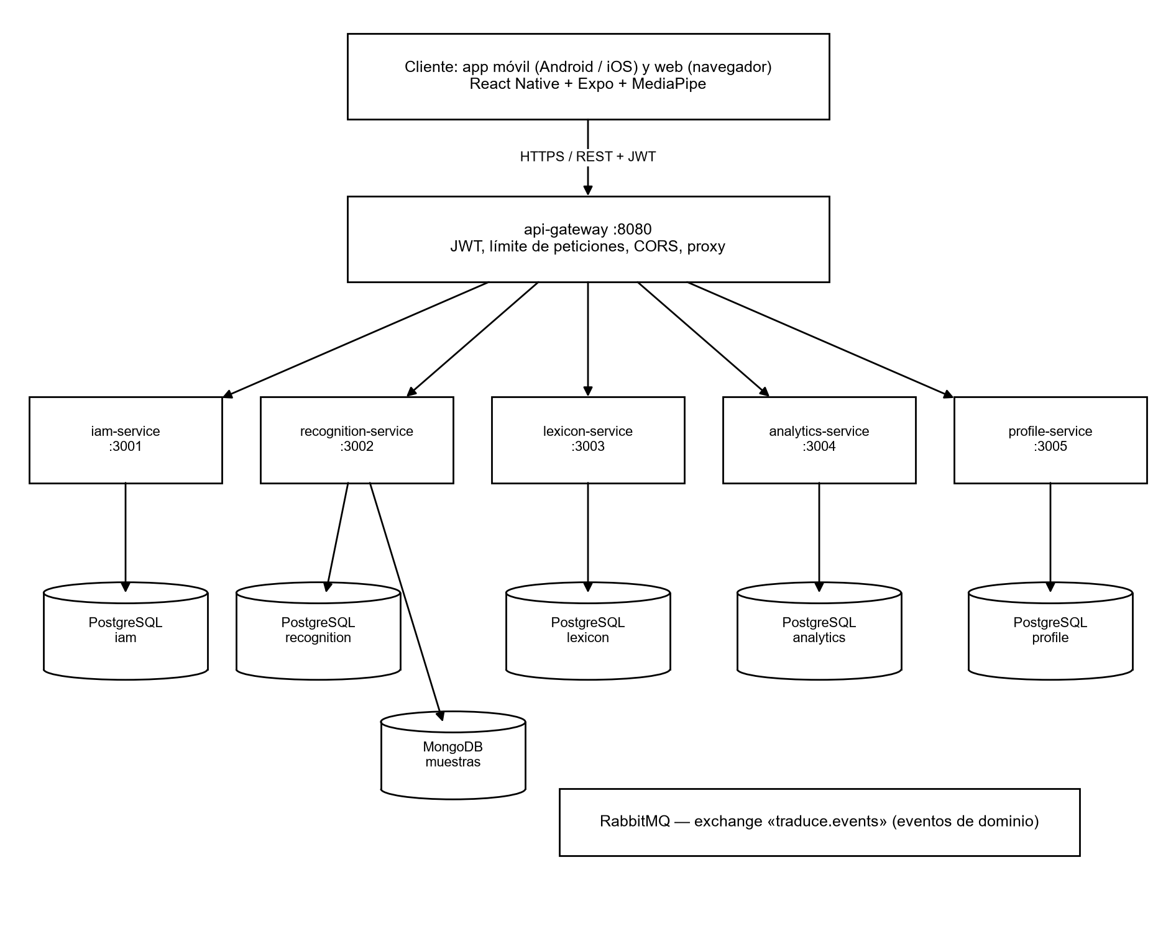
Note. Own elaboration.
Table 5
Deployable backend artifacts
Artifact | Responsibility | Port | Own database | Docker image
api-gateway | Single entry point: JWT, rate limiting, CORS and proxy | 8080 | — | services/api-gateway/Dockerfile
iam-service | Accounts, authentication, roles and permissions | 3001 | PostgreSQL iam | services/iam-service/Dockerfile
recognition-service | Translations, sign templates and samples | 3002 | PostgreSQL recognition + MongoDB | services/recognition-service/Dockerfile
lexicon-service | Sign catalog, categories and alphabet | 3003 | PostgreSQL lexicon | services/lexicon-service/Dockerfile
analytics-service | Usage events and statistics | 3004 | PostgreSQL analytics | services/analytics-service/Dockerfile
profile-service | Profile, preferences, notifications and achievements | 3005 | PostgreSQL profile | services/profile-service/Dockerfile
Note. The @traduce/shared package is not a service: it is a common library (configuration, JWT, middleware and event bus) that each microservice includes in its own image.

Communication between microservices
Table 6
Communication mechanisms
Type | Mechanism | Example
Client → backend | REST over HTTPS through the api-gateway, with JWT | POST /api/translations → recognition-service
Service → service | Asynchronous events in RabbitMQ (traduce.events exchange) | recognition.TranslationProduced → profile and analytics
Shared data | Logical identifiers only (user_id), with no foreign keys between databases | translations.user_id references iam without FK

Structure of the service repositories
The six artifacts are stored in a single repository to share build tools, but each one lives in its own folder with its package.json, its Dockerfile, its migrations and its tests:
backend/
├── docker-compose.yml orchestrates the 6 services, 5 PostgreSQL, MongoDB and RabbitMQ
├── packages/shared/ common library @traduce/shared
└── services/
├── api-gateway/ Dockerfile · package.json · src/ · tests/
├── iam-service/ Dockerfile · package.json · db/ · src/ · tests/
├── recognition-service/ Dockerfile · package.json · db/ · src/ · tests/
├── lexicon-service/ Dockerfile · package.json · db/ · src/ · tests/
├── analytics-service/ Dockerfile · package.json · db/ · src/ · tests/
└── profile-service/ Dockerfile · package.json · db/ · src/ · tests/

Internal structure of each microservice
Within each service, hexagonal architecture is applied: the domain and the use cases do not depend on Express or the database, but on ports implemented by adapters.
Figure 2
Hexagonal architecture within a microservice
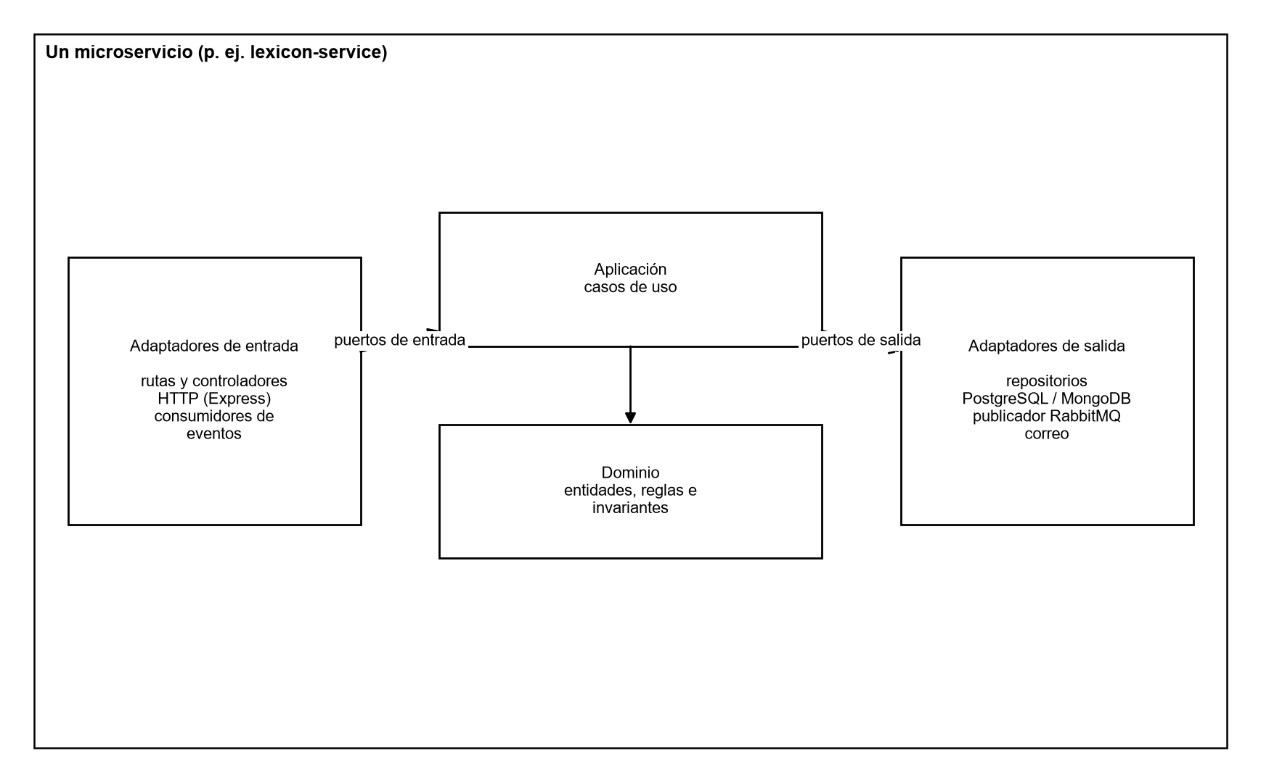
Note. Own elaboration.
services/lexicon-service/
├── Dockerfile
├── db/003_lexicon.sql migrations of its own database
└── src/
├── domain/ entities and rules
├── application/ use cases
├── ports/ interfaces
├── adapters/inbound/http/ Express routes
├── adapters/outbound/ PostgreSQL repository and event publisher
├── lexicon.module.ts dependency composition
└── app.ts service startup

Inventory and code size
Table 7
Code size by component
Component | .ts files (src) | Lines (src) | Test files
api-gateway | 7 | 265 | 1
iam-service | 77 | 2 094 | 22
recognition-service | 58 | 3 016 | 11
lexicon-service | 23 | 1 629 | 6
analytics-service | 13 | 487 | 4
profile-service | 20 | 823 | 4
@traduce/shared | 21 | 671 | 5
Total backend | 219 | 8 985 | 53
Client (frontend/src, .ts and .tsx) | 109 | 16 713 | —
Note. Count performed on October 7, 2026 on the branches indicated in Table 1.

Exposed interfaces
Table 8
Public API Gateway routes
Prefix | Service | Operation examples
/api/auth | iam-service | register, login, verify-email, resend-verification, forgot-password, reset-password
/api/users, /api/iam | iam-service | me, me/password, roles, role assignment to users
/api/translations | recognition-service | Save translation, history, logical deletion
/api/sign-templates, /api/samples, /api/recognition | recognition-service | Sign templates and training samples
/api/lexicon | lexicon-service | alphabet, search, categories, señas, publicar, localizaciones, recursos
/api/analytics | analytics-service | events, summary, daily, top-signs, reports/sections
/api/profile, /api/notifications, /api/achievements | profile-service | me, me/stats, notifications and achievements
Note. Complete OpenAPI contracts in 07-api/contracts/openapi of the documentation repository.

Building the artifacts

Backend: one artifact per microservice
Each microservice is built, tested and deployed independently:
cd backend
cp .env.example .env # JWT_SECRET (32+) and passwords
npm install
npm run build -w @traduce/lexicon-service # build a single service
npm test # tests for all services
docker compose build lexicon-service # single-service image
docker compose up -d --no-deps lexicon-service # deploy only that service
docker compose up --build -d # start all services

Mobile application
cd frontend
npm install
npx expo start --android # or --ios; opens in Expo Go
# To generate the installer (APK/AAB or IPA), EAS Build is used:
npx eas build --platform android

The EAS Build configuration (eas.json) is not yet in the repository; it is created when the first distribution installer is generated.

Web and desktop application
cd frontend
npx expo export --platform web --output-dir dist
docker build -t traduce-senas-web .
docker run -p 8081:80 traduce-senas-web

Code conventions and version control
- Strict TypeScript on the client and server.
- Backend file names in snake_case; React components in PascalCase.
- Commits in English following Conventional Commits (feat, fix, chore, docs, test, refactor).
- One branch per feature; work is never done directly on main.
- Pull request with review and squash and merge.
- Sensitive variables only in .env (excluded by .gitignore); never in the code.

Conclusions
The project's code artifacts are a single client delivered on mobile, web and desktop, and a microservices backend made up of an API Gateway and five domain services, each with its own Docker image and its own database. Each microservice can be built, tested and deployed without affecting the others, and Docker Compose makes it possible to start all of them together when the complete system is needed.

References
Broadcom. (2026). RabbitMQ documentation. https://www.rabbitmq.com/docs
Docker Inc. (2026). Docker Compose documentation. https://docs.docker.com/compose/
Expo. (2026). Expo documentation. https://docs.expo.dev/
Martin, R. C. (2017). Clean architecture: A craftsman's guide to software structure and design. Prentice Hall.
Newman, S. (2021). Building microservices: Designing fine-grained systems (2nd ed.). O'Reilly Media.
Zhang, F., Bazarevsky, V., Vakunov, A., Tkachenka, A., Sung, G., Chang, C.-L., & Grundmann, M. (2020). MediaPipe Hands: On-device real-time hand tracking (arXiv:2006.10214). arXiv. https://doi.org/10.48550/arXiv.2006.10214

