Traduce Señas:
Installation Manual

Juan Mauricio Suaza Solórzano
Luis Alejandro Duarte Aldana
Juan Camilo Fierro Esquivel

Instructor: Karol Daniela Correa
October 7, 2026
Table of Contents

Introduction
This manual explains how to get Traduce Señas running on a local computer with Docker. It does not cover production. It does not include configuration values: you define the keys and passwords yourself, and they are never written in this manual or in the repository.
Important warning
Today the complete Docker installation depends on changes that are not in any commit yet:
- The new Dockerfile with HEALTHCHECK and the new .dockerignore exist only as uncommitted changes on the Backend disk (local branch chore/docker-backend). That branch is older than develop: it has no email verification, no /api/iam, no users.status and none of migrations 003-006. It is not useful for running the system described in these manuals. The committed Dockerfile is identical in both branches, which is why the uncommitted changes can be carried over to develop (section 2.3).
- The Dockerfile that is in origin/develop does not define HEALTHCHECK, and docker-compose.yml makes the frontend wait for the backend to be "healthy" (service_healthy). With the develop Dockerfile, the frontend does not start with docker compose up.
- The docker-compose.yml, build-frontend.sh and build-backend.sh files are not in any of the three repositories: they live in the local infra/ folder of the project folder (sena/). Anyone who only clones the repos does not have them; ask the team for them.
Section 2.3 is the recommended route and section 2.4 an alternative.

1. Key Concepts

1.1 General Characteristics (Ports)
Table 1
General Characteristics (Ports)
Component | On your computer | Inside Docker
Web (nginx) | http://127.0.0.1:8080 | port 80
Backend (API) | http://127.0.0.1:3000 | port 3000
PostgreSQL 16 | 127.0.0.1:5433 | port 5432
All ports are published only on 127.0.0.1: nobody else on the network can connect. To test the app from a real phone you would have to remove 127.0.0.1: from the backend port, and do so only on trusted networks.
The web (nginx; F5, Inc., n.d.) serves the application and forwards everything starting with /api/ to the backend. There is no Redis or MongoDB.

1.2 Database Platform (Migrations)
The compose file mounts ../repos/Backend/migrations (relative to infra/) at /docker-entrypoint-initdb.d. PostgreSQL runs those .sql files in order only when the volume is empty (the first time; The PostgreSQL Global Development Group, n.d.).
- In origin/develop there are seven migrations: 000_users.sql, 001_translations.sql, 002_sign_templates.sql, 003_iam_roles_permissions.sql, 004_analytics_usage_events.sql, 005_auth_email_normalization_user_tokens.sql and 006_users_status_email_verification.sql.
- The schema depends on the branch that is on disk in repos/Backend/ (which must be an up-to-date develop, 2c4e62d): otherwise migrations 003 to 006 are missing and the roles, statistics and email verification features will not work. The local chore/docker-backend branch (and the outdated local develop, ad9815d) only have migrations 000 to 002: with them sign-up fails, /api/iam/me/access returns 404 and the first-use SQL statements (users.status, user_roles) do not work.
- If you change branches or a migration fails, you must reset the volume.

1.3 Configuration Variables (Names Only)
The backend reads these variables (Backend@develop:src/shared/config/config.ts). They are defined in repos/Backend/.env, which is never pushed to git:
Table 2
Configuration Variables (Names Only)
Variable | Purpose
PORT | Backend port (3000 if missing).
DB_HOST, DB_PORT, DB_USER, DB_PASSWORD, DB_NAME | PostgreSQL connection. With Docker Compose, the compose file sets them for you; you do not need to put them in .env.
JWT_SECRET | Secret used to sign sessions. Required. Choose a long, random text.
EMAIL_USER, EMAIL_PASS | Email account (gmail service) used to send the verification codes.
Steps:
- Copy the example file: cp repos/Backend/.env.example repos/Backend/.env (from sena/).
- Open repos/Backend/.env and fill in JWT_SECRET with your own value.
- If you want the code emails to be delivered, fill in EMAIL_USER and EMAIL_PASS (Gmail usually requires an "app password"). If you don't, sign-up works but the code does not arrive: activate the account manually (section 3.2).
The database credentials in the compose file are development values defined in docker-compose.yml itself. Do not copy them into any document or use them on a real server.

2. Installation

2.1 Requirements
Table 3
Requirements
You need | Details
Git | To clone the repositories.
Node.js 20 or later | JavaScript runtime (OpenJS Foundation, n.d.). Only for development mode without Docker (section 2.5). The images use Node inside the container.
Docker Desktop | With docker and docker compose available (Docker Inc., n.d.).
Disk space | Reserve several free GB: Docker images, node_modules and the recognition model.
Internet | To download images and dependencies, and for the browser to fetch MediaPipe when using the camera.
A bash-like terminal | On Windows, Git Bash. The build-*.sh scripts are bash.
An email account to send codes | Optional for testing (see section 1.3). Sending uses the gmail service of nodemailer.

2.2 Getting the Code
This is the recommended layout (the one used on the development team's machine): a sena/ folder with the three repositories inside repos/ and the infrastructure files in infra/. sena/ is not a git repository. Your teammates may have a different layout: the compose file and the scripts are outside the repos and only need to find Backend and Frontend through relative paths (the compose file uses ../repos/... from infra/; if you change the layout, adjust those paths).
sena/
repos/
Backend/ <- github.com/mauro-1508/backendTS (develop branch)
Frontend/ <- github.com/tadeo77789/frontendTS (develop branch)
Docs/ <- github.com/code-sena/trans-sl-docs (main branch)
infra/
docker-compose.yml <- NOT in any repo; ask the team for it
build-frontend.sh <- same
build-backend.sh <- same
mkdir -p sena/repos sena/infra && cd sena
git clone -b develop https://github.com/mauro-1508/backendTS.git repos/Backend
git clone -b develop https://github.com/tadeo77789/frontendTS.git repos/Frontend
git clone -b main https://github.com/code-sena/trans-sl-docs.git repos/Docs
The commands in this manual are run from the sena/ root (the git and cp ones) or from sena/infra/ (the docker compose ones and the build-*.sh scripts). Each block states where to run it from.
In the Backend repository, the main branch only has a README. The code is in develop: check with git -C repos/Backend branch --show-current.
Cloud-synced folders (OneDrive and similar). If you put sena/ in a synced folder, Docker (BuildKit) cannot read some of its files. That is why the build-*.sh scripts exist (section 2.3). Also, mark repos/Backend/migrations as "Always keep on this device"; otherwise the migrations mount may appear empty.

2.3 Installation With Docker (Recommended Route)
Requirements: docker-compose.yml and build-*.sh in infra/, and the Backend on an up-to-date develop branch (commit 2c4e62d), keeping the uncommitted changes to Dockerfile and .dockerignore.
Step A. Switch the Backend to develop and update it. The local develop may be behind origin/develop:
(from sena/)
git -C repos/Backend checkout develop
git -C repos/Backend pull --ff-only origin develop
git -C repos/Backend rev-parse --short HEAD # must show 2c4e62d
The uncommitted changes to Dockerfile and .dockerignore are kept because the committed version of those files is the same in chore/docker-backend and in develop. If Git refuses because of other modified files (for example .gitignore, which does differ between the branches), save a copy of that file, discard your changes to it and repeat the command. After the pull, add back to the end of .gitignore the lines from your copy that are missing (the liquibase.properties ones): they protect files with credentials and must not be lost.
Step B. Build and start, from sena/infra/:
cd infra
./build-frontend.sh
./build-backend.sh --dockerfile-from develop
docker compose up -d
What each command does:
- ./build-frontend.sh builds the traduce-senas-frontend:latest image. It sends the files of repos/Frontend/ to Docker as a tar (without node_modules, .git, dist or .expo) and builds the web app with Expo (Expo, n.d.) inside the image. It takes several minutes the first time.
- ./build-backend.sh --dockerfile-from develop builds traduce-senas-backend:latest. With that option, the current branch matches the "Dockerfile branch" and the script packages the working folder directly, that is, with the uncommitted Dockerfile that has HEALTHCHECK. Without the option, the script looks for the Dockerfile in chore/docker-backend and, being on develop, aborts because that committed Dockerfile is the same as develop's.
  - The script will always show "AVISO: se esperaba feat/email-verification…": that branch no longer exists and the warning is harmless.
  - It also warns if there are uncommitted changes (they are included in the image, which is expected) and if repos/Backend/.env is missing.
- docker compose up -d starts PostgreSQL, the backend and the web. The frontend waits for the backend to be healthy.
Why there are scripts instead of docker compose build: the project folder is usually cloud-synced and BuildKit cannot read those files (reparse points). The scripts avoid the problem by sending the context as a tar.
If you change the code, run the corresponding script again and then docker compose up -d.

2.4 Alternative Route Without the Uncommitted Changes
If you only have the three repos cloned (Backend on origin/develop) and the docker-compose.yml, follow these steps:
- Build the images with the names the compose file uses:
docker build -t traduce-senas-backend:latest repos/Backend
docker build -t traduce-senas-frontend:latest repos/Frontend
(These two commands are run from sena/. If sena/ is in a cloud-synced folder, this step may fail for the reason explained above; move the project to a local folder, e.g. C:\dev\sena. The following docker compose commands are run from sena/infra/.)
- Start the database and the backend first: docker compose up -d postgres backend.
- Start the web without waiting for the "healthcheck" that the origin/develop Dockerfile does not define: docker compose up -d --no-deps frontend.
On this route the backend will not have healthy status (there is no HEALTHCHECK): in 3.1, only check that it is running and that the API responds.

2.5 Development Mode Without Docker
Use it to program with automatic reload. You need Node 20+ and a PostgreSQL database.
- Database: you can use the compose one: docker compose up -d postgres (from infra/; it runs at 127.0.0.1:5433).
- Backend: in repos/Backend/:
npm install
cp .env.example .env
npm run dev
In .env set DB_HOST (127.0.0.1), DB_PORT (5433), DB_NAME (traduce_senas), DB_USER, DB_PASSWORD (the compose ones), JWT_SECRET, and optionally EMAIL_USER/EMAIL_PASS. Other commands: npm run build, npm start, npm test (uses vitest).
- Frontend: in repos/Frontend/: npm install and then npm run web (Expo). The terminal shows you the address. In development the web calls http://localhost:3000/api. Other commands: npm start, npm run android, npm run ios, npm run typecheck.

2.5.1 Port 3000 Conflict
The development backend uses port 3000, the same one the backend container publishes. If both run at the same time, they conflict. Stop the container before npm run dev:
docker compose stop backend
(The Docker web uses 8080, so with the development backend on 3000 you can keep the Docker database.)

2.6 Installation on a Production Server
This version of the project does not include a procedure for installing on a production server: the system runs on a local computer, as described in the previous sections.

3. Configuration and First Use

3.1 Checking That It Works
- Service status: docker compose ps. All three must be up (running). With the route in section 2.3, the backend and the database also show as healthy; with the route in section 2.4 the backend does not.
- Open http://127.0.0.1:8080: the home page must load.
Figure 1
Application Home Page
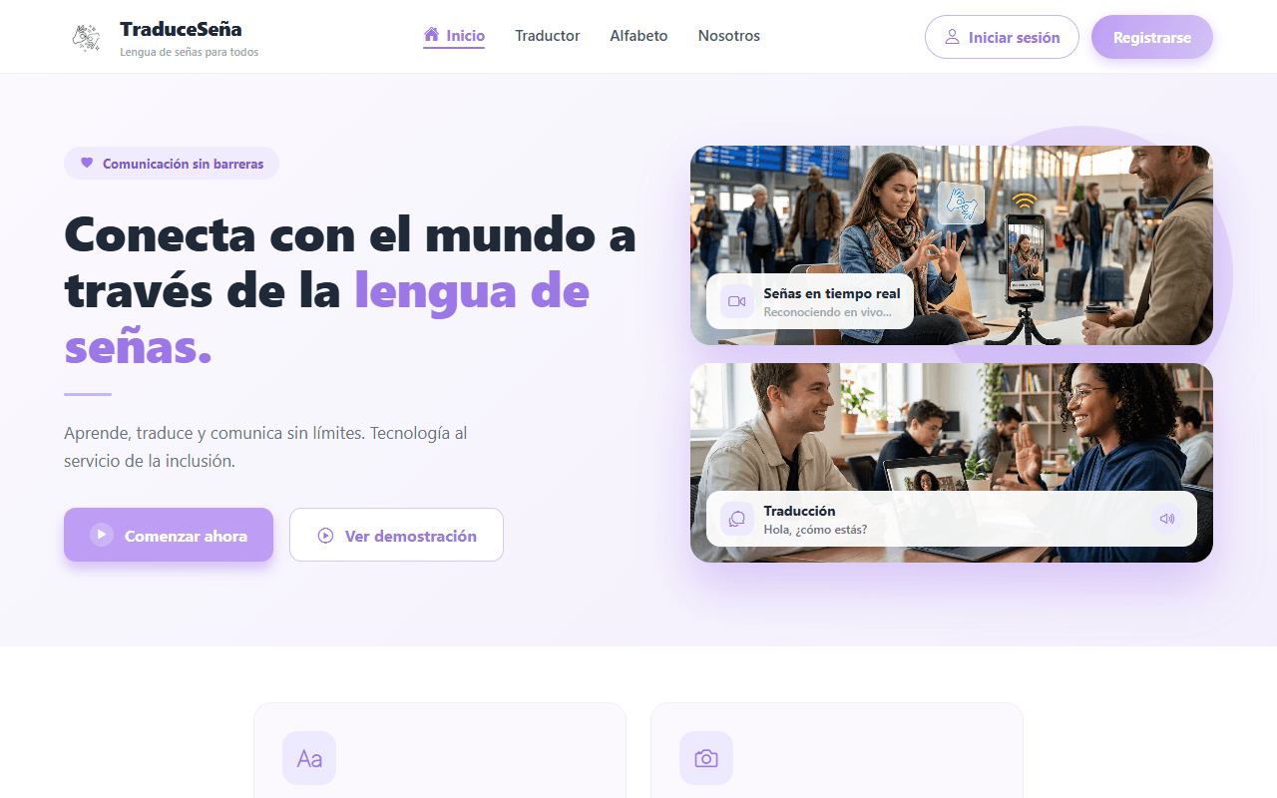
- Check that the API responds through the web: curl http://127.0.0.1:8080/api/sign-templates must return a JSON response (the list may be empty).
- If something fails: docker compose logs backend and docker compose logs postgres.

3.2 Creating and Activating the First Account
- On the web, tap Sign up and complete the Create your Account form.
- New accounts stay inactive until the email is confirmed with a code. If you configured EMAIL_USER and EMAIL_PASS, the code arrives by email. Otherwise, activate the account manually:
docker compose exec postgres psql -U <database_user> -d traduce_senas -c "UPDATE users SET status='ACTIVE' WHERE email='<email>'"
(<database_user> is the PostgreSQL user defined in the compose file.)

3.3 First Administrator
It is done with an SQL statement, only once. It is explained step by step in the Administrator manual, section 3. In short, the ADMIN role is inserted for that email in the user_roles table.

3.4 Resetting the Database (Deletes All Data)
This deletes ALL the data in the database (accounts, history, templates). Make a backup first if you care about it:
docker compose exec postgres pg_dump -U <database_user> traduce_senas > backup.sql
docker compose down -v
docker compose up -d

4. Operation
Table 4
Operation
I want to... | Command
Stop everything without deleting data | docker compose stop
Start again | docker compose up -d
Stop and remove containers (data is kept) | docker compose down
See backend messages | docker compose logs -f backend
Also delete the data | docker compose down -v (deletes the data)
Update the code | git pull in each repo (repos/Backend, repos/Frontend, repos/Docs), rebuild the images (section 2.3) and docker compose up -d. New migrations are not applied automatically to an existing database.

5. Common Problems
Table 5
Common Problems
Symptom | Likely cause | What to do
./build-backend.sh says the branch does not exist or that it "does not have the new Dockerfile committed" | You ran the script without --dockerfile-from develop: the chore/docker-backend branch does not exist or its Dockerfile is not committed | Run ./build-backend.sh --dockerfile-from develop (section 2.3) or use section 2.4
docker compose up fails with the frontend "has no healthcheck" | The backend Dockerfile is the develop one, without HEALTHCHECK | Section 2.4, step 3
The frontend does not start (nginx: host not found in upstream "backend") | Nginx needs the backend service to exist already | Start backend first; check docker compose logs frontend
The build fails with unreadable-file errors | Cloud-synced folder | Use the build-*.sh scripts or move the project to a local folder
Tables do not exist or roles/statistics are missing | Volume created with another branch, or a failed migration | Sections 1.2 and 3.4: reset the volume with the correct branch
Database error after the database name changed | The old volume has another database | docker compose down -v (deletes data)
The verification code does not arrive | EMAIL_USER/EMAIL_PASS not configured or rejected | Activate the account manually (3.2) or configure email
All users lose their session after a restart | JWT_SECRET changed or is empty | Set a fixed JWT_SECRET in repos/Backend/.env
Port 8080, 3000 or 5433 is in use | Another program is using it | Close that program or change the port in the compose file
The camera does not work on the web | The browser does not have permission | Accept the permission. Some browsers only allow the camera on localhost/127.0.0.1 or over HTTPS
npm run dev fails with "EADDRINUSE" | Port 3000 is taken by the container | docker compose stop backend

References
Docker Inc. (n.d.). Docker Compose. Docker Docs. Retrieved October 7, 2026, from https://docs.docker.com/compose/
Expo. (n.d.). Expo documentation. Retrieved October 7, 2026, from https://docs.expo.dev/
F5, Inc. (n.d.). nginx documentation. Retrieved October 7, 2026, from https://nginx.org/en/docs/
OpenJS Foundation. (n.d.). Node.js documentation. Retrieved October 7, 2026, from https://nodejs.org/docs/latest/api/
The PostgreSQL Global Development Group. (n.d.). PostgreSQL 16 documentation. Retrieved October 7, 2026, from https://www.postgresql.org/docs/16/

