The folder name in the google drive was not correct compared to jsons. I modified manually in the FTP (I copied the data from drive to FTP).

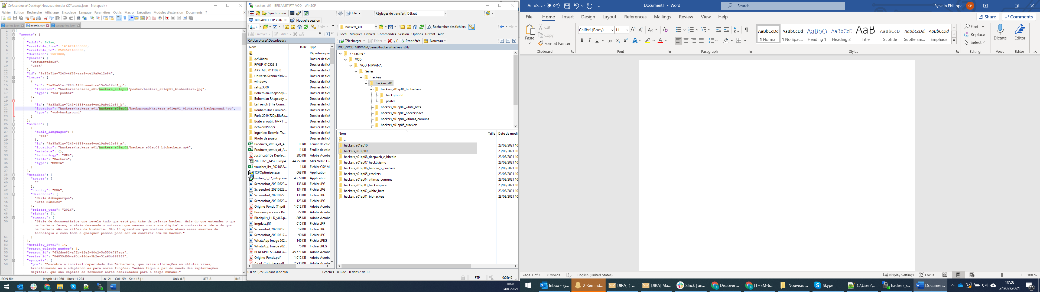

The file names of the background provided in the google drive is not correct compared to jsons (landscape instead of background). I changed the file name in the FTP.

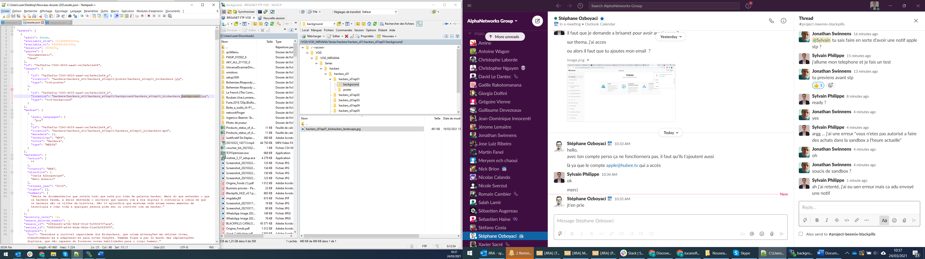

Genre = Geek is not interpreted. It is interpreted as Crime.

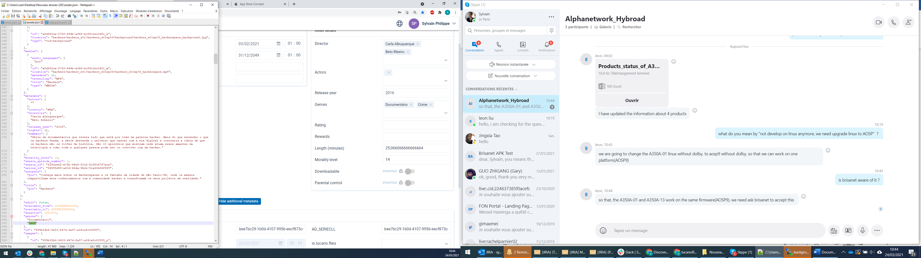

Categories.json is not correct.

It is needed to have a parent category (see example – all series), list all the series as category and set the parent category.

It is needed to set the series_id

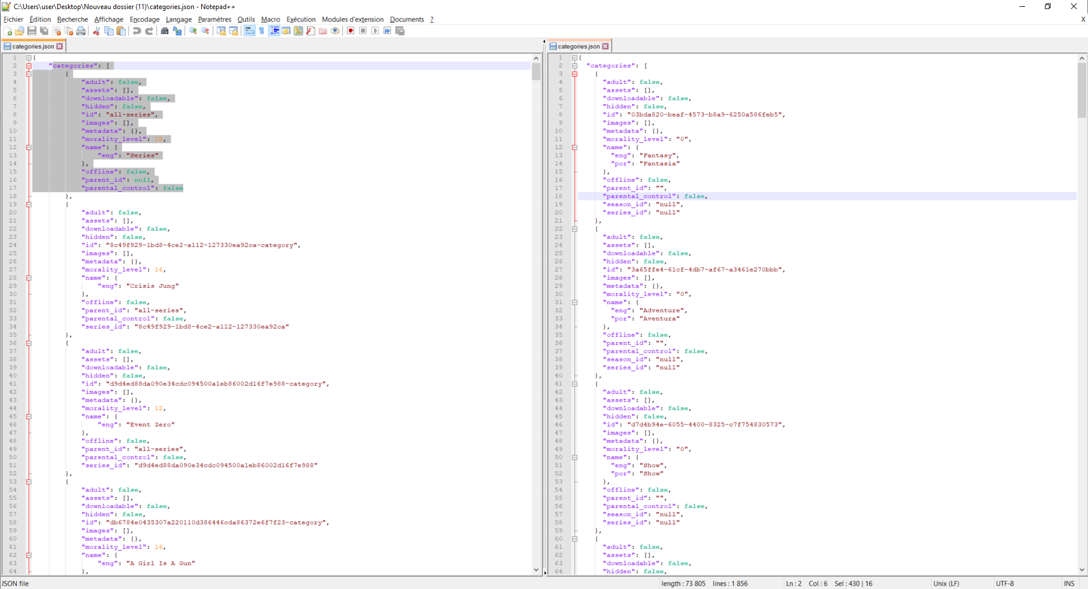

See the example of All Wrong which is a serie with 2 seasons.

