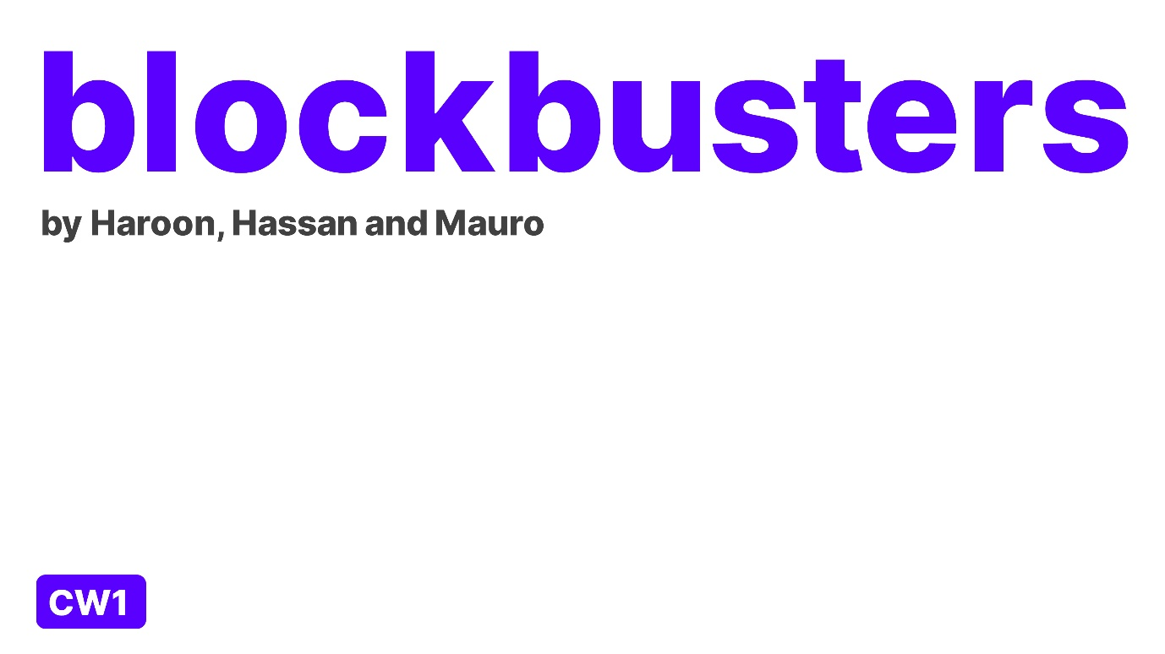

Contents

Project Background 2

Feature List 3

Use Case Diagrams 4

Use Case Documentation 5

Customer Use Case 5

Staff Use Case 6

ERD Diagrams 7

Class Diagrams 8

UI Designs (wireframes) 9

Extra Designs 12

Project Background

Blockbuster’s project is based around making a newer and better version of Netflix, or any streaming website that has already been made. We decided on making the project around Movies because we thought what gets people on the internet, so we first thought music, then YouTube and lastly video games. Not all of us were happy on choosing video games as the whole group was not big into games but we all decided that music would have been a great choice but none of our music choices were all the same, but we decided that everyone in the world loves movies even if they prefer different genres. We first wanted to make a simple application that allowed people just to watch movies by clicking on listed movies, but we decided at the end we would want to make a newer version of Netflix, such as we wanted to take in consideration user experience as some users find it difficult to find movies, sometimes the screen can be too dark and so many other issues that users have. Speaking on what the user required we understood that the user will want to watch, buy, or rent movies so we decided on this application will allow the user to stream a movie as the user could either rent the movie for a specific number of days on the other hand, they could buy the movie and download it to their device.

So, we first thought what pages will be needed as of course there will need to be a home page that included the name of the web application, an automatic slideshow of trending movies of the home page and links to the other page of the application. In addition, we will need to add a page where the user can search for a movie and read the descriptions and review, a page for where the user could check their basket within they could either add or delete some movies and lastly a page where they confirm their order and get a receipt that confirms their order showing when the movie will either be delivered to them or they will be able to download the movie.

Next, we thought of the user and staff process as what the process does the user need to go through to use our application as the start from registering/logging in to the web application to the end of where they buy/receive their purchase. Furthermore, we thought of what the staff will need to go through to manage the application as what will need to happen behind the scenes of our application to manage and uphold the structure of the application. All these processes will be contained in two different use cases one for the staff and one for the user. We knew that whatever the user did the staff will need something to do as well, as an example if the user searches frequently for a movie that has not been uploaded on the application the staff will need to add that movie later, also at the start when the user registers on the application for the first time the staff will need to add the account to the database.

After considering all the processes that the staff and user will need to go through we then thought of each process that will be added on each page from adding/deleting a movie into the basket, registering or logging in to the application but we decided that each thing that will be on each page will be shown on a ERD diagram that will also explain how each page has a relationship such as the movie page will be connected to the orders page by a primary and foreign key but with a many one many relationship. So, after making an ERD diagram it will be easier for us to see what will be needed on each page for the user.

Our main priority when making this application was taking into consideration different type of users as there are expert users on technology and beginners who find it difficult to use modern day technology, so we wanted to make this application modern and newer than any other application before, but we firstly wanted to make it simple to use. We looked at what main issues users have on applications, and we learned that it was small font was used in many applications and bad colours were used that made it difficult to see where some words were. The solution to this was allowing for user change as having something on the settings of the application that will allow the user to change the web application to their preference this does not mean changing the whole layout of the page but it means they will have the choice of changing background colours of the pages, words on each page as this will make it easier to see where is each thing in addition of being able to increase or decrease the size of the font to their preference.

After all that was stated above we chose colours/backgrounds that mixed well with each other, we chose on fonts that were clear to read, pages that included the register/login page, home page, movie page, purchase page where you will able to pay for your orders, add or delete movies to your order, order history page where you can check the history of the purchases you have made and then a page where you can watch the movie that you have bought straight on the website. On each page will be the name of the web application and a background that will keep on changing.

# Feature List

* The Customer will be ale to Register an Account
* The Customer will be able to Sign In with their own unique username and password
* The Customer will be able to Edit their Preferences as they will be able to choose which genre they prefer
* The Customer will be able to Search Movies by director or producer of the movies
* The Customer will be able to Add Movies to their Basket
* The Customer will be able to View their Basket
* The Customer will be able to Remove Movies from their basket which they do not wish to purchase
* The Customer will be able to Edit/Input Card Details to ensure they can pay for their order
* The Customer will be able to Remove Order as start the whole order from scratch
* The Customer will be able to Edit/Input the Billing Address to ensure that the download is sent to the correct device
* The Customer will be able to Confirm Order after the Card Details and Billing Address has been accepted
* The Customer will be able to Get an E-receipt which will confirm their Order and Payment
* The Staff will be able to Add Movies
* The Staff will be able to Remove Movies
* The Staff will be able to Edit Movies

# Graphical user interface Description automatically generatedUse Case Diagrams

# Use Case Documentation

Customer Use Case

Register Account - The user will first register their details such as name/username, password, address, email address and etc.  
  
Sign in - After the user has registered their details, the user will be allowed to sign in and will have a choice of the application to remember them or not every time they log in  
  
Edit Preferences - The user will have the choice of adding their preferences to a list that means if the user prefers a genre such as horror they will able to click on the horror genre and whenever they sign in to their account, the first thing that will pop up will be suggested horror movies  
  
Search Movies - After, seeing a movie they will want to rent/buy they can add this movie into their basket for purchase  
  
Add to Basket - After, seeing a movie they will want to rent/buy they can add this movie into their basket for purchase  
  
View Basket - Before proceeding with payment, the user will be able to check their basket, Extending this to sometimes the user will want to either remove a movie or add another movie  
  
Remove Movie - Removing or adding a movie in the basket is the process that will allow the user to either remove a movie from their basket or add more in case they decide that the movies they have chosen are not the correct ones.  
  
Edit Card Details - The user will need to input their card details so the payment can happen, adding card details like card number, CVS. date of expiry, as well as the cardholder name.  
  
Confirm Order - You confirm the order by checking all your details such as the billing address, card details are correct and you are certain that the movie you are wishing to get is the correct one.  
  
Remove Order - Sometimes, after inputting the billing address and the card details the user may want to get rid of their order and have the choice to do so.  
  
Edit Billing Address - The user will need to input a billing address for their order as if the movie is a DVD and not an online version the product will need to be delivered at a place  
  
Get E-Receipt - Getting an E-receipt will show what movie you have purchased, when you purchased it, it is important to keep the receipt in case the movie you have chosen is not up to quality and you will either want to exchange or return it

Staff Use Case

Store Details - After the user has registered their details with their name/email/number the staff will add these details in the database so they can see which customer is who

Add Account - After details have been put in the staff will allow the user to make the account, but if the account has details that have already been provided such as email address the user will be denied access on making an account details can only be used once  
  
Delete Account - The staff can delete accounts which have not been paying their monthly subscriptions  
  
Add Movie - The staff will either daily/weekly upload or remove movies based on how many people have either watched/liked/disliked it and new movies will be put by checking how many people have searched for a movie that has not been yet uploaded to the website.  
  
Remove Movie - This process will allow the staff to remove movies that either have been disliked too much or have not been watched by many users.  
  
Edit Movie - This process allows the staff to edit the movie, so if the users get complaints about not being able to understand the movie the staff will be able to add subtitles and even add higher resolution.

# ERD Diagrams

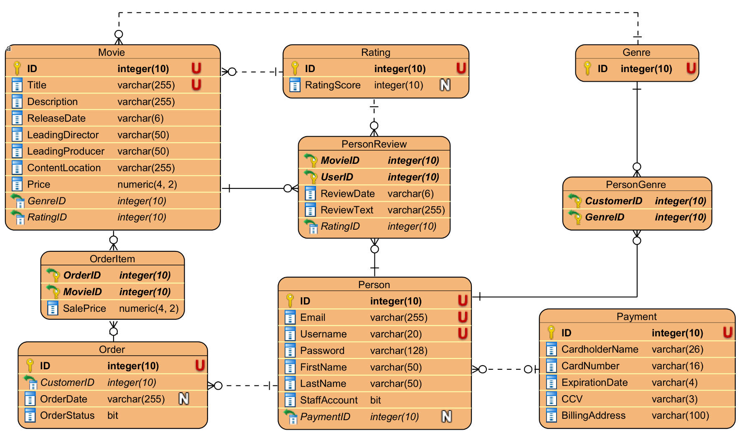

# Class Diagrams

# UI Designs (wireframes)

**Home**

**Explore**

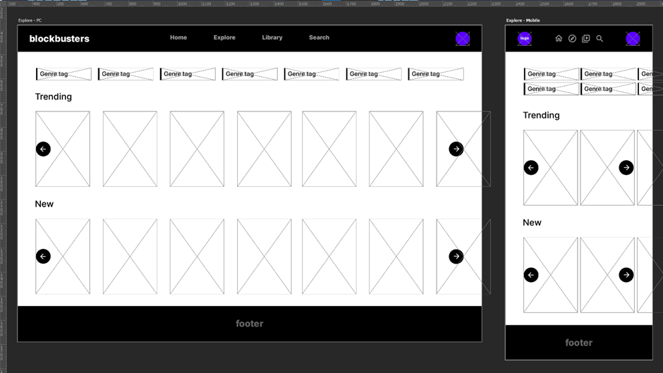

**Library**

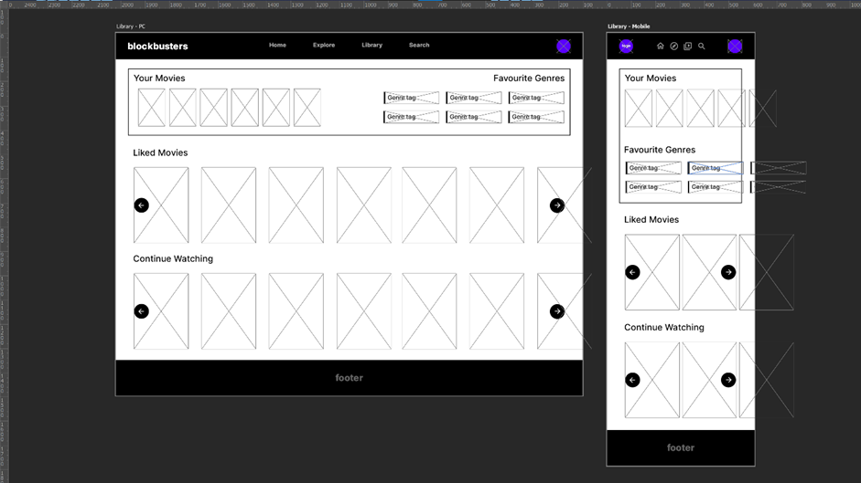

**Search**

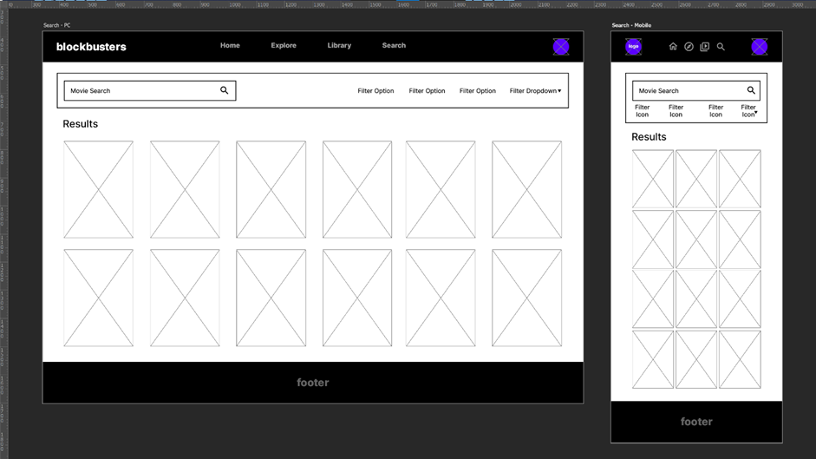

**Movies**

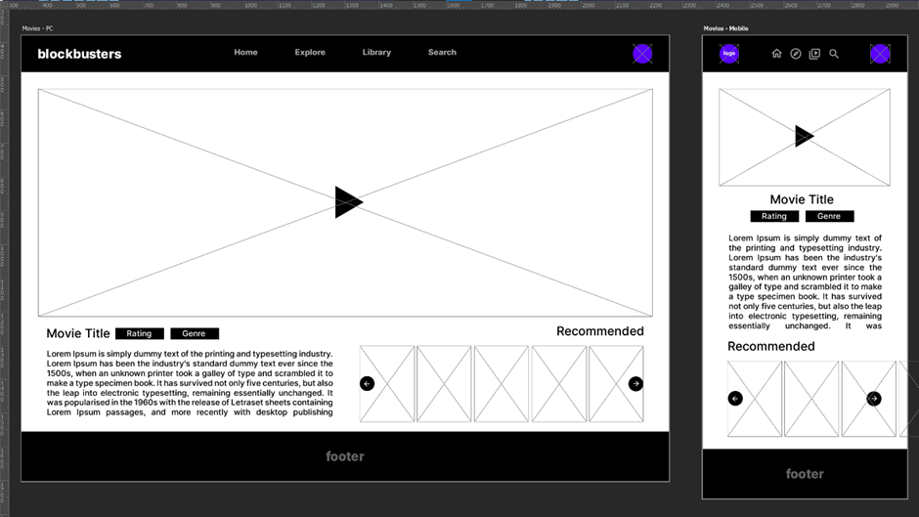

**Login**

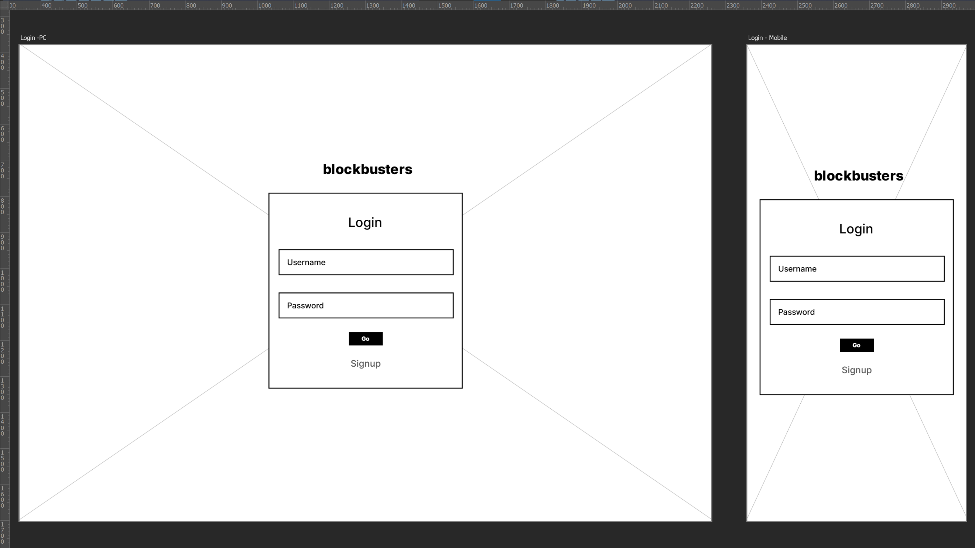

# Extra Designs

Activity Diagram for Signing Up

Activity Diagram for Purchasing a Movie