Ship to: PLANET IFE | Repair Note: {repairNote} | Date: {date}
Statement

P/N | SN | Repair Order | Description
73001020-013 | {snList} | {orderList} | The server(s) has been updated to the latest software version. The  software process was conducted by skilled personnel and no  alterations were made to the hardware. Functional tests have been.  performed, and the device has been verified to be fully operational  and ready for installation and use
 |  |  | 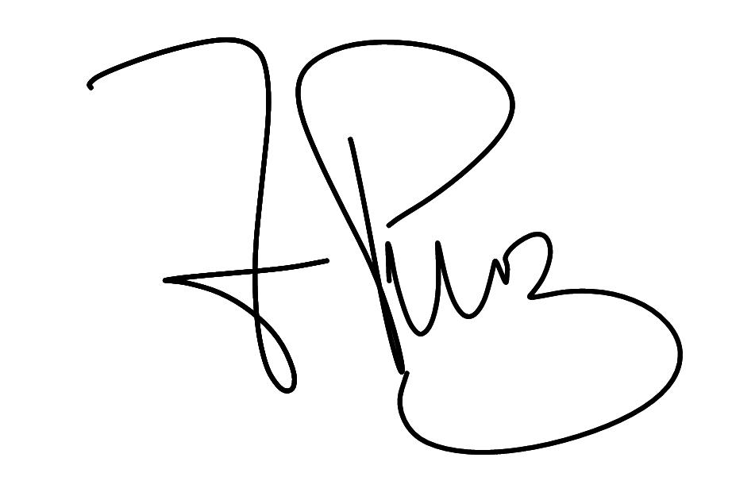
Freddy Mauricio Pérez.
Immfly Operations Team

