**-- Seleccionar todos los campos de la tabla**

**-- SELECT nombre_columna, nombre_columna2, ... FROM nombre_tabla**

SELECT * FROM actor; -- * para todas las columnas

SELECT first_name, last_name, email FROM customer;

**-- Seleccionar 10 registros de la tabla film**

**-- SELECT nombre_columna,... FROM nombre_tabla LIMIT numero_registros**

SELECT * FROM film LIMIT 10;

SELECT * FROM payment LIMIT 5;

**-- Seleccionar los 5 primeros registros despues de los primeros 100 registros**

**-- de la tabla clientes**

**-- SELECT columnas FROM nombre_tabla LIMIT numero_cuantos OFFSET numero_desde**

SELECT * FROM customer LIMIT 5 OFFSET 100;

**-- SELECT CON CONDICIONAL**

**-- Seleccionar todos los campos de clientes que se llamen John**

**-- SELECT columnas FROM nombre_tabla WHERE condicion**

SELECT * FROM customer WHERE first_name = 'John';

SELECT * FROM customer WHERE customer_id = 1;

**-- Si no conocemos el valor exacto para el nombre del cliente: LOWER, UPPER**

SELECT * FROM customer WHERE LOWER(first_name) = 'john';

SELECT * FROM customer WHERE UPPER(first_name) = 'JOHN';

**-- Si deseo consultar un dato pero no se su valor exacto puedo utilizar**

**-- LIKE junto con los signos % y _**

**-- % : zero a muchos caracteres y _: un unico caracter**

SELECT * FROM customer WHERE last_name LIKE 'Ma%';

SELECT * FROM customer WHERE last_name LIKE 'Ma____';

SELECT * FROM customer WHERE last_name LIKE '%tox';

SELECT * FROM customer WHERE UPPER(last_name) LIKE '%TOX';

**-- Seleccionar todos los campos de películas que tengan un rating de PG o G.**

SELECT * FROM film WHERE rating = 'PG' OR rating = 'G';

**-- Buscar valores especificos**

**-- SELECT columnas FROM nombre_table WHERE nombre_columna IN (valor1, valor2, ..., valorn)**

SELECT * FROM film WHERE rating IN ('PG', 'G', 'PG-13');

SELECT title FROM film WHERE LOWER(title) IN ('alice fantasia', 'blade polish');

**-- Buscar las peliculas con el id de 1 a 10**

**-- SELECT columnas FROM nombre_tabla WHERE nombre_columna BETWEEN numero AND numero;**

SELECT * FROM film WHERE film_id BETWEEN 1 AND 10;

SELECT * FROM film WHERE film_id >= 1 AND film_id <= 10;

**-- Buscar valores nulos o vacios**

**-- SELECT columnas FROM nombre_table WHERE nombre_columna IS NULL;**

**-- Selecionar todos los campos de la tabla direcciones DONDE direccion 2 sea NULL**

SELECT * FROM address WHERE address2 IS NULL;

**-- Seleccionar todos los campos de la tabla direcciones donde direccion 2 sea vacio**

SELECT * FROM address WHERE address2 = '';

**-- ORDER LOS REGISTROS**

**-- SELECT columnas FROM nombre_table**

**-- WHERE condicional (opcional)**

**-- ORDER BY columna(s)**

**-- DESC (opcional)**

**-- Seleccionar todos los campos de películas (film) y ordenarlos por su id.**

SELECT * FROM film

ORDER BY film_id;

**-- Seleccionar customer_id y rental_id de rental y**

**-- ordenarlos por customer_id y luego por rental_id**

SELECT customer_id, rental_id FROM rental

ORDER BY customer_id, rental_id; -- el orden importa

**-- puedo ordenar por**

SELECT * FROM film

ORDER BY title;

SELECT * FROM payment

SELECT MIN (amount) FROM payment

SELECT MAX (amount) FROM payment WHERE amount <= 7

SELECT MIN (payment_date) FROM PAYMENT

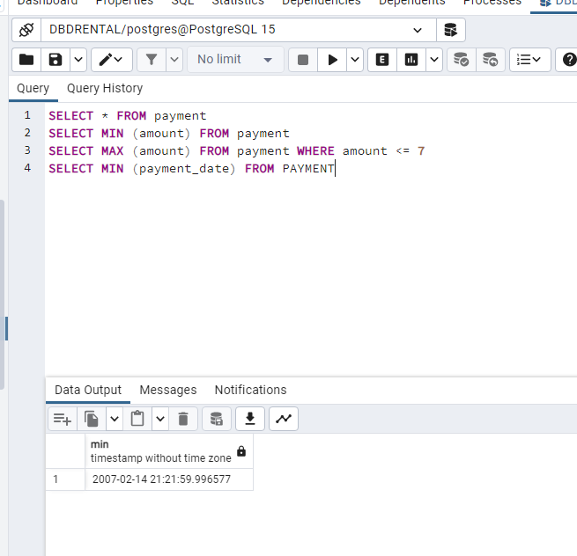

SELECT COUNT (* )FROM customer

**– Que no se repita**

SELECT COUNT (DISTINCT active) FROM customer

SELECT * FROM address ORDER BY postal_code

SELECT COUNT (DISTINCT postal_code) FROM address

SELECT COUNT (*) FROM address

**– El conteo a una columna especifica n cuenta los null**

SELECT rating, COUNT (rating) FROM FILM GROUP BY rating

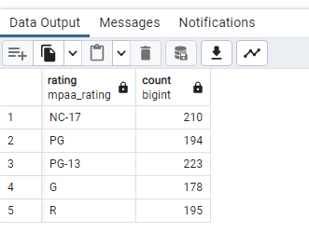

SELECT rating as Clasificación, COUNT (rating) as conteo FROM FILM GROUP BY rating

SELECT customer_id AS cliente, AVG (amount) as Promedio FROM payment GROUP BY customer_id

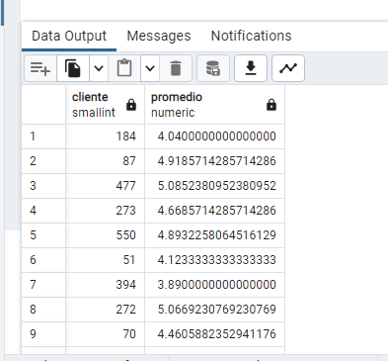

SELECT customer_id AS cliente, AVG (amount) as Promedio FROM payment GROUP BY customer_id ORDER BY Promedio DESC

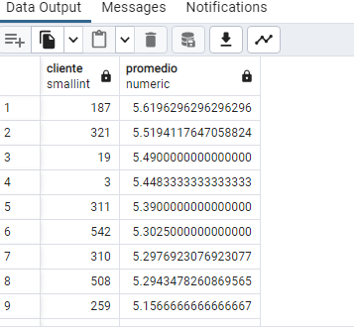

SELECT * FROM actor where first_name = 'Julia';

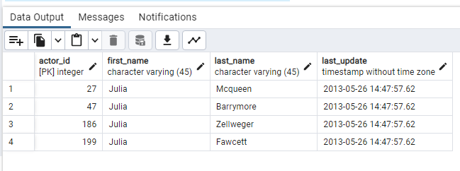

SELECT * FROM actor WHERE first_name IN ('Chris','Cameron','Cuba');

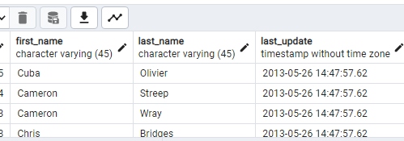

SELECT * FROM actor WHERE first_name IN ('Chris','Cameron','Cuba');

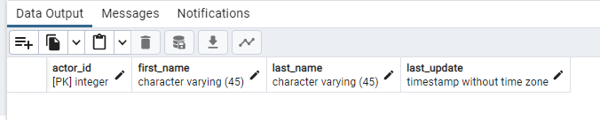

**Selecciona el monto y la fecha de pago de la tabla payment donde el monto pagado sea menor a $1.**

SELECT * FROM payment WHERE amount > 1;



SELECT * FROM rental WHERE rental_date IS NOT null ORDER BY return_date DESC LIMIT 3

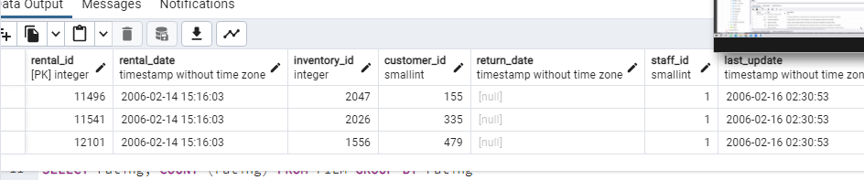

SELECT rating, COUNT (rating) FROM film WHERE rating IN ('NC-17','PG','PG-13') GROUP BY rating

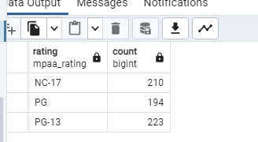

SELECT country_id, COUNT (*) FROM city GROUP BY country_id ORDER BY country_id

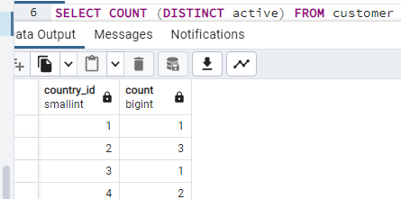

SELECT country_id, COUNT (*) as conteo FROM city GROUP BY country_id ORDER BY conteo

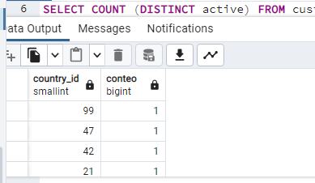

SELECT * FROM payment

SELECT MIN (amount) FROM payment

SELECT MAX (amount) FROM payment WHERE amount <= 7

SELECT MIN (payment_date) FROM PAYMENT

SELECT COUNT (* )FROM customer

SELECT COUNT (DISTINCT active) FROM customer

SELECT * FROM address ORDER BY postal_code

SELECT COUNT (DISTINCT postal_code) FROM address

SELECT COUNT (*) FROM

SELECT * FROM film

SELECT rating, COUNT (rating) FROM FILM GROUP BY rating

SELECT rating as Clasificación, COUNT (rating) as conteo FROM FILM GROUP BY rating

SELECT customer_id AS cliente, AVG (amount) as Promedio FROM payment GROUP BY customer_id ORDER BY Promedio DESC

**-- Selecciona las columnas film_id y title de la tabla film.**

SELECT * FROM actor where first_name = 'Julia';

**-- Obtén una lista de actores con los nombres Chris, Cameron o Cuba.**

SELECT * FROM actor WHERE first_name IN ('Chris','Cameron','Cuba');

**-- Selecciona la fila de la tabla customer para el cliente con el nombre Jamie Rice.**

SELECT * FROM actor WHERE first_name = 'Jamie' and last_name ='Rice';

**-- Selecciona el monto y la fecha de pago de la tabla payment donde el monto pagado sea menor a $1.**

SELECT * FROM payment WHERE amount > 1;

**-- ¿Cuáles son las diferentes duraciones de alquiler permitidas por la tienda?**

SELECT * FROM rental GROUP BY

**-- Ordena las filas en la tabla city por country_id y luego por city.**

**-- ¿Cuáles son los ID de los últimos 3 clientes que devolvieron un alquiler?**

SELECT * FROM rental WHERE rental_date IS NOT null ORDER BY return_date DESC LIMIT 3

**-- ¿Cuántas películas tienen clasificación NC-17? ¿Cuántas tienen clasificación PG o PG-13?**

SELECT rating, COUNT (rating) FROM film WHERE rating IN ('NC-17','PG','PG-13') GROUP BY rating

SELECT country_id, COUNT (*) FROM city GROUP BY country_id ORDER BY country_id

SELECT country_id, COUNT (*) as conteo FROM city GROUP BY country_id ORDER BY conteo