Chapter 3: Theoretical Fundamentals

3.1. Transient Response and Slew Rate
The Slew Rate directly impacts the transient response of the voltage regulator, which is crucial for maintaining stable operation under varying load conditions. In automotive applications, where power efficiency and reliability are paramount, optimizing the Slew Rate can lead to improved performance and reduced power consumption.
Usually, for a step in the output load current, from 0 to a maximum value $I_{load_max}$, the maximum output voltage variation $ΔV_{out_max}$ can be expressed as:
$$ΔV_{out_max}=(\frac{1}{BW_{cl}}+\frac{ΔV_{gate}⋅C_{gate}}{I_{SR}})⋅\frac{I_{load_max}}{C_{load}}$$
At the first moment of the current step, the control loop has not had time to react. The extra current demand, $ΔI_{load_max}$, is supplied entirely by the output capacitor, $C_{load}$. This causes the output voltage to start dropping at a rate: $\frac{ΔI_{load_max}}{C_{load}}$. The output voltage will stop dropping at the instant when the power stage supplies exactly the same value of the demanded load current. Until then, the loop will try to react and restore the output voltage, but the response time is limited by the loop bandwidth, $BW_{cl}$. During this time, the output voltage will have dropped by an amount: $\frac{ΔI_{load_max}}{C_{load}⋅BW_{cl}}$. After the loop starts to react, the gate voltage of the pass transistor will begin to change. The time it takes for the gate voltage to change by the required amount such as to supply the demanded load current can be written as: $t_{sr}=\frac{ΔV_{gate}}{SR_{Gate}}=\frac{ΔV_{gate}⋅C_{gate}}{I_{SR}}$.
As can be seen from the equation the loop bandwidth and the slew rate of the OTA play an essential role in shaping the transient response of the voltage regulator.
If we consider the NMOS voltage regulator as a two-pole system with the dominant pole at the power stage’s node and the second pole at the output node, the worst case stability scenario is at low load current and high output capacitance. The value of the gate capacitor should be chosen such that stability at the lowest required load current and maximum load capacitance is ensured. From this design constraint, there is an effective upper bound on the possible bandwidth of the control loop.
The other parameter that we are free to tune is the Slew Rate of the OTA. Indeed, increasing the Slew Rate will reduce the time it takes for the gate voltage to change, thus improving the transient response of the regulator.
//[insert pictures of two linear SR of OTA]
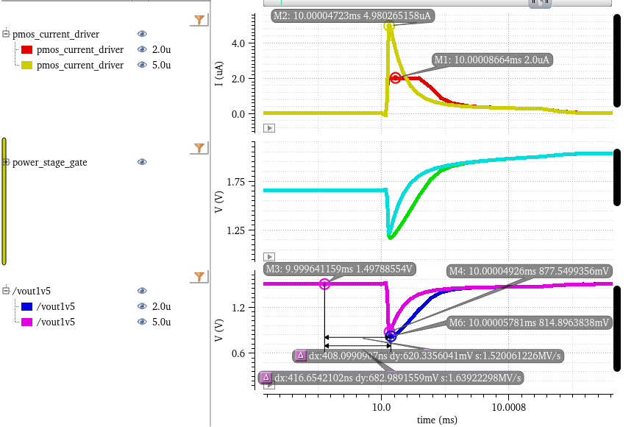
Load jump response comparison between two OTA models with different Slew Rates
However, increasing the Slew Rate typically requires more current from the OTA, which can lead to increased power consumption. Therefore, there is a trade-off between transient response and power efficiency that must be carefully balanced in the design of the voltage regulator, for class-A type OTAs.
Another fact to keep in mind is the conditions for which eq (1) was derived and for which it is valid. The equation assumes a linear dependence of the output current on the input differential voltage, a limitation that can be overcome:
//[insert pic of quadratic response of the OTA]
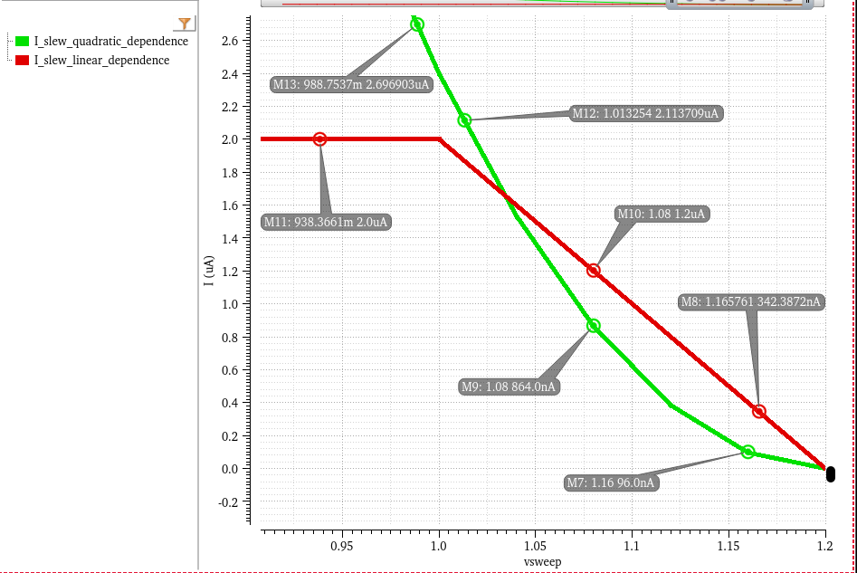
DC sweep of the output current injected by the OTA block for a decrease in its negative input voltage
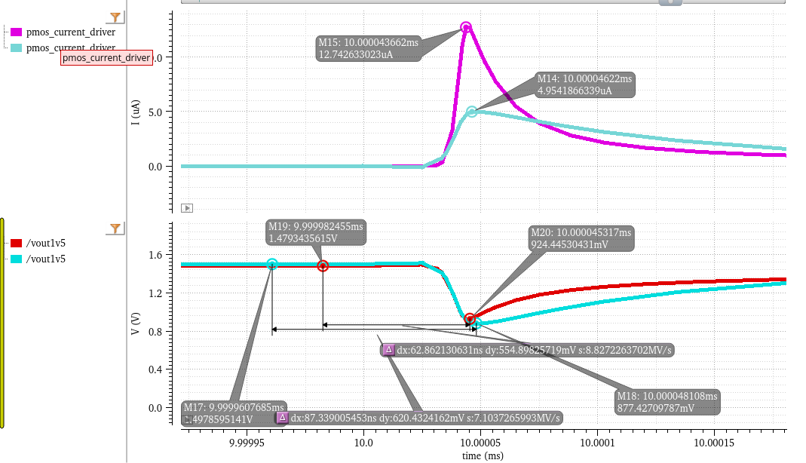
Load jump response comparison between one OTA model with linear Iout dependence on input differential voltage and Slew Rate cap and another OTA model with quadratic Iout dependence on input differential voltage

