Robot Streaming
- Introduction- This tool allows you to stream the working of an unattended/attended robot to any other machine in same domain network.
- How to Use- Run the exe file in the robot machine and it will start broadcasting the working of the robot on a specific port and you can view the same from any machine in same network, you just need to browse the URL given below in any browser-
http://<hostname of the robot machine>:<port number>
For example- If the hostname of the robot machine is machinerobot and you have configured the port 8080 to broadcast the streaming then the URL would be
http://machinerobot:8080
Note: You can view the same on your screen once you run the exe
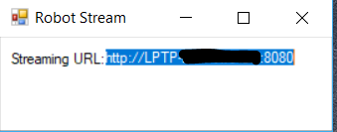
Note: To stream the unattended robot you can use Start Process activity inside your workflow to run this tool and Kill Process activity to stop this once the automation completes.
- Pre-requisites- The robot machine and the machine where you want to view the stream should be in same network/domain.
- Configuring the Port Number to Broadcast- Open the StreamRobotScreen.exe.config file and specify the port number in the appSettings for the key port and save the same-
