**Report: A Parsing Problem**

1. Curly brackets ”{“ and “}” match or not

Implementation:

1. Java StringTokenizer is used to parse file and achieved time complexity of O (nlogn) with execution time of 8 milliseconds.
2. Implemented Stack using array (having resize feature) and Linked List.

Array Resize:

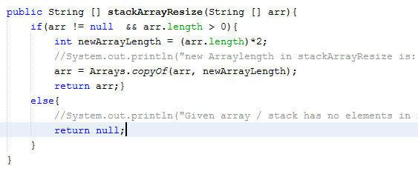

Counting opening and closing braces:

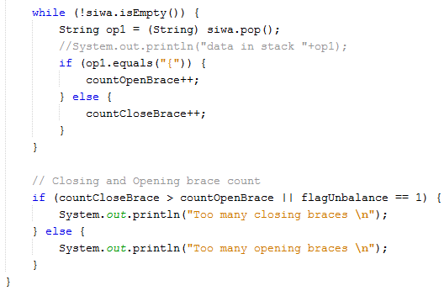

Balanced and unbalanced result:

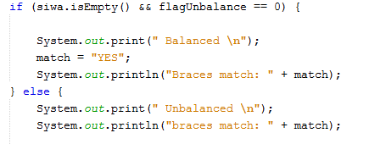

Braces check:

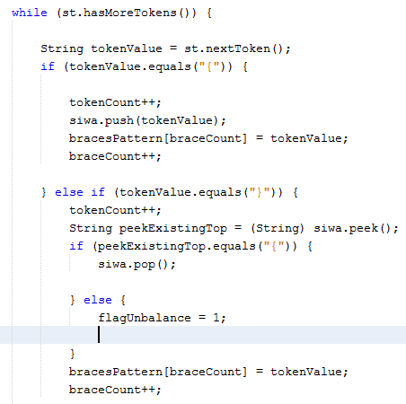

Test Cases under consideration:

1. Given balanced braces java file

Given input file is:



Output Screenprint:

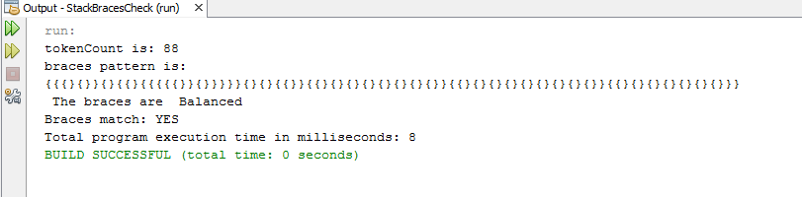

Console output explanation:

Tokens counted when encountered curly braces.

Brace patterns displayed using Sys.outs when encountered.

Braces Balanced and match-YES is determined by checking the Stack, if stack is empty or not.

System.currentTimeMillis () is used at start of main and at end to determine execution time.

Case 2: Unbalanced braces java file: No opening brackets

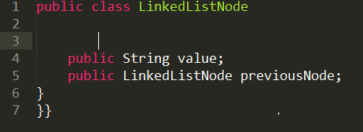

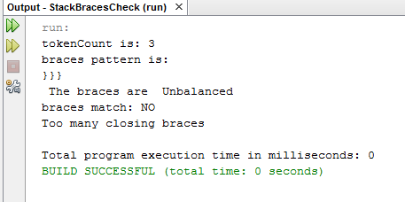

Case 3: Unbalanced braces java file: No closing brackets

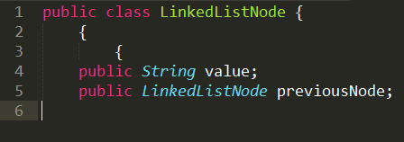

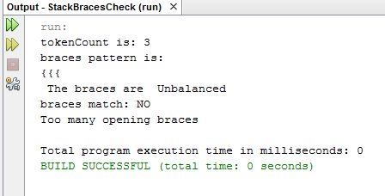

1. Unbalanced braces java file: Many opening brackets

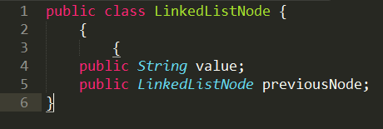

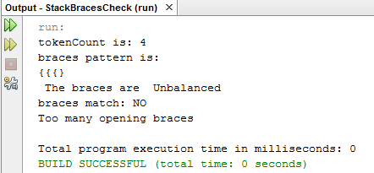

1. Unbalanced braces java file: Many closing brackets

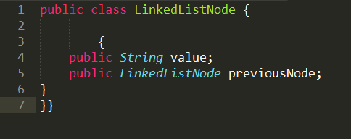

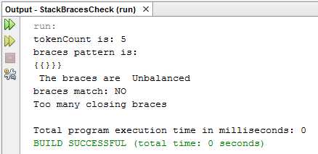

1. Xml tags (angle brackets (“<tag>”)) all match (Assuming no blank tags)

Implementation:

1. Java StringTokenizer is used to parse file and achieved time complexity of O (nlogn) with execution time of 4 milliseconds.
2. Implemented same Stack using array (having resize feature) and Linked List from Question 1.

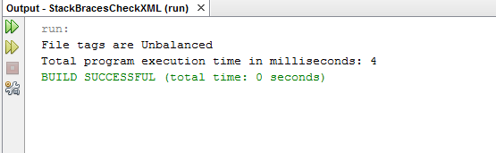

Tag balance check:

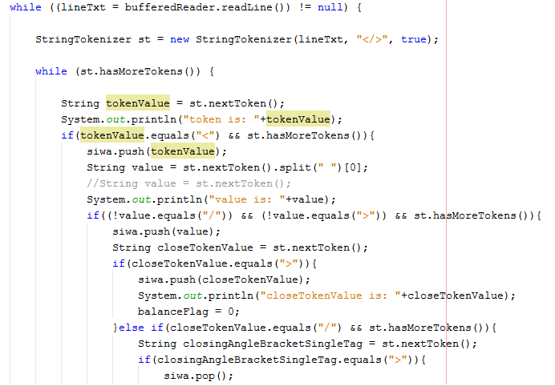

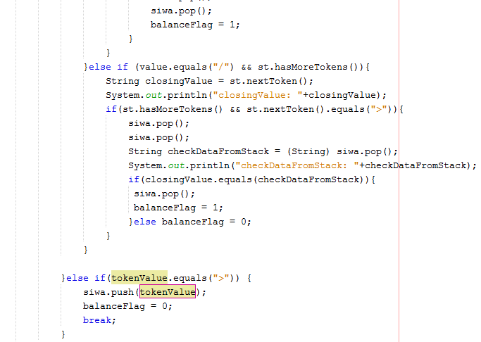

Check for balanced tags:

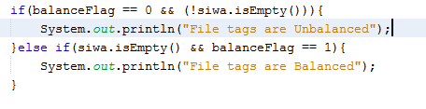

Execution time:



Test Cases under consideration:

1. Given balanced tags xml file

Given input file is:



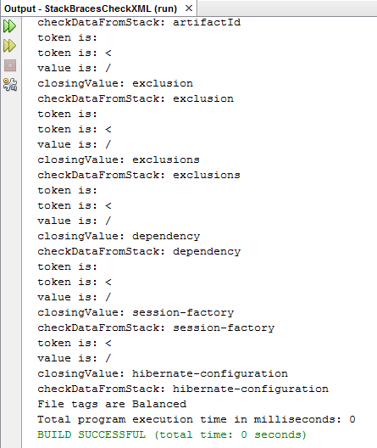

Remove <dependencies> tag to make balanced tags

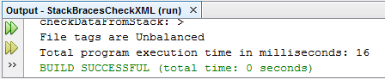

<dependencies> tag is unbalanced

1. Unbalanced Tags: extra closing angle bracket

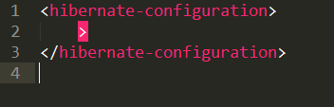

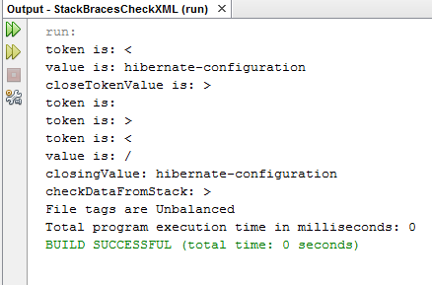

1. Unbalanced Tags: extra closing tag

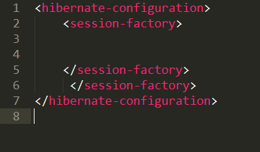

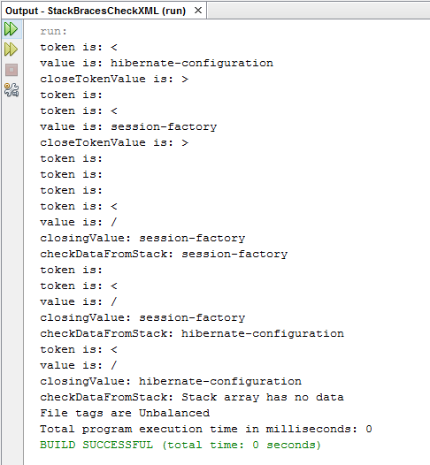

1. Unbalanced Tags: extra opening angle bracket

