**Blockchain Approach to Data Security Issue**

**in Modern ERP Software**

By

**Maurya Samanta**

**002211701092**

Bachelor in Production Engineering

3rd Year 1st Semester

Jadavpur University

Under the guidance of

**Professor Asim Gopal Barman**

**Department of Production Engineering**

**Jadavpur University**

**ACKNOWLEDGMENT**

The success and final outcome of this report on term paper required a lot of guidance and assistance and I feel extremely privileged to have received this immense amount of support from the conception of this term paper up until its successful completion. All that I have done is only due to such supervision and assistance and through this Section, I wish to express my utmost gratitude to everyone involved.

I respect and thank Prof. Asim Gopal Barman for providing me an opportunity to do the term paper work in the field of “ERP Software” and giving me all the support and guidance, which helped me complete the project duly. I am extremely thankful to him for taking time out of his busy schedule to assist me. I am also grateful to the rest of the faculty and staff of the Department of Production Engineering, for providing me with the necessary resources, opportunities and support. Finally, I would like to express my heartfelt thanks to my family and friends, for their constant support, understanding and encouragement throughout the time it took to complete this term paper. Their unwavering belief in my abilities and their willingness to listen and offer support have been a source of strength and inspiration throughout the process.

Maurya Samanta

B.E. Production Engineering

Roll No.:- 002211701092

**ABSTRACT**

The introduction of Enterprise Resource Planning (ERP) systems has transformed operations management across industries, particularly in the manufacturing sector, by integrating processes such as inventory, procurement, production, and sales. However, ERP systems face significant limitations, including challenges in data security, high costs, integration with legacy systems, and user adaptation issues. Among these, data security concerns have become increasingly critical with the rise of cloud-based ERP solutions, which are vulnerable to breaches, unauthorized access, and compliance risks.

This study focuses on addressing the data security limitations of ERP systems by proposing the integration of blockchain technology. Blockchain, with its decentralized, tamper-proof architecture, offers enhanced data security, transparency, and integrity for ERP systems. The research explores blockchain’s potential to mitigate risks associated with traditional ERP databases, improve secure data sharing, and strengthen overall system reliability.

Through a comprehensive review of literature, case studies, and industry practices, this study evaluates the feasibility of implementing blockchain-based ERP systems. It also proposes a structured architecture for integrating blockchain into ERP platforms, outlining front-end and back-end frameworks and consensus mechanisms. The study highlights blockchain’s applicability in critical ERP modules, such as supply chain management and financial transactions, and provides actionable insights for manufacturing firms to enhance data security while maintaining operational efficiency.

This research contributes to the advancement of secure and innovative ERP solutions, paving the way for future studies and practical implementations in the manufacturing sector.

**CONTENTS**

**INTRODUCTION……………………………………………………………………………4**

**METHODLOGY……………………………………………………………………………..8**

**LITERATURE REVIEW……………………………………………………………………9**

**DISCUSSIONS AND SOLUTION…………………………………………………………22**

**LIMITATIONS OF THE STUDY………………………………………………………….31**

**SCOPE OF FUTURE RESEARCH……………………………………………………….31**

**CONCLUSIONS……………………………………………………………………………32**

**REFERENCES……………………………………………………………………………...33**

**LIST OF FIGURES**

**Figure 1 Various Modules of ERP Systems 7**

**Figure 2 Broad Classification of ERP Systems 8**

**Figure 3 Flowchart demonstrating flow of ERP system 10**

**Figure 4 ERP System deployment Models 11**

**Figure 5 Top Inhibitors of 2013 (Faucett, 2013) 12**

**Figure 6 Blockchain Process Flow (Wikipedia, 2017) 24**

**Figure 7 Visual representation of Hashing Function 25**

**Figure 8 Visual Representation of Encryption (Chowdhury et al., 2023)……………….25**

**Figure 9 Visual Representation of Block Data Structure 26**

**LIST OF TABLES**

**Table 1 Comparison between On-Premise and Cloud-Based ERP Systems 8**

**Table 2 Data Security Issues 12**

**Table 3 Data on Manufacturing Companies in Indonesia that implemented ERP system (Wulan et al., 2024) 17**

**Table 4 Summary of Technical Challenges and Mitigation Strategies (Al Basher et al., 2024) 20**

**Table 5 Financial Costs and ROI analysis (Al Basher et al., 2024) 20**

**Table 6 Organisational Challenges and Change Management Strategies (Al Basher et al., 2024) 21**

**INTRODUCTION**

Definition of **Enterprise Resource Planning Systems**: Enterprise Resource Planning (ERP) systems are integrated software applications. that manage and automate various business processes, such as accounting, human resources, supply chain management, and customer relationship management, within an organization. ERP systems consolidate data from different functional areas into a centralized database, providing a comprehensive view of the business.

ERP systems typically include the following core modules:

**Financial Management**: Handles accounting, general ledger, accounts payable, and accounts receivable.

**Human Resources Management**: Manages employee data, payroll, benefits, and personnel activities.

**Supply Chain Management**: Coordinates the flow of materials, information, and finances across the supply chain, including procurement, inventory, and logistics.

**Customer Relationship Management (CRM)**: Manages customer data, sales, and marketing activities. Production and Operations Management: Handles production planning, scheduling, and inventory control and management.

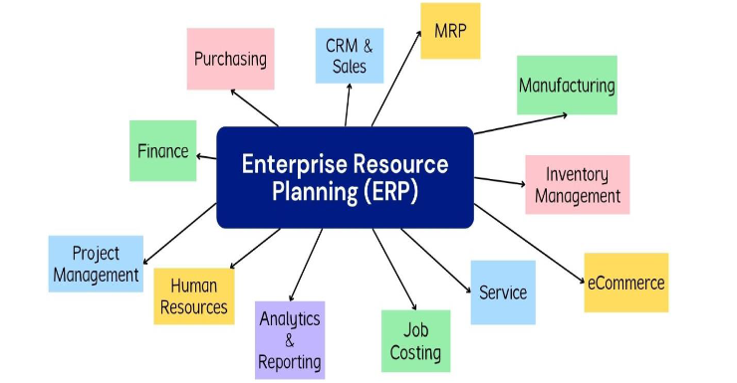

Figure Various Modules of ERP Systems

The integration of these modules within an ERP system allows organizations to streamline their business processes, improve data accuracy and accessibility, and make more informed decisions based on a unified view of the organization's operations.

**ERP Systems**

**On-Premise ERP**

**Cloud-Based ERP**

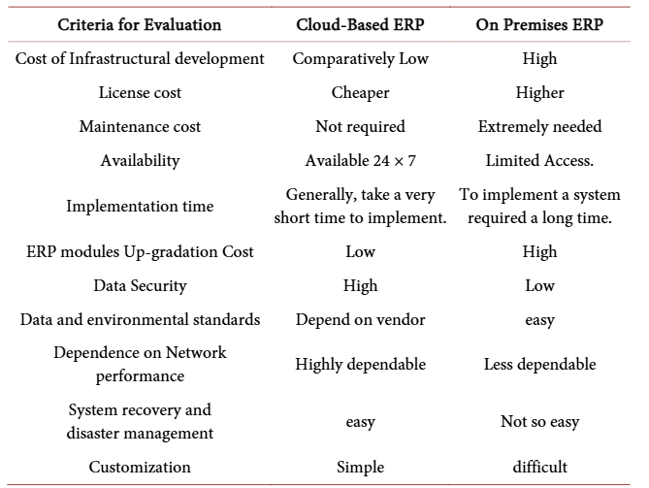

Table Comparison between On-Premise and Cloud-Based ERP Systems

Figure Broad Classification of ERP Systems

Application Cloud-based systems:

**Web-based access**: Users can access the software and their financial data through a web browser or mobile app, eliminating the need for local software installation.

**Subscription-based pricing**: Cloud-based ERP software is typically offered on a subscription basis, with users paying a monthly or annual fee to access the software and services.

**Automatic updates**: The software is automatically updated by the provider, ensuring that users always have access to the latest features and security patches.

**Scalable storage and computing**: Cloud-based platforms provide scalable and elastic computing resources, allowing businesses to easily expand or contract their storage and processing needs as required.

**Real-time data access**: Cloud-based ERP software provides users with real-time access to their financial data, enabling better decision-making and collaboration across the organization.

**Increased mobility**: With cloud-based solutions, users can access their accounting data and perform tasks from anywhere with an internet connection, using various devices such as laptops, tablets, and smartphones.

The adoption of cloud-based accounting software has become increasingly popular as it offers businesses greater flexibility, cost savings, and improved collaboration and data management capabilities compared to traditional on-premises accounting software.

Need for using ERP software:

**Increased efficiency and productivity**: ERP systems and cloud-based accounting software help businesses streamline their operations, automate repetitive tasks, and eliminate data silos, leading to increased efficiency and productivity across the organization. The integration of various business functions within an ERP system and the real-time data access provided by cloud-based solutions enable employees to work more collaboratively and make faster, more informed decisions.

**Improved data management and accessibility**: ERP systems consolidate data from different functional areas into a centralized database, providing a comprehensive and accurate view of the business. Cloud-based accounting software enhances data accessibility by allowing users to access financial information from anywhere with an internet connection. This improved data management and accessibility enables better decision-making, reporting, and compliance.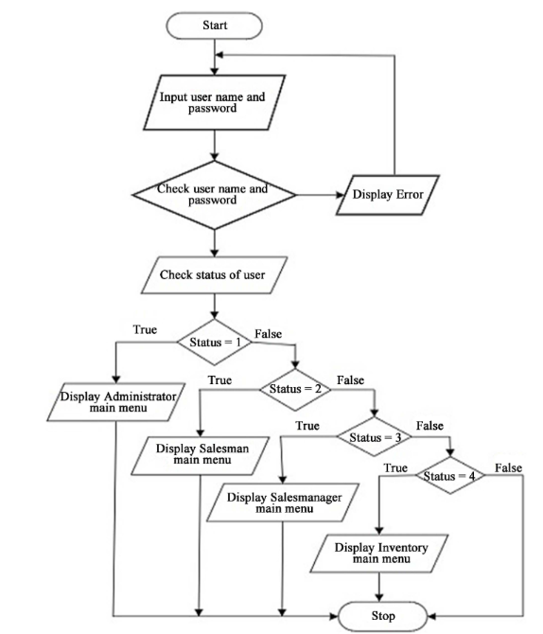 **Enhanced financial reporting and analysis**: ERP systems and cloud-based accounting software offer robust financial reporting and analytical capabilities, allowing businesses to generate customized reports, monitor key performance indicators, and gain deeper insights into their financial health. These capabilities support more informed decision-making and strategic planning.

**Scalability and flexibility**: ERP systems and cloud-based accounting software are designed to be scalable, allowing businesses to easily adapt to changing operational needs and market conditions. Cloud-based solutions, in particular, offer the flexibility to scale computing resources up or down as required, without the need for significant investments in hardware or IT infrastructure.

Figure Flowchart demonstrating flow of ERP system

**METHODOLOGY**

To perform a thorough investigation of the issues connected with ERP systems in the industrial industry, a multifaceted research strategy was used. This methodology consists of a comprehensive literature review, qualitative case studies. Each approach was carefully chosen to ensure a thorough knowledge of the issues from both theoretical and practical viewpoints.

The initial element of the investigation included a thorough literature review. Academic journals, industry reports, and conference proceedings were consulted to obtain existing information on ERP installation issues in the manufacturing sector. This review sought to identify major themes, common difficulties, and potential solutions raised in earlier research. Relevant publications were accessed through databases such as Google Scholar, ResearchGate, and IEEE Xplore. Keywords such as "ERP implementation challenges," "manufacturing sector," "system integration," and "employee resistance" helped lead the search process. The literature review offered a core understanding of the topic and identified gaps in existing research, which guided the study's future phases.

After reading and studying the papers, knowledge of software development was applied to propose an architecture and framework for a potential ERP System on Blockchain.

**LITERATURE REVIEW**

Moving ERP systems to the cloud-Data Security Issues: The paper, *"Moving ERP Systems to the Cloud: Data Security Issues(2017),"* explores the growing trend of organizations adopting cloud-based Enterprise Resource Planning (ERP) systems and focuses on the accompanying data security challenges. It provides a comprehensive examination of the advantages and limitations of moving from traditional on-premise ERP solutions to cloud-based alternatives, emphasizing the need for effective security measures to ensure successful adoption.

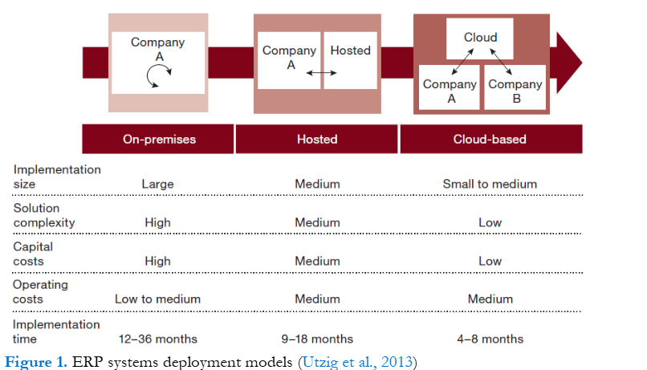The review highlights how cloud ERP systems, delivered as Software-as-a-Service (SaaS), offer significant benefits, including cost efficiency, scalability, reduced infrastructure requirements, and faster implementation times. These systems are particularly advantageous for Small and Medium Enterprises (SMEs), which may lack the financial and technical resources to deploy traditional on-premise ERP solutions. For SMEs, the pay-per-use model of cloud ERP reduces upfront costs and allows access to advanced IT capabilities without heavy investments.

Figure ERP System deployment Models

However, for larger organizations, the transition to cloud ERP presents significant challenges. Key concerns include loss of data control, uncertainty about data storage arrangements, and dependence on cloud providers for security protocols. The review categorizes these issues into two main areas: **data confidentiality** and **data integrity**.

* **Data Confidentiality**: The lack of direct control over data stored in third-party cloud environments raises fears of unauthorized access and data breaches. Risks are further exacerbated by limited oversight of cloud provider personnel and shared hosting environments, where data from multiple organizations might be co-located.
* **Data Integrity**: Maintaining consistent, accurate, and uncorrupted data in cloud environments is another major concern. The paper discusses how errors or failures at the provider’s end can compromise data integrity, and how public auditing and trust-based relationships between providers and clients are critical in mitigating these risks.

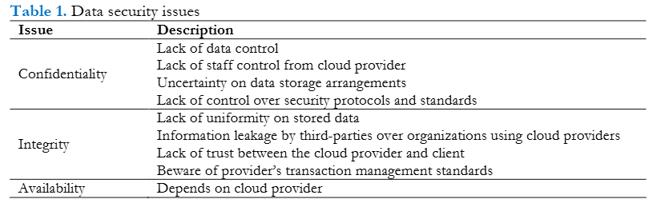The literature review also contrasts traditional on-premise ERP systems with cloud ERP solutions. While cloud ERP offers flexibility, mobility, and reduced maintenance costs, the

Table Data Security Issues

paper identifies trade-offs, such as diminished internal control and potential reliability issues. It emphasizes that larger organizations, which often rely on mission-critical applications, are more cautious about migrating to cloud ERP due to the risks associated with security breaches and the potential for industrial espionage.

The following figure shows the principle inhibitors for cloud-based ERP as far as companies are concerned.

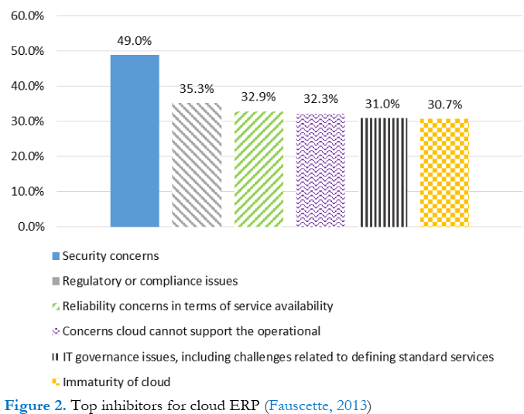

Figure Top Inhibitors of 2013 (Faucett, 2013)

To address these challenges, the paper introduces **hybrid ERP systems** as a middle-ground solution. Hybrid ERP allows organizations to retain sensitive applications and data on-premise while leveraging cloud technology for less critical operations. This approach combines the benefits of both models, offering scalability and agility while preserving control over critical data.

The review concludes by emphasizing the importance of proactive security strategies, including:

* Negotiating stringent Service Level Agreements (SLAs) with cloud providers.
* Implementing strong encryption techniques for data transmission.
* Conducting thorough evaluations of cloud vendor security practices.
* Educating employees about potential risks and mitigation strategies.

The findings underscore that while cloud ERP systems have the potential to revolutionize IT infrastructure and business processes, ensuring data security remains a critical factor for their adoption. The hybrid model is recommended as a strategic path for larger organizations to balance innovation with security.

Critical Review of ERP Systems Implementation in Multinational Corporations: Trends, Challenges, and Future Directions: The paper by Ebirim et al. (2024) critically evaluates the implementation of Enterprise Resource Planning (ERP) systems in multinational corporations (MNCs), focusing on the evolving trends, challenges, and potential future directions. As MNCs increasingly rely on integrated software solutions to streamline operations across diverse geographical locations, understanding the complexities of ERP adoption is essential for achieving operational efficiency and strategic alignment.

Ebirim et al. identify several prominent trends that are shaping the landscape of ERP implementation in MNCs:

* **Integration of Emerging Technologies**: The authors emphasize the transformative impact of **Artificial Intelligence (AI)** and **Machine Learning (ML)** on ERP systems. These technologies enable organizations to move beyond traditional rule-based processes to adaptive systems capable of learning from data. For instance, AI algorithms can analyze historical sales data to provide predictive insights for inventory management, allowing MNCs to optimize stock levels and reduce costs. This capability enhances decision-making by providing actionable insights that drive efficiency across supply chains.
* **Blockchain Technology**: The integration of blockchain within ERP systems is highlighted as a significant trend that enhances transparency and security in transactions. By creating immutable records of transactions, blockchain addresses issues of data integrity and fraud, particularly in supply chain management. For example, MNCs can utilize blockchain to trace the origin of raw materials, ensuring compliance with regulatory standards and fostering trust among stakeholders. This technology not only streamlines operations but also mitigates risks associated with errors and fraud.
* **Cloud-Based Solutions**: The shift towards cloud-based ERP systems is noted as a critical development in facilitating real-time data access and collaboration among globally dispersed teams. Cloud solutions enable MNCs to standardize processes while allowing for local adaptations as needed. This trend supports operational agility by providing a centralized platform where employees can access up-to-date information regardless of their location, thereby enhancing communication and collaboration across different regions.
* **Focus on Integrated Software Solutions**: MNCs are increasingly seeking ERP systems that consolidate diverse business processes into a unified platform. This trend is driven by the need for centralized control and visibility, enabling organizations to respond swiftly to market changes and regulatory requirements. Integrated ERP systems empower MNCs to streamline operations, reduce redundancy, and achieve economies of scale by creating a cohesive operational environment.

Despite the positive trends, Ebirim et al. outline several challenges that MNCs face during ERP implementation:

* **Cultural Diversity**: The authors point out that cultural differences can significantly impact user acceptance and system usage. Employees from various cultural backgrounds may have different levels of comfort with technology, leading to resistance against new systems. To address this challenge, organizations should implement culturally sensitive training programs and user interfaces that accommodate local preferences. Fostering an inclusive culture that encourages open communication can also enhance collaboration among diverse teams.
* **Regulatory Variations**: Navigating diverse regulatory frameworks poses a substantial challenge for MNCs during ERP implementation. Legal requirements regarding data protection and industry-specific regulations differ across countries, which can complicate compliance efforts. The authors emphasize the importance of developing configurable modules within ERP systems that can adapt to specific regulatory demands. Collaborating with legal experts in each region and conducting regular compliance audits are essential strategies for maintaining alignment with evolving regulations.
* **Business Process Differences**: Variations in market demands and consumer behaviors necessitate customization of ERP systems to align with local business practices. However, excessive customization can lead to scalability challenges and hinder standardization efforts across the organization. Ebirim et al. suggest a strategic approach that identifies common core processes suitable for global standardization while allowing for necessary regional adaptations.
* **Project Management Considerations**: Effective project management is crucial for successful ERP implementation in MNCs. The authors highlight the need for top management commitment to champion the ERP initiative actively. Senior leaders should engage stakeholders throughout the process, ensuring alignment with organizational goals and fostering a sense of ownership among users.

Looking ahead, Ebirim et al. propose several future directions for ERP implementation within MNCs:

* **Sustainability Integration**: As sustainability becomes increasingly important for businesses, future ERP systems are expected to incorporate features that support sustainable practices within MNC operations. This includes tracking environmental impacts and optimizing resource usage across supply chains.
* **Advancements in Industry 4.0 Technologies**: The paper anticipates that the ongoing evolution of Industry 4.0 technologies will further influence ERP adoption strategies. MNCs will need to leverage advancements such as IoT (Internet of Things) integration to enhance real-time data collection and analysis capabilities within their ERP systems.
* **Continuous Improvement Focus**: The authors emphasize the importance of post-implementation evaluation and continuous improvement strategies to adapt to evolving business requirements effectively. Organizations should establish feedback mechanisms that allow users to share insights on system performance, enabling ongoing refinements that enhance usability and functionality.

Ebirim et al.'s critical review provides a thorough analysis of the current state of ERP systems implementation in multinational corporations. By synthesizing existing literature on trends and challenges, the authors offer valuable insights that can guide practitioners and researchers in navigating the complexities associated with ERP adoption. Their findings underscore the necessity for strategic approaches encompassing technology integration, cultural sensitivity, regulatory compliance, effective project management, and continuous improvement efforts. This literature review serves as a roadmap for understanding how MNCs can leverage ERP systems to enhance operational efficiency while addressing unique challenges posed by their diverse operational landscapes in an increasingly interconnected global business environment.

The paper titled "*Impact of ERP System Implementation on Operational and Financial Efficiency in Manufacturing Industry*," authored by Titis Sri Wulan et al., explores the significant relationship between Enterprise Resource Planning (ERP) systems and their effects on **operational and financial efficiency within the manufacturing sector**. The study is particularly relevant given the increasing complexity of manufacturing operations and the necessity for effective resource management in a competitive environment.

The introduction emphasizes on the critical challenges faced by the manufacturing industry, such as **fragmented data systems that hinder decision-making and operational efficiency**. The authors argue that ERP systems can serve as integrative solutions to these challenges by **automating workflows and providing real-time data access**. Previous studies have established that ERP systems can **enhance efficiency and profitability** by consolidating various business functions into a unified platform (*Pamungkas & Iskandar, 2021*). The literature indicates a gap in empirical research specifically addressing the impact of ERP on operational and financial efficiency, particularly in the manufacturing sector.

The primary objective of this research is to analyze how ERP implementation influences operational efficiency—measured through production time reduction, inventory management, productivity improvement—and financial efficiency, which includes cash flow improvement and operating cost reduction. The authors aim to provide insights that can guide manufacturing companies in their investment decisions regarding ERP systems.

The study employs a quantitative approach, utilizing **linear regression analysis to evaluate data collected from ten manufacturing companies in Indonesia** that adopted ERP systems between 2016 and 2021. The authors gathered primary data through structured questionnaires directed at managers and operational staff involved in ERP implementation, alongside secondary data from company financial reports. This methodological framework allows for a robust analysis of the relationship between ERP implementation variables and efficiency outcomes.

Table Data on Manufacturing Companies in Indonesia that implemented ERP system (Wulan et al., 2024)

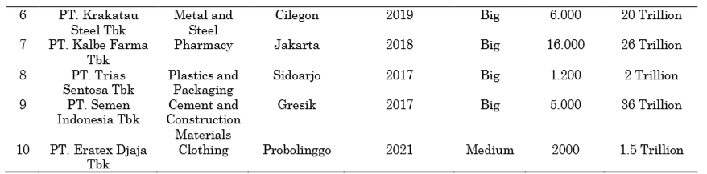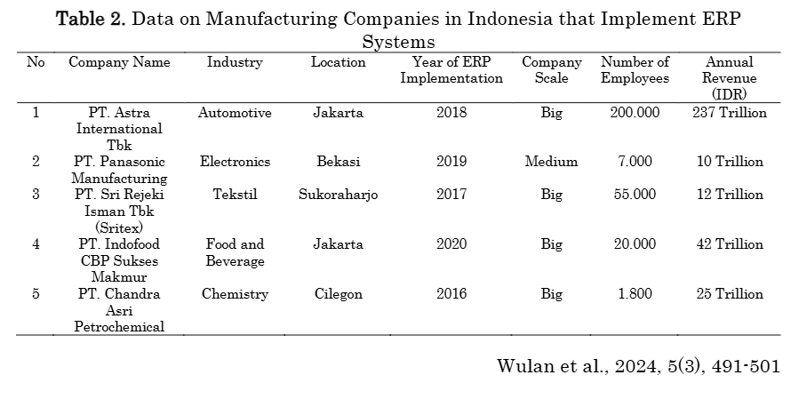

Indicators of Efficiency

The paper identifies specific indicators for measuring operational and financial efficiency:

* **Operational Efficiency**:
  + Reduced production time
  + Improved inventory management
  + Increased employee productivity
  + Enhanced data integration
* **Financial Efficiency**:
  + Improved cash flow
  + Reduced operating costs
  + Better asset management
  + Increased profitability

These indicators are pivotal for assessing the tangible impacts of ERP systems on manufacturing operations.

Key Findings

The results from the linear regression analysis reveal that all independent variables positively influence both operational and financial efficiency. Notably:

* **Production Time Reduction**: Coefficient of 0.452 indicates a significant positive impact on efficiency.
* **Inventory Management**: Coefficient of 0.328 suggests effective inventory practices enhance overall efficiency.
* **Increased Productivity**: Coefficient of 0.378 reflects productivity improvements correlate with higher efficiency.
* **Improved Cash Flow**: Coefficient of 0.414 shows a strong relationship with financial performance.
* **Operating Cost Reduction**: Coefficient of 0.391 emphasizes cost savings as a critical component of financial efficiency.

The statistical significance (p-values < 0.001) associated with these coefficients underscores the reliability of these findings.

The discussion section contextualizes these findings within existing literature, highlighting that while previous studies often focused on technical or organizational aspects of ERP implementation, this research specifically addresses its operational and financial impacts. The authors argue that their empirical evidence contributes to understanding how ERP systems can drive efficiency improvements in manufacturing settings. Furthermore, they discuss the implications for practice, suggesting that companies considering ERP investments should focus not only on technology adoption but also on strategic alignment with operational goals to maximize benefits.

In conclusion, this study provides valuable insights into the effectiveness of ERP systems in enhancing operational and financial efficiency within the manufacturing industry. By addressing a gap in empirical research, it contributes to both academic literature and practical applications for businesses seeking to optimize their operations through technological investments. The findings advocate for a comprehensive understanding of ERP's role in improving productivity, cost management, and overall organizational performance.

The authors suggest several avenues for future research, including longitudinal studies to assess long-term impacts of ERP implementation across different industries and exploring how varying scales of companies experience different outcomes from ERP adoption. This literature review underscores the relevance of Wulan et al.'s study within the broader discourse on ERP systems, emphasizing its contributions to understanding their operational and financial ramifications in manufacturing contexts.

*Challenges of ERP systems in Manufacturing sector--A Comprehensive Analysis (2024)*:

Mahboob Al Basher et. al. 2024 conducted a study of challenges faced by ERP systems in Manufacturing sector through a comprehensive literature review of a number of papers, academic journals, industry reports, case studied of various companies and industry reviews.

Following the literature study**, qualitative case studies of manufacturing organizations that used ERP systems** were done. These case studies sought to investigate the real-world deployment of ERP systems and **identify specific obstacles** encountered during adoption. To ensure a comprehensive variety of insights, **purposive sampling** was employed to select organizations of varying sizes, industry sub-sector, and geographical location. The data gathering process included evaluating company documentation, implementation reports, and conducting semi-structured interviews with key stakeholders such as project managers, IT workers, and end users. The case studies provided a detailed, contextualized understanding of the difficulties and how different organizations addressed them.

To supplement the case studies, **expert interviews were held with individuals who have substantial experience implementing ERP** in the manufacturing industry. These professionals included **ERP consultants, system integrators, and senior IT executives**. The interviews were intended to obtain thorough information about the technical, financial, and organizational challenges of ERP deployment.

Data analysis entailed coding and theme analysis of qualitative data from case studies and interviews. A software application such as **NVivo** was utilized to help organize and analyze the data. Thematic analysis enabled the discovery of recurring patterns and themes related to ERP implementation issues.

The authors explored the Technical, Financial and Organizational aspects of the limitations of modern ERP software.

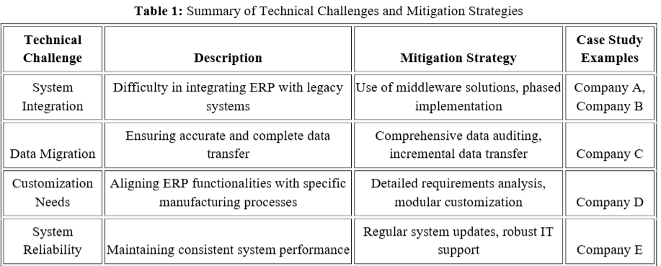Technical aspects include stem integration, data migration, customization, and reliability are all important considerations. During the modeling process, the authors built a flowchart depicting the interactions between these components. For example, successful data migration is contingent on the ERP system's interoperability with legacy systems. The industrial sector's distinct procedures and requirements have an impact on customization demands. The most important aspect of technical limitations was **data security** as per data collected by interviewing experts and consultants. As data is stored in cloud, sensitive data had high chances of getting leaked thereby making firms reluctant to take up ERP systems.

Table Summary of Technical Challenges and Mitigation Strategies (Al Basher et al., 2024)

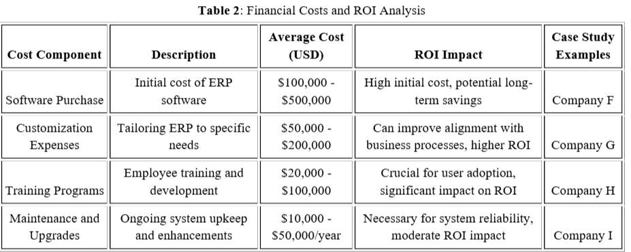The financial cost is a significant barrier, particularly for small and medium-sized organizations. The **cost analysis model** revealed that the initial investment expenses, which include **software acquisition, customization, and training, are significant. Furthermore, continual maintenance and upgrade charges increase the financial strain**. Regardless of these costs, the cost-benefit analysis revealed that organizations with greater ROI often invested in comprehensive training and support systems. These investments resulted in increased operational efficiency and lower long-term expenses, demonstrating the value of considering ERP deployment as a strategic investment rather than an expense

Table Financial Costs and ROI analysis (Al Basher et al., 2024)

**Organizational problems are largely concerned with employee resistance** to change and the effectiveness of training programs. According to the behavioural model, opposition is often motivated by **a lack of understanding and a fear of job displacement.** Effective change management practices, such as early employee involvement in the implementation phase and ongoing training, were found to be critical. Companies that developed an inclusive culture and provided **solid support mechanisms experienced higher ERP system acceptance and utilization**. This stresses the importance of comprehensive change management plans that consider the human aspect of ERP deployment.

Table Organisational Challenges and Change Management Strategies (Al Basher et al., 2024)

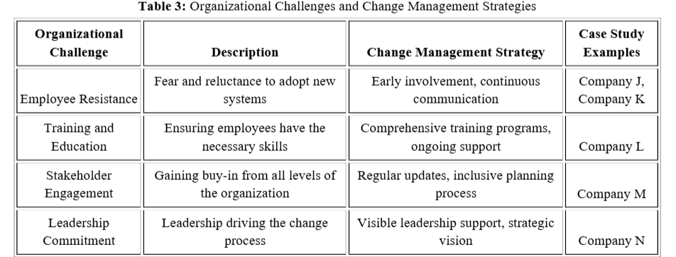  
"*Factors Affecting the Adoption of Cloud-Based ERP in companies of Malaysia*"(2024) provides a comprehensive overview of existing research related to the adoption of Enterprise Resource Planning (ERP) systems, particularly in the context of cloud computing.

**Cloud Computing and ERP**: The transition from traditional **on-premise ERP systems** to **cloud-based solutions** is discussed. Cloud computing offers advantages such as scalability, cost-effectiveness, and accessibility, which are crucial for modern businesses. The literature indicates a growing trend towards cloud-based ERP adoption, driven by these benefits.

**Factors Influencing Adoption**: Several studies are cited that identify key factors influencing the adoption of cloud-based ERP systems. These factors include:

* **Technological Readiness**: Organizations must assess their technological infrastructure and readiness to adopt cloud solutions.
* **Top Management Support**: Leadership commitment is critical for successful implementation and adoption.
* **User Training and Support**: Adequate training and support for users are essential to facilitate the transition to new systems.
* **Cost Considerations**: The cost of implementation and ongoing maintenance plays a significant role in the decision-making process for adopting cloud-based ERP.

**Challenges in Adoption**: The literature also highlights various challenges faced by organizations in adopting cloud-based ERP systems. These include concerns about **data security**, **integration with existing systems**, and **resistance to change** among employees. Studies suggest that addressing these challenges is vital for successful adoption.

**Theoretical Frameworks**: The review references several theoretical frameworks used in previous studies to analyze ERP adoption, such as the **Technology Acceptance Model** (TAM) and the **Unified Theory of Acceptance and Use of Technology** (UTAUT). These frameworks help in understanding the factors that influence user acceptance and usage intentions.

**Empirical Evidence**: The review includes empirical studies that provide evidence of the factors affecting cloud-based ERP adoption in various sectors, including manufacturing, retail, and education. These studies contribute to a deeper understanding of the context-specific challenges and drivers of adoption.

"*Cloud based ERP systems and Data Security for Cloud based ERP Applications - SAP S/4HANA*"(2024) provides a comprehensive examination of the growing adoption of cloud-based ERP systems, particularly focusing on **SAP S/4HANA**, and the associated **data security challenges**.

Key Points include:

**Growth of Cloud-Based ERP Systems**: The paper highlights the rapid growth of cloud technology in the field of Information and Communication Technology (ICT), noting that a significant percentage of large ERP users are expected to transition from on-premises solutions to software-as-a-service (SaaS) models. Factors influencing this shift include the relative advantages of cloud solutions, management support, and the availability of ICT skills and equipment.

1. **Security Necessity**: As organizations increasingly rely on distributed networks for data management, the **need for robust security measures becomes paramount**. The paper discusses the critical importance of **ensuring that data and processes meet business requirements while preventing unauthorized access**. It emphasizes that security challenges are particularly relevant for SAP S/4HANA, which is deployed on public cloud platforms.
2. **Key Management and Data Protection**: The implementation of **Key Management Services (KMS)** is presented as a vital component for enhancing **data security in SAP S/4HANA**. The KMS allows **customers to maintain control over their cryptographic keys**, thereby improving the protection of sensitive data stored in cloud environments. This aspect is crucial for organizations pursuing a cloud-first strategy.
3. **Implementation Risks and Best Practices**: The paper outlines several best practices for mitigating risks associated with the implementation of cloud-based ERP systems. Recommendations include **selecting experienced partners, integrating data into a single database, and ensuring compatibility with customer and supplier systems**. These practices aim to enhance the likelihood of successful project completion within budget and time constraints.
4. **Data Security Framework**: The authors discuss the comprehensive security framework provided by **SAP HANA**, which is designed to protect data confidentiality, integrity, and availability. This framework includes features such as **multitenant database security, application-level security, and compliance with security standards**. The paper emphasizes the need for a 360-degree approach to database security, which is essential for safeguarding against common threats.
5. **Threat Detection and Monitoring**: The paper also addresses the importance of real-time threat detection and monitoring in cloud environments. The **SaaS Threat Detection Cloud Version** is highlighted as a service that enables organizations to monitor security incidents effectively, leveraging SAP's expertise to identify and respond to vulnerabilities promptly.

The paper concludes by reiterating the growing trend of cloud data storage and the associated security risks. It calls for ongoing research into **effective encryption methods and security measures to protect cloud-based data**. The authors suggest that understanding the risks posed by hypervisors and multitenancy is crucial for developing robust security strategies in cloud computing.

**DISCUSSIONS**

From the literature review, it is evident that traditional Cloud-Based ERP systems are highly susceptible to **data breaches**, **unauthorized access**, and a **lack of transactional transparency**. These challenges highlight **the urgent need for a security framework** that ensures data integrity, transparency, and resilience against cyberattacks. In accordance with Ebirim et. al. 2024 in *Critical Review of ERP Systems Implementation in Multinational Corporations: Trends, Challenges, and Future Direction*, implementing **Cloud-Based ERP Systems on Blockchain** can be a feasible solution to promote better secured data storage, immutability and transparency.

**Blockchain:**

Blockchain is a **digital ledger** system that securely **records and verifies transactions across a distributed network of computers**. Unlike traditional databases that rely on a **central authority**, blockchain operates in a **decentralized manner**, meaning no single entity controls the data. Each transaction is added as a "**block**" in a chronological chain, and once recorded, it **cannot be altered, ensuring transparency and data integrity.**

To simplify, think of blockchain as a **production logbook in a factory**. Imagine every step in a product's lifecycle—from sourcing raw materials to final assembly—is recorded in this logbook. However, **instead** of the logbook being kept in one office (a centralized system), it’s shared with **everyone** involved in the production process. Each participant has a copy, and new entries are only added after everyone verifies and agrees they are accurate. This **prevents tampering and ensures all participants can trust the record**.

In blockchain, this process is automated using **cryptographic techniques**, making it **highly secure and reliable**.

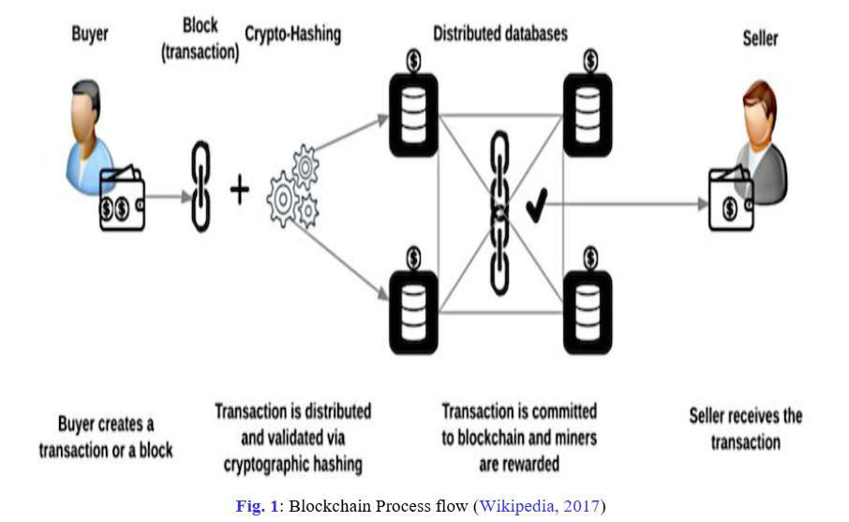

Figure Blockchain Process Flow (Wikipedia, 2017)

**Cryptographic Techniques to Secure Data in Blockchain**

Blockchain uses **cryptography**, which is a method of securing information so only authorized people can access or understand it. Two main techniques are used in blockchain: **hashing** and **digital signatures**.

**1. Hashing: Protecting Data Integrity**

Hashing is like assigning a unique fingerprint to data. A special mathematical function takes any piece of information (like a document, number, or transaction) and converts it into a fixed-length string of characters, called a "hash." If even one tiny detail of the original data changes, the hash completely changes.

Hashed data

Unencrypted data

Hashing Function

Figure Visual representation of Hashing Function

**Example:** Imagine you’re shipping a package from a factory to a customer. Before shipping, you write down the exact weight of the package (e.g., 10.254 kg). When the package arrives, the receiver checks the weight again. If it still reads 10.254 kg, you know the package hasn’t been tampered with during transit. Similarly, hashing ensures that data in the blockchain hasn’t been altered—if even one letter or number changes, the hash will no longer match.

In blockchain, each block contains the hash of the previous block, creating a chain. If someone tries to change one block, it breaks the chain, making tampering obvious.

**2. Digital Signatures: Ensuring Authenticity**

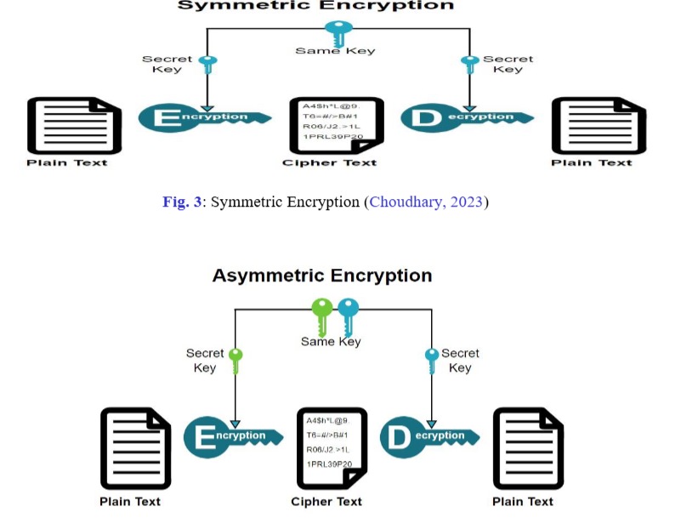Digital signatures are like signing a document with your unique penmanship, but in the digital world. Each user in the blockchain has two cryptographic keys: a **private key** and a **public key**.

* **Private Key:** Known only to the user, like a personal PIN or fingerprint.
* **Public Key:** Shared with everyone, like your email address.

When you send a message or transaction, your private key creates a digital signature for that transaction. Anyone can use your public key to verify that the message really came from you and hasn’t been tampered with.

Figure Visual Representation of Symmetric and Asymmetric Encryption (Chowdhury et al., 2023)

**Example:** Think of a production engineer authorizing an order. They sign a paper document with their unique signature, and everyone trusts that only they could have signed it. In **blockchain, the private key acts as your signature**, ensuring that only you can authorize transactions, and **the public key allows others to verify that it’s really you**.

These two techniques work together in blockchain:

1. Hashing ensures that data cannot be altered without detection.
2. Digital signatures confirm that the transaction came from the right person.

Together, they make the blockchain secure, trustworthy, and tamper-proof.

**Blockchain as a Data Structure**

At its core, blockchain is a **linked list** of records (called blocks), where:

1. **Each block contains data** (such as transaction details).
2. **Each block is linked to the previous block** using a cryptographic hash.
3. **The chain forms an immutable sequence of records.**

Block Number

Unique Block hash

Previous Block hash

Timestamp

Block Data

Figure Visual Representation of Block Data Structure

This structure ensures:

* **Order:** Blocks are added sequentially.
* **Integrity:** Tampering with a block changes its hash, breaking the chain.
* **Traceability:** Every block contains a reference to its predecessor, making the entire history transparent.

**Steps to Implement Blockchain in an ERP System**

**1. Understand the Use Cases**

First, we need to identify where blockchain will add the most value in the ERP system. Common areas include:

* **Supply Chain Management**: Blockchain can provide transparent and immutable tracking of goods and services from suppliers to customers.
* **Inventory Management**: Blockchain can ensure real-time, accurate records of stock levels.
* **Transaction Verification**: Payments and invoices can be verified with blockchain, reducing fraud and errors.
* **Contract Management**: Smart contracts can automate processes and reduce the risk of human error.
* **Audit and Compliance**: Blockchain’s immutability can provide a transparent and unalterable audit trail.

**2. Select the Blockchain Type**

Before implementation, it’s important to decide on the type of blockchain that will be used:

* **Public Blockchain** (e.g., Ethereum): Accessible by anyone and offers high decentralization but slower speeds and higher costs.
* **Private Blockchain** (e.g., Hyperledger): Controlled by specific participants (e.g., within a company or between partners), offering faster processing and privacy.
* **Consortium Blockchain**: A hybrid of public and private blockchains where multiple organizations share control over the network.

For an ERP system, a **private blockchain** or **consortium blockchain** is often more suitable because these networks are faster, offer more control over participants, and protect sensitive business data.

**The Roadmap of building this system:**

**1. Blockchain Layer**

**Purpose**: Enable secure, tamper-proof data storage and execution of smart contracts.

* **Smart Contracts Module**:
  + **Functions**: Automate processes like inventory updates, payment processing, and approvals.
  + **Tools**: **Solidity** (Ethereum), Chaincode (Hyperledger Fabric).
  + **Features**:
    - Business rules (e.g., order approval).
    - Asset tracking (e.g., raw materials, products).
    - Payment triggers.
* **Blockchain Network Management Module**:
  + **Functions**: Setup, deploy, and manage blockchain nodes.
  + **Tools**: Geth (Ethereum), Fabric CLI (Hyperledger).
  + **Features**:
    - Consensus configuration (e.g., PoW, PBFT).
    - Node addition/removal.
    - Monitoring network health.
* **Data Anchoring Module**:
  + Functions: Store hashes of critical records for tamper-proof validation.
  + Tools: IPFS, Filecoin for off-chain storage.

**2. Middleware Layer**

**Purpose**: Facilitate communication between the blockchain and backend systems.

* **Blockchain API Module**:
  + **Functions**: Provide RESTful/GraphQL APIs for interacting with the blockchain.
  + **Tools**: Web3.js, Ethers.js, Hyperledger SDK.
  + **Features**:
    - Send transactions.
    - Query blockchain state.
    - Monitor contract events.

**3. Backend Layer**

**Purpose**: Handle business logic, user authentication, and non-blockchain processes.

* **Business Logic Module**:
  + **Functions**: Manage workflows, validations, and processing outside the blockchain.
  + **Tools**: Node.js, Django.
  + **Features**:
    - Inventory updates.
    - Employee data management.
    - Financial calculations.
* **Authentication and Authorization Module**:
  + **Functions**: Secure user access to different system features.
  + **Tools**: OAuth 2.0, JWT.
  + **Features**:
    - Role-based access control (RBAC).
    - Multi-factor authentication (MFA).
    - Blockchain identity integration.
* **Database Module**:
  + **Functions**: Store off-chain data for faster access.
  + **Tools**: PostgreSQL, MongoDB.
  + **Features**:
    - Storage for user data, logs, and reports.
    - Backup and restore mechanisms.

**4. Frontend Layer**

**Purpose**: Provide user-friendly interfaces for interacting with the system.

* **Dashboard Module**:
  + **Functions**: Display ERP analytics and blockchain activity.
  + **Tools**: React.js, Material-UI.
  + **Features**:
    - Customizable dashboards for admins and employees.
    - Visualizations for blockchain activity (e.g., transaction history).
* **Transaction Management Module**:
  + **Functions**: Initiate and track transactions on the blockchain.
  + **Tools**: React.js, Chart.js.
  + **Features**:
    - Forms to input data (e.g., purchase orders).
    - Progress tracking of approvals and payments.
* **Reporting Module**:
  + **Functions**: Generate real-time and historical reports.
  + **Tools**: D3.js, Highcharts.
  + **Features**:
    - Inventory reports.
    - Audit trails from the blockchain.

**5. Security and Monitoring Layer**

**Purpose**: Ensure data integrity, system security, and monitoring.

* **Encryption and Data Security Module**:
  + Functions: Encrypt data at rest and in transit.
  + **Tools**: AES, TLS.
  + Features:
    - Key management.
    - Encrypted communication between modules.
* **Audit and Monitoring Module**:
  + **Functions**: Monitor performance and detect anomalies.
  + **Tools**: Prometheus, Grafana, ELK Stack.
  + **Features**:
    - Log blockchain transactions and system events.
    - Alert on anomalies or failed smart contracts.

**6. Testing and Deployment Layer**

**Purpose**: Ensure reliability, scalability, and maintainability of the system.

* **Unit Testing Module**:
  + **Functions**: Test individual smart contracts and APIs.
  + **Tools**: Truffle, Mocha.
* **Integration Testing Module**:
  + **Functions**: Test blockchain and backend interactions.
  + **Tools**: Postman, Selenium.
* **CI/CD Module**:
  + **Functions**: Automate deployment and version control.
  + **Tools**: Jenkins, GitHub Actions.

**Real-Life Example: Implementing Blockchain in a Supply Chain ERP**

1. **Scenario:** A company BizTech Pvt. Ltd., a fictitious firm, uses ERP to manage inventory and procurement from multiple suppliers.
2. **Blockchain Solution:**
   * Each time goods are ordered from a supplier, the transaction is recorded on the blockchain.
   * Once the goods are shipped, their location and status are tracked on the blockchain in real-time, ensuring all parties can verify where the goods are at any given moment.
   * Once the goods are received, a smart contract is triggered to automatically release payment to the supplier.
   * The entire transaction, from purchase to payment, is logged on the blockchain, providing an immutable audit trail for both the company and regulatory bodies.

**LIMITATIONS OF THE STUDY**

While the findings provide valuable insights into the integration of Blockchain with ERP systems, there are inherent limitations. The study primarily draws from research papers, articles, thesis and reports available on ResearchGate, hypothetical scenarios and a limited set of real-world case studies. Moreover, the rapidly evolving nature of Blockchain technology and its applications in various industries might lead to changes in the observed patterns and outcomes.

**SCOPE FOR FUTURE RESEARCH**

The **future scope of study** for developing and implementing a blockchain-based ERP system is vast, as it integrates emerging technologies to solve current and anticipated challenges in enterprise management. Below are potential avenues for further exploration:

**1. Performance Optimization**

* **Scalability Solutions**: Research on using Layer 2 scaling solutions, sidechains, or sharding to improve transaction throughput and reduce latency for ERP systems.
* **Hybrid Models**: Investigating how hybrid systems (blockchain + traditional databases) can achieve a balance between speed and decentralization.
* **Consensus Mechanisms**: Exploring new or improved consensus mechanisms tailored for enterprise use cases, such as Byzantine Fault Tolerance (BFT) or Proof of Authority (PoA).

**2. Cost Reduction**

* **Efficient Smart Contracts**: Optimizing smart contract designs to minimize gas fees or transaction costs on public blockchains.
* **Energy-Efficient Blockchains**: Studying blockchains that focus on lower energy consumption (e.g., Proof of Stake, eco-friendly consensus models).
* **Off-Chain Data Management**: Developing frameworks to minimize on-chain storage costs by efficiently utilizing off-chain solutions like InterPlanetary File System (IPFS).

**3. Interoperability**

* **Cross-Chain Solutions**: Investigating mechanisms for seamless integration between multiple blockchains used in different departments or companies.
* **Middleware for Legacy Systems**: Designing middleware that simplifies integration between legacy systems and blockchain-based ERP systems.

**CONCLUSION**

**Summary of Findings**

From Research Papers, articles and reports it is evident that integrating ERP software in Manufacturing Industry enhances operational efficiency to a great extent. However, it comes with its own challenges. Challenges range from Data Security concerns, financial issues, integration problems with legacy systems, reluctance of the workforce to accept new technology and adapt to it.

**Contributions of the Study**

This Study provides a solution to one of the problems regarding Cloud-Based ERP software which is Data security concerns.

* **Solution:** Implementing ERP System on decentralized blockchain instead of traditional databases to enhance security, transparency and efficiency of various business processes. Blockchain Technology can be applied to various modules of modern ERP software like financial transactions, inventory management, supply chain tracking, and contract management.
* **Architecture for Implementation:** The study proposes a structured architecture for a Blockchain-based ERP software with Frontend, Backend and Blockchain Layer frameworks to be utilised to build the software application.
* **Future Directions**: By highlighting areas that warrant further exploration, the research paves the way for subsequent studies in this domain which include the efforts towards development of novel ERP software based on Blockchain.

**REFERENCES**

Alam, M.J., Sharma, S.D. and Chowdhury, T. (2024) A Model of Cloud-Based Enterprise Resource Planning (ERP) for Small and Medium Enterprise. Journal of Computer and Communications, 12, 37-50. <https://doi.org/10.4236/jcc.2024.1210004>

Arnold Masud Abukari & Vivek Gupta “A Homomorphic Block Approach to Blockchain and Cloud ERP Implementation” *Journal of applied Intelligent Systems and Information Sciences* 4.1(2023): 55-59

Faccia, A., & Petratos, P. (2021). Blockchain, Enterprise Resource Planning (ERP) and Accounting Information Systems (AIS): Research on e-Procurement and System Integration. Applied Sciences. <https://dx.doi.org/10.3390/APP11156792>

G. U. Ebirim & I. F. Unigwe “A Critical Review Of ERP Systems Implementation In Multinational Corporations: Trends, Challenges, AND Future Directions” *International Journal of Management & Entrepreneurship Research* 06.02(2024): 281-295

K. M. Verma & N. D. Chowdary “Cloud based ERP systems and Data Security for Cloud based ERP Applications -SAP S/4HANA.” *International Journal of Scientific Research in Engineering and Management (IJSREM)* 07.02 (2023)

M. A. Basher & M. A. Taher “Challenges Of ERP Systems In The Manufacturing Sector: A Comprehensive Analysis” *International Journal of Progressive Research in Engineering Management and Science (IJPREMS)* 04.05(2024): 1858-1866

M. Bolanle & Mark J Keown “Adoption of enterprise resource planning (ERP) systems and cloud-based accounting software” (2024)

M. H. Miraz & H. H. Jin “What factors affect the adoption of cloud-based ERP in companies' operations in Malaysia?” *International Journal of Management and Sustainability 13.03*(2024): 490-505

Mohanta, B. K., Panda, S. S., & Jena, D. (2018). An Overview of Smart Contract and Use Cases in Blockchain Technology. ICCCNT. <https://dx.doi.org/10.1109/ICCCNT.2018.8494045>

Oliver Bodemer “Navigating the Uncharted Waters of Integrating Blockchain with Enterprise Resource Planning” (2023)

Pablo Saa & Andres Costales “Moving ERP Systems to the Cloud - Data Security Issues” *Journal of Information Systems Engineering* 02.04(2017)

T. S. Wulan & P. W. Novika “Impact of ERP System Implementation on Operational and Financial Efficiency in Manufacturing Industry” 05.02 (2024) <https://journal.unm.ac.id/index.php/JE3S/index>