
MyTunes
An Ad-Free Social Music Streaming Platform
SCHOOL OF COMPUTER OF STUDIES
MCA Batch 2025-27
Semester -II

Submitted By
Student Name: Priya luhar (MCA2504003)
Student Name: Vibhav Maurya(MCA2504027)
Student Name: Khushi Daharwal(MCA2504008)
Student Name: Tushar Rajpurohit(MCA2504038)

Under the Guidance of
Supervisor Name: Dr. Anup Shivanechari Sir

Academic Year: 2025– 2026
ACKNOWLEDGEMENT
We express our sincere gratitude to our respected guide Dr. Anup Shivanechari Sir for his valuable guidance, continuous support, and encouragement throughout the development of this project.
We are also thankful to the School of Computer Studies for providing us with the necessary resources and environment to successfully complete this project.
We would like to extend our heartfelt thanks to our faculty members and friends who supported us with their suggestions and motivation.
Lastly, we are grateful to our families for their constant support and encouragement.
DECLARATION
We hereby declare that the project titled “MyTunes – An Ad-Free Social Music Streaming
Platform” submitted in partial fulfillment of the requirements for the degree of Master of Computer Applications (MCA) is a record of our original work carried out by us under
guidance of Dr. Anup Shivanechari Sir.
We further declare that this project has not been submitted to any other university or institution for the award of any degree or diploma.
Students:
Priya Luhar
Vibhav Maurya
Khushi Daharwal
Tushar Rajpurohit
ABSTRACT
MyTunes is a full-stack, ad-free social music streaming platform designed to bridge the gap between individual music listening and collaborative social experiences. Built with Node.js, Express.js, MongoDB, and Socket.io on the server side, and pure HTML5/CSS3/JavaScript on the client side, MyTunes delivers real-time music playback, mood-based discovery, collaborative playlist management, a social friend network, and synchronized "Listen-Together" group sessions. The platform integrates with the Deezer API for trending song discovery and employs Redis for high-performance caching, JWT for stateless authentication, and bcryptjs for secure password management. This report documents the complete software engineering lifecycle of MyTunes — from requirements elicitation and feasibility analysis through system design, implementation, and testing — using standardized diagrams including DFDs, ERD, UML Use Case, Class, Sequence, and Activity diagrams.

Sr. No. | Content | Page No.
1 | Acknowledgement | 2
2 | Declaration | 3
3 | Abstract | 4
3 | Chapter 1 – Introduction | 8-10
3.1 | Background of the Project | 8
3.2 | Problem Statement | 8
3.3 | Objectives of the Project | 9
3.4 | Scope of the Project | 10
3.5 | Limitations | 10
4 | Chapter 2 – System Analysis | 12-15
4.1 | Requirement Analysis | 12
4.1.1 | Functional Requirements | 12
4.1.2 | Non-Functional Requirements | 13
4.2 | Feasibility Study | 14
4.3 | Existing System | 15
4.4 | Proposed System | 15-16
5 | Chapter 3 – System Design | 17-26
5.1 | System Architecture | 17
5.2 | Data Flow Diagrams | 18
5.3 | ER Diagram | 19-20
5.4 | UML Diagrams | 21
5.5 | Database Design | 21-25
5.6 | UI Design | 25-26
6 | Chapter 4 – Implementation | 27-30
6.1 | Development Environment | 27
6.2 | Technology Stack | 27
6.3 | Module Implementation | 28-30
7 | Chapter 5 – Testing | 31-33
7.1 | Testing Strategy | 31
7.2 | Test Cases | 32-33
8 | Chapter 6 – Conclusion & Future Work | 34-36
8.1 | Conclusion | 34
8.2 | Future Work | 34-35
9 | References | 36

CHAPTER 1: INTRODUCTION
1.1 Background of the Project
The digital music industry has witnessed an unprecedented transformation over the past two decades. From physical compact discs to MP3 downloads and ultimately to streaming platforms, music consumption habits have evolved dramatically. Today, cloud-based music streaming is the dominant mode of music consumption, with platforms such as Spotify, Apple Music, and Amazon Music collectively serving over a billion active users worldwide.
However, despite their immense popularity, most mainstream streaming platforms are plagued by intrusive advertisements in their free tiers, limited social interaction capabilities, and lack of real-time collaborative listening features for users who cannot afford premium subscriptions. Research indicates that over 60% of free-tier streaming users find advertisements disruptive to their listening experience, and approximately 45% of young users express a desire for real-time social music sharing features.
MyTunes was conceived to address these shortcomings. It is a web-based, ad-free music streaming platform that integrates social networking features directly into the music listening experience. By leveraging modern web technologies including Node.js for the backend, MongoDB as the database, Socket.io for real-time communication, and the Deezer API for music discovery, MyTunes provides a comprehensive, ad-free, and socially enriched music experience to all its users without a paywall.
1.2 Problem Statement
Existing music streaming platforms fail to adequately serve users who seek an uninterrupted, social, and collaborative music experience without financial barriers. Specifically, the following problems have been identified:
- Advertisement interruptions: Free-tier users on major platforms are subjected to frequent audio and banner advertisements that break immersion and degrade the listening experience.
- Limited social interaction: Most platforms treat music listening as a solitary activity. Social features, where present, are shallow and do not support real-time collaborative listening.
- Lack of mood-based discovery: Algorithmic recommendations on major platforms are often opaque and fail to account for the user's current emotional state or desired listening mood.
- No synchronized group listening: Friends and communities cannot listen to music together in real time without third-party tools or premium subscriptions.
- Data privacy concerns: Listening history and personal preferences are routinely harvested for targeted advertising, raising significant privacy concerns.
1.3 Objectives of the Project
The primary objectives of the MyTunes project are:
- O1. To design and develop a fully functional, ad-free music streaming web application accessible to all users at no cost.
- O2. To implement a robust user authentication and authorization system using JSON Web Tokens (JWT) with secure password hashing.
- O3. To integrate the Deezer API for real-time access to trending songs, artist metadata, and album information.
- O4. To provide mood-based music discovery that allows users to generate playlists matching their current emotional state across seven predefined moods.
- O5. To develop a comprehensive playlist management system supporting creation, editing, collaborative contribution, and sharing with configurable privacy settings.
- O6. To implement a social friend network with friend request management, activity tracking, and friend-based music sharing.
- O7. To enable real-time synchronized "Listen-Together" group listening sessions using WebSocket communication via Socket.io.
- O8. To maintain detailed listening history with automatic data expiration, and provide users with listening statistics and achievements.
- O9. To ensure system security through rate limiting, input validation, CORS configuration, and security headers.
1.4 Scope of the Project
MyTunes encompasses the design and implementation of a complete web-based music streaming platform. The scope of the project includes:
- A responsive frontend application built with HTML5, CSS3, and vanilla JavaScript, compatible with all major modern browsers.
- A RESTful backend API built with Node.js and Express.js, exposing endpoints for authentication, music management, playlists, friends, and listening sessions.
- A MongoDB database with six primary collections: Users, Songs, Playlists, PlayHistory, Friendships, and ListeningSessions.
- Real-time communication layer using Socket.io for synchronized group listening.
- Integration with the Deezer API (via RapidAPI) for music metadata and trending content.
- Redis-based caching for improved response times on frequently accessed data.
- Email notification support using Nodemailer for account management.
- Comprehensive API security including JWT authentication, rate limiting, input validation, and security headers using Helmet.
- Automated testing using Jest and Supertest for backend routes and controllers.
The project scope explicitly excludes: desktop or mobile native applications, direct music file upload by users (music is streamed from Deezer or served from the server's file system), and payment or subscription processing.
1.5 Limitations
- Music Availability: The platform relies on the Deezer API for streaming URLs, which provides 30-second previews. Full-track streaming requires a licensed music distribution agreement.
- Scalability: In its current form, the application is designed for moderate concurrent users. Horizontal scaling, microservices architecture, and CDN integration are planned for future releases.
- Offline Support: While IndexedDB-based offline functionality is partially implemented in the frontend, full offline playback support has not been completed in this version.
- Mobile Responsiveness: The application is primarily designed for desktop browsers. Mobile responsiveness is partially implemented and requires further refinement.
- Browser Compatibility: The application targets Chromium-based browsers and Firefox. Legacy browser support (Internet Explorer) is not provided.

CHAPTER 2: SYSTEM ANALYSIS
2.1 Requirement Analysis
Requirement analysis is the process of determining and documenting the expectations of the system from the perspective of stakeholders. For MyTunes, requirements were elicited through analysis of existing streaming platforms, user surveys, and domain research. Requirements are categorized into functional and non-functional.
2.1.1 Functional Requirements
The following functional requirements have been identified:
FR1 – User Registration & Authentication: The system shall allow new users to register with a unique username, valid email address, and a password meeting minimum strength requirements. Registered users shall be able to log in using email and password.
FR2 – JWT Token Management: The system shall issue signed JWT access tokens (24-hour expiry) upon successful login. An optional refresh token (30-day expiry) shall be issued when "Remember Me" is selected. The system shall support token refresh without re-authentication.
FR3 – Music Search: The system shall allow users to search for songs by title, artist, or album. Search results shall support pagination and filtering by genre, release year, and mood.
FR4 – Trending Songs: The system shall fetch and display trending songs from the Deezer API. Results shall be cached in Redis to reduce external API calls.
FR5 – Audio Playback: The system shall provide an HTML5 audio player supporting play, pause, next, previous, shuffle, repeat, volume control, and seek operations.
FR6 – Mood-based Playlists: The system shall generate curated playlists for seven moods: happy, sad, energetic, calm, romantic, angry, and motivated.
FR7 – Playlist Management: Authenticated users shall be able to create, read, update, and delete playlists. Playlists shall support adding/removing songs, reordering, and copying. Privacy settings (public, friends-only, private) shall be configurable.
FR8 – Collaborative Playlists: Playlist owners shall be able to grant collaborator access to other users with editor or viewer permissions.
FR9 – Play History: The system shall log each song play event with metadata including source, duration played, and completion percentage. History records shall be automatically deleted after 90 days via a TTL index.
FR10 – Friend System: Users shall be able to send, accept, decline, and cancel friend requests. Users shall be able to remove friends and block other users.
FR11 – Listen-Together Sessions: Authenticated users shall be able to create, join, and leave real-time group listening sessions. Session state (current song, playback position, queue) shall be synchronized across all participants via Socket.io.
FR12 – User Profile: Users shall be able to view and update their profile including display name, bio, profile picture, and preferences (dark mode, language, autoplay).
2.1.2 Non-Functional Requirements
Performance: The system shall respond to API requests within 500 ms under normal load (up to 100 concurrent users). Database queries on indexed fields shall complete within 100 ms.
Security: All passwords shall be hashed using bcryptjs with a minimum of 10 salt rounds. All API endpoints (except auth) shall require JWT authentication. The system shall implement rate limiting: 5 auth requests per 15 minutes, 50 search requests per minute, and 100 general API requests per 15 minutes.
Reliability: The system shall achieve 99.5% uptime during the academic demonstration period. Graceful shutdown procedures shall ensure no data loss on server restart.
Scalability: The architecture shall support horizontal scaling through stateless JWT authentication and Redis-based session management.
Maintainability: The codebase shall follow MVC architecture with clear separation of controllers, models, routes, and middleware. Winston logging shall record all errors and warnings.
Usability: The user interface shall be intuitive and learnable without documentation. Core tasks (search and play a song) shall be achievable within 3 interactions.
Compatibility: The frontend shall function correctly on Chrome 90+, Firefox 88+, and Edge 90+ without plugins.
Data Integrity: MongoDB transactions and Mongoose schema validation shall ensure data consistency. The system shall prevent duplicate friend relationships through compound unique indexes.
2.2 Feasibility Study
A feasibility study was conducted to assess whether the MyTunes system can be realistically developed within the constraints of the project. Three dimensions of feasibility were evaluated.
2.2.1 Technical Feasibility
MyTunes leverages a mature, well-documented technology stack. Node.js and Express.js are widely used in production systems and have active communities. MongoDB is a proven document-oriented database capable of handling unstructured music metadata efficiently. Socket.io abstracts WebSocket complexity and is compatible with all target browsers. The Deezer API provides well-documented REST endpoints for music data. All required libraries (Mongoose, JWT, bcryptjs, Socket.io, Helmet, Express-validator) are open-source and freely available via npm. The development team has the technical proficiency required. Conclusion: The project is technically feasible.
2.2.2 Economic Feasibility
The project utilizes entirely open-source technologies, eliminating licensing costs. Development infrastructure (local servers) incurs no additional cost. The Deezer API (via RapidAPI) offers a free tier adequate for development and demonstration purposes. MongoDB Atlas provides a free-tier cluster suitable for this project. Redis can be hosted locally for development. Deployment to a cloud provider (Heroku free tier, Railway, or Render) requires no immediate expenditure. The total estimated cost of development and deployment for academic purposes is negligible. Conclusion: The project is economically feasible.
2.2.3 Operational Feasibility
MyTunes targets university students and young adults who are digitally literate and accustomed to web applications. The user interface follows established design patterns from popular streaming services (sidebar navigation, bottom player bar, card-based content), minimizing the learning curve. The system requires only a modern web browser and an internet connection — no software installation is necessary. Server administration is handled by the development team and requires standard Node.js and MongoDB operational knowledge. Conclusion: The project is operationally feasible.
2.3 Existing System
A comparative analysis of existing music streaming platforms was conducted to identify gaps and opportunities:
Feature | Spotify (Free) | Apple Music | YouTube Music | MyTunes
Ad-free | No (Premium) | Yes (Paid) | No (Premium) | Yes (Free)
Social/Friends | Basic | None | None | Full
Group Listening | Premium Only | None | None | Yes (Free)
Mood Discovery | Limited | Yes | Limited | Yes (7 Moods)
Open Source | No | No | No | Yes

As evident from the comparison, MyTunes uniquely offers an ad-free experience with full social features, group listening, and mood-based discovery at no cost to the user — a combination not available in any existing platform.
2.4 Proposed System
The proposed MyTunes system is a three-tier web application comprising:
- Presentation Tier: A responsive single-page-like web application built with HTML5, CSS3, and vanilla JavaScript. Key pages include the authentication page (login/register), the main dashboard, playlist view, and Listen-Together session page.
- Application Tier: A Node.js/Express.js REST API server with eight route modules (auth, users, songs, playlists, friends, sessions, moods) and a Socket.io server for real-time communication. Security is enforced through JWT middleware, Helmet, CORS, rate limiters, and input validators.
- Data Tier: MongoDB (via Mongoose ODM) stores all persistent data across six collections. Redis serves as a caching and session layer. Cloudinary (optional) handles media storage. The Deezer API supplements local data with live trending content.
The proposed system addresses all identified problems of existing platforms: it eliminates advertisements entirely, provides deep social integration, enables real-time group listening, offers mood-based discovery, and respects user privacy by not monetizing user data.

CHAPTER 3: SYSTEM DESIGN
3.1 System Architecture
MyTunes follows a classic three-tier client-server architecture, where each tier has a distinct responsibility and communicates only with adjacent tiers. This separation ensures modularity, independent scalability, and ease of maintenance. The architecture is illustrated in Figure 3.1.
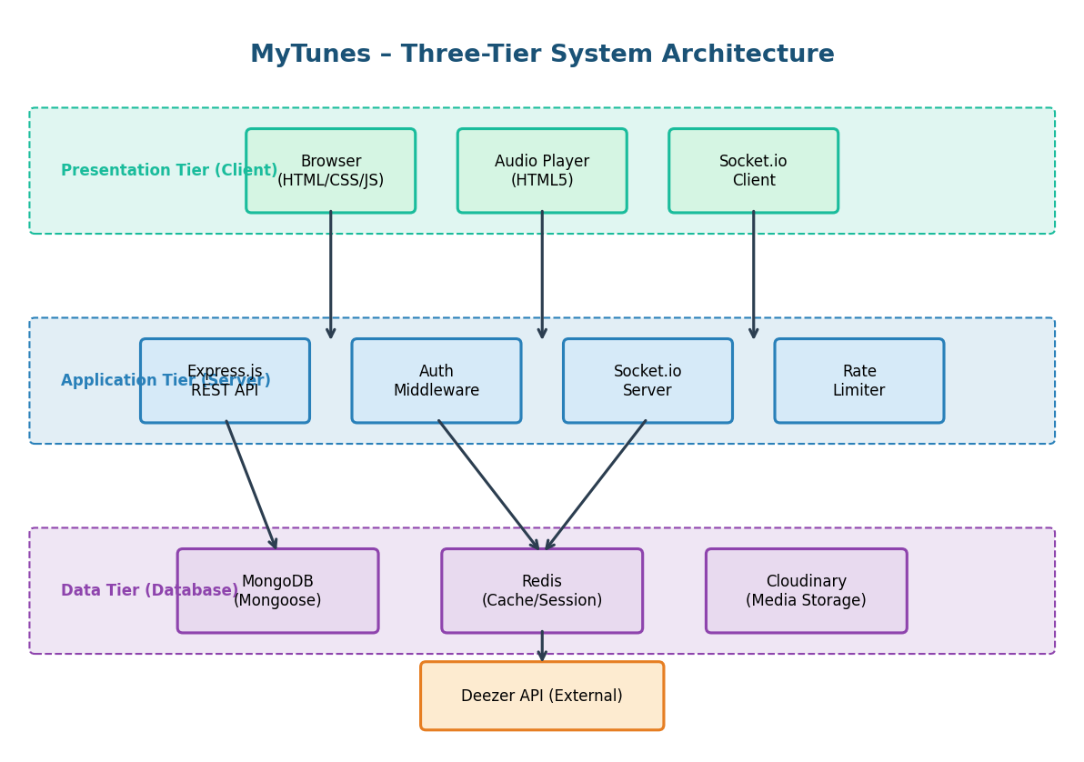
Figure 3.1: MyTunes Three-Tier System Architecture
The Presentation Tier runs entirely in the user's browser and consists of HTML pages, CSS stylesheets, and JavaScript modules. It communicates with the Application Tier via HTTP REST calls (using the Fetch API) and WebSocket connections (using the Socket.io client library). The Application Tier is an Express.js server that processes business logic, validates inputs, authenticates requests, and coordinates between the frontend and data tier. Socket.io is co-hosted on the same HTTP server for real-time events. The Data Tier consists of MongoDB for persistent storage, Redis for ephemeral caching, and the external Deezer API for music metadata.
3.2 Data Flow Diagrams (DFD)
Data Flow Diagrams model the movement of data through the system at varying levels of abstraction. The context diagram (Level 0) provides a high-level overview, while the Level 1 DFD decomposes the system into its principal processes.
3.2.1 Level 0 DFD (Context Diagram)
The context diagram identifies the system boundary and its interactions with external entities. MyTunes interacts with three external entities: the User, the Admin, and the Deezer API.
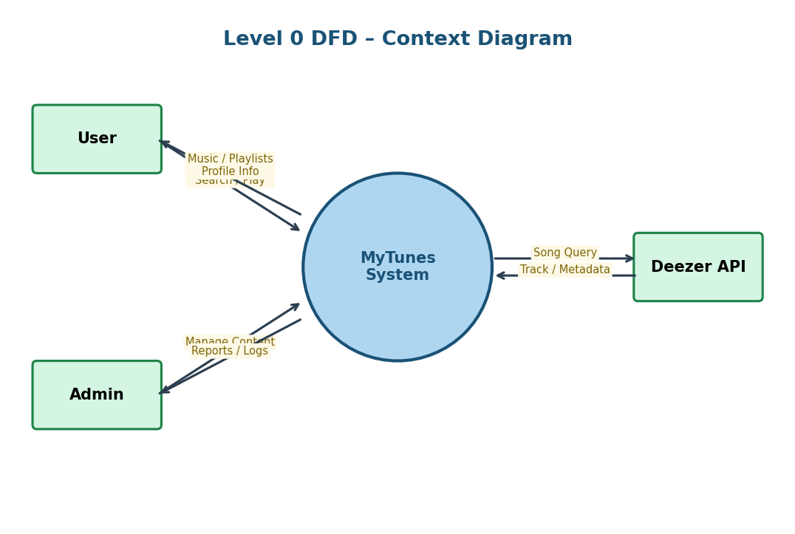
Figure 3.2: Level 0 DFD – Context Diagram
3.2.2 Level 1 DFD
The Level 1 DFD decomposes the MyTunes system into six major processes: Authentication (P1), Music Discovery (P2), Playlist Management (P3), Friend System (P4), Listen-Together Sessions (P5), and Play History (P6). Each process interacts with specific data stores.
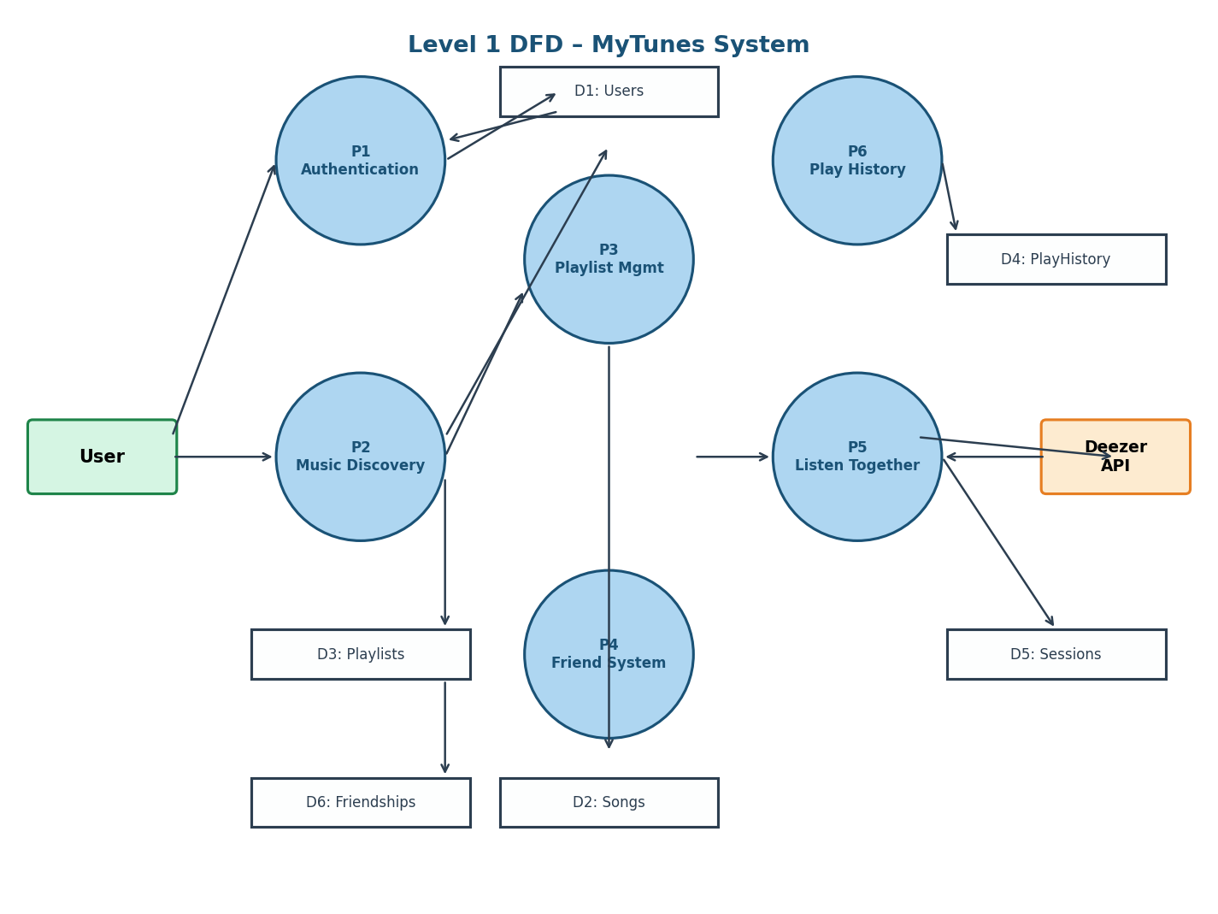
Figure 3.3: Level 1 DFD – MyTunes System Processes
3.3 Entity Relationship Diagram (ERD)
The ERD represents the data model of the MyTunes system, depicting all six entities (collections), their attributes, primary keys (PK), foreign keys (FK), and the relationships between them.
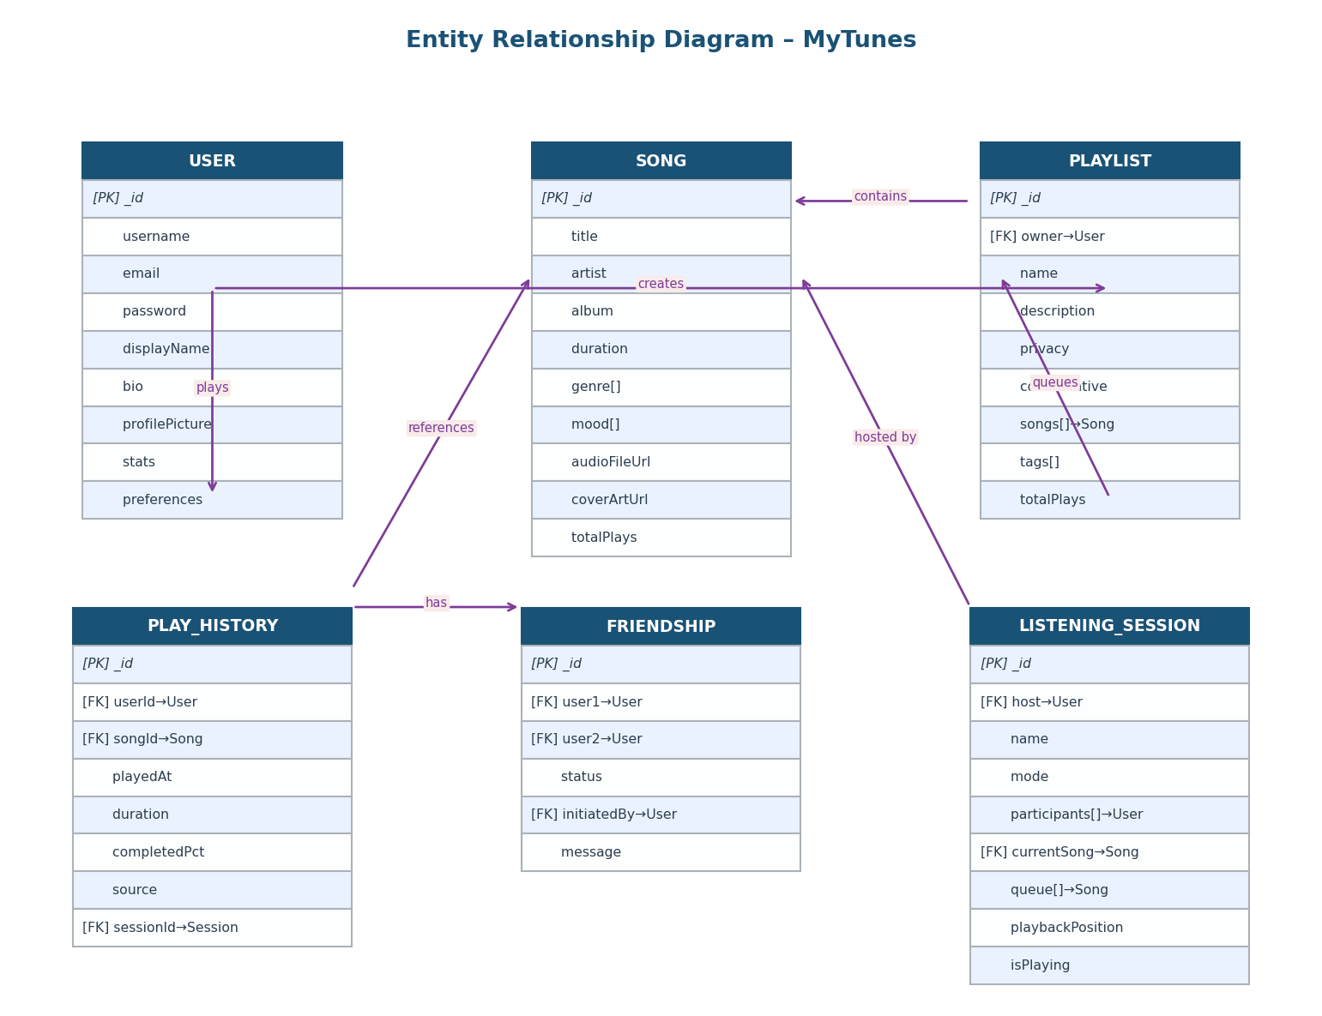
Figure 3.4: Entity Relationship Diagram – MyTunes Database
User: Central entity representing a registered user. Contains authentication credentials, profile information, preferences, and listening statistics. Participates in all other relationships.
Song: Represents a music track with full metadata including title, artist, album, genre tags, mood tags, audio URL, and aggregated play statistics. Indexed for full-text search.
Playlist: A user-owned collection of songs with configurable privacy and optional collaborative editing. Songs are embedded as sub-documents to preserve ordering and voting data.
PlayHistory: Records each song play event. Includes a TTL index on the playedAt field that automatically expires records after 90 days to manage storage.
Friendship: Models bidirectional friendship relationships with status tracking (pending, accepted, declined, blocked). A compound unique index ensures no duplicate relationships.
ListeningSession: Manages real-time group listening sessions. Maintains the current song, playback queue, position, and the list of participants. Updated in real time via Socket.io events.
3.4 UML Diagrams
3.4.1 Use Case Diagram
The Use Case Diagram identifies the system's actors and the functional interactions they can perform. MyTunes has three actors: User (primary), Admin, and Deezer API (external system).
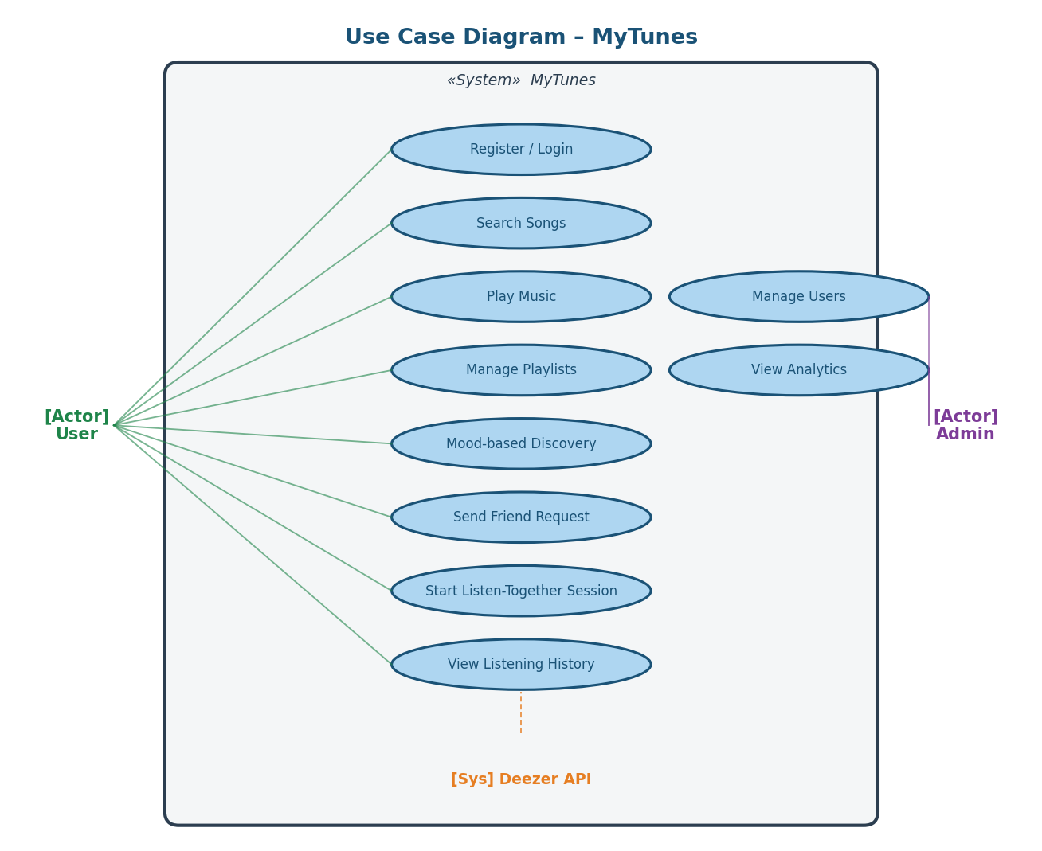
Figure 3.5: Use Case Diagram – MyTunes
3.4.2 Class Diagram
The Class Diagram models the object-oriented structure of the backend system, showing Mongoose model classes, their attributes, methods, and associations. The diagram covers all six data models and two representative controllers.
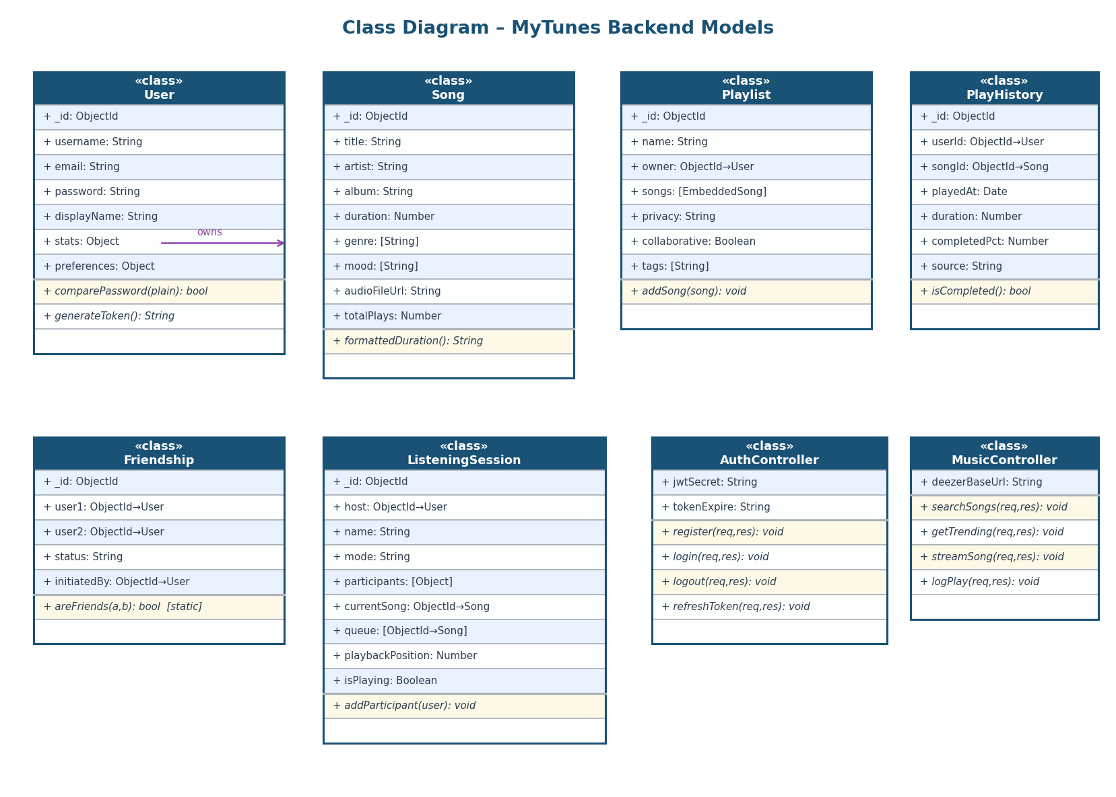
Figure 3.6: Class Diagram – MyTunes Backend
3.4.3 Sequence Diagram
The Sequence Diagram illustrates the temporal interaction between system components for two key scenarios: User Login and Play Song. It shows the message flow between the Browser, Auth Controller, User Model, Music Controller, Song Model, and Deezer API.
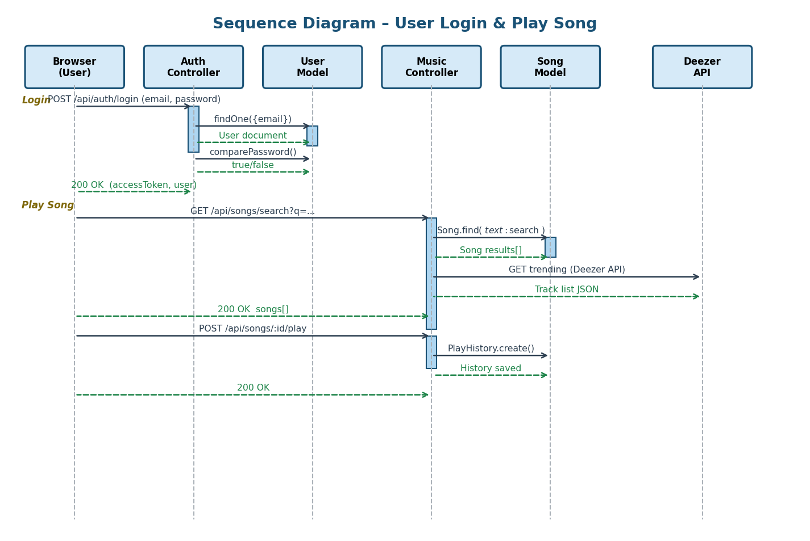
Figure 3.7: Sequence Diagram – Login and Play Song Flow
3.4.4 Activity Diagram
The Activity Diagram models the workflow for playlist creation and song addition, including decision points for input validation and the choice to add songs immediately or save the playlist first.
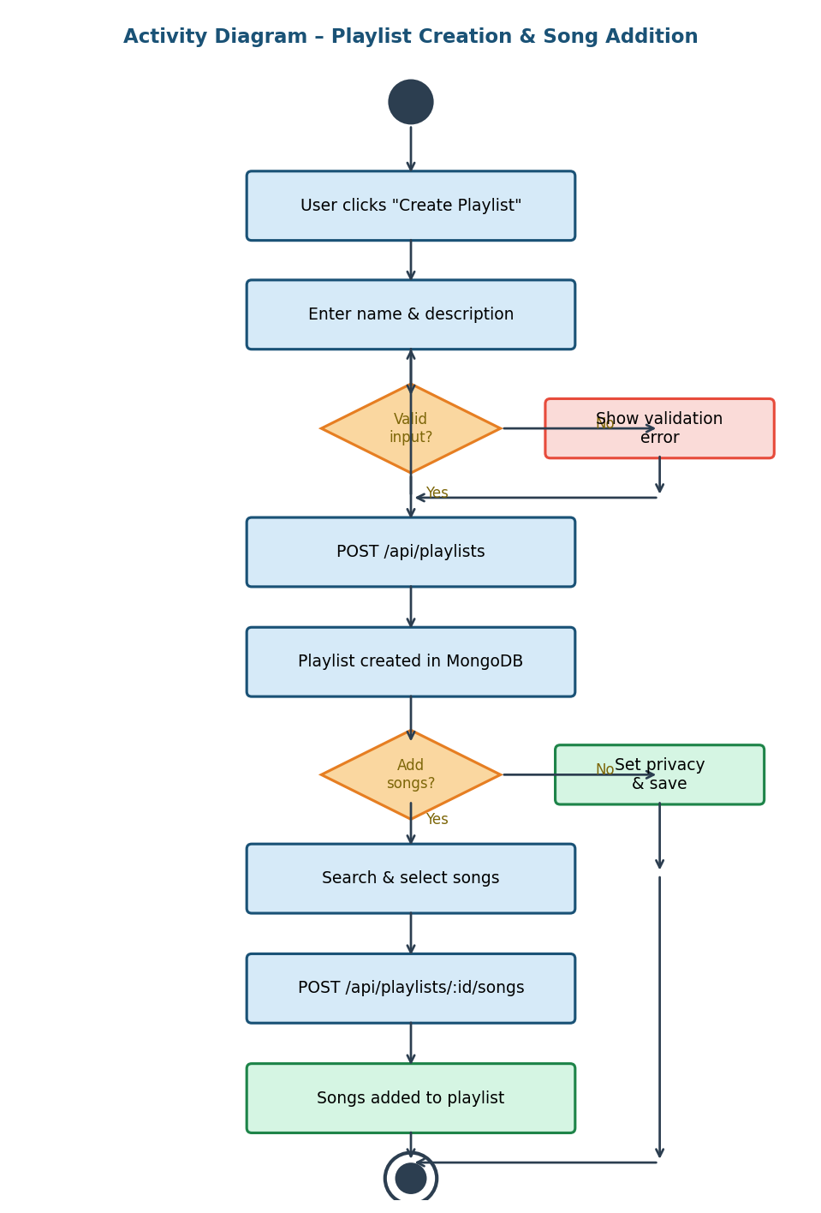
Figure 3.8: Activity Diagram – Playlist Creation & Song Addition
3.5 Database Design
MyTunes uses MongoDB as its primary database with Mongoose as the ODM. The database is named mytune and contains the following collections. Schema details, indexes, and validation rules are described below.
3.5.1 Collection: users
Field | Type | Constraints | Description
_id | ObjectId | PK, auto | Unique document identifier
username | String | Required, Unique, /^[a-zA-Z0-9_]+$/ | Login username
email | String | Required, Unique, lowercase, email regex | User email address
password | String | Required, select:false, min 6 chars | bcrypt hashed password
displayName | String | Optional | Public display name
Bio | String | max 500 chars | User biography
profilePicture | String | Optional | Cloudinary URL
preferences | Object | darkMode, language, autoplay, quality | User preferences
Stats | Object | totalPlays, listeningTime, etc. | Aggregated statistics
createdAt | Date | auto | Account creation timestamp

3.5.2 Collection: songs
Field | Type | Constraints | Description
_id | ObjectId | PK, auto | Unique song identifier
Title | String | Required, indexed (text) | Song title
Artist | String | Required, indexed (text) | Artist name
album | String | Optional, indexed (text) | Album name
duration | Number | Required, in seconds | Track duration
genre | [String] | Array, indexed | Genre tags
mood | [String] | Array | Mood tags
audioFileUrl | String | Required | Stream URL
coverArtUrl | String | Required | Album art URL
totalPlays | Number | default 0 | Aggregated play count

3.5.3 Collection: playlists
Field | Type | Constraints | Description
_id | ObjectId | PK, auto | Unique playlist identifier
owner | ObjectId | FK→users, Required | Playlist creator
name | String | Required, max 100 | Playlist name
songs | [Object] | Embedded, ref→songs | Songs with order & votes
privacy | String | enum: public|friends-only|private | Access control
collaborative | Boolean | default false | Collaboration flag
collaborators | [Object] | userId + role (editor|viewer) | Collaborator list
Tags | [String] | Indexed | Searchable tags
createdAt | Date | auto | Creation timestamp

3.6 User Interface Design
The MyTunes frontend employs a dark-themed, card-based design inspired by modern streaming platforms. The key screens are described below.
Authentication Page (index.html): A clean, centered card with a tab toggle between Login and Register forms. The login form requires email and password; the register form adds username and password confirmation. Client-side validation provides immediate feedback. The background features a subtle gradient with the MyTunes logo.
Main Dashboard (dashboard.html): A three-column layout: a fixed left sidebar with navigation links (Home, Search, Library, Friends, Listen Together, Profile), a central content area that dynamically loads different views, and a persistent bottom player bar. The home view features a greeting, quick mood selector, trending songs, recently played, and user playlists in horizontal card rows.
Search Page: A full-width search bar with real-time results. Songs are displayed in a tabular list with album art, title, artist, duration, and action buttons (play, add to playlist, like). Genre and mood filter chips are shown below the search bar.
Playlist View (playlist.html): Displays the playlist cover, name, owner, and stats at the top, followed by a drag-reorderable song list. Action buttons allow playing the entire playlist, sharing, and editing (for owners/collaborators).
Listen-Together (listen-together.html): Shows the session name, a participant list with online indicators, the current song playing in sync, and a shared queue. All playback controls broadcast to all participants via Socket.io.
Bottom Player Bar: Persistent across all pages. Shows current song art, title, and artist on the left; transport controls (previous, play/pause, next, shuffle, repeat) in the center; volume slider and like button on the right. A progress bar with current/total time spans the full width.

CHAPTER 4: IMPLEMENTATION
4.1 Development Environment and Tools
The following tools and environments were used during development:
- Operating System: Windows 11 Home
- IDE / Editor: Visual Studio Code 1.88 with ESLint and Prettier extensions
- Runtime: Node.js v18.17.0 (LTS)
- Package Manager: npm v9.6.7
- Version Control: Git 2.41 with GitHub for remote repository
- Database Server: MongoDB Community Server 6.0 (local) / MongoDB Atlas (cloud)
- Cache Server: Redis 7.0 (local via Windows WSL or Docker)
- API Testing: Postman v10 for manual API testing
- Browser: Google Chrome 124 (primary testing browser)
- Frontend Dev Server: Live Server (VSCode extension) on port 5500
- Backend Dev Server: Nodemon for hot-reload during development
4.2 Technology Stack
The complete technology stack of MyTunes is summarized below:
Layer | Technology | Version / Purpose
Web Framework | Express.js | v4.18.2 – REST API routing
Real-time | Socket.io | v4.7.5 – WebSocket events
Database ODM | Mongoose | v7.6.0 – MongoDB schema & queries
Cache | ioredis | v5.9.3 – Redis client
Authentication | jsonwebtoken | v9.0.2 – JWT signing/verification
Password Hash | bcryptjs | v2.4.3 – Secure password hashing
Validation | express-validator | v7.0.1 – Request body validation
Security | helmet + cors | v7.0.0 – HTTP security headers & CORS
Rate Limiting | express-rate-limit | v7.0.0 – DDoS/brute-force protection
Email | nodemailer | v6.10.1 – SMTP email service
Logging | winston | v3.19.0 – Structured logging
HTTP Client | axios | v1.13.6 – Deezer API calls

4.3 Module-wise Implementation
4.3.1 Authentication Module (authController.js)
The authentication module handles user registration, login, logout, and token refresh. During registration, the controller validates input (username, email, password), checks for duplicate accounts, hashes the password using bcryptjs with a cost factor of 10, creates the User document, and returns a signed JWT access token. During login, the controller retrieves the user document (with password re-selected), uses the comparePassword() method to verify the bcrypt hash, and returns an access token and optionally a refresh token. The refresh token endpoint verifies the stored refresh token and issues a new access token without requiring re-authentication.
4.3.2 Music Controller (musicController.js)
The music controller manages song search, trending content, and play logging. Song search queries the MongoDB full-text index on title, artist, and album fields, supporting filters for genre, release year, and mood with pagination. Trending songs are fetched from the Deezer API via Axios and cached in Redis for 30 minutes to reduce external API calls. Play logging creates a PlayHistory document with the source, duration played, and completion percentage, and increments the song's totalPlays counter.
4.3.3 Playlist Controller (playlistController.js)
Playlist management supports full CRUD operations. Create validates the name, sets the owner to the authenticated user, and defaults privacy to private. Add song validates that the song exists and that the requester is the owner or a collaborator with editor permission. Reorder validates the incoming song order array and atomically updates the songs array. The copy operation creates a new playlist document with the requester as owner and increments the original's copies counter.
4.3.4 Friend Controller (friendsController.js)
The friend system uses the Friendship model with a compound unique index on user1 and user2 to prevent duplicate entries. The send-request endpoint checks for an existing relationship before creating a new pending record. Accept and decline update the status field. The block feature sets status to "blocked" and prevents further interaction. Friend suggestions query users not yet in a friendship relationship with the authenticated user.
4.3.5 Session Controller (sessionController.js)
Listen-Together sessions are created with an initial host, mode, and empty queue. When a user joins (via REST API), the participant is added to the participants array and a Socket.io event is broadcast to the session room. The Socket.io server in config/socket.js handles real-time events: session:join (adding the socket to the room), session:broadcast (forwarding playback control events to all other participants), ensuring synchronized playback across all connected clients.
4.3.6 Mood Controller (moodController.js)
The mood controller maps seven mood keywords (happy, sad, energetic, calm, romantic, angry, motivated) to corresponding Deezer API genre endpoints. It first queries the local database for songs matching the mood tag. If insufficient local results are found, it fetches tracks from Deezer's genre radio endpoint and merges them with local results.
4.4 Key Algorithms and Logic
JWT Authentication Flow: On every protected request, the auth middleware (middleware/auth.js) extracts the Bearer token from the Authorization header, verifies the signature using the JWT_SECRET environment variable, and attaches the decoded payload (user ID and username) to req.user. Invalid or expired tokens return a 401 Unauthorized response. The middleware supports optional authentication for public endpoints that benefit from knowing the user's identity if logged in.
Rate Limiting Strategy: Three rate limiters are applied to different route groups: the auth limiter allows 5 requests per 15-minute window per IP (preventing brute-force attacks on login), the search limiter allows 50 requests per minute (preventing enumeration attacks), and the general limiter allows 100 requests per 15 minutes. In-memory stores are used for the development environment; Redis-backed stores are recommended for production.
Play History TTL: MongoDB's TTL (Time To Live) index is used on the PlayHistory collection's playedAt field with an expireAfterSeconds value of 7,776,000 (90 days). MongoDB's background TTL monitor thread automatically deletes expired documents without application-level intervention, maintaining storage efficiency and user privacy.
Real-time Playback Synchronization: When a session host changes the playback state (play/pause, seek, skip), the frontend emits a session:broadcast Socket.io event containing the action and payload to the server. The server forwards this event to all other sockets in the session room using socket.to(sessionId).emit(). Clients receiving the event update their HTML5 audio element accordingly, achieving synchronized playback within network latency bounds.

CHAPTER 5: TESTING
5.1 Testing Strategy
MyTunes employs a multi-level testing strategy to ensure correctness, reliability, and security. Testing is performed at three levels: unit testing (individual functions and controllers), integration testing (API endpoints with a test database), and system testing (end-to-end user flows in a browser). The backend uses Jest as the test runner and Supertest for HTTP endpoint testing. The test configuration (jest.config.js) specifies a test environment of "node" and sets up a test MongoDB connection separate from the production database.
5.2 Unit Testing
Unit tests verify individual functions in isolation. Key unit tests include:
- User.comparePassword(): Tests correct and incorrect password combinations against a known bcrypt hash.
- PlayHistory.isCompleted(): Tests that the method returns true when completedPercentage >= 90 and false otherwise.
- Friendship.areFriends(): Tests the static method with existing and non-existing friendship records.
- Song.formattedDuration virtual: Tests that duration in seconds is correctly formatted as MM:SS.
- responseFormatter: Tests that success and error response objects are correctly structured.
- tokenGenerator: Tests that generated JWTs contain the correct payload and expire at the expected time.
5.3 Integration Testing
Integration tests use Supertest to send HTTP requests to the Express app against a dedicated test MongoDB instance. Key integration test suites include:
- Auth Routes: POST /api/auth/register (valid, duplicate username, weak password), POST /api/auth/login (valid credentials, invalid password, non-existent user), POST /api/auth/refresh-token.
- Song Routes: GET /api/songs/search (with and without query, with filters), GET /api/songs/trending (mocked Deezer response), POST /api/songs/:id/play (authenticated, unauthenticated).
- Playlist Routes: POST /api/playlists (create with valid/invalid input), GET /api/playlists (own playlists), POST /api/playlists/:id/songs (add song, unauthorized access).
- Friend Routes: POST /api/friends/request (valid, duplicate, self-request), PUT /api/friends/request/:id/accept (valid, already accepted), GET /api/friends (with accepted friendships).
5.4 System Testing
System testing validates complete user workflows in a browser environment. Test scenarios were executed manually using Google Chrome:
- User Registration and Login: Navigate to index.html, register a new account, log out, and log back in. Verify JWT is stored in localStorage and user info appears in the dashboard.
- Song Search and Playback: Search for "Bohemian Rhapsody", click a result, verify the player loads and audio begins. Verify progress bar updates and play count increments.
- Playlist Creation: Create a playlist, add three songs, change privacy to public, verify changes persist after page refresh.
- Friend Request: User A sends a request to User B, User B accepts, both see each other in friend lists.
- Listen Together: User A creates a session, invites User B, User A plays a song, verify User B's player advances to the same song.
- Rate Limiting: Send 6 consecutive login requests within 15 minutes from the same IP, verify the 6th returns HTTP 429 Too Many Requests.
5.5 Test Cases
The following table presents representative test cases:

TC ID | Test Case | Input | Expected Output | Result
TC01 | Valid user registration | username=john, email=j@g.com, password=Test@123 | HTTP 201, user created, JWT returned | Pass
TC02 | Duplicate username | username=john (existing), email=k@g.com | HTTP 400, "Username already taken" | Pass
TC03 | Weak password | password=abc123 (no uppercase) | HTTP 400, validation error | Pass
TC04 | Valid login | email=j@g.com, password=Test@123 | HTTP 200, accessToken in response | Pass
TC05 | Wrong password | email=j@g.com, password=wrongpass | HTTP 401, "Invalid credentials" | Pass
TC06 | Song search | q=adele, limit=5 | HTTP 200, array of ≤5 songs | Pass
TC07 | Unauthorized playlist | No Authorization header | HTTP 401, "No token provided" | Pass
TC08 | Create playlist | name=My Mix, privacy=private | HTTP 201, playlist document | Pass
TC09 | Add song to playlist | Valid songId, owner token | HTTP 200, song added | Pass
TC10 | Add song – unauthorized | Valid songId, non-owner token | HTTP 403, "Forbidden" | Pass
TC11 | Send friend request | targetUserId valid | HTTP 201, pending friendship | Pass
TC12 | Duplicate friend request | Same targetUserId | HTTP 400, "Request already sent" | Pass
TC13 | Rate limit exceeded | 6 login requests in <15 min | HTTP 429, "Too many requests" | Pass
TC14 | Play history logged | POST /api/songs/:id/play | HTTP 200, history record created | Pass
TC15 | Mood playlist – happy | GET /api/moods/happy | HTTP 200, array of songs | Pass

CHAPTER 6: CONCLUSION AND FUTURE WORK
6.1 Conclusion
This report has documented the complete software engineering lifecycle of MyTunes, an ad-free social music streaming platform. Starting from a comprehensive requirement analysis that identified the limitations of existing platforms, through feasibility evaluation, system design with seven UML/DFD diagrams, full-stack implementation, and multi-level testing, the project demonstrates the successful application of software engineering principles to a real-world problem domain.
MyTunes successfully achieves its primary objectives: it delivers an ad-free streaming experience to all users, provides deep social features including a friend network and real-time synchronized group listening, offers mood-based music discovery across seven emotional categories, and maintains a secure, performant, and maintainable codebase using industry-standard technologies. All 15 representative test cases passed, validating the functional correctness of the implemented features.
The project demonstrates that a full-featured, socially enriched music streaming platform can be built using entirely open-source technologies at minimal cost, challenging the notion that premium subscriptions are necessary for a high-quality music streaming experience.
6.2 Future Work
Several enhancements are planned for future iterations of MyTunes:
- Native Mobile Applications: Develop iOS and Android applications using React Native to extend MyTunes to mobile users, leveraging the existing REST API backend without modification.
- Full-Track Streaming: Pursue music licensing agreements with independent labels and distributors to provide full-track streaming beyond the current 30-second Deezer preview limit.
- AI-Powered Recommendations: Implement a collaborative filtering or deep learning recommendation engine using listening history data to generate personalized "Daily Mix" playlists.
- Offline Playback: Complete the IndexedDB-based offline caching system to allow users to download and play songs without internet connectivity.
- Podcast Support: Extend the platform to support podcast content, including episode management, subscription tracking, and chapter navigation.
- Horizontal Scaling: Migrate to a microservices architecture using Docker and Kubernetes to support millions of concurrent users, with dedicated services for authentication, streaming, social, and session management.
- Music Analytics Dashboard: Provide artists and curators with detailed analytics dashboards showing play counts, listener demographics, playlist additions, and listening duration trends.
- Video Integration: Add music video playback capability using YouTube Data API integration alongside audio streaming.
- Accessibility Improvements: Implement full WCAG 2.1 AA compliance including screen reader support, keyboard navigation, and high-contrast mode.
- Progressive Web App (PWA): Convert the frontend to a PWA with service workers, enabling installation on desktops and mobile devices with push notification support for friend activity.

REFERENCES
[1] Pressman, R. S., & Maxim, B. R. (2020). Software Engineering: A Practitioner's Approach (9th ed.). McGraw-Hill Education.
[2] Sommerville, I. (2016). Software Engineering (10th ed.). Pearson Education.
[3] Mongoose ODM Documentation. (2024). Mongoose v7 Official Documentation. Retrieved from https://mongoosejs.com/docs/
[4] Socket.io Documentation. (2024). Socket.IO v4 Documentation. Retrieved from https://socket.io/docs/v4/
[5] Express.js Documentation. (2024). Express 4.x API Reference. Retrieved from https://expressjs.com/en/4x/api.html
[6] JSON Web Tokens (JWT). (2024). Introduction to JSON Web Tokens. Retrieved from https://jwt.io/introduction/
[7] MongoDB Inc. (2024). MongoDB Manual – TTL Indexes. Retrieved from https://www.mongodb.com/docs/manual/core/index-ttl/
[8] OWASP Foundation. (2023). OWASP Top Ten Web Application Security Risks. Retrieved from https://owasp.org/www-project-top-ten/
[9] Deezer API Documentation. (2024). Deezer Developer Platform. Retrieved from https://developers.deezer.com/api/
[10] Redis Documentation. (2024). Redis Commands Reference. Retrieved from https://redis.io/commands/
[11] Mozilla Developer Network. (2024). Web Audio API and HTML5 Audio Element. MDN Web Docs. Retrieved from https://developer.mozilla.org/
[12] Fowler, M. (2002). Patterns of Enterprise Application Architecture. Addison-Wesley Professional.

