Unix and Linux Programming Laboratory
Course Code: BT CS 627

Submitted By:
Mausam Kr Giri
211563
Btech CSE

Submitted To:
Dr. Nitin Goyal
Department of Computer Science and Engineering

Table of Contents
Sl. | Practical | Page no
1 | Familiarize with Unix/Linux logging/logout and simple commands. | 3-4
2 | Familiarize with vim editor and Linux GUIs. | 5-6
3 | Using Bash shell develop simple shell programs. | 7-8
4 | Develop advanced shell programs using awk and grep.
5 | Compile and debug various C programs using different options.
6 | Learning of installation and upgradation of Linux operating system
7 | Install Linux on a PC having some other previously installed operating system. All OSs should be usable.
8 | As supervisor create and maintain user accounts, learn package installation, taking backups, creation of scripts for file and user management, creation of startup and shutdown scripts using at, cron etc.

1. Familiarize with Unix/Linux logging/logout and simple commands.

Logging in
Logging in to a Unix system requires two pieces of information: A username, and a password.
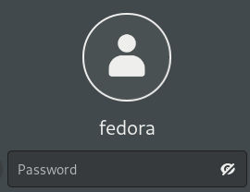

Lunix session login prompt picture
Type your username at the login prompt, and press the return key. The system will then ask you for your password.
Your username
Your username is assigned by the person who creates your account. The standard username is the first four letters of your last name concatenated with the first four letters of your first name.
Your username must be unique on the system where your account exists since it is the means by which you are identified on the system.
Your password
When your account is created, a password is assigned.
Some rules for selecting a good password:
- Do not use any part of your personal information or easily-guessable number related to social life.
- Do not use any word that can be found in an English or foreign-language dictionary.
- Do not use all the same letter, or a simple sequence of keys on the keyboard, like qwerty.
- Do use a mix of upper-case and lower-case letters, numbers, and control characters.
- Do use at least six characters.
Logging Out
When you're ready to quit, type the command
>> exit / logout / bye / quit (possible variations of this command)
>> gnome-session-quit (Ubuntu)

Before you leave your terminal, make sure that you see the login prompt, indicating that you have successfully logged out.

Basic commands
Some basic Unix/Linux commands:
- ls: Lists the files and directories in the current directory
- cd: Changes the current directory
- pwd: Displays the current directory path
- touch: Creates a new empty file
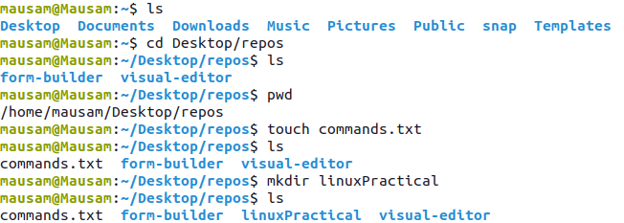
- cp: Copies files and directories
- mv: Moves or renames files and directories
- rm: Removes files and directories
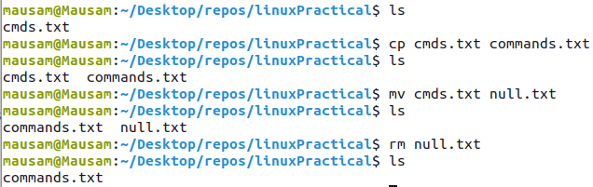
- nano: A simple text editor for creating and editing files
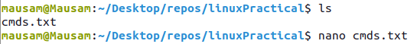

- man: Displays the manual page for a command

2. Familiarize with vim editor and Linux GUIs.

The Vim editor (and its predecessor, vi) is a command line editor for Linux systems. It has a long standing reputation as being the most powerful text editor on Linux.
To invoke Vi. At the command line, type vi <filename> to create a new file, or to edit an existing one.
$ vi filename.txt (Open or edit a file)
Vi edit modes
The Vi editor has two modes: Command and Insert.
When first opening a file with Vi, use remains in Command mode. Command mode means to use keyboard keys to navigate, delete, copy, paste, and do a number of other tasks—except entering text.
To enter Insert mode, press i. In Insert mode, allows to enter text, use the Enter key to go to a new line, use the arrow keys to navigate text, and use vi as a free-form text editor.
To return to Command mode, press the Esc key once.
Vi shortcuts
The best way to learn Vi is to create a new file and try it out for yourself. Feel free to use the common keyboard shortcut list below to help you learn Vi’s extensive vocabulary. This list of shortcuts is by no means exhaustive, but they will enable you to edit files and learn Vi in a short amount of time.
Some of the shortcuts to work with vi editor:

- i — Switch to Insert mode.
- Esc — Switch to Command mode.
- :w — Save and continue editing.
- :wq or ZZ — Save and quit/exit vi.
- :q! — Quit vi and do not save changes.
- yy — Yank (copy) a line of text.
- p — Paste a line of yanked text below the current line.
- o — Open a new line under the current line.
- O — Open a new line above the current line.
- A — Append to the end of the line.
- a — Append after the cursor’s current position.
- I — Insert text at the beginning of the current line.
- b — Go to the beginning of the word.
- e — Go to the end of the word.
- x — Delete a single character.
- dd — Delete an entire line.
- Xdd — Delete X number of lines.
- Xyy — Yank X number of lines.
- G — Go to the last line in a file.
- XG — Go to line X in a file.
- gg — Go to the first line in a file.
- :num — Display the current line’s line number.
- h or left arrow key — Move left one character.
- j or down arrow key — Move down one line.
- k or up arrow key — Move up one line.
- l or right arrow key — Move right one character.

3. Using Bash shell develop simple shell programs.

The Bash shell is a popular command-line interface and scripting language for Unix/Linux systems. It provides a powerful way to interact with the system, automate tasks, and execute programs.
Bash shell is needed for many reasons, including:
- It allows users to interact with the system in a flexible and efficient way.
- It provides a powerful scripting language that can be used to automate repetitive tasks, automate system administration, and create custom workflows.
Script naming conventions
By naming convention, bash scripts end with .sh. However, bash scripts can run perfectly fine without the sh extension.
Adding the Shebang
Bash scripts start with a shebang. Shebang is a combination of bash # and bang ! followed by the bash shell path. This is the first line of the script. Shebang tells the shell to execute it via bash shell. Shebang is simply an absolute path to the bash interpreter.
#!/bin/bash (example of shebang)

Basic Bash Application:
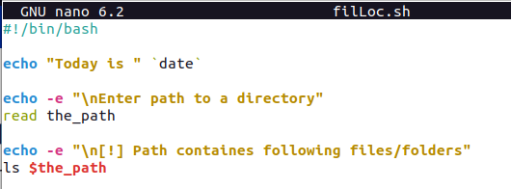

​Output
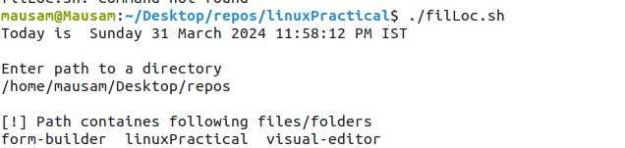

Basic Bash commands
- cd: Change the directory to a different location.
- ls: List the contents of the current directory.
- mkdir: Create a new directory.
- touch: Create a new file.
- rm: Remove a file or directory.
- cp: Copy a file or directory.
- mv: Move or rename a file or directory.
- echo: Print text to the terminal.
- cat: Concatenate and print the contents of a file.
- grep: Search for a pattern in a file.
- chmod: Change the permissions of a file or directory.
- sudo: Run a command with administrative privileges.
- df: Display the amount of disk space available.
- history: Show a list of previously executed commands.
- ps: Display information about running processes.

4. Develop advanced shell programs using awk and grep

grep and awk are both powerful command-line utilities in Unix-like operating systems used for text processing, but they serve different purposes and have different capabilities.
grep:
- grep stands for "global regular expression print".
- It is primarily used for searching text files for lines that match a specified pattern.
- Usage examples:
  - grep "pattern" file: Searches for lines containing "pattern" in the specified file.
  - grep -r "pattern" directory: Searches recursively in all files under the specified directory for lines containing "pattern".
  - grep -i "pattern" file: Performs a case-insensitive search for "pattern" in the file.
  - grep -v "pattern" file: Displays all lines that do not match "pattern".
awk:
- awk is a versatile programming language designed for text processing and data extraction.
- It operates on records (lines) and fields (columns) within those records.
- Usage examples:
  - awk '{print $1}' file: Prints the first column of each line in the file.
  - awk '/pattern/ {print $2}' file: Prints the second column of each line containing "pattern".
  - awk '{sum += $3} END {print sum}' file: Calculates and prints the sum of values in the third column of the file.
  - awk -F, '{print $NF}' file.csv: Sets the field separator to comma and prints the last field of each line in a CSV file.

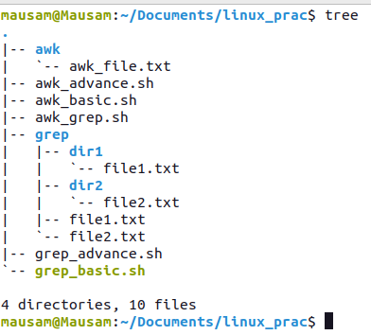
Program:
Folder Structure:

1. Grep Basic Program
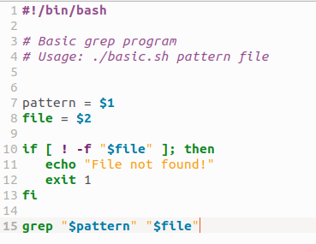

Output
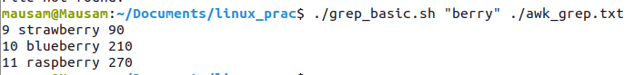
2. Grep Advance Program
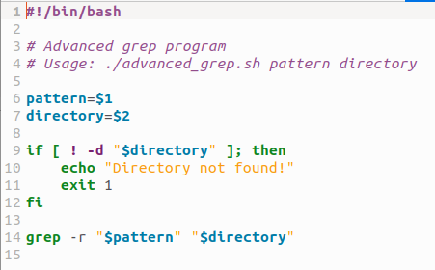

Output
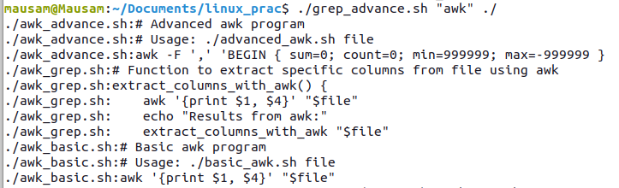
3. AWK Program
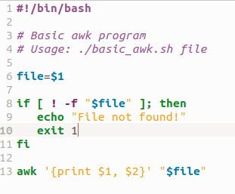

Output
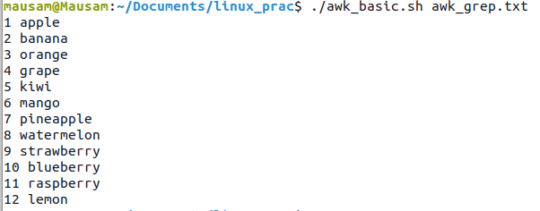

5. Compile and debug various C programs using different options.
Compile a C program in Linux:
gcc -g -o program_name program_name.c
This command compiles the C program named "program_name.c" with debugging symbols enabled (-g flag) and generates an executable named "program_name".
Run the compiled program:
bash
- ./program_name
This command executes the compiled program named "program_name".
Debug a program using gdb:
bash
gdb ./program_name
This command starts the GNU debugger (gdb) and loads the executable "program_name" for debugging purposes.

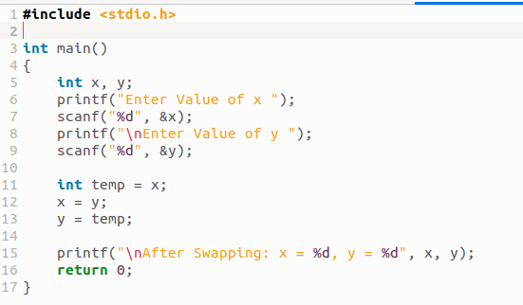
C Program

Output
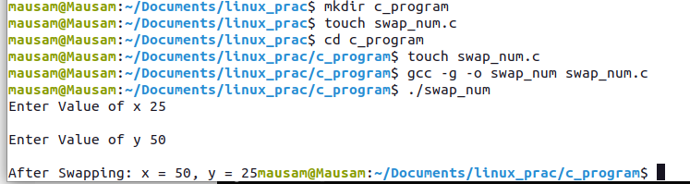
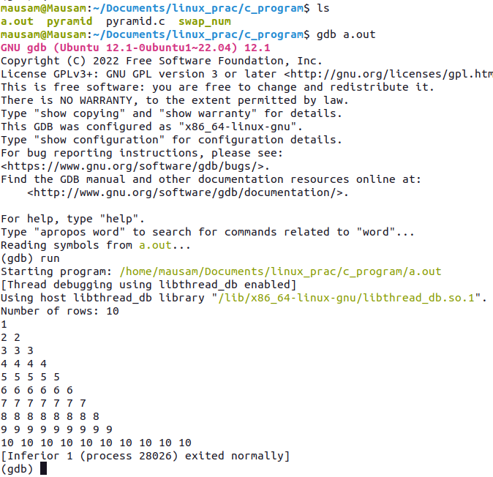
Debugging:

6. Learning of installation and upgradation of Linux operating system.
1. Requirement:
- A laptop or PC with at least 25GB of storage space.
- A flash drive (12GB or above recommended).
2. Download an Linux Image:
- I’m using Ubuntu Image as my linux distro for this practical. And you have to download ISO Image file from the source website of the linux provided by the distrubutor.
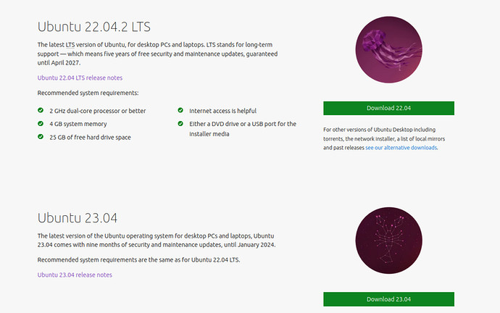
3. Create a Bootable USB stick
To install Ubuntu Desktop, we need to write your downloaded ISO to a USB stick to create the installation media.
For this practical, I’m using Balena Etcher to create bootable USB Stick for linux distro.
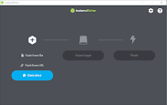

4. Boot from USB flash drive
Insert the USB flash drive into the laptop or PC you want to use to install Ubuntu and boot or restart the device. It should recognise the installation media automatically. If not, try holding F12 during startup and selecting the USB device from the system-specific boot menu.
Then presented with the option to try or install Ubuntu:
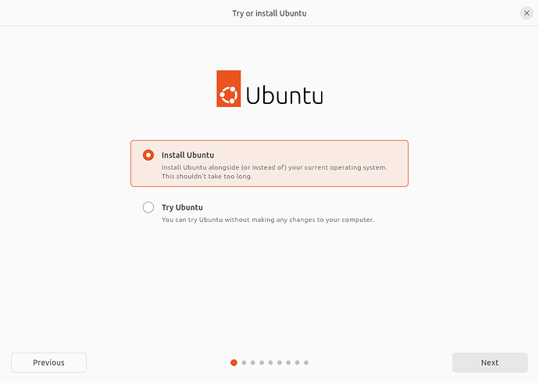

5. Installation Setup
You will be prompted to choose between the Normal installation and Minimal installation options. The minimal installation is useful for those with smaller hard drives or who don’t require as many pre-installed applications.
In Other options, you will be prompted to download updates as well as third-party software that may improve device support and performance (for example, Nvidia graphics drivers) during the installation. It is recommended to check both of these boxes.
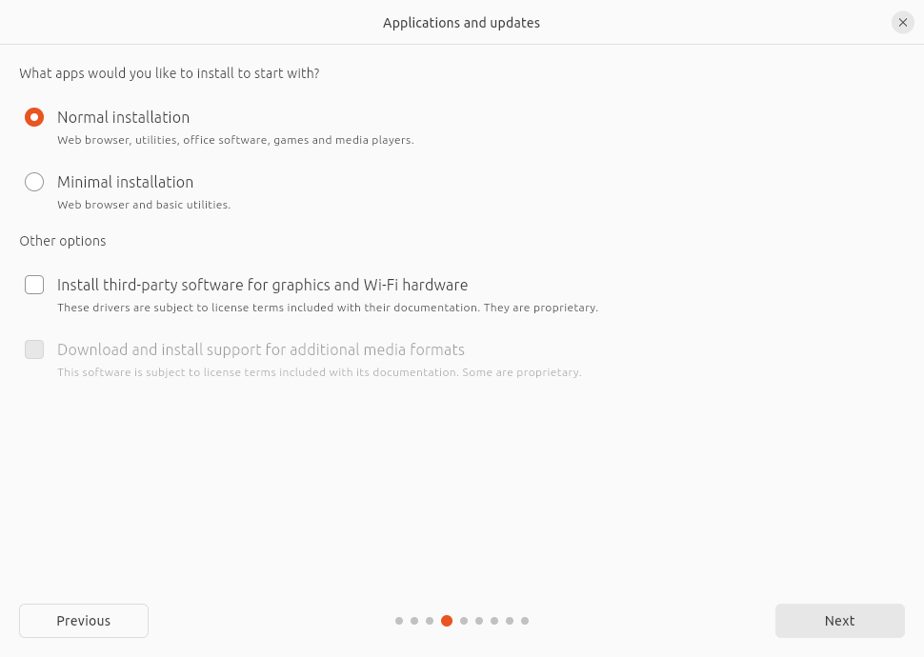

6. Create Login Details
On this screen, you will be prompted to enter your name and the name of your computer as it will appear on the network. Finally, you will create a username and a strong password.
You can choose to log in automatically or require a password. If you are using your device whilst travelling, it’s recommended to keep “Require my password to log in” enabled.

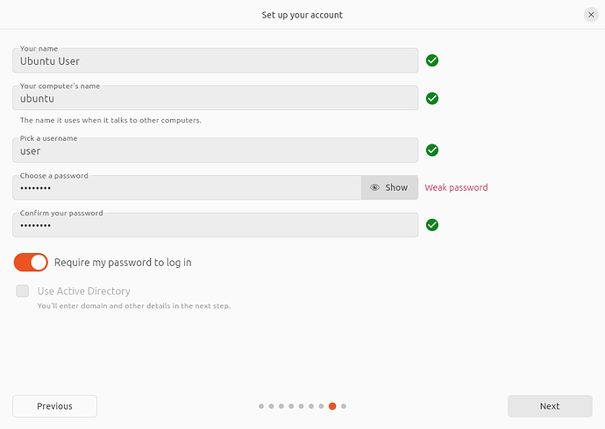

7. Complete the Installation
And that’s it, welcome to your new Ubuntu Desktop!
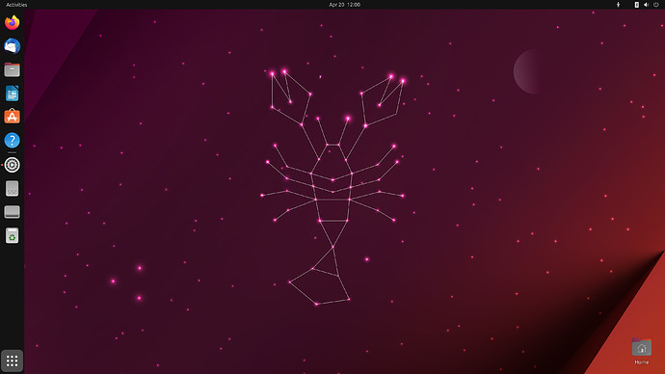

8. Update and Upgrade Linux Distro
Press CTRL+ALT+T to bring up a Terminal window (or click the terminal icon in the sidebar).
Type in:
sudo apt update
You will be prompted to enter your login password.
This will check for updates and tell you if there are any that need applying. To apply any updates, type:
sudo apt upgrade
Type Y, then press ENTER to confirm to finish the update process

7. Install Linux on a PC having some other previously installed operating system. All OSs should be usable.

1. Prerequisite
- A computer preinstalled with Windows 10
- A partitioned hard drive
- A BIOS in UEFI mode (Unified Extensible Firmware Interface)
- An empty USB drive of at least 4Gig for creating a bootable disk
- An internet connection to download Ubuntu ISO image (the Linux distro) and Rufus (a bootable drive creation tool)
2. Prepare System for Dual Boot
Assuming that the host system having Windows 10 pre-installed, and user having free disk space to install the linux distro. In this case the linux distro going to be used is Ubuntu.
- Make Sure PC BIOS is in UEFI Mode
Type system information, after pressing Win button to Open StartUp menu:
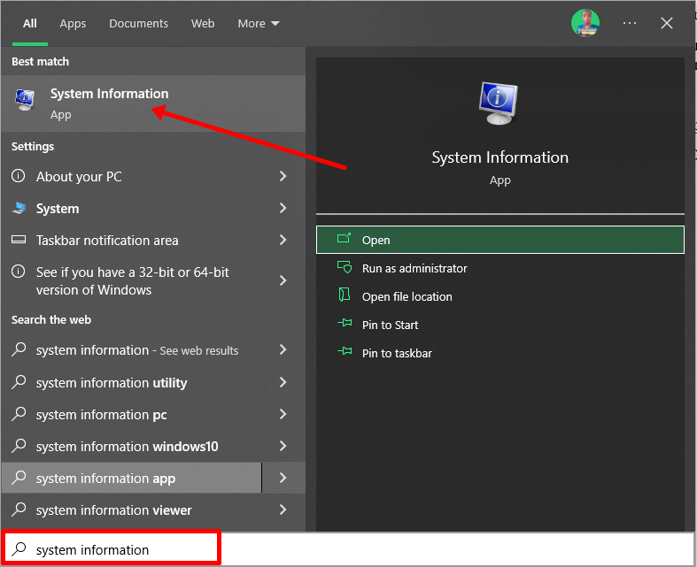

Look for the bios info:
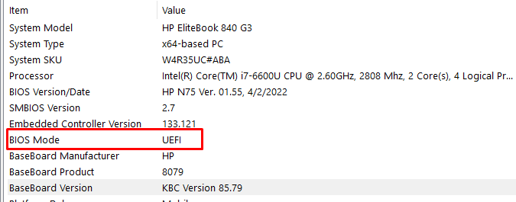

( Note: If PC BIOS is not in UEFI Mode, two operating systems can’t see each other: https://www.freecodecamp.org/news/uefi-vs-bios/ )

- Partition system Hard driver for Ubuntu
Right-click on Start or open Start menu and select “Disk Management”.
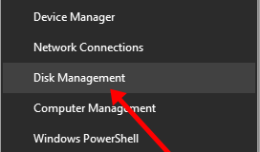

Right-click on your C drive and select shrink volume.
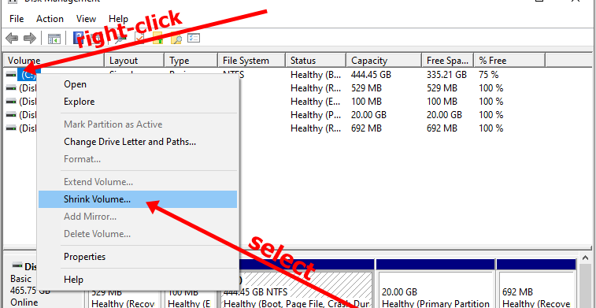

Select at least (20000) 20GB for Ubuntu and click “Shrink”. It can take some time to complete.
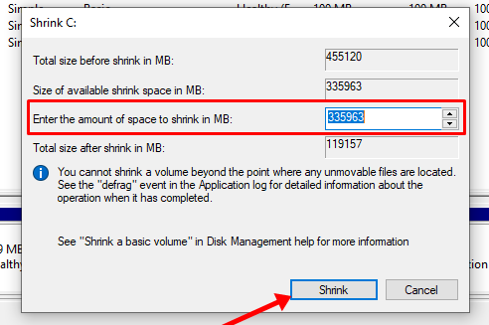

3. Make an Ubuntu(Linux) Bootable USB Drive
Follow the previous step followed in experiment 6 to create an Ubuntu Bootable USB Drive
  - Visit the official website of Ubuntu and download the latest stable version Image file
  - Choose any Media Creation Tool to convert usb drive to bootable usb drive (ex: Rufus, Balena Etcher, etc)
  - Follow the Step 2 and Step 3 of Experiment 6, listed in page no 14
4. Install Ubuntu Linux Distro along with Windows 10
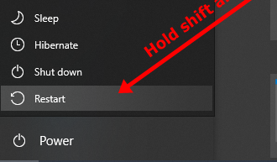
Ensure the bootable drive is inserted into your Windows 10 PC. And Right-click on Start, hold SHIFT, and select Restart.

Select “Use a Device”.
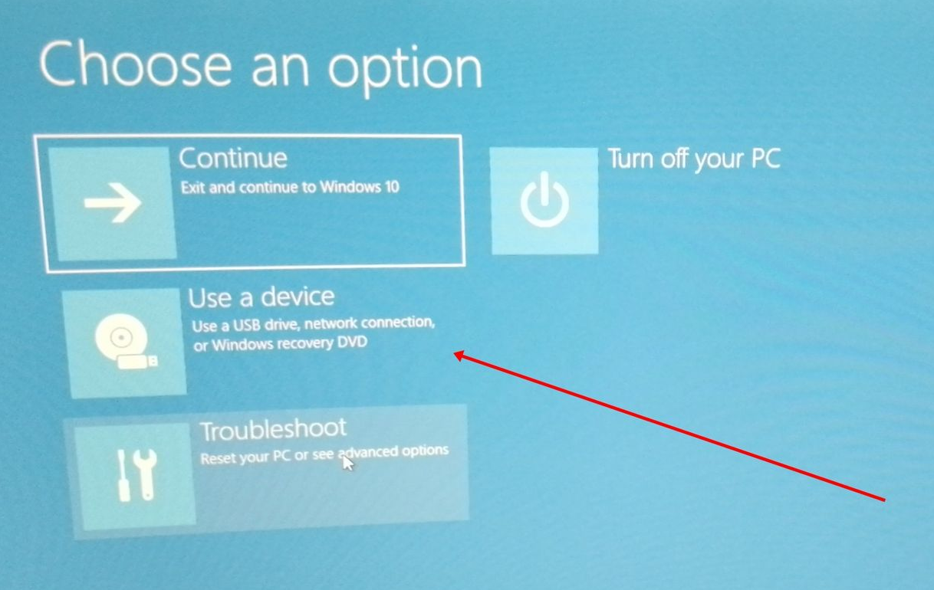

On the next screen, you should see several devices you can boot from. You may see the bootable drive as the name of the USB brand.
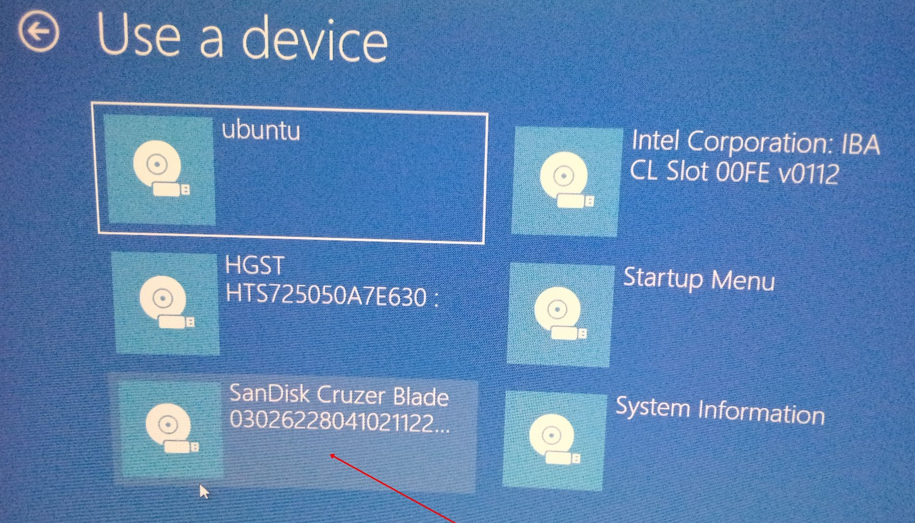

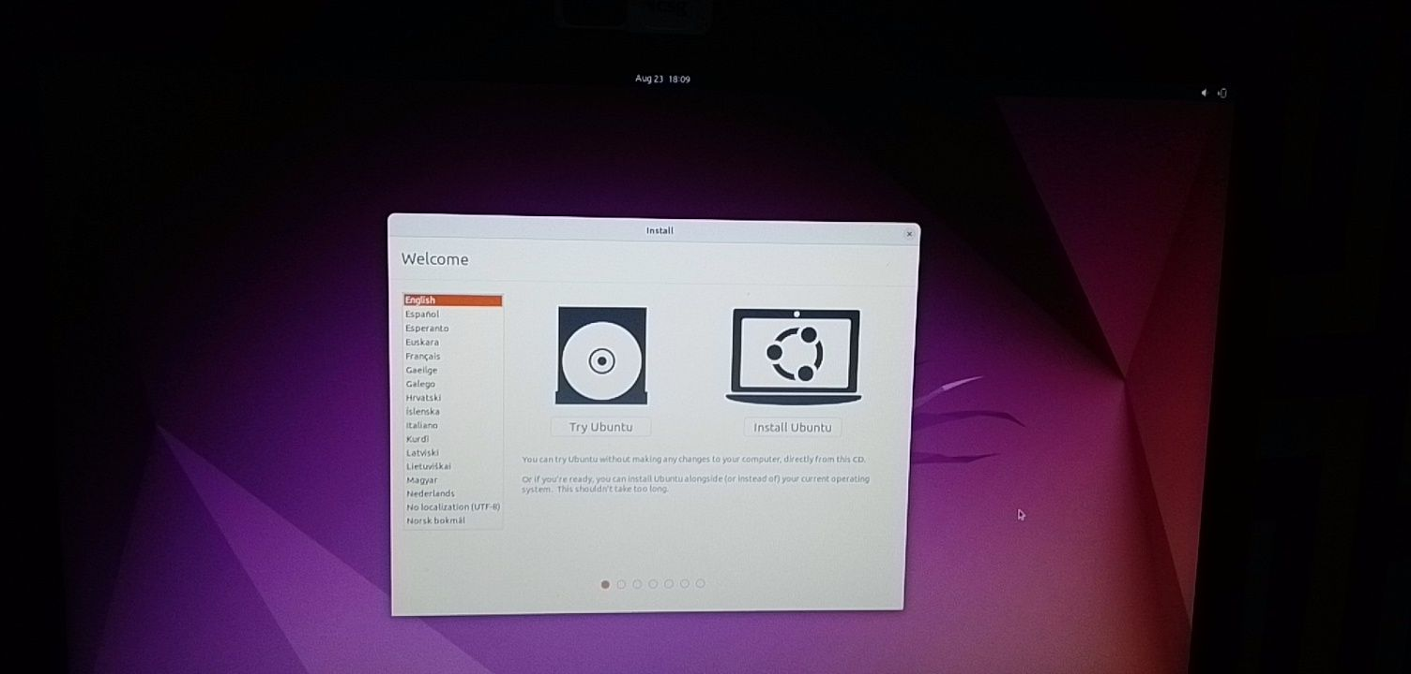
Choose "Install Ubuntu". You can also try it before installing it.

Follow other prompts of the installation wizard and When you get to the point to select the partition you made, scroll to the partition you made earlier and press ENTER.
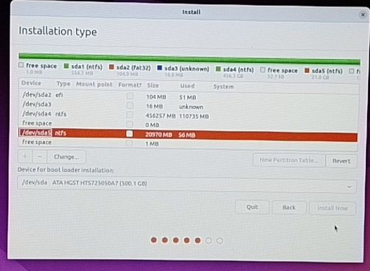

Click OK to select all the space in the partition.
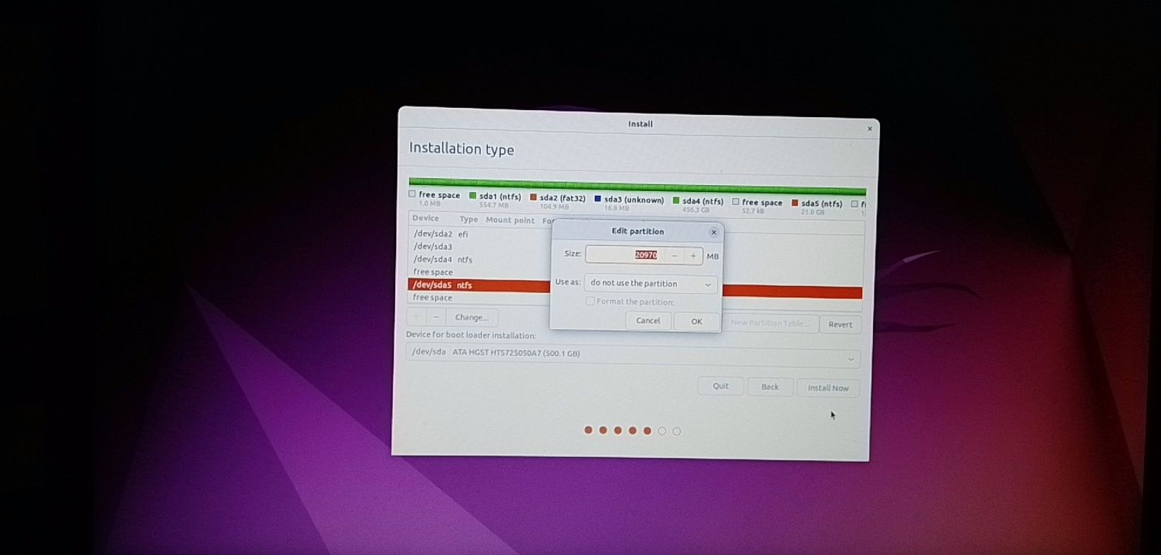

Follow other prompts until Ubuntu starts installing.
After the installation is done, Ubuntu will prompt you to remove the bootable drive and press ENTER to reboot your Computer.

5. Dual Boot Ubuntu and Windows 10
Immediately after you reboot the computer, you can see a screen that looks as shown below:
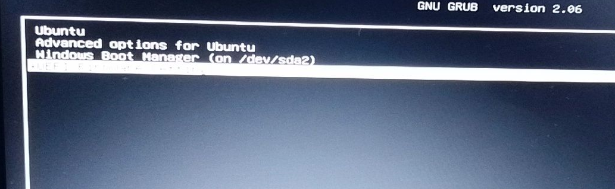
Now user can boot into Windows and Ubuntu, after starting the PC. To boot into Ubuntu, select Ubuntu. And to boot into Windows 10, select Windows boot manager.

8. As supervisor create and maintain user accounts, learn package installation, taking backups, creation of scripts for file and user management, creation of startup and shutdown scripts using at, cron etc.

