Google Search :  https://prnt.sc/u9hy7g  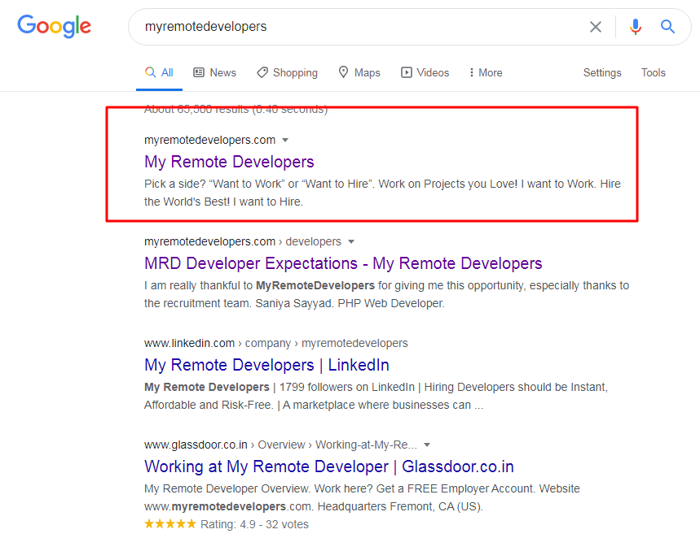 | Expected  When I searched other sites  https://prnt.sc/u9i8o9  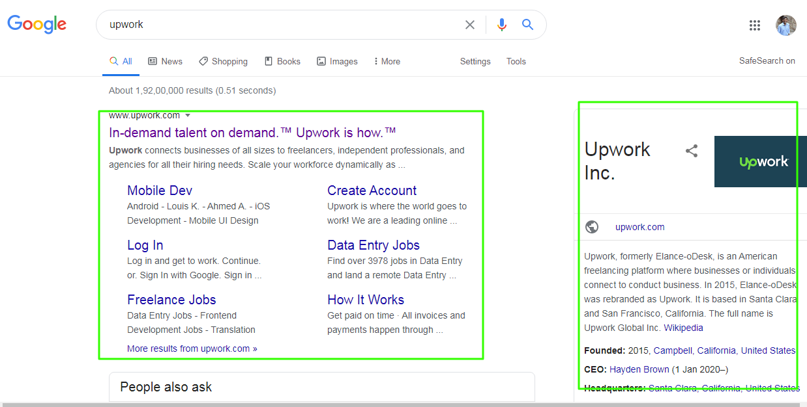
Home Url:
When I open
https://myremotedevelopers.com/
Redirected to https://myremotedevelopers.com/developers/
But domain has already developers the why redirected to /developers/ on home page?
Speed Comparison:
I have compared with upwork mostly same time but myreomterdevelopers has pre loader so until full content load loader is showing so user have to wait till.
Browse Jobs
When clicked on top Browse jobs (Without login) no job found.
https://prnt.sc/u9jeqh
https://prnt.sc/u9jehp
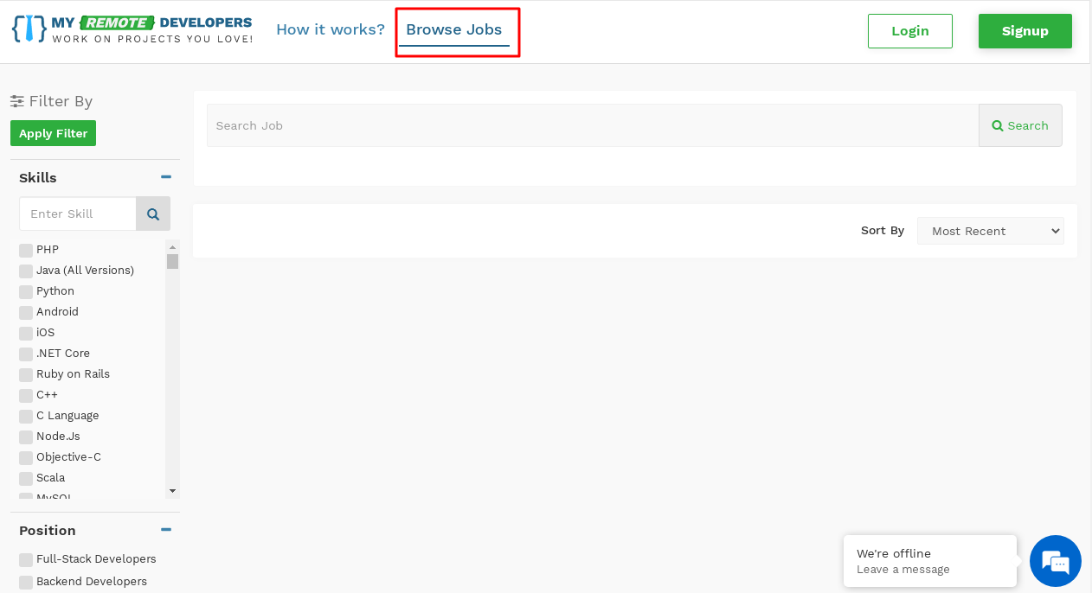
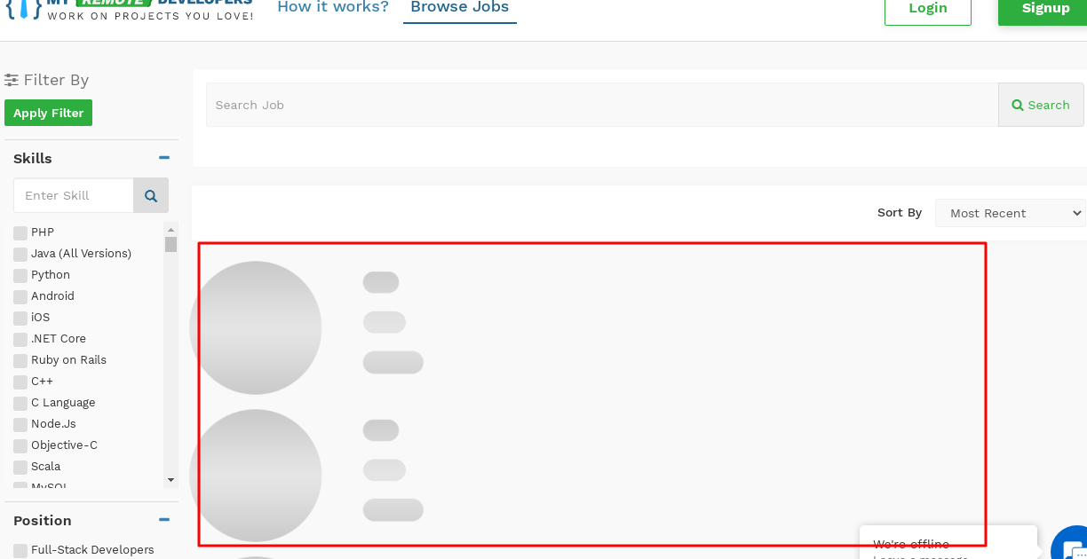
https://prnt.sc/u9k8l2
