BEFORE MODIFYING THE KITCHEN APP:
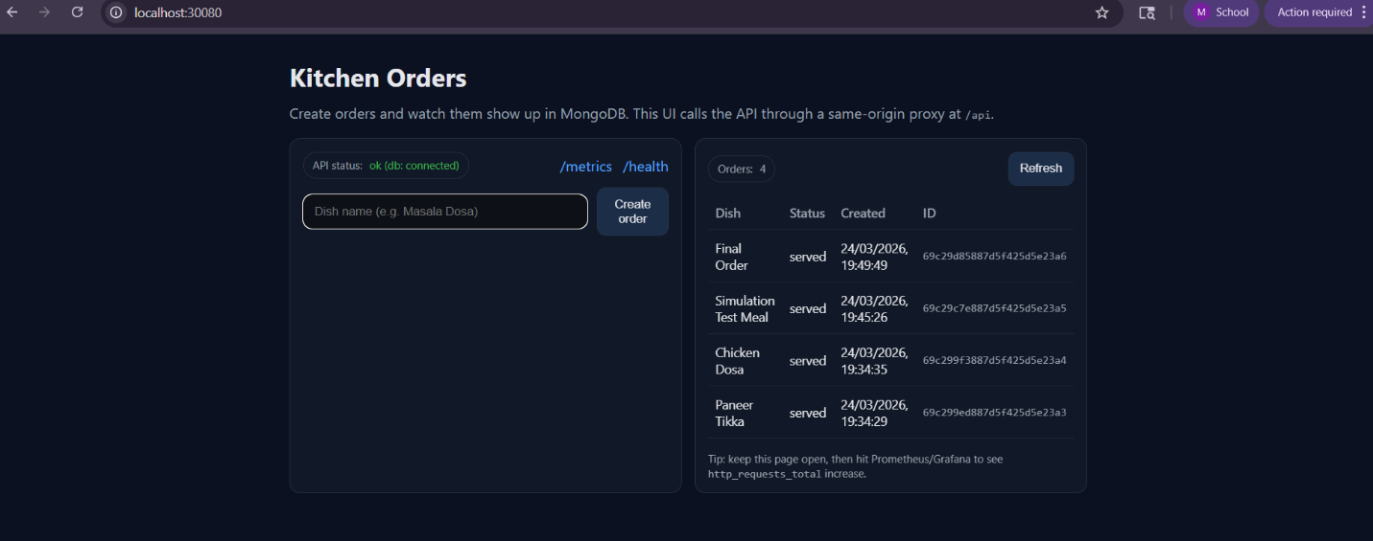
AFTER MODIFYING THE KICTHEN APP:
