**VISVESVARAYA TECHNOLOGICAL UNIVERSITY**

**Jnana Sangama Belgaum – 590018**



**PROJECT REPORT**

**ON**

**“STUDENT ACHIEVEMENT MANGEMENT SYSTEM”**

Submitted in Partial fulfillment of the requirement for the award of

**BACHELOR OF ENGINEERING**

**IN**

**COMPUTER SCIENCE AND ENGINEERING**

Submitted By

ABDUL NAFIH - 4PA21CS004

ABDUL MAUSOOQ – 4PA21CS003

Under the Guidance of

|  |  |
| --- | --- |
| Mrs. Divya K K | Mrs. Sakeena |
| (Professor, Dept of CSE) | (Professor, Dept of CSE) |

**DEPARTMENT OF COMPUTER SCIENCE AND ENGINEERING**

**P.A. COLLEGE OF ENGINEERING**

**NADUPADAPU, BANTWAL, D.K. 574153**

**2023-2024**

Department of Computer Science and Engineering



CERTIFICATE

This is to certify that **ABDUL NAFIH** bearing **USN 4PA21CS004** and **ABDUL MAUSOOQ** bearing **USN 4PA21CS003** has successfully completed the project work entitled “STUDENT ACHIEVEMENT MANAGEMENT SYSTEM” in DBMS WITH MINI PROJECT LABARATORY as a partial fulfilment of the requirement of 5 semester mini project in Computer Science & Engineering of Visvesvaraya Technological University, Belagavi, during the year 2023-24.



Signature of Staff In-Charge Signature of H.O.D.

EXTERNAL

Name of the Examiners Signature with date

1.



2.

DECLARATION

We Mr. ABDUL NAFIH and Mr. ABDUL MAUSOOQ of “P .A College of Engineering”, students of Computer science Department (semester V) here by declare that, I have completed this project on “STUDENT ACHIEVEMENT MANAGEMENT SYSTEM” in the academic year 2023-2024.This information submitted is true original to the best of my knowledge.

Signatures of students:

(ABDUL NAFIH)

(ABDUL MAUSOOQ)

ACKNOWLEDGEMENT:

We would like to acknowledge our debt to each & every person associated in this Project Development.

The Project Development required huge Commitment from all the individuals involved in it.

We are also indebted to Prof. Sakeena & prof. Javad Beig who has guided us throughout the Project Development. We are Thankful for the patience with which they stood by us till the end of our Project. We are very Thankful for them Bounteousness for standing by us in peak movements of the Project Development.

We would also like to acknowledge all the staffs for providing a helping hand to us in times of queries & problems. The Project is a result of the efforts of all the peoples who are associated with the Project directly or indirectly, who helped us to successfully complete the Project within the specified Time Frame.

We would also like to Thanks all the Professors of computer science department who helped us in developing the Project. Without their Courage & Support, the Project Development would have been Futile. We would like to express our Appreciation to all the people who have contributed to the

Successful completion of the Project With all Respects & Gratitude, we would like to

Thanks to all the people, who have helped in the Development of the mini Project

ABDUL NAFIH

&

ABDUL MAUSOOQ

ABSTRACT

the "Student Achievement Management System" is a comprehensive web application designed to empower students in managing and tracking their academic progress, extracurricular achievements, projects, and internships seamlessly. Built using Node.js, Handlebars, JavaScript, HTML, CSS, and MySQL, this system offers a user-friendly interface for students to input, organize, and access their academic and non-academic accomplishments.

The primary objective of this system is to provide students with a centralized platform to record their semester-wise marks from 1 to 8, facilitating easy tracking of academic performance over time. Additionally, students can log various achievements, ranging from small milestones to significant accomplishments in extracurricular activities, fostering a holistic view of their personal growth.

Moreover, the system allows students to document their completed projects and internships, enabling them to showcase their practical experiences and skills to potential employers or academic institutions. By offering a secure user registration and login mechanism, students can access their personalized database of information, including marks, projects, internships, and achievements, ensuring data privacy and confidentiality.

Overall, the "Student Achievement Management System" aims to streamline the process of managing and monitoring student achievements, promoting self-awareness, goal-setting, and continuous improvement in both academic and non-academic pursuits. With its intuitive interface and robust functionality, this web application serves as a valuable tool for students to take ownership of their learning journey and professional development.

PROJECT PROFILE

|  |  |
| --- | --- |
| Project Definition | STUDENT ACHIEVEMENT MANAGEMENT SYSTEM |
| Objective | To manage the personal achievements of students |
| Front End | HTML,HANDLEBARS,CSS,JAVASCRIPT |
| Back End | MY SQL ,NODEJS,EXPRESS |
| Other tools | MS Office 2016, Figma, notepad++ |
| Operating Environment | Windows 11 , Any Compatible OS |
| Project Internal Guide | Prof. Divya  &  Prof.Sakeena |
| Submitted to Department | Computer science & Engineering |

TABLE OF CONTENTS

**CHAPTER 1. INTRODUCTION I - II**

1.1 PURPOSE I

1.2 OBJECTIVE I

1.3 ORGANIZATION OVERVIEW II

1.4 SCOPE OF THE PROJECT II

**CHAPTER 2. SYSTEM ANALYSIS II – III**

2.1 REQUIREMENT SPECIFICATION II

2.2 SYSTEM STUDY II

2.3 FUNCTION SPECIFICATION III

**CHAPTER 3. SYSTEM DESIGN IV – VIII**

3. 1 TABLE DESIGN IV - VIII

3. 2 ER DIAGRAM VII

3. 3 SCHEMA DIAGRAM VIII

**CHAPTER 4. IMPLEMENTATION IX**

**CHAPTER 5. SCREENSHOTS X**

**CHAPTER 6. CONCLUSION X**

**CHAPTER 7. REFERENCES XI**

**1.INTRODUCTION**

The "Student Achievement Management System" (SAMS) is a cutting-edge web application designed to revolutionize the way students manage and track their academic progress, extracurricular engagements, projects, and internships. Built on robust technologies like Node.js, Handlebars, JavaScript, HTML, CSS, and MySQL, SAMS provides students with an intuitive interface to input, organize, and access their semester-wise marks, achievements, projects, and internships. By centralizing student achievements, SAMS streamlines record-keeping processes, fosters self-awareness, and promotes continuous improvement. Through secure user registration and login features, SAMS ensures the confidentiality and privacy of student data, instilling confidence in its usage.

1.1 PURPOSE:

The primary purpose of the "Student Achievement Management System" (SAMS) is to provide students with a centralized platform to effectively manage and track their academic progress, extracurricular achievements, projects, and internships. By offering a seamless and user-friendly interface, SAMS aims to streamline the process of recording and accessing diverse student accomplishments, promoting self-awareness, goal-setting, and continuous improvement. Moreover, SAMS serves as a repository for students to showcase their academic and non-academic achievements, facilitating the transition from educational institutions to the workforce or higher education.

1.2 OBJECTIVE:

The objectives of the "Student Achievement Management System" (SAMS) encompass providing students with a centralized platform for efficiently managing their academic grades, extracurricular achievements, projects, and internships. This includes creating an intuitive user interface for seamless navigation, facilitating longitudinal tracking of academic progress, enabling comprehensive recording of achievements, ensuring secure user authentication, promoting self-awareness and goal-setting, enhancing academic and professional prospects, and fostering continuous improvement through feedback mechanisms. Ultimately, SAMS aims to empower students to take control of their educational journey, facilitating holistic development and success in both academic and professional endeavors.

1.3 ORGANIZATION OVERVIEW:

The "Student Achievement Management System" (SAMS) is developed as a comprehensive web application by a team of skilled developers with expertise in Node.js, Handlebars, JavaScript, HTML, CSS, and MySQL. The organization overseeing SAMS consists of dedicated professionals committed to delivering a user-centric solution that empowers students in managing their academic and extracurricular achievements effectively. With a focus on intuitive design and robust functionality, the organization aims to provide a seamless experience for users while ensuring the security and privacy of student data. SAMS is developed by a skilled team specializing in Node.js, Handlebars, JavaScript, HTML, CSS, and MySQL. Their focus is on creating an intuitive, secure, and feature-rich platform tailored to students' need.

1.4 SCOPE OF THE PROJECT:

The scope of the "Student Achievement Management System" (SAMS) encompasses providing students with a comprehensive platform to manage their academic grades, extracurricular achievements, projects, and internships. SAMS will enable users to input, organize, and access their data securely, promoting self-awareness, goal-setting, and continuous improvement. The system will facilitate longitudinal tracking of academic performance, enhance students' academic and professional prospects, and serve as a valuable tool for personal development in the educational landscape.

**2.SYSTEM ANALYSIS:**

2.1 Requirement Specification

The "Student Achievement Management System" (SAMS) must enable secure user registration and authentication, facilitating students' access to their academic grades from semester 1 to 8 and allowing them to input and manage extracurricular achievements and project/internship details. The system should prioritize an intuitive user interface, robust data security measures, and optimal performance to ensure seamless navigation, confidentiality, and efficient data handling, thereby enhancing the overall user experience and facilitating effective achievement management. SAMS must offer a user-friendly interface for students to easily input and access their academic marks, extracurricular achievements, projects, and internships. It should prioritize simplicity in data entry while ensuring comprehensive functionality, allowing students to efficiently manage their achievements. Additionally, the system must incorporate robust security measures to protect student data and adhere to scalability standards to accommodate potential future growth in user base and data volume.

2.2 SYSTEM STUDY

The system study for the "Student Achievement Management System" (SAMS) entails a thorough examination of existing processes, garnered insights from stakeholders, and an in-depth analysis of their requirements. This multifaceted approach involves dissecting the current methods students employ to track their academic progress and extracurricular engagements, discerning pain points, and identifying areas ripe for enhancement. By engaging in extensive research, surveys, and interviews with students, educators, and administrators, we aim to gain a comprehensive understanding of the intricacies involved. This holistic assessment will serve as the cornerstone for defining the scope, objectives, and critical functionalities of SAMS. With a nuanced comprehension of user needs and system requirements, we can devise a robust framework that not only streamlines achievement management but also fosters student success and personal growth.

The initial phase of developing the "Student Achievement Management System" (SAMS) involves a thorough system study.

2.3 Function Requirement Specifications

The user screen be informative web page with different links and pop-ups which is simple and easy to understand all the services provided by the system.

Hardware Requirements

|  |  |
| --- | --- |
| PROCESSOR SPEED | 2GHZ |
| PROCESSOR | Intel Pentium 4 or higher |
| MEMORY SIZE | 1GB RAM (minimum) |
| STORAGE | 80 GB Hard Disk (minimum) |

Software Requirements

|  |  |
| --- | --- |
| FRONT END | HANDLEBARS,HTML,CSS,JAVASCRIPT |
| BACK END | MYSQLNODEJS,EXPRESS |
| Operating System | Windows 10, Any other Compatible  devices |

Communication Interfaces

Database Connection, NodeJS.

**3. SYSTEM DESIGN**

System Design involves the architectural planning and conceptualization of the "Student Achievement Management System" (SAMS), aiming to translate requirements into a structured and efficient solution. This phase encompasses various aspects, including defining system components, their interactions, and data flow. The design will feature a modular architecture, ensuring scalability and maintainability. Frontend components will utilize HTML, CSS, and JavaScript for user interface development, with Handlebars serving as the templating engine for dynamic content generation. On the backend, Node.js will handle server-side logic, while MySQL will serve as the database management system for storing student data. The system will incorporate secure authentication mechanisms to safeguard user information. Additionally, system interfaces will be designed to facilitate seamless communication between different modules, ensuring smooth data exchange and system functionality. Overall, the system design phase aims to lay a robust foundation for the development of SAMS, ensuring alignment with requirements and scalability for future enhancements.

**TABLE DESIGN:-**

**PROJECTS (PROJECT_ID, TITLE, DESCRIPTION, DATE, IMAGE_PATH, ID)**

|  |  |  |
| --- | --- | --- |
| FIELD | DATA TYPE | CONSTRAINT |
| PROJECT_ID | BIGINT(20) | PRIMARY KEY |
| ID | BIGINT(20) | FOREIGN KEY |
| DESCRIPTION | VARCHAR(10000) |  |
| DATE | DATE | NOT NULL |
| LOCATION | VARCHAR(100) |  |
| IMAGE_PATH | VARCHAR(255) |  |
| TITLE | VARCHAR(50) | NOT NULL |

**STUDENT (ID, NAME, PASSWORD, EMAIL, USN,PHONE)**

|  |  |  |
| --- | --- | --- |
| FIELD | DATA TYPE | CONSTRAINT |
| ID | BIGINT | PRIMARY KEY |
| NAME | VARCHAR(30) | NOT NULL |
| PASSWORD | VARCHAR(255) | NOT NULL |
| EMAIL | VARCHAR(100) | UNIQUE |
| USN | VARCHAR(20) | UNIQUE |
| PHONE | VARCHAR(12) |  |

**ACHIEVEMENT (AWID, TITLE, DESCRIPTION, IMAGE_PATH, LOCATION, ID, DATE)**

|  |  |  |
| --- | --- | --- |
| FIELD | DATA TYPE | CONSTRAINT |
| AW_ID | BIGINT(20) | PRIMARY KEY |
| ID | BIGINT(20) | FOREIGN KEY |
| DESCRIPTION | VARCHAR(10000) |  |
| DATE | DATE | NOT NULL |
| LOCATION | VARCHAR(100) |  |
| IMAGE_PATH | VARCHAR(255) |  |
| TITLE | VARCHAR(50) | NOT NULL |

**AWARD (AID, TITLE, DESCRIPTION, IMAGE_PATH, LOCATION, ID, DATE)**

|  |  |  |
| --- | --- | --- |
| FIELD | DATA TYPE | CONSTRAINT |
| A_ID | BIGINT(20) | PRIMARY KEY |
| ID | BIGINT(20) | FOREIGN KEY |
| DESCRIPTION | VARCHAR(10000) |  |
| DATE | DATE | NOT NULL |
| LOCATION | VARCHAR(100) |  |
| IMAGE_PATH | VARCHAR(255) |  |
| TITLE | VARCHAR(50) | NOT NULL |

**ECA (EID, TITLE, DESCRIPTION, IMAGE_PATH, LOCATION, ID, DATE)**

|  |  |  |
| --- | --- | --- |
| FIELD | DATA TYPE | CONSTRAINT |
| EID | BIGINT(20) | PRIMARY KEY |
| ID | BIGINT(20) | FOREIGN KEY |
| DESCRIPTION | VARCHAR(10000) |  |
| DATE | DATE | NOT NULL |
| LOCATION | VARCHAR(100) |  |
| IMAGE_PATH | VARCHAR(255) |  |
| TITLE | VARCHAR(50) | NOT NULL |

**INTERNSHIP (IID, TITLE, DESCRIPTION, IMAGE_PATH, LOCATION, ID, DATE)**

|  |  |  |
| --- | --- | --- |
| FIELD | DATA TYPE | CONSTRAINT |
| IID | BIGINT(20) | PRIMARY KEY |
| ID | BIGINT(20) | FOREIGN KEY |
| DESCRIPTION | VARCHAR(10000) |  |
| DATE | DATE | NOT NULL |
| LOCATION | VARCHAR(100) |  |
| IMAGE_PATH | VARCHAR(255) |  |
| TITLE | VARCHAR(50) | NOT NULL |

**MARKS(ID, SEMID, SUBID, SUBNAME, MAXMARKS, SUBMARK, GRADE)**

|  |  |  |
| --- | --- | --- |
| FIELD | DATA TYPE | CONSTRAINT |
| SEMID | INT(11) | FOREIGNKEY |
| ID | BIGINT(20) | FOREIGN KEY |
| SUBID | INT(11) | PRIMARYKEY |
| GRADE | CHAR(2) |  |
| SUBNAME | VARCHAR(100) |  |
| MAXMARK | INT(11) | NOTNULL |
| SUBMARKS | INT(11) | NOT NULL |

**SEMESTER (ID, SEMID,SEMESTERNAME)**

|  |  |  |
| --- | --- | --- |
| FIELD | DATA TYPE | CONSTRAINT |
| SEMID | INT(11) | PRIMARY KEY |
| ID | BIGINT(20) | FOREIGN KEY |
| SEMESTERNAME | VARCHAR(20) |  |

3.2 ENTITY RELATIONSHIP DIAGRAM

A set of primary component are identified for the E-R Diagram: data object, attributes, relationships and various type indicators. The primary purpose of the E-R Diagram is to represent data object and their relationships. Data objects: A data objects is a representation of almost any composite information that must be understood by software. Composite information refers to something that has a number of different properties or attributes.

Attributes: Attributes defines the properties of a data object and take on one of three different characteristics. They can be used to (1) name an instance of the data object, (2) describe the instance, or (3) make reference to another instance in another table. In addition, one or more of the attributes must be defined as an identifier that is, the identifier attribute becomes a “key” when we want to find an instance of the data object.

Relationship: Relationships indicate the manner in which data objects are “connected” to one another.

Cardinality: The data model must be capable of representing the number of occurrences objects in a given relationship. Tillman defines the cardinality of an object/relationship pair in the following manner: “Cardinality is the specification of the number of occurrences of one [object] that can be related to the number of occurrences of another [object]. Cardinality is usually expressed as simply ‘one’ and ‘many’, two [objects] can be as:

• One-to-One(1:1): An occurrence of [object] ‘A’ can relate to one and only one occurrence of [object] ‘B’, and an occurrence of ‘B’ can relate to only one occurrence of ‘A’.

• One-to-Many (1:N): One occurrence of [object] ‘A’ can relate to one or many occurrences of [object] ‘B’, but an occurrence of ‘B’ can relate to only one occurrence of [object] ‘A’.

• Many-to-Many(M:N): An occurrence of [object] ‘A’ can relate to one or more occurrence of ‘B’, while an occurrence of ‘B’ can relate to one or more occurrences of ‘A’.

**RELATIONAL SCHEMA**

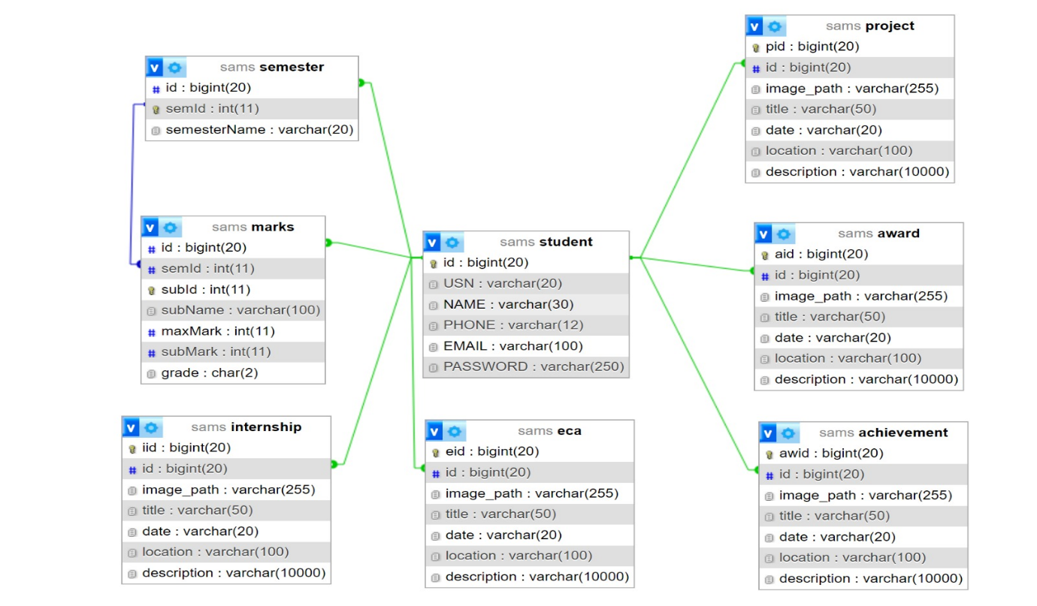

**ER DIAGRAM**

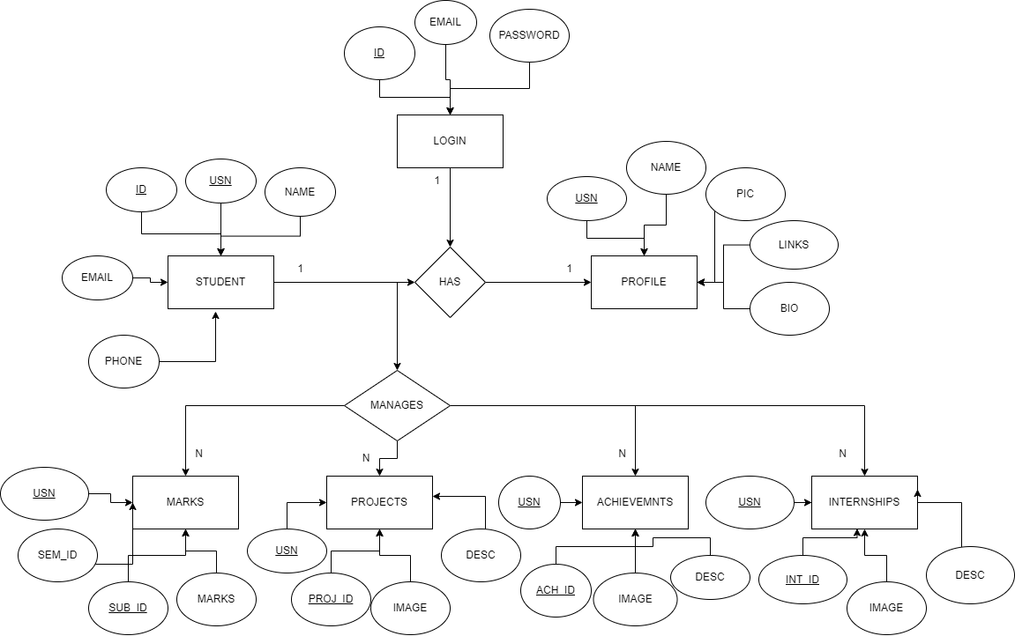

**4.IMPLEMENTATION**

CREATE TABLE STUDENT (

id BIGINT PRIMARY KEY,

USN VARCHAR(20) NOT NULL,

NAME VARCHAR(30) NOT NULL,

PHONE VARCHAR(12) NOT NULL,

EMAIL VARCHAR(100),

PASSWORD VARCHAR(250)

);

CREATE TABLE PROJECT (

pid BIGINT PRIMARY KEY,

id BIGINT,

FOREIGN KEY (id) REFERENCES STUDENT(id),

image_path VARCHAR(255),

title VARCHAR(50) NOT NULL,

date VARCHAR(20) NOT NULL,

location VARCHAR(100) NOT NULL,

description varchar(10000) NOT NULL

);

CREATE TABLE ACHIEVEMENT (

aid BIGINT PRIMARY KEY,

id BIGINT,

FOREIGN KEY (id) REFERENCES STUDENT(id),

image_path VARCHAR(255),

title VARCHAR(50) NOT NULL,

date VARCHAR(20) NOT NULL,

location VARCHAR(100) NOT NULL,

description varchar(10000) NOT NULL

);

CREATE TABLE INTERNSHIP (

iid BIGINT PRIMARY KEY,

id BIGINT,

FOREIGN KEY (id) REFERENCES STUDENT(id),

image_path VARCHAR(255),

title VARCHAR(50) NOT NULL,

date VARCHAR(20) NOT NULL,

location VARCHAR(100) NOT NULL,

description varchar(10000) NOT NULL

);

CREATE TABLE AWARD (

aid BIGINT PRIMARY KEY,

id BIGINT,

FOREIGN KEY (id) REFERENCES STUDENT(id),

image_path VARCHAR(255),

title VARCHAR(50) NOT NULL,

date VARCHAR(20) NOT NULL,

location VARCHAR(100) NOT NULL,

description varchar(10000) NOT NULL

);

CREATE TABLE ECA (

eid BIGINT PRIMARY KEY,

id BIGINT,

FOREIGN KEY (id) REFERENCES STUDENT(id),

image_path VARCHAR(255),

title VARCHAR(50) NOT NULL,

date VARCHAR(20) NOT NULL,

location VARCHAR(100) NOT NULL,

description varchar(10000) NOT NULL

);

CREATE TABLE Semester (

id bigint,

foreign key (id) references student(id),

semId INT PRIMARY KEY,

semesterName varchar(20)

);

CREATE TABLE MARKS(

id bigint,

semId int,

subId int primary key,

subName varchar(100),

maxMark int,

subMark int,

grade char(2),

foreign key (id) references student(id),

foreign key (semId) references semester(semId)

);

**5. SCREENSHOTS**

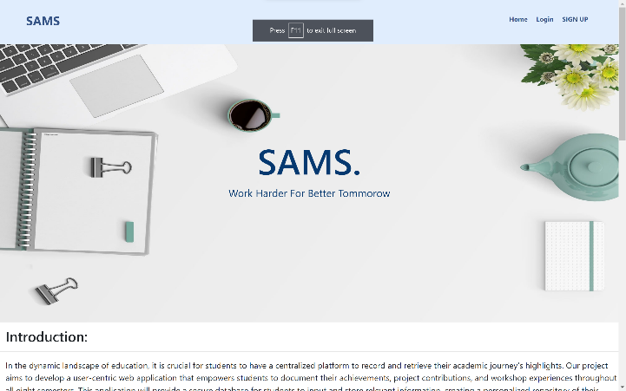 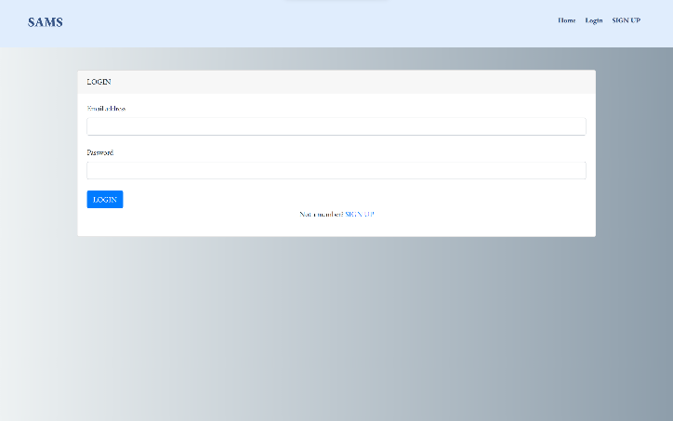

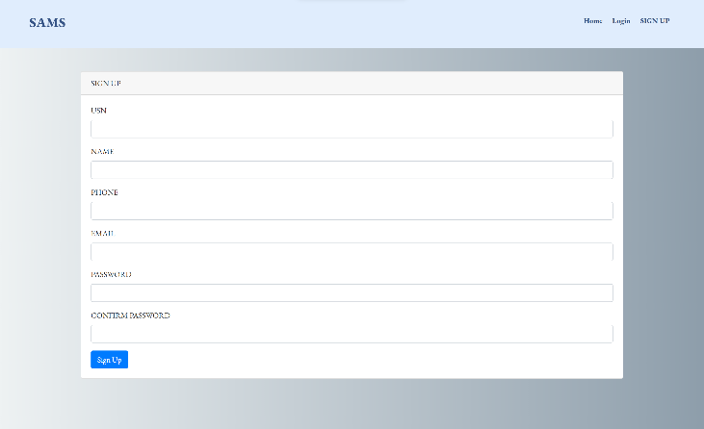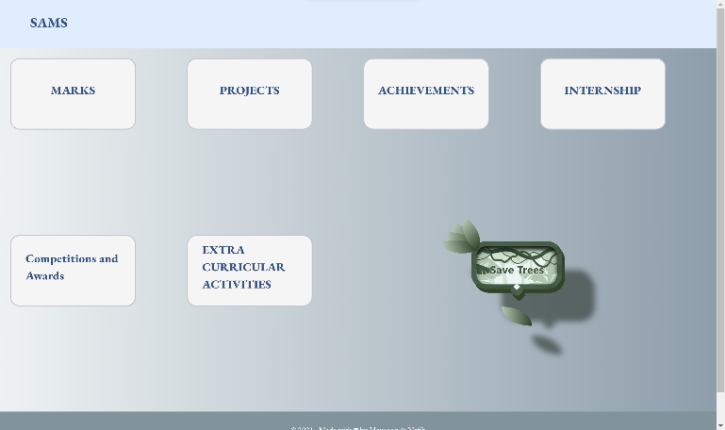

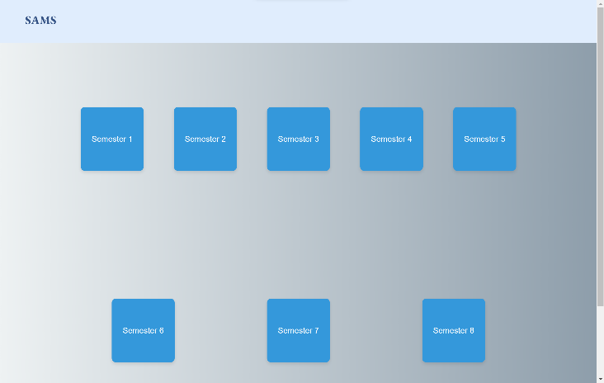

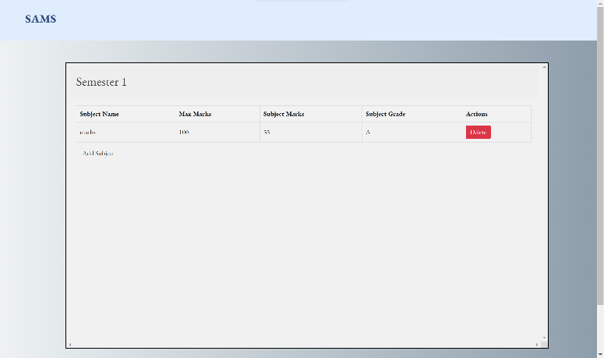

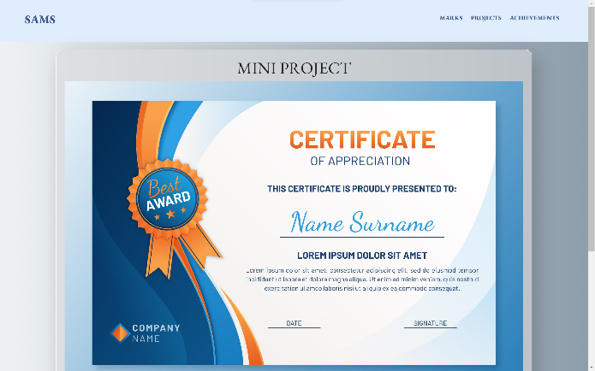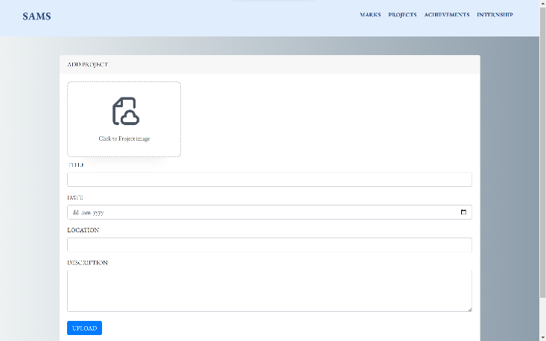

**6. CONCLUSION**

The "Student Achievement Management System" (SAMS) represents a significant advancement in empowering students to manage their academic progress, extracurricular achievements, projects, and internships effectively. Through a comprehensive system study, meticulous requirement specification, and thoughtful system design, SAMS has been developed as a robust and user-centric platform. By leveraging technologies such as Node.js, Handlebars, JavaScript, HTML, CSS, and MySQL, SAMS offers a seamless and intuitive user experience, facilitating easy access to critical information. With SAMS, students can track their achievements longitudinally, fostering self-awareness, goal-setting, and continuous improvement. Moreover, the system prioritizes data security and scalability, ensuring the confidentiality of student information and adaptability to future needs. As a result, SAMS not only streamlines achievement management but also contributes to enhancing students' academic and professional prospects. Moving forward, continuous refinement and enhancements to SAMS will further elevate its utility and impact, reaffirming its position as an indispensable tool for student success in the ever-evolving educational landscape.

Furthermore, the successful implementation of SAMS underscores the commitment to innovation and student-centricity within educational institutions. By embracing technological solutions like SAMS, institutions can empower students to take ownership of their learning journey, fostering a culture of self-directed learning and personal development. Additionally, SAMS serves as a valuable resource for educators and administrators, providing insights into student achievements and facilitating data-driven decision-making processes. As the educational landscape continues to evolve, SAMS stands poised to adapt and grow alongside it, continuously enriching the educational experience and contributing to the success of students worldwide.

**7. REFERENCES**

1. <https://www.w3schools.com>/
2. <https://nodejs.org/en/docs>/
3. <https://expressjs.com>/
4. <https://dev.mysql.com/doc>/
5. <https://stackoverflow.com/>
6. Fundamentals of Database Systems, Ramez Elmasri and Shamkant B. Navathe, 7th Edition, 2017, Pearson.
7. Database management systems, Ramakrishnan, and Gehrke, 3rd Edition, 2014, McGraw Hill