Group 1 Final Project: Mickey Autry, Yameena Powell, Yuri Riveria, Kamon Robinson,
Javon Darby
Present dataset for approval by me. Upload document that shows the URL of original dataset.
Mid-Term Project Group 1 url - Used Car Dataset: https://www.kaggle.com/datasets/austinreese/craigslist-carstrucks-data
Upload dataset to Corelab as u_cars_prices_10_098 (Spreadsheet)
https://docs.google.com/spreadsheets/d/1R2A6ec7iwIF7A8un6p1_kB77o3E9kIbd/edit?gid=295197431#gid=295197431
The book that correlated most of the algorithms for this project corresponds to:
Machine Learning with Python by Oliver Theobald (Highest review rate for Python book)

I have accomplished cleaning up data sets by replacing certain column values that were zero or missing with mean values from high correlated features.
Major columns (manufacturer or price) that had missing values were deleted since I was unable to replace them with certain values.
Next, I removed outlier samples with several iteration’s car years newer than 2010 and price greater than $9,000 USD dollars.
A correlation matrix table was created showing correlation coefficients between variables. It helps identify relationships and patterns in data. This table determines the variables in modeling analysis. The X variables selected was automobile car: year, engine volume in liters, and seller rating. The Y variable selected was car price in us dollars.
Move to splitting our data into train data frame with 70 percent of the total samples, validation and test data frames with each with 15 percent of the total samples,
We validated our splitting data was correct by output from each data frame with the row counts for each (train = .7*(all samples), validation = .15*(all samples), test = .15(all samples)).
First, we trained and validated the models using linear regression, decision tree regressor, random forest regressor, gradient boosting regressor (with XGBoost), k-nearest neighbors regressor. We obtain the lowest average three values from the mse (mean square errors), mae (mean absolute errors), and the highest three values for r2 (r2 - squared) and average those categories of values from the formula listed below.
(mse or mae.nsmallest(3).mean().round(0)) – (r2.nlargest(3).mean().round(3))

Linear Regressor plots a straight line or plane called the hyperplane that predicts the target value of data inputs by determining the dependence between the dependent variables Y and its changing independent variable X.
Random Forest Regressor is constructed multiple decision trees during training and combining their outputs to improve accuracy and reduce overfitting.
At each split in a tree, a random subset of features is chosen to determine the best split.
Decision Tree Regressor is used to predict continuous values using a tree-like structure. It splits the data into smaller groups based on simple rules derived from input features, helping reduce prediction errors.
K-Nearest Neighbors regressors, learns to classification techniques is k-nearest neighbors, which classifies new unknown data points based on there proximity to known data points.
The worst output model from my training data set was Decision Tree Regressor.
Gradient Boosting Regressor was the best model for my training dataset because it is an ensemble method that sequentially builds and combines multiple decision trees, with each new tree correcting the errors of the previous ones, leading to higher accuracy. A single decision tree is a weak learner that is prone to high variance and overfitting; it lacks the ability of gradient boosting to iteratively improve its predictions.
I ran the Bayesian model in the Train and Validation data frames, with different values for the number of evaluations. (25, 50, 100, 200). The value of 50 gave the best results.
The ensemble voter was the best overall model for the my progressor predictions.
- Accounts for model uncertainty – Instead of picking one “best” model, it combines all models proportionally to how likely they are correct. Import the different models for analysis.
- Better generalization – Reduces overfitting by averaging predictions.
- Handles imbalanced model performance – Stronger models get more influence automatically.
Team members contribution:
Mickey Autry – Selected the user cars data set and had it approved for our project. Completed most of the python coding made sure each step was completed properly.
Yahmeania Powell – Worked on researching anomalies in the data set. Researched the modeling algorithms. Very helpful with documentation on the mid-term project.
Yuri Riveria – Help with plotting algorithms. Researched anomalies in the data set.
Kemon Robinson - Help with plotting algorithms. Researched anomalies in the data set.
Javon Darby - Help with plotting algorithms. Researched anomalies in the data set.

Correlation table:
# Calculate the correlation matrix for only numerical columns
correlation_matrix = df.select_dtypes(include=['number']).corr()

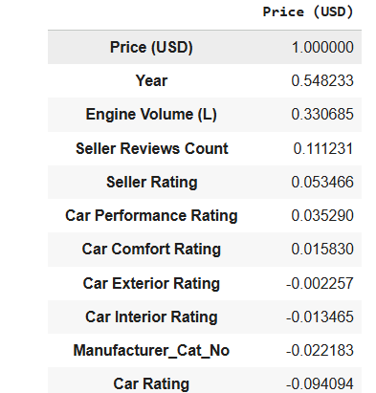

REGRESSION PROBLEM:
- Preprocess the data: - 5 points
  - You already completed this step
  - Split your data into Train (70%), Validation (15%), and Test (15%)
from sklearn.model_selection import train_test_split

# Step 1: Split into training (70%) and a combined test/validation set (30%) Validation (15%), and Test (15%)
X_train, X_test, y_train, y_test = train_test_split(X, y, test_size=0.7, random_state=42)

# Step 2: Split the combined test/validation set (X_temp, y_temp) into validation (15% and test (15%)
train_val_split_ratio = 0.7
test_size = 1 - train_val_split_ratio
train_val_df, test_df = train_test_split(df, test_size=0.15, random_state=42)
#train_val_df, test_df = train_test_split(df, test_size=test_size,
random_state=42)

val_size = 1 - (0.7 / (0.7 + 0.3))
train_df, val_df = train_test_split(train_val_df, test_size=(0.1764), random_state=42)

# Print the sizes of the resulting sets
print(f"Original Dataframe size: {len(df)}")
print(f"Training set size: {len(train_df)}")
print(f"Validation set size: {len(val_df)}")
print(f"Test set size: {len(test_df)}")

Output: Original Dataframe size: 5617
Training set size: 3931
Validation set size: 843
Test set size: 843

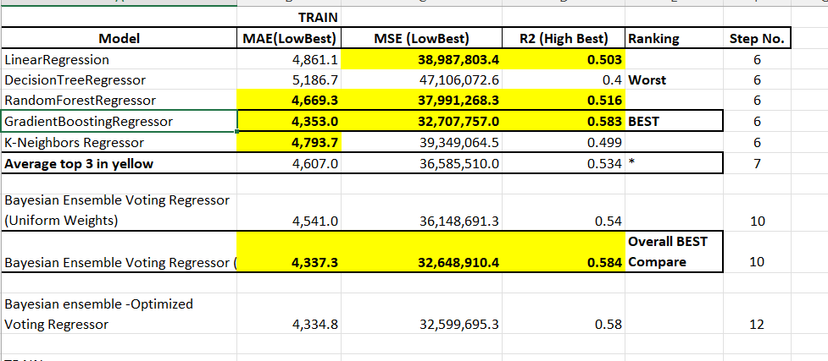
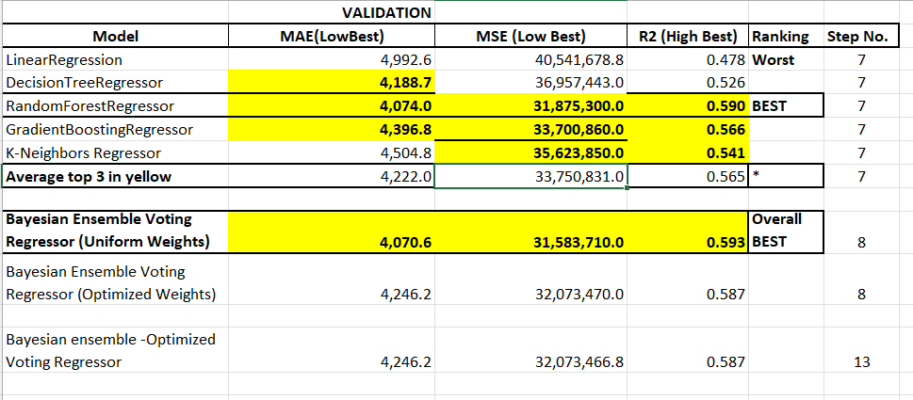

Plot Model Values
