Using GitHub Desktop to Upload Your Notebook:
  - Clone Your Repository:
    - Enter the URL of your repository
(e.g., mautry001-sudo/juypter_exploration)
(my google mail account is: mauty001@gmail.com) (https://github.com/mautry001-sudo/juypter_exploration)
  - Add Your Notebook File:
    - Copy your My_First_Notebook.ipynb file into this folder.
Link to My_First_Notebook.ipynb https://github.com/mautry001-sudo/juypter_exploration/blob/main/My_First_Notebok.ipynb
Link to L01_Mickey_Autry_ITAI2373.ipynb https://github.com/mautry001-sudo/juypter_exploration/blob/main/L01_Mickey_Autry_ITAI2373.ipynb
Below is my GitHb repository (https://github.com/mautry001-sudo/juypter_exploration)
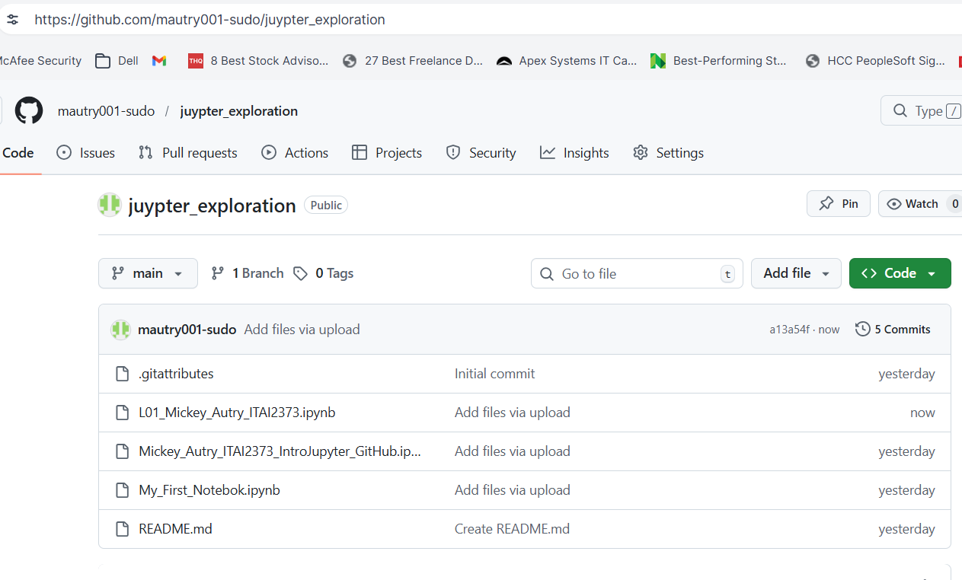

What I learned from this exercise L01
My github account is (mautry001-sudo) from last semester with Machine Learning course.
Yes, I installed the Github Desktop version local on my computer in the following path: C:\Users\17138\Documents\GitHub\juypter_exploration

https://github.com/mautry001-sudo/juypter_exploration

- Ensure that you also submit the link to your GitHub repository with your journal/summary.
- GitHub Desktop simplifies the process of uploading files to your GitHub repository.
- Make it very easy to upload documents to GitHub.
- GitHub is very useful for software version control you have to your folders. Also records who made the changes to the software for later reference.
- Has the ability for Push and pull changes to my GitHub folders.
- You can save files in numerous file types to GitHub folders.

- GitHub Desktop provides a simple graphical interface for Git.

- It provides a user-friendly interface to manage your repositories without using command-line tools.
- GitHub Desktop provides a simple graphical interface for Git.
- Cloning files from desktop computer to your GitHub folders.
5. Choosing an Environment:
Online Environments (Google Colab or AWS SageMaker Studio Lab):
I chose to use Google Colab since have an account with Google and like that program.

