
School of Engineering

EGE311 Database Design & Applications

Project Report

Maverick Chin Yu Heng
231581L
E1

- Design Rationale
Assumptions on Operational Flow
Overview
- For anyone to interact with the hospital management system, a user account is needed. A user account can have multiple profiles (e.g., doctor/patient).

- Only patients create appointment requests.
Appointment requests can be cancelled by the patient.

- Receptionists handle appointment requests.
They can reject or approve the appointment request. Approving the appointment request means creating an appointment for the patient by linking them to a doctor.

- Appointments can be cancelled by either the patient or doctor.
They can also be created by the doctor for the purpose of follow-up appointments.
- A prescription can be linked to an appointment. It contains prescription items which indicate the medicine and its instructions.
Detailed
- Appointment requests must be made with a related specialty. Only doctors with that specialty can be selected as a preferred doctor.
- Appointments can be linked to appointment requests. However, their specialties do not need to be the same as the patient may have selected the wrong specialty.
- An admin does not have full control over the entire database. They should only be to do maintenance work that do not belong to the other roles, such as:
  - Activate/deactivate users
  - Add/deactivate profiles for users
  - Add/deactivate specialties/medicines
- The history should be kept intact for viewing even after the deactivation of entities.

Key Specification & Features
- User login with multi-role (profile) system
A person logs in using their username and password. However, they can have multiple roles. For example, they are able to login as a doctor/patient with the same account. The account stores personal information that is separate from profile specific information.
This allows doctors to become patients at the hospital they work at, without having to create a new user account!
- Appointment and appointment related management
  - Create appointment requests
    - Actions: Cancel, approve, reject
  - Create appointments
    - Actions: Cancel, complete, miss
  - Create prescriptions
- Action tracking with timestamp
Enables the tracking of who was responsible for an action (e.g., creating an appointment).

- Lookup tables
Enhances data integrity while maintaining database flexibility.
This allows for the ease of future expansion at the cost of added complexity.
  - Appointment request status
  - Appointment status
  - Specialty
  - Medications
- Soft delete (deactivation) system
Ensures the ability to view historical data without it being incomplete/corrupted.
This is at the added cost of an increased need for storage and needing to search through more rows. However, this is trivial for modern SQL databases.

Table: person
Purpose: Stores core demographic information for all individuals in the system (patients, doctors, receptionists, admins). This is the central identity table that other tables reference.

Column Name | Data Type | Default Value | Description
person_id | int | AUTO_INCREMENT | Primary key, unique identifier for each person
sex | tinyint | 0 | ISO/IEC 5218: 0=Unknown, 1=Male, 2=Female, 9=Not applicable
first_name | varchar(50) | NULL | Person's first name
last_name | varchar(50) | NULL | Person's last name
date_of_birth | date | NULL | Person's date of birth
primary_email | varchar(254) | NULL | Person's primary email address
primary_phone_number | varchar(32) | NULL | Person's primary phone number
primary_home_address | varchar(255) | NULL | Person's primary home address
created_datetime | datetime | now() | Timestamp when the record was created
is_in_service | bool | true | Soft delete flag - whether this person record is active

Table: user
Purpose: Stores authentication credentials for system login. Separated from person table to maintain security and allow one person to have one login account.

Column Name | Data Type | Default Value | Description
user_id | int | AUTO_INCREMENT | Primary key, unique identifier for each user account
person_id | int | NULL | Foreign key to person table (unique - one user per person)
username | varchar(64) | NULL | Unique username for login
password_hash | varchar(255) | NULL | Hashed password for authentication
created_datetime | datetime | now() | Timestamp when the user account was created
is_in_service | bool | true | Soft delete flag - whether this user account is active

Table: profile_type
Purpose: Lookup table that defines the different role types available in the system (doctor, patient, receptionist, admin). Allows for easy addition of new role types without schema changes.
Column Name | Data Type | Default Value | Description
profile_type_id | int | AUTO_INCREMENT | Primary key, unique identifier for each profile type
name | varchar(32) | NULL | Name of the profile type (e.g., "doctor", "patient", "receptionist", "admin")

Table: profile
Purpose: Assigns roles to people. One person can have multiple profiles (e.g., a doctor who is also a patient). This is the central table that links people to their role-specific data.
Column Name | Data Type | Default Value | Description
profile_id | int | AUTO_INCREMENT | Primary key, unique identifier for each profile
person_id | int | NULL | Foreign key to person table
profile_type_id | int | NULL | Foreign key to profile_type table
created_datetime | datetime | now() | Timestamp when the profile was created
is_in_service | bool | true | Soft delete flag - whether this profile is active

Table: patient_profile
Purpose: Stores patient-specific information that extends the base profile. Only contains data relevant to patients.
Column Name | Data Type | Default Value | Description
profile_id | int | NULL | Primary and foreign key to profile table
medication_allergies | text | NULL | Patient's medication allergies
Table: doctor_profile
Purpose: Stores doctor-specific information that extends the base profile. Only contains data relevant to doctors.
Column Name | Data Type | Default Value | Description
profile_id | int | NULL | Primary and foreign key to profile table
office_phone_number | varchar(32) | NULL | Doctor's office phone number
Table: receptionist_profile
Purpose: Stores receptionist-specific information that extends the base profile. Currently a placeholder for future receptionist-specific attributes.
Column Name | Data Type | Default Value | Description
profile_id | int | NULL | Primary and foreign key to profile table
Table: admin_profile
Purpose: Stores admin-specific information that extends the base profile. Currently a placeholder for future admin-specific attributes.
Column Name | Data Type | Default Value | Description
profile_id | int | NULL | Primary and foreign key to profile table

Table: specialty
Purpose: Lookup table that stores medical specialties (e.g., Cardiology, Dermatology). Used to categorize doctors and appointments.
Column Name | Data Type | Default Value | Description
specialty_id | int | AUTO_INCREMENT | Primary key, unique identifier for each specialty
name | varchar(100) | NULL | Name of the medical specialty
is_in_service | bool | true | Soft delete flag - whether this specialty is still offered
Table: doctor_specialty
Purpose: Junction table that creates a many-to-many relationship between doctors and specialties. One doctor can have multiple specialties, and one specialty can have multiple doctors.
Column Name | Data Type | Default Value | Description
doctor_profile_id | int | NULL | Foreign key to doctor_profile table (part of composite primary key)
specialty_id | int | NULL | Foreign key to specialty table (part of composite primary key)

Table: appointment_status
Purpose: Lookup table that defines the different states an appointment can be in (e.g., Pending, Scheduled, Completed, Cancelled).
Column Name | Data Type | Default Value | Description
appointment_status_id | int | AUTO_INCREMENT | Primary key, unique identifier for each status
name | varchar(50) | NULL | Name of the appointment status
Table: appointment_request_status
Purpose: Lookup table that defines the different states an appointment request can be in (e.g., Pending, Approved, Rejected).
Column Name | Data Type | Default Value | Description
appointment_request_status_id | int | AUTO_INCREMENT | Primary key, unique identifier for each status
name | varchar(50) | NULL | Name of the request status

Table: appointment
Purpose: Stores scheduled appointments between patients and doctors. Tracks who created the appointment, when it was created, and if/when it was cancelled.
Column Name | Data Type | Default Value | Description
appointment_id | int | AUTO_INCREMENT | Primary key, unique identifier for each appointment
start_datetime | datetime | NULL | When the appointment starts
end_datetime | datetime | NULL | When the appointment ends
patient_profile_id | int | NULL | Foreign key to patient_profile table
doctor_profile_id | int | NULL | Foreign key to doctor_profile table
specialty_id | int | NULL | Foreign key to specialty table
room_name | varchar(50) | NULL | Room where the appointment takes place
reason | text | NULL | Reason for the appointment
appointment_status_id | int | NULL | Foreign key to appointment_status table
doctor_notes | text | NULL | Notes written by the doctor during/after appointment
created_by_profile_id | int | NULL | Foreign key to profile table - who created this appointment
created_datetime | datetime | now() | Timestamp when the appointment was created
cancelled_by_profile_id | int | NULL | Foreign key to profile table - who cancelled this appointment
cancelled_datetime | datetime | NULL | Timestamp when the appointment was cancelled
cancellation_reason | text | NULL | Reason for cancellation

Table: appointment_request
Purpose: Stores patient requests for appointments before they are approved and become actual appointments. Tracks the workflow from request to scheduled appointment.
Column Name | Data Type | Default Value | Description
appointment_request_id | int | AUTO_INCREMENT | Primary key, unique identifier for each request
patient_profile_id | int | NULL | Foreign key to patient_profile table - who is requesting
specialty_id | int | NULL | Foreign key to specialty table - what specialty is needed
reason | text | NULL | Reason for the appointment request
preferred_doctor_profile_id | int | NULL | Foreign key to doctor_profile table - preferred doctor (optional)
preferred_datetime | datetime | NULL | Preferred date and time (optional)
created_datetime | datetime | now() | Timestamp when the request was created
appointment_request_status_id | int | NULL | Foreign key to appointment_request_status table
appointment_id | int | NULL | Foreign key to appointment table - links to created appointment
handled_by_profile_id | int | NULL | Foreign key to profile table - who processed this request
handled_datetime | datetime | NULL | Timestamp when the request was handled
handling_notes | text | NULL | Notes from the person who handled the request

Table: prescription
Purpose: Stores the header information for prescriptions. Acts as a container for prescription items (medications). Links prescriptions to patients, doctors, and optionally to appointments.
Column Name | Data Type | Default Value | Description
prescription_id | int | AUTO_INCREMENT | Primary key, unique identifier for each prescription
patient_profile_id | int | NULL | Foreign key to patient_profile table - who the prescription is for
doctor_profile_id | int | NULL | Foreign key to doctor_profile table - who wrote the prescription
appointment_id | int | NULL | Foreign key to appointment table - related appointment (optional)
created_datetime | datetime | now() | Timestamp when the prescription was created
Table: prescription_item
Purpose: Stores individual medications within a prescription. One prescription can have multiple items (medications). Each item includes medication-specific instructions.
Column Name | Data Type | Default Value | Description
prescription_item_id | int | AUTO_INCREMENT | Primary key, unique identifier for each prescription item
prescription_id | int | NULL | Foreign key to prescription table - which prescription this belongs to
medication_id | int | NULL | Foreign key to medication table - which medication is prescribed
instructions | text | NULL | Instructions for taking this medication (dosage, frequency, etc.)
Note: Foreign key constraint for prescription_id is set to CASCADE for ON DELETE.
Table: medication
Purpose: Lookup table that stores available medications by their generic names. Used to standardize medication references across prescriptions.
Column Name | Data Type | Default Value | Description
medication_id | int | AUTO_INCREMENT | Primary key, unique identifier for each medication
generic_name | text | NULL | Generic name of the medication
is_in_service | bool | true | Soft delete flag - whether this medication is still available

- Implementation
Database
UNF
hospital_data (composite key (record_id, specialty_name, medication_name))
| patient_first_name | patient_last_name | patient_dob | patient_sex | patient_email | patient_phone | patient_home_address | patient_allergies | patient_username | patient_password | appointment_datetime | appointment_end_datetime | appointment_room | appointment_reason | appointment_status | appointment_doctor_notes | doctor_first_name | doctor_last_name | doctor_dob | doctor_sex | doctor_email | doctor_phone | doctor_home_address | doctor_office_phone | doctor_username | doctor_password | doctor_specialties | prescription_date | medication_1 | medication_1_instructions | medication_2 | medication_2_instructions | medication_3 | medication_3_instructions | request_datetime | request_reason | request_preferred_datetime | request_status | request_handled_by | request_handled_datetime | receptionist_first_name | receptionist_last_name | receptionist_username | admin_first_name | admin_last_name |

To 1NF
- Repeating groups eliminated:
  - doctor_specialties (comma-separated: "Cardiology, Internal Medicine") → split into multiple rows with single specialty_name value
  - medication_1, medication_2, medication_3 columns → split into multiple rows with single medication_name value
  - medication_1_instructions, medication_2_instructions, medication_3_instructions → split into multiple rows with single medication_instructions value
- Atomic values ensured:
  - Each field now contains only one value (no comma-separated lists)
  - Added record_id as primary key to uniquely identify each row

hospital_records
| record_id | patient_first_name | patient_last_name | patient_dob | patient_sex | patient_email | patient_phone | patient_home_address | patient_allergies | patient_username | patient_password | appointment_datetime | appointment_end_datetime | appointment_room | appointment_reason | appointment_status | appointment_doctor_notes | doctor_first_name | doctor_last_name | doctor_dob | doctor_sex | doctor_email | doctor_phone | doctor_home_address | doctor_office_phone | doctor_username | doctor_password | specialty_name | prescription_date | medication_name | medication_instructions | request_datetime | request_reason | request_preferred_datetime | request_status | request_handled_by | request_handled_datetime | receptionist_first_name | receptionist_last_name | receptionist_username | admin_first_name | admin_last_name |

To 2NF / 3NF
Partial Dependencies Eliminated
- patient_first_name → record_id (depends only on record_id, not on specialty_name or medication_name)
- patient_last_name → record_id (depends only on record_id, not on specialty_name or medication_name)
- patient_dob → record_id (depends only on record_id, not on specialty_name or medication_name)
- patient_sex → record_id (depends only on record_id, not on specialty_name or medication_name)
- patient_email → record_id (depends only on record_id, not on specialty_name or medication_name)
- patient_phone → record_id (depends only on record_id, not on specialty_name or medication_name)
- patient_home_address → record_id (depends only on record_id, not on specialty_name or medication_name)
- patient_allergies → record_id (depends only on record_id, not on specialty_name or medication_name)
- patient_username → record_id (depends only on record_id, not on specialty_name or medication_name)
- patient_password → record_id (depends only on record_id, not on specialty_name or medication_name)
- appointment_datetime → record_id (depends only on record_id, not on specialty_name or medication_name)
- appointment_end_datetime → record_id (depends only on record_id, not on specialty_name or medication_name)
- appointment_room → record_id (depends only on record_id, not on specialty_name or medication_name)
- appointment_reason → record_id (depends only on record_id, not on specialty_name or medication_name)
- appointment_status → record_id (depends only on record_id, not on specialty_name or medication_name)
- appointment_doctor_notes → record_id (depends only on record_id, not on specialty_name or medication_name)
- doctor_first_name → record_id (depends only on record_id, not on specialty_name or medication_name)
- doctor_last_name → record_id (depends only on record_id, not on specialty_name or medication_name)
- doctor_dob → record_id (depends only on record_id, not on specialty_name or medication_name)
- doctor_sex → record_id (depends only on record_id, not on specialty_name or medication_name)
- doctor_email → record_id (depends only on record_id, not on specialty_name or medication_name)
- doctor_phone → record_id (depends only on record_id, not on specialty_name or medication_name)
- doctor_home_address → record_id (depends only on record_id, not on specialty_name or medication_name)
- doctor_office_phone → record_id (depends only on record_id, not on specialty_name or medication_name)
- doctor_username → record_id (depends only on record_id, not on specialty_name or medication_name)
- doctor_password → record_id (depends only on record_id, not on specialty_name or medication_name)
- prescription_date → record_id (depends only on record_id, not on specialty_name or medication_name)
- request_datetime → record_id (depends only on record_id, not on specialty_name or medication_name)
- request_reason → record_id (depends only on record_id, not on specialty_name or medication_name)
- request_preferred_datetime → record_id (depends only on record_id, not on specialty_name or medication_name)
- request_status → record_id (depends only on record_id, not on specialty_name or medication_name)
- request_handled_by → record_id (depends only on record_id, not on specialty_name or medication_name)
- request_handled_datetime → record_id (depends only on record_id, not on specialty_name or medication_name)
- receptionist_first_name → record_id (depends only on record_id, not on specialty_name or medication_name)
- receptionist_last_name → record_id (depends only on record_id, not on specialty_name or medication_name)
- receptionist_username → record_id (depends only on record_id, not on specialty_name or medication_name)
- admin_first_name → record_id (depends only on record_id, not on specialty_name or medication_name)
- admin_last_name → record_id (depends only on record_id, not on specialty_name or medication_name)

Transitive Dependencies Eliminated
- username, password_hash → person_id → first_name, last_name, email, etc.
  - Transitive dependency: Authentication credentials depend on person_id, which then determines other person attributes
  - Solution: Separated user table from person table
- profile_type_name → profile_type_id → profile_id
  - Transitive dependency: The name of a profile type (e.g., "doctor", "patient") depends on profile_type_id, not directly on profile_id
  - Solution: Created profile_type lookup table to store the profile type names separately
- specialty_name → specialty_id → doctor_profile_id
  - Transitive dependency: The name of a specialty (e.g., "Cardiology") depends on specialty_id, not directly on doctor_profile_id
  - Solution: Created specialty lookup table and doctor_specialty junction table
- appointment_status_name → appointment_status_id → appointment_id
  - Transitive dependency: The name of an appointment status (e.g., "Scheduled", "Completed") depends on appointment_status_id, not directly on appointment_id
  - Solution: Created appointment_status lookup table
- appointment_request_status_name → appointment_request_status_id → appointment_request_id
  - Transitive dependency: The name of a request status depends on the status ID, not directly on the request ID
  - Solution: Created appointment_request_status lookup table
- medication_generic_name → medication_id → prescription_item_id
  - Transitive dependency: The generic name of a medication depends on medication_id, not directly on prescription_item_id
  - Solution: Created medication lookup table
- office_phone_number → doctor_profile_id → person_id
  - Transitive dependency: Office phone is a doctor-specific attribute that depends on the doctor profile, which then depends on person_id
  - Solution: Created doctor_profile extension table to store doctor-specific attributes
- medication_allergies → patient_profile_id → person_id
  - Transitive dependency: Medication allergies are patient-specific attributes that depend on patient profile, which then depends on person_id
  - Solution: Created patient_profile extension table to store patient-specific attributes
person
| person_id | sex | first_name | last_name | date_of_birth | primary_email | primary_phone_number | primary_home_address | created_datetime | is_in_service |
user
| user_id | person_id | username | password_hash | created_datetime | is_in_service |
profile_type
| profile_type_id | name |
profile
| profile_id | person_id | profile_type_id | created_datetime | is_in_service |
doctor_profile
| profile_id | office_phone_number |
patient_profile
| profile_id | medication_allergies |
receptionist_profile
| profile_id |
admin_profile
| profile_id |
specialty
| specialty_id | name | is_in_service |
doctor_specialty
| doctor_profile_id | specialty_id |
appointment_status
| appointment_status_id | name |
appointment
| appointment_id | start_datetime | end_datetime | patient_profile_id | doctor_profile_id | specialty_id | room_name | reason | appointment_status_id | doctor_notes | created_by_profile_id | created_datetime | cancelled_by_profile_id | cancelled_datetime | cancellation_reason |
appointment_request_status
| appointment_request_status_id | name |
appointment_request
| appointment_request_id | patient_profile_id | specialty_id | reason | preferred_doctor_profile_id | preferred_datetime | created_datetime | appointment_request_status_id | appointment_id | handled_by_profile_id | handled_datetime | handling_notes |
medication
| medication_id | generic_name | is_in_service |
prescription
| prescription_id | patient_profile_id | doctor_profile_id | appointment_id | created_datetime |
prescription_item
| prescription_item_id | prescription_id | medication_id | instructions |

Final ER Diagram
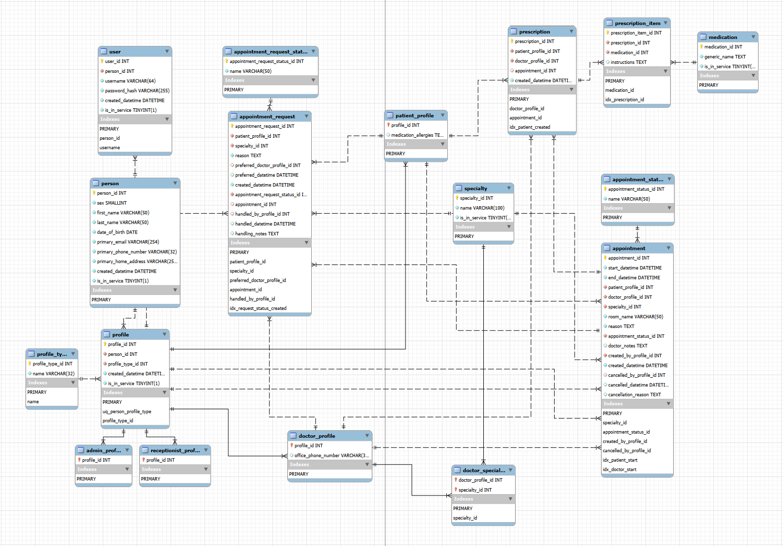

Application Interface (Python)
Some menus are omitted for clarity of the document, as they have are limited in action and already described in other menus.
Application
- App Start
Select which profile to login in with.
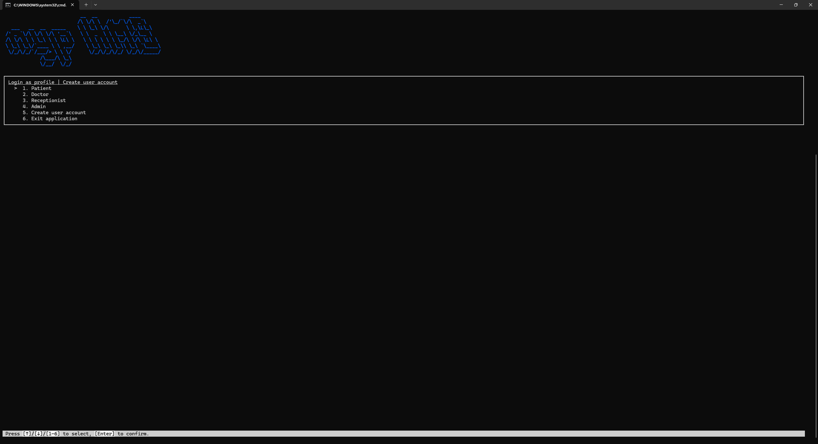
- Login Page
Enter username and password to login.
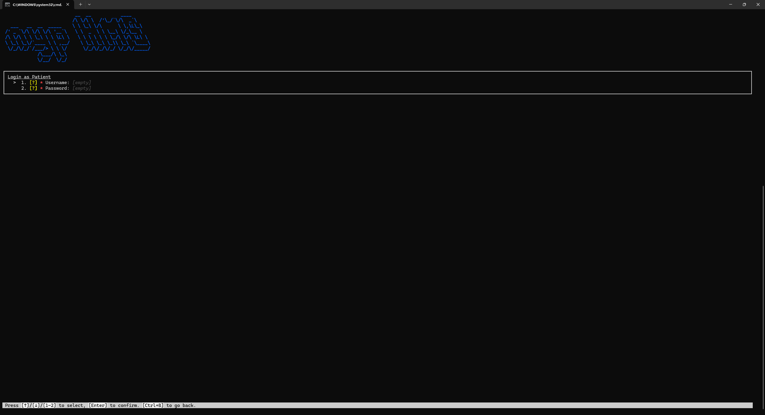

- Create user account
Fill in a form to create a new user account. This version of the application helps create an empty patient profile as well.
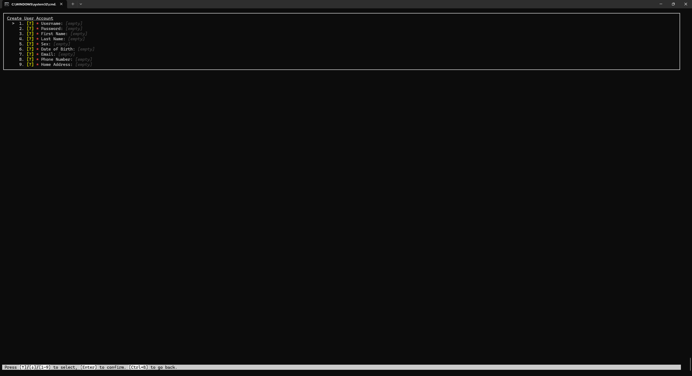

Patient
- Home Page
View appointment requests made and appointments at a glance.
Select action to perform.
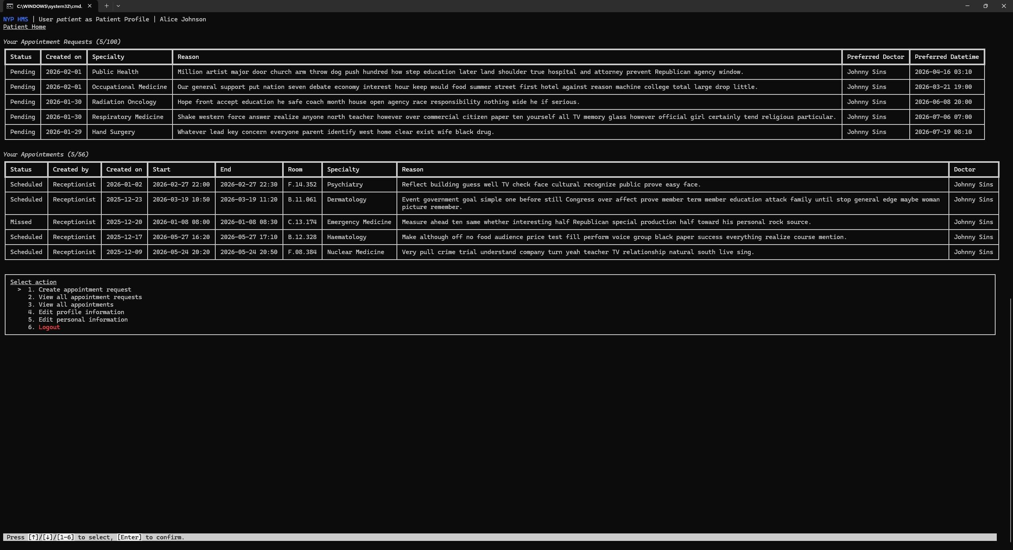
- Create appointment request
Fill out a form to create an appointment request.
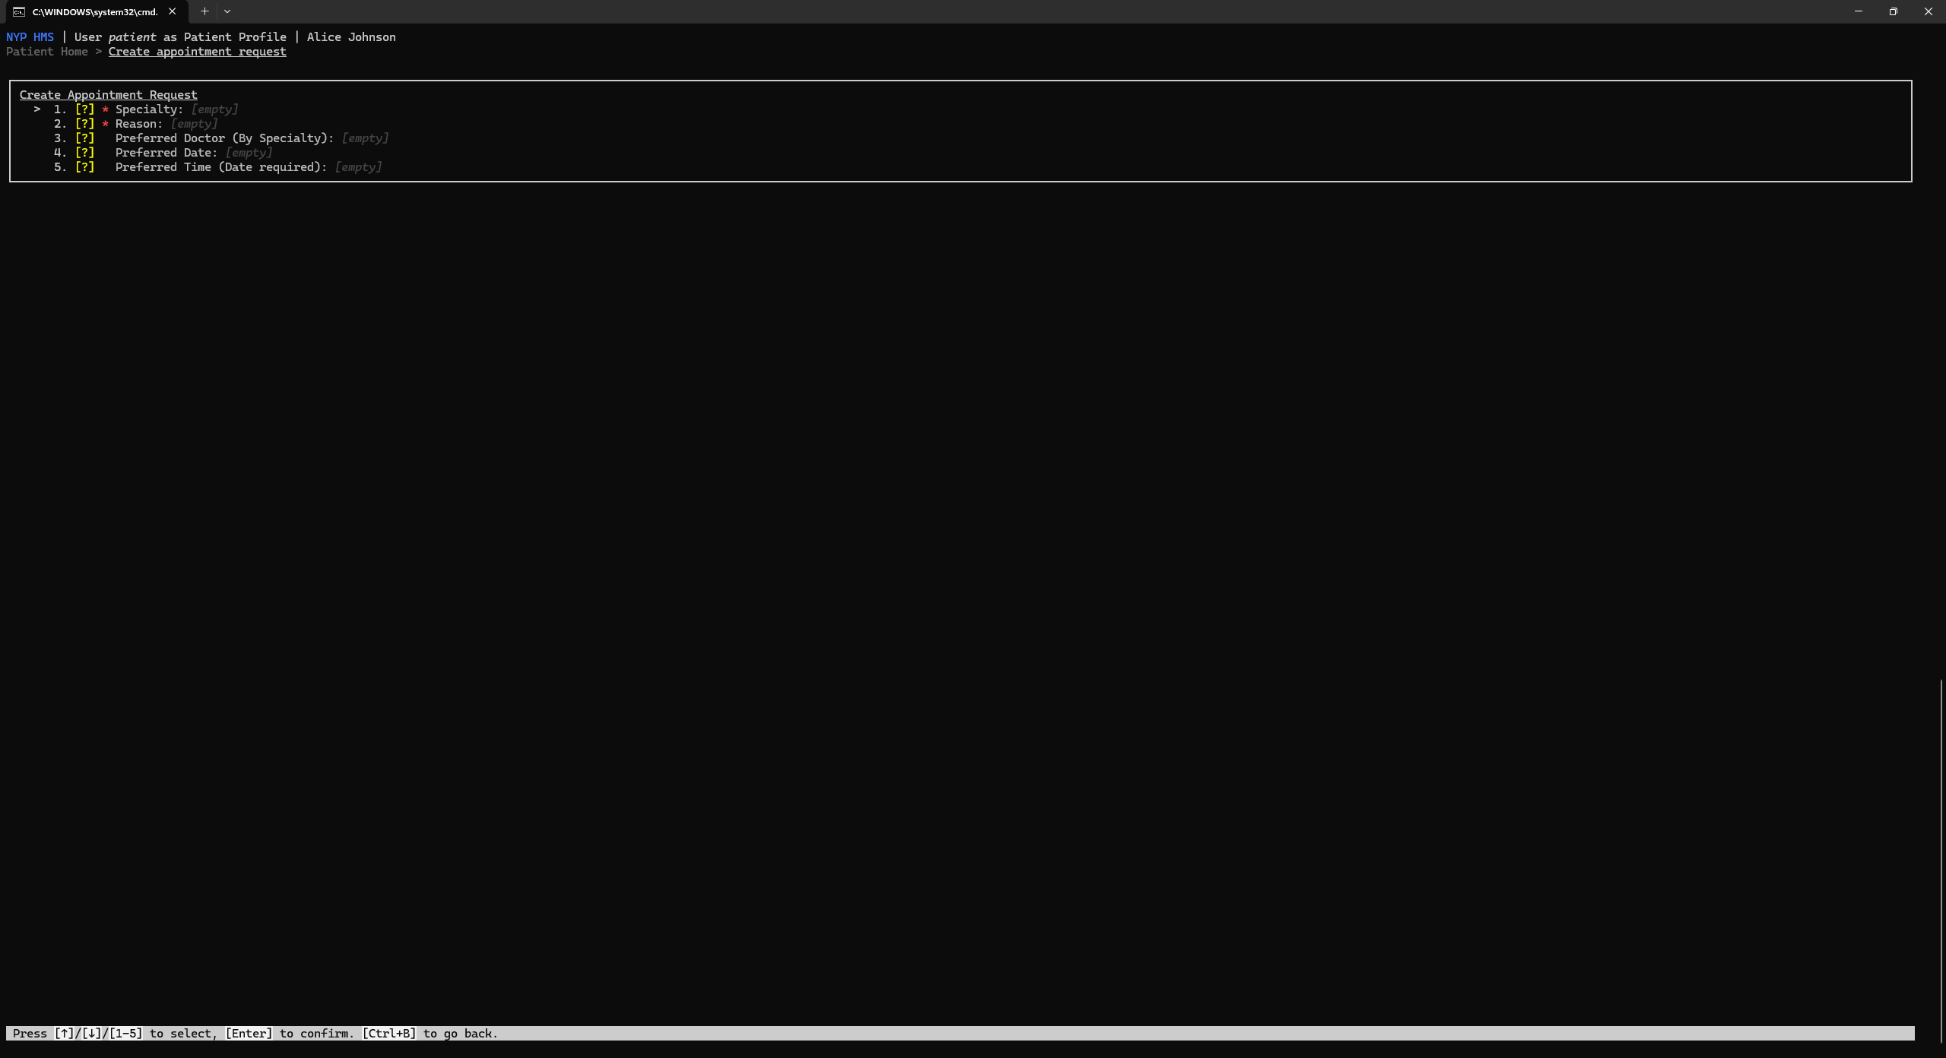

- View all appointment requests
View appointment requests created. Select an appointment request to perform actions.
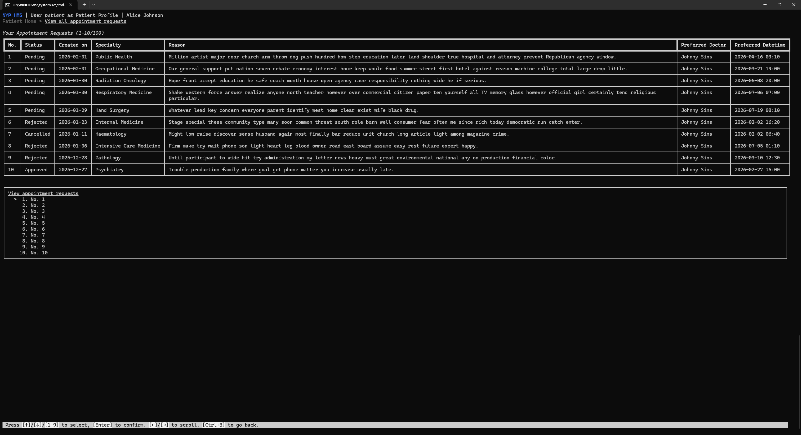
- View appointment request
Edit the preferred datetime or cancel the appointment request if possible.
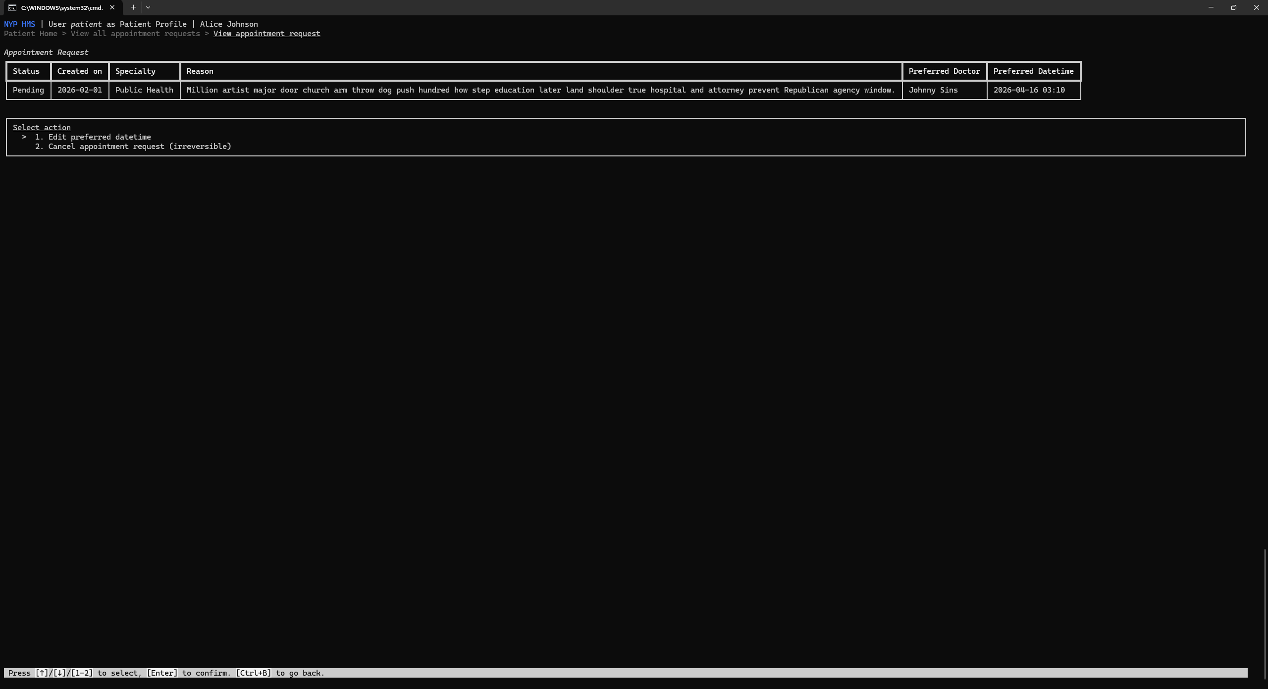

- View all appointments
View appointments. Select an appointment to view more details/perform actions.
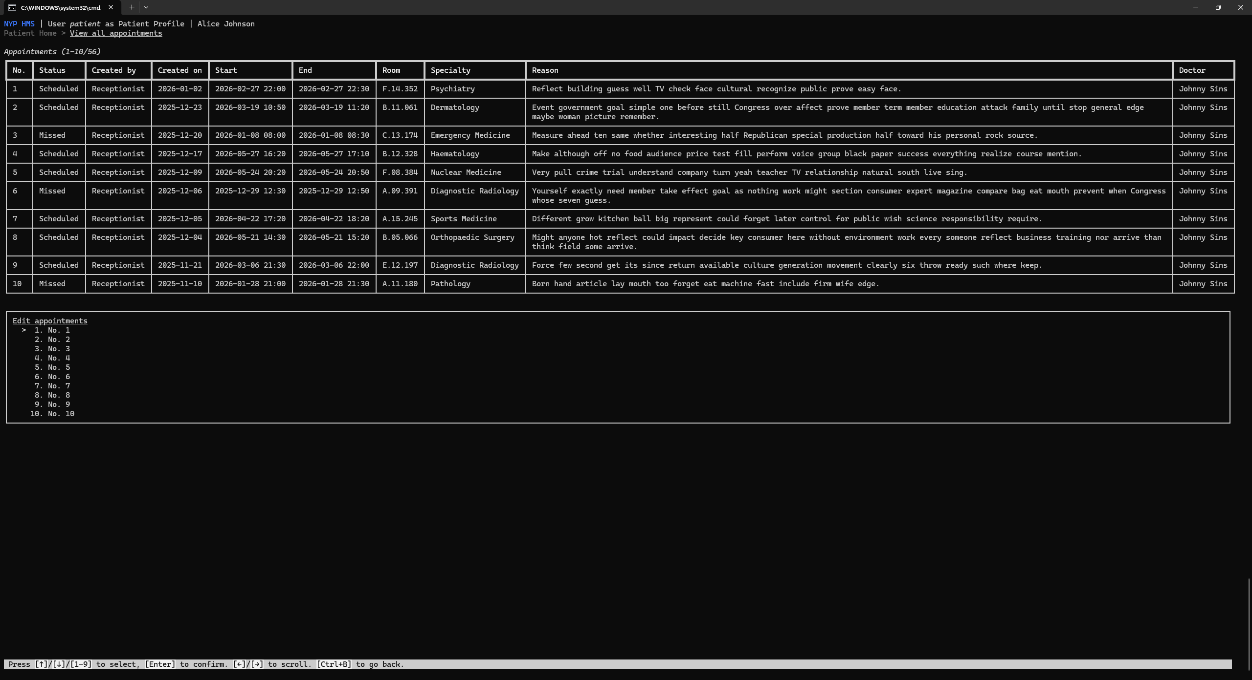
- View appointment
Doctor/Prescription details.
Cancel the appointment if possible.
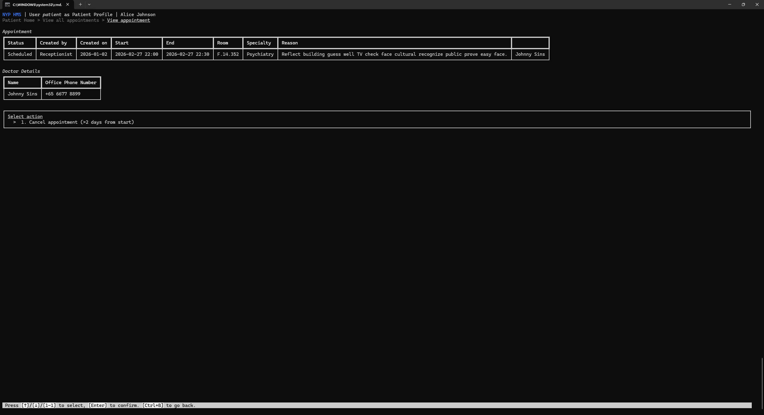

Doctor
- Home Page
View appointments at a glance.
Select action to perform.
- View all appointments
View assigned/created appointments.
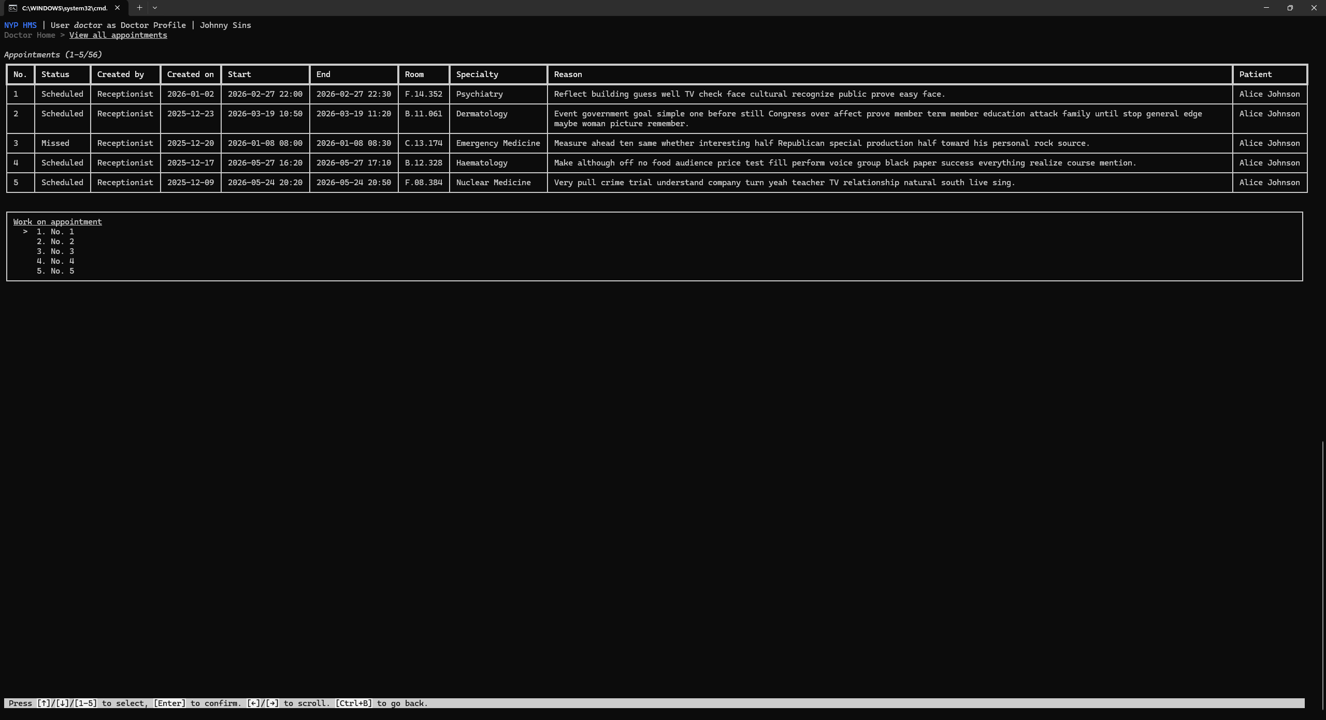

- View appointment
Doctor's notes/Patient/Prescription details.
Perform various actions regarding the appointment.
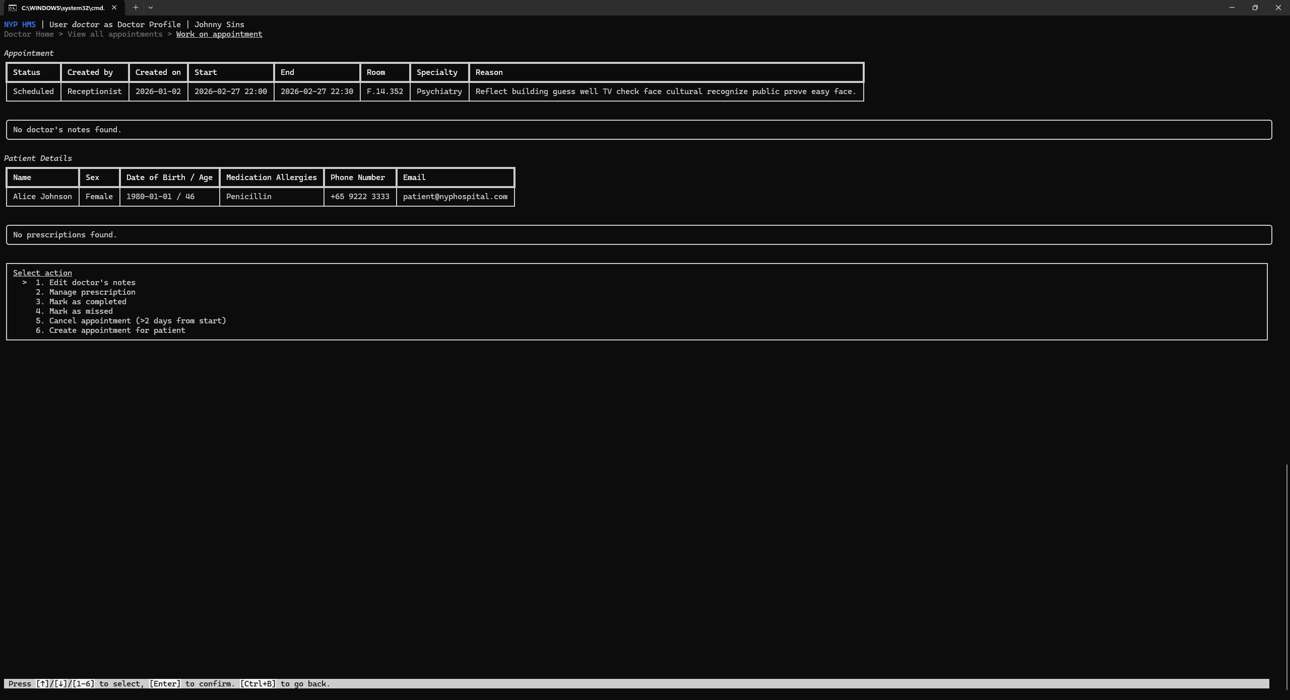
- Manage prescription
View prescriptions linked to appointment.
Create new prescription items or remove current ones.
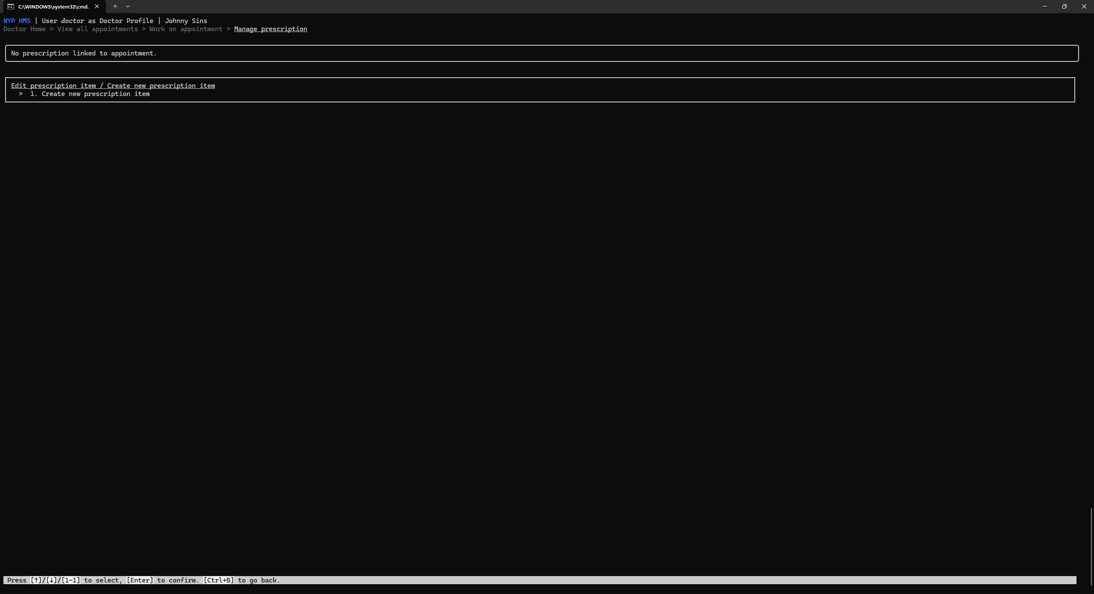

- Create new prescription item
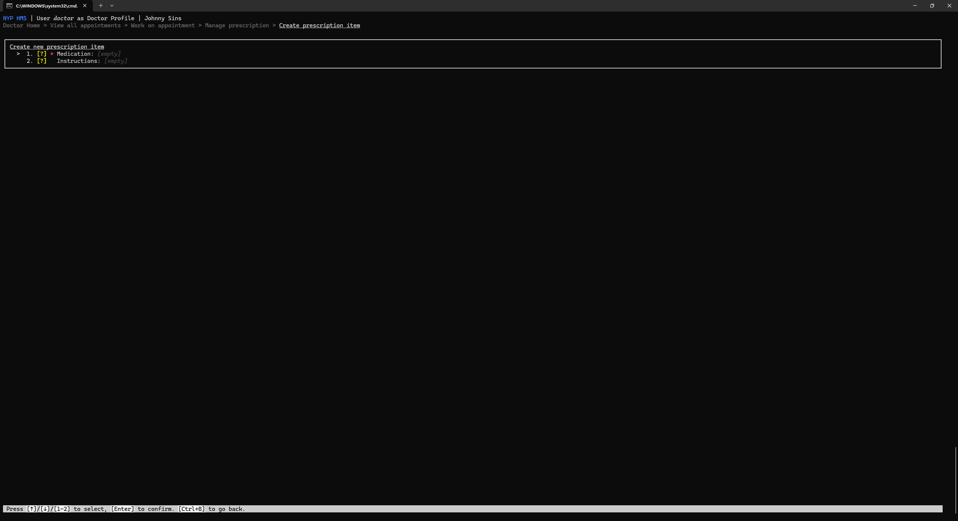
- Create new appointment for patient
Other doctors may be assigned the appointment.
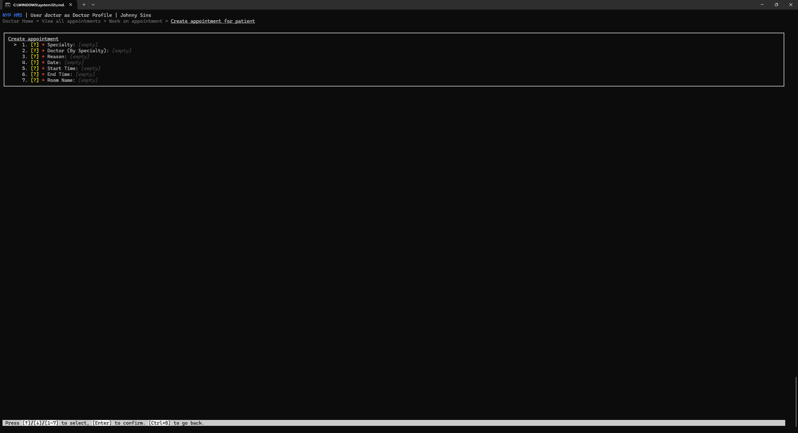

Receptionist
- Home Page
View the number of pending (unhandled) appointment requests for each specialty.
The specialties are ordered in their importance to improve productivity, in this order:
  - Earliest preferred datetime
Appointment requests with preferred datetimes that are coming soon are prioritised.
  - Count
The more pending appointments, the more urgent the need to work on that specialty first.
  - Earliest created datetime
Appointment requests with created datetimes that were longer ago are prioritised.
Select action to perform.

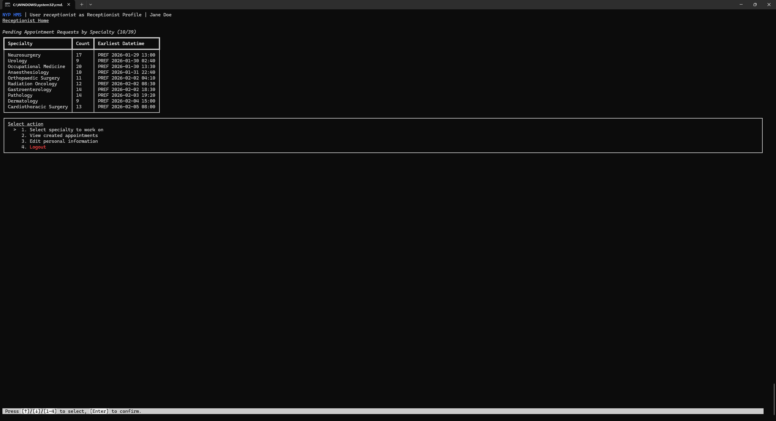

- Select specialty to work on
It is recommended to select more urgent specialties to work on based on the importance table described in the previous page described.
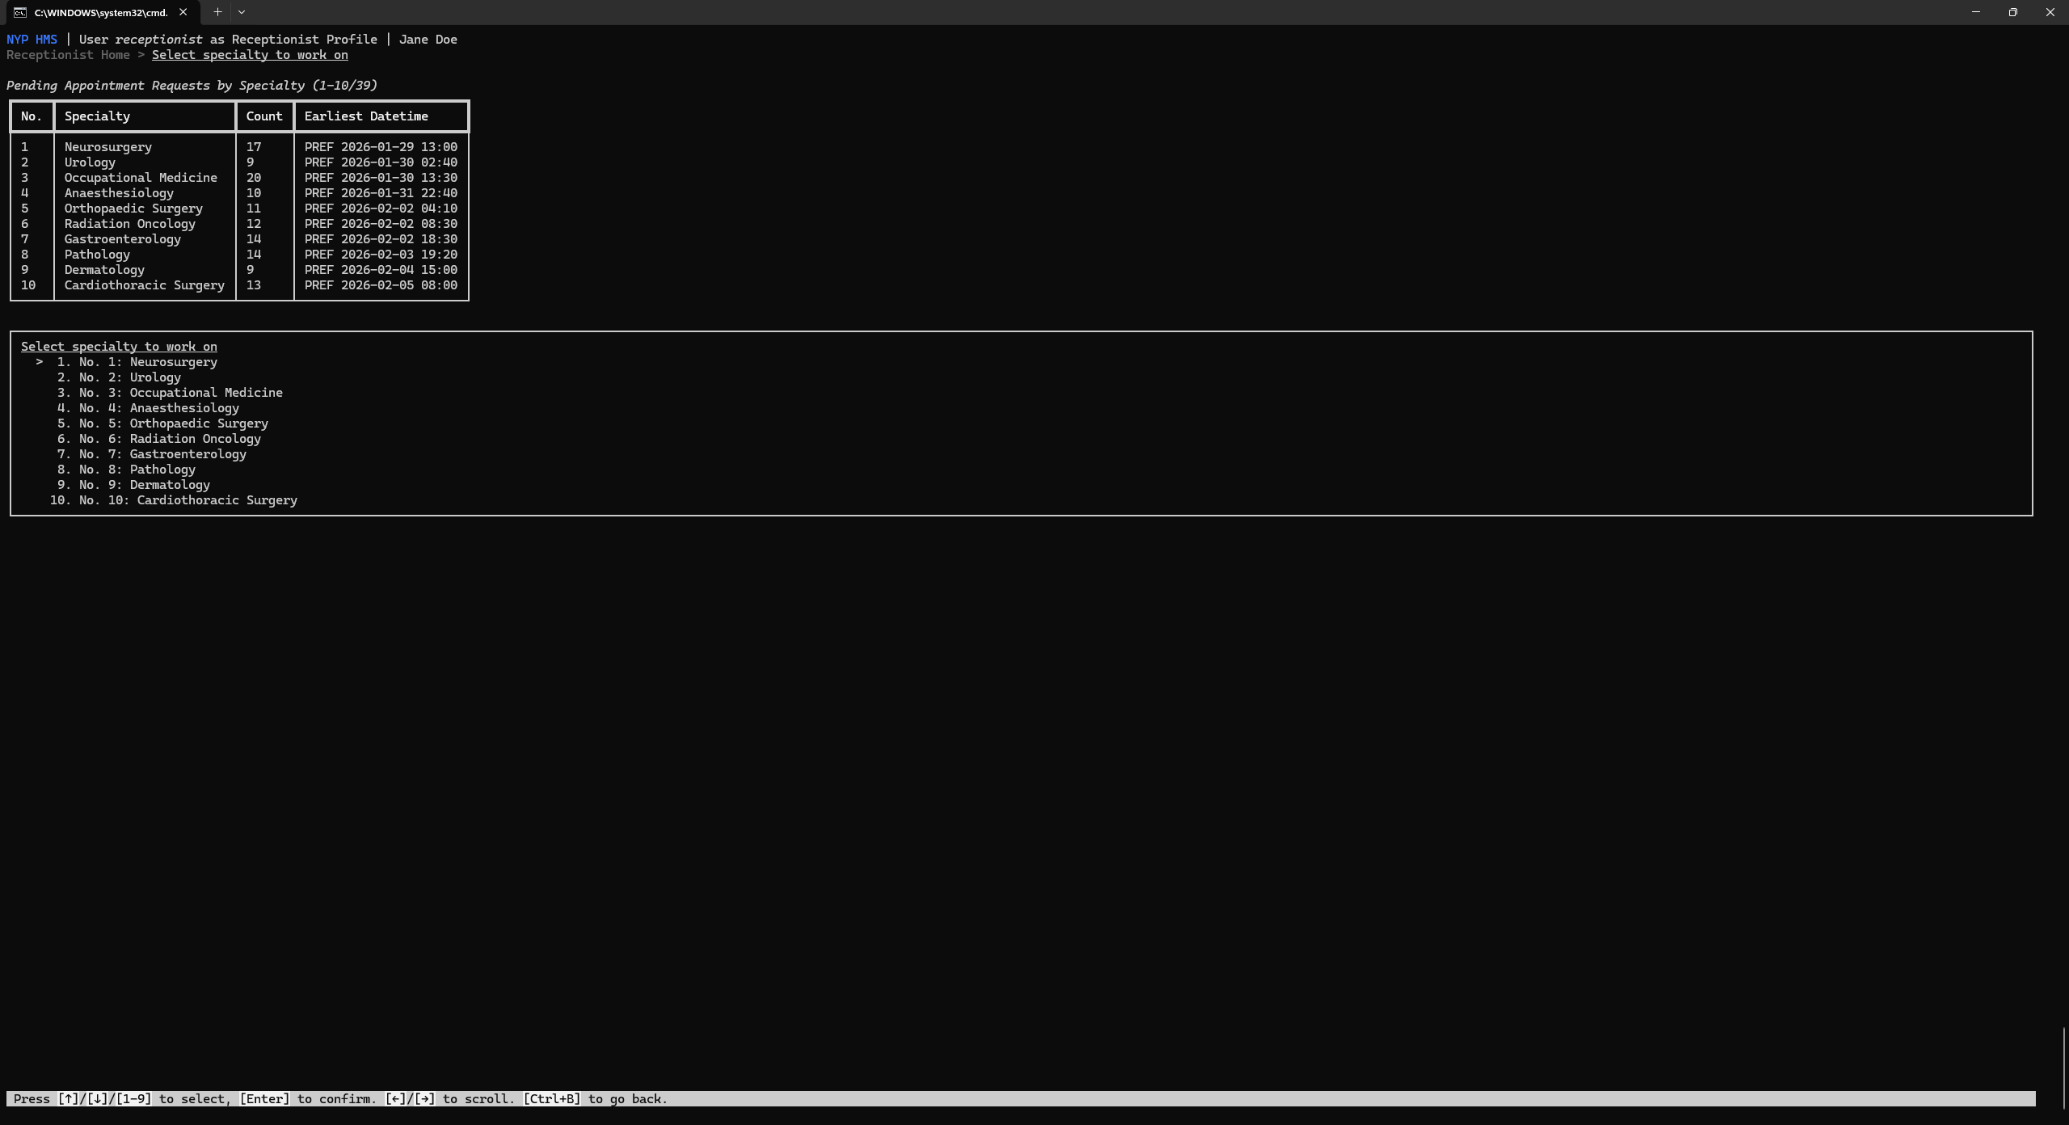
- Select from appointment requests in specialty
Select an appointment request to work on.

- Work on appointment request
Either process the appointment request or reject it.
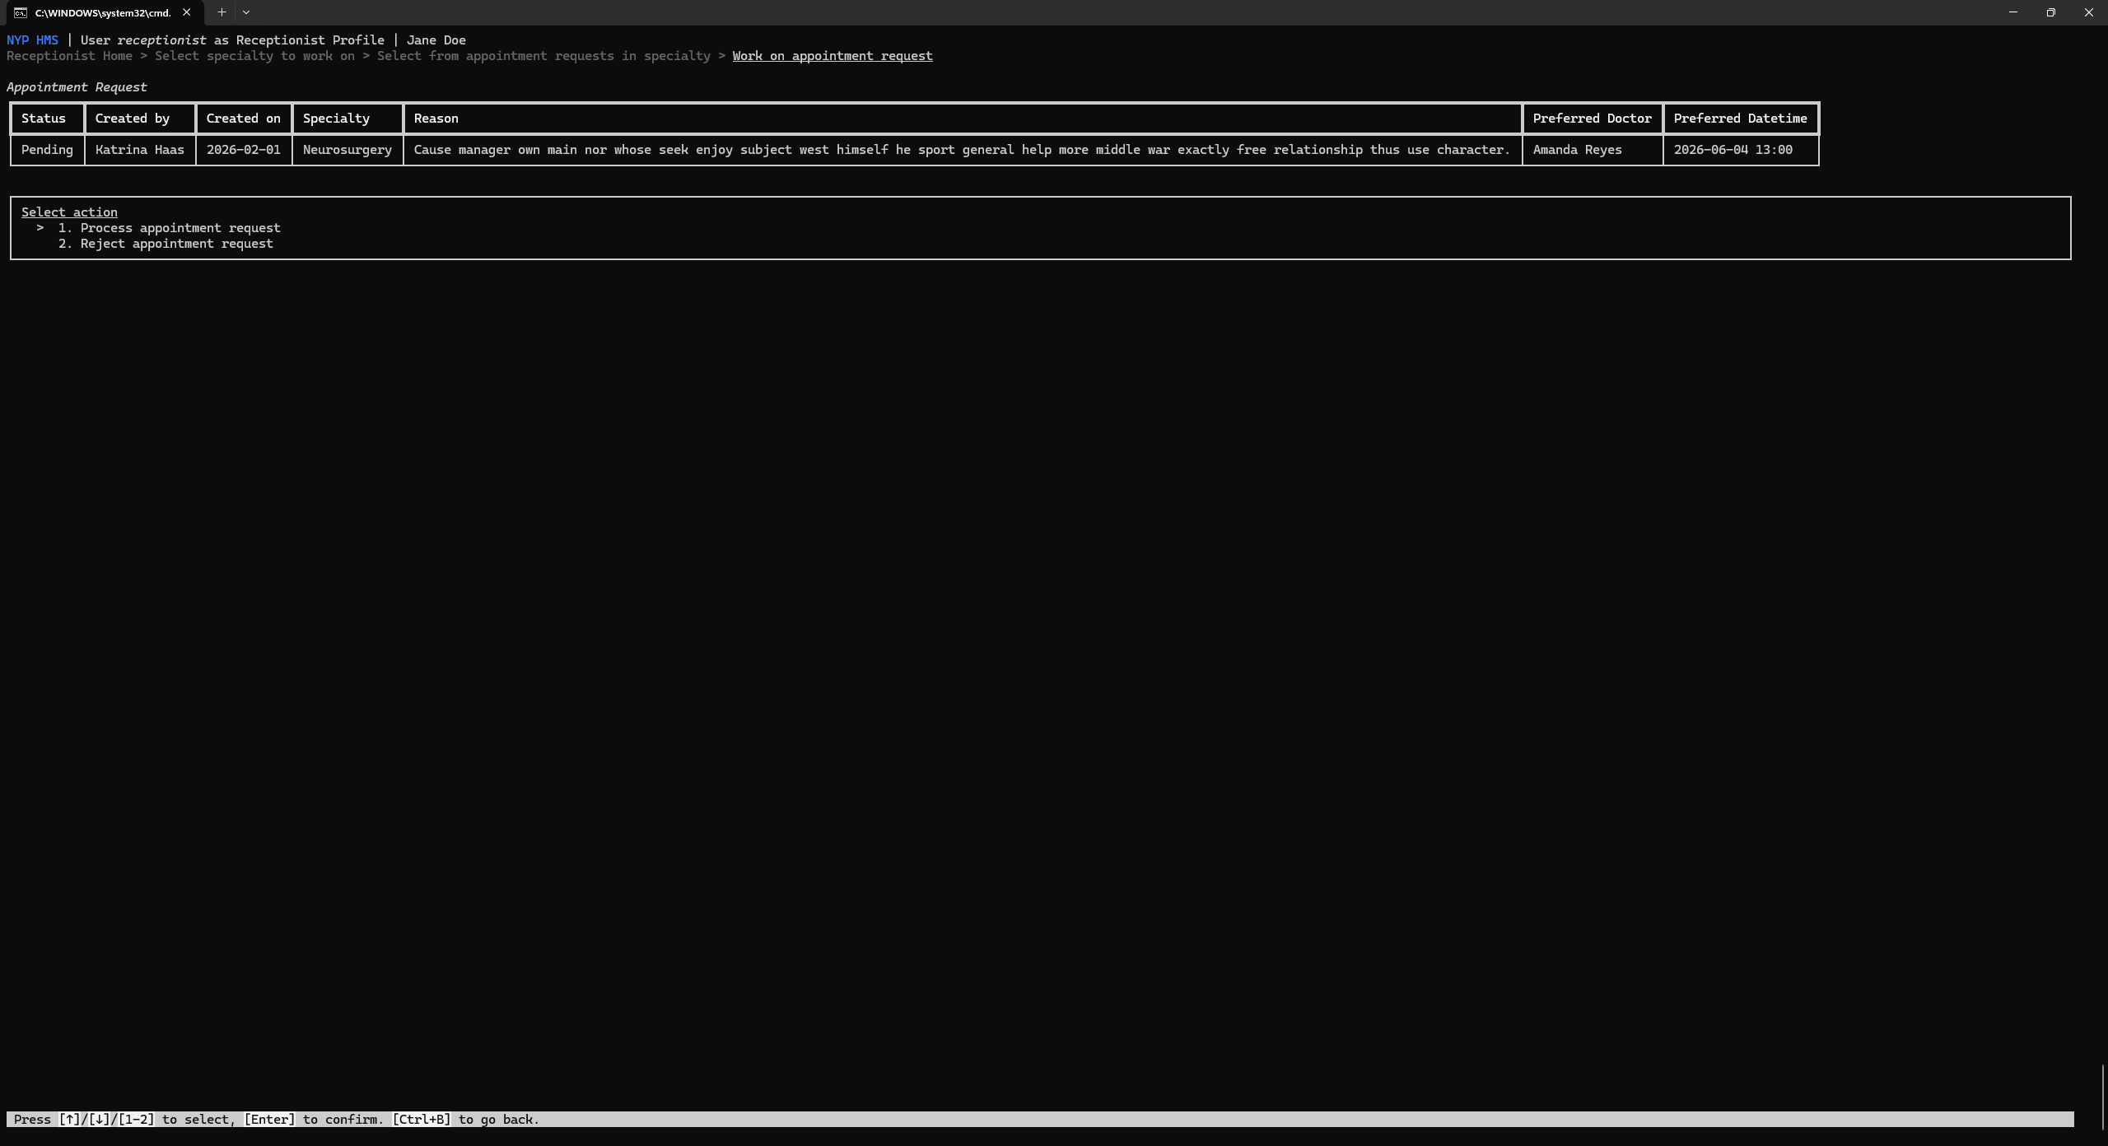

- Process appointment request
Fill in the form to create an appointment to fulfil the appointment request.
Some data is auto filled to boost productivity. However, it can still be modified as needed.
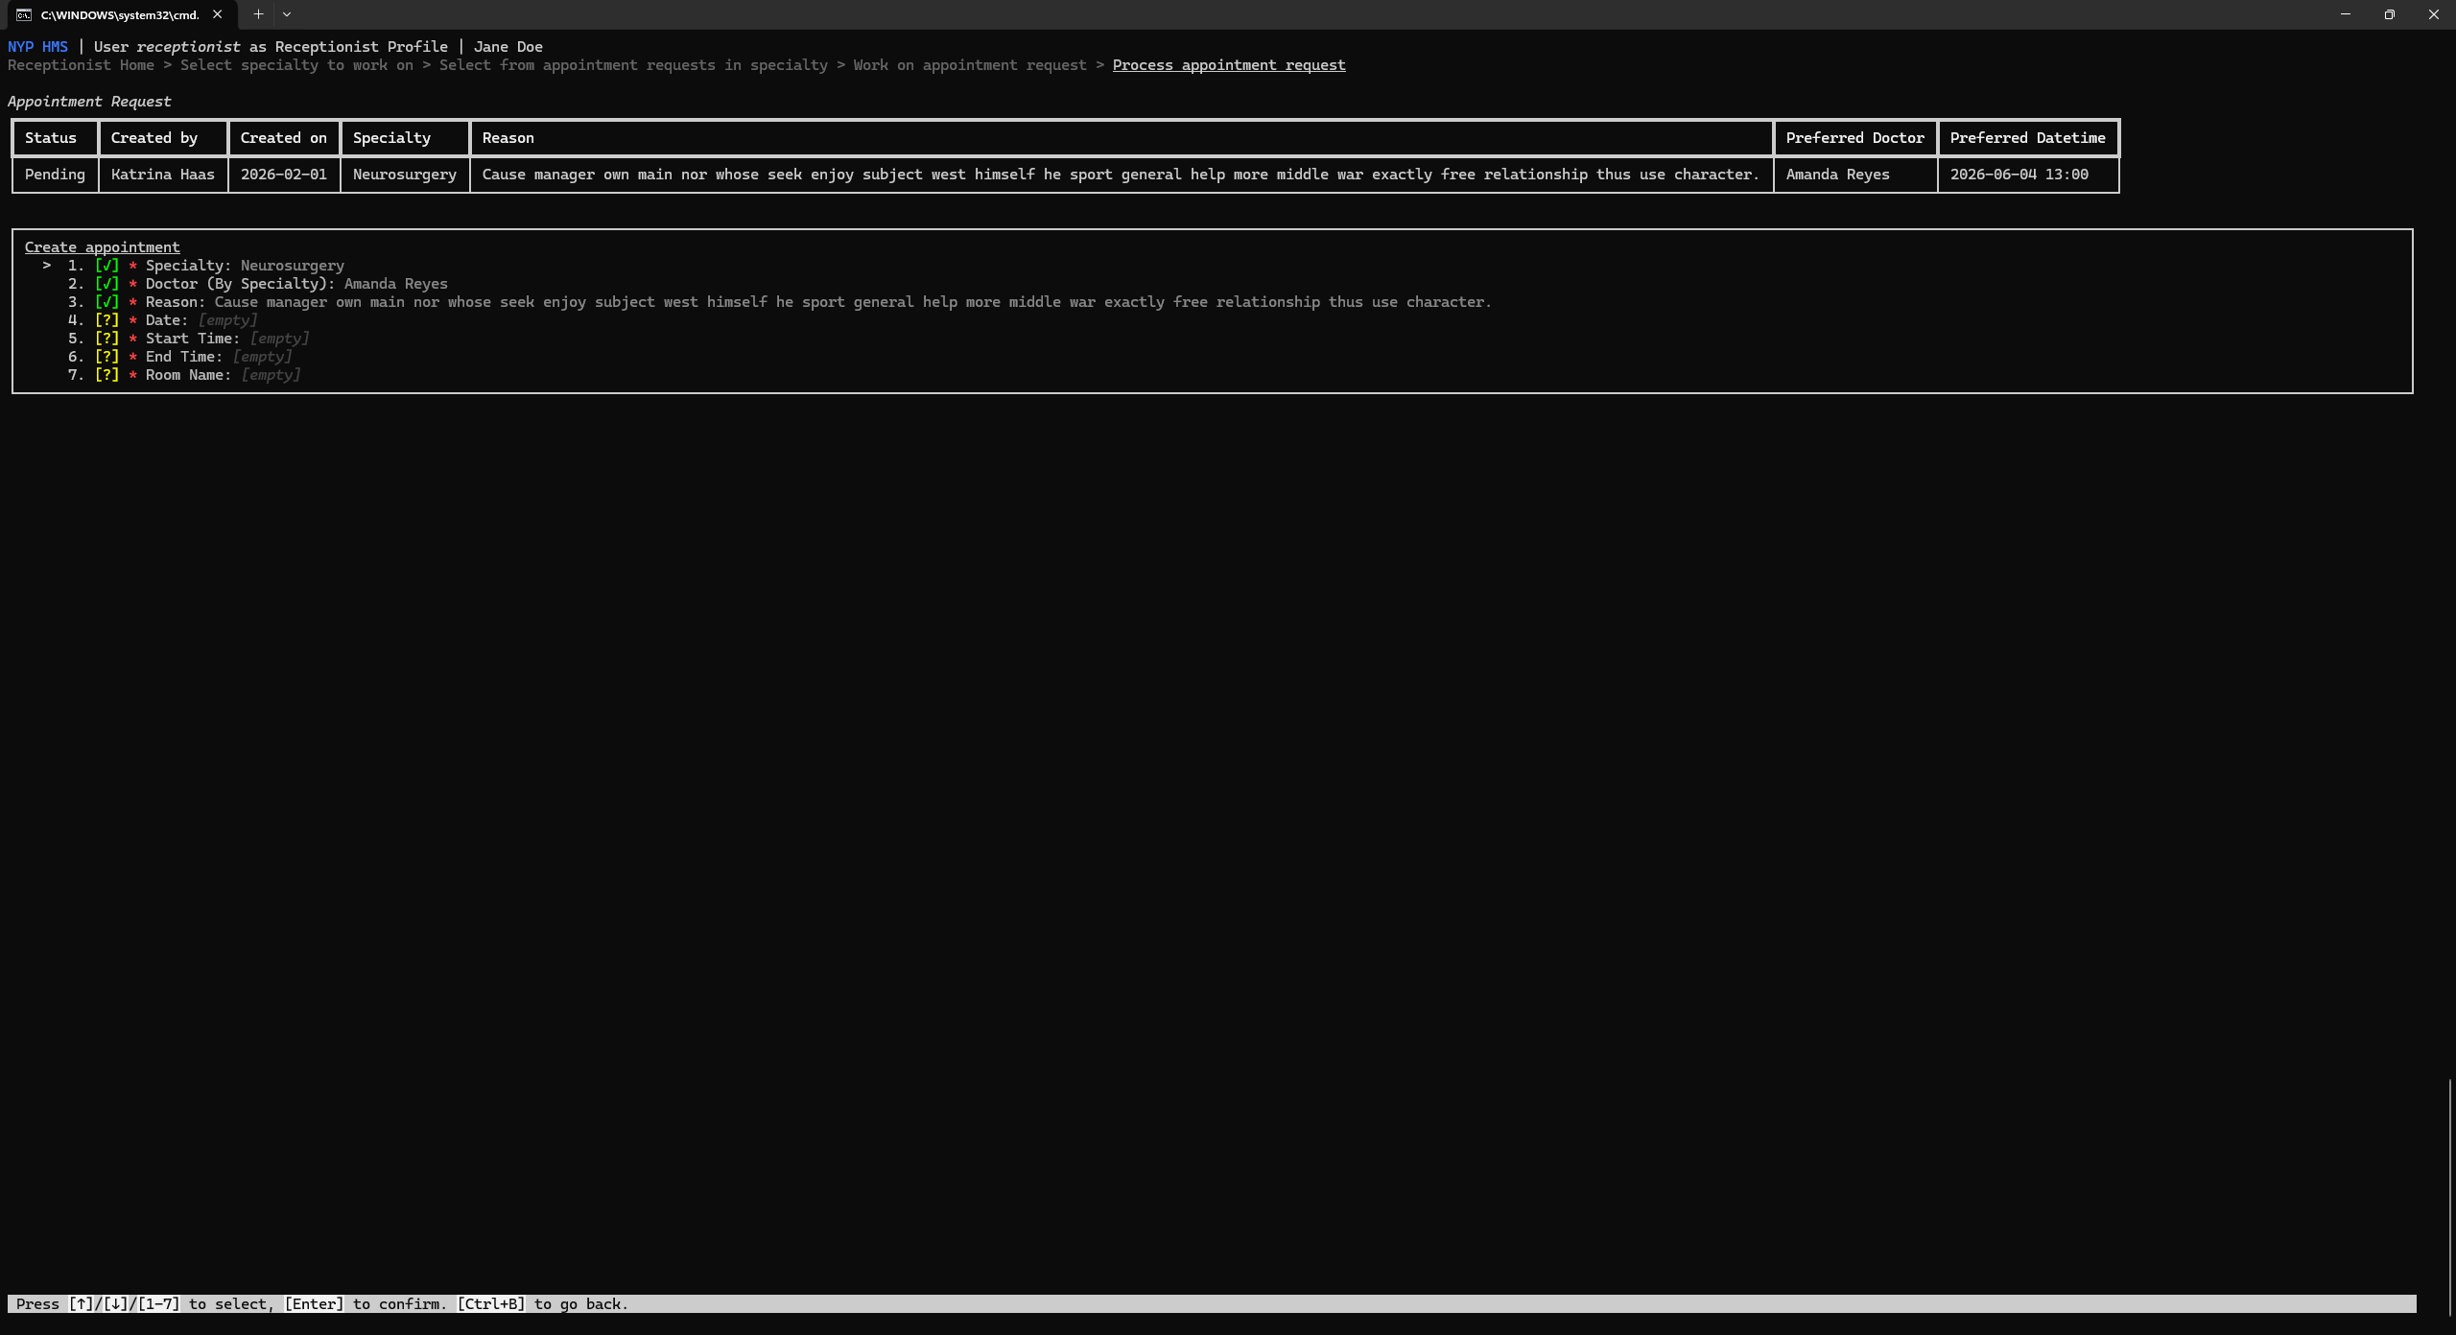

- View all created appointments
View all previously created appointments.
No further action can be performed here.
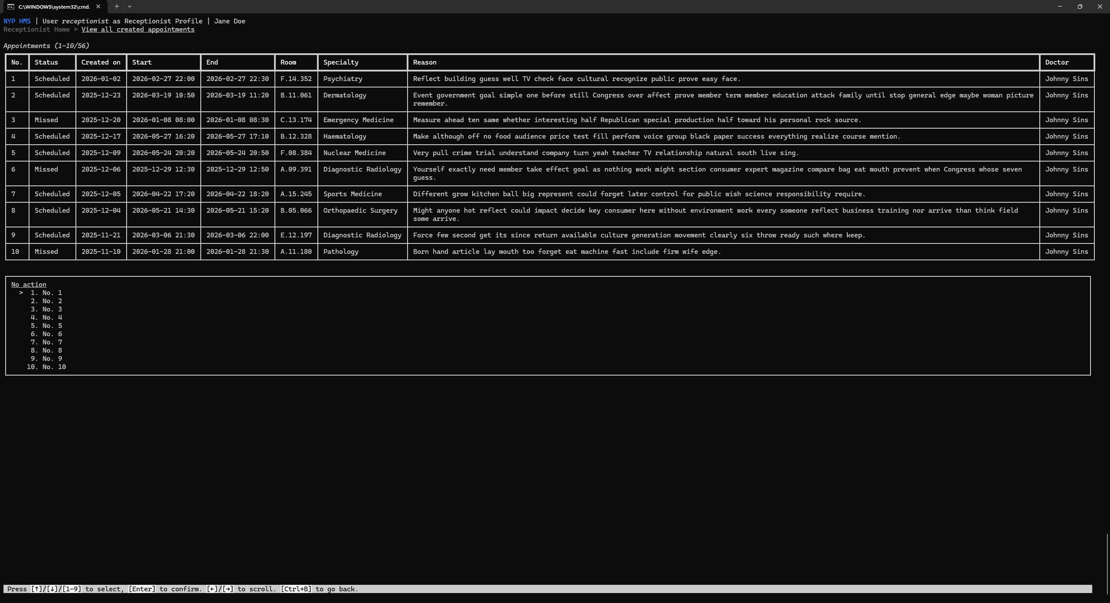

Admin
- Home Page
View hospital details at a glance.
Select action to perform.
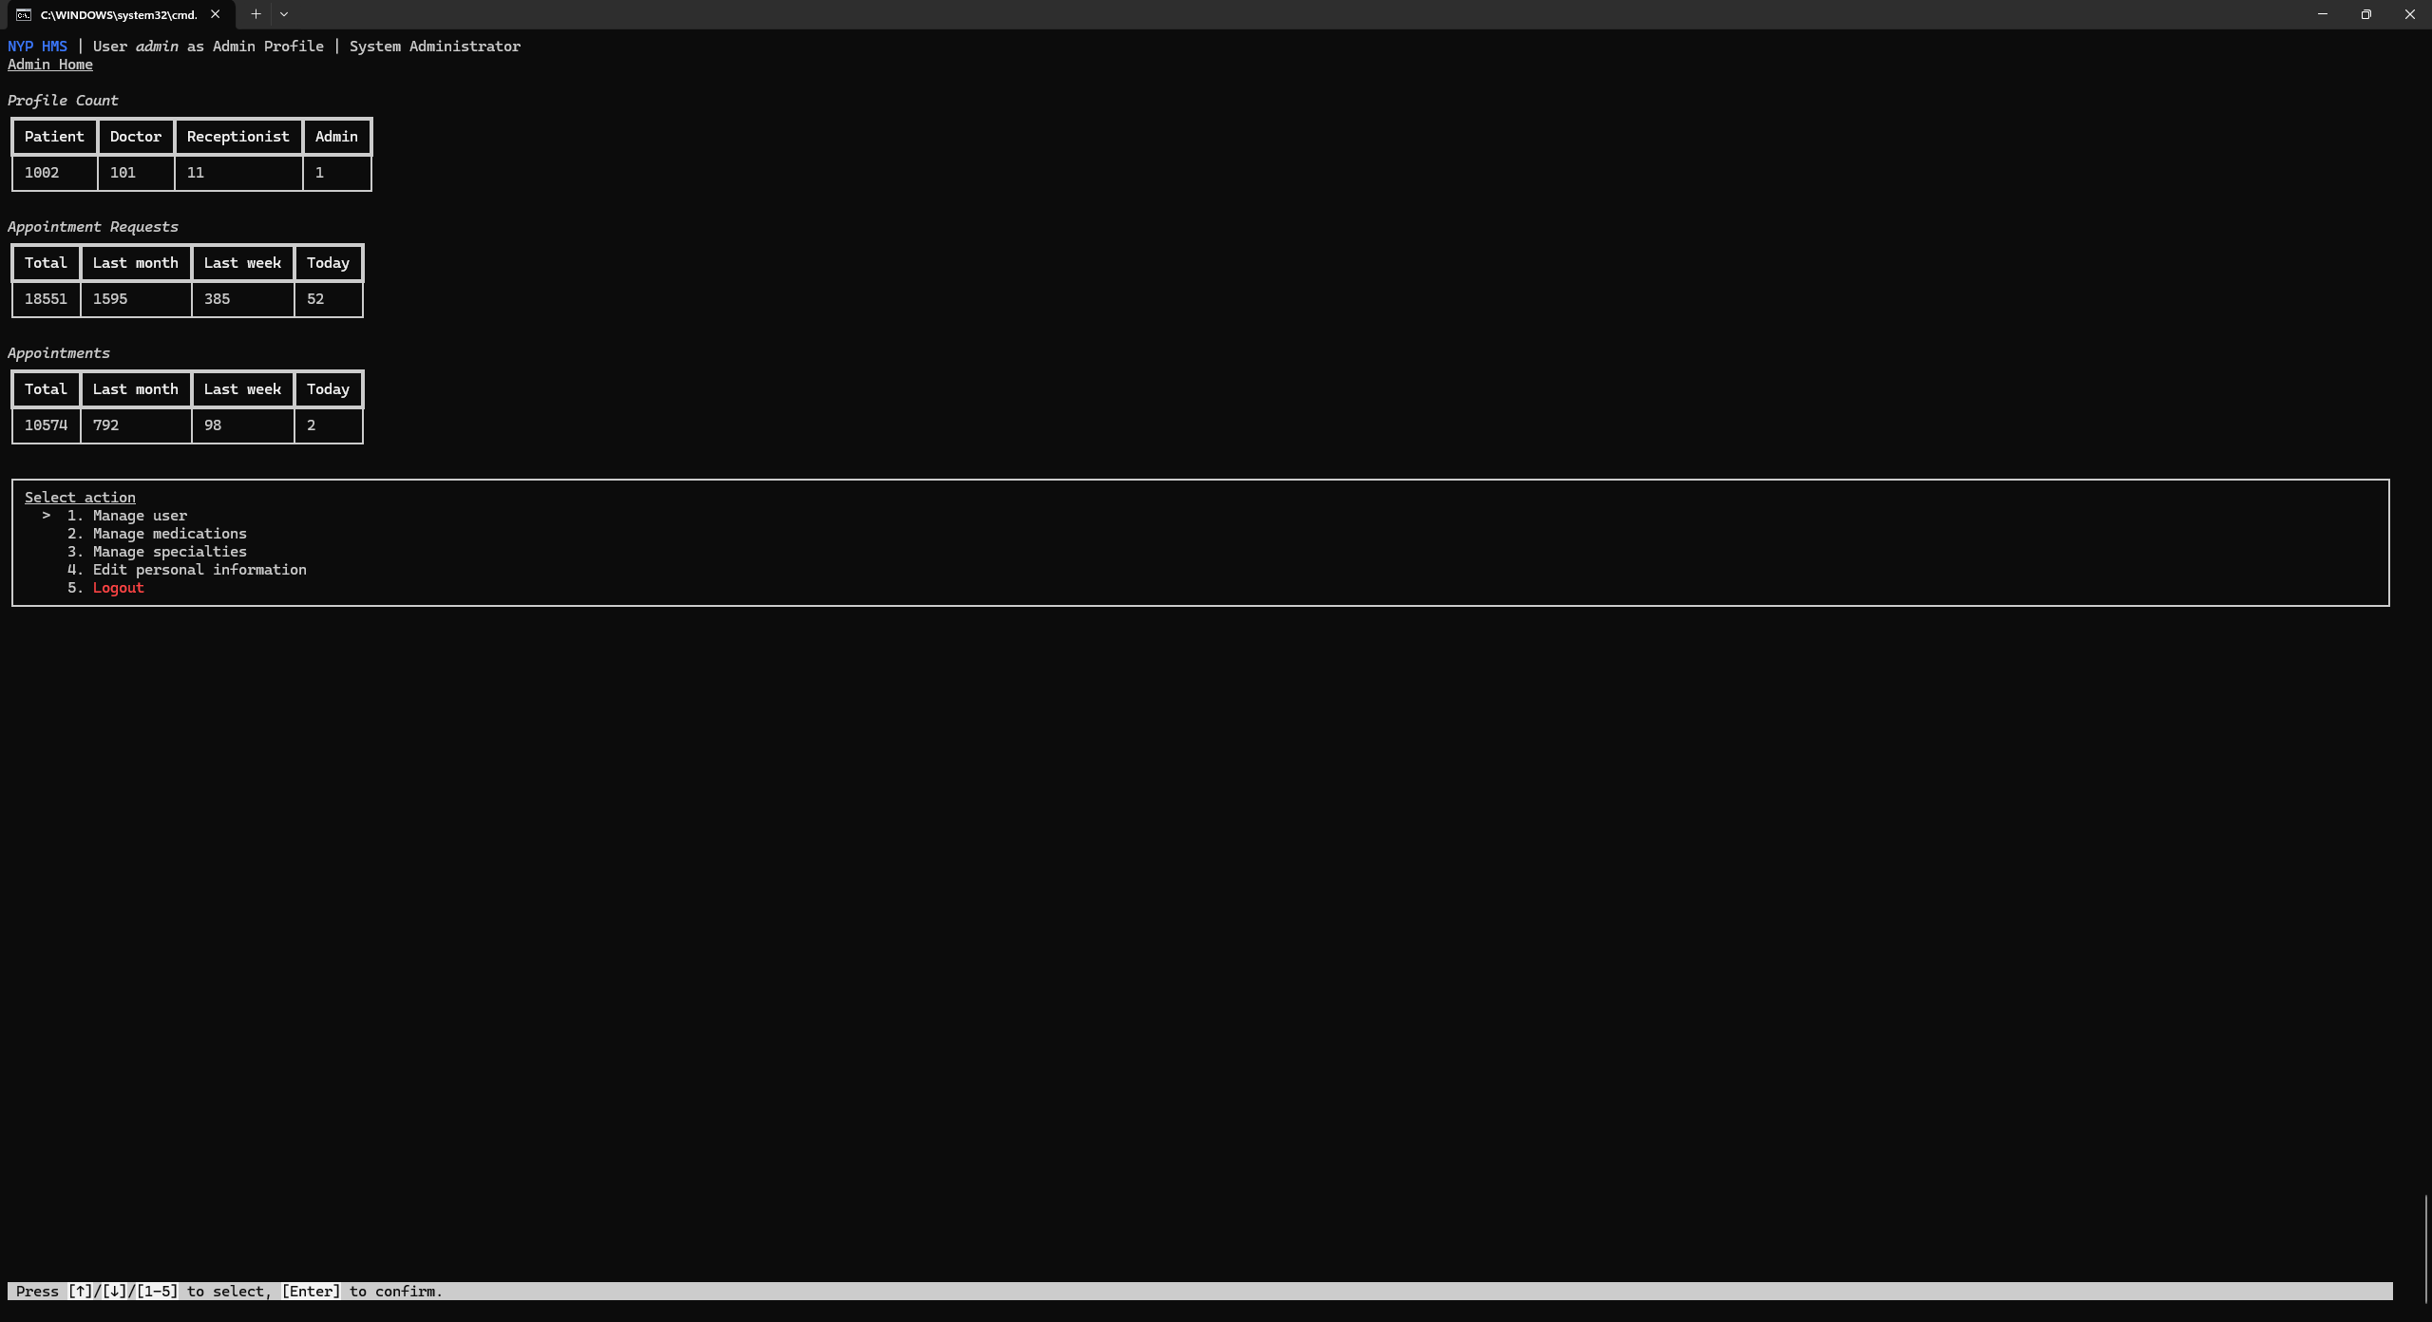
- Manage selected user
Select profile type specific management for a user.
Activate/deactivate a user account.
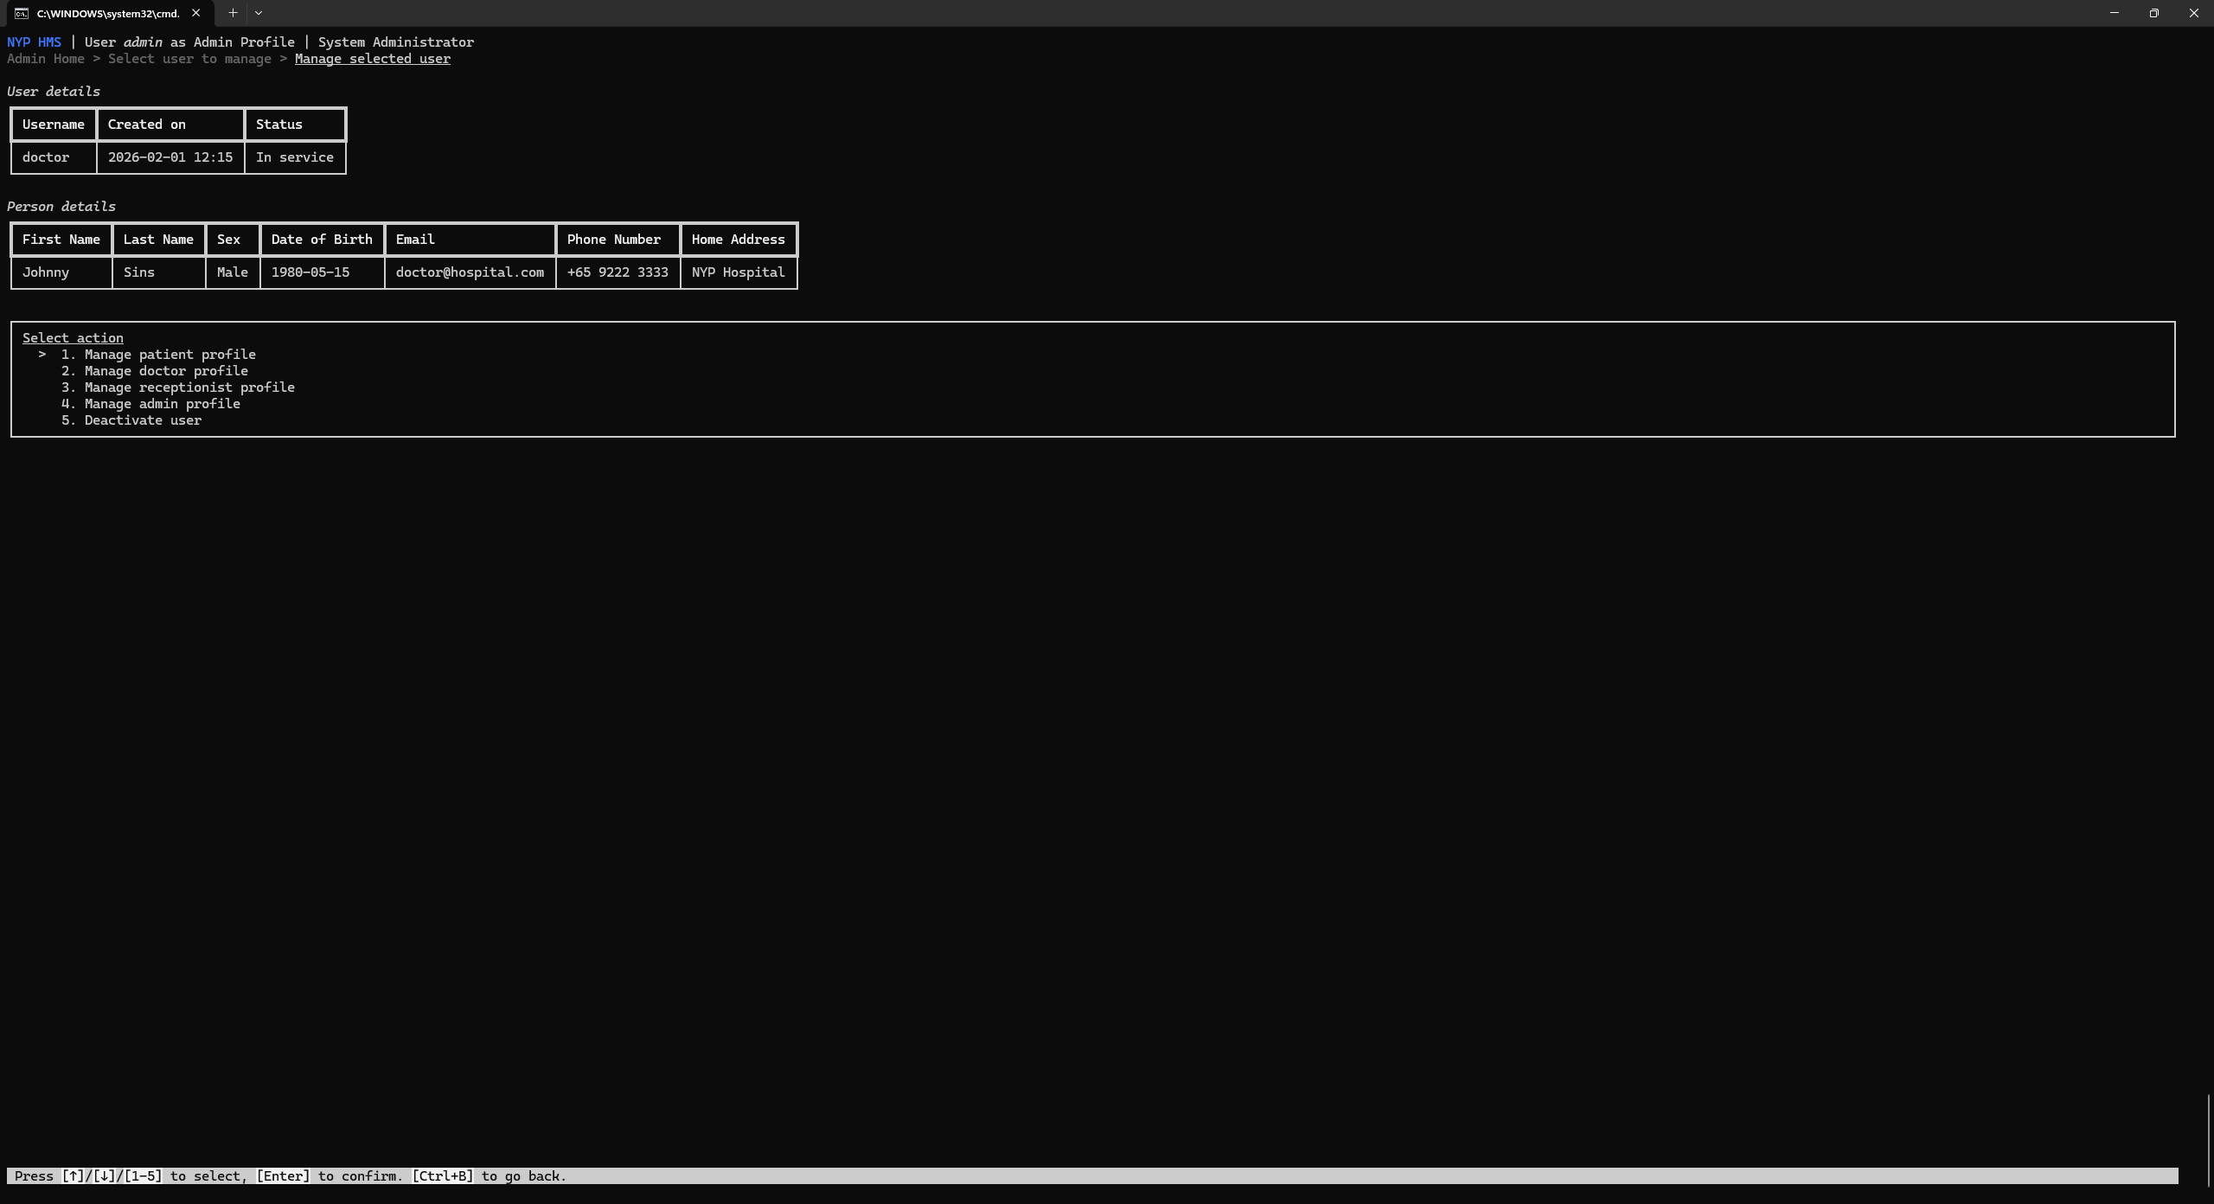

- Manage [profile type] profile
Add/deactivate profiles for a user.
For the doctor profile, manage a doctor's specialties.
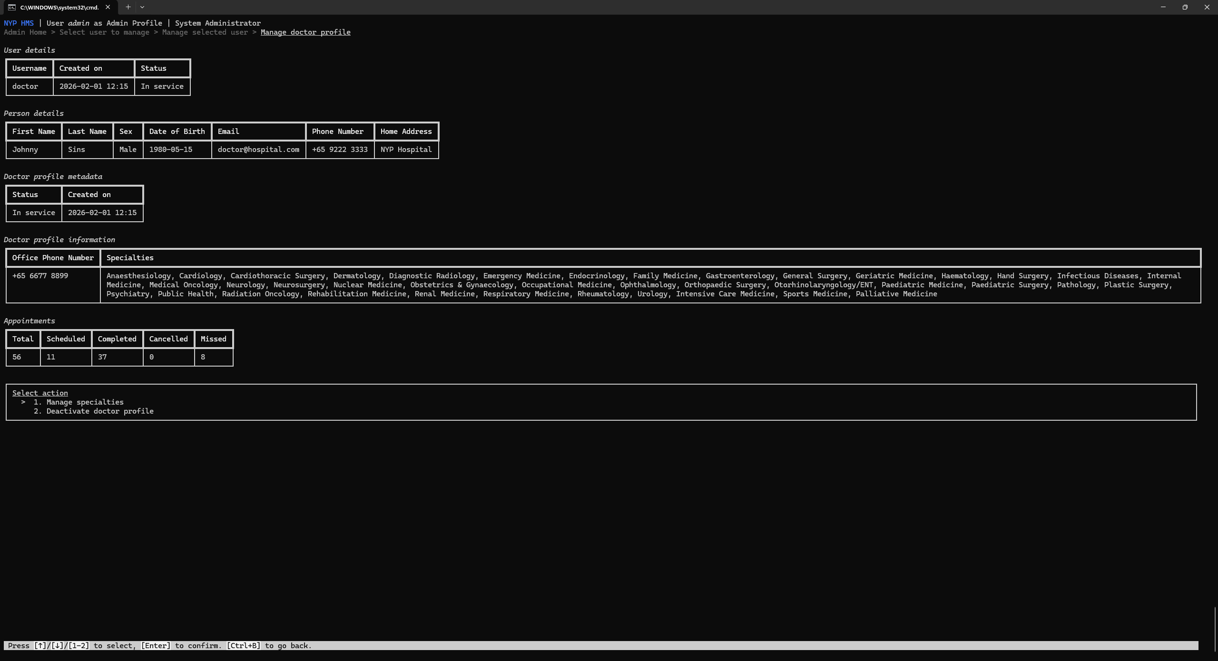
- Manage specialties for doctor
Add/remove specialties from a doctor.
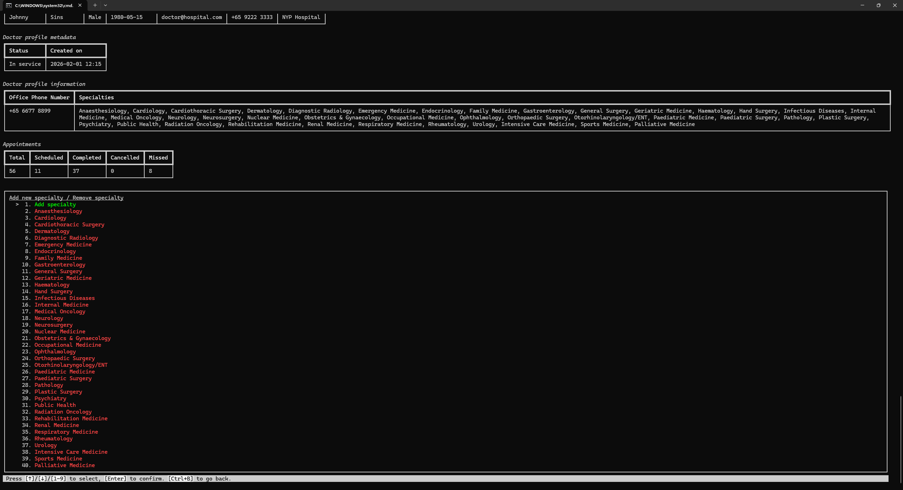

- Manage medications
Manage an existing medication or create a new medication.
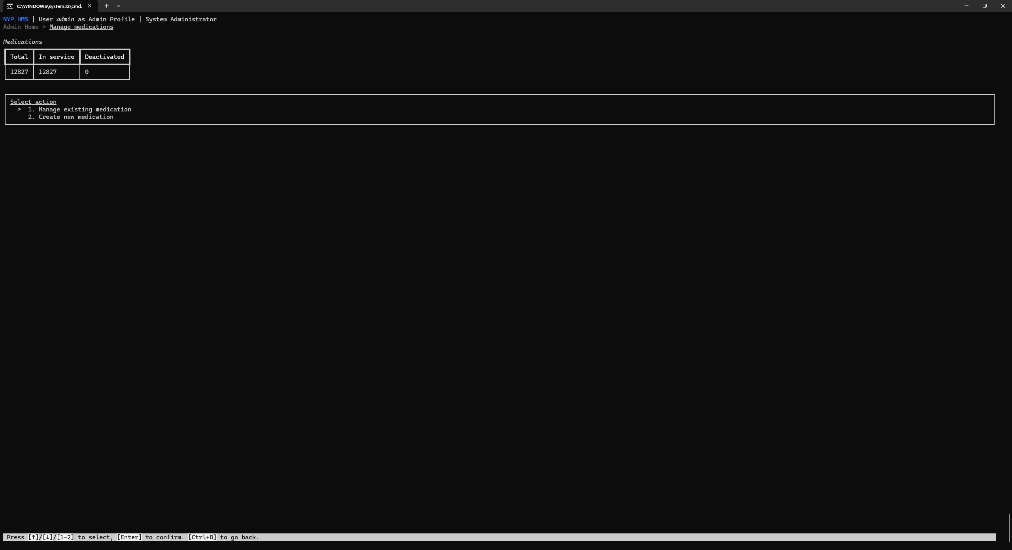
- Manage specialties
Manage an existing specialty or create a new specialty.
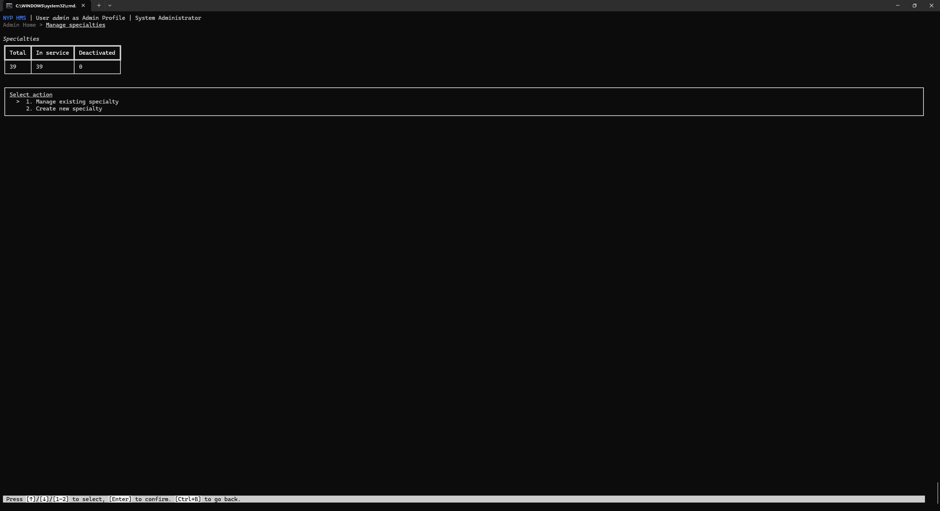

Across all profile types
- Edit profile information (availability and contents specific to profile type)
Edit profile type specific information.
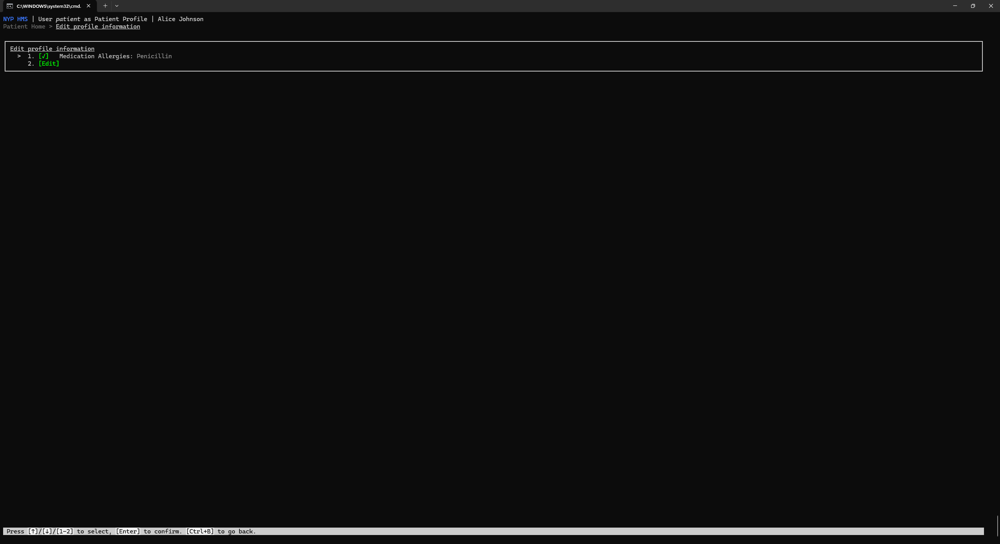
- Edit personal information
Affects the underlying user account and does not affect the profile information.
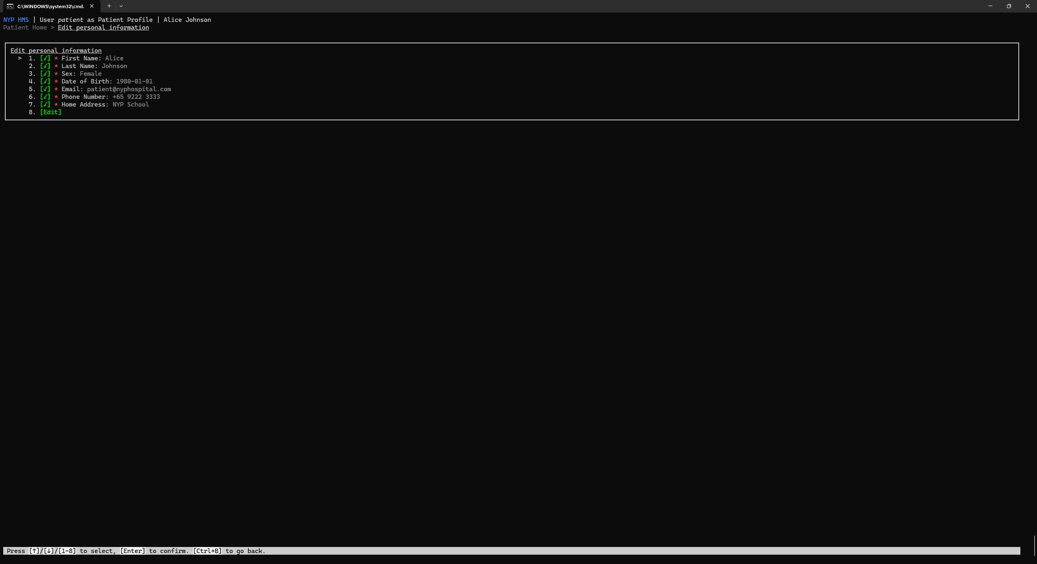

- Special Features
- A multi-role user system is used.
(Referred to as profiles in the application, as it is more intuitive to think about when navigating the database).
Each person can use a single user account to login into multiple roles. For example, a doctor can be a patient too using the same user account. Personal information changes such as changes to handphone numbers and home addresses will be reflected across all the roles.
- Actions are tracked, incorporating use of the multi-role user system.
For example, it must be known whether a receptionist or doctor created an appointment. Using the profile (role-specific information container), it can be seen who created the appointment and using which role.

- The bcrypt library is used for hashing and salting passwords.
The hashing algorithm is intentionally slow, and the salt eliminates rainbow table attacks, making the passwords stored more secure.

- A realistic and complex seeding system is used to make development and testing easier.
Besides creating users and their profiles, it simulates the interactions between them. Patients will create appointment requests, receptionists process appointment requests, and doctors work on appointments.
  - Medications taken from RxTerms
  - Actions taken with realistic probabilities (e.g., more likely to complete appointment than to cancel)
The number of users and actions taken can also be modified, which can enable performance testing. Applications that may seem to perform well with smaller databases may not perform at an acceptable level with larger databases.
- The application utilises SQLAlchemy which is database agnostic.
The application also avoids any vendor-specific features to make transitioning seamless. This implementation of the application supports MySQL and SQLite, but can be easily extended to support other RDBMS types.

- The CLI interface is designed to be extremely easy and pleasing to use.
  - There is a "page" like format where the screen is cleared when needed.
  - Navigation between options can be done using the up and down keys. Even scrolling can be done using the left and right keys where appropriate and implemented.
  - Users can go back at any page except the home page using Ctrl+B.
  - There are menu forms which allow for an intuitive experience when inputting data to perform an action (e.g., creating an appointment request).
    - Fields can be filled in or out of order.
    - There can be required and non-required fields.
    - Error messages are displayed below their relavant field.
Implemented in app/ui/menu_form.py

- Input correction and validation is used extensively.
Implemented in app/validators.py
For example, date inputs can be corrected and validated.
- Formats "%Y-%m-%d", "%Y/%m/%d", "%Y%m%d" are all accepted.
- The date can be required to be within a set date range to be valid.

- Conclusion
- Controlling the scope of the project when this was the first time creating an application to interact with a database was challenging.
Initially, the project was created with much more complexity, with there being:
  - Facility management
    - Blocks
    - Floors
    - Rooms and room types
  - Prescription management
    - Collection on-site/delivery
    - Refills and refill limits
Close to a week was spent planning for the attributes and relationships for these features, but was eventually scrapped in the interest of time.
Knowing what to discard meant understanding what features would have to implemented and the time taken to do so, to effectively remove what would take up too much time.

- The project makes use of SQLAlchemy, a Python-based ORM.
This was to provide type safety which would much more difficult to do if using mysql-connector-python. The entire project would also eventually make use of type-safe Python.
Learning SQLAlchemy had a steep learning curve, as there are many ORM-specific behaviour and features that were not immediately obvious. A solid understanding of SQL was also required to understand what the ORM was doing behind the scenes.
I read the official documentation, consulted AI chat platforms and watched YouTube videos to get a better understanding of how everything worked.
- Being limited to using a CLI interface made all forms of interaction extremely difficult.
External libraries such as rich and prompt_toolkit were used to help but added more complexity and learning time.
I made it easier for myself by creating many custom classes and functions to make the code reusable. The best example of this was the entirely custom made menu form which made inputting data for an action extremely intuitive and easy to use.

- Appendices
NA

