USER TRAINING GUIDE
Mass Material Maintenance Tool
Create, Update and Extend materials with an Excel file
SAP report ZMM_MATERIAL_MAINTENANCE
Operation-wise guide with screens, examples and troubleshooting
Version 1.0 | 19 October 2026
Audience: material master key users and requesters
The screens in this guide are illustrations. Field texts and colours can differ slightly in your system.
Contents
1. Introduction 4
1.1 What is this tool for? 4
1.2 The three operations 4
1.3 Before you read on 5
2. The process in short 5
2.1 Test run and actual run 5
2.2 What happens inside the report 6
3. Before you start 6
3.1 What you need 6
3.2 Where is the report? 7
3.3 Golden rules 7
4. The selection screen 8
4.1 Fields and buttons 8
4.2 Executing the report 9
4.3 The screen for each operation 10
5. The Excel template 11
5.1 Layout of the sheet 11
5.2 Types of columns 11
5.3 Which sheet is read? 13
5.4 How to enter values 13
5.5 One row = one material and one org. level 14
5.6 File format and number of records 14
5.7 Local PC or application server? 14
6. Functions for all operations 15
6.1 Reference material (copy from an existing material) 15
6.2 Default values 16
6.3 Status dates and unit lines 16
6.4 Descriptions and languages 16
6.5 Product hierarchy 16
6.6 Classification 16
6.7 Texts 17
6.8 Mandatory and conditional mandatory fields 17
7. Operation CREATE - create new materials 18
7.1 When to use Create 18
7.2 Prerequisites 18
7.3 Step by step 18
7.4 Filling the Create template 19
7.5 Material numbers in Create 19
7.6 Example with a reference material 20
7.7 What is checked in Create 20
7.8 Result of a Create run 20
7.9 Typical Create problems 22
7.10 Create checklist 22
8. Operation UPDATE - change existing materials 23
8.1 When to use Update 23
8.2 Prerequisites 23
8.3 Step by step 23
8.4 Filling the Update template 23
8.5 Special topics 24
8.6 What is checked in Update 24
8.7 Typical Update problems 25
8.8 Update checklist 25
9. Operation EXTEND - add org. levels 26
9.1 When to use Extend 26
9.2 Prerequisites 26
9.3 Step by step 26
9.4 Filling the Extend template 27
9.5 What is checked in Extend 27
9.6 Typical Extend problems 28
9.7 Extend checklist 28
10. Reading the result 29
10.1 The result list on the screen 29
10.2 What happens when something is wrong 29
10.3 The Excel result file 30
10.4 The e-mail 30
10.5 Running in the background 30
10.6 After a partly successful run 31
11. Messages and what to do 32
12. Questions and answers 34
13. Best practices 35
13.1 Do 35
13.2 Do not 35
14. Quick reference 35
14.1 The three operations at a glance 35
14.2 Limits 36
14.3 Glossary 36

1. Introduction

1.1 What is this tool for?
The Mass Material Maintenance Tool (report ZMM_MATERIAL_MAINTENANCE) lets you create, change and extend many materials at once. Instead of maintaining each material by hand in MM01 / MM02, you fill an Excel file, run the report, and SAP does the work.
For every material the report:
- reads your Excel (.xlsx) or CSV file,
- checks every value (mandatory fields, formats, lengths, existing materials, classification),
- fills the SAP material master through the standard SAP function BAPI_MATERIAL_SAVEREPLICA (and the classification through the standard BAPI_OBJCL_* functions),
- shows a clear result list (what worked, what did not, and why), and
- in an actual run also writes an Excel result file to the server and/or e-mails it.

1.2 The three operations
The tool works in three operations. You choose the operation on the selection screen, and you use a matching Excel template.
 | CREATE | UPDATE | EXTEND
Purpose | Create new materials | Change data of existing materials | Add new organisational levels to existing materials
Material must exist? | No - must not exist yet | Yes | Yes
MATNR (material number) | Empty = SAP assigns the number. Filled = your own number (if the number range allows) | Mandatory | Mandatory
What is written | Basic data and the org. levels in the file (plant, storage location, sales area, valuation, ...) | The fields you fill, on the basic data and on org. levels that already exist | New plants, storage locations, sales areas, valuation areas, warehouses
Basic data changed? | Yes - created | Yes - only fields you fill | No - never
Default values used? | Yes | No | No
ACTION column | C or CREATE | U, UPDATE or CHANGE | E or EXTEND
Template | Create template | Update template | Extend template

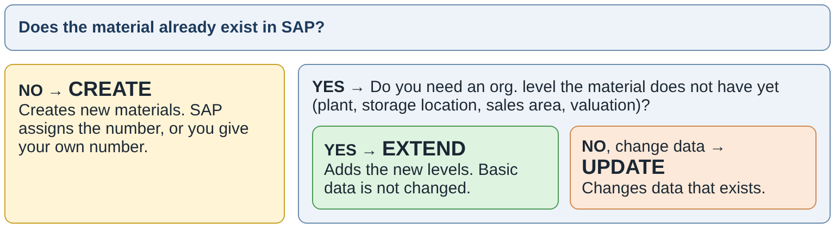
Figure 1 - Which operation do I need?

1.3 Before you read on
NOTE - How to use this guide
Chapters 2 to 6 explain what is the same for all operations: process, selection screen, Excel template and common functions. Read them once.
Chapters 7, 8 and 9 are one chapter per operation (Create, Update, Extend). Each one can be used alone as a step-by-step instruction.
Chapters 10 to 13 explain the result, the messages you can get and what to do about them.

2. The process in short
Every run follows the same six steps. The most important rule of the whole tool: always start with a test run. A test run checks everything, tells you every error and warning, and changes nothing in SAP.
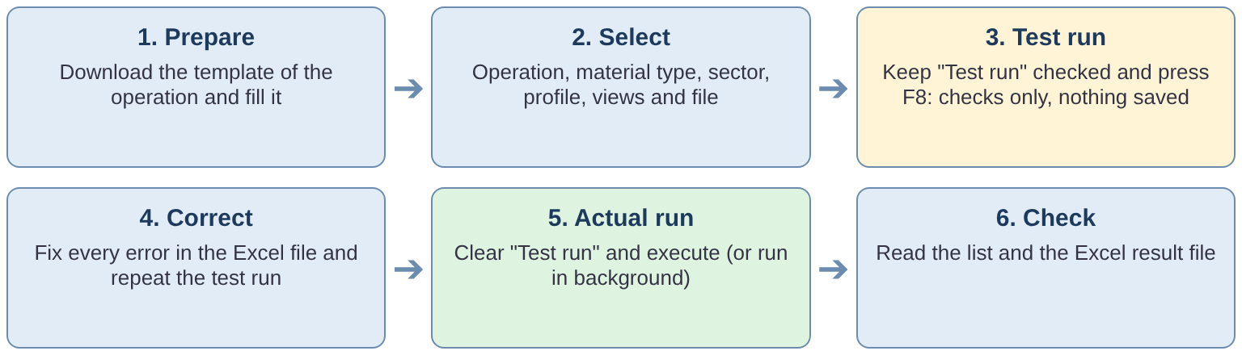
Figure 2 - The six steps of every run

2.1 Test run and actual run
 | Test run (checkbox set) | Actual run (checkbox cleared)
Saved in SAP? | No. SAP simulates the posting and then undoes it. | Yes. Every correct material is saved and committed.
Material numbers | Create without MATNR: temporary numbers TEMPMATNR_<row> are shown. No number is used up. | Real numbers are assigned from the SAP number range.
Output file on server / e-mail | Not created, not sent. If an output path or e-mail is entered, the list says: "Test run - output file on server and e-mail skipped". | Created and sent if an output path and/or e-mail recipient is entered.
Result list | Lines start with "Simulation OK" or "Simulation failed". | Lines start with "Posted" or "Posting failed".
When to use | Always first. Repeat until there are no errors. | Only after a clean test run.

ATTENTION - Test run limits
A test run for Create cannot check everything that depends on a real material. For example the classification of a new material is only checked against the class master ("BAPI simulation needs an existing material"). A few errors can still appear only in the actual run.

2.2 What happens inside the report
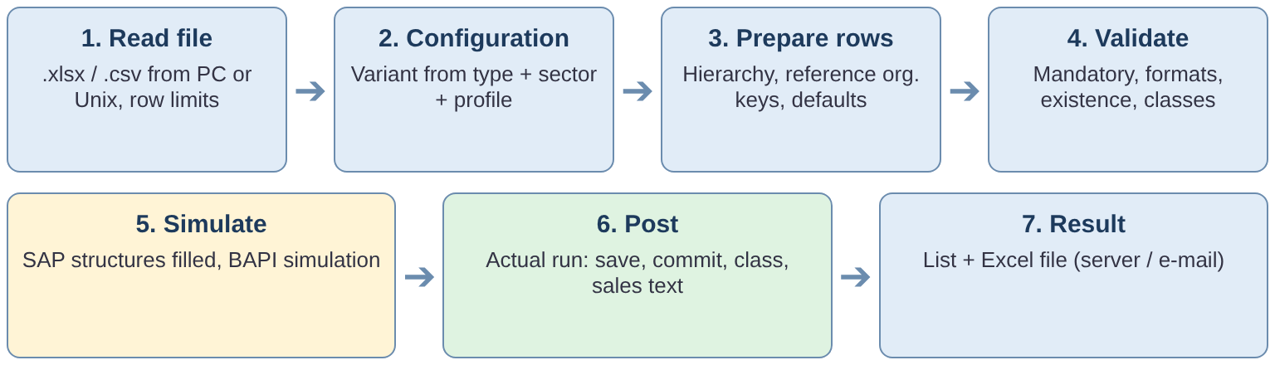
Figure 3 - Processing steps inside the report
- Read file. The report reads the first data sheet of the Excel file (see 5.3) or the CSV file. It stops with an error if the file has more records than allowed (see 5.6).
- Configuration. From material type, industry sector, business profile and operation SAP finds the active variant. The variant tells the report which fields are part of your views and which are mandatory.
- Prepare rows. The product hierarchy is built from the levels, plant / sales area can be taken from the reference material, and default values are added (Create only).
- Validate. Every cell is checked and converted to the SAP format. Mandatory and conditional mandatory fields are checked. For Update and Extend, the existence of the material and its org. levels is checked.
- Map and simulate. The values are placed in the SAP structures. For Create without a material number, SAP first simulates the material with a temporary number.
- Post (actual run only). The material is saved and committed, then the classification, then the sales text. Each material is saved on its own: if one fails, the others are not affected.
- Result. The result list is shown. In an actual run the Excel result file is written and e-mailed.

3. Before you start

3.1 What you need
Requirement | Details
Authorization | Your user must be allowed to run the report and to maintain materials of the material type, plants and sales areas in your file (the same rights as for MM01 / MM02). For a file on the application server you also need file access to the directory. Ask your SAP authorization team if you get an authorization message.
A variant for your case | For each combination of operation, material type, industry sector and business profile the administrators maintain a variant. If a listbox on the selection screen is empty or does not offer your value, the variant does not exist or is not active - contact your administrator.
The Excel template | Use the template for your operation (button Download Template on the selection screen). Do not use an old file from another operation.
Material master data ready | Know your material type, industry sector, business profile, plants, storage locations, sales areas, units, material groups, MRP controllers etc. The report validates values but cannot guess them.
SAP GUI (for a local file) | A file on your PC needs SAP GUI. A local file cannot be used in a background job.

3.2 Where is the report?
Start the report ZMM_MATERIAL_MAINTENANCE with the transaction code your organisation has assigned to it (ask your SAP team or look in your user menu), or with transaction SE38 > program name > Execute (F8).

3.3 Golden rules
- Test first, then run for real.
- One file = one operation. Never mix Create, Update and Extend rows in one file. The ACTION column of every row must match the operation on the screen.
- One material type, one industry sector per run. The values in the file must match the screen.
- Do not change rows 3 and 4 of the template (technical names and descriptions).
- Do not edit a result file and upload it again as input. Create a new file from the template.
- Keep files small. More than 1000 rows must run in background; more than 2000 rows are rejected (see 5.6).

4. The selection screen
The selection screen is the same for the three operations. Only the content of the listboxes changes with the operation. The numbers in the picture are explained in the table below.
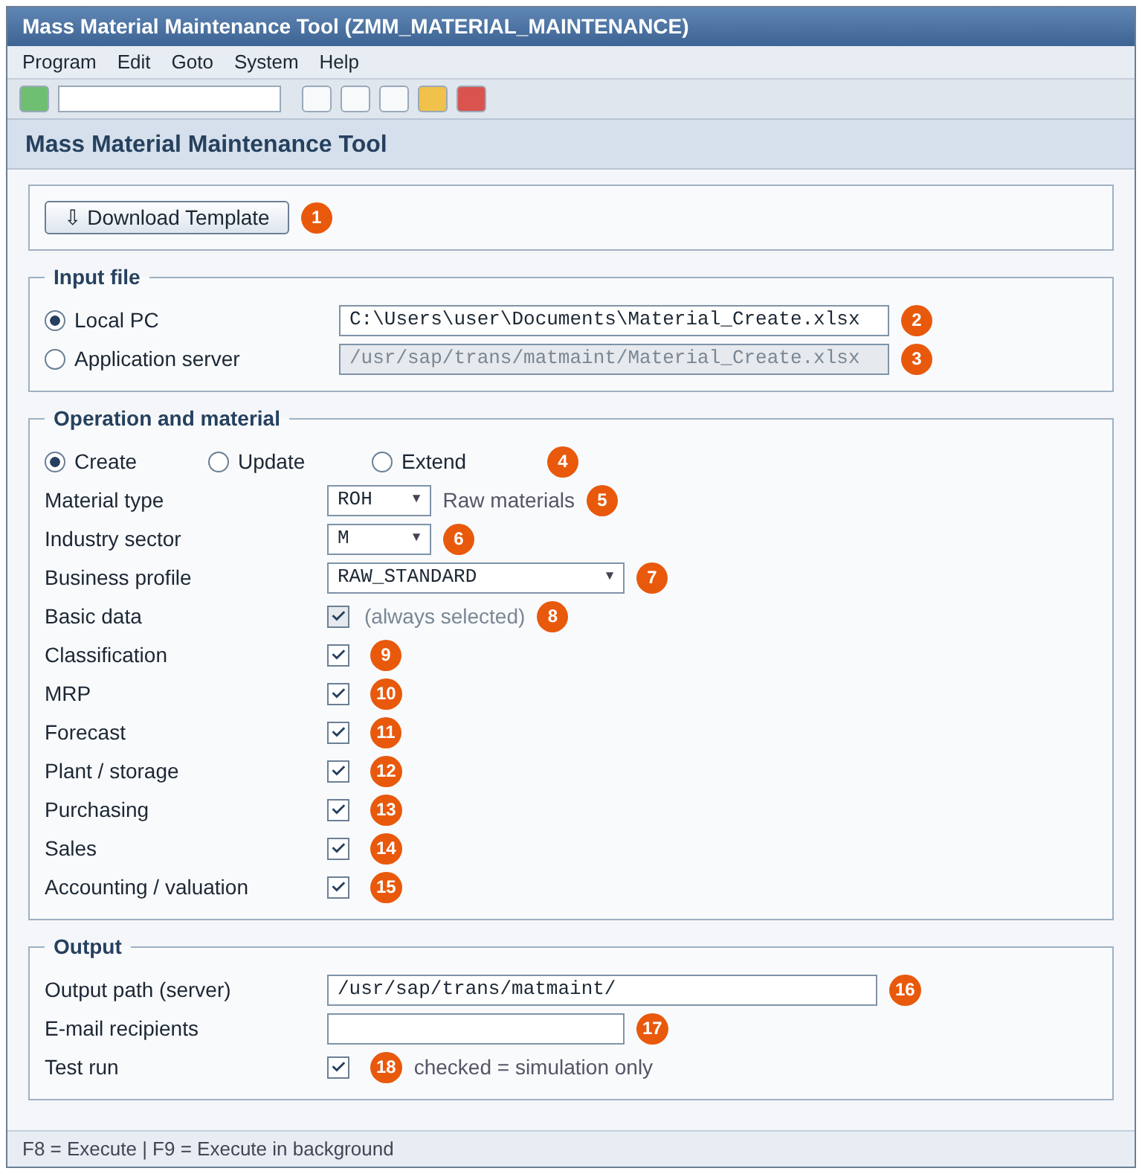
Figure 4 - Selection screen (example: Create, file on local PC)

4.1 Fields and buttons
No. | Field | What to do
1 | Download Template | Downloads the Excel template for the operation selected in 4. A save dialog asks for the folder. The three templates are ZMMCREATE_Create_Template.xlsx, ZMMCREATE_Update_Template.xlsx and ZMMCREATE_Extend_Template.xlsx. If the message "SMW0 object ... not found" appears, the template has not been loaded into SAP - contact your administrator.
2 | Local PC + file path | Select this to read a file from your PC. Press F4 for a file dialog (filter .xlsx / .csv). Not possible in background.
3 | Application server (Unix) + file path | Select this to read a file that is stored on the SAP application server, e.g. /usr/sap/trans/matmaint/Material_Create.xlsx. The path is case-sensitive. Needed for background runs. The field of the option you did not select is greyed out.
4 | Create / Update / Extend | The operation. Changing it clears the listboxes below if the old value is not valid for the new operation.
5 | Material type | Listbox. Shows only material types for which an active variant exists for the operation. Mandatory.
6 | Industry sector | Listbox. Depends on the material type. Mandatory.
7 | Business profile | Listbox. Depends on material type and industry sector. The profile decides which fields are part of the file and which are mandatory. Mandatory.
8 | Basic data | Always selected, cannot be changed.
9 | Classification | Process class assignment and characteristic values (columns CLASS_TYPE, CLASS_NAME, CHAR_NAME_n, CHAR_VALUE_n).
10-11 | MRP, Forecast | MRP data and forecast data of the plant.
12 | Plant / storage | Plant data and storage location data (e.g. storage conditions, storage location).
13 | Purchasing | Purchasing data (e.g. purchasing group).
14 | Sales | Sales organisation data, tax classification and the sales text. Needs VKORG and VTWEG in the file.
15 | Accounting / valuation | Valuation data (e.g. valuation class, price control, prices). The valuation area is the plant of the row.
16 | Output path (server) | Directory (ending with /) or a complete file name on the application server where the result file is stored. Optional. Used in an actual run only.
17 | E-mail recipients | One or more e-mail addresses (single values only). The result file is sent as an attachment. Optional. Actual run only.
18 | Test run | Set = simulation only, nothing saved. Set by default.

ATTENTION - Views you did not select
Columns of a view that is not selected are not processed - even if you filled them. Select exactly the views whose columns are in your file. If you extend a material to a new plant, select at least Plant / storage and the views you need there (for example Purchasing, MRP, Accounting).

4.2 Executing the report
- F8 (Execute) runs the report in the dialog (foreground).
- F9 (menu Program > Execute in Background) schedules a background job. Use it for larger files (more than 1000 rows) and read the file from the application server.
- Before the run the report checks the screen. You get an error in the status bar when: material type, industry sector or business profile is missing; no view is selected; no file path is entered; the file is not .xlsx or .csv; an e-mail address is invalid or is not a single value.

4.3 The screen for each operation
The screen looks the same. These examples show the other two operations. In the Extend example the file is read from the application server and an e-mail recipient is entered.
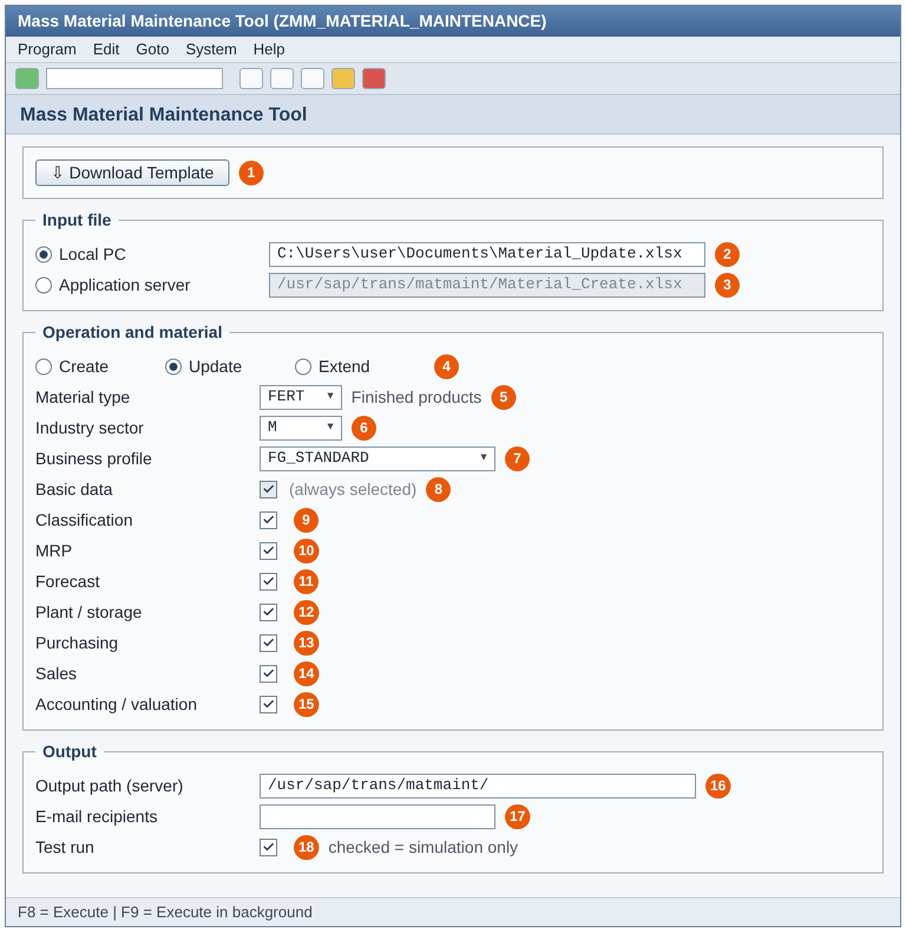
Figure 5 - Selection screen for Update (file on local PC)
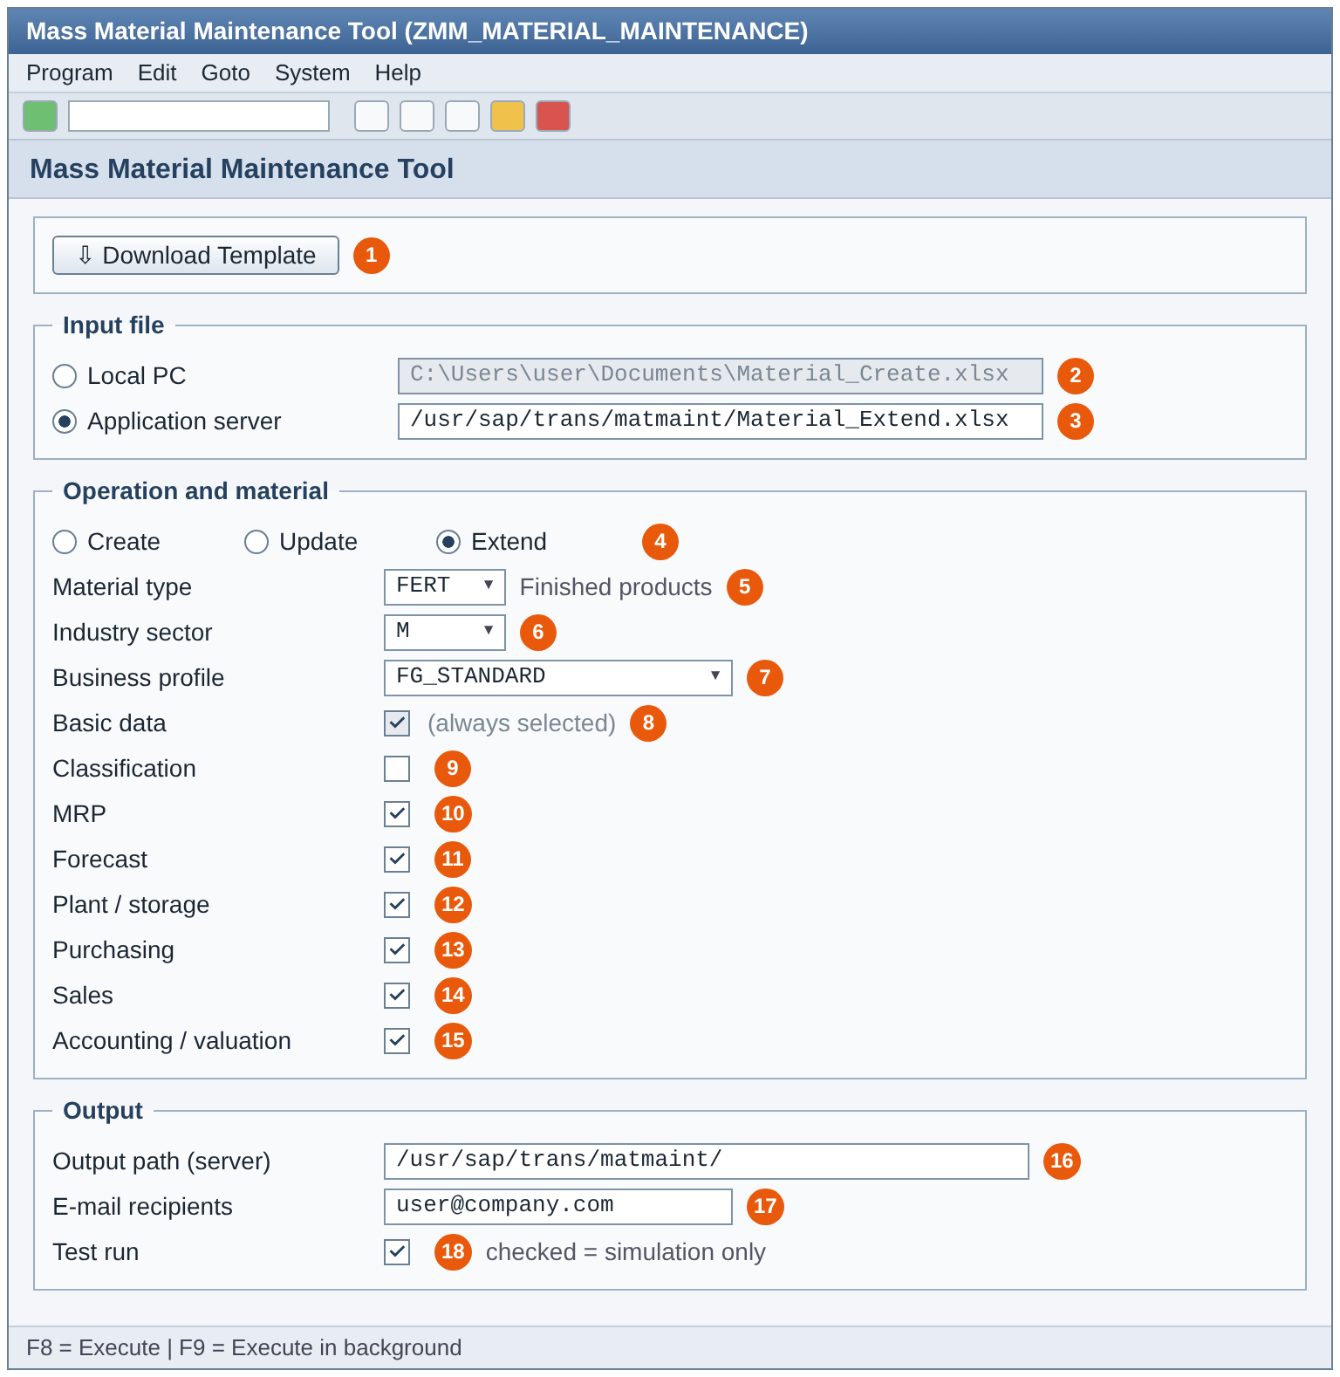
Figure 6 - Selection screen for Extend (file on application server, e-mail entered)

5. The Excel template

5.1 Layout of the sheet
The program reads a fixed layout. Do not insert or delete rows above the data.
Row | Content | Notes
1-2 | Title and instruction text | Free text, ignored by the program.
3 | Technical field names (ACTION, MATNR, MAKTX, ...) | The program finds each column by this name. Never rename it. The order of columns does not matter. Empty headers and the column MESSAGE are ignored. If a name appears twice, the first column is used and a warning is shown.
4 | Field descriptions | For you only, ignored by the program.
5 ... | Data rows | One row per material and organisational level. Completely empty rows are skipped.

5.2 Types of columns
A template contains three kinds of columns.

Control columns
Column | Meaning
ACTION | C / CREATE, U / UPDATE / CHANGE or E / EXTEND. If filled, it must match the operation on the screen, otherwise the row gets an error. Leave empty if you do not need it.
MATNR | Material number. Create: empty (SAP assigns it) or your own number. Update / Extend: mandatory.
REFERENCE_MATNR | Material to copy values from (see 6.1).
REF_WERKS, REF_LGORT, REF_VKORG, REF_VTWEG | Plant, storage location, sales organisation and distribution channel of the reference material to copy from (see 6.1).
REF_EKORG | Not supported. If filled, it is ignored with a warning (purchasing organisation data is not part of the SAP function used).
COPY_BASIC, COPY_PURCH, COPY_MRP, COPY_FRCST, COPY_SALES, COPY_ACCOUNTING, COPY_CLASS | Select which views are copied from the reference material. Enter X (also Y, YES, 1, TRUE work). No flag = all views selected on the screen.
SALES_TEXT | Sales text of the sales area (see 6.7).
MESSAGE | Ignored. You may use it for your own notes.
PROCESS_PROFILE, DEFAULT_MODE | Reserved columns. They are accepted but not used.

Organisational key columns
Column | Meaning
WERKS | Plant. A row with a plant maintains the plant data (and valuation, because the valuation area is the plant).
LGORT | Storage location (belongs to the plant of the row).
VKORG, VTWEG | Sales organisation and distribution channel = sales area.
Others | e.g. warehouse number and storage type, if they are part of your business profile.

Data columns
All other columns are material master fields (for example MAKTX description, MEINS base unit, MATKL material group, BRGEW gross weight, DISMM MRP type, DISPO MRP controller, EKGRP purchasing group, BKLAS valuation class). The list of fields depends on your business profile and on the views you selected. Fields that are mandatory for your profile must be present and filled.

Special column groups
Columns | Purpose
PRODH_LVL1 ... PRODH_LVL5, PRDHA | Product hierarchy (see 6.5).
CLASS_TYPE, CLASS_NAME, CHAR_NAME_1, CHAR_VALUE_1, CHAR_NAME_2, CHAR_VALUE_2 ... | Classification (see 6.6). Pairs can be continued with any number.
PO_TEXT | Purchase order text (see 6.7).
SALES_TEXT | Sales text (see 6.7).

5.3 Which sheet is read?
A workbook can have several sheets. The program uses this rule:
- More than one sheet: the second sheet is the data sheet. The first sheet (for example instructions) and all other sheets are ignored.
- Only one sheet: that sheet is the data sheet.
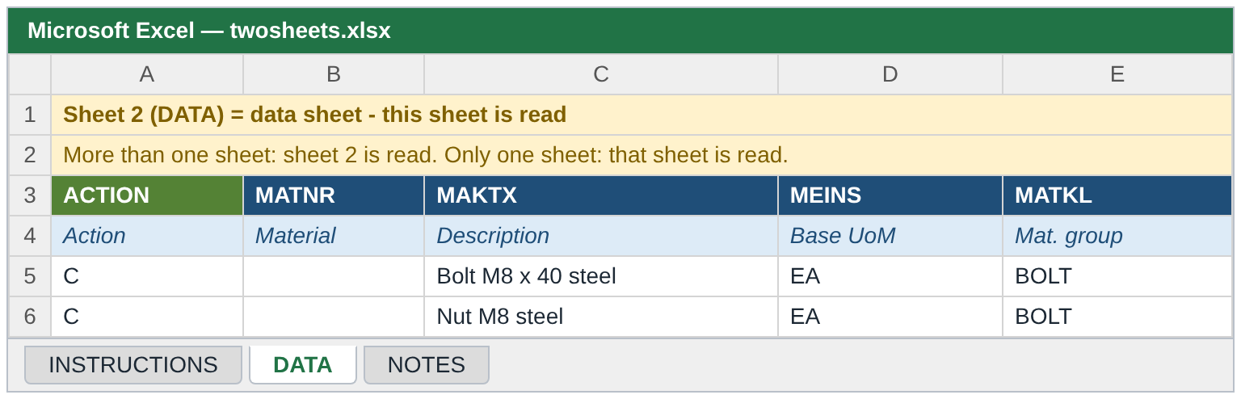
Figure 7 - A file with several sheets: sheet 2 (DATA) is read
ATTENTION - Check the sheet order
If you save a file that still contains the template instruction sheet in the wrong position, the program may read the wrong sheet. If you see "template contains no data rows" or many unknown-field errors, check which sheet is second.

5.4 How to enter values
Type | Rule | Example
Text | Enter the SAP value exactly. Leading and trailing blanks are removed. Key values (material number, plant, org. keys) are converted to capital letters. | BOLT, 1000
Numbers with decimals | Use a decimal point (0.015). A decimal comma (12,5) is also understood. Thousands separators are removed. Do not add units. | 0.015
Dates | Use your SAP user date format, YYYYMMDD, or a normal Excel date. Exception: the material status valid-from dates MSTDV and VMSTD must be YYYYMMDD. | 20261031
Codes with conversion | Material numbers, units and similar codes are converted by SAP (leading zeros, unit codes). You can enter them as you see them in SAP. | EA, KG
Long text | One text line, maximum 132 characters per cell.
Empty cell | Create: field stays empty (or gets a default, see 6.2). Update: the existing value is not changed. Extend: nothing is sent for the field.
Formulas | Enter values, not formulas, in cells that SAP reads. Save the file before you use it.

5.5 One row = one material and one org. level
The data rows of one material belong together. The material number (MATNR) links the rows.
- A material in two plants needs two rows with the same MATNR and a different WERKS. Data of the basic data level (description, base unit, ...) can be given in either row; if several rows give the same field, the values must be identical.
- A material in two sales areas needs two rows with the same MATNR and different VKORG / VTWEG.
- Fields that belong to the plant (MRP type, purchasing group, valuation class, ...) are taken from the row that has the plant.
- Create without a material number: every row is treated as a separate new material, because SAP cannot know that two rows belong together. To create one material in several plants in a single file you must enter the same material number in all its rows (external numbering). Alternatively, create the material first with one plant, then use Extend for further plants.

5.6 File format and number of records
Topic | Rule
Formats | .xlsx (recommended) or .csv. CSV: separator ;, , or tab is detected from the header line. Save CSV files as UTF-8 if they contain special characters. Other formats (.xls, .txt) are rejected.
Up to 1000 rows | Can run in the foreground (dialog) and in the background.
1001 to 2000 rows | Foreground: the run stops with the error "... can not be processed in foreground, please run in background". Background: allowed. The file must be on the application server.
More than 2000 rows | Error in foreground and background ("maximum is 2000 ... split the file"). Nothing is processed. Split the file into several files.
What is counted | Data rows with at least one filled cell (empty lines are not counted). The limits are set per operation by the administrators and are currently the same for Create, Update and Extend.

5.7 Local PC or application server?
 | Local PC | Application server (Unix)
Where is the file? | On your computer | On the SAP application server, e.g. /usr/sap/trans/matmaint/
Background job | Not possible | Possible
How to select | F4 file dialog | Type the full path (case-sensitive). Needs file access rights
Typical use | Small files, quick tests | Large files, scheduled runs

IMPORTANT - Upload Excel files to the server in binary mode
An Excel file is a compressed (zip) file. If you copy it to the application server (for example with transaction CG3Z) choose the transfer format Binary (BIN). With ASCII (ASC) the file is changed during the copy and the program cannot read it: you get the message "File is not a valid XLSX file" or "A BRFplus exception occurred". Copy the file again in binary mode. Check that the file size on the server is the same as on your PC.
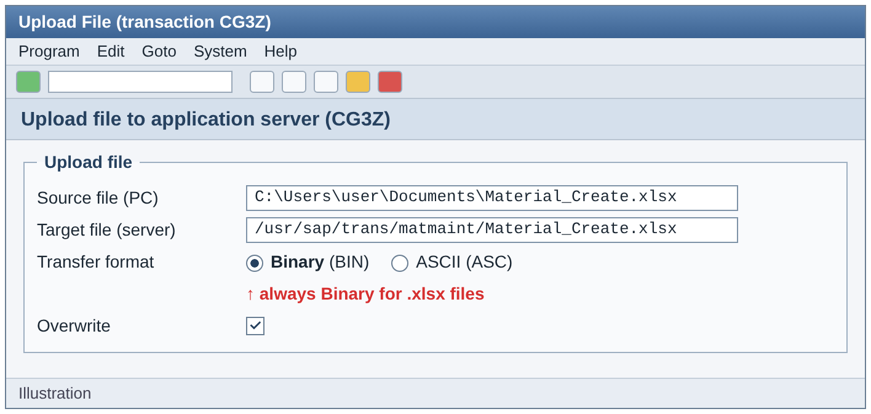
Figure 8 - Upload with transaction CG3Z: choose Binary (BIN) (illustration)
CSV files are plain text and are not damaged by the text transfer (ASC), but should be saved as UTF-8.

6. Functions for all operations

6.1 Reference material (copy from an existing material)
If many materials are similar, you do not have to fill every field. Enter a reference material and the report copies the field values from it. In the file you only enter what is different.
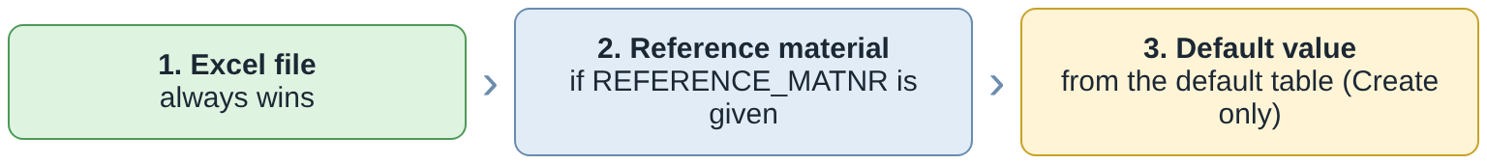
Figure 9 - Priority of the values
How it works
- Enter the existing material in REFERENCE_MATNR.
- Choose the organisational level of the reference with REF_WERKS (plant), REF_LGORT (storage location), REF_VKORG and REF_VTWEG (sales area). If you leave them empty, the plant / sales area of the row itself is used for the reference. The valuation area of the reference is its plant.
- Choose the views to copy with the flags COPY_BASIC, COPY_PURCH, COPY_MRP, COPY_FRCST, COPY_SALES, COPY_ACCOUNTING, COPY_CLASS (enter X). If you set no flag, all views selected on the screen are copied.
- If the plant, sales organisation or distribution channel of the new row is empty, it is taken from REF_WERKS, REF_VKORG, REF_VTWEG ("Plant 1000 taken from REF_WERKS").
What is copied
- All fields of the selected views that belong to your business profile, except organisational keys (plant, storage location, sales area, valuation area), which are never copied.
- Material descriptions per language, alternative units of measure (only if the base unit is the same), long texts (the purchase order text goes with the purchasing view, the others with basic data) and tax classifications per country.
- The classification: the class and the characteristic values that are not given in your file.
- The European article numbers (EAN) are never copied, because they must be unique per material.
Checks. The reference material must exist (MARA). If its material type differs from the screen, you get a warning. For each view the report checks that the reference has data at the chosen plant / sales area / valuation area. If a view was requested explicitly with a flag and the data is missing, the row gets an error. If no flag was set, you get a warning and the view is simply not copied.
TIP - Good practice
Use a reference that is fully maintained for the plant and sales area you copy from. Always check the log lines "Reference ... copied for view(s) ...".

6.2 Default values
For Create only, the administrators can maintain default values for fields in the table ZTMM_DEFLT_DATA. A default is used only if the field is empty in your file and was not copied from the reference material. The log shows "Value ... for ... taken from default table ZTMM_DEFLT_DATA". Defaults are not used for Update or Extend.

6.3 Status dates and unit lines
- Material status valid-from dates (MSTDV at client level, VMSTD at sales level): for Create, if the field belongs to your profile and is empty (no file value, no reference, no default), today's date is set ("Current date ... set for blank field ..."). A value you enter must be YYYYMMDD.
- Units of measure: if an alternative unit line has no unit, numerator or denominator, the report sets unit = base unit and numerator = denominator = 1 (log message "missing unit / numerator / denominator set").

6.4 Descriptions and languages
A material description given without a language is saved in the language of your SAP logon. Descriptions in other languages can be given by the columns of your template or copied from the reference material.

6.5 Product hierarchy
Enter either the complete product hierarchy in PRDHA, or the levels in PRODH_LVL1 to PRODH_LVL5. The report builds PRDHA from the levels and pads each level to the length defined in table T179.
- Levels must be filled without gaps (level 3 without level 2 = error).
- A level value longer than its position in the hierarchy = error.
- If PRDHA and the levels are both given and differ, PRDHA is used and a warning is shown.
- The resulting hierarchy must exist in T179 ("Product hierarchy ... does not exist").

6.6 Classification
Classification (class assignment and characteristic values) is done with these columns. The checkbox Classification (9) must be set.
Column | Meaning
CLASS_TYPE | Class type, e.g. 001. If empty, 001 is used.
CLASS_NAME | Class. Must exist for the class type.
CHAR_NAME_1, CHAR_VALUE_1 | Characteristic and its value (first pair). Continue with CHAR_NAME_2 / CHAR_VALUE_2, CHAR_NAME_3 ... for more. A name always needs a value and a value always needs a name.
Checks: the class exists; every characteristic belongs to the class (or a superior class); the value is allowed in the value list of the characteristic; the format (character, numeric, currency, date) and the length are correct; a single-value characteristic has only one value; rows of the same material do not give different values for the same single-value characteristic.
When it is saved: the classification is saved after the material. If it fails, the material stays saved without classification and the log says "Material saved without classification ... - correct the class data and classify it with Update". Fix the class data and run an Update with only the classification columns. In a Create test run the class data is checked against the class master only.

6.7 Texts

Purchase order text (PO_TEXT)
Enter the text in the column PO_TEXT. It is saved as the material purchase order text (text ID BEST). One line, maximum 132 characters. Longer text gives the error "Long text has N characters - maximum is 132".

Sales text (SALES_TEXT)
Enter the text in SALES_TEXT. It is saved as the sales text of the sales area (text object MVKE, text ID 0001).
- The row must have VKORG and VTWEG, and the checkbox Sales must be set. Otherwise: "SALES_TEXT needs sales organization (VKORG) and distribution channel (VTWEG)" or "... sales view is not selected".
- A line break in the Excel cell (Alt+Enter) becomes a new line in the text. Long lines are wrapped at 132 characters.
- The text is saved after the material was posted. The sales area must exist at that time; otherwise the error "Sales text not saved - sales area ... does not exist for the material" appears.
- An existing sales text of the same sales area is replaced.
- In a test run nothing is saved; the log only says "sales text ... checked, not saved in a test run".

6.8 Mandatory and conditional mandatory fields
- Mandatory fields of your business profile must be a column of the file and must be filled in every row (a value copied from the reference or a default counts as filled). Messages: "<FIELD> (<description>) is mandatory" and "Mandatory field is not a column of the template".
- Conditionally mandatory: the administrators can define "if field A is filled, then field B is mandatory". Message: "<B> (<description>) is mandatory when <A> (<description>) is maintained".
- A mandatory field that belongs to the basic data (client level) needs to be filled only in one row of the material.

7. Operation CREATE - create new materials

7.1 When to use Create
Use Create when the materials do not exist yet. The report creates the material with its basic data and with the organisational levels (plants, storage locations, sales areas, valuation) that are in your file.
NOTE - Create or Extend?
If the material already exists and you only need it in another plant or sales area, use Extend (chapter 9). Create gives the error "Material already exists - use Update or Extend" for an existing material.

7.2 Prerequisites
- An active variant exists for Create, your material type, industry sector and business profile (the listboxes offer your values).
- The number range of the material type allows what you want: internal numbering (MATNR empty) or external numbering (your own number).
- All master data you use exists: material group, base unit, plant, storage location, purchasing group, MRP controller, valuation class, sales organisation, distribution channel, class and characteristics, etc.
- The Create template is downloaded and filled (7.4).

7.3 Step by step
- Start the report. On the selection screen select Create (4).
- Press Download Template (1) and save the Create template. (Skip this if you already have one.)
- Fill the template from row 5 (see 7.4). Save it as .xlsx.
- Select the file: Local PC (2) and press F4, or Application server (3) and enter the path. (The numbers refer to Figure 4.)
- Select Material type (5), Industry sector (6) and Business profile (7).
- Select the views you filled in the file (9 to 15). Basic data is always selected.
- Keep Test run (18) checked. Optionally enter an output path (16) and an e-mail recipient (17); they are used only in the actual run.
- Press F8. Read the result list (chapter 10). The red lines are errors.
- Correct the file for every error, save it and repeat from step 8 until the test run has no error.
- Clear the Test run checkbox and press F8 again (or F9 for a background job with a file on the application server).
- Check the result list: "Posted ..." lines show the new numbers ("Internal material number ... assigned"). Open the Excel result file if you entered a path or e-mail. Sheet MATERIAL_DATA shows the data of the created materials.

7.4 Filling the Create template
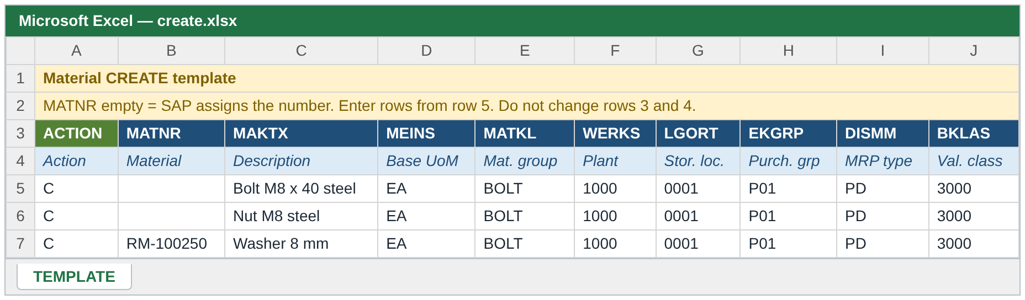
Figure 10 - Create template with three example materials (illustration)
Row | What it does
5 | No material number: SAP assigns the number. A new material "Bolt M8 x 40 steel" with base unit EA and material group BOLT, in plant 1000 with storage location 0001, purchasing group P01, MRP type PD and valuation class 3000. (The real template has more columns for the other fields of your profile, for example weights, MRP controller and prices.)
6 | Same, for "Nut M8 steel". It is a separate new material (no number given = separate material).
7 | The material number RM-100250 is given: external numbering. This works only if the number range of the material type allows this number and the material does not exist.

Rules for Create files
- Fill every field that is mandatory for your profile in every row (or in one row for basic data fields).
- Fill MTART / MBRSH only if you want to repeat the screen values; they must be identical to the screen.
- ACTION = C (or empty).
- Every row with a plant (WERKS) creates the plant data and the valuation data for that plant. Storage location, purchasing, MRP, accounting data of the plant come from the same row.
- A row with VKORG and VTWEG creates the sales data for that sales area (select Sales).
- You may use REFERENCE_MATNR to copy the fields from a similar material (6.1) and default values are added automatically (6.2).

7.5 Material numbers in Create
 | MATNR empty (internal numbering) | MATNR filled (external numbering)
Number | Assigned by SAP from the number range of the material type (function BAPI_MATERIAL_GETINTNUMBER). Shown in the log: "Internal material number 100245 assigned". | Your number is used. It must not exist and must be allowed by the number range.
Test run | Temporary number TEMPMATNR_<row>. No real number is used. | Your number.
Several rows of the same material | Not possible - every row is a new material. | Rows with the same number belong together (plants, sales areas).

Protection of your number range
In an actual run, for materials without a material number, the report protects the number range: it first runs a simulation with a temporary number. Only if the simulation has no error does it draw the real number and save the material. A material that would fail therefore does not use up a number.
ATTENTION - Numbers can still be lost in rare cases
If the real posting fails although the simulation was correct (for example a lock, or a change in the system in between), the number is already drawn and stays unused - a gap in the number sequence. Gaps in number ranges are normal in SAP.

7.6 Example with a reference material
You want to create a new material like RM-100100 in plant 1000. The file only needs the differences:
ACTION | MAKTX | WERKS | REFERENCE_MATNR | REF_WERKS | COPY_PURCH | COPY_MRP
C | Bolt M10 steel | 1000 | RM-100100 | 1000 | X | X

Purchasing and MRP fields are copied from RM-100100 (plant 1000); the description comes from the file. Add COPY_ACCOUNTING = X to copy the accounting fields as well. Basic data fields that are mandatory but not copied (COPY_BASIC not set) must still be in the file or come from defaults. If you set no COPY_* flag at all, all selected views are copied.

7.7 What is checked in Create
Check | Result
The file layout and the number of records | Error and stop if the file is empty or too large (5.6).
Variant for operation + type + sector + profile | Error "No active variant ..." if none exists.
ACTION, MTART, MBRSH of every row | Error if different from the screen.
Material number | Error "Invalid material number" for a wrong format; error "Material already exists - use Update or Extend" if it exists.
Mandatory / conditional mandatory fields | Error per field and row.
Values: format, length, conversion | Error "Value ... exceeds maximum length ...", "... must be numeric", "Invalid date ...", "... rejected by conversion exit ...".
Reference material | Errors / warnings as in 6.1.
Product hierarchy, classification, texts | Errors as in 6.5, 6.6, 6.7.
SAP check (simulation) | SAP messages are shown as [ID/number] text. They are SAP's own standard messages.

7.8 Result of a Create run
The pictures show the most important columns of the list; the real list has all columns described in 10.1.
Test run without error. Every line is green. Material numbers are temporary.
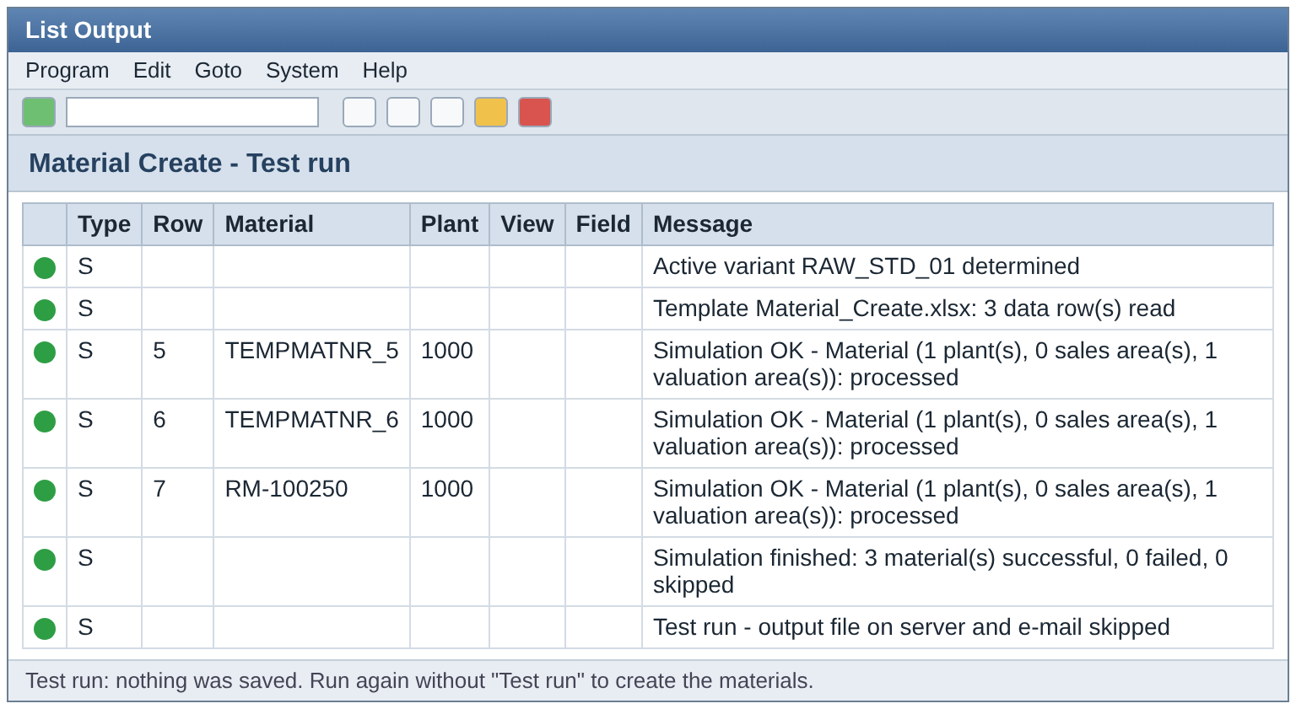
Figure 11 - Create, test run without errors (illustration)
Test run with errors. Red lines are errors, yellow lines are warnings. When one row of a material has an error, the whole material is skipped; nothing is posted for it.
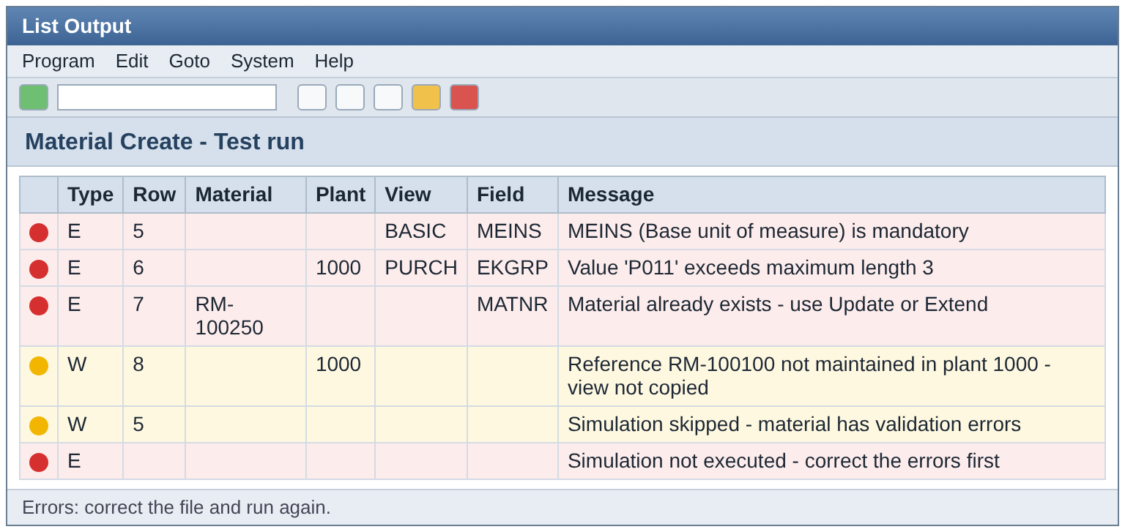
Figure 12 - Create, test run with errors (illustration)
Actual run. "Posted" lines show the real material numbers. One material failed in the classification: it is saved, the class assignment must be repeated with Update.
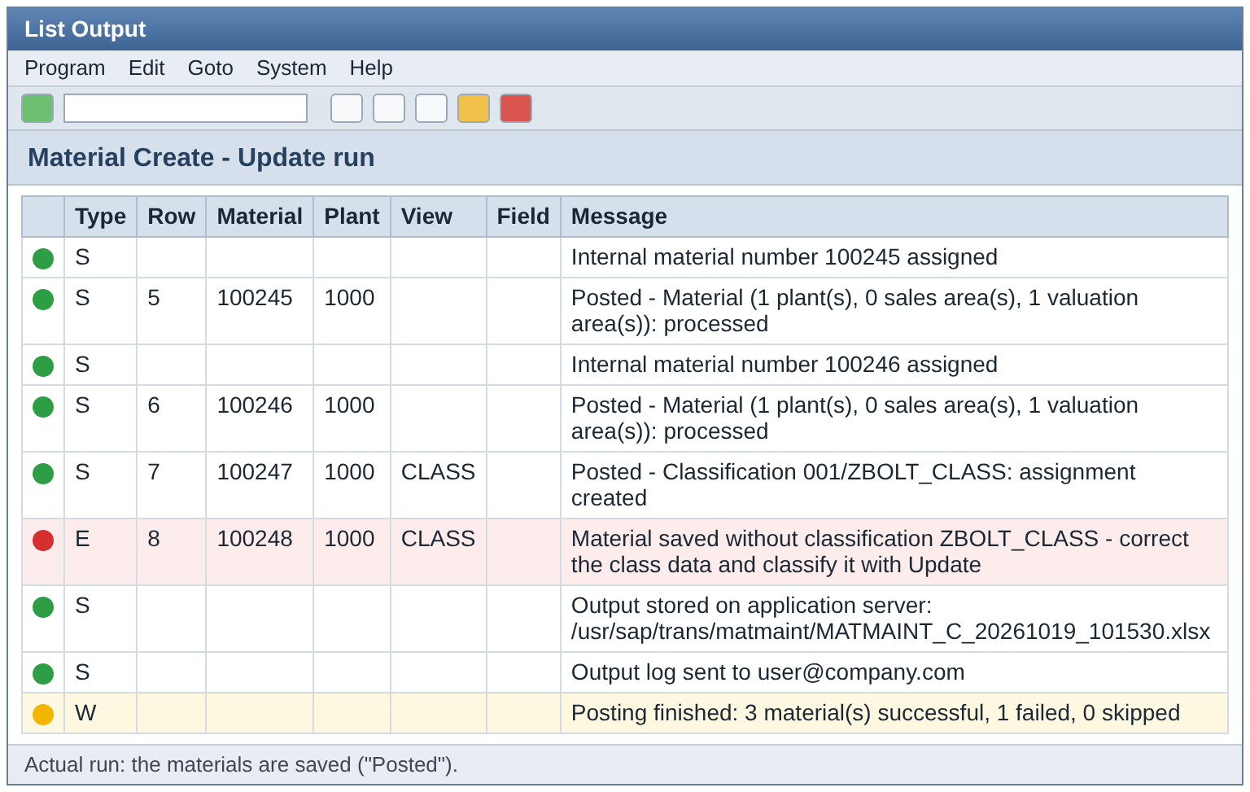
Figure 13 - Create, actual run (illustration)

7.9 Typical Create problems
Message | Cause | What to do
Material already exists - use Update or Extend | The number in MATNR exists. | Remove the row, or use Update / Extend.
<FIELD> (<description>) is mandatory | A mandatory field is empty in the row. | Fill the cell, or ask for a default value / use a reference material.
Mandatory field is not a column of the template | The column is missing from the file. | Download a new Create template and add the column.
Material type X differs from selection Y | MTART in the file is not the type chosen on the screen. | Correct the file or the screen. One type per run.
Value ... exceeds maximum length n | Text is too long. | Shorten the value.
Reference ... not maintained in plant ... - view not copied | The reference material has no data at that plant. | Use another REF_WERKS or reference material.
Simulation with a temporary number failed (no material number was drawn) | SAP found an error in the simulation. The SAP messages are shown in the lines above. | Correct the data. No number was lost.

7.10 Create checklist
- Operation Create selected, Create template used, ACTION = C or empty
- MATNR empty or a free external number; several rows of one material have the same MATNR
- All mandatory fields filled; master data values exist; one material type per file
- Views selected = columns filled; reference columns correct
- Test run without errors; actual run executed; result checked

8. Operation UPDATE - change existing materials

8.1 When to use Update
Use Update to change data of materials that already exist: description, material group, weights, MRP controller, purchasing group, prices, classification values, texts and so on. You only fill the fields that you want to change.
ATTENTION - An empty cell does NOT clear a field
In Update, a cell without a value means "do not change". The report cannot delete or blank out a value. Use transaction MM02 to clear a field.

8.2 Prerequisites
- The materials exist, with the material type and industry sector you select on the screen.
- The organisational levels in the file (plant, storage location, sales area, valuation, warehouse) already exist for the material. For levels that do not exist yet, use Extend.
- An active variant exists for Update, your material type, industry sector and business profile.
- The Update template is downloaded and filled.

8.3 Step by step
- Start the report and select Update (4).
- Press Download Template (1) and save the Update template.
- Fill the template from row 5 (see 8.4). MATNR is mandatory in every row. Save the file as .xlsx.
- Select the file (2 or 3), the material type (5), industry sector (6) and business profile (7).
- Select the views whose columns you filled.
- Keep Test run checked and press F8.
- Read the list (chapter 10), correct the file and repeat until there is no error.
- Clear Test run and run again (F8, or F9 with a server file for large files).
- Check the "Posted" lines and the result file.

8.4 Filling the Update template
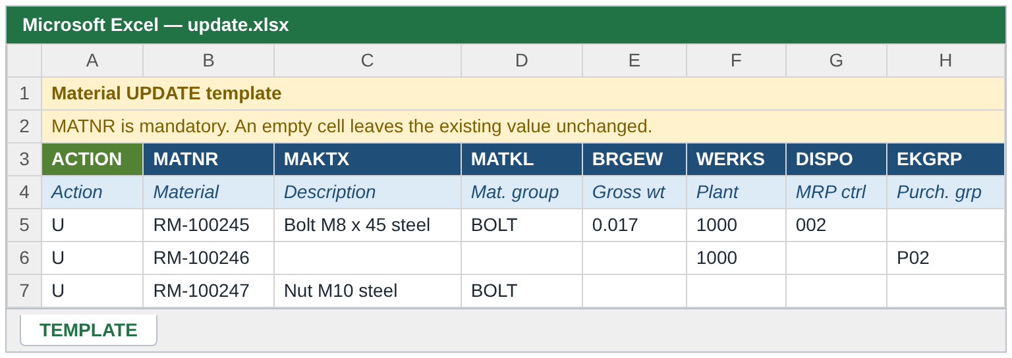
Figure 14 - Update template with three example rows (illustration)
Row | What it does
5 | Changes the description, material group and gross weight of material RM-100245 and the MRP controller of its plant 1000.
6 | Changes only the purchasing group P02 in plant 1000 for RM-100246. All other cells are empty = unchanged.
7 | Changes only description and material group of RM-100247. No plant is given, so no org. level is touched.

Rules for Update files
- MATNR is mandatory. Without it: "MATNR is required for Update / Extend".
- ACTION = U (or UPDATE, CHANGE, or empty).
- Only filled cells are sent to SAP. Empty cells never overwrite existing values.
- Give the plant (WERKS) / sales area (VKORG, VTWEG) of the data you change. It must already exist for the material.
- Default values and the automatic current date are not used in Update.
- If you enter a reference material, the copied fields of the selected views overwrite the existing values. Normally leave the reference columns empty in Update.

8.5 Special topics
- Descriptions: a description is saved in your logon language unless the template column defines the language.
- Classification: the report reads the existing class assignment and keeps its values. Values you enter overwrite the same characteristic; other characteristics stay. To correct a class that failed during Create, run an Update with MATNR, CLASS_TYPE, CLASS_NAME and the CHAR_NAME_n / CHAR_VALUE_n pairs.
- Texts: PO_TEXT replaces the purchase order text. SALES_TEXT replaces the sales text of the sales area (the sales area must exist).
- Several rows for one material: use the same MATNR in each row, one row per plant / sales area.

8.6 What is checked in Update
Check | Result
The material exists | Error "Material does not exist - use Create".
Material type and industry sector of the material | Error "Material has type X - selection is Y" / "Material has industry sector X - selection is Y".
Org. levels in the row exist for the material | Error "Plant 2000 does not exist for the material - use Extend" (also for sales area, storage location, valuation area, warehouse).
ACTION, MTART, MBRSH | Error if different from the screen.
Format, length, mandatory | Mandatory checks apply to the fields you give; fields you leave empty are not required (except where the profile requires a pair of fields).
SAP simulation | SAP messages [ID/number] text are shown.

8.7 Typical Update problems
Message | Cause | What to do
Material does not exist - use Create | Wrong MATNR. | Correct the number or use Create.
MATNR is required for Update / Extend | MATNR empty. | Fill MATNR.
Plant ... does not exist for the material - use Extend | You changed data of an org. level the material does not have. | Run Extend first for that plant / sales area.
Material has type X - selection is Y | The material is of another type than the screen. | Use the correct type on the screen. One type per run.
Characteristic ... is not assigned to class ... | Class data not valid. | Check the class / characteristic names in CL02 / CT04.
Value ... is not allowed for characteristic ... | The value is not in the value list. | Use an allowed value.

8.8 Update checklist
- Operation Update selected, Update template used, MATNR in every row
- Only the cells to change are filled; org. levels exist; material type and sector match
- Reference columns empty (unless you want to overwrite)
- Test run without errors, then actual run; changes checked in MM03

9. Operation EXTEND - add org. levels

9.1 When to use Extend
Use Extend when an existing material must be maintained at a new organisational level:
- a new plant (with its MRP, purchasing, plant / storage and accounting data),
- a new storage location in a plant,
- a new sales area (sales organisation + distribution channel),
- a new valuation area, warehouse number or storage type (if part of your profile),
- a new country for the tax classification.
NOTE - Basic data is not changed
Extend never changes the basic data of the material (description, base unit, weights, units of measure, texts). To change them, use Update. If basic data columns are filled in an Extend file, you only get the warning "Basic data / descriptions / units / texts are not changed by Extend - use Update".

9.2 Prerequisites
- The material exists, with the material type and industry sector you select.
- The new plant / storage location / sales area exists in SAP organisational structure and is allowed for the material type.
- An active variant exists for Extend, your material type, industry sector and business profile.
- You know the values for the new org. level - or you have a reference material that is already extended to a similar plant / sales area (6.1).

9.3 Step by step
- Start the report and select Extend (4).
- Download the Extend template (1) and fill it from row 5 (see 9.4). MATNR is mandatory.
- Select the file, material type, industry sector and business profile.
- Select the views you need at the new level (for example Plant / storage, MRP, Purchasing, Accounting for a new plant; Sales for a new sales area). The classification is normally not needed.
- Keep Test run checked and press F8.
- Read the result. Correct the file until there is no error. Pay attention to the yellow lines (warnings): "already exists - its values will be changed" means the level was already there.
- Clear Test run and run again.
- Check the "Posted" lines and open the material in MM03 for a spot check.

9.4 Filling the Extend template
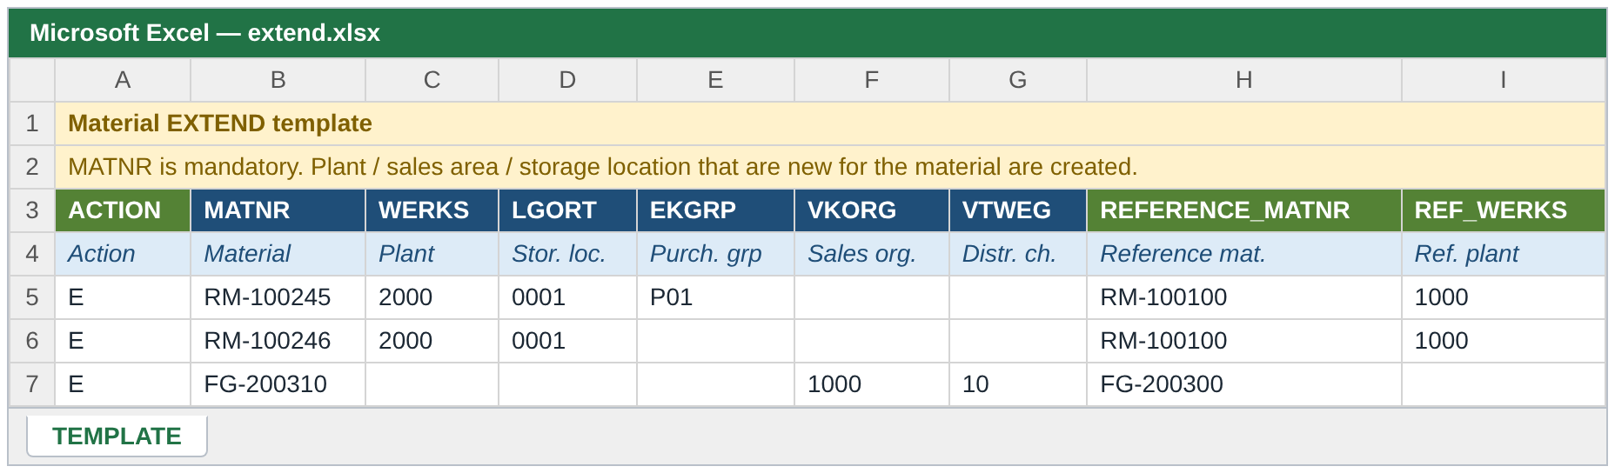
Figure 15 - Extend template with three example rows (illustration)
Row | What it does
5 | Extends RM-100245 to the new plant 2000 with storage location 0001 and purchasing group P01. The reference material RM-100100 with reference plant 1000 is given: the other plant fields (MRP, purchasing, accounting) are copied from it.
6 | Extends RM-100246 to plant 2000 with storage location 0001 and copies everything else from the reference.
7 | Extends FG-200310 to the sales area 1000 / 10. The sales data is copied from the reference FG-200300; the reference sales area is the sales area of the row because REF_VKORG / REF_VTWEG are empty.

Rules for Extend files
- MATNR is mandatory; ACTION = E (or EXTEND, or empty).
- One row per new org. level. A material extended to two plants needs two rows with the same MATNR and different WERKS.
- The valuation area is the plant: a plant row with accounting data creates the valuation data for that plant.
- A mandatory basic-data field does not have to be in the file (basic data is not sent in Extend).
- Default values are not used in Extend. Use a reference material or fill the cells.
- COPY_BASIC is ignored (warning "COPY_BASIC ignored - Extend does not change basic data").
- Tax classifications for new countries are allowed in Extend.

9.5 What is checked in Extend
Check | Result
The material exists | Error "Material does not exist - use Create".
Material type and industry sector | Error if different from the screen.
Basic data columns filled | Warning "Basic data / descriptions / units / texts are not changed by Extend - use Update".
Org. level already exists | Warning "<level> already exists - its values will be changed". The values of the file are written to the existing level.
All org. levels of the row already exist | Error "Nothing to extend - all org. levels of the row already exist (use Update)".
Mandatory fields | Only fields of the new org. level are required; client-level mandatory fields are not required.
SAP simulation | SAP messages [ID/number] text are shown.

9.6 Typical Extend problems
Message | Cause | What to do
Nothing to extend - all org. levels of the row already exist (use Update) | The plant / sales area is already maintained for the material. | Use Update to change values, or remove the row.
Plant ... already exists - its values will be changed | Warning: the level existed. | Check that this is intended.
Material does not exist - use Create | Wrong MATNR. | Correct MATNR.
Reference ... not maintained in plant ... - view not copied | The reference material is not maintained in the reference plant. | Use another reference or fill the values.
<FIELD> is mandatory | A field of the new level is empty and not copied. | Fill it, or use a reference material.

9.7 Extend checklist
- Operation Extend, Extend template, MATNR in every row, ACTION = E or empty
- One row per new org. level; org. keys (plant / sales area) given or taken from REF_*
- Views selected for the new level; reference ready or values filled
- Test run without errors; actual run; check in MM03

10. Reading the result

10.1 The result list on the screen
After every run the report shows the log as a list (an SAP ALV list). You can sort, filter, change the layout and export it with the standard ALV buttons.
Column | Meaning
Status | Traffic light: green = information / success, yellow = warning, red = error.
Type | S success / information, W warning, E error.
Template Row | The Excel row number of the data row. Use it to find the problem in your file.
Material | The material number (real or temporary TEMPMATNR_<row> in a test run).
Plant, Sales Org, Distr. Channel | The org. keys of the row.
View | The view the message belongs to (BASIC, PURCH, MRP, FRCST, PLNTST, SALES, VAL, CLASS).
Template Field | The field (column) the message is about.
Field Description | Description of that field.
Message | The text. SAP's own messages are shown as [ID/number] text.

What each colour means for you
Colour | Meaning | Action
Green (S) | Information or success: "Template ... rows read", "Simulation OK", "Posted ...", "... taken from REF_WERKS". | None.
Yellow (W) | Warning: the row is processed, but something is worth checking (a reference view not copied, a level that already exists, a duplicate column). | Read and decide if it is acceptable.
Red (E) | Error: this material is not processed (and in a run with a global error nothing is processed). | Correct the file and run again.

The summary line
The last line of every run says how many materials were processed, for example: "Posting finished: 3 material(s) successful, 1 failed, 0 skipped". Skipped means the material was not tried because it had validation errors or no number could be assigned.

10.2 What happens when something is wrong
- Error in one row: the whole material (all rows with that MATNR) is skipped with the message "Posting skipped - material has validation errors". Other materials are processed.
- Error that belongs to no row (no variant, file unreadable, too many records, no data rows): nothing is processed. The last line says "Simulation not executed - correct the errors first" or "Posting not executed - correct the errors first".
- SAP error during posting: the material is rolled back. For further rows of the same material the message "Remaining rows of this material not posted after the error" is shown.
- Classification error after posting: the material is saved; the log says "Material saved without classification ...". Correct it with an Update (6.6).

10.3 The Excel result file
In an actual run, the report writes the result as an Excel file to the application server (if an output path was entered) and/or sends it by e-mail (if recipients were entered). In a test run neither happens.
 | Content
File name | MATMAINT_<C|U|E>_<date>_<time>.xlsx, for example MATMAINT_C_20261019_101530.xlsx. If the output path is a directory (ends with /) the name is created automatically.
Sheet 1: ALV_OUTPUT | The result list exactly as shown on the screen.
Sheet 2: MATERIAL_DATA | The data of the successfully processed materials, one line per processed row: Row Number, Material Number, and then every field with a value that SAP returns for the material (client data, plant data, MRP / forecast / planning data, valuation, sales data, descriptions, units of measure, EANs, texts, tax classification) and the classification. The column headers are the field descriptions. A column is shown only if at least one material has a value in it.
Test run | No file is written and no e-mail is sent.

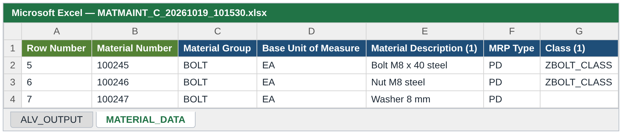
Figure 16 - Sheet MATERIAL_DATA of the result file (illustration)
Column names in sheet 2
- Table lines are numbered, e.g. Material Description (1), (2) for more languages.
- Classification: Class (1) is the class, Class type (1) its type, and one column per characteristic (header = characteristic description). Several values of one characteristic are separated by ;.
- If two columns have the same description, the technical name is added in brackets so that they can be told apart.
TIP - Use sheet 2 to check your work
Sheet 2 shows what SAP really stored - not what you sent. Compare it with your input file after a Create or Extend. A value that is empty in sheet 2 although you filled it was not saved by SAP.

10.4 The e-mail
The e-mail has the subject "Material maintenance log <date> <time>", a short text with the material type / sector / profile and the number of errors, warnings and successes, and the Excel result file as attachment. If the mail cannot be sent, the list shows the warning "E-mail not sent: ...".

10.5 Running in the background
- Use a file on the application server (option 3).
- Press F9 / Program > Execute in Background and schedule the job. The list is not displayed in a background job; use the output path and/or e-mail to receive the result.
- Use the background run for files with more than 1000 rows (up to 2000).

10.6 After a partly successful run
- Open the result list and note the rows with errors (red) and the materials in "Posting failed".
- Create: remove the rows of materials that were already created from the file (otherwise: "Material already exists"). Correct the failed rows and run again.
- Update / Extend: you can run the whole corrected file again, but it is cleaner to run only the failed rows.
- For "Material saved without classification": run an Update with the classification columns only.

11. Messages and what to do
The most frequent messages, in the order of the processing. ... stands for a value from your file.
Message | Cause | What to do
No active variant in ZTMM_MATMAS_MAST for ... | No variant for this operation, type, sector and profile. | Check the selection or ask the administrator to maintain the variant.
Template contains no data rows | No filled row from row 5, or the wrong sheet is read. | Check the sheet order (5.3) and the data rows.
File ... not supported - only .xlsx and .csv files are allowed | Wrong file type. | Save as .xlsx or .csv.
Local file cannot be read in background - use application server | Background run with a local file. | Put the file on the server and select option 3.
Cannot open file ... | Path wrong / file missing / no authorization on the server. | Check the path (case!), file and authorization.
File is not a valid XLSX file | The file is damaged or not a real .xlsx (e.g. copied to the server in ASCII mode). | Copy again in binary mode (BIN); check the size (5.7).
File has N records - more than 1000 ... please run in background | Foreground run with more than 1000 rows. | Run in background with a server file, or split the file.
File has N records - maximum is 2000 ... split the file | More than 2000 rows. | Split the file.
Duplicate column - first occurrence used | A column name appears twice in row 3. | Delete the duplicate column.
MATNR is required for Update / Extend | MATNR empty. | Fill MATNR.
Row action ... does not match the action selected on the screen | ACTION in the row differs from the operation. | Correct ACTION or the operation. One operation per file.
Material type ... differs from selection ... | MTART / MBRSH in the file differs from the screen. | One type and sector per run.
Invalid material number | Wrong format. | Correct MATNR.
Material already exists - use Update or Extend | Create for an existing material. | Use Update / Extend.
Material does not exist - use Create | Update / Extend for a missing material. | Correct MATNR or use Create.
... does not exist for the material - use Extend | Update for an org. level the material does not have. | Run Extend first.
... already exists - its values will be changed | Extend for an existing org. level (warning). | Check that this is intended.
Nothing to extend - all org. levels of the row already exist (use Update) | All levels of the row exist. | Use Update or remove the row.
Basic data / descriptions / units / texts are not changed by Extend - use Update | Basic data columns filled in an Extend file (warning). | Use Update for these fields.
... is mandatory | A mandatory field is empty. | Fill it, or use a reference / default.
Mandatory field is not a column of the template | The column is missing. | Use the current template.
... is mandatory when ... is maintained | Conditional mandatory rule. | Fill the second field.
Value ... exceeds maximum length n | Too long. | Shorten.
Value ... must be numeric | Letters in a numeric field. | Enter digits only.
Invalid date ... | Date not readable. | Use your user date format or YYYYMMDD.
... is not a valid date - format must be YYYYMMDD | MSTDV / VMSTD not in YYYYMMDD. | Use YYYYMMDD.
Value ... rejected by conversion exit ... | SAP cannot convert the value (e.g. an unknown unit). | Use a valid SAP value.
Long text has N characters - maximum is 132 | PO text too long. | Shorten the text.
PRODH_LVLn is filled but PRODH_LVLm is empty | Gap in the product hierarchy levels. | Fill the levels without gaps.
Product hierarchy ... does not exist (T179) | Unknown hierarchy. | Use an existing hierarchy.
Reference material ... does not exist | Wrong REFERENCE_MATNR. | Correct it.
Reference ... not maintained in plant ... - view not copied | The reference lacks the plant (warning, or error if the COPY flag was set). | Use another reference plant / material.
No reference plant (REF_WERKS / WERKS) - view not copied | No plant to read the reference from. | Fill REF_WERKS or WERKS.
COPY_* flags ignored - no REFERENCE_MATNR given | Flags without a reference. | Fill REFERENCE_MATNR or clear the flags.
Characteristic ... is not assigned to class ... | Wrong characteristic for the class. | Check the class in CL02.
Value ... is not allowed for characteristic ... | Not in the value list. | Use an allowed value.
Characteristic ... allows one value only | More than one value for a single-value characteristic. | Give one value.
SALES_TEXT needs sales organization (VKORG) and distribution channel (VTWEG) | Sales area missing in the row. | Fill VKORG and VTWEG.
Simulation failed / Posting failed - ... | SAP rejected the material. The lines above contain [ID/number] text from SAP. | Read the SAP text, correct the data.
Posting not executed - simulation with a temporary number failed | The pre-check simulation of a Create without MATNR failed. | Correct the data. No number was used.
Material saved without classification ... | Class data wrong. | Correct and run Update (6.6).
Output file not written / E-mail not sent | Path or mail problem. | Check the output path / e-mail address. The materials are saved anyway.

12. Questions and answers
Question | Answer
Can I mix Create, Update and Extend in one file? | No. One file = one operation. Rows with a different ACTION get an error.
Why must I start with a test run? | It finds all errors without changing SAP. A wrong actual run creates real materials and uses real numbers.
I get "Mandatory field is not a column of the template". Why? | The column is missing from your file. Always start from the current template of the operation.
Can I create one new material in two plants in one Create file? | Yes, but you must give the same material number in both rows. Without a number, each row would be a separate material. Or create it in one plant and use Extend.
How do I find the number of the material that was created? | In the log ("Internal material number ... assigned", "Posted") and in sheet MATERIAL_DATA of the result file (column Material Number, row = Excel row).
Can I delete a value with Update? | No. Empty cells are ignored. Use MM02.
Why was nothing posted for my material although only one row had an error? | A material with any error is skipped completely. Fix the error and run again.
My list shows warnings only. Is the file correct? | Yes, warnings do not stop the material. Read them anyway.
Why does my classification fail but the material is saved? | The classification is a separate step after the material. Correct the class data and run Update (6.6).
Can I use the same file again after an actual run? | Not for Create (the materials exist now). Remove the processed rows first.
What is the reference material good for? | It saves typing: similar materials copy their values. The file values always win.
Why does my file work locally but not on the server? | Most often the file was copied in ASCII mode. Copy it in binary mode and compare the size (5.7).
How many rows can I process? | Up to 1000 in the dialog, up to 2000 in the background, more than 2000 is rejected.
What do the red / yellow / green lights mean? | Red = error, yellow = warning, green = information or success (10.1).
Is a test run enough to be sure? | It is very reliable, but a few checks that need a real material (for example the classification of a new material) can only be done in the actual run.

13. Best practices

13.1 Do
- Use the template of the operation and keep rows 3 and 4 unchanged.
- Always run a test run first and repeat it until there are no errors.
- Prepare small batches (for example 200 to 500 rows). Smaller files are easier to correct and to repeat.
- Keep a copy of the file that you used for the actual run together with the result file.
- Use a reference material for similar materials; check the "copied for view(s)" line.
- Spot check a few materials in MM03 after the run, or compare with sheet MATERIAL_DATA.
- Save Excel files as .xlsx and CSV files as UTF-8.

13.2 Do not
- Do not run a large file in the dialog; use the background.
- Do not mix operations or material types in one file.
- Do not rename or delete the technical names in row 3.
- Do not copy Excel files to the server in ASCII mode.
- Do not upload the result file as an input file.
- Do not run the actual run twice with the same Create file.

14. Quick reference

14.1 The three operations at a glance
 | Create | Update | Extend
MATNR | Empty or own number | Mandatory | Mandatory
Material exists | Must not | Must | Must
Org. levels | Created | Must exist | Created (new ones)
Basic data | Created | Changed (filled cells) | Not changed
Empty cell | Empty / default | No change | Nothing sent
Default values | Yes | No | No
Reference material | Yes | Possible (overwrites) | Yes (not COPY_BASIC)
Typical error | Material already exists | Level does not exist - use Extend | Nothing to extend - use Update

14.2 Limits
Item | Limit
Rows in foreground | 1000
Rows in background | 2000 (more = error)
Long text per cell | 132 characters
File formats | .xlsx, .csv
Sheets read | Second sheet if there are several, otherwise the only sheet
Local file in background | Not possible

14.3 Glossary
Term | Meaning
ALV | SAP list with sort, filter and export functions - the result list of the report.
BAPI | Standard SAP function used to save data. The report uses BAPI_MATERIAL_SAVEREPLICA for the material and BAPI_OBJCL_* for the classification.
Variant | The configuration for operation + material type + industry sector + business profile: which fields exist and which are mandatory.
Business profile | A set of fields (and mandatory rules) for a kind of material.
Org. level | Plant, storage location, sales area, valuation area, warehouse - the levels below client level.
Sales area | Sales organisation + distribution channel.
Reference material | An existing material that supplies values.
Test run | A simulation. Nothing is saved.
Internal / external numbering | SAP assigns the number / you give the number.
Application server (Unix) | The SAP server on which files can be stored for background runs.
CG3Z | SAP transaction to upload a file from the PC to the application server.

NOTE - Questions
For problems that are not explained in this guide, send the result list (screenshot or the Excel result file), the input file and the selection you used to your SAP key user / support team.

