[CLIENT NAME]
SAP TECHNICAL SPECIFICATION
Mass Material Maintenance Tool
Create, Update and Extend material masters from an Excel template
Program: ZMM_MATERIAL_MAINTENANCE
Demand / Change request: DMND0025421
October 2026
Version 0.1
Contents
1. Introduction 3
1.1 Document Purpose and Context 3
1.2 Document Outline 3
1.3 Intended Audience and Reading Suggestions 3
1.4 Assumptions 3
2. Overview 4
2.1 Business Requirement 4
2.2 Solution Summary 4
2.3 Scope 4
3. Proposed Design 5
3.1 Development Objects 5
3.2 Program Structure 5
3.3 Selection Screen 6
3.4 Upload Template 7
3.5 Configuration Tables 8
3.6 Processing Logic 9
3.7 Operation Create 10
3.8 Operation Update 10
3.9 Operation Extend 10
3.10 Classification, Texts and Product Hierarchy 10
3.11 Material Number Protection 10
3.12 Output - ALV, Result File and E-mail 11
3.13 Error Handling and Messages 11
3.14 Volume Limits and Performance 11
3.15 SAP Standard Functions Used 12
4. Transaction Code 13
5. Roles 13
6. Testing 14
6.1 High-level Test Scenarios 14
6.2 Unit Test Cases 14
Appendix A. Definitions and Acronyms 15
Appendix B. Document Control and Approval 16
B.1 Responsibilities 16
B.2 Quality Check 16
B.3 Reviewer List 16
B.4 Approvers List 17
B.5 Version Control 17
B.6 Reference Documents 17
B.7 Related Documents 17

1. Introduction

1.1 Document Purpose and Context
This document describes the technical design of the custom report ZMM_MATERIAL_MAINTENANCE (Mass Material Maintenance Tool), developed under demand DMND0025421. The tool lets the material master data team create, update and extend material masters in bulk from one Excel template, using SAP standard BAPIs. Field rules are held in custom configuration tables, so most changes to fields need configuration, not code.

1.2 Document Outline
This document contains the following sections:
- Overview: business requirement, solution summary and scope.
- Proposed Design: development objects, program structure, selection screen, template, configuration tables, processing logic per operation, output, error handling, performance and the SAP functions used.
- Transaction Code: how users start the tool.
- Roles: who may use the tool and the authorisation approach.
- Testing: high-level test scenarios and unit test cases.
- Appendices: definitions and document control.

1.3 Intended Audience and Reading Suggestions
Position | Use of Document
Architects | To understand the solution design and its integration with SAP standard
Development Team | To understand the program structure for build, maintenance and enhancement
Functional / Master Data Team | To understand configuration tables, template and processing rules
Testing Team | To understand the functions and prepare test cases
Release & Support Team | To understand transport objects, dependencies and support topics
Governance Team | To measure the quality and completeness of the document

1.4 Assumptions
ID | Description
1 | The configuration tables ZTMM_MATMAS_MAST, ZTMM_*_DATA, ZTMM_DEFLT_DATA and ZTMM_COND_MAND exist in the system and are maintained by the functional team.
2 | The three upload templates are stored in SMW0 (objects ZMMCREATE_CRT_XLSX, ZMMCREATE_UPD_XLSX, ZMMCREATE_EXT_XLSX).
3 | Users have SAP authorisation for material master maintenance (MM01 / MM02) for the material types and organisational levels they upload.
4 | An application server directory for the result files exists and is writable by the background user.
5 | SAPconnect (SCOT) is configured so that e-mails with attachments can be sent.
6 | Transaction code and role names in this document are proposals and are to be confirmed.

2. Overview

2.1 Business Requirement
The SAP standard transactions MM01 (create) and MM02 (change) maintain one material at a time. For large volumes - new product ranges, plant roll-outs, data corrections - this is slow and error-prone: field rules depend on the person entering the data, errors are found only after posting, and failed postings can use up material numbers.
The material master data team needs a single tool to:
- create new materials in bulk, optionally copying data from a reference material,
- change selected fields of existing materials without touching other fields,
- extend existing materials to new plants, storage locations and sales areas,
- check all data before anything is saved and see a clear log of the result.

2.2 Solution Summary
A custom ABAP report ZMM_MATERIAL_MAINTENANCE reads an Excel template, validates every row against configuration, maps the values to BAPI_MATERIAL_SAVEREPLICA and posts the materials. Classification, purchase order text, sales text and product hierarchy are supported. Each run can be a test run (simulation only) or an actual run.
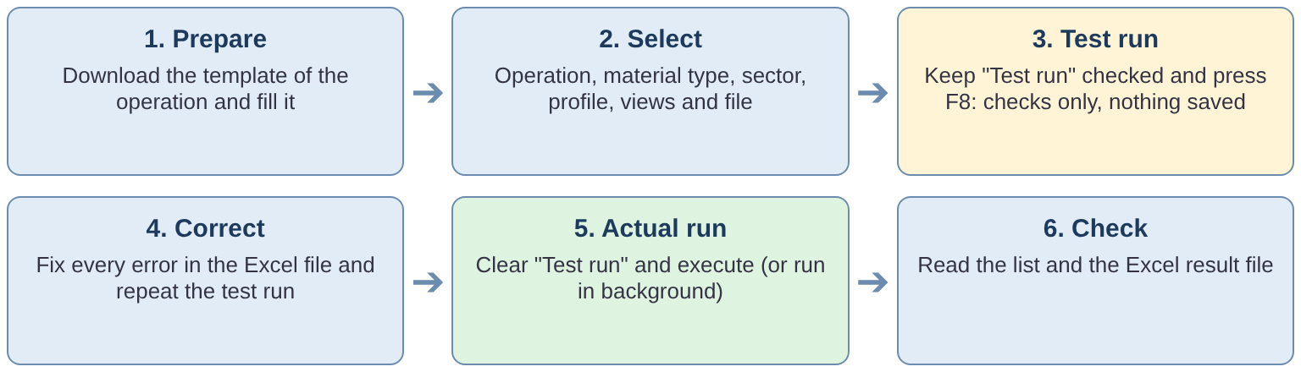
Figure 1 - End-to-end process

2.3 Scope
In scope | Out of scope
• Create, Update and Extend of material masters  • Basic, classification, purchasing, MRP, forecast, plant / storage, sales and accounting views  • Classification (class type 001 by default)  • Purchase order text and sales text  • Upload from local PC or application server; background processing  • ALV log, result Excel file, e-mail | • Deletion flags and archiving  • Clearing a field value with Update (an empty cell never changes a value)  • Mass change of material numbers or material types  • Fiori app (the tool is a SAP GUI report)

3. Proposed Design

3.1 Development Objects
Object | Type | Description
ZMM_MATERIAL_MAINTENANCE | Executable program | Main report - events INITIALIZATION, AT SELECTION-SCREEN, START-OF-SELECTION
ZMM_MATERIAL_MAINTENANCE_D01 | Include | Constants, types and global declarations
ZMM_MATERIAL_MAINTENANCE_S01 | Include | Selection screen
ZMM_MATERIAL_MAINTENANCE_C01 | Include | Local class definitions
ZMM_MATERIAL_MAINTENANCE_C02 | Include | Local class implementations
ZTMM_MATMAS_MAST | Table (custom) | Variant master per material type, industry sector, business profile and operation
ZTMM_BASIC_DATA, ZTMM_CLASS_DATA, ZTMM_PURCH_DATA, ZTMM_MRP_DATA, ZTMM_FRCST_DATA, ZTMM_PLNTST_DATA, ZTMM_SALES_DATA, ZTMM_VAL_DATA | Tables (custom) | View tables - field catalogue per view (same structure)
ZTMM_DEFLT_DATA | Table (custom) | Default values per template field
ZTMM_COND_MAND | Table (custom) | Conditional mandatory rules
Z_DE_OP_ID, Z_DE_VAR_VIEW | Data elements | Operation ID (C / U / E) and variant view
ZMMCREATE_CRT_XLSX, ZMMCREATE_UPD_XLSX, ZMMCREATE_EXT_XLSX | SMW0 binary objects | Upload templates for Create, Update and Extend
Text elements | Program texts | Selection texts, block titles (TEXT-001 ... TEXT-006, R01 - R03), messages E01 - E05
[Transaction code - TBC] | Transaction | Report transaction for ZMM_MATERIAL_MAINTENANCE

3.2 Program Structure
The program is built with local classes. The event blocks of the main report only delegate to these classes.
Class | Responsibility
LCL_APP | Main controller: loads configuration and template, derives values, validates and maps rows, processes the materials, collects data for the result file.
LCL_SCREEN | Selection screen: initialisation, PBO (fixed basic data checkbox, dropdowns, field visibility), PAI checks, F4 help, template download from SMW0, determination of the operation.
LCL_CONFIG | Reads the active variant (ZTMM_MATMAS_MAST), the field catalogue from the selected view tables, default values and conditional mandatory rules; parses the BAPI mapping.
LCL_FILE_READER | Reads the file from the PC (GUI_UPLOAD) or the application server (OPEN DATASET) and parses .xlsx (CL_FDT_XL_SPREADSHEET) or .csv.
LCL_MAPPER | Moves template values into the BAPI structures, sets the X-structures, builds the BAPI parameter tables.
LCL_MATERIAL_BAPI | Wraps the BAPI calls: number draw, reference read, SAVEREPLICA, classification, sales text, commit / rollback, read-back of posted data.
LCL_CLASS_INFO | Buffers class and characteristic master data for the classification checks.
LCL_TEMPLATE | Temporary material numbers and the material-data sheet of the result file (xlsx built with CL_ABAP_ZIP).
LCL_OUTPUT | ALV (CL_SALV_TABLE), result xlsx, save to the application server, e-mail (CL_BCS).
LCL_LOG | Message collection with row, material, view, field and description.
LCX_ERROR | Exception class for errors that stop the run.

3.3 Selection Screen
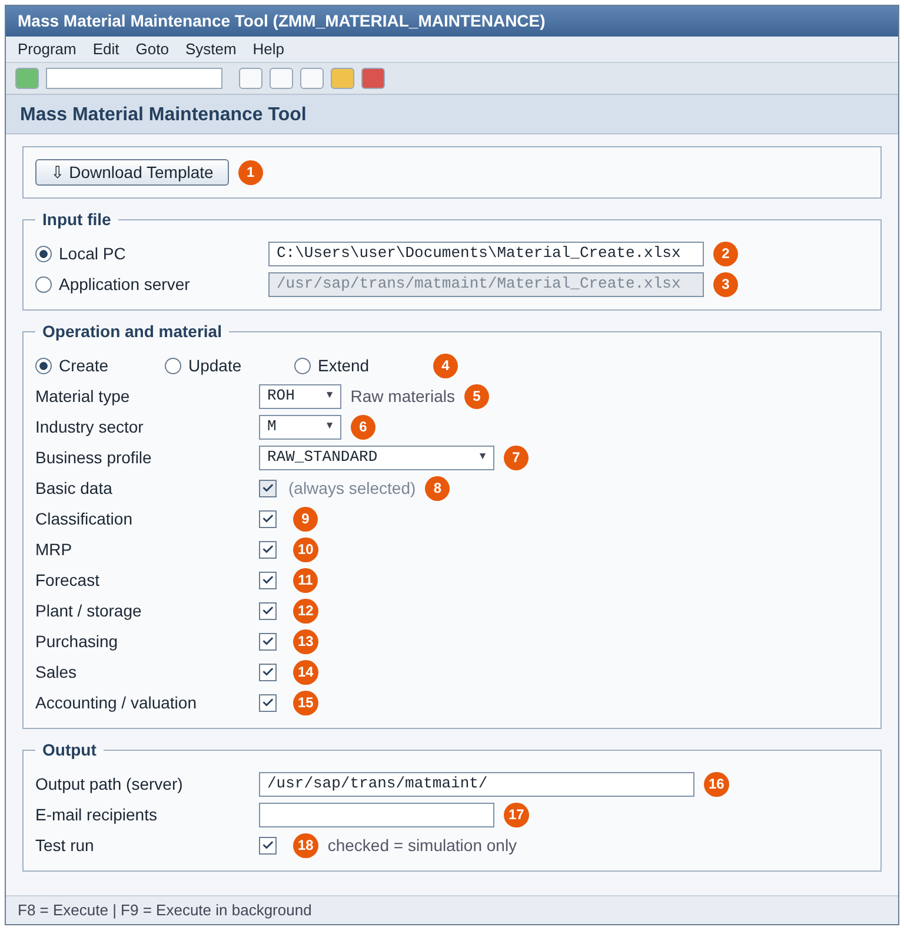
Figure 2 - Selection screen (illustration)
Field | Technical name | Description / validation
Download template | P_BTN (pushbutton) | Downloads the SMW0 template of the selected operation
Local PC / Application server | R_LOCAL / R_UNIX, P_FILE1 / P_FILE2 | File source and path. F4 help on the PC path. Only .xlsx and .csv (message E04)
Create / Update / Extend | R_CREATE / R_UPDATE / R_EXTEND | Operation C / U / E
Material type | P_MTART (listbox) | Values from ZTMM_MATMAS_MAST for the operation
Industry sector | P_INDSEC (listbox) | Values from ZTMM_MATMAS_MAST
Business profile | P_BUSPRF (listbox) | Values from ZTMM_MATMAS_MAST. All three are mandatory (E01)
Views | P_BASIC, P_CLASS, P_MRP, P_FRCST, P_PLNTST, P_PURCH, P_SALES, P_VAL | Each switches one view table. Basic data is fixed to X. At least one other view (E02)
Output path | P_FILE3 | Application server directory for the result file
E-mail recipients | S_EMAIL | Single values only (E05), valid address format
Test run | P_TEST (default X) | X = simulation only, nothing is saved

3.4 Upload Template
- One template per operation, downloaded from SMW0 with the button on the selection screen.
- Row 3 holds the technical field names (gc_hdr_row), row 4 the descriptions, data starts in row 5 (gc_data_row).
- If the file has more than one worksheet, the second sheet is read (the first is the instruction sheet); with one worksheet, that sheet is read.
- Empty lines are skipped. The column MESSAGE is ignored. A duplicate column gives a warning and the first occurrence is used.
- File types: .xlsx and .csv. On the application server the file must be transferred in binary mode.

Control columns
Column | Use
ACTION | C / CREATE, U / UPDATE / CHANGE, E / EXTEND - must match the selected operation
MATNR | Material number. Create without MATNR = internal number per row
REFERENCE_MATNR, REF_WERKS, REF_LGORT, REF_VKORG, REF_VTWEG | Reference material and its org. levels. REF_EKORG is ignored with a warning
COPY_BASIC, COPY_PURCH, COPY_MRP, COPY_FRCST, COPY_SALES, COPY_ACCOUNTING, COPY_CLASS | Copy that area from the reference (X / Y / YES / 1 / TRUE)
PRODH_LVL1 ... PRODH_LVL5 / PRDHA | Product hierarchy by level (no gaps allowed) or complete
CLASS_TYPE, CLASS_NAME, CHAR_NAME_n, CHAR_VALUE_n | Classification; default class type 001
PO_TEXT, SALES_TEXT | Purchase order text and sales text (MVKE / 0001), max. 132 characters per line
PROCESS_PROFILE, DEFAULT_MODE | Reserved

3.5 Configuration Tables
The configuration decides which fields exist for a selection, which are mandatory and where each value goes in the BAPI. The fields listed are those read by the program.

ZTMM_MATMAS_MAST - variant master
Field | Description
MAT_TYPE, IND_SEC, BUS_PROF | Material type, industry sector, business profile
OPERATION_ID | C = Create, U = Update, E = Extend
ACTIVE_FLAG | X = active
VALID_FROM, VALID_TO | Validity; VALID_TO initial = open
VARIANT_VIEW | Variant key used by all other tables
Logic: only active rows valid today are read; with several matches the latest VALID_FROM wins. No match stops the run: "No active variant in ZTMM_MATMAS_MAST for ...". The same table fills the selection screen listboxes.

ZTMM_*_DATA - view tables (field catalogue)
Field | Description
VARIANT_VIEW | Variant from ZTMM_MATMAS_MAST
TEMP_FIELD_NAME | Column name in the template (row 3)
DESCRIPTION | Field text for messages
BAPI_STRUCT_NAME | BAPI structure (e.g. CLIENTDATA, PLANTDATA)
BAPI_FIELD_NAME | Target field(s). Syntax: target{,target}, target = [STRUCT-]FIELD{;QUAL=VALUE}
MANDATORY | X = must be filled
COND_MANDATORY | X = rule in ZTMM_COND_MAND
OPTIONAL | X = optional
SYSTEM_DERIVED | X = set by the system, template value not used
The eight view tables have the same structure and are read with a dynamic table name. A selected view without entries gives a warning; no entries at all stop the run. A mandatory field without BAPI mapping is a configuration error.

ZTMM_DEFLT_DATA - default values
Field | Description
MTART, BUS_PROF, VARIANT_VIEW | Key from the selection and variant
TEMP_FIELD_NAME | Template field
DEF_FIELD_VALUE | Default value
Create only. A default is used only if the template and the reference material give no value; it is validated like a typed value. Entries on control or key fields, or fields not in the variant, are reported as errors.

ZTMM_COND_MAND - conditional mandatory rules
Field | Description
MAT_TYPE, IND_SEC, BUS_PROF, VARIANT_VIEW | Key from the selection and variant
SOURCE_FIELD, SOURCE_DEC | Field that triggers the rule, and its description
CONDMAT_FIELD, CONDMAT_DEC | Field that then becomes mandatory, and its description
If SOURCE_FIELD is filled, CONDMAT_FIELD must be filled (constant gc_cond_if_source). A field flagged COND_MANDATORY without a rule gives a warning.

3.6 Processing Logic
Method LCL_APP->RUN controls the flow:
- Load configuration (LCL_CONFIG->LOAD): variant, field catalogue, conditional rules, defaults.
- Load template (LOAD_TEMPLATE): header row, non-empty cells, row keys; record limit check.
- Check defaults (CHECK_DEFAULTS): usable ZTMM_DEFLT_DATA entries (Create).
- Derive values (DERIVE_VALUES) and inherit org. keys (INHERIT_ORG_KEYS): empty WERKS / VKORG / VTWEG taken from REF_*.
- Check columns (CHECK_COLUMNS): template columns against the field catalogue.
- Validate and map (VALIDATE_AND_MAP): existence prefetch, row control, reference copy, defaults, mandatory and conditional checks, format checks, classification checks, mapping to the BAPI structures.
- Process materials (PROCESS_MATERIALS): simulate / post per row, classification per material, sales text.
- Read posted data (READ_POSTED_DATA): BAPI_MATERIAL_GET_ALL for the result file.
- Publish (LCL_OUTPUT->PUBLISH): ALV, result file, e-mail.
If a global error is found in steps 1 - 6, the run stops before posting: "Simulation / Posting not executed - correct the errors first".

Value priority per field
Priority | Source | Applies to
1 | Value in the template | All operations
2 | Value copied from the reference material (COPY_ flag) | Create, Extend
3 | Default from ZTMM_DEFLT_DATA | Create
4 | System value (current date for status valid-from MSTDV / VMSTD; alternative unit = base unit 1:1) | Create

3.7 Operation Create
- Without MATNR each row is a new material with an internal number; with MATNR an external number is used, or several rows with the same MATNR maintain several org. levels.
- Reference copy: REFERENCE_MATNR with REF_ org. levels and COPY_ flags copies whole areas; template values overwrite copied values.
- Existing material gives "Material already exists - use Update or Extend".
- Defaults (ZTMM_DEFLT_DATA) and system values fill remaining empty fields.

3.8 Operation Update
- MATNR must exist; the org. level of the row must exist (otherwise Extend).
- Only filled cells are sent: X-structures are set only for filled fields (LCL_MAPPER=>BUILD_X_TABLES / SET_ALL_X). An empty cell never clears a value.
- No reference copy and no defaults.
- Classification, texts and product hierarchy can be changed.

3.9 Operation Extend
- MATNR must exist; the row gives new plants, storage locations or sales areas (VKORG and VTWEG together).
- Basic data is not changed.
- Optional reference copy for org.-level data.
- If all org. levels already exist: "Nothing to extend - all org. levels of the row already exist (use Update)".

3.10 Classification, Texts and Product Hierarchy
- Classification: class type default 001 (gc_def_classtype), object table MARA. Classes and characteristics are checked against class master data (buffered). Values of several rows of one material are merged per class; conflicting values are rejected. Assignment with BAPI_OBJCL_CREATE or BAPI_OBJCL_CHANGE after the material exists. If only the classification fails, the material is kept and the log says so.
- PO_TEXT: purchase order text mapped to the BAPI text tables.
- SALES_TEXT: sales text per sales area, text object MVKE, ID 0001, saved with SAVE_TEXT.
- Product hierarchy: PRODH_LVL1..5 combined into PRDHA (levels without gaps) or PRDHA directly.
- Long texts: max. 132 characters per line (gc_max_longtext).

3.11 Material Number Protection
In an actual Create run with internal numbering, each row is first simulated with a temporary number (TEMPMATNR_<row>). Only if the simulation is clean is a number drawn with BAPI_MATERIAL_GETINTNUMBER and the material posted. A row that fails the simulation never consumes a number ("Posting skipped - material has validation errors"). In a test run no number is drawn (gc_sim_int_num = space).

3.12 Output - ALV, Result File and E-mail
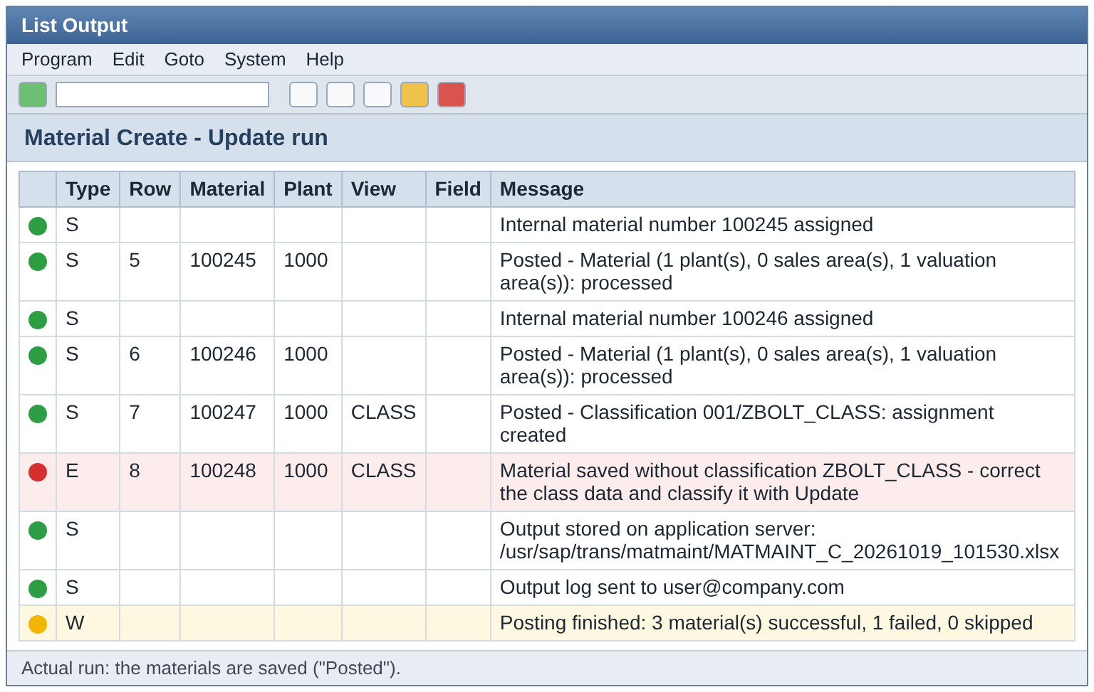
Figure 3 - Result list (illustration)
- ALV (CL_SALV_TABLE): type, row, material, plant, view, field and message; summary line with successful / failed / skipped.
- Result file MATMAINT_<C|U|E>_<YYYYMMDD>_<HHMMSS>.xlsx with sheet ALV_OUTPUT (messages) and MATERIAL_DATA (posted materials read back with BAPI_MATERIAL_GET_ALL, incl. classification; headers with DDIC field descriptions).
- Application server: file written to the output path (actual run only).
- E-mail: CL_BCS with the result file attached to all recipients (actual run only).

3.13 Error Handling and Messages
Level | Behaviour
Selection screen | Type E messages E01 - E05 stop execution
Global (configuration, file, record limit) | LCX_ERROR stops the run, nothing is posted
Row | Errors collected per row; the row is skipped, other rows continue
BAPI | RETURN messages taken to the log; BAPI_TRANSACTION_ROLLBACK on error, BAPI_TRANSACTION_COMMIT (wait) on success
Classification | Error logged; material stays saved

3.14 Volume Limits and Performance
Constant | Value | Effect
gc_max_rows-fg-create / update / extend | 1000 | More rows in foreground: error, run in background
gc_max_rows-hard-create / update / extend | 2000 | More rows: error in foreground and background, split the file
- Existence of materials and org. levels is read with one SELECT per table before the row loop (PREFETCH_EXISTENCE).
- Reference data, class information and DDIC texts are buffered.
- One BAPI_MATERIAL_SAVEREPLICA call per row; commit per material. Runtime grows linearly with the number of rows.
- Local files can only be processed in foreground; large files: application server and background job.

3.15 SAP Standard Functions Used
Function / class | Purpose
BAPI_MATERIAL_SAVEREPLICA | Create / change / extend material
BAPI_MATERIAL_GETINTNUMBER | Internal material number
BAPI_MATERIAL_GET_ALL | Read reference and posted materials
BAPI_OBJCL_GETDETAIL / GETCLASSES / CREATE / CHANGE | Classification
BAPI_TRANSACTION_COMMIT / ROLLBACK | LUW handling
SAVE_TEXT | Sales text
CONVERSION_EXIT_MATN1_INPUT, CONVERT_DATE_TO_INTERNAL, DATE_CHECK_PLAUSIBILITY | Conversions and checks
WWWPARAMS_READ_ALL, WWWDATA_IMPORT | Template download from SMW0
VRM_SET_VALUES | Selection screen listboxes
CL_GUI_FRONTEND_SERVICES | Upload / download on the PC
CL_FDT_XL_SPREADSHEET | Read .xlsx
CL_ABAP_ZIP | Build the result .xlsx
CL_SALV_TABLE | ALV output
CL_BCS, CL_DOCUMENT_BCS | E-mail with attachment

4. Transaction Code
A report transaction will be created for program ZMM_MATERIAL_MAINTENANCE.
Item | Value
Transaction code | [To be confirmed]
Description | Mass Material Maintenance Tool
Program / screen | ZMM_MATERIAL_MAINTENANCE / 1000
Fiori | Not in scope - SAP GUI report (can be added to the launchpad as a GUI tile if required)

5. Roles
The transaction should be available only to the material master data team.
- Role: [to be confirmed] with S_TCODE for the new transaction.
- Material master authorisations (M_MATE_*) for the material types and org. levels the user maintains.
- Authorisation to read the application server path (S_DATASET) and to send e-mail.
ATTENTION - Open point
The program has no explicit AUTHORITY-CHECK. Access is controlled by the transaction and the user role. Security to confirm whether an explicit check on the material type / plant is required before go-live.

6. Testing

6.1 High-level Test Scenarios
S.No | Test scenario
1 | Create materials with internal numbering (test run and actual run)
2 | Create with external number and several org. levels
3 | Create with reference material and COPY_ flags
4 | Update selected fields - unchanged fields stay as they are
5 | Extend to a new plant, storage location and sales area
6 | Classification create and change; classification error keeps the material
7 | PO text and sales text
8 | Mandatory, conditional mandatory and default value rules
9 | Material number protection - failed row does not consume a number
10 | Application server file in background; result file and e-mail
11 | Record limits: 1001 rows in foreground, 2001 rows
12 | Instruction sheet + data sheet; single-sheet file

6.2 Unit Test Cases
ID | Input | Expected result
UT01 | No material type selected | E01 "Select material type, industry sector and business profile"
UT02 | File .xls | E04 "Only .xlsx and .csv files are allowed"
UT03 | No active variant for the selection | Run stops: "No active variant in ZTMM_MATMAS_MAST ..."
UT04 | Create, MATNR of an existing material | "Material already exists - use Update or Extend"
UT05 | Mandatory field empty | Row error, row not posted
UT06 | Source field filled, conditional field empty | Row error "<B> is mandatory when <A> is maintained"
UT07 | Update, one field filled | Only that field changed (check MM03 / change documents)
UT08 | Extend, all org. levels exist | "Nothing to extend - ... (use Update)"
UT09 | Actual run, row fails simulation | No number drawn, "Posting skipped - material has validation errors"
UT10 | PRODH_LVL3 filled, PRODH_LVL2 empty | Error: levels must be filled without gaps
UT11 | 1001 rows in foreground | Error: please run in background
UT12 | 2001 rows | Error: maximum is 2000 - split the file
Detailed test scripts are maintained by the testing team.

Appendix A. Definitions and Acronyms
Acronym / Term | Description
ALV | SAP List Viewer
BAPI | Business Application Programming Interface
LUW | Logical Unit of Work
MRP | Material Requirements Planning
Org. level | Plant, storage location, sales organisation / distribution channel, valuation area
SMW0 | SAP Web Repository - storage of binary objects such as templates
TS | Technical Specification
Variant | Combination of material type, industry sector, business profile and operation in ZTMM_MATMAS_MAST

Appendix B. Document Control and Approval

B.1 Responsibilities
Role | Responsibility | Assigned to | Position
Document Owner | Overall responsibility for document accuracy and distribution list.
Document Author | Prepare the document to the Document Owner's specification. | Omkar Sutar | ABAP Developer
Document Controller | Version control and distribution to nominated document holders.
Confidentiality | [Company confidentiality statement]

B.2 Quality Check
Document approval is made against the quality criteria below by the relevant approver for each section.
# | Section | Criteria | Domain Mgr | Ent. Architect | Security Mgr
1 | Document Quality | All mandatory sections completed or marked N/A; standard template used
2 | Solution Impact | No conflicts; no unresolved issues; impacts on other systems and projects identified
3 | Interfaces | System and user interfaces identified
4 | Data Integrity | Data integrity addressed end to end
5 | Information Security | Users / groups and access levels considered
6 | Reporting | Reporting requirements described
7 | Performance | Run times, volumes and resource use described
8 | Operational Requirements | Support and operation defined
9 | Design Alignment | Aligned to the IT strategy
The appropriate representatives from my team have reviewed this document according to the quality criteria above and I authorise it for issue.

B.3 Reviewer List
Name | Title | Signature | Date

B.4 Approvers List
Name | Title | Signature | Date

B.5 Version Control
Numbering convention: Initial Draft = 0.1, Approved Version = 1.0, Minor Amendments = 0.2, 0.3, 1.1 etc.
Version | Date | Section | Nature of Amendment | Author
0.1 | 23/10/2026 | All | Initial draft | Omkar Sutar

B.6 Reference Documents
Reference Document | Version | Date | File Location
Mass Material Maintenance - User Training Guide | 1.0 | Oct 2026 | Git repository, documents/
Mass Material Maintenance - Presentation (v2) | 2.0 | Oct 2026 | Git repository, documents/
Template instruction sheets (Create / Update / Extend) | 1.0 | Oct 2026 | Git repository, documents/instruction_sheets/

B.7 Related Documents
Related Document | Version | Date | File Location
Functional specification - DMND0025421

