Technical Design Specification (TDS)

Logistics
MM: Mass Material Maintenance - Create / Update / Extend of Material Master
ZMM_MATERIAL_MAINTENANCE

Version v0.1

General information

Object ID / Reference to ITSM tool | ZMM_MATERIAL_MAINTENANCE / DMND0025421
Description | Mass Material Maintenance Tool - Create, Update and Extend materials from an Excel template
Process / Functional Area | MM
Type of Development | Report
Deployment | O4P
Package | [To be confirmed]

Revision History
Version | Author | Section Amended | Summary of Changes | Creation/Change Date | Reviewed by | Approved by
V0.1 | Omkar Sutar | All | Initial version - Mass Material Maintenance (Create / Update / Extend) | 23/10/2026

Table of Contents
1. Functional Design Reference 5
2. Technical Solution Design 5
2.1 High level technical solution design 5
2.2 Technical Process flow diagram 5
2.3 Technical Program Logic / Pseudo code 6
2.4 Custom Object Attributes/Details 11
2.4.1 Report 11
2.4.1.1 Report Attributes: 11
2.4.1.2 Selection Screen Criteria: 11
2.4.1.3 Report Output 11
2.4.1.4 Transaction: 11
2.4.1.5 Batch Jobs 11
2.4.2 Interface 12
2.4.2.1 For IDoc: 12
2.4.2.2 For File Transfer: 13
2.4.3 Conversion 13
2.4.3.1 For BDC/Call Transactions: 13
2.4.3.2 LSMW: 13
2.4.3.3 BODS: 14
2.4.3.4 SLT Configuration: 14
2.4.4 Enhancement 14
2.4.4.1 BADI: 15
2.4.4.2 Enhancement Implementation: 15
2.4.4.3 SAP User-Exits: 15
2.4.4.4 Function Exits: 15
2.4.4.5 Screen Exits: 15
2.4.4.6 In-App Extension (Custom Fields and Logic): 16
2.4.4.7 Side-by-Side Extensibility 16
2.4.5 SAP Build Apps / Process Automation 16
2.4.6 Forms 16
2.4.7 Workflow 17
2.4.8 SAP BRF+: 18
2.4.9 Fiori Application 18
2.4.10 WebDynpro ABAP 18
2.4.11 Gateway Service 18
2.4.11.1 Overview: 18
2.4.11.2 Data Model: 19
2.4.11.3 Runtime Artefacts: 19
2.4.12 Function Module 19
2.4.13 Class/Methods 19
2.4.14 Data Definition Language 19
2.4.15 Data Dictionary 20
2.4.15.1 Custom Infotype / Table Definition 20
2.4.15.2 Data Element 20
2.4.15.3 Structure 20
2.4.15.4 Search Help 20
2.4.15.5 Text Elements 20
2.4.15.6 Message Class 21
3. Security/Authorization and Data Privacy 21
4. Data Archiving Requirement 21
5. Error Handling Requirement 21
6. Object List 22

Functional Design Reference

FDS No# | ITSM No# | Document / SOP Title | Document Link
 | DMND0025421 | Mass Material Maintenance - Create / Update / Extend of Material Master
Functional Design Document Link and Name

Technical Solution Design

- New Report: ZMM_MATERIAL_MAINTENANCE (includes D01, S01, C01, C02)

High level technical solution design

Create a New Report ZMM_MATERIAL_MAINTENANCE

Selection Screen:
1. Purpose of Selection Screen
The selection screen collects the inputs to create, update or extend material masters from an Excel template. It controls the operation, the material variant (material type, industry sector, business profile), the views to process, the file source, the output and the test mode, and checks the mandatory inputs before processing.
2. Selection Screen Components
2.1 Template Download
Field Name | Description | Type
P_BTN | Download Template | Pushbutton
- Downloads the template of the selected operation from SMW0 (ZMMCREATE_CRT_XLSX / ZMMCREATE_UPD_XLSX / ZMMCREATE_EXT_XLSX)
2.2 Input File
Field Name | Description | Type
R_LOCAL | Local PC | Radio Button
P_FILE1 | File path on the PC | Parameter
R_UNIX | Application server | Radio Button
P_FILE2 | File path on the application server | Parameter
- Default value: Local PC
- Only the path of the selected source is open for input
- Allowed file types: .xlsx and .csv
2.3 Operation and Material
Field Name | Description | Type
R_CREATE | Create | Radio Button
R_UPDATE | Update | Radio Button
R_EXTEND | Extend | Radio Button
P_MTART | Material type | Listbox
P_INDSEC | Industry sector | Listbox
P_BUSPRF | Business profile | Listbox
- Default value: Create
- The operation determines the operation ID (C / U / E) used to read ZTMM_MATMAS_MAST
- Listbox values come from ZTMM_MATMAS_MAST (active, valid today) for the selected operation
2.4 Views
Field Name | Description | Configuration table
P_BASIC | Basic data (always selected) | ZTMM_BASIC_DATA
P_CLASS | Classification | ZTMM_CLASS_DATA
P_MRP | MRP | ZTMM_MRP_DATA
P_FRCST | Forecast | ZTMM_FRCST_DATA
P_PLNTST | Plant / storage | ZTMM_PLNTST_DATA
P_PURCH | Purchasing | ZTMM_PURCH_DATA
P_SALES | Sales | ZTMM_SALES_DATA
P_VAL | Accounting / valuation | ZTMM_VAL_DATA
- Each checkbox switches one view table of the field catalogue
2.5 Output Parameters
Field Name | Description
P_FILE3 | Output path on the application server
S_EMAIL | E-mail recipients
P_TEST | Test run (default X) - simulation only
- Result file and e-mail are produced in an actual run only

3. Dynamic Screen Behavior
- Field input is controlled at runtime with screen groups:
  - MD1 → local file path (P_FILE1)
  - MD2 → application server path (P_FILE2)
- Basic data checkbox is fixed to X and not editable
- Listboxes are filled in AT SELECTION-SCREEN OUTPUT (method LCL_SCREEN=>PBO)

4. Value Help (F4)
Field | Implementation
P_FILE1 | File open dialog (CL_GUI_FRONTEND_SERVICES), filter .xlsx / .csv
P_MTART, P_INDSEC, P_BUSPRF | Listbox values with VRM_SET_VALUES from ZTMM_MATMAS_MAST

5. Validations
- Material type, industry sector and business profile must be selected (E01)
- At least one view besides basic data must be selected (E02)
- File path must be entered (E03); only .xlsx and .csv (E04)
- E-mail recipients: single values only and valid address format (E05)

6. Variant Determination
Operation | Operation ID
Create | C
Update | U
Extend | E
- The active variant is read from ZTMM_MATMAS_MAST for material type, industry sector, business profile and operation ID
- Processing is stopped if no active variant exists

7. Error Handling
- Selection screen errors are shown before execution (type E messages)
- Messages are program text symbols (no message class)

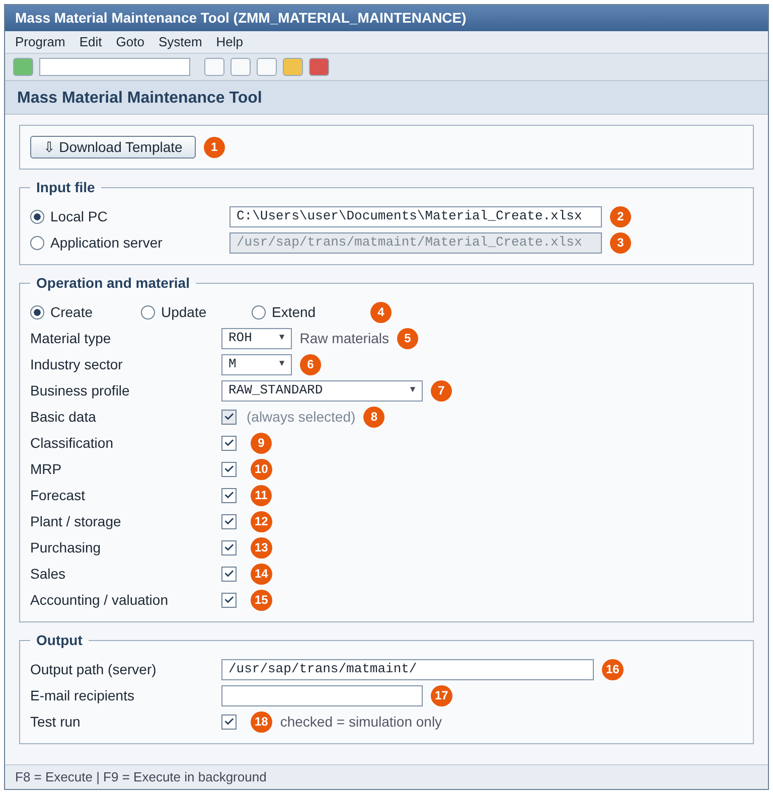

The solution is a custom ABAP executable program that creates, changes and extends material masters in bulk from an Excel template using the standard BAPI BAPI_MATERIAL_SAVEREPLICA. All field rules (fields per view, mandatory flags, BAPI mapping, defaults and conditional rules) are read from custom configuration tables, so most changes need configuration only.

Overall Design Approach
The program provides one interface for three operations:
- Create - create new materials (internal or external number), optionally copying data from a reference material
- Update - change existing materials; only filled template cells are sent, an empty cell never clears a value
- Extend - extend existing materials to new plants, storage locations and sales areas; basic data is not changed
Each run is either a test run (simulation, nothing saved) or an actual run.

Key Technical Components
1. Selection Screen Controller (LCL_SCREEN)
- Captures operation, variant, views, file source, output and test mode
- Fills the listboxes from ZTMM_MATMAS_MAST and downloads the template from SMW0
- Performs early validations

2. Configuration Framework (LCL_CONFIG)
- ZTMM_MATMAS_MAST → active variant (VARIANT_VIEW)
- ZTMM_*_DATA (8 view tables, same structure, dynamic table name) → field catalogue with BAPI mapping and flags
- ZTMM_COND_MAND → conditional mandatory rules
- ZTMM_DEFLT_DATA → default values (Create only)

3. File Reading (LCL_FILE_READER)
- Local PC: CL_GUI_FRONTEND_SERVICES=>GUI_UPLOAD; application server: OPEN DATASET in binary mode
- .xlsx read with CL_FDT_XL_SPREADSHEET; .csv parsed directly
- More than one worksheet → 2nd sheet is the data sheet (1st = instruction sheet); one worksheet → that sheet
- Row 3 = technical field names, data from row 5

4. Validation and Mapping (LCL_APP / LCL_MAPPER)
- Existence of materials and org. levels prefetched with one SELECT per table
- Reference material copy (BAPI_MATERIAL_GET_ALL) controlled by COPY_ flags
- Mandatory, conditional mandatory, format and classification checks
- Values mapped to the SAVEREPLICA structures; X-structures only for filled fields

5. Posting (LCL_MATERIAL_BAPI)
- BAPI_MATERIAL_SAVEREPLICA per template row; BAPI_TRANSACTION_COMMIT / ROLLBACK
- Create with internal numbering: simulation with a temporary number first, BAPI_MATERIAL_GETINTNUMBER only after a clean simulation
- Classification with BAPI_OBJCL_CREATE / BAPI_OBJCL_CHANGE; sales text with SAVE_TEXT

6. Output and Logging (LCL_OUTPUT / LCL_LOG)
- ALV log (CL_SALV_TABLE) with row, material, org. level, view, field and message
- Actual run: result file MATMAINT_<C|U|E>_<date>_<time>.xlsx on the application server and by e-mail (CL_BCS)
- Record limits: 1000 rows in foreground, 2000 rows maximum

Design Benefits
- Configuration driven - new fields and variants mostly without code changes
- One program for Create, Update and Extend
- Full simulation before posting; no material numbers lost on errors
- SAP standard BAPIs ensure data consistency
- Clear log per row and a result file for audit

Technical Process flow diagram
[Add process flow diagram of the technical process]
Figure 1 - Overview of the technical process
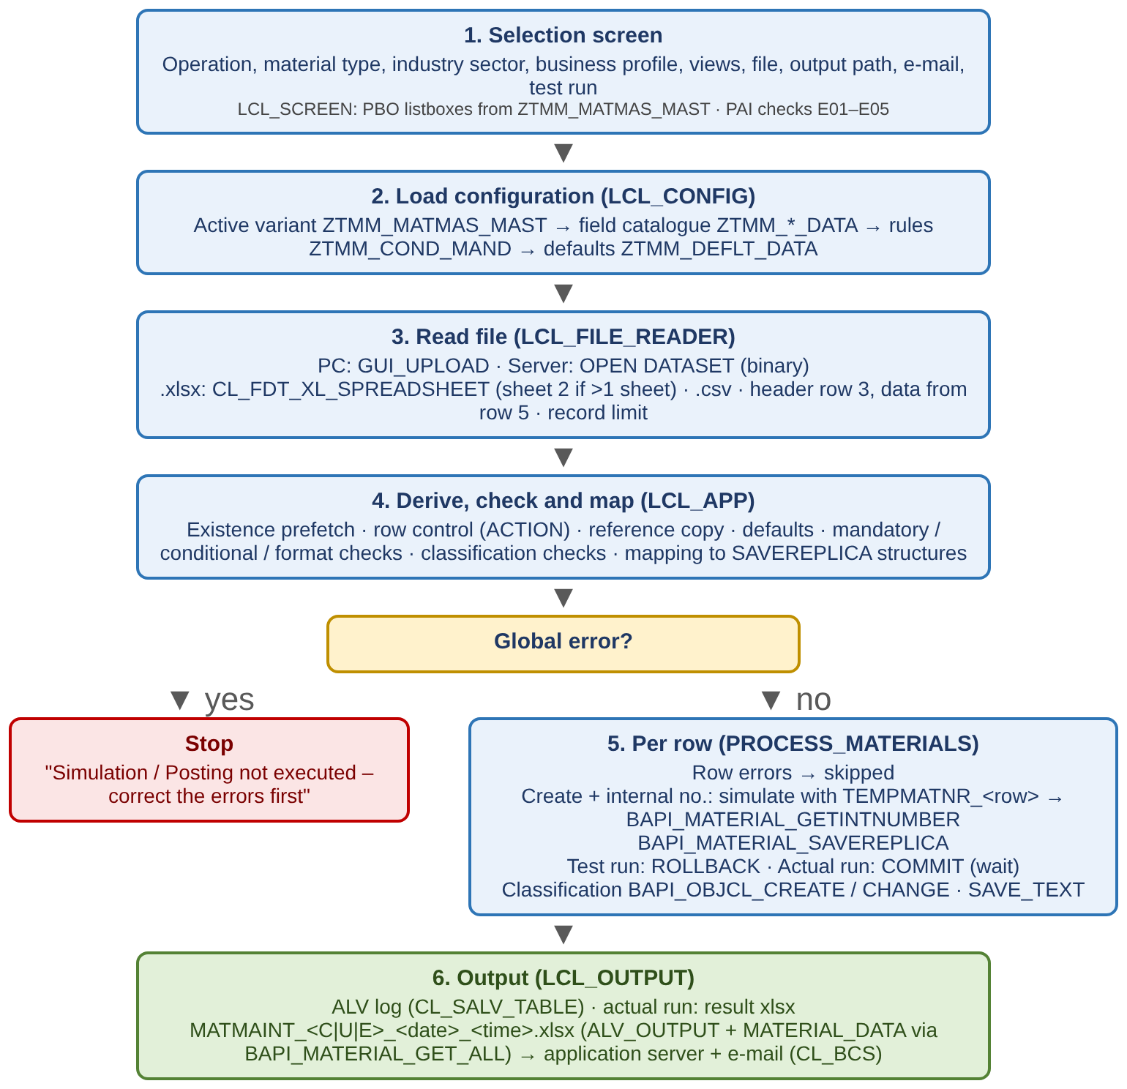

The detailed technical process is shown in three parts below.
- Part 1 - Selection screen, configuration load and file reading
- Part 2 - Validation and mapping of the template rows
- Part 3 - Posting, classification and output
- Colour key: dark blue = start / end, light blue = program step, yellow diamond = decision, purple = SAP BAPI call, green cylinder = configuration table, red = error path, purple pill = link to the next part
Figure 2 - Detailed flow, Part 1: Selection screen, configuration and file
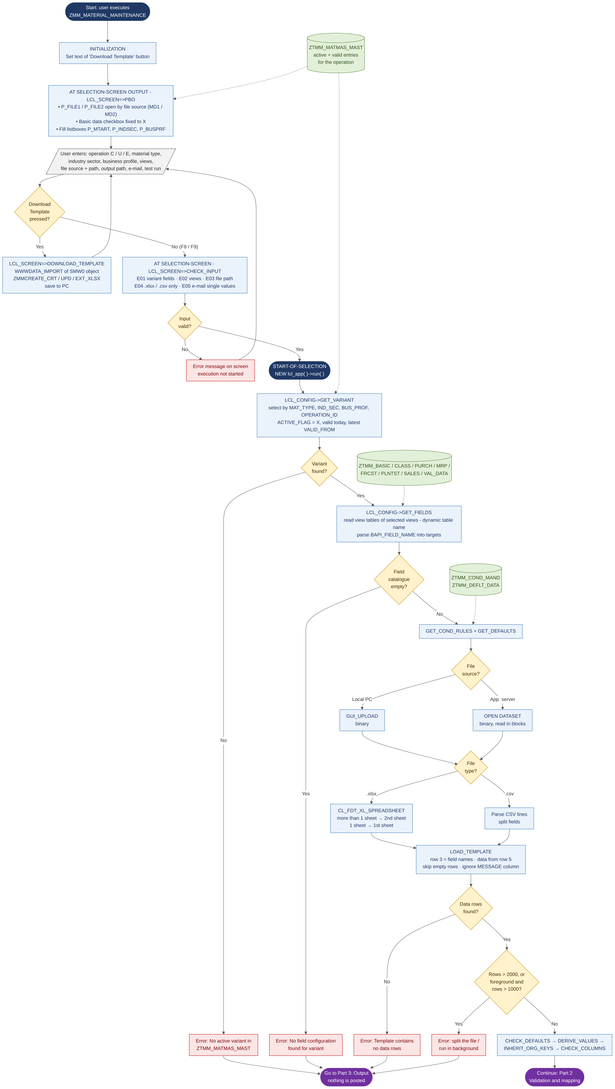
Figure 3 - Detailed flow, Part 2: Validation and mapping
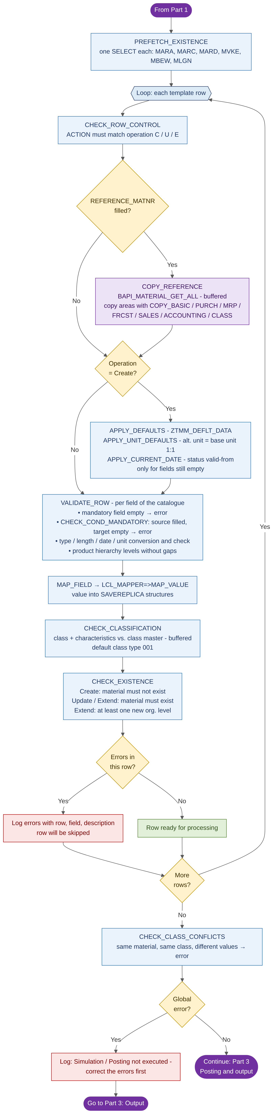
Figure 4 - Detailed flow, Part 3: Posting and output
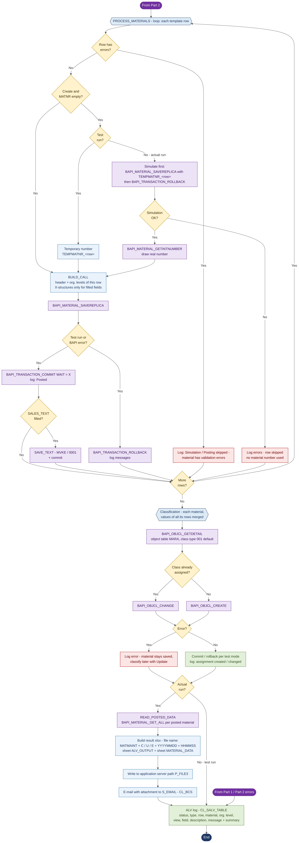
Process steps

Step 1: Program Initialization
- User executes the report ZMM_MATERIAL_MAINTENANCE
- INITIALIZATION sets the template button text; the selection screen is displayed

Step 2: Selection Screen Input & Validation
- User selects operation, material type, industry sector, business profile, views, file and output options
- Optional: download the template for the operation
- Mandatory validations E01 - E05; on error the execution is stopped

Step 3: Configuration and File
- Determine the active variant from ZTMM_MATMAS_MAST
- Read the field catalogue of the selected views, conditional rules and defaults
- Read the Excel / CSV file from the PC or the application server
- Check the record limit (foreground 1000, maximum 2000)

Step 4: Validation and Mapping
- Check default entries, derive values and inherit org. keys from the reference columns
- Check the template columns against the field catalogue
- Per row: row control (ACTION), reference copy, defaults, mandatory / conditional / format checks, classification checks
- Map the values to the BAPI structures

Step 5: Processing
- Global error → stop: "Simulation / Posting not executed - correct the errors first"
- Otherwise per row: rows with errors are skipped
  - Create with internal numbering (actual run): simulate with TEMPMATNR_<row>, then draw the number
  - BAPI_MATERIAL_SAVEREPLICA; test run → rollback, actual run → commit
  - Classification and sales text after the material exists

Step 6: Output
- ALV log of all messages
- Actual run: posted materials read back with BAPI_MATERIAL_GET_ALL, result file written to the server and sent by e-mail

Error Handling in Process Flow
- Selection screen and configuration errors stop the execution immediately
- Row errors skip only that row; processing continues for the other rows
- BAPI errors are logged per row and rolled back

Technical Program Logic / Pseudo code
[Please elaborate in detail how the requested change/new functionality should be implemented. Please add pseudo code.]
This section explains the program logic step by step. Each step starts with a short business explanation ("In simple words") for functional readers, followed by the technical logic in pseudo code and, where useful, an example and the message the user sees.

Legend
Term | Meaning
Row | One data line of the Excel template (from row 5). Row numbers in all messages refer to the Excel row.
Variant | Combination of material type, industry sector, business profile and operation in ZTMM_MATMAS_MAST. It decides which fields are used and which rules apply.
Field catalogue | List of template fields of the variant from the view tables ZTMM_*_DATA, with the target field in the SAP BAPI and the flags (mandatory, conditional, optional, system derived).
Org. level | Plant, storage location, sales organisation / distribution channel, valuation area, warehouse.
Test run | Everything is checked and simulated in SAP, but nothing is saved and no number is used.
Actual run | Materials are really saved (posted) in SAP.
Global error | Error that concerns the whole file (configuration, file, columns). Nothing is posted.
Row error | Error in one row. Only this row (material) is skipped; the other rows continue.

Step 1 - Start and Selection Screen
In simple words: The user opens the program, chooses what to do (Create, Update or Extend), for which kind of material (material type, industry sector, business profile), which views, where the file is, and whether it is only a test. Only combinations that are configured are offered in the dropdowns.
Logic:
WHEN the program starts (INITIALIZATION)
- Set the button text "Download Template"
EVERY TIME the screen is displayed (AT SELECTION-SCREEN OUTPUT)
- IF file source = Local PC → only the PC path is open for input
- IF file source = Application server → only the server path is open for input
- Set "Basic data" checkbox to X and lock it (basic data is always processed)
- Operation ID = C (Create) / U (Update) / E (Extend) from the radio button
- Fill dropdowns with the values in ZTMM_MATMAS_MAST where operation = operation ID, ACTIVE_FLAG = X and today is within VALID_FROM / VALID_TO
  - Material type → industry sector → business profile (each list depends on the previous selection)

Step 2 - Template Download (optional)
In simple words: The user can download the empty Excel template of the chosen operation. It is stored centrally in SAP (transaction SMW0), so everybody uses the same version.
Logic:
IF button "Download Template" is pressed
- Object = ZMMCREATE_CRT_XLSX (Create) / ZMMCREATE_UPD_XLSX (Update) / ZMMCREATE_EXT_XLSX (Extend)
- Read the object from SMW0 (WWWDATA_IMPORT) and ask the user where to save it on the PC
- IF download fails → message "Template could not be downloaded"
- Return to the selection screen (the program is not executed)

Step 3 - Check the Selection Screen
In simple words: Before anything runs, the program checks that the user filled the screen correctly. Wrong input is reported immediately on the screen.
Logic:
IF material type OR industry sector OR business profile is empty
- Error E01 "Select material type, industry sector and business profile"
IF no view other than Basic data is selected
- Error E02 "Select at least one view"
IF the file path of the chosen source is empty
- Error E03 "Enter the template file path"
IF the file extension is not .xlsx or .csv
- Error E04 "Only .xlsx and .csv files are allowed"
FOR each e-mail recipient
- IF it is a range or exclusion → Error E05 "E-mail recipients: only single values can be included"
- IF the address is not a valid e-mail format → Error "Invalid e-mail address: <address>"
Message to user: the error is shown at the bottom of the selection screen; the program does not start until it is corrected.

Step 4 - Read the Configuration
In simple words: The program looks up the rules for the chosen combination: which fields exist, which are mandatory, where each Excel column goes in SAP, which default values apply and which fields become mandatory depending on other fields. If nothing is configured for the combination, the program stops.
Logic:
4.1 Find the variant
- Read ZTMM_MATMAS_MAST with material type, industry sector, business profile and operation ID
  - Only ACTIVE_FLAG = X and VALID_FROM <= today and (VALID_TO >= today OR VALID_TO empty)
- IF nothing found → STOP with "No active variant in ZTMM_MATMAS_MAST for <type> / <sector> / <profile> / operation <C/U/E>"
- IF several found → take the one with the latest VALID_FROM
4.2 Read the field catalogue
- FOR each view selected on the screen (Basic, Classification, Purchasing, MRP, Forecast, Plant/storage, Sales, Accounting)
  - Read the view table (e.g. ZTMM_MRP_DATA) for the variant
  - IF the view table has no entries → warning "No fields maintained in <table> for variant <variant>"
  - FOR each field: remember template column name, description, flags and BAPI target(s)
- IF no field at all is found → STOP with "No field configuration found for variant <variant> and the selected views"
4.3 Read conditional rules (ZTMM_COND_MAND)
- IF a field is flagged "conditional mandatory" but has no rule → warning
4.4 Read default values (ZTMM_DEFLT_DATA) for material type, business profile and variant
Example: ROH / M / RAW_STANDARD / Create → variant V001 → fields of the basic, MRP and purchasing view tables for V001 are used.

Step 5 - Read the Excel File
In simple words: The program reads the file from the user's PC or from the SAP server. If the workbook has an instruction sheet, the data is taken from the second sheet. Empty lines are ignored. Too large files are rejected before any processing.
Logic:
IF source = Local PC → upload file in binary mode (GUI_UPLOAD)
IF source = Application server → OPEN DATASET in binary mode, read in blocks
IF file is .xlsx
- Open workbook (CL_FDT_XL_SPREADSHEET) and list the worksheets
- IF more than one worksheet → use worksheet 2 (worksheet 1 = instructions)
- ELSE → use worksheet 1
IF file is .csv → split each line into fields
Row 3 = technical field names (column headers)
- IF a column name appears twice → warning "Duplicate column - first occurrence used"
FOR each row from row 5
- Keep only filled cells; ignore column MESSAGE
- IF the whole row is empty → skip it
IF no data row is found → STOP "Template contains no data rows"
IF number of rows > 2000 → STOP "File has <n> records - maximum is 2000 ... split the file"
IF running in foreground AND rows > 1000 → STOP "... please run in background"
Example: a file with 1500 rows can only be run as a background job (F9) with the file on the application server.

Step 6 - Prepare the Data
In simple words: Before checking row by row, the program completes some values that can be derived and checks that the Excel columns fit the configuration.
Logic:
6.1 Default values (Create only)
- FOR each entry in ZTMM_DEFLT_DATA: IF the field is a control or key field, or not part of the variant → error (entry cannot be used)
6.2 Product hierarchy
- IF PRODH_LVL1..5 are filled → build PRDHA from the levels (each level padded to its length from T179)
  - Levels must be filled without gaps → else error "PRODH_LVL<n> is filled but PRODH_LVL<m> is empty"
  - PRDHA must exist in T179; IF PRDHA and levels are both given → PRDHA wins, difference is reported
6.3 Org. levels from the reference material
- IF plant / sales org. / distribution channel is empty AND a reference is given → take REF_WERKS / REF_VKORG / REF_VTWEG
6.4 Column check
- IF a template column is not configured in any selected view → reported
- IF a mandatory field is not a column of the template and has no default → error

Step 7 - Check and Prepare Each Row
In simple words: Every row is checked completely before anything is saved. The program fills the data from the reference material and the default values, checks mandatory fields, rules and formats, and translates the Excel values into the SAP structure. All problems of a row are collected, so the user sees every error in one run.
Logic:
7.0 Read in one step which materials and org. levels already exist (MARA, MARC, MARD, MVKE, MBEW, MLGN)
FOR each row
- 7.1 Control columns
  - ACTION must match the operation on the screen (C/CREATE, U/UPDATE/CHANGE, E/EXTEND)
  - COPY_* flags accept X / Y / YES / 1 / TRUE; REF_EKORG is ignored (warning)
- 7.2 Reference material (if REFERENCE_MATNR is filled)
  - Read the reference with BAPI_MATERIAL_GET_ALL for REF_WERKS / REF_VKORG / REF_VTWEG (read once, then buffered)
  - Copy only the areas whose COPY_ flag is set; no flag set = all selected views
  - Copy only fields that are empty in the template → the template always wins
  - Tables: descriptions per language, units of measure, long texts, tax classification - only lines not given in the template; EANs are never copied
  - Classification: class and values not given in the template
- 7.3 Default values (Create only, only for fields still empty)
  - Value from ZTMM_DEFLT_DATA
  - Units of measure: alternative unit = base unit, ratio 1 : 1
  - Status valid-from dates (MSTDV / VMSTD) = today if empty
- 7.4 Field checks - for each field of the field catalogue
  - IF flagged MANDATORY and empty → error "<field> (<description>) is mandatory"
  - IF a rule in ZTMM_COND_MAND says: source field filled → target field required, and target is empty → error "<target> (<desc>) is mandatory when <source> (<desc>) is maintained"
  - Convert the value to SAP format (numbers, dates, units, material number) and check length and type → error if not valid
  - IF flagged SYSTEM_DERIVED → the template value is not used
  - Move the value into the BAPI target field(s) of the catalogue
- 7.5 Classification
  - Class type default 001; class and characteristics must exist in the class master
  - Single-value characteristic may have only one value; value format is taken from the characteristic (CABN)
- 7.6 Texts
  - PO_TEXT → purchase order text; SALES_TEXT needs sales org. + distribution channel and the Sales view; max. 132 characters per line
- 7.7 Existence check
  - MATNR invalid → error "Invalid material number"
  - Create: material exists → error "Material already exists - use Update or Extend"
  - Update / Extend: material does not exist → error "Material does not exist - use Create"
  - Update / Extend: material type or industry sector differs from the screen → error
  - Update: org. level of the row does not exist → error "<org. level> does not exist for the material - use Extend"
  - Extend: basic data in the row → warning (not changed); org. level exists → warning (values will be changed); all org. levels exist → error "Nothing to extend ..."
END FOR
7.8 Across rows: the same material must not get different values for a single-value characteristic in different rows → error
Example: row 7 has MRP type PD but no MRP controller, and ZTMM_COND_MAND says "DISPO is mandatory when DISMM is maintained" → row 7 gets an error and will not be posted; rows 5, 6 and 8 continue.

Step 8 - Decide Whether Posting Can Start
In simple words: If there is a problem with the whole file (configuration, file, columns), nothing is posted at all. Errors in single rows only stop those rows.
Logic:
IF global error exists
- Log "Simulation / Posting not executed - correct the errors first" → go to Step 12 (output)
ELSE → continue with Step 9

Step 9 - Save the Materials (row by row)
In simple words: Each correct row is sent to SAP with the standard BAPI. In a test run SAP checks everything and the change is undone. In an actual run the material is saved. For new materials with internal numbers, the program first checks the row with a temporary number and only takes a real number when the check is clean, so no material numbers are wasted.
Logic:
FOR each row
- IF the row has errors → log "Simulation / Posting skipped - material has validation errors", next row
- IF Create AND MATNR is empty
  - IF test run → use temporary number TEMPMATNR_<row>
  - IF actual run → call BAPI_MATERIAL_SAVEREPLICA with TEMPMATNR_<row> and roll back (simulation)
  - IF simulation fails → log errors, skip the row (no number is used)
  - IF simulation is OK → BAPI_MATERIAL_GETINTNUMBER gives the real material number
- Build the BAPI data
  - Basic data from all rows of the material + org. levels of this row only
  - Update: "change flags" (X-structures) only for filled fields → empty cells change nothing
- Call BAPI_MATERIAL_SAVEREPLICA
- IF test run OR the BAPI returns an error → BAPI_TRANSACTION_ROLLBACK, log the messages
- ELSE → BAPI_TRANSACTION_COMMIT (wait until saved), log "Posted - ..."
- IF SALES_TEXT is filled → SAVE_TEXT (text object MVKE, ID 0001) for the sales area of the row, then commit
END FOR
Example: actual run, rows 5 and 6 are new materials without number. Row 5 simulates clean → number 100245 is drawn and saved. Row 6 fails the simulation → no number is drawn, the number range has no gap.

Step 10 - Classification
In simple words: After the material exists, its class and characteristic values are assigned. Values from all rows of the same material are combined. If only the classification fails, the material itself stays saved and can be classified later with Update.
Logic:
FOR each material with class data
- Read the current assignment (BAPI_OBJCL_GETDETAIL, object table MARA)
- IF the class is already assigned → BAPI_OBJCL_CHANGE ELSE → BAPI_OBJCL_CREATE
- Test run → rollback; actual run → commit
- IF error → log "Material saved without classification <class> - correct the class data and classify it with Update"
- ELSE → log "Posted - Classification 001/<class>: assignment created / changed"
END FOR

Step 11 - Read Back the Saved Data (actual run only)
In simple words: For the result file, the program reads the materials back from SAP, so the user sees what was really saved, not only what was in the Excel.
Logic:
IF actual run
- FOR each posted material → BAPI_MATERIAL_GET_ALL (incl. classification)
- IF a material cannot be read → it is listed without data

Step 12 - Show and Send the Result
In simple words: The user always sees a result list on the screen. In an actual run, an Excel result file is also stored on the SAP server and sent by e-mail.
Logic:
Show ALV list: status light, type (S / W / E), Excel row, material, plant, sales org., distr. channel, view, field, field description, message
Last line = summary, e.g. "Posting finished: 3 material(s) successful, 1 failed, 0 skipped"
IF actual run
- Create Excel MATMAINT_<C|U|E>_<YYYYMMDD>_<HHMMSS>.xlsx
  - Sheet ALV_OUTPUT = the result list
  - Sheet MATERIAL_DATA = saved materials from Step 11, column headers with field descriptions
- Write the file to the output path on the application server → log the path
- Send e-mail with the file attached to all recipients (CL_BCS) → log the recipients
END

Summary of Rules for Functional Users
Topic | Rule
Value priority | 1. value in Excel 2. value from reference material 3. default value (Create) 4. system value (today / 1:1 unit)
Update | Only filled cells are changed. An empty cell never deletes a value.
Extend | Only new org. levels are added. Basic data is not changed.
Errors | Errors are shown per Excel row. A row with an error is not posted; other rows continue.
Numbers | In an actual run a new material number is taken only after a successful check.
Test run | Same checks as an actual run, nothing saved, no number used, no file and no e-mail.
Volume | Up to 1000 rows in foreground, up to 2000 rows in background.
Classification | Error in classification does not undo the material.

Custom Object Attributes/Details

Report

Report Attributes:
Report Name |  | ZMM_MATERIAL_MAINTENANCE
Description |  | Mass Material Maintenance Tool - Create / Update / Extend
Report Created Using |  | SAP ABAP program CDS SAP Query
ABAP  Attributes | Authorization  Group | N/A
 | Package | [To be confirmed]
 | Logical Database | N/A

Selection Screen Criteria:

Screen No | Screen Field Description | Technical Name | Input Type | Data Type / Length | Mandatory / Optional | Default Value | Description
1 | Download Template | P_BTN | Pushbutton | CHAR 25 | Optional | N/A | Downloads the template of the selected operation from SMW0
1 | Local PC | R_LOCAL | Radio Button | CHAR 1 | Mandatory | X | File from the local PC
1 | File path (PC) | P_FILE1 | Parameter | STRING | Mandatory (Local) | TEXT-002 | Template file on the PC (.xlsx / .csv)
1 | Application server | R_UNIX | Radio Button | CHAR 1 | Mandatory | N/A | File from the application server
1 | File path (server) | P_FILE2 | Parameter | STRING | Mandatory (Server) | TEXT-003 | Template file on the application server
1 | Create | R_CREATE | Radio Button | CHAR 1 | Mandatory | X | Operation Create (C)
1 | Update | R_UPDATE | Radio Button | CHAR 1 | Mandatory | N/A | Operation Update (U)
1 | Extend | R_EXTEND | Radio Button | CHAR 1 | Mandatory | N/A | Operation Extend (E)
1 | Material type | P_MTART | Listbox | MTART (CHAR 4) | Mandatory | N/A | Values from ZTMM_MATMAS_MAST
1 | Industry sector | P_INDSEC | Listbox | CHAR 1 | Mandatory | N/A | Values from ZTMM_MATMAS_MAST
1 | Business profile | P_BUSPRF | Listbox | CHAR 20 | Mandatory | N/A | Values from ZTMM_MATMAS_MAST
1 | Basic data | P_BASIC | Checkbox | CHAR 1 | Fixed | X | Always processed, not editable
1 | Classification | P_CLASS | Checkbox | CHAR 1 | Optional | X | View table ZTMM_CLASS_DATA
1 | MRP | P_MRP | Checkbox | CHAR 1 | Optional | X | View table ZTMM_MRP_DATA
1 | Forecast | P_FRCST | Checkbox | CHAR 1 | Optional | X | View table ZTMM_FRCST_DATA
1 | Plant / storage | P_PLNTST | Checkbox | CHAR 1 | Optional | X | View table ZTMM_PLNTST_DATA
1 | Purchasing | P_PURCH | Checkbox | CHAR 1 | Optional | X | View table ZTMM_PURCH_DATA
1 | Sales | P_SALES | Checkbox | CHAR 1 | Optional | X | View table ZTMM_SALES_DATA
1 | Accounting / valuation | P_VAL | Checkbox | CHAR 1 | Optional | X | View table ZTMM_VAL_DATA
1 | Output path | P_FILE3 | Parameter | STRING | Optional | TEXT-006 | Application server directory for the result file
1 | E-mail recipients | S_EMAIL | Select-Option | AD_SMTPADR | Optional | N/A | Recipients of the result file (single values)
1 | Test run | P_TEST | Checkbox | CHAR 1 | Optional | X | X = simulation only, nothing is saved

Report Output
Output Fieldname | Field Type  (DDIC Type) | Data Type / Length | Description
ICON | ICON_D | CHAR 4 | Status icon (green / yellow / red)
MSGTY | SYMSGTY | CHAR 1 | Message type S / W / E
ROW | I | INT4 | Template row number
MATNR | CHAR40 | CHAR 40 | Material number (or temporary number)
WERKS | WERKS_D | CHAR 4 | Plant
VKORG | VKORG | CHAR 4 | Sales organisation
VTWEG | VTWEG | CHAR 2 | Distribution channel
VIEW | CHAR10 | CHAR 10 | View (BASIC, CLASS, MRP ...)
FIELD | FIELDNAME | CHAR 30 | Template field
FDESC | Z_DE_FIELD_DESC | CHAR | Field description
TEXT | BAPI_MSG | CHAR 220 | Message text
Result file (actual run) | XLSX | N/A | MATMAINT_<C|U|E>_<YYYYMMDD>_<HHMMSS>.xlsx: sheet ALV_OUTPUT (log) and MATERIAL_DATA (posted materials from BAPI_MATERIAL_GET_ALL, headers with DDIC descriptions)

Transaction:
Transaction Code | Authorization Object | Fiori Tile Name, if applicable:
[To be confirmed] | S_TCODE | N/A

Batch Jobs
[Describe the requirements regarding selection criteria and frequency of required batch jobs]
Batch Job Name: | Optional - user-scheduled background job (F9 / SM36)
Description: | Mass upload of more than 1000 rows; file on the application server
Frequency: | On demand
Start Time: | As scheduled by the user
Job Owner:  (Contact Name, Department) | Material master data team

Interface

Direction
  Inbound | Interface data flows inbound to SAP
  Outbound | Interface data flows outbound to SAP
Interface  Type
  Batch | One-way transfer of “accumulated” data set; Usually done by scheduled file transfer.
  Near Real-Time | One-way message-based transfer of data; Usually triggered by event.
  Real-Time | Immediate transfer of small data set; Usually triggered by event.
  Excel Upload | Manually invoked from SAP session; Local spreadsheet file uploaded from PC.
  Other | Specify: | N/A
Type of  Records  Sent
  Full record load | Send all records every time interface is executed
  Delta full records | Only send records where one or more fields have changed since previous execution
  Delta records | Only send fields (and keys) that changed since previous interface execution
  Other | Specify: | N/A

For IDoc:
SAP IDoc Type: |  | N/A
IDoc Extension: |  | N/A
Parent Segment: |  | N/A
New Child Segment: |  | N/A
IDoc Field
Field Name | Data Element/Type |  | Format/Length | Comments
N/A | N/A |  | N/A | N/A

Function Module |  | FctTyp | BasicTyp | Log mess type
 | Obj type | Directn | Extension | MsgCode | MsgFunct
1 | N/A | N/A | N/A | N/A | N/A

Process Code | Process Code description
N/A | N/A

For File Transfer:
Filename | Any name chosen by the user (.xlsx / .csv); result: MATMAINT_<C|U|E>_<YYYYMMDD>_<HHMMSS>.xlsx
File Type | Excel (.xlsx) or CSV
Location | Local PC or application server (input); application server path P_FILE3 (output)
Logical Filename | N/A (physical path)
Delimiter | CSV: separator detected; xlsx: N/A

Input / Output File Name |  | Upload template (data from row 5, field names in row 3)
Field Name | Field Type |  | Starting Position / Delimiter | Length | Decimal | Format | Mandatory (M) / Optional (O)
ACTION | CHAR |  | Column | 10 | 0 | C / U / E | M
MATNR | CHAR |  | Column | 40 | 0 | Material number | M (Update / Extend), O (Create)
Reference columns | CHAR |  | Column | 40 | 0 | REFERENCE_MATNR, REF_WERKS / LGORT / VKORG / VTWEG | O
COPY_* | CHAR |  | Column | 5 | 0 | X / Y / YES / 1 / TRUE | O
Material fields | Per DDIC |  | Column | Per DDIC | Per DDIC | As in field catalogue (ZTMM_*_DATA) | Per configuration
Classif. columns | CHAR |  | Column | 30 | 0 | CLASS_TYPE, CLASS_NAME, CHAR_NAME_n, CHAR_VALUE_n | O
Long texts | STRING |  | Column | 132 per line | 0 | PO_TEXT, SALES_TEXT | O

Conversion

For BDC/Call Transactions:
Non-SAP |  |  |  |  | Conversion Rules/ | SAP |  |  |  |  |  | Comments
No | Field Name | Format | Length | Description | Logic | Program | Screen | Field Name. | Format | Length | Field Desc. | Pgrm/Trans Name
1 | N/A | N/A | N/A | N/A | N/A | N/A | N/A | N/A | N/A | N/A | N/A | N/A

LSMW:
Project | N/A
Sub-project | N/A
Object | N/A
Object Type and Import Technique | Standard Batch/ Direct Input  Object:  Method:  Program Name:  Program Type:  Batch Recording  Recording:  Business Object Method (BAPI)  Business Object:  Method:  Message Type:  Basic Type:  IDOC (Intermediate Document)  Message Type:  Basic Type:  Enhancement:

BODS:
Source | N/A
Target | N/A
BODS Server | N/A
Data Model Diagram  (Add in section 3.2) | N/A
Architectural View  (BODS layers - Add in section 3.3) | N/A
List of Tables | N/A
Column Mapping  (Attach the mapping fileà) | N/A

SLT Configuration:
Source | N/A
Target | N/A
Configuration Name | N/A
Connection to Source System | N/A
Connection to target System | N/A
Trigger - List of Tables | N/A
Replication Option | N/A

Enhancement
Type of Enhancement | User-Exit BADI Enhancement Implementation  In-App Extension SAP Side-by-Side Extension  Details:
Purpose of Enhancement | Substitution & Validation SAP Standard Program Modification  Others (Specify): N/A  Details:

BADI:
BADI Name | N/A
Implementation name | N/A
Description | N/A
Class Name | Methods Used
N/A | N/A

Enhancement Implementation:
Enhancement Name | N/A
Programs or Function Modules | N/A
Description | N/A
Explicit or Implicit | N/A
Enhancement Spot
N/A

SAP User-Exits:
Enhancement | Main Program | Includes | Form Routines
N/A | N/A | N/A | N/A

Function Exits:
Enhancement | Main Program Logical trigger Point | Function Module Name | Includes
N/A | N/A | N/A | N/A

Screen Exits:
Enhancement | Main Program Name | Screen Number | Program Name & Sub-Screen Number
N/A | N/A | N/A | N/A

In-App Extension (Custom Fields and Logic):
Business Context | Field Name | Extension Type
N/A | N/A | UI Extensibility Field Extensibility Table Extensibility Forms & Email extensibility Analytics extensibility

Side-by-Side Extensibility
Cloud application Programming (CAP) | Project:  CDS:  App Detail:  Deployment Configuration:
RESTful Application Programming Model (RAP) | CDS:  Behavior Definition:  Behavior Implementation:  Service Definition:  Service Binding:  App detail:  Deployment Configuration:

SAP Build Apps / Process Automation
SAP Build | Project ID:  SAP Build App:  Automation:  Automation Trigger:  Deployment:

Forms

Output type(s): | N/A
Form Types: | Sapscript Smartform Adobe Form Interactive Adobe Form  New Output Type (XML-based Adobe Form)
Transmission medium: | Print Output Fax External Send EDI
Layout Form Names | N/A
Print Program changes? If Yes, state Program Name | Yes (Specify): No

Workflow

Trigger mechanism | N/A
Start Condition | N/A
SAP Business Object | N/A
Level of approval required | N/A
Agent determination technique | If the agent determination technique is different for each foreground step, then please repeat this section.
  Role | Security Role
  Org Unit | HR org structure.
  Custom Table | Agents maintained in custom table
  Distribution lists
  Unspecified | To be decided in technical design; Will provide  detailed requirements in this doc.
  Other | Specify: | N/A
Mention logic for agent determination (if any) | N/A
Notification destination
  Internal SAP user
  External E-mail Id
Integration with portal | Yes (Specify): No
Substitution | N/A

Workflow ID | Task ID | Task ID Description
N/A | N/A | N/A

SAP BRF+:
BRF+ Application | N/A
BRF+ function | N/A
Rules and Rule sets | N/A
Decision tables | N/A
Authority check class | N/A
Other artefacts | N/A

Fiori Application
Standard Fiori App ID | N/A
Custom Fiori App Name | N/A
Fiori Catalog Name | N/A
Deployment Configuration | N/A

WebDynpro ABAP
WebDynpro Component | N/A
Application ID | N/A
Assistance Class | N/A
Application configuration | N/A
Floorplan Configuration | N/A

Gateway Service

Overview:
Project | N/A
Description | N/A
Gateway System | N/A
System Alias | N/A
SICF Service Node | N/A

Data Model:
Entity Types | Entity Sets | ABAP Structure
N/A | N/A | N/A

Runtime Artefacts:
Name | Artefact Type
N/A | N/A

Function Module

Function Group | N/A
Description | N/A
Package | N/A
Function Module Name | Field Name/Parameter | Importing/Exporting/Changing/Table | Data Element/Structure
N/A | N/A | N/A | N/A

Exceptions
Function Module Name | Exception | Condition | Short Text
N/A | N/A | N/A | N/A

Class/Methods

Class | Local classes in include ZMM_MATERIAL_MAINTENANCE_C01 / C02
Description | LCL_APP, LCL_SCREEN, LCL_CONFIG, LCL_FILE_READER, LCL_MAPPER, LCL_MATERIAL_BAPI, LCL_CLASS_INFO, LCL_TEMPLATE, LCL_OUTPUT, LCL_LOG, LCX_ERROR
Package | [To be confirmed]
Method Name | Parameters | Type | Associated Type
LCL_APP->RUN | - | Instance | Main flow: configuration, template, validation, processing, output
LCL_APP->VALIDATE_AND_MAP | - | Instance | Reference copy, defaults, checks and mapping per row
LCL_APP->PROCESS_MATERIALS | - | Instance | Simulate / post per row, classification, sales text
LCL_SCREEN=>PBO / PAI / CHECK_INPUT | - | Static | Screen control and validations E01 - E05
LCL_SCREEN=>DOWNLOAD_TEMPLATE | - | Static | Template download from SMW0
LCL_CONFIG->LOAD | RAISING LCX_ERROR | Instance | Variant, field catalogue, rules, defaults
LCL_FILE_READER=>READ | IV_FILE, IV_SERVER / RT_RAW | Static | Read xlsx / csv from PC or server
LCL_MAPPER=>MAP_VALUE / BUILD_X_TABLES | IS_TARGET, IV_VALUE / CS_BAPI | Static | Map values to BAPI structures, set X-flags
LCL_MATERIAL_BAPI->SAVE_MATERIAL | IS_CALL, IT_ROWS, IV_MATNR, IV_SIMULATE / RV_OK | Instance | BAPI_MATERIAL_SAVEREPLICA and LUW handling
LCL_MATERIAL_BAPI->GET_MATERIAL_NUMBER | IS_ROW / RV_MATNR | Instance | Internal number (BAPI_MATERIAL_GETINTNUMBER)
LCL_MATERIAL_BAPI->CLASSIFY | IS_CLASS, IS_ROW, IV_MATNR / RV_OK | Instance | BAPI_OBJCL_CREATE / CHANGE
LCL_MATERIAL_BAPI->SAVE_SALES_TEXT | IS_ROW, IV_MATNR, IV_TEXT / RV_OK | Instance | SAVE_TEXT (MVKE / 0001)
LCL_OUTPUT->PUBLISH | IT_POSTED | Instance | ALV, result file, server, e-mail
LCL_LOG->ADD | IV_TYPE, IV_TEXT, IS_ROW, IV_MATNR, IV_VIEW, IV_FIELD, IV_FDESC | Instance | Collect messages

Data Definition Language

Data Definition | Description | Type of View | Table Function | AMDB Class
N/A | N/A | N/A | N/A | N/A

Data Dictionary

Custom Infotype / Table Definition
Technical Object Name | ZTMM_MATMAS_MAST
Description | Variant master per material type, industry sector, business profile and operation
Authorization Requirement | Maintenance by the material master / functional team only
Maintenance Details | Table maintenance (SM30)
Remarks | Fields listed are those used by the program
Field Name | Key Field | Data Element | Domain | Data Type/Length | Check Table-Field | Search Help | Remarks
MAT_TYPE | Y | MTART | MTART | CHAR 4 | T134-MTART | N/A | Material type
IND_SEC | Y | Z_DE_IND_SEC | As per SE11 | CHAR 1 | N/A | N/A | Industry sector
BUS_PROF | Y | Z_DE_BUS_PROF | As per SE11 | CHAR 20 | N/A | N/A | Business profile
OPERATION_ID | Y | Z_DE_OP_ID | As per SE11 | CHAR 1 | N/A | N/A | C / U / E
VALID_FROM / VALID_TO | N | As per SE11 | DATS | DATS 8 | N/A | N/A | Validity
ACTIVE_FLAG | N | As per SE11 | XFELD | CHAR 1 | N/A | N/A | X = active
VARIANT_VIEW | N | Z_DE_VAR_VIEW | As per SE11 | As per SE11 | N/A | N/A | Variant key

Technical Object Name | ZTMM_BASIC_DATA (same structure: ZTMM_CLASS_DATA, ZTMM_PURCH_DATA, ZTMM_MRP_DATA, ZTMM_FRCST_DATA, ZTMM_PLNTST_DATA, ZTMM_SALES_DATA, ZTMM_VAL_DATA)
Description | View tables - field catalogue per variant and view
Authorization Requirement | Maintenance by the material master / functional team only
Maintenance Details | Table maintenance (SM30)
Remarks | Fields listed are those used by the program
Field Name | Key Field | Data Element | Domain | Data Type/Length | Check Table-Field | Search Help | Remarks
VARIANT_VIEW | Y | Z_DE_VAR_VIEW | As per SE11 | As per SE11 | N/A | N/A | Variant
TEMP_FIELD_NAME | Y | As per SE11 | As per SE11 | CHAR 30 | N/A | N/A | Template column name
DESCRIPTION | N | Z_DE_FIELD_DESC | As per SE11 | As per SE11 | N/A | N/A | Field text
BAPI_STRUCT_NAME | N | As per SE11 | As per SE11 | As per SE11 | N/A | N/A | BAPI structure
BAPI_FIELD_NAME | N | As per SE11 | As per SE11 | As per SE11 | N/A | N/A | Target(s): [STRUCT-]FIELD{;QUAL=VALUE}
MANDATORY / COND_MANDATORY / OPTIONAL / SYSTEM_DERIVED | N | As per SE11 | XFELD | CHAR 1 | N/A | N/A | Field flags

Technical Object Name | ZTMM_DEFLT_DATA
Description | Default values per template field (Create only)
Authorization Requirement | Maintenance by the material master / functional team only
Maintenance Details | Table maintenance (SM30)
Remarks | Fields listed are those used by the program
Field Name | Key Field | Data Element | Domain | Data Type/Length | Check Table-Field | Search Help | Remarks
MTART | Y | MTART | MTART | CHAR 4 | T134-MTART | N/A | Material type
BUS_PROF | Y | Z_DE_BUS_PROF | As per SE11 | CHAR 20 | N/A | N/A | Business profile
VARIANT_VIEW | Y | Z_DE_VAR_VIEW | As per SE11 | As per SE11 | N/A | N/A | Variant
TEMP_FIELD_NAME | Y | As per SE11 | As per SE11 | CHAR 30 | N/A | N/A | Template field
DEF_FIELD_VALUE | N | As per SE11 | As per SE11 | As per SE11 | N/A | N/A | Default value

Technical Object Name | ZTMM_COND_MAND
Description | Conditional mandatory rules
Authorization Requirement | Maintenance by the material master / functional team only
Maintenance Details | Table maintenance (SM30)
Remarks | Fields listed are those used by the program
Field Name | Key Field | Data Element | Domain | Data Type/Length | Check Table-Field | Search Help | Remarks
MAT_TYPE / IND_SEC / BUS_PROF / VARIANT_VIEW | Y | As above | As above | As above | N/A | N/A | Selection key
SOURCE_FIELD | Y | As per SE11 | As per SE11 | CHAR 30 | N/A | N/A | Field that triggers the rule
SOURCE_DEC | N | As per SE11 | As per SE11 | As per SE11 | N/A | N/A | Description of the source field
CONDMAT_FIELD | Y | As per SE11 | As per SE11 | CHAR 30 | N/A | N/A | Field that becomes mandatory
CONDMAT_DEC | N | As per SE11 | As per SE11 | As per SE11 | N/A | N/A | Description of the mandatory field

Data Element
Field Name | Description | Data Type/Length | Domain | Search Help | Field Label
Z_DE_OP_ID | Operation ID (C / U / E) | CHAR 1 | As per SE11 | N/A | Operation
Z_DE_VAR_VIEW | Variant view | As per SE11 | As per SE11 | N/A | Variant
Z_DE_IND_SEC | Industry sector | CHAR 1 | As per SE11 | N/A | Industry sector
Z_DE_BUS_PROF | Business profile | CHAR 20 | As per SE11 | N/A | Business profile
Z_DE_FIELD_DESC | Field description | As per SE11 | As per SE11 | N/A | Field description

Structure
Technical Object Name | N/A
Description | N/A
Remarks | N/A
Component | Typing Method | Component Type | Data Type/Length | Check Table-Field | Currency/Quantity Field | Remarks
N/A | N/A | N/A | N/A | N/A | N/A | N/A

Search Help
Field Name/ Parameter | Description | Import/ Export (I/E) | Data Element | Data Type/Length | Key Field (Y/N) | Default Value
N/A | N/A | N/A | N/A | N/A | N/A | N/A

Text Elements
Error No. | Condition | Message Type | Message Text
E01 | Material type, industry sector or business profile not selected | E | Select material type, industry sector and business profile
E02 | No view selected besides basic data | E | Select at least one view
E03 | File path initial | E | Enter the template file path
E04 | File is not .xlsx / .csv | E | Only .xlsx and .csv files are allowed
E05 | E-mail range not single value | E | E-mail recipients: only single values can be included
E10 | ALV could not be built | I | Error building the output ALV
E11 | Template download failed | E | Template could not be downloaded
B01 | Button text | N/A | Download Template
001 - 006, R01 - R03 | Block titles, default paths, radio button texts | N/A | Selection screen texts

Message Class
Message Class | Message ID | Message Text | Condition
N/A | N/A | N/A | N/A

Security/Authorization and Data Privacy

No. | Authorization Object | Authorization Field Name | Value | Remarks
1 | S_TCODE | TCD | [Transaction code TBC] | Start of the report - material master data team only
2 | M_MATE_MAR / M_MATE_WRK / M_MATE_VKO | BEGRU / WERKS / VKORG, VTWEG | As per role | Checked by the material master BAPI during posting
3 | S_DATASET | PROGRAM, ACTVT, FILENAME | Read / write on the file paths | Application server input and output files
4 | N/A | N/A | N/A | Open point: the program has no explicit AUTHORITY-CHECK; access is controlled by the transaction and role

Data Archiving Requirement
[In terms of Archiving considerations, please specify Z-Tables which are expected to construct a huge data volume]

Table(s) Involved  e.g. (ADK object -> Header table)  BC_DBLOGS -> DBTABLOG  BC_SBAL -> BALHDR  IDOC -> EDIDC  WORKITEM -> SWWWIHEAD | N/A - the configuration tables hold a small, static data volume; no log tables are written
Retention Time  e.g. BC_DBLOGS & BC_SBAL: 1 + Current Quarter (CQ) | N/A
ADK object(s) Required for Z-Tables  e.g. BC_DBLOGS, IDOC, WORKITEM | N/A

Error Handling Requirement
(Mention the error handling scenario and error description)
No. | Error Handling Scenario | Description
1 | Selection screen input missing / invalid | Type E message (E01 - E05); execution not started
2 | No active variant / no field configuration | Run stops: "No active variant in ZTMM_MATMAS_MAST ..." / "No field configuration found ..."
3 | File cannot be read or has no data rows | Run stops with the file error / "Template contains no data rows"
4 | Record limit exceeded | More than 1000 rows in foreground → run in background; more than 2000 → split the file
5 | Mandatory / conditional / format error in a row | Row error in the log; row is skipped, other rows continue
6 | Create: material already exists | "Material already exists - use Update or Extend"
7 | Extend: all org. levels exist | "Nothing to extend - all org. levels of the row already exist (use Update)"
8 | Simulation fails before number draw | No number drawn; "Posting skipped - material has validation errors"
9 | BAPI_MATERIAL_SAVEREPLICA error | BAPI messages logged; BAPI_TRANSACTION_ROLLBACK
10 | Classification error | Error logged; material stays saved, classify later with Update
11 | Result file / e-mail error | Message in the log; ALV is still displayed

Object List
List of unique objects created for this TDS
Object Type | Object Name | Remarks
PROG | ZMM_MATERIAL_MAINTENANCE | Main report
PROG (INCLUDE) | ZMM_MATERIAL_MAINTENANCE_D01 | Declarations
PROG (INCLUDE) | ZMM_MATERIAL_MAINTENANCE_S01 | Selection screen
PROG (INCLUDE) | ZMM_MATERIAL_MAINTENANCE_C01 | Local class definitions
PROG (INCLUDE) | ZMM_MATERIAL_MAINTENANCE_C02 | Local class implementations
TABL | ZTMM_MATMAS_MAST | Variant master
TABL | ZTMM_BASIC_DATA, ZTMM_CLASS_DATA, ZTMM_PURCH_DATA, ZTMM_MRP_DATA, ZTMM_FRCST_DATA, ZTMM_PLNTST_DATA, ZTMM_SALES_DATA, ZTMM_VAL_DATA | View tables
TABL | ZTMM_DEFLT_DATA | Default values
TABL | ZTMM_COND_MAND | Conditional mandatory rules
DTEL | Z_DE_OP_ID, Z_DE_VAR_VIEW, Z_DE_IND_SEC, Z_DE_BUS_PROF, Z_DE_FIELD_DESC | Data elements
W3MI (SMW0) | ZMMCREATE_CRT_XLSX, ZMMCREATE_UPD_XLSX, ZMMCREATE_EXT_XLSX | Upload templates
TRAN | [To be confirmed] | Report transaction

