Task 3 Report Contribution
Task 3 adds three Reversi victory objectives, computer players that choose moves tactically, reversible moves, and save/load with validation. All of it sits on the shared framework from Task 1, and none of it required changes to Game.Play. Verification is described alongside each feature.

Strategy pattern
Strategy separates move rules from victory objectives and computer decision making.
Victory objectives
All three Reversi variants run on the same ReversiGame, with the same board and capture rules. What differs is how a game is won, so that decision sits behind IWinStrategy and each variant’s factory plugs in its own.
Standard (MajorityWin): when neither player can move, whoever has more disks wins.
Anti (MisereWin): the same ending, but fewer disks wins.
Corner (CornerDominanceWin): taking a third corner wins on the spot. If nobody gets there, the finished game is scored by majority.
Equal counts are a draw. The shared game checks the strategy after every move, and a player with no legal placement passes as long as the opponent can still move.
Smarter computer players
IComputerStrategy.Choose receives the state, the computer’s player, and the list of legal placements, and returns one of them. The Reversi AI scores moves differently for each objective:
Standard maximises flips.
Anti avoids corners and minimises flips.
Corner first looks for a move that captures the third corner. Failing that, it prioritises avoiding moves that allow the opponent to capture a third corner on the next reply, and otherwise prefers corners.
This is a tactical heuristic with one-ply defence rather than an exhaustive search; it does not guarantee optimal play.
The Gomoku AI works in priority order. It plays an immediate five-in-a-row if one exists, then reduces the opponent’s immediate winning threats (including ones with a gap in the middle). It considers legal Heavy placements and Eraser responses, since an Eraser can remove a stone from an open four and defend both ends at once. If nothing is urgent, it extends its own line, prefers the centre, and uses an ordinary stone on ties. Under Task 1’s Fog rule, only the human view is masked; the AI reads the true board.
Design rationale
Both AIs evaluate hypothetical moves without changing the live board or history and return an input from the supplied legal list. Game classes depend on the strategy interfaces rather than on concrete rules. In practice, adding a new victory objective means writing one strategy class and registering one factory. Game.Play stays unchanged. Every win strategy follows the shared result contract, including returning a win or a draw when the game ends.

Command pattern
Every move, including a pass, is an object. IMoveCommand defines Execute, Undo and ToRecord. When the game gets a valid input it creates a command, CommandHistory executes it, and GameState and Board take the resulting changes. ReversiPlaceCommand handles placement and captures. The shared PassCommand records a pass and leaves the board alone.
Reversible board changes
A Reversi move touches many cells at once, so undoing it by “flipping things back” would be fragile. Instead, ReversiPlaceCommand records exactly what it changed. The first time it executes, it scans all eight directions from the placed disk, finds the captures, and stores one CellChange for the new disk and one for each flipped disk. Each CellChange holds the cell position plus immutable before and after pieces.
Undo is then trivial: write the before values back. Redo writes the stored after values and does not rescan for captures. This keeps redo cheap, and it means a redone move cannot differ from the original, even if the capture logic changes later.
Board.Apply validates the whole batch before touching any cell and raises a single BoardChanged event per move. Without this, a UI listening to the board would redraw once per flipped disk. Disk counts are derived from the board rather than stored, so they stay correct after undo and redo without extra bookkeeping. The eight-direction test places a disk whose captures run in every direction, undoes it, and checks that the board matches the original exactly and that one BoardChanged event is raised per execution or undo.
Turn history
The shared history keeps two lists: applied commands and undone ones. A full-turn undo pops two commands, so the requesting player gets control back in both HvH and HvC. A pass counts as one of the two commands reverted by a full-turn undo. Redo replays the undone commands in their original order, and any new move clears the redo list. Task 3 did not need its own history rules; it uses the policies defined in Task 1 as they are.
Saving and restoring commands
A save file stores the game setup and applied move records, together with board and inventory snapshots used to validate replay. MoveRecord holds the actor, the move code and the coordinates, with null coordinates meaning a pass. JsonGameRepository implements IGameRepository in its own project, which depends only on Core. To save, it gathers the setup, board, inventories and applied records through Game.ToSaveData, writes everything to a temporary JSON file, and only then replaces the destination, so a failed write cannot destroy an existing save.

Loading is deliberately strict. It checks the schema, version and records, resolves the right factory through GameCatalog, and builds a fresh game. Each record is then replayed through the normal validation and command path, and any move recorded after a terminal result is rejected. Because replay goes through real commands, full-turn undo works immediately after a load. As a last check, the repository compares the rebuilt board and inventories against the saved snapshots. Automatic drawing is switched off during replay and restored afterwards. The menu only switches games once loading has succeeded, and a completed save shows its result.

Redo history is not saved, as agreed in the team contract. Final integration with Task 2’s real Fog view and Eraser command is still outstanding.

Reversi runtime object diagram
After P3:4,P3:3,P4:3,P5:3, the fourth command flips the disks at (4,3) and (5,4). The resulting board has X=3 and O=5. P1 is active, four commands remain in the undo list and the redo list is empty. The figure shows the retained before and after pieces that support exact reversal.
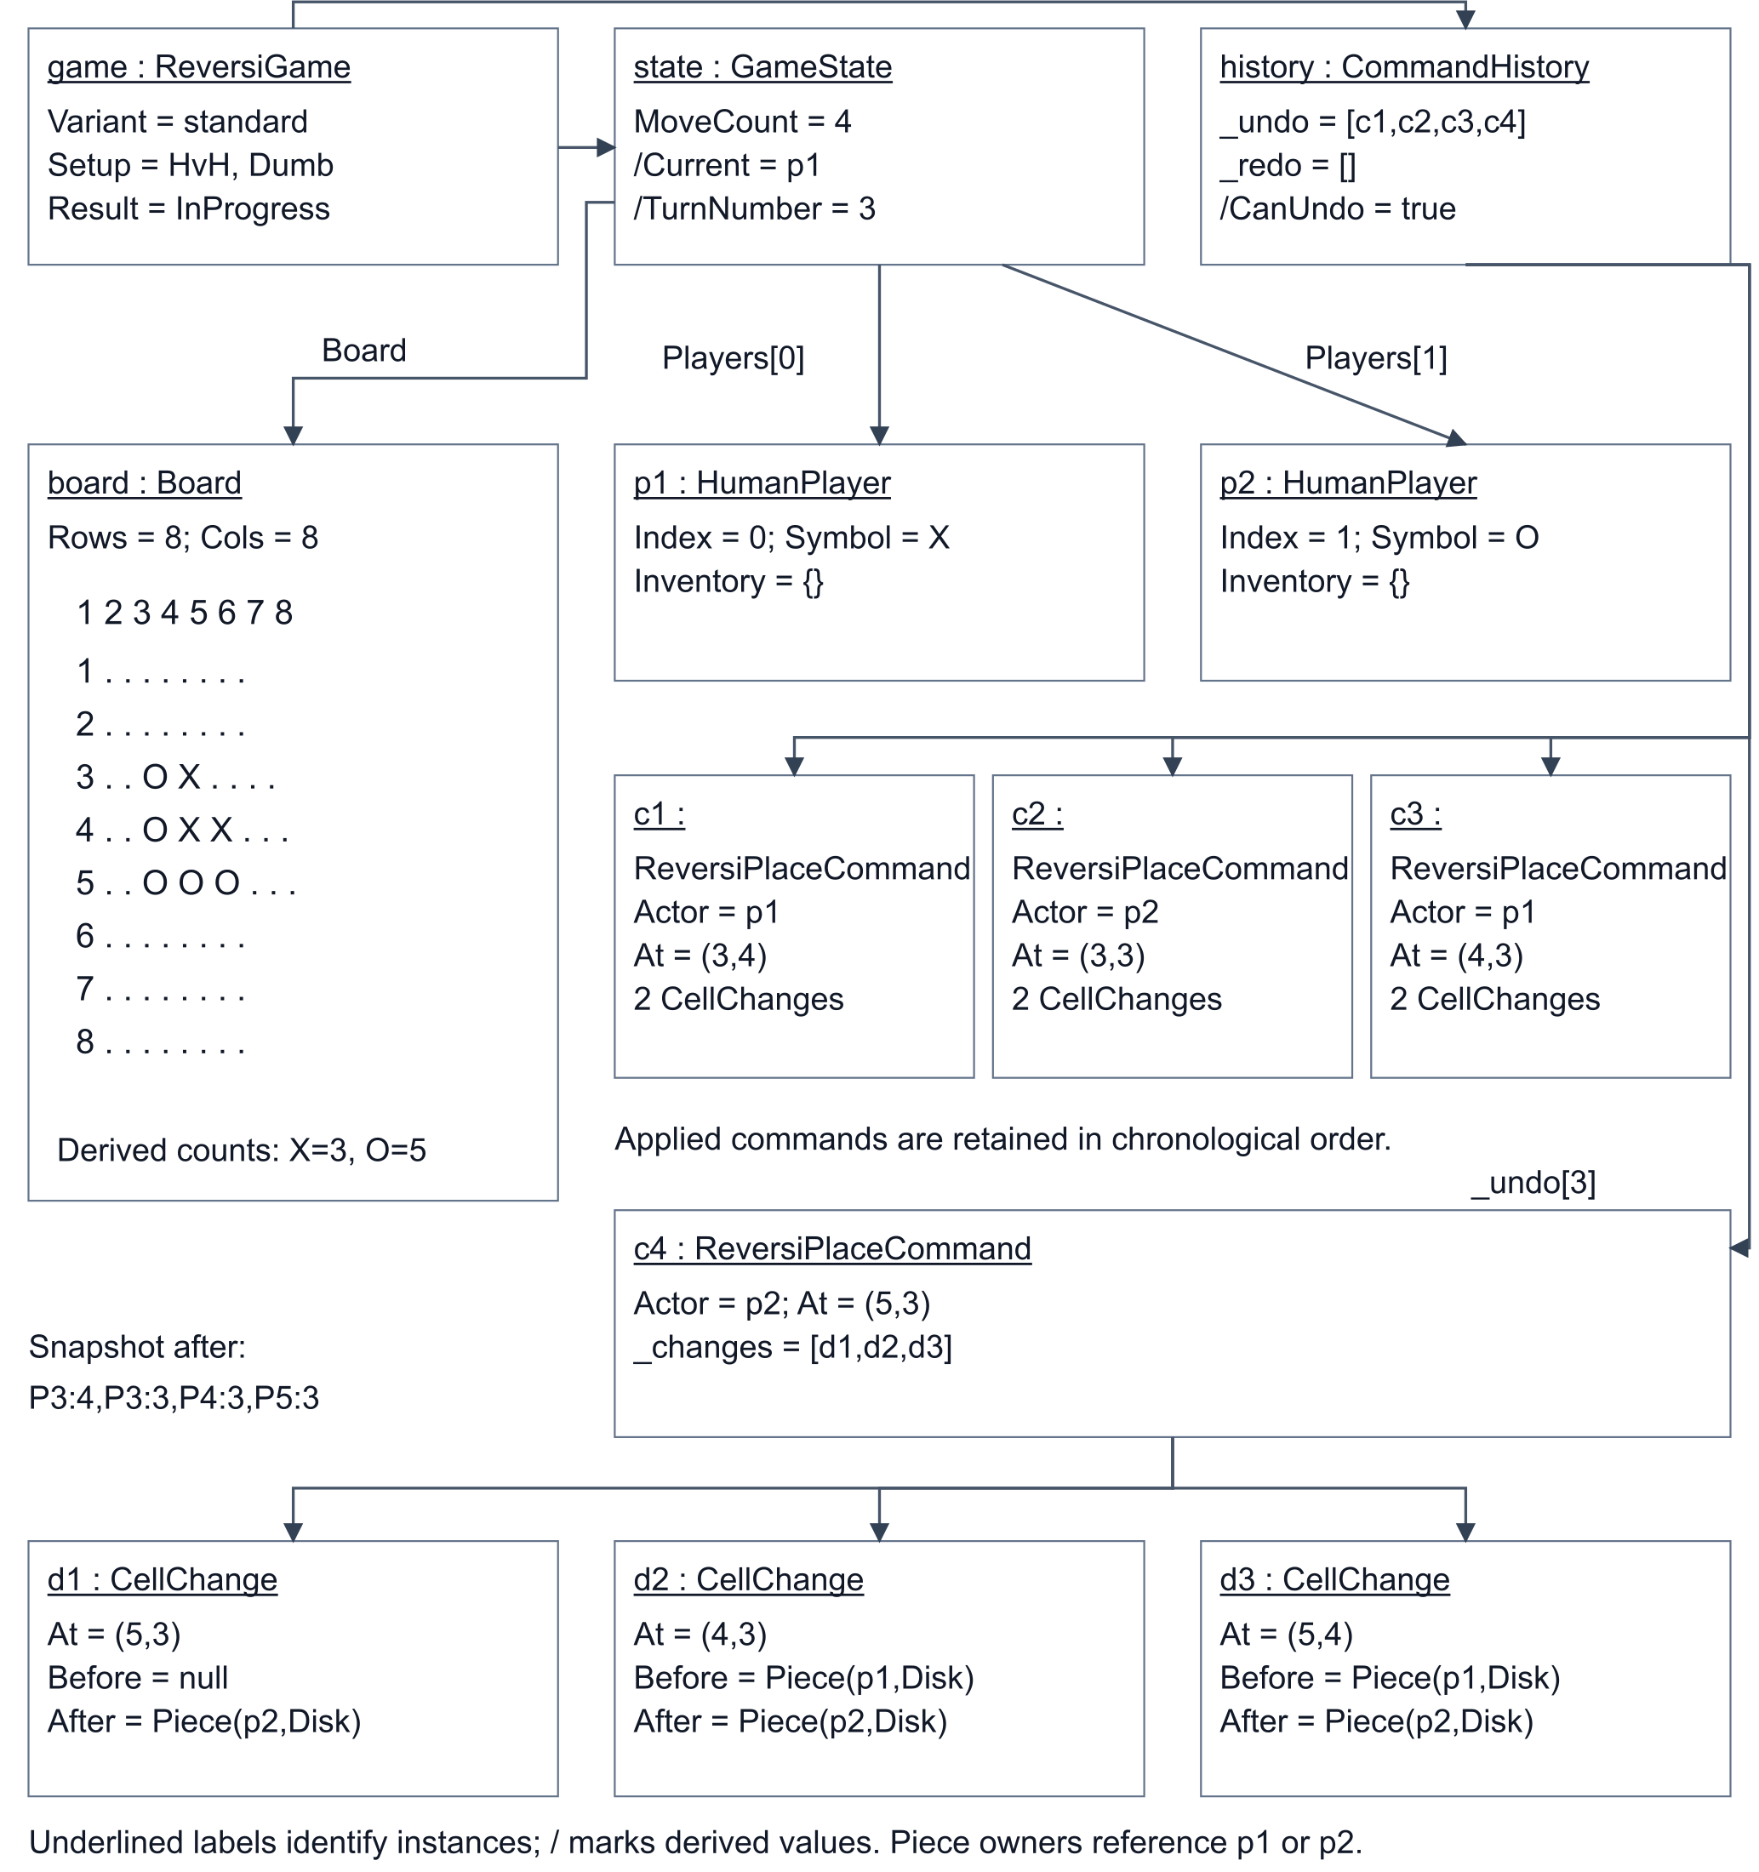
Figure 1 Reversi runtime snapshot after four legal moves. Underlined labels identify instances; slash-prefixed properties are derived. The c1, c2 and c3 boxes separate instance names from their common ReversiPlaceCommand type.

Verification evidence
At this Task 3 checkpoint, dotnet build BoardGames.slnx -warnaserror and dotnet test BoardGames.slnx --no-build pass. The suite contains 193 passing cases, comprising the 50 existing cases and 143 added Task 3 cases. Coverage includes all eight capture directions, unbounded and interrupted lines, rejection without mutation, disk restoration, full-turn undo and redo, history branching, forced passes, majority and misere results, draws, third-corner victory, tactical AI choices, complete matches and persistence validation.
Twenty-four complete seeded HvH matches compare every legal move list against an independently written endpoint-based oracle. Nine complete HvC matches exercise the Smarter strategy through the actual shared loop. Repository round trips cover all six currently registered variants, both modes and both AI levels. Reversi tests use the implemented rules; the Gomoku round trips currently exercise Task 1's placeholder rules. Additional tests load a real forced-pass history, restore undo after restart, reject inconsistent saves and preserve the current game after a failed in-game load.
The three assignment Reversi CLI examples execute successfully. The standard and anti examples finish with X=5, O=4, P2 active. The corner example finishes with X=5, O=5, P1 active. These examples remain in-progress matches; they do not demonstrate complete victory conditions. The dedicated full-match and corner-dominance tests provide that evidence.

Save and load sequence diagrams
Saving captures the setup and applied command records together with board and inventory snapshots. The repository writes the JSON completely before replacing an existing destination file.
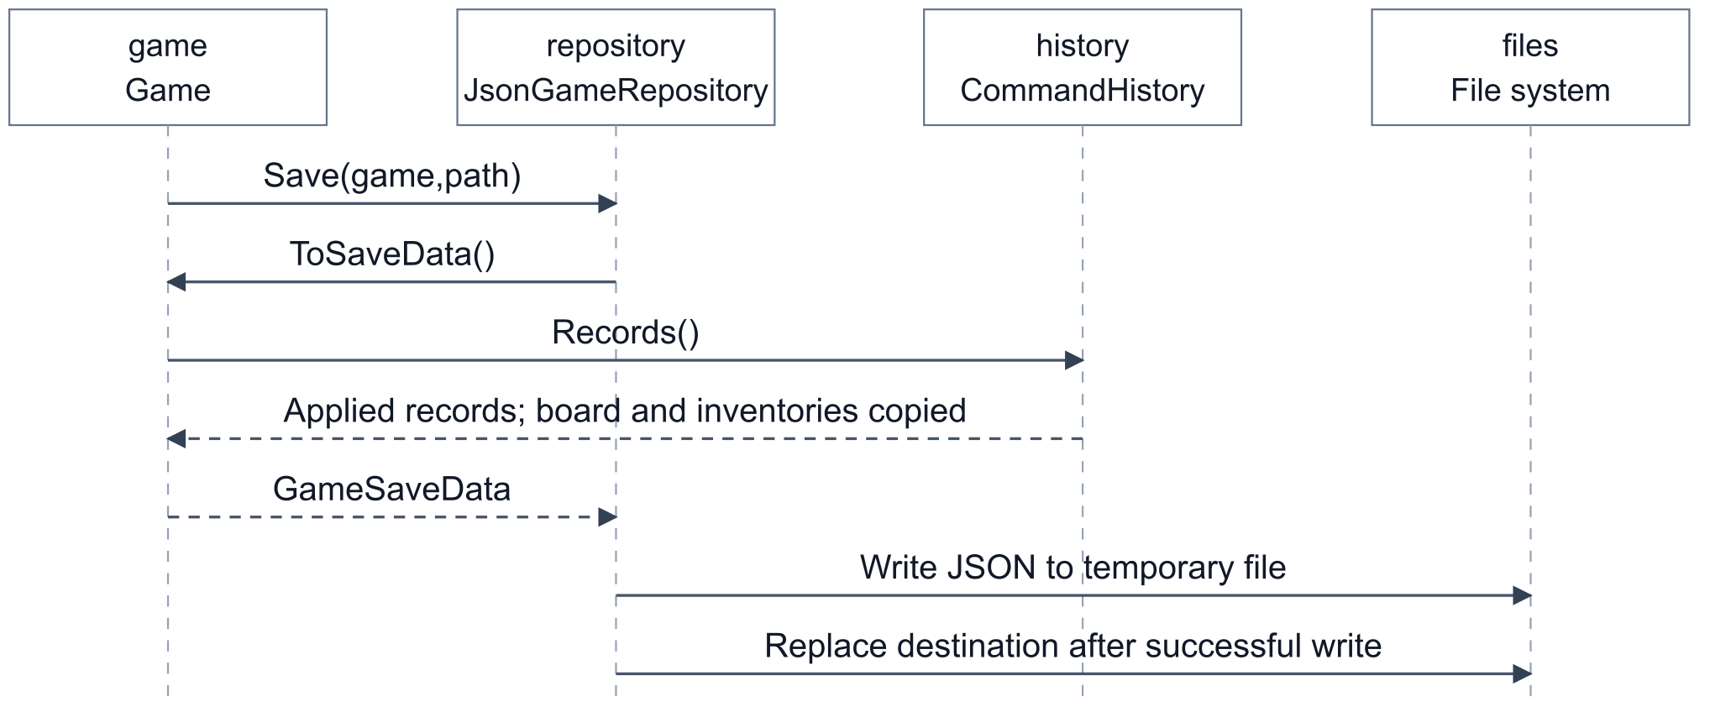
Figure 2a Save sequence. Board snapshots and inventory copies are collected inside Game.ToSaveData; the command records come from CommandHistory.Records.

Save and load sequence diagrams continued
Loading constructs a fresh game through its registered factory and replays each record to rebuild the command history. The repository checks the reconstructed board and inventories before the menu switches games.
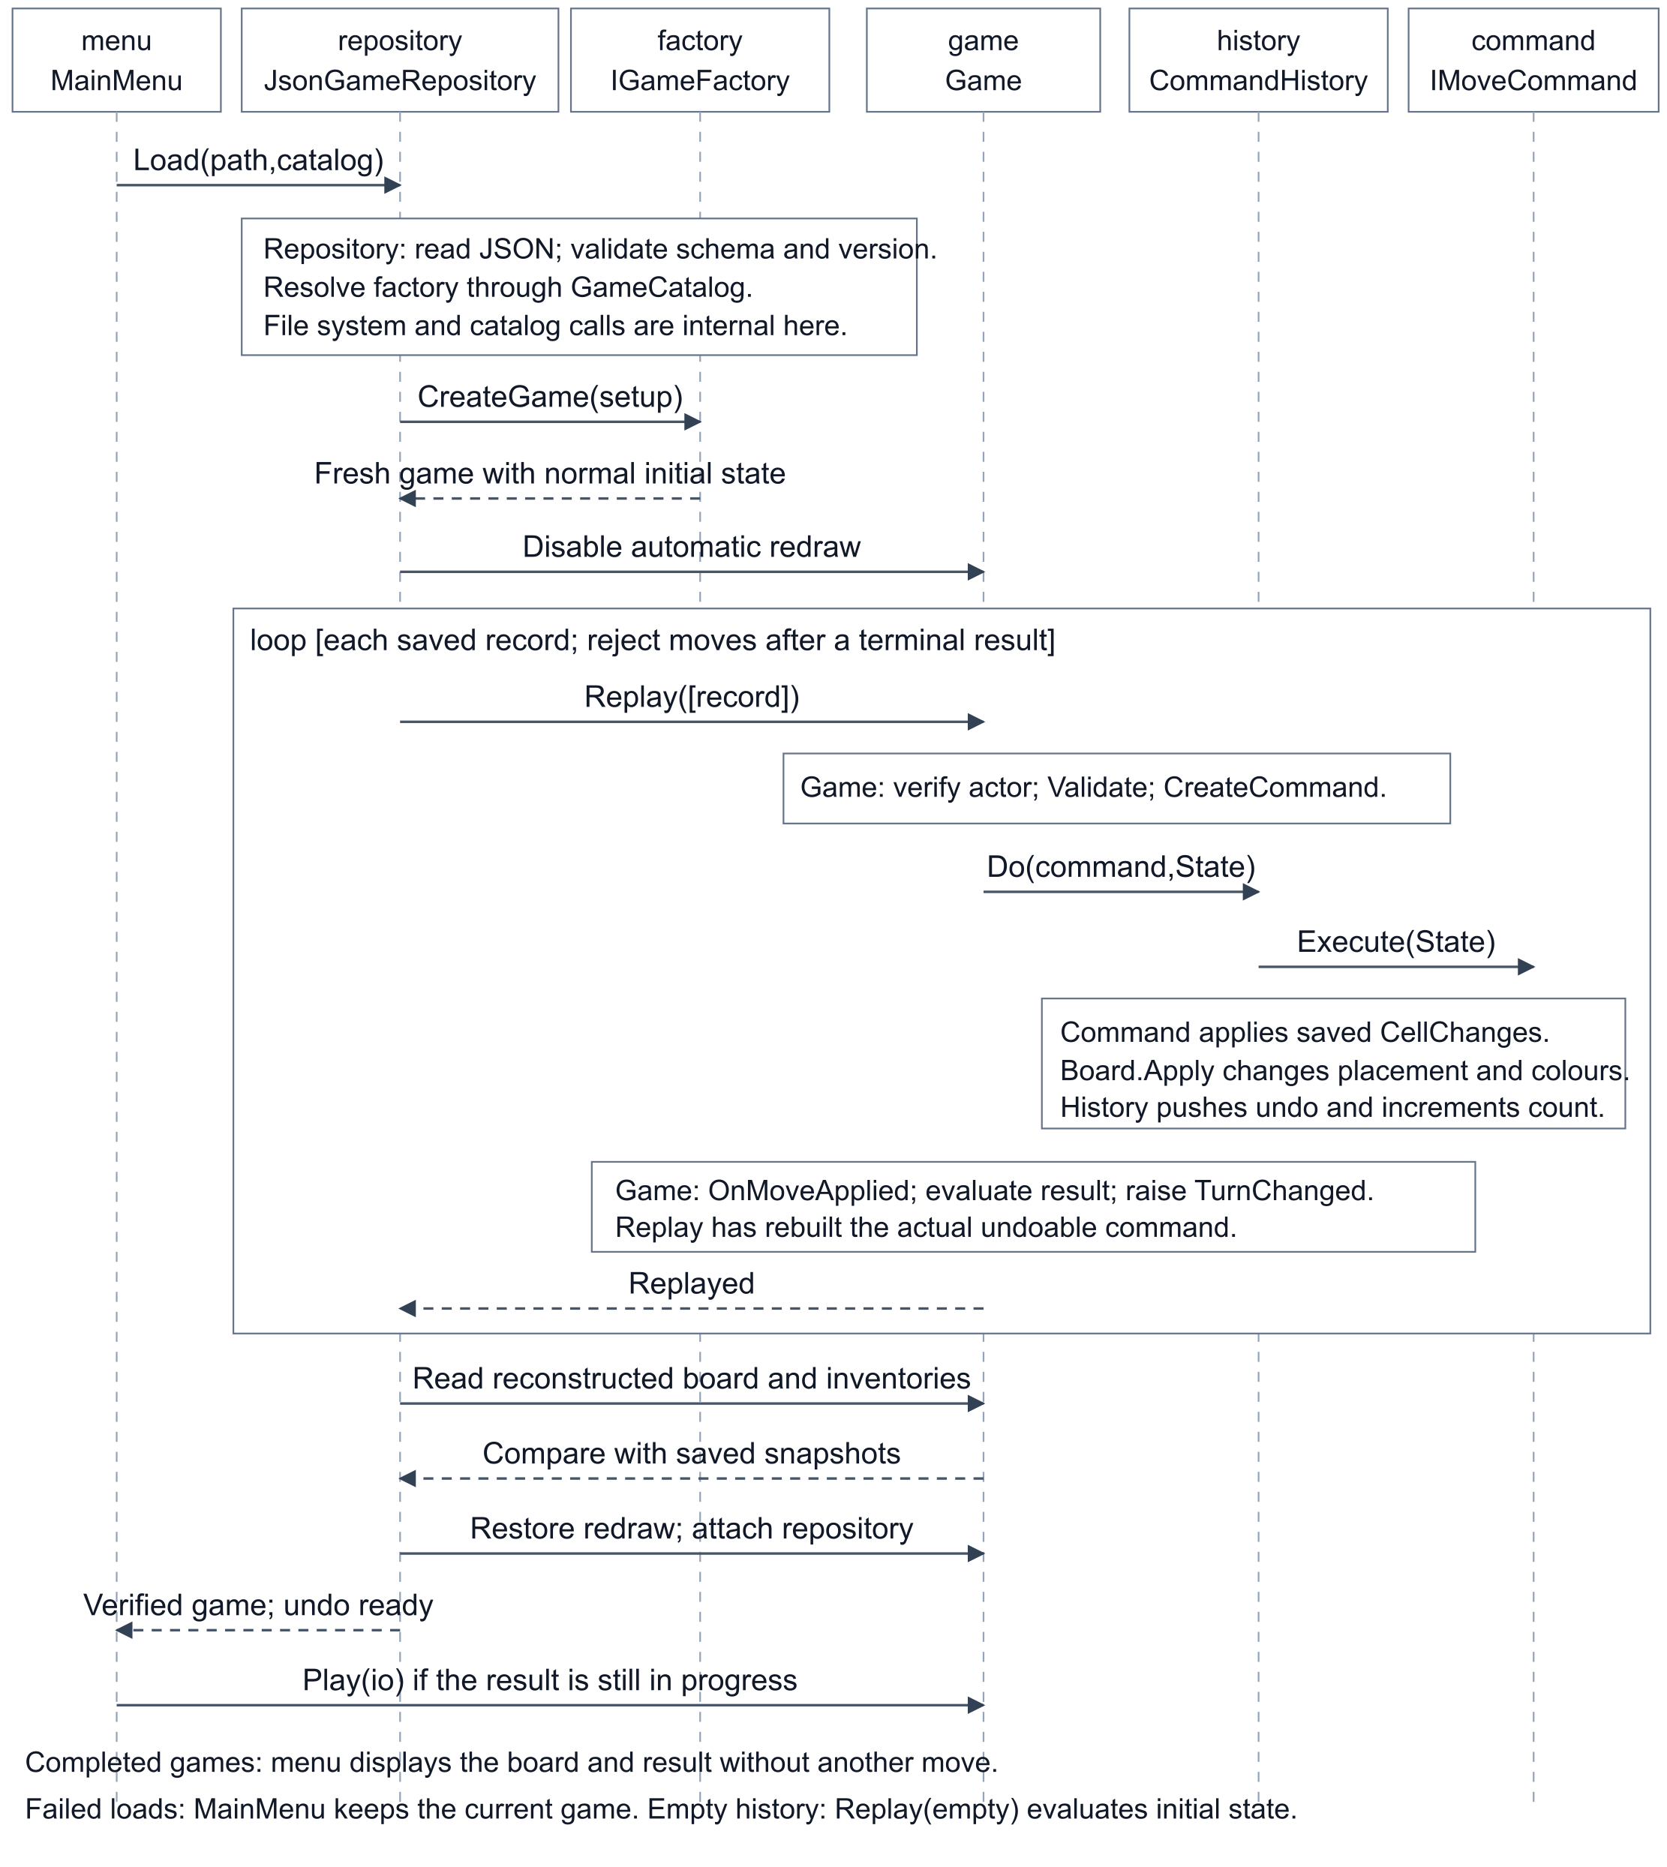
Figure 2b Load sequence and immediate undo readiness. Notes represent internal calls to receivers without separate lifelines. The Game lifeline denotes the reconstructed game. Failed loads retain the current game; completed saves display their result.

