To establish the connection between Raspberry and Fujitsu tablet the following should be done:

1. Devices should be connected to the same network
2. Open WinSCP client (C:/LinecameraProjekte/soft/WinSCP)
3. Type the Raspberry IP in the ‘Host Name’ field (by default, Raspberry’s IP is 192.168.2.159 but it could be changed. To see Raspberry’s IP address type **hostname –I** in the Raspberry command line
4. Then, enter the username and password

Username – pi

Password – raspberry

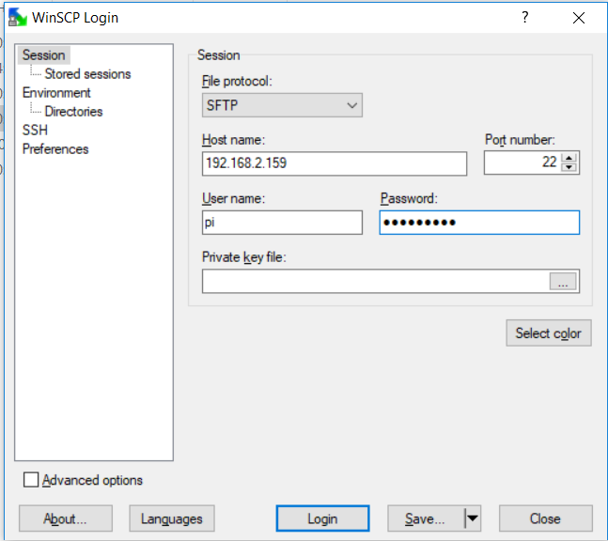

1. After this, connection between two devices is established and it’s possible to share the files between them. Results of the measurement on Raspberry are stored in the **/home/pi/linecamproject/results** directory. On Fujitsu tablet they should be stored in the **C:/LinecameraProjekte/datei** directory

Measurement

1. Run the script **CamReader.py** from directory **/home/pi/linecamproject/code (Thonny Python editor)**
2. Choose the necessary measurement mode and press ‘Start’ button

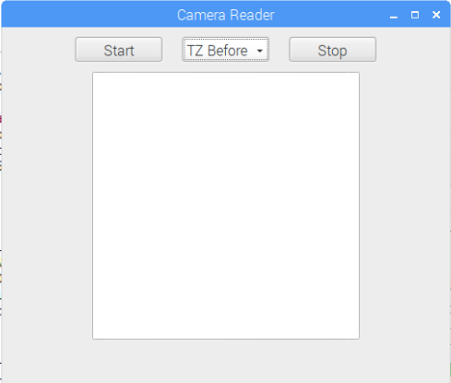

1. When The measurement is done, press ‘Stop’ button
2. Now it’s possible to send result file with measurement to the Fujitsu tablet using WinSCP client
3. On the Fujitsu device run **main.last.py** script that is in the directory **C:/LinecameraProjekte/windows (PyCharm IDE)**
4. To run the program you have to choose python interpreter:

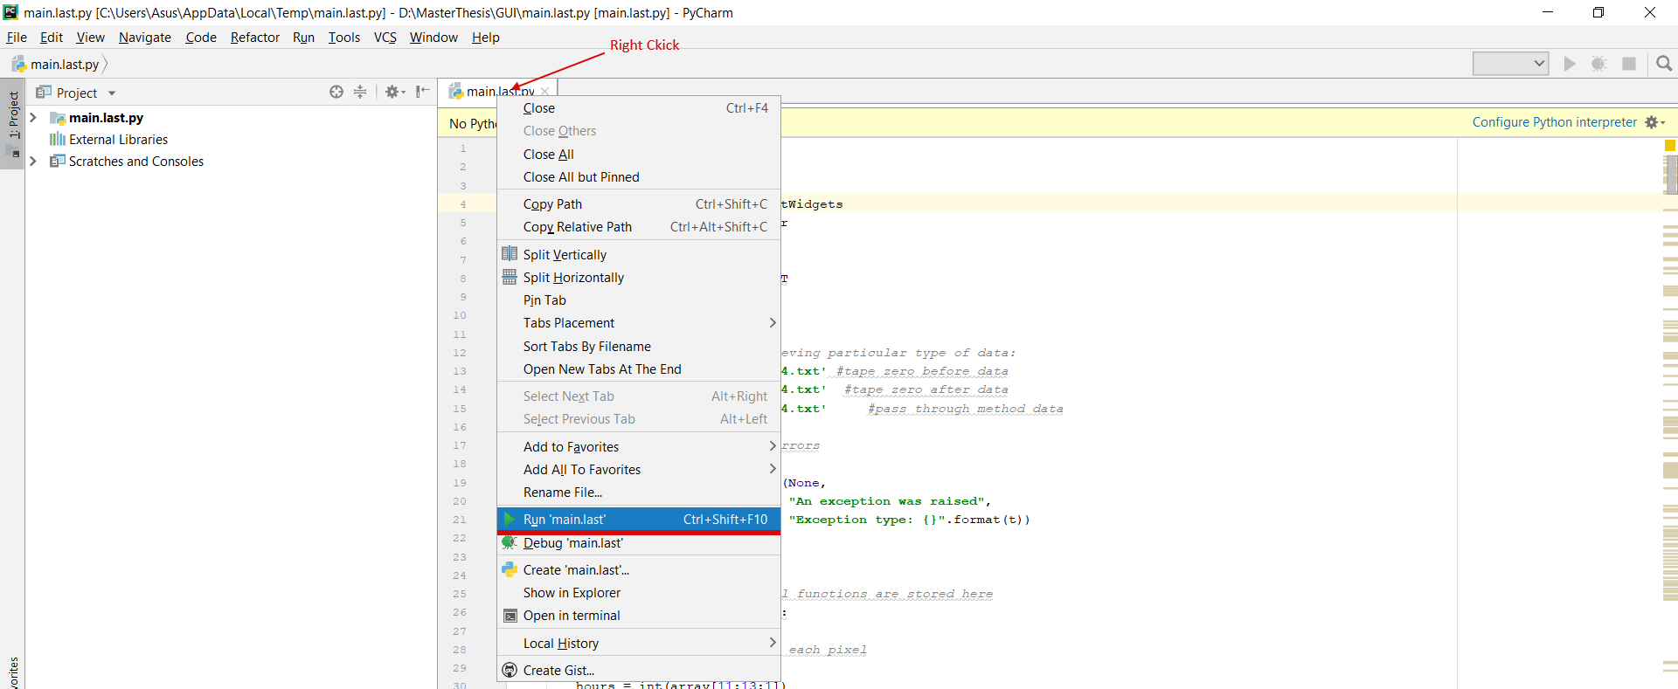

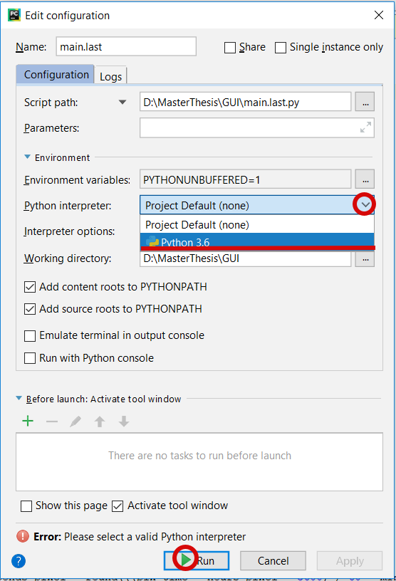

1. On the first tab type the name of the project and create it.
2. The computation procedure is the following:

* Type all necessary values in the **Config** tab. Press **“apply”** button to confirm changes.
* On the **TapeZero** tab choose **Before measurement** radio button.
* Type the HZ angle value and press **Z measure**
* Press **Compute**
* Switch to the PTM tab and enter the preorientation value. Press **Preliminary orientation** button
* Press **Compute**
* Switch back to the **TapeZero** tab and choose **After measurement** radio button
* Press **Compute**
* Type the HZ angle value and press **Z measure**

For filtering and smoothing the data flow a Savitzky-Golay filter was applied. It’ embedded function of scipy library: scipy.signal.savgol_filter(input_array,window_length, polyorder)

Now all computed values are displayed in the tab **Azimuth.**

To save results into the xml file press **Save changes** button on the bottom of the window. Results are stored in the **C:/LinecameraProjekte/xml** directory