Question 1

1. The uncovered set is {a, b, c}
2. The top cycle is {a, b, c}
3. The set of Copeland winners is {a, b, c}
4. The set of Banks winners is {a, b, c}
5. The set of Condorcet winners is {}

Because there are three alternatives {a, b, c} preferred by a majority of voters, and Condorcet winner can only have one alternative. Thus, Condorcet winner does not exist.

Question 2

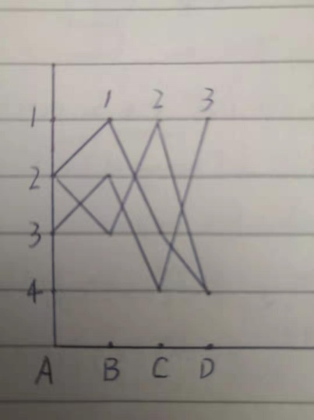

(A, B, C, D mean alternatives a, b, c, d)

As the above picture shows, the preference profile is not single-peaked.

From agent 1 and 3, 2 voters prefer b than a

From agent 1 and 3, 2 voters prefer b than c

From agent 1 and 2, 2 voters prefer b than d

Thus, b is pairwise preferred by a majority of voters over every other alternative.

Therefore, b is Condorcet winner for the preference profile.

Question 3

1 : o5, o2, o1, o3, o4

2 : o5, o4, o3, o1, o2

3 : o4, o2, o3, o5, o1

4 : o2, o1, o5, o3, o4

5 : o2, o4, o1, o5, o3

Agent 4 cannot get a more preferred allocation as only agent 3 most prefer item 4 and no agent most prefer agent 3, thus, a cycle cannot form before agent point to item 3.

As theorem, for housing markets, TTC is individually rational. And we can easily see from the outcome of the TTC that no agent minds participating in the allocation procedure, thus, the outcome is individually rational.

Question 4

Agent 1 applies e, agent 2 applies b, agent 3 and 4 applies a, agent 5 applies d

a reject 3 in favor of 4 {{1, e}, {2, b}, {4, a}, {5, d}}

agent 3 applies b

b reject 2 in favor of 3 {{1, e}, {3, b}, {4, a}, {5, d}}

agent 2 applies a

a reject 4 in favor of 2 {{1, e}, {2, a}, {3, b}, {5, d}}

agent 4 applies b

b reject 4 in favor of 3

agent 4 applies c and get accepted {{1, e}, {2, a}, {3, b}, {4, c} {5, d}}

As theorem shown, Student Proposing DA returns an allocation that satisfies justified envy-freeness. And justified envy-freeness means that there exists no agent i who prefers another school s over her match and s admits j a lower priority agent than i. From above, we get school a, b, d, e allocate their most preferable student, just c is allocated student 4 which is less preferable than student 2 and 3, student 2 and 3 prefer a and b than c. Therefore, there exists no agent i who prefers another school s over her match and s had admitted j a lower priority agent than i. As a result, we can say that the resultant matching is Pareto optimal for the students.

Question 5

1. As the allocation is Adjusted Winner, therefore, just as theorem shows, Adjusted Winner is Pareto optimal, equitable, envy-free, and proportional, and requires at most one item to be split. So there always exists an envy-free and Pareto optimal allocation of the divisible items.
2. Each item is assigned to the agent that values it the most. Ties are broken in favour of agent 1.

Some of the items are redistributed to ensure equitability ( total points used by both agents on items they have won is same). In order for that to happen, at most one item may be required to be split.

1. As the allocation is Adjusted Winner, so there always exists an envy-free and Pareto optimal allocation of the divisible items.